Khyle Calpe

405016683

12/6/2017

Math 31A Lecture Notes: Mean Value and Areas of Solids of Revolution

$a{}_{1},…,a_{n}$ Average $=\frac{a_{1}+…+a_{n}}{n}=\frac{1}{n}\sum_{i=1}^{n}{a_{i}}$

Average of the value of $f\left(x_{1}\right),…f\left(x_{n}\right)=\frac{1}{N}\left(f\left(x_{1}\right)+…+f\left(x_{N}\right)\right)=\frac{1}{N}\sum_{i=1}^{N}{f\left(x_{i}\right)}$

Average value of $f$ on $\left[a,b\right]=\lim_{N→∞}R_{N}{=}\frac{1}{b-a}\int_{a}^{b}{f\left(x\right)dx}$

Definition; Mean value Theorem:

The average value (mean value) of an integrable function $f$ on $\left[a,b\right]$ is defined by:

$$\frac{1}{b-a}\int_{a}^{b}{f\left(x\right)}dx$$

Example 1: Find the average value of $f\left(x\right)=sin\left(x\right)$ on $\left[0,π\right]$

Solution: $\frac{1}{π}\int_{0}^{π}{sin\left(x\right)}dx=\frac{1}{π}-cos\left(x\right)|_{0}^{π}=\frac{2}{π}=0.637$

Example 2: A monkey named Larry jumps in the air with an initial velocity of 6 m/s.

Using Galileo’s formula for his height ( $g≈10$ m/s):

$$h\left(t\right)=v_{0}t-\frac{1}{2}gt^{2}$$

Compute the average velocity while in the air

Solution: $h\left(t\right)=6t-5t^{2}=t\left(6-5t\right)$

Larry is in the air $\left(h≥0\right)$, for $0≤t≤1.2$. The velocity is given by:

$v\left(t\right)=h^{'}\left(t\right)=v_{0}-10t=\left\{\begin{aligned}=0, t≤6/10 \\ <0,t>6/10\end{aligned}\right.$

His average velocity $=\frac{1}{1.2}\int_{0}^{1.2}{\left|v\left(t\right)\right|}dt$ $=$ $\frac{1}{1.2}\left(\int_{0}^{0.6}{v\left(t\right)}dt+\int_{0.6}^{1.2}{-v\left(t\right)}dt\right)$

$=$ $\frac{5}{6}((6t-5t^2)|_{0}^{0.6})+(-6t+5t^2)|_{0.6}^{1.2})$

$=$ 3 m/s

Definition; Solid of Revolution: A SoR is obtained by rotating a region about an axis

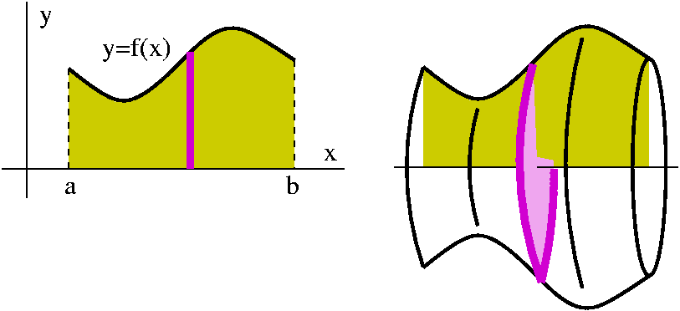

Goal: Compute the volume of a solid of revolution

Suppose: $f\left(x\right)≥0$ or $a≤x≤b$

 $A\left(x\right)=$ area of vertical cross section

$=πR^{2}=πf{\left(x\right)}^{2}$

Hence, the volume of the solid obtained by

Rotating the region under the graph of a

Function $y=f\left(x\right)$ is given by:

$V=\int_{a}^{b}{A\left(x\right)}dx=π\int_{a}^{b}{f{\left(x\right)}^{2}}dx$

Example 3: Compute the volume V of the solid of revolution obtained by rotating the region under the graph $y=x^{2}$ about the x-axis for $0≤x≤2$

$$V=π\int_{0}^{2}{f{\left(x\right)}^{2}}dx=π\int_{0}^{2}{x^{4}}dx=π\frac{x^{5}}{5}|_{0}^{2}=\frac{32}{5}π$$

Variation: We can also rotate the region between two graphs

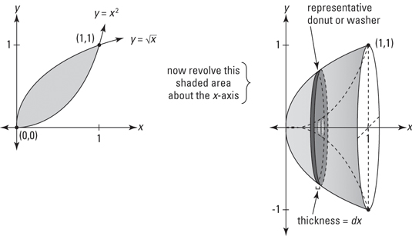

Assuming $f\left(x\right)≥g\left(x\right)$ then

$$V=π\int_{a}^{b}{f{\left(x\right)}^{2}-g{\left(x\right)}^{2}}dx$$

! Do not take $\int{{\left(f-g\right)}^{2}}dx$