YouTube silent audio demo on the project: [**https://youtu.be/ZsDclr572ew**](https://youtu.be/ZsDclr572ew)

Create a database, **APPD_BikeBookingSystemDB**.

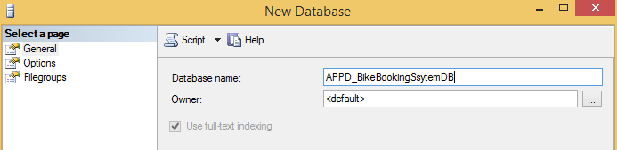

Unzip the **BookingSystem.zip** and ensure that the **BookingSystem** project directory is sitting inside **D:\APPD** folder as shown in the figure below. This preparation is important to you because you are going to use an SQL script file. The SQL script file has SQL commands which create **Item** table records. While the SQL command creates an item record, it will read the respective image file from the **ImageData** directory to populate the **Photo** field.

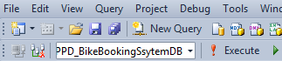

Within the SQL Server Management Studio, ensure that it is focusing on the correct database. So that, when you click the **Execute** button to apply the SQL script file, **CreateTablesAndData.sql** later, tables and records are created in the correct database.

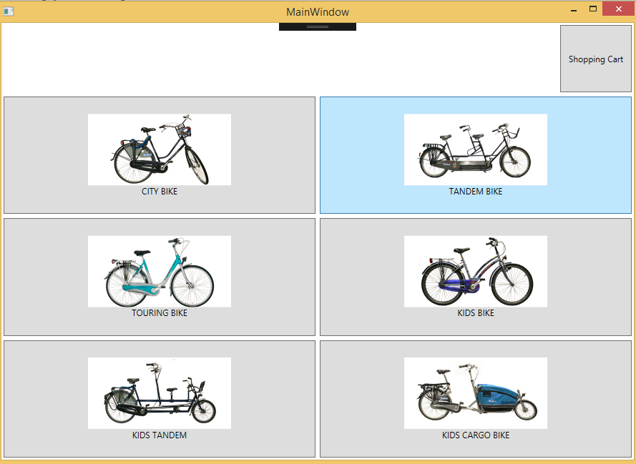

The following error usually occurs due to typo on the database name.

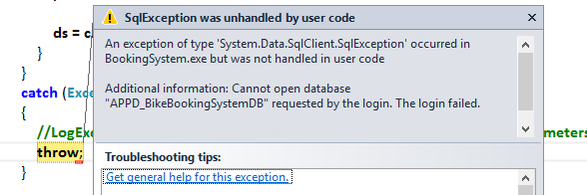

To add a new user control such as **ShoppingCartScreen.xaml** into the **Screens** directory, I will right click on the Screens folder and choose **Add** ▶ **New Item**.

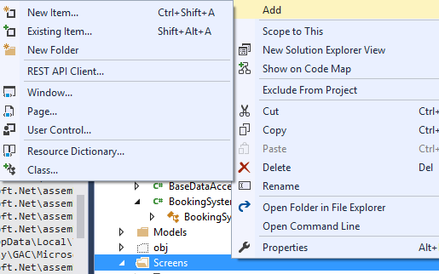

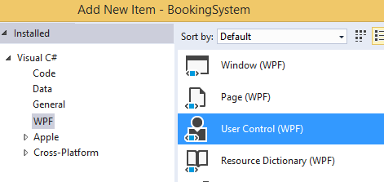

When you are binding the ComboBox type control to a List of instances, you need to be careful on the XAML markup.

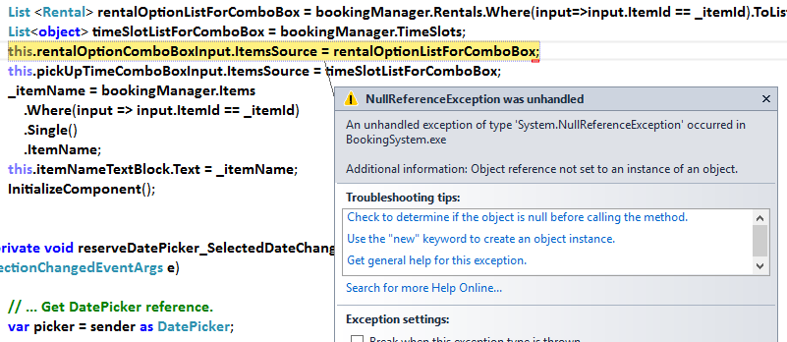

The **DisplayMemberPath** property in the mark-up is "**RentalName**". This did not match with the property name, **RentalType** which is defined in the **Rental** class.



Other reasons can be, the command is *executed* before the **InitializeComponent()** statement.

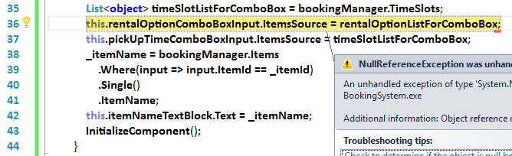

I have referred to this site to obtain some ideas on the reservation form interface.

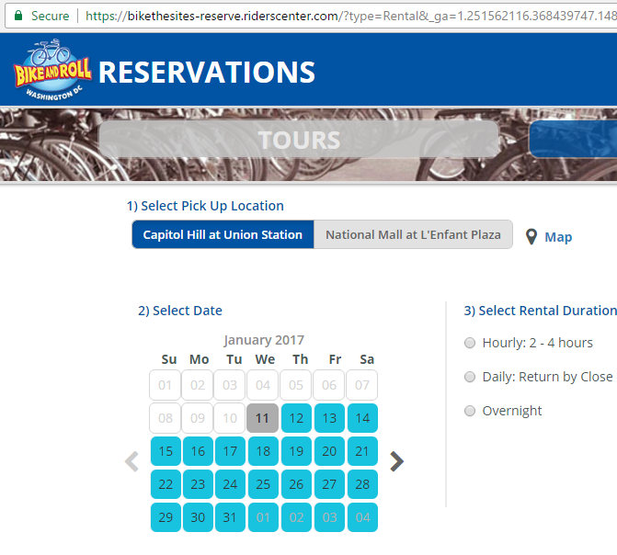

I have also referred to this site to gather some inspiration on the rental pricing

