Active Suspension System

**Submitted by,**

**Kirti Maan**

**UniqueID-2005139**

Active suspensions use separate [actuators](https://en.wikipedia.org/wiki/Actuator) which can exert an independent force on the suspension to improve the riding characteristics.

When the vehicle is experiencing any road disturbance, the vehicle body should not have large oscillations, and the oscillations should dissipate quickly.

When the suspension system is designed, a 1/4 model (one of the four wheels) is used to simplify the problem to a 1-D multiple spring-damper system. A diagram of this system is shown below.

This model is for an Active Suspension System where an actuator is included that can generate the control force U to control the motion of the bus body.

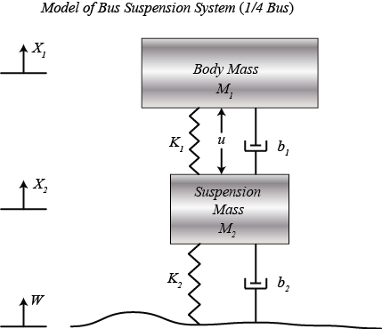

# Equations of motion

From the picture above and Newton's law, we can obtain the dynamic equations as the following:

$$ M_1 \ddot{X}_1 = - b_1 (\dot{X}_1 - \dot{X}_2) - K_1 (X_1 - X_2) + U \ $$

$$ M_2 \ddot{X}_2 = b_1 (\dot{X}_1 - \dot{X}_2) + K_1 (X_1 - X_2) + b_2 (\dot{W} - \dot{X}_2) + K_2 (W - X_2) - U$$

When the vehicle is experiencing any road disturbance (i.e., potholes, cracks, and uneven pavement), the vehicle body should not have large oscillations, and the oscillations should dissipate quickly. Since the distance X1-W is very difficult to measure, and the deformation of the tire (X2-W) is negligible, we will use the distance X1-X2 instead of X1-W as the output in our problem. Keep in mind that this is an estimation.

Designed a feedback controller so that the output should have an overshoot less than 5% and a settling time shorter than 5 seconds.

The road disturbance (W) in this problem will be simulated by a step input. This step could represent the vehicle coming out of a pothole.

# System Parameters

M1 1/4 bus body mass 2500 kg

M2 suspension mass 320 kg

K1 spring constant of suspension system 80,000 N/m

K2 spring constant of wheel and tire 500,000 N/m

b1 damping constant of suspension system 350 N.s/m

b2 damping constant of wheel and tire 15,020 N.s/m

U control force

# Solver Selection

While solver selection, ode23s and ode45 were giving the desired output. ODE45 solver was chosen as it is a six-stage, fifth order, Runge-Kutta method. ode45 does more work per step than ode23 but can take much larger steps. For differential equations with smooth solutions, ode45 is often more accurate than ode23. In fact, it may be so accurate that the interpolant is required to provide the desired resolution.

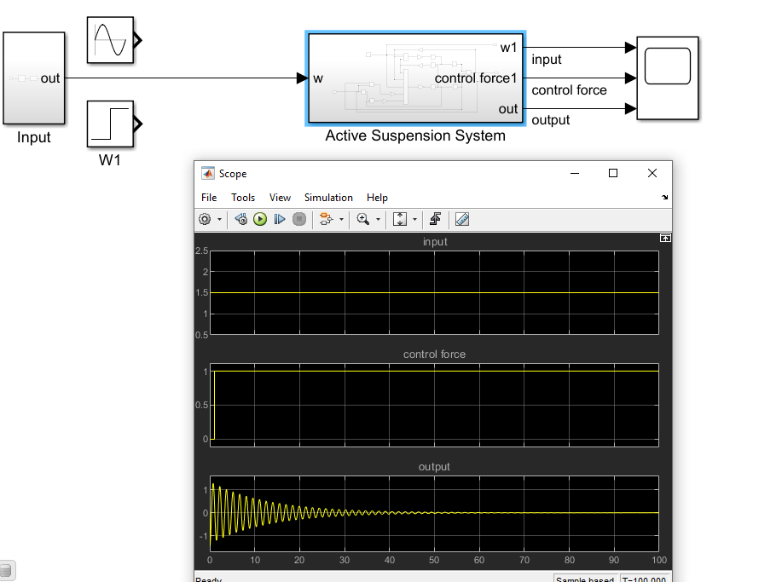

Figure : Output for Plain Straight road

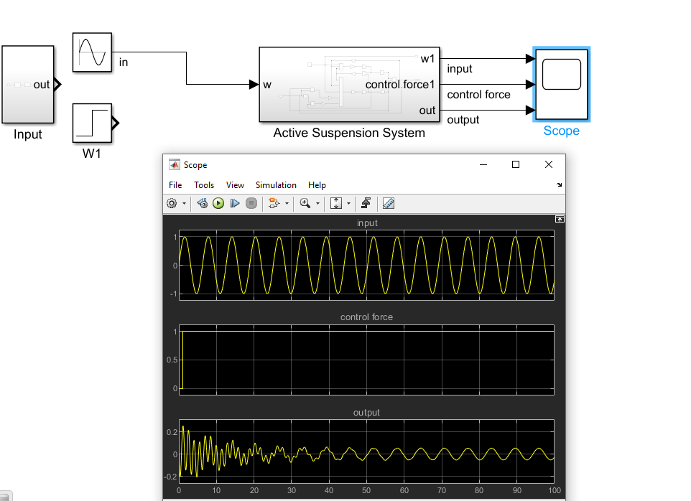

Figure : Output for road full of ups and downs