CvPcb
The KiCad Team


Reference manual
Copyright
This document is Copyright © 2010–2013 by it’s contributors as listed below. You may distribute it and/or modify it under the terms of either the GNU General Public License (http://www.gnu.org/licenses/gpl.html), version 3 or later, or the Creative Commons Attribution License (http://creativecommons.org/licenses/by/3.0/), version 3.0 or later.
All trademarks within this guide belong to their legitimate owners.
Contributors
Jean-Pierre Charras, Fabrizio Tappero, Wayne Stambaugh.
Feedback
Please direct any comments or suggestions about this document to the KiCad mailing list: https://launchpad.net/~kicad-developers
Acknowledgments
None
Publication date and software version
Published on February 4, 2013.
Note for Mac users
The KiCad support for the Apple OS X operating system is experimental.

Introduction to CvPcb
CvPcb is a tool that allows you to associate components in your schematic to component footprints used when laying out the printed circuit board. This association is added to the net list file created by the schematic capture program Eeschema.
Typically the net list file generated by Eeschema does not specify which printed circuit board footprint is associated with each component in the schematic. Although this is not always the case as component footprints can be associated during schematic capture by setting the component’s footprint field. CvPcb provides a convenient method of associating footprints to components. It provides footprint list filtering, footprint viewing, and 3D component model viewing to help ensure the correct footprint is associated with each component.
Components can be assigned to their corresponding footprints manually or automatically by creating equivalence files. Equivalence files are look up tables associating each component with it’s footprint.
This interactive approach is simpler and less error prone than directly associating the footprints in the schematic editor.
CvPcb allows you to see the list of available footprints available and display them on the screen to ensure you are associating the correct footprint.

CvPcb Features

Manual or Automatic Association
CvPcb allows for interactive assignment (manual) as well as automatic assignment via equivalence files. It is also possible to generate back-annotation files which are useful for automatically associating the footprints selected by CvPcb schematic captured by Eeschema.

Input Files
- The net list file (*.net) created by Eeschema with or without footprint associations.
- The auxiliary component assignment file (*.cmp) previously created by CvPcb if one exists.

Output Files
Two files are genera ted for Pcbnew:
- The net list file with footprint associations.
- An auxiliary component association file (*.cmp).

Invoking CvPcb
CvPcb is typically invoked from the schematic capture program Eeschema. Eeschema automatically passes the correct net list file name to CvPcb. Before running CvPcb for the first time for each project, you must first save the initial net list by selecting the “Generate Netlist” entry in to “Tools” menu or click on the generate net list button on the top tool bar in Eeschema. By default the net list file has the same name as the project with a “net” file extension. If the net list file for the project already exists, all footprint associations will be preserved. After the initial net list file is created by Eeschema, CvPcb can be invoked directly from the KiCad project manager. CvPcb can also be invoked as a stand alone program rather than being launch from the KiCad project manager or the schematic editor. If CvPcb is run as a stand alone program, the net list file must be opened manually by selecting the “Open” entry in the “File” menu or clicking the “Open” file button on the tool bar.

CvPcb Commands

Main Screen
The image below shows the main window of CvPcb.
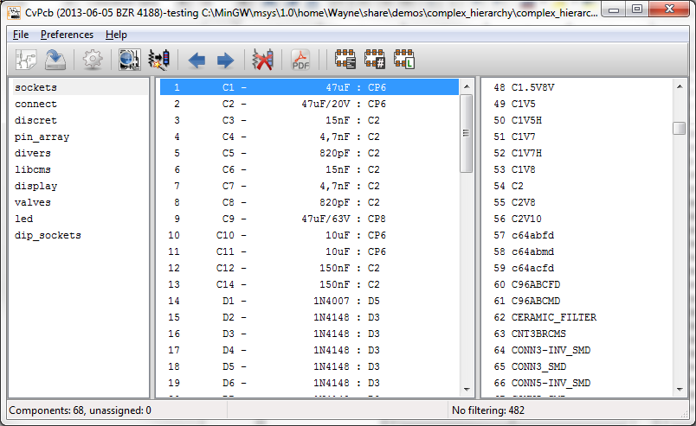
The left pane contains the list of available footprint library file names associated with the project. The center pane contains the list of components loaded from the net list file. The right pane contains the list of available footprints loaded from the project footprint libraries. The component pane will be empty if no netlist file has been loaded and the footprint pane can be also empty if no footprint libraries are found.

Main Window Toolbar
The top toolbar allows for easy access to the following commands:
 | Select the net list file to be processed.
 | Save the footprint association file (.cmp) and the updated net list (.net) file.
 | Invoke the CvPcb configuration menu.
 | Display the footprint of the component selected in the footprint window.
 | Automatically associate footprints with components starting using an equivalence file.
 | Automatically select the previous component in the list without a footprint association.
 | Automatically select the next component in the list without a footprint association.
 | Delete all footprint assignments.
 | Open the selected footprint documentation pdf file using the default pdf viewer.
 | Enable or disable the filtering to limit the list of footprints to the footprint filters of the selected component.
 | Enable or d isable the filtering to limit the list of footprints using the pin count of t he selected component.
 | Enable or disable filtering to limit the list of footprints using the selected library.

Main Window Keyboard Commands
The following table lists the keyboard commands for the main window:
[multiblock cell omitted] | Activate the next pane to the right of the currently activated pane. Wrap around to the first pane if the last pane is currently activated.
Left Arrow | Activate the next pane to the left of the currently activated pane. Wrap around to the last pane if the first pane is currently activated.
Up Arrow | Select the previous item of the currently selected list.
Down Arrow | Select the next item of the currently selected list.
Page Up | Select the item up one full page of the currently selected list.
Page Down | Select the item down one full page of the currently selected list.
Home | Select the first item of the currently selected list.
End | Select the last item of the currently selected list.

CvPcb Configuration
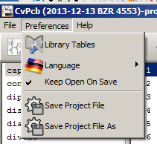
CvPcb can be automatically closed after saving the footprint association file, or not.
Invoking the “Libraries” entry in the “Preferences” menu displays the library configuration dialog.
Depending of the CvPcb version, there are 2 different libraries management:
- The legacy management, using *.mod files, and a library list of files
- The new “Pretty” format, using one file by footprint. It uses a folder list. Each folder (*.pretty folder name) is a library. When using the new management, You also can use native libraries coming from GEDA/GPCB or Eagle xml format files .

Footprint Libraries Management

Legacy management: selecting Footprint Libraries
This section of the footprint library configuration dialog is used to add, remove, and change the search order of the footprint libraries for the current project. The library order is critical when searching for footprints with duplicate names. CvPcb will use the first occurrence of the footprint name it finds. If you create a new footprint, it is always a good idea to give it a unique name to prevent naming conflicts. This is a known issue and will be fixed in a future version of KiCad. Please note that changing these libraries will also effect Pcbnew.
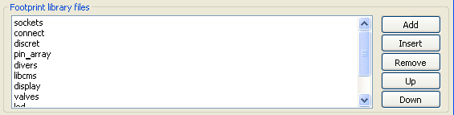
- Remove: Removes the selected footprint library from the list.
- Add: Adds a new footprint library to the end of the list.
- Insert: Inserts a new footprint library to the list before the currently selected library.
- Up: Move the currently select library up the list.
- Down: Move the currently selected library down the list.

Changing the Footprint Documentation File.
Select the “Browse” button to select a new footprint documentation file with the display file select dialog.

Changing Footprint Library Search Paths.
CvPcb uses two types of paths: the default paths automatically set by KiCad when a new project is created and paths added by the user. These paths are used to find the footprints library files (.mod), equivalence files (.equ), and 3D model files (.wrl) used by CvPcb. The default paths cannot be edited. Only new user defined paths can be added to the search path list.
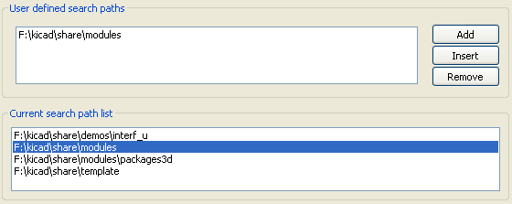

Changing User Define Paths.
Click the “Add” button to add a new path after the selected entry in the search path list. Click the “Insert” button to insert a new path before the selected entry in the search path list. Click the “Remove” button to remove the selected user defined search path. Clicking the “Remove” button will have no effect if a default search path is selected.
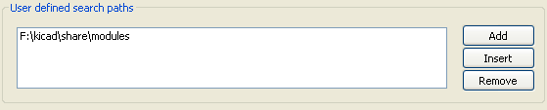

Default Library Paths
By default CvPcb internally uses a set of predefined paths used to search for footprint libraries. These paths are operating system dependent. It is generally preferable to use relative paths rather than absolute paths whenever possible to prevent platform dependency problems. In other words: “c:\Program Files\kicad\share” has no meaning and will fail on Linux and OSX.
The default Linux library paths will be as follows:
- root/share/kicad/modules
- root/share/kicad/modules/packages3d (for 3D shapes files format VRML created par Wings3D).
- root/share/template
Where the root path is relative to the binary path where KiCad is installed. Typically on Linux Kicad is installed in the /usr/bin path. Therefore the root path would be /usr.

New Management: Footprint Libraries tables
Since December 2013, CvPcb no longer uses the library management tool described in #5.1.Legacy%20management:%20selecting%20Footprint%20Libraries|outline[section 5.1].
The new footprint library table implementation is how footprint libraries are now managed.
The image below shows the footprint library table editing dialog which can be opened by invoking the “Library Tables” entry from the “Preferences” menu.
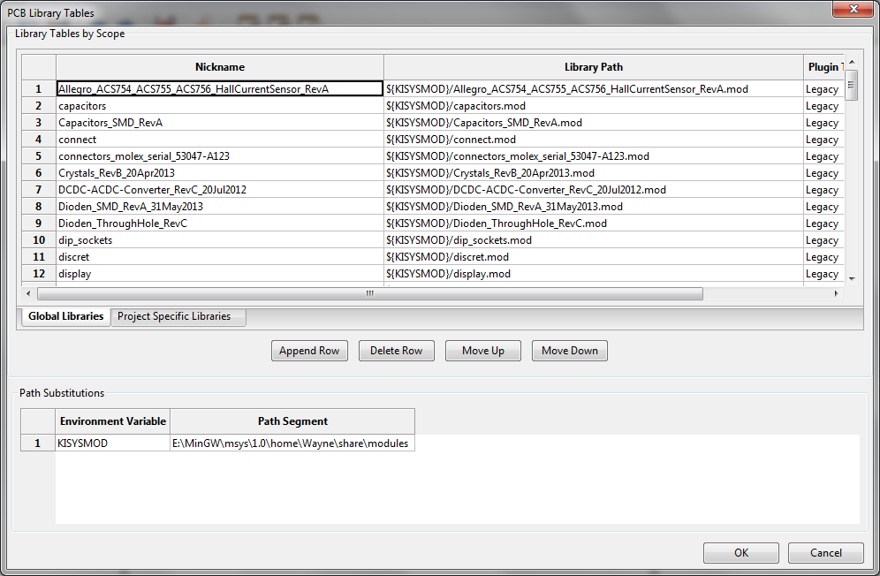
The footprint library table is used to map a footprint library of any supported library type to a library nickname. This nickname is used to look up footprints instead of the previous method which depended on library search path ordering. This allows CvPcb to access footprints with the same name in different libraries by ensuring that the correct footprint is loaded from the appropriate library. It also allows CvPcb to support loading libraries from different PCB editors such as Eagle and GEDA.

Global Footprint Library Table
The global footprint library table contains the list of libraries that are always available irregardless of the currently loaded project file. The table is saved in the file fp-lib-table in the user’s home folder. The location of this folder is dependent on the operating system.

Project Specific Footprint Library Table
The project specific footprint library table contains the list of libraries that are available specifically for the currently load ed project file. The project specific footprint library table can only be edited when it is loaded along with the project netlist file. If no project file is loaded or there is no footprint library table file in the project path, an empty table is created which can be edited and later saved along with the footprint assignment file.

Initial Configuration
The first time CvPcb or Pcbnew is run and the global footprint table file fp-lib-table is not found in the user’s home folder, CvPcb will attempt to copy the default footprint table file fp-lib-table stored in the system’s KiCad template folder to the file fp-lib-table in the user’s home folder.
If fp-lib-table cannot be found, an empty footprint library table will be created in the user’s home folder. If this happens, the user can either copy fp-lib-table manually or configure the table by hand.
The default footprint library table includes all of the standard footprint libraries that are installed as part of KiCad.

Adding Table Entries
In order to use a footprint library, it must first be added to either the global table or the project specific table. The project specific table is only applicable when you have a net list file open.
Each library entry must have a unique nickname.
This does not have to be related in any way to the actual library file name or path. The colon : character cannot be used anywhere in the nickname. Each library entry must have a valid path and/or file name depending on the type of library. Paths can be defined as absolute, relative, or by environment variable substitution (see section below).
The appropriate plug in type must be selected in order for the library to be properly read. CvPcb currently supports reading KiCad legacy, KiCad Pretty, Eagle, and GEDA footprint libraries.
There is also a description field to add a description of the library entry. The option field is not used at this time so adding options will have no effect when loading libraries.
- Please note that you cannot have duplicate library nicknames in the same table. However, you can have duplicate library nicknames in both the global and project specific footprint library table.
- The project specific table entry will take precedence over the global table entry when duplicated names occur. When entries are defined in the project specific table, an fp-lib-table file containing the entries will be written into the folder of the currently open net list.

Environment Variable Substitution
One of the most powerful feature s of the footprint library table is environment variable substitution. This allows you to define custom paths to where your libraries are stored in environment variables. Environment variable substitution is supported by using the syntax ${ENV_VAR_NAME} in the footprint library path.
By default, at run time CvPcb define s the KISYSMOD environment variable. This points to where the default footprint libraries that were installed with KiCad are located.
You can override KISYSMOD by defining it yourself which allows you to substitute your own libraries in place of the default KiCad footprint libraries.
When a project netlist file is loaded, CvPcb also defines the KIPRJMOD using the file path. This allows you to create libraries in the project path without having to define the absolute path to the library in the project specific footprint library table.

Using the GitHub Plugin
The GitHub is a special plugin that provides an interface for read only access to a remote G it H ub repo sitory consisting of pretty (Pretty is name of the KiCad footprint file format) footprints and optionally provides “Copy On Write” (COW) support for editing footprints read from the GitHub repo and saving them locally. Therefore the “Git Hub” plugin is for read only for accessing remote pretty footprint libraries at https://github.com. To add a GitHub entry to the footprint library table the “Library Path” in the footprint library table row for a must be set to a valid GitHub URL.
For example:
https://github.com/liftoff-sr/pretty_footprints
or
https://github.com/ KiCad
Typicality GitHub URLs take the form:
https://github.com/user_name/repo_name
The “Plugin Type” must be set to “Github”. To enable the “Copy On Write” feature the option allow_pretty_writing_to_this_dir must be added to the “Options” setting of the footprint library table entry. This option is the “Library Path” for local storage of modified copies of footprints read from the GitHub repo. The footprints saved to this path are com bined with the read only part of the Git Hub repository to create the footprint library. If th is option is missing, then the Git Hub library is read only. If the option is present for a Git Hub library, then any writes to this hybrid library will go to the local *.pretty directory. Note that the github.com resident portion of this hybrid COW library is always read only, meaning you cannot delete anything or modify any footprint in the specified Git Hub repository directly. The aggregate library type remains “Github” in all further discussions, but it consists of both the local read/write portion and the remote read only portion.
The table below shows a footprint library table entry without the option allow_pretty_writing_to_this_dir:
Nickname | Library Path | Plugin Type | Options | Description
github | https://github.com/liftoff-sr/pretty_footprints | Github | [multiblock cell omitted] | Liftoff’s GH footprints
The table below shows a footprint library table entry with the COW option given. Note the use of the environment variable ${HOME} as an example only. The github.pretty directory is locat ed in ${HOME}/pretty/ path. Anytime you use the option allow_pretty_writing_to_this_dir, you will need to create that directory manually in advance and it must end with the extension .pretty.
Nickname | Library Path | Plugin Type | Options | Description
github | https://github.com/liftoff-sr/pretty_footprints | Github | allow_pretty_writing_to_this_dir=${HOME}/pretty/github.pretty | Liftoff’s GH footprints
Footprint loads will always give precedence to the local footprints found in the path given by the option allow_pretty_writing_to_this_dir. Once you have saved a footprint to the COW library’s local directory by doing a footprint save in the footprint editor, no Git Hub updates will be seen when loading a footprint with the same name as one for which you’ve saved locally.
Always keep a separate local *.pretty directory for each Git Hub library, never combine them by referring to the same directory more than once.
Also, do not use the same COW (*.pretty) directory in a footprint library table entry. This would likely create a mess.
The value of the option allow_pretty_writing_to_this_dir will expand any environment variable using the ${} notation to create the path in the same way as the “Library Path” setting.
What’s the point of COW? It is to turbo-charge the sharing of footprints.
If you periodically email your COW pretty footprint modifications to the Git Hubrepo sitory maintainer, you can help update the Git Hub copy. Simply email the individual *.kicad_mod files you find in your COW directories to the maintainer of the GitHub repository. After you’ve received confirmation that your changes have been committed, you can safely delete your COW file(s) and the updated footprint from the read only part of Git Hub library will flow down. Your goal should be to keep the COW file set as small as possible by contributing frequently to the shared master copies at https://github.com.

Usage Patterns
F ootprint libraries can be defined either globally or specifically to the currently loaded project. Footprint libraries defined in the user’s global table are always available and are stored in the fp-lib-table file in the user’s home folder.
Global footprint libraries can always be accessed even when there is no project net list file opened.
The project specific footprint table is active only
for the currently open net list file .
The project specific footprint library table is saved in the file fp-lib-table in the path of the currently open net list . You are free to define libraries in either table.
There are advantages and disadvantages to each method. You can define all of your libraries in the global table which means they will always be available when you need them. The disadvantage of this is that you may have to search through a lot of libraries to find the footprint you are looking for. You can define all your libraries on a project specific basis.
The advantage of this is that you only need to define the libraries you actually need for the project which cuts down on searching.
The disadvantage is that you always have to remember to add each footprint library that you need for every project. You can also define footprint libraries both globally and project specific ally.
One usage pattern would be to define your most commonly used libraries globally and the library only require for the project in the project specific librar y table . There is no restriction on how you define your libraries.

Viewing the Current Footprint

The view footprint command
The view footprint command displays the footprint currently selected in the footprint window. A 3D model of the component can be shown if it has been created and assigned to the footprint. Below is the footprint viewer window.
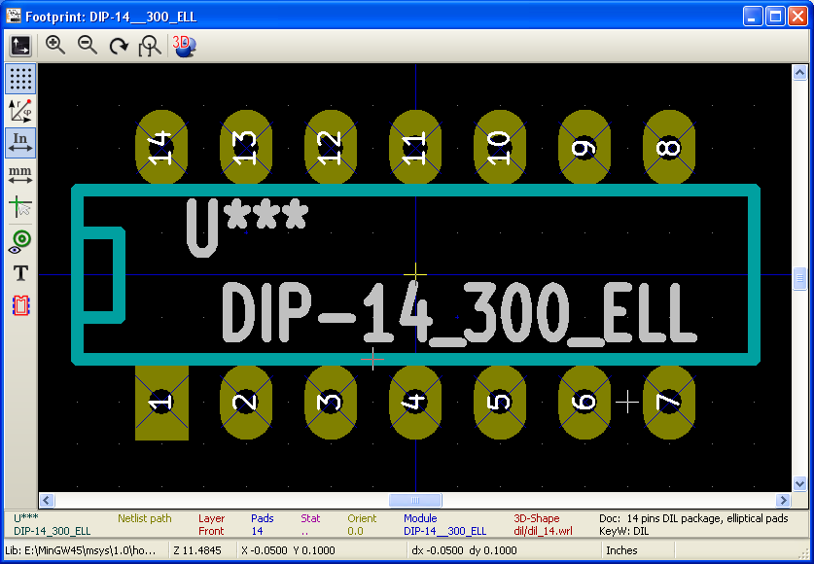

Status Bar Information
The status bar is located a the bottom of the CvPcb new main window and provides useful information to the user. The following table defined the contents of each pane in the status bar.

Keyboard Commands
F1 | Zoom In
F2 | Zoom Out
F3 | Refresh Display
F4 | Move cursor to center of display window
Home | Fit footprint into display window
Space Bar | Set relative coordinates to the current cursor position
Right Arrow | Move cursor right one grid position
Left Arrow | Move cursor left one grid position
Up Arrow | Move cursor up one grid position
Down Arrow | Move cursor down one grid position

Mouse Commands
Scroll Wheel | Zoom in and out at the current cursor position
Ctrl + Scroll Wheel | Pan right and left
Shift + Scroll Wheel | Pan up and down
Right Button Click | Open context menu

Context Menu
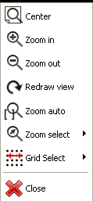
Displayed by right-clicking the mouse:
Zoom Selection (Select Zoom) | Direct selection of the display zoom .
Grid Selection (Grid Select) | Direct selection of the grid.

Horizontal Toolbar
Show display options dialog
Zoom in
Zoom out
Redraw
Fit drawing in display area
Open 3D model viewer

Vertical Toolbar
Show or hide the grid
Show coordinates in polar or rectangular notation
Display coordinates in inches
Display coordinates in millimeters
Toggle cursor style
Toggle between drawing pads in sketch or normal mode
Toggle between drawing text in sketch or normal mode
Toggle between drawing edges in sketch or normal mode

Viewing the Current 3D Model
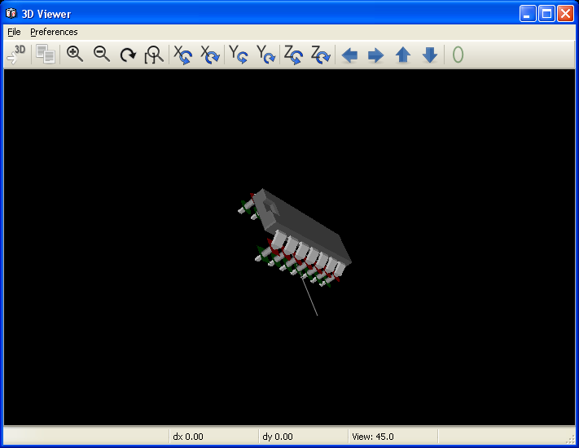

Mouse Commands
Scroll Wheel | Zoom in and out at the current cursor position
Ctrl + Scroll Wheel | Pan right and left
Shift + Scroll Wheel | Pan up and down

Horizontal Toolbar
Reload the 3D model
Copy 3D image to clipboard
Zoom in
Zoom out
Redraw
Fit drawing in display area
Rotate backward along the X axis
Rotate forward along the X axis
Rotate backward along the Y axis
Rotate forward along the Y axis
Rotate backward along the Z axis
Rotate forward along the Z axis
Pan left
Pan right
Pan up
Pan down
Toggle orthographic projection mode on and off

Using CvPcb to Associate Components with Footprints

Manually Associating Footprints with Components
To manually associate a footprint with a component first select a component in the component pane. Then select a footprint in the footprint pane by double-clicking the left mouse button on the name of the desired footprint. The unassigned next component in the list is automatically selected. Changing the component footprint is performed in the same manner.

Filtering the Footprint List
If the selected component and/or library is highlighted when the one or more of the filter ing option is enabled, the displayed footprint list in CvPcb is filtered accordingly.
Without filtering.
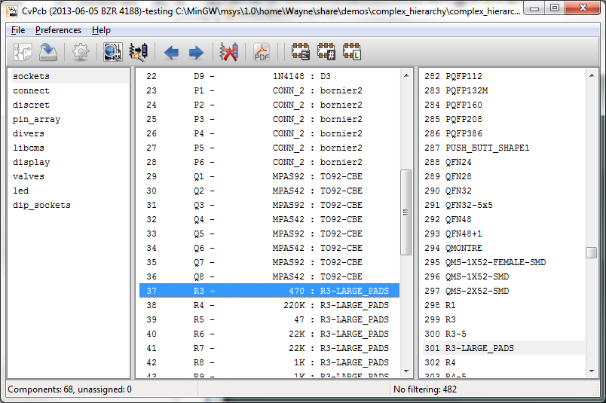
F ilter ed by list of footprint filters assigned to the selected component . The component filters are listed on the center pane of the status bar at the bottom of the main window.
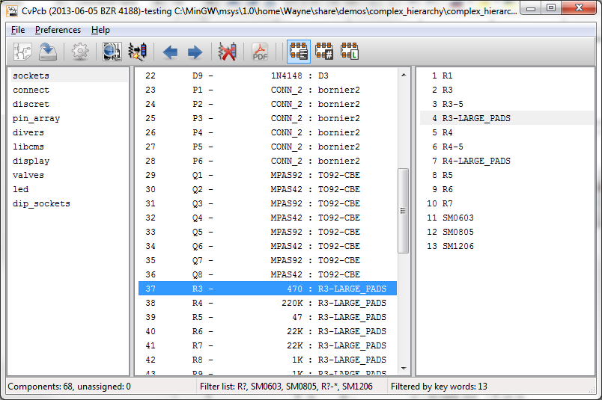
In the component library editor in Eeschema, the footprint list was set using the entries in the footprint filter tab of the component properties dialog as shown below.
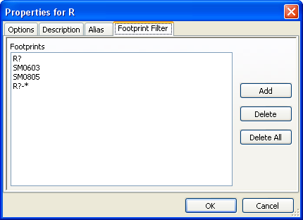
Filtered by the pin count of the selected component.
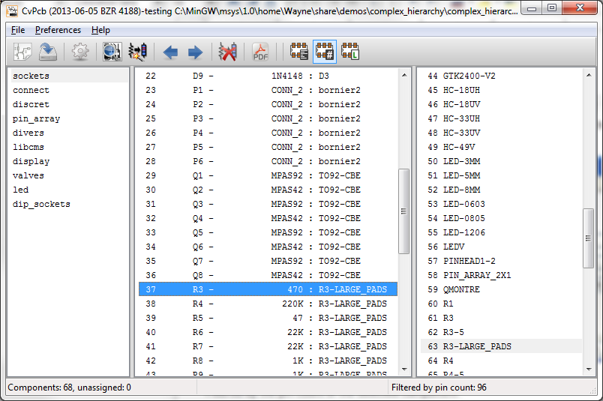
Filtered by the selected library.
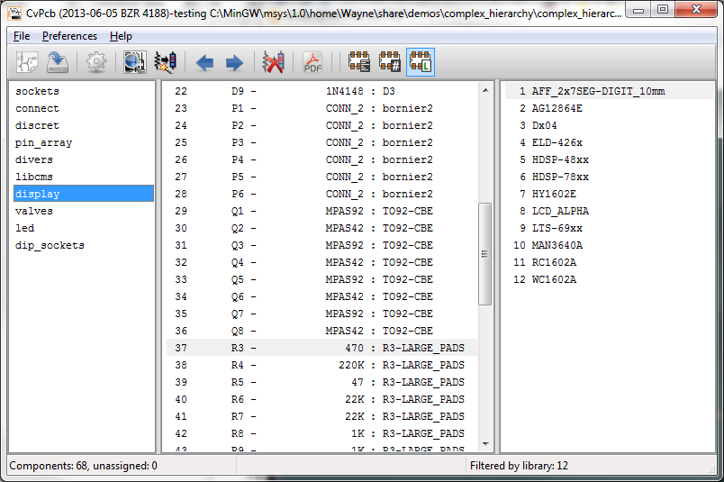
The icons enable and disable the filtering feature. When the filtering is not enabled, the full footprint list is shown. The filtering can be combined to form more complex filtering to help reduce the number of footprints in the footprint pane.
Filtered by the selected component pin count and the selected library.
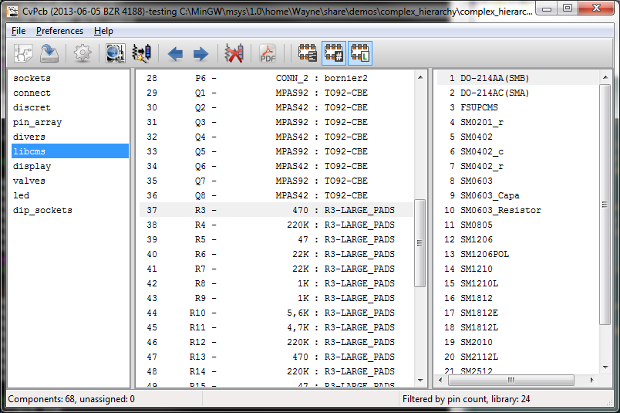

Automatic Associations

Equivalence files
Equivalence files allow for automatic assignment of footprints to components. They list the name of the corresponding footprint according to the name ( value field ) of the component. These files typically have the .equ file extension. The are plain text files and may be edited by any plain text editor. Refer to the section “Selecting the equivalence files” for more information.

Equivalence File Format
Equivalence files consist of one line for each component. Each line has the following structure:
‘component value’ ‘footprint name’
Each name must be single quoted by the ’ character and the component and footprint names must be separated by one or more spaces.
Example:
If the U3 component is circuit 14011 and its footprint is 14DIP300, the line is:
‘14011’ ‘14DIP300’
Any line starting with # is a comment.
Here is an example equivalence file:
#integrated circuits (smd):
‘74LV14’ ‘SO14E’
‘74HCT541M’ ‘SO20L’
‘EL7242C’ ‘SO8E’
‘DS1302N’ ‘SO8E’
‘XRC3064’ ‘VQFP44’
‘LM324N’ ‘S014E’
‘LT3430’ ‘SSOP17’
‘LM358’ ‘SO8E’
‘LTC1878’ ‘MSOP8’
‘24LC512I/SM’ ‘SO8E’
‘LM2903M’ ‘SO8E’
‘LT1129_SO8’ ‘SO8E’
‘LT1129CS8-3.3’ ‘SO8E’
‘LT1129CS8’ ‘SO8E’
‘LM358M’ ‘SO8E’
‘TL7702BID’ ‘SO8E’
‘TL7702BCD’ ‘SO8E’
‘U2270B’ ‘SO16E’
#Xilinx
‘XC3S400PQ208’ ‘PQFP208’
‘XCR3128-VQ100’ ‘VQFP100’
‘XCF08P’ ‘BGA48’
#upro
‘MCF5213-LQFP100’ ‘VQFP100’
#regulators
‘LP2985LV’ ‘SOT23-5’

Automatically Associating Footprints to Components
Click on the automatic footprint association button on the top toolbar to process an equivalence file. All components found by their value in the selected equivalence (*.equ) file will have their footprint automatically assigned.

