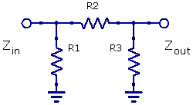 | with A = attenuation in dB  Zin = desired input impedance  Zout = desired output impedance

PI

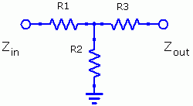 | with A = attenuation in dB  Zin = desired input impedance  Zout = desired output impedance

TEE

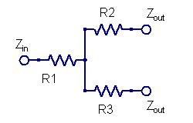 | Attenuation = 6 dB  Zin = Zout = desired impedance

Splitter

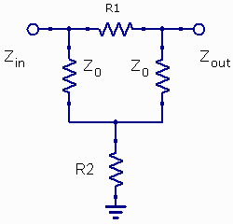 | with A = attenuation in dB  Zin = Zout = Z₀  R1 = Z0 * (G – 1)  R2 = Z0 / (G - 1)

Bridget Tee

