**Assessing climate change impacts on snow cover area by using a hybrid NARX-LSTM machine learning model**

**1. Introduction**

1) Importance of snow dominated basins and sensitivity of mountains to climate change

2) Remote sensing products to monitor snow cover area; problem of gaps🡪 MOD10A1F

3) Models to simulate snow cover area. Importance of models that only use climate variables to use them to propagate climate change scenarios

4) Objective a novelty of the work. To highlight the use of the method in several case studies around the world.

**2. Method**

Figure 1. Flow chart of the proposed methodology

**2.1. Generation of climate change scenarios**

**2.2. Hybrid** **NARX-LSTM machine learning model**

**3. Case studies and data**

**3.1. Case studies**

Figure 2. Location of the case studies.

**3.2. Data**

Figure 3. Elevation maps for each basin.

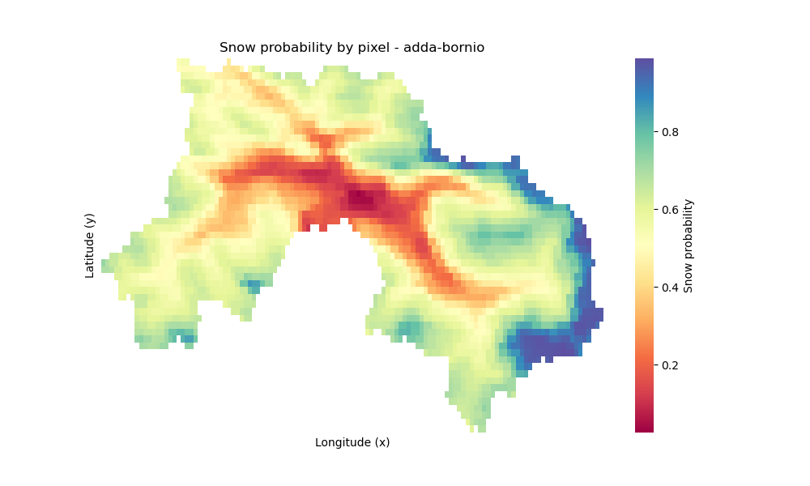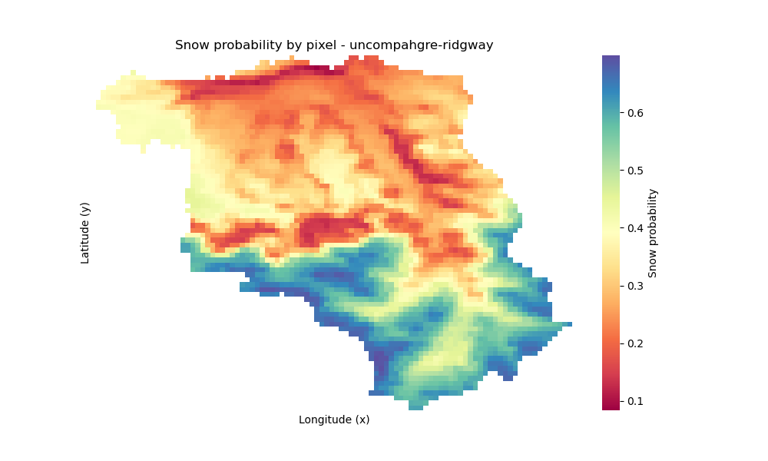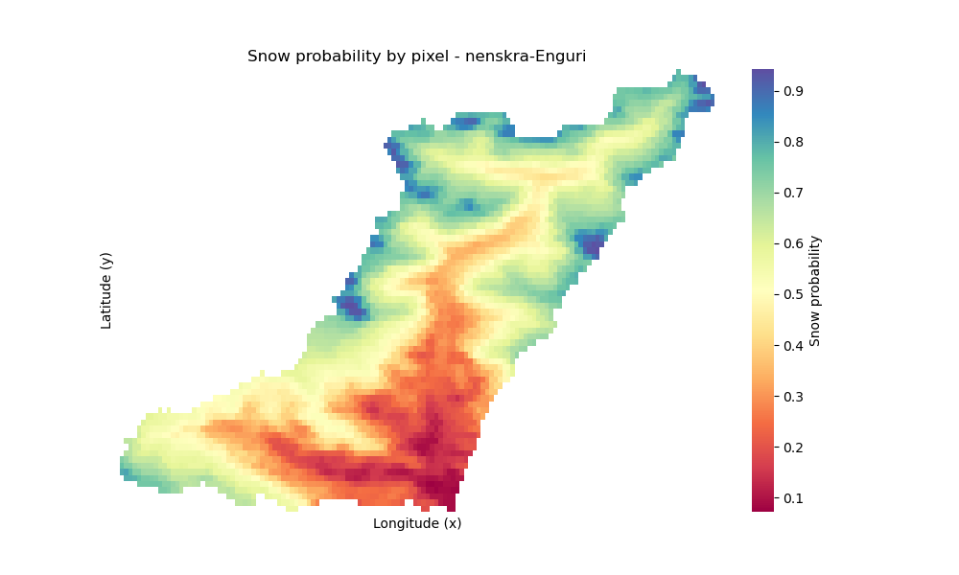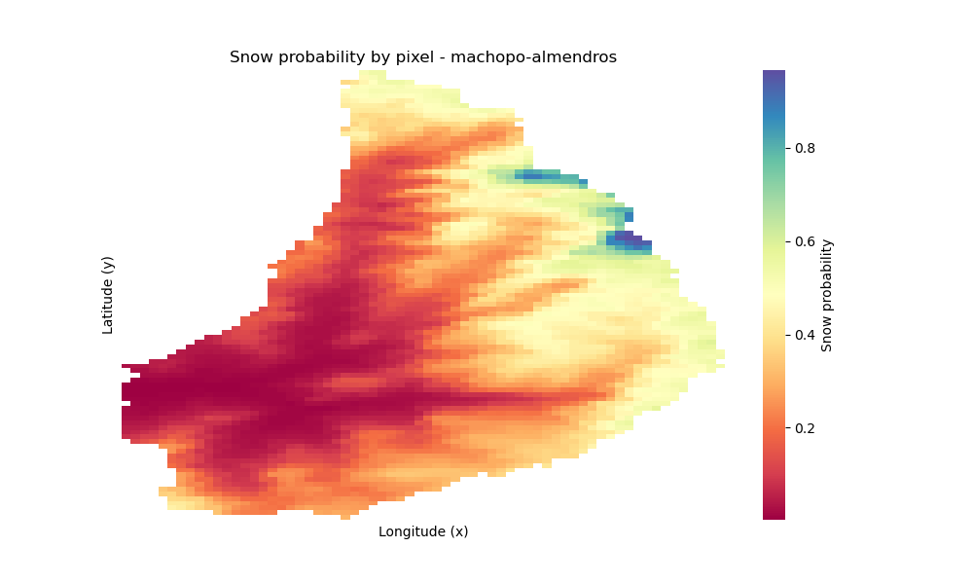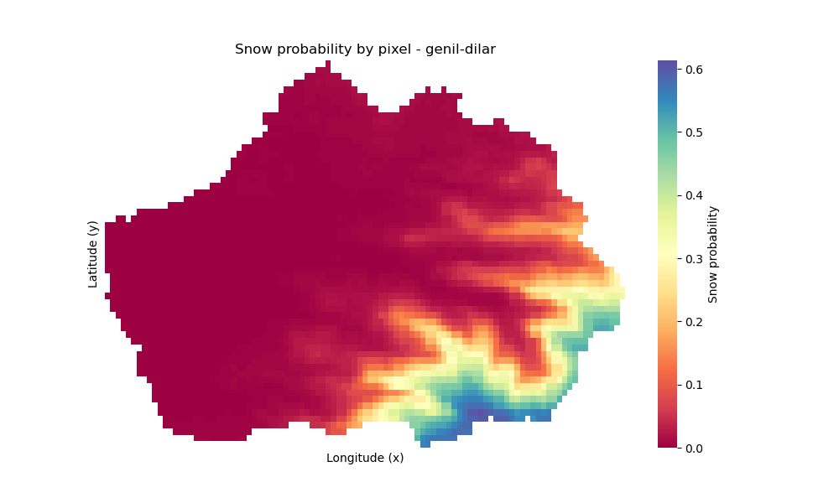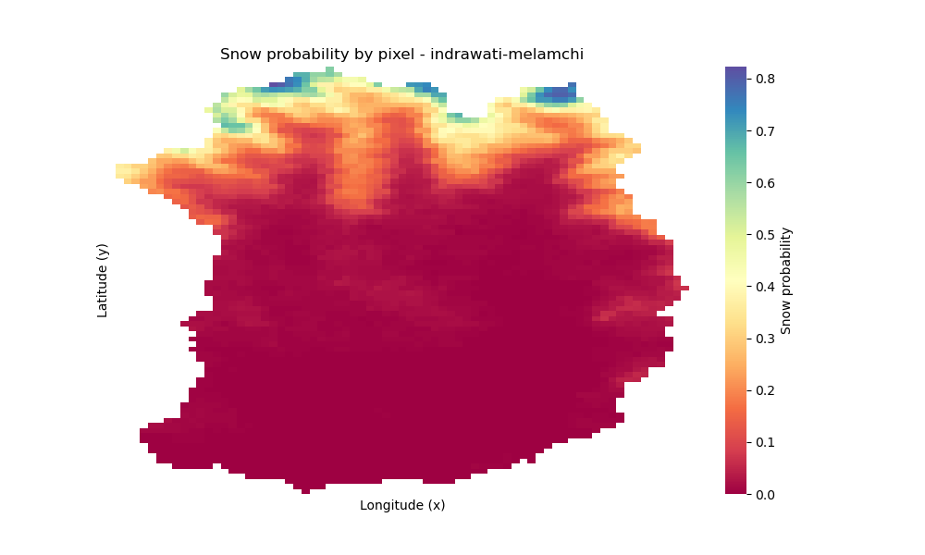

Figure 4. The probability that a pixel is covered by snow during the historical period (2000-2023) for each basin.

This figure illustrates the long-term spatial distribution of snow cover probability across six distinct basins, derived from historical data spanning 2000-2023 through Kriging interpolation. A general trend observed across most basins (e.g., 'adda-bornio', 'iracheos-almendros', 'rercise-liquin', 'suwampalyu-ralgayu') is the **strong influence of topography**, with higher probabilities of snow cover consistently found in **elevated and mountainous regions**, and gradually diminishing probabilities in lower-lying areas. This altitudinal gradient is particularly evident in basins like 'rercise-liquin', which shows a clear north-south decrease in snow probability aligning with decreasing elevation.

Conversely, the 'imduwael-malanahi' basin (Figure 1c) presents a unique case, characterized by a remarkably **high and spatially uniform snow probability across its entire extent**, suggesting consistently favorable conditions for snow accumulation or high average elevations throughout the basin. The 'gqali-allar' basin (Figure 1b) also displays generally high probabilities over a large area, though with some internal variations. These maps collectively provide critical insights into the regional snow regimes, identifying persistent snow zones and highlighting the diverse hydro-climatic characteristics that govern snow presence across the studied basins.

**4. Results**

**4.1. Historical and future climate change scenarios**

Figure 5. Monthly average precipitation and temperature for the mean year over the historical scenario (1995-2014) and future climate change scenarios (2051-2070) considering the SSP 2 and RCP 4.5 and the different GCMs for each basin.

Figure 6. Monthly average precipitation and temperature for the mean year over the historical scenario (1995-2014) and future climate change scenarios (2081-2100) considering the SSP 2 and RCP 4.5 and the different GCMs for each basin.

Figure 7. Monthly average precipitation and temperature for the mean year over the historical scenario (1995-2014) and future climate change scenarios (2051-2070) considering the SSP 5 and RCP 8.5 and the different GCMs for each basin.

Figure 8. Monthly average precipitation and temperature for the mean year over the historical scenario (1995-2014) and future climate change scenarios (2081-2100) considering the SSP 5 and RCP 8.5 and the different GCMs for each basin.

**4.2. NARX-LSTM machine learning models performance**

Table 1. Best configurations of the NARX-LSTM machine learning models for each basin.

Figure 9. Historical and simulated (using the forecasting mode) daily snow cover area series for the period 2000-2023 and performance metrics for each basin.

**4.3. Propagation of climate change scenarios to snow cover area**

Figure 10. Daily average snow cover area for the mean year over the historical scenario (1995-2014) and future climate change scenarios (2051-2070) considering the SSP 2 and RCP 4.5 and the different GCMs for each basin.

Figure 11. Daily average snow cover area for the mean year over the historical scenario (1995-2014) and future climate change scenarios (2081-2100) considering the SSP 2 and RCP 4.5 and the different GCMs for each basin.

Figure 12. Daily average snow cover area for the mean year over the historical scenario (1995-2014) and future climate change scenarios (2051-2070) considering the SSP 5 and RCP 8.5 and the different GCMs for each basin.

Figure 13. Daily average snow cover area for the mean year over the historical scenario (1995-2014) and future climate change scenarios (2081-2100) considering the SSP 5 and RCP 8.5 and the different GCMs for each basin.

**5. Discussion**

**6. Conclusion**

**References**