Questions and Exercises to work out and turn in:

Grading Guidelines (See Appendix):

A right answer will get full credit when:

1. It is right (worth 25%)
2. It is right **AND** neatly presented making it easy and pleasant to read. (worth an **extra** 15%)
3. There is an **obvious and clear link[1]** between 1) the information provided in the exercise and in class and 2) the final answer. A clear link is built by properly writing, justifying, and documenting an answer (worth an **extra** 60%).
4. Calculation mistakes will be minimally penalized (2 to 5% of full credit) while errors on units will be more heavily penalized.

**Late Submission** : as specified in the syllabus. Day counting starts one minute after the deadline.

**Check Your Submission:**  after submitting, download your submission to check whether it is the right version and it is complete.

You are welcome/encouraged to discuss exercises with other students or the instructor. But, ultimately, **personal** writing is expected.

* USE THIS FILE AS THE STARTING DOCUMENT YOU WILL TURN IN. **KEEP IN THE QUESTIONS** AND INSERT YOUR ANSWERS.
* IF USING HAND WRITING (STRONGLY DISCOURAGED), REWRITE THE QUESTIONS.
* FAILING TO FOLLOW TURN IN DIRECTIONS /GUIDELINES WILL COST A 30% PENALTY.

Objectives of this assignment:

* to get a sense of round-trip time of packets over the network
* to explore the topology of the Internet.

What you need to do:

Answer the questions and/or solve the exercises described below.

Exercise 1 (60 points)

The ping program allows you to send a test packet to a given location and see how long it takes to get there and back. Try using ping to see how long it takes to get from your location to several known locations. From these data, plot the one-way transit time over the Internet as a function of distance. The ping provides the round trip time. Half the minimum[2] round trip time is in general a reasonable estimate of the one-way transit time. It is best to use universities since the location of their servers is *in* *general* known very accurately. For example, yale.edu is in New Haven, Connecticut; harvard.edu is in Cambridge, Massachusetts; scu.edu.au (*Southern Cross University*, Australia); une.edu.au (*University of New England*, Australia); and www.zju.edu.cn (Zhejian University, China).

Add three other universities of your choice (must respond to your pings).

(10 points) Provide **one** **screenshot** (*document*) of ONE ping to any of the above destinations. Insert the screenshot in this document

(30 points) Sort on the x-axis the locations (all universities provided and the three universities you provide) in increasing distance from Auburn and plot the one-way transit time.

(20 points) Discuss the plot. Does the one-way transit correlate with the distance? If not, why?

**In case you are not in Auburn**,

There are two ways you can complete this exercise:

**Method 1**:

Log in remotely on the Engineering Tux machines to ping. To log in remotely, you must use an ssh client such as SecureCRT (Windows).

On Windows 10, you may use from the command prompt the following command (if ssh is available):

ssh username@gate.eng.auburn.edu

where username is your Auburn University username.

On Mac or any Unix machine (Ubuntu...), use the same command (see above) on a terminal.

**Method 2**:

Use a virtual desktop at:  <https://rdp.eng.auburn.edu/>

**If you have problems to log in remotely to Tux machines, ask on Piazza for help.**

Exercise 2 (40 points)

a) (25 points) A system has a 6 layer protocol hierarchy. The upper layer (Applications) generates messages of length 100 bytes. At **each** of the 6 layers, a 30 byte header is added. What fraction of the network bandwidth is filled with headers? The fraction ***f*** is equal the total number of bytes of all headers over the total number of bytes sent out by a sender at the application layer. We assume that there are no trailers and that the application layer also has a header.

i. (15 points) **Draw** the full message with all headers assuming there are no trailers. Refer to the Slide 12 about encapsulation. Draw similarly to that slide the messages/headers as rectangles.

ii. (10 points). **Derive** the fraction f.

b) (15 points). Consider a DNS request on the Internet. The DNS request (application layer) is a message of about 125 bytes. The UDP header is 8 bytes long. The IP header is in general 20 bytes long. An IEEE 802.3 Ethernet frame may have up to a 26 bytes header and a 16 bytes trailer. What fraction ***f*** of the network bandwidth is filled with headers/trailer?

i. (10 points) **Draw** the full message with all headers/trailer. Draw similarly to the slide about encapsulation.

ii. (5 points) **Derive** the fraction f.

What you need to turn in:

* Electronic copy of this file (including your answers) (standalone). Submit the file as a Microsoft Word or PDF file.
* Recall that answers must be well written, documented, justified, and presented to get full credit.
* How this assignment will be graded:
* A right answer will get full credit when:
* It is right (worth 25%)
* It is right AND neatly presented making it easy and pleasant to read. (worth 15%)
* There is an obvious and clear link between 1) the information provided in the exercise and in class and 2) the final answer. A clear link is built by properly writing, justifying, and documenting an answer (worth 60%).
* Calculation mistakes will be minimally penalized (2 to 5% of full credit) while errors on units will be more heavily penalized.
* You are welcome/encouraged to discuss exercises with other students or the instructor. But, ultimately, personal writing is expected.

**Appendix**: Grading: What is an OBVIOUS and CLEAR LINK?

Here is an example to explain what an **obvious and clear link** is and how we grade your work.

Consider the following problem:

"(100 points) John travels from Auburn to Atlanta in his car at a speed of 60 mph. Leaving at 8am, at what time will John reach Atlanta".

Here are the answers of three students and their scores:

* **Student 1** answers: "9:48am". Student 1 will get 25 points.
* **Student 2**answers : "John will reach Atlanta at 9:48am". Student 2 will get 25+15 = 40 points
* **Student 3** answers: "The time t to travel a distance d at speed v is equal to d/v = d/60mph. The problem does not provide the distance d from Auburn to Atlanta. Based on GoogleMaps, the distance from Auburn to Atlanta is approximately 108 miles (**document is attached**).

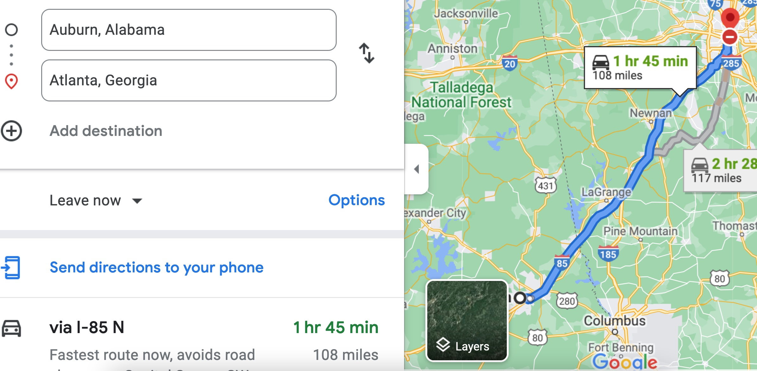

Therefore, the time t = 108 miles/60mph * 60 minutes/hour= 108 minutes. Since John left at 8am, he will then reach Atlanta at 8am + 108 minutes = 8 am + 60 minutes + 48 minutes = 9:48".

**Student 3** will get 25 + 15 + 60 = 100 points

Do you see the **direct** **link** going from the data provided in the question to the final answer, using general knowledge/formula and documents?.... Can you now solve the following problem and get 100 points?

"(100 points) Alice travels from Auburn to Atlanta in her car at a speed of 60 mph. Leaving at 8am, at what time will Alice reach Atlanta assuming that she had a flat tire that delayed her 30 minutes".

1. See on the appendix what an obvious and clear link is.
2. Smallest round trip time provided by multiple ping packets to the target machine.