Powershell – admin

windows 10 enable hyper v

Enable Hyper-V using PowerShell

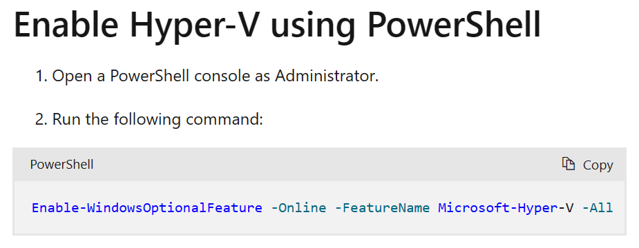

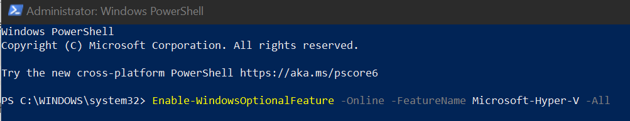

PS C:\WINDOWS\system32> Enable-WindowsOptionalFeature -Online -FeatureName Microsoft-Hyper-V -All

Path :

Online : True

RestartNeeded : False

PS C:\WINDOWS\system32> Enable-WindowsOptionalFeature -Online -FeatureName containers -Al

Path :

Online : True

RestartNeeded : False

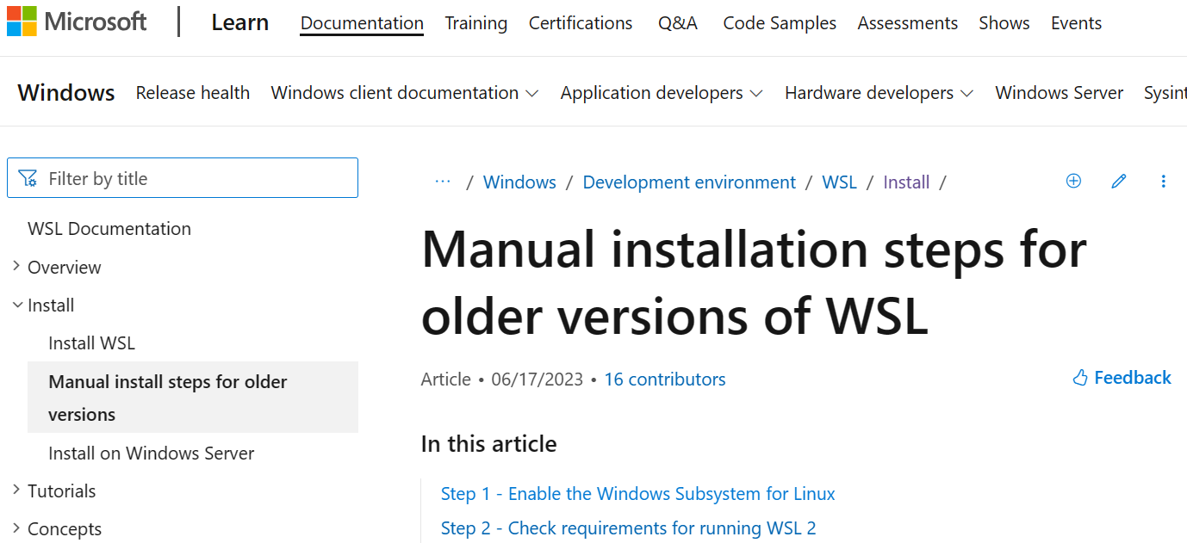

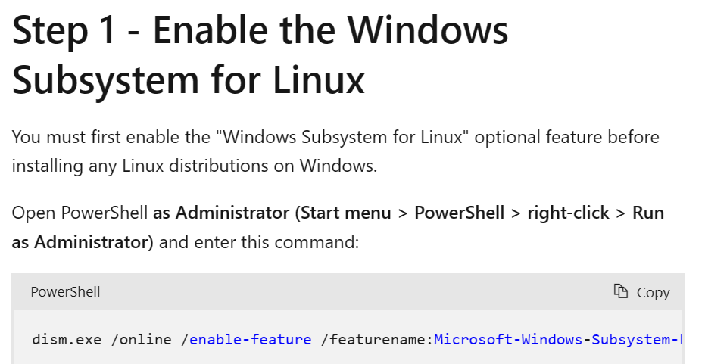

Enable wsl <https://learn.microsoft.com/en-us/windows/wsl/install-manual#step-1---enable-the-windows-subsystem-for-linux>

PS C:\WINDOWS\system32> dism.exe /online /enable-feature /featurename:Microsoft-Windows-Subsystem-Linux /all /norestart

Deployment Image Servicing and Management tool

Version: 10.0.19041.844

Image Version: 10.0.19045.3086

Enabling feature(s)

[==========================100.0%==========================]

The operation completed successfully.

Enable Virtual Machine feature

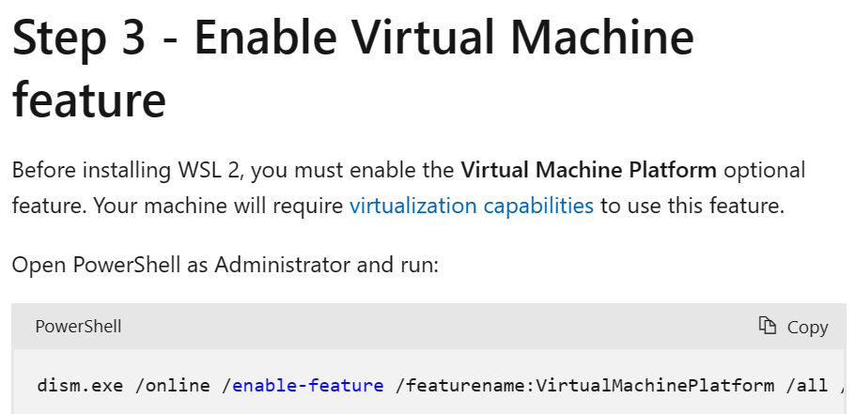

PS C:\WINDOWS\system32> dism.exe /online /enable-feature /featurename:VirtualMachinePlatform /all /norestart

Deployment Image Servicing and Management tool

Version: 10.0.19041.844

Image Version: 10.0.19045.3086

Enabling feature(s)

[==========================100.0%==========================]

The operation completed successfully.

Download the Linux kernel update package

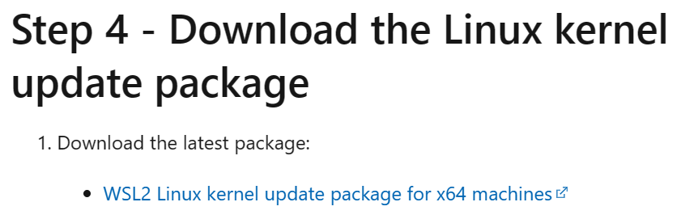

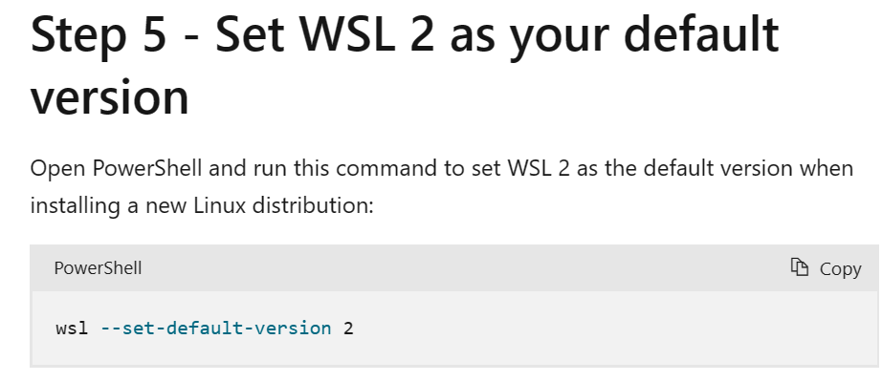

PS C:\WINDOWS\system32> wsl --set-default-version 2

