**Start screen**

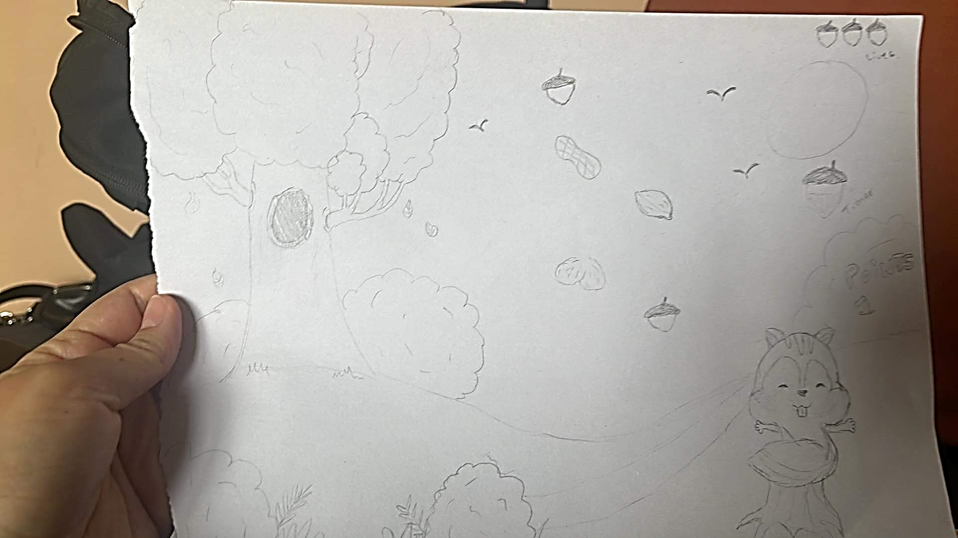

**Gameplay**

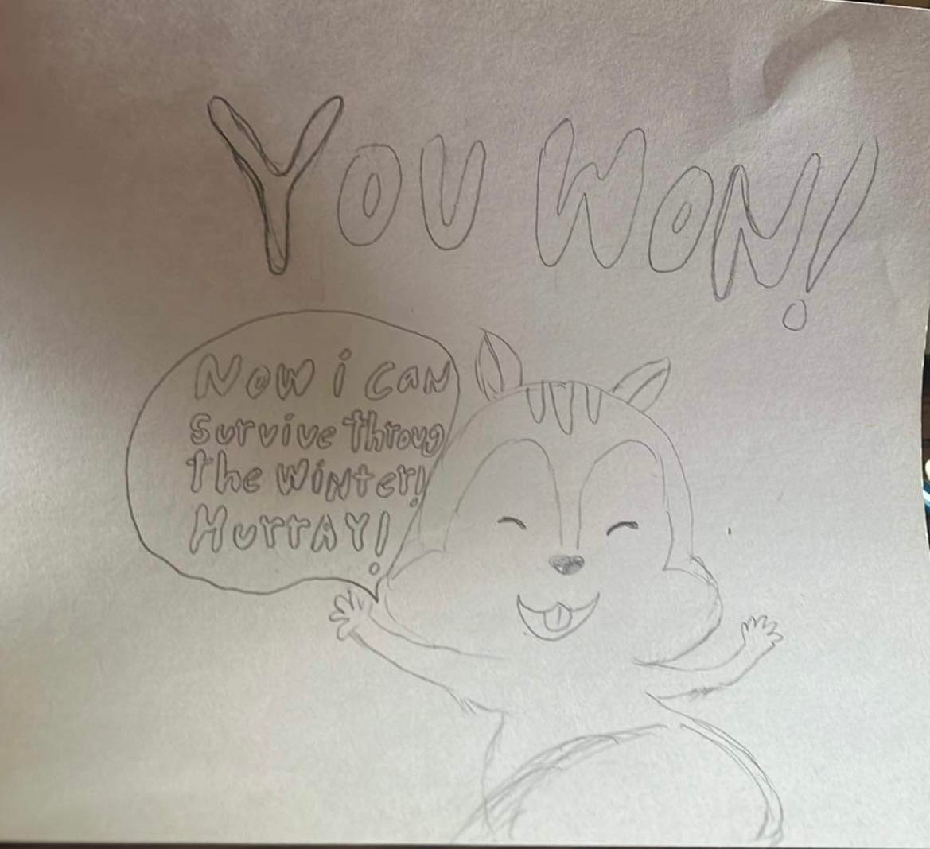**Winning screen**

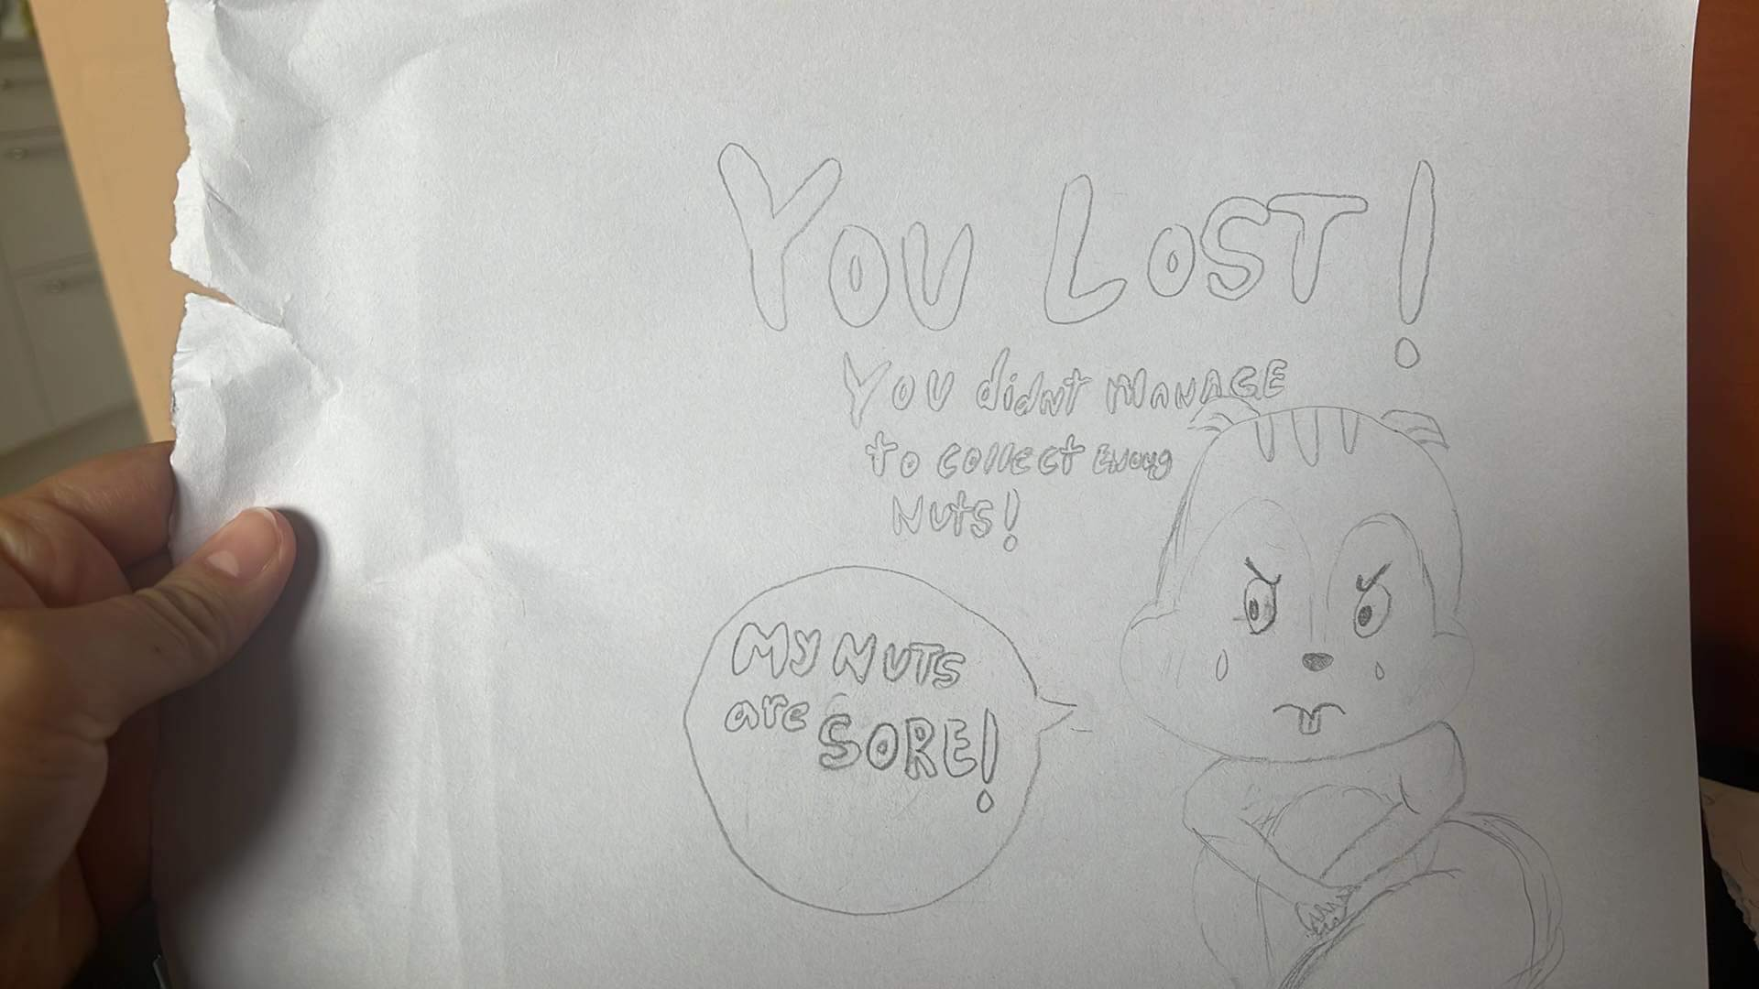

**Loosing screen**