Kian Charles S. Angeles  
WD – 304  
  
**MIDTERM LAB ACTIVITY 1: BASIC ROUTING (DISCUSSION)**

**server_routing.js**

**Get   
  
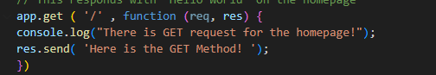**

**Post**

**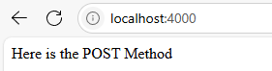  
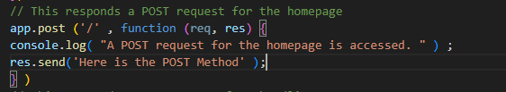**

**List  
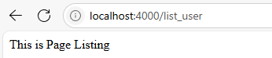  
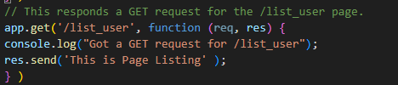**

**Abcd  
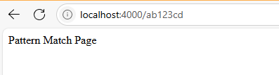  
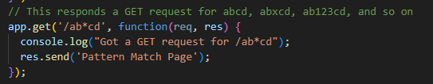**

**Profile  
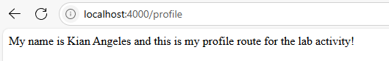**

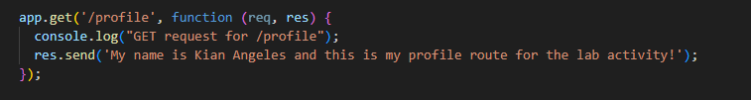

**server_static.js**

**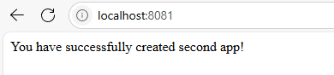  
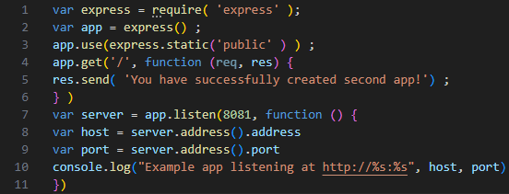**

**Logo.jpg  
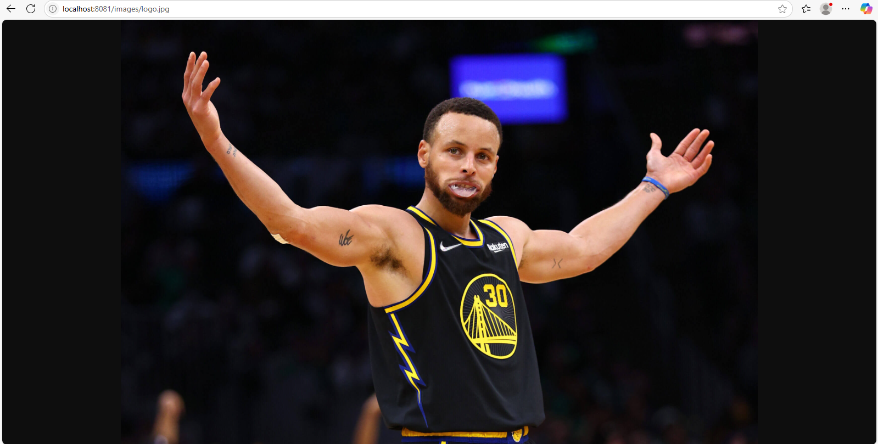**

**server.js  
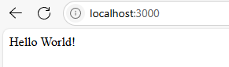  
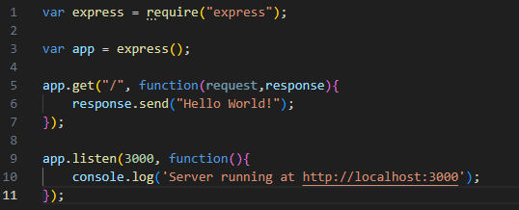**

**server2.js  
