UML

|  |
| --- |
| TwoDimRaggedArrayUtility |
|  |
| + getAverage(data : double[][]) : double  + getColumnTotal(data : double[][], col : int) : double  + getHighestInArray(data : double[][]) : double  + getHighestInColumn(data : double[][], col : int) : double  + getHighestInColumnIndex(data : double[][], col : int) : int  + getHighestInRow(data : double[][], row : int) : double  + getHighestInRowIndex(data : double[][], row : int) : int  + getLowestInArray(data : double[][]) : double  + getLowestInColumn(data : double[][], col : int) : double  + getLowestInColumnIndex(data : double[][], col : int) : int  + getLowestInRow(data : double[][], row : int) : double  + getLowestInRowIndex(data : double[][], row : int) : int  + getRowTotal(data : double[][], row : int) : double  + getTotal(data : double[][]) : double  + readFile(file : File) : double[][]  + writeToFile(data : double[][]) : void |

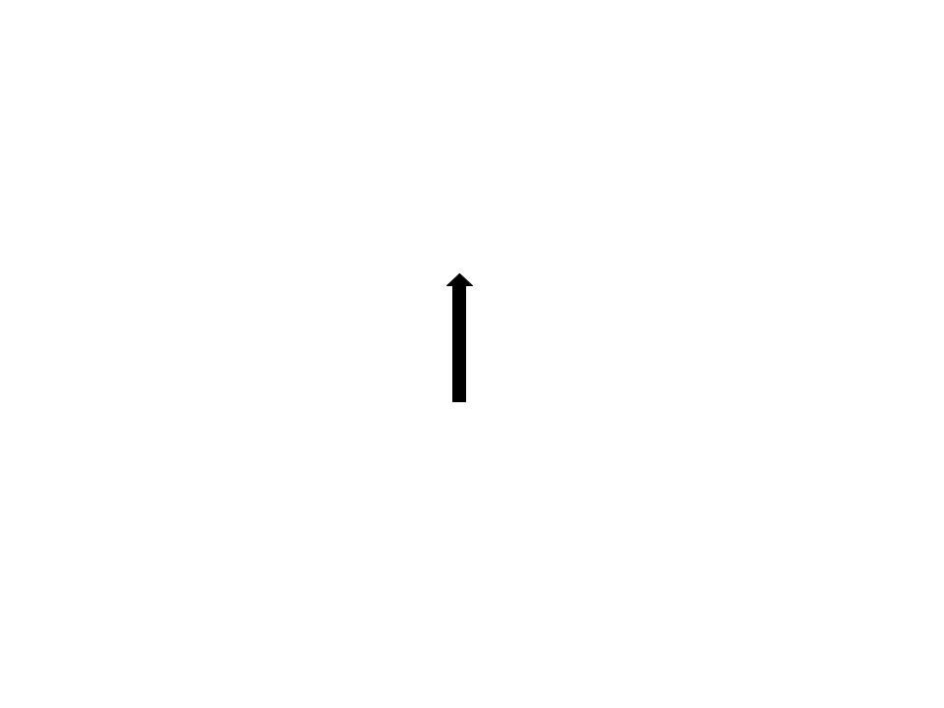

|  |
| --- |
| HolidayBonus |
|  |
| + calculateHolidayBonus(data : double[][], high : double, low : double, other : double) : double[]  + calculateTotalHolidayBonus(data : double[][], high : double, low : double, other : double) : int |

Screenshot

GUI

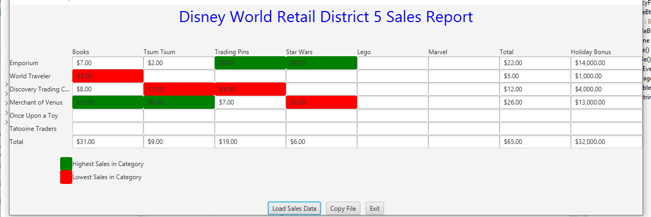

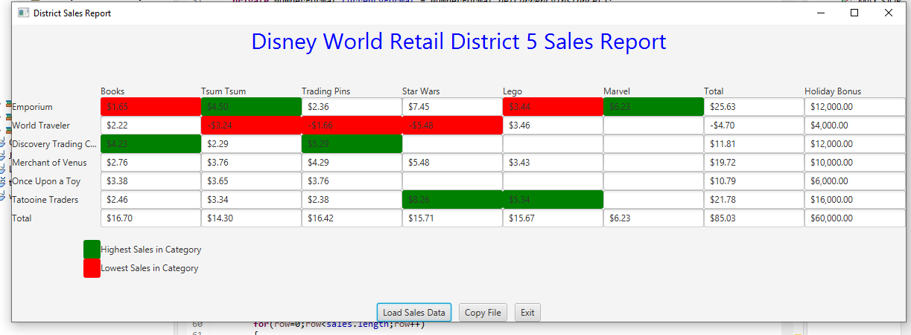

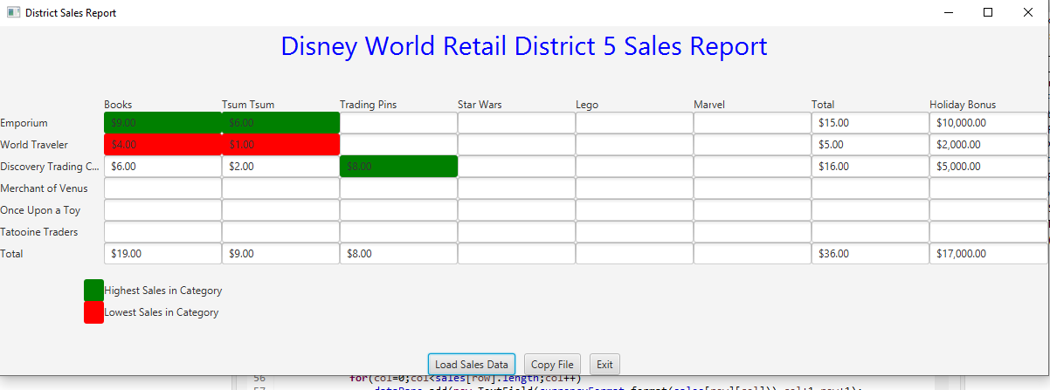

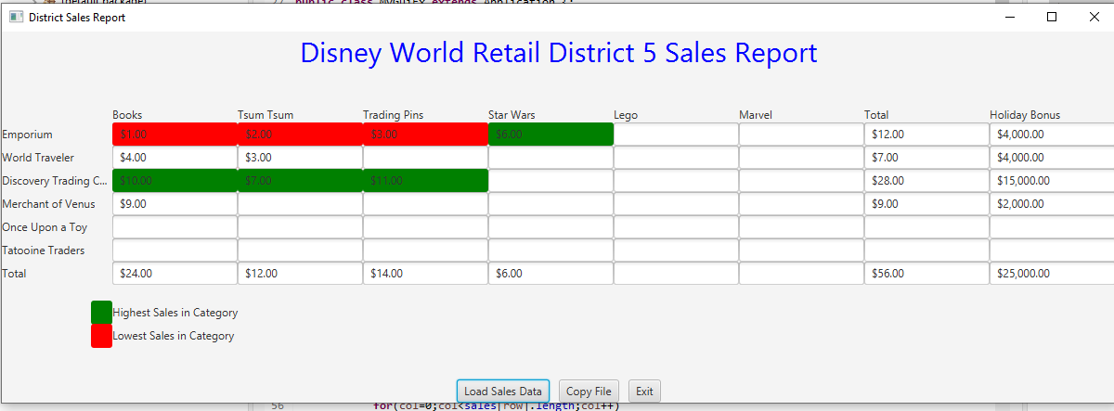

Junit

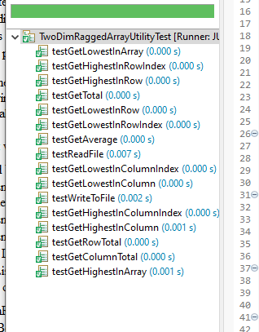

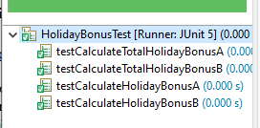

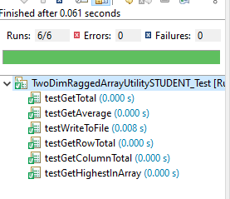

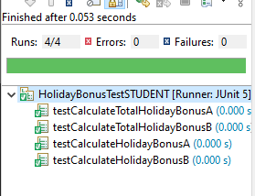

GitHub

Lessons Learned

* What have you learned?

I learned how to work with a ragged array. I also relearned how to write to a file since I forgot how to do so, alongside reading from a file.

* What did you struggle with?

I struggled a bit with writing to a file because of all the different classes that it seemed I could use. Reading from a file was much easier. I did struggle a lot with all of the column methods in the TwoDimRaggedArrayUtility class and had a hard time figuring out why the methods would only work for some of the test cases. After finishing the TwoDimRaggedArrayUtility class the HolidayBonus class was easy to complete since I was using a lot of the methods from TwoDimRaggedArrayUtility.

* What will you do differently on your next project?

I am not going to work on parts of the project that are further ahead than how far I have gotten in the project. In this one I tried to do HolidayBonus before being anywhere near done with TwoDimRaggedArrayUtility which only served to waste time and confuse me more.

* Include what parts of the project you were successful at, and what parts (if any) you were not successful at.

I successfully compelted the TwoDimRaggedArrayUtility class the HolidayBonus class and there respective STUDENT_Test classes.

Check List

|  |  |  |  |
| --- | --- | --- | --- |
| # |  | Y/N or N/A | Comments |
| ⦁ | Assignment files: |  |  |
|  | ⦁ FirstInitialLastName_ Assignment5_Moss.zip | Y |  |
|  | ⦁ FirstInitialLastName_Assignment5_Complete.zip | Y |  |
| ⦁ | Program compiles | Y |  |
| ⦁ | Program runs with desired outputs related to a Test Plan | Y |  |
| ⦁ | Documentation file: |  |  |
|  | ⦁ Comprehensive Test Plan | Y |  |
|  | ⦁ Screenshots for each Junit Test | Y |  |
|  | ⦁ Screenshots for each Test case listed in the Test Plan | Y |  |
|  | ⦁ Screenshots of your GitHub account with submitted Assignment# (if required) | Y |  |
|  | ⦁ UML Diagram | Y |  |
|  | ⦁ Algorithms/Pseudocode | N/A |  |
|  | ⦁ Flowchart (if required) | N/A |  |
|  | ⦁ Lessons Learned | Y |  |
|  | ⦁ Checklist is completed and included in the Documentation | Y |  |