Cadungog, Kian Chryslyr Q. 1-BSCS-A

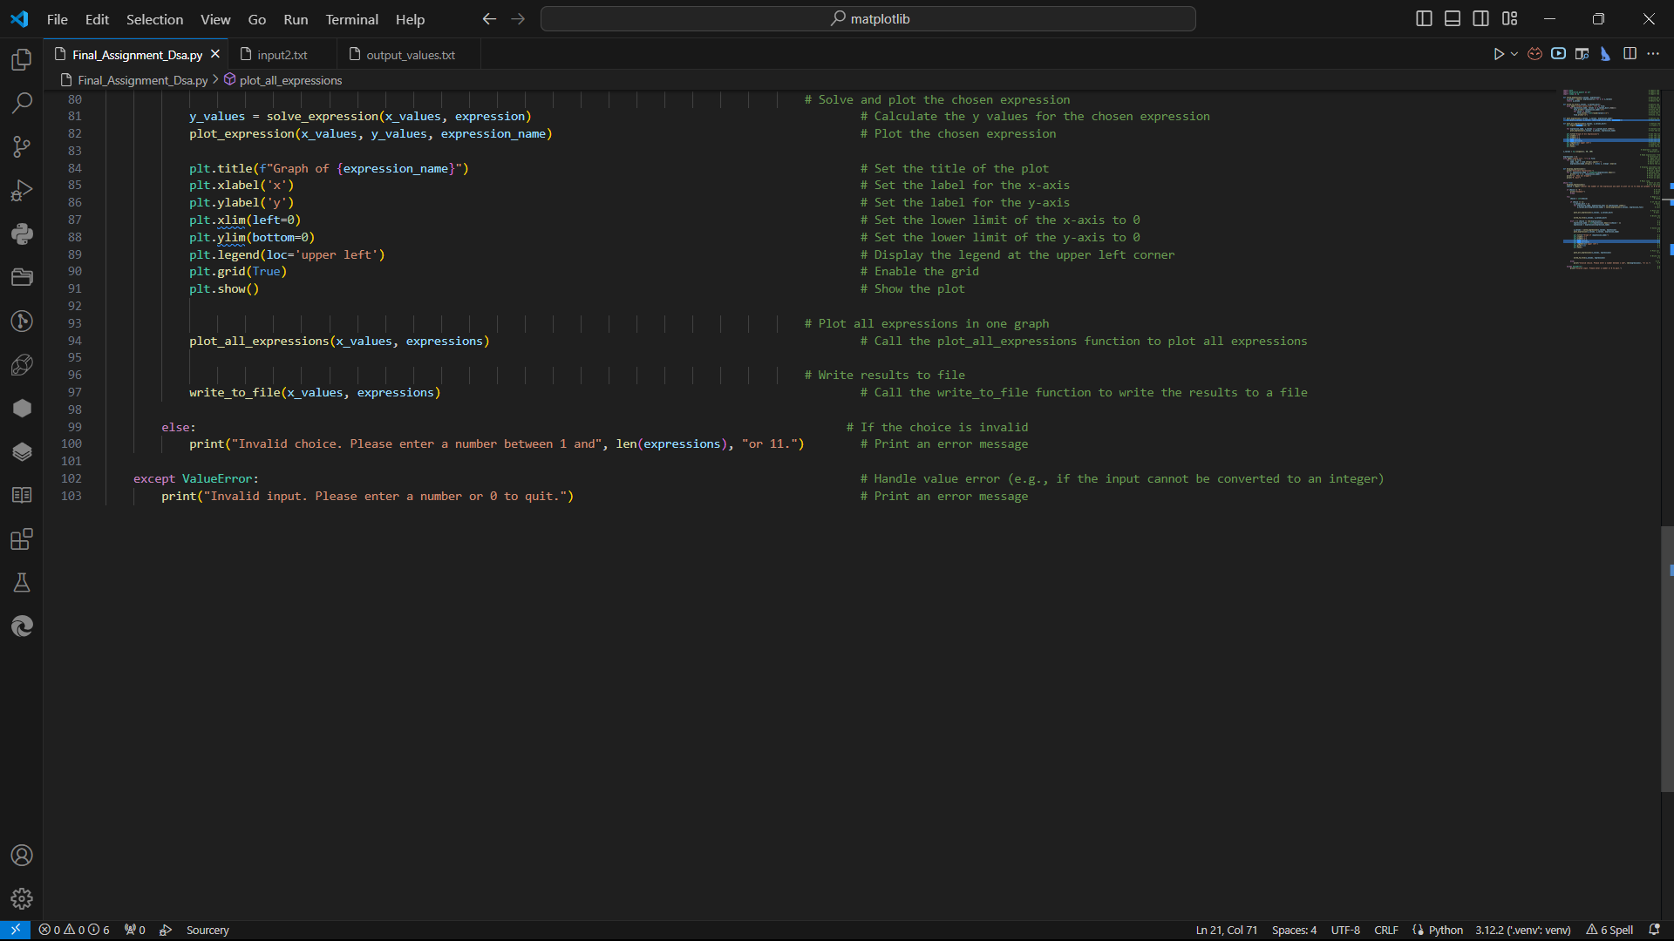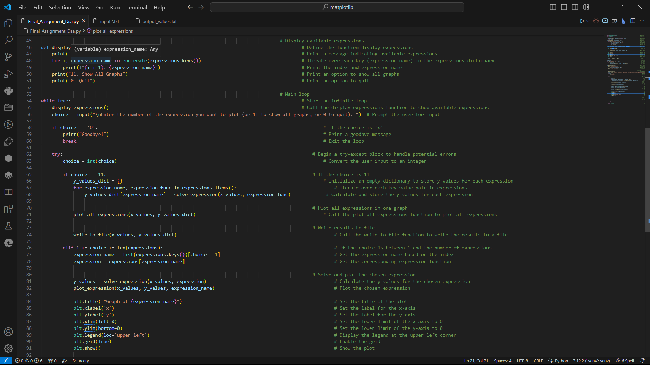**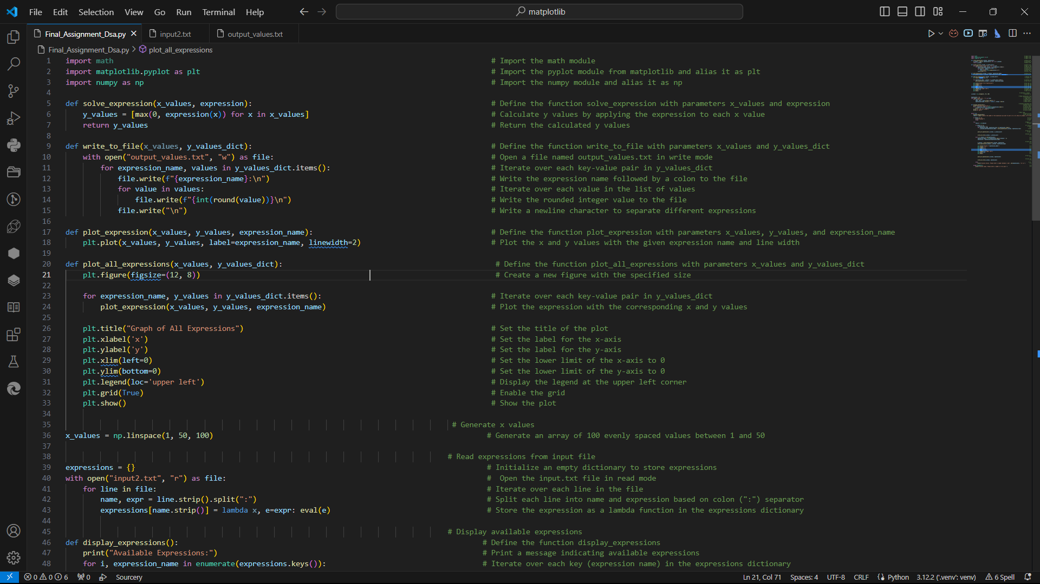Data Structure and Algorithms**

*Main File :*

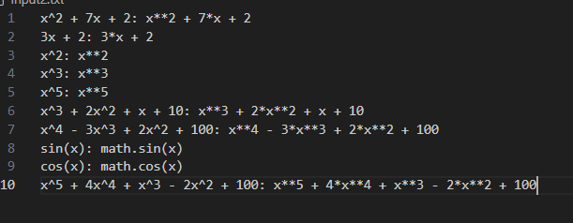*Input file:*

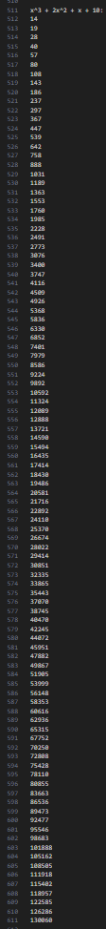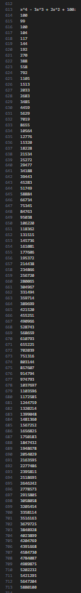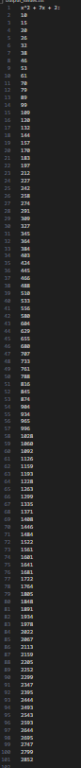   
  
  
  
  
  
  
  
  
  
*Output file*prob. 1 prob. 2 prob. 3 prob. 4 prob. 5 prob. 6 prob. 7

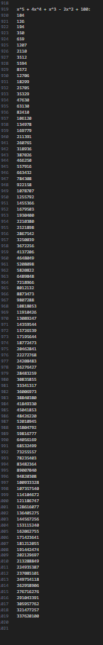prob. 8 prob. 9 prob. 10

*Graphs*

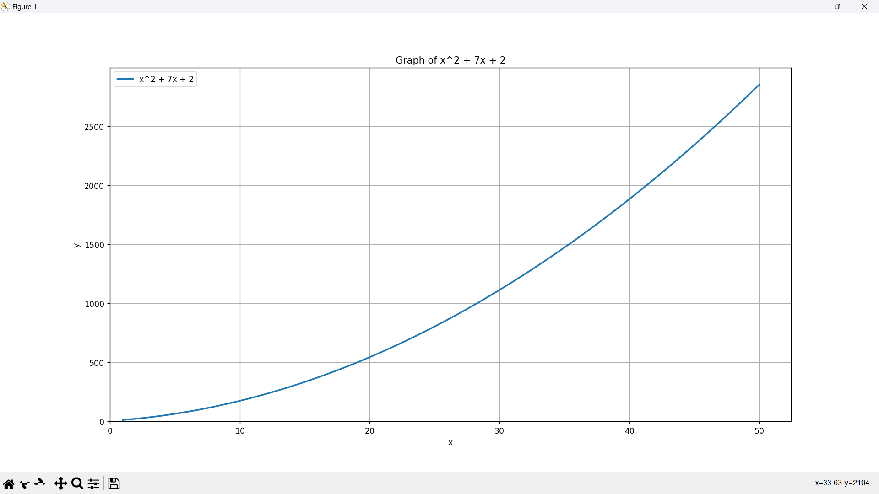prob. 1

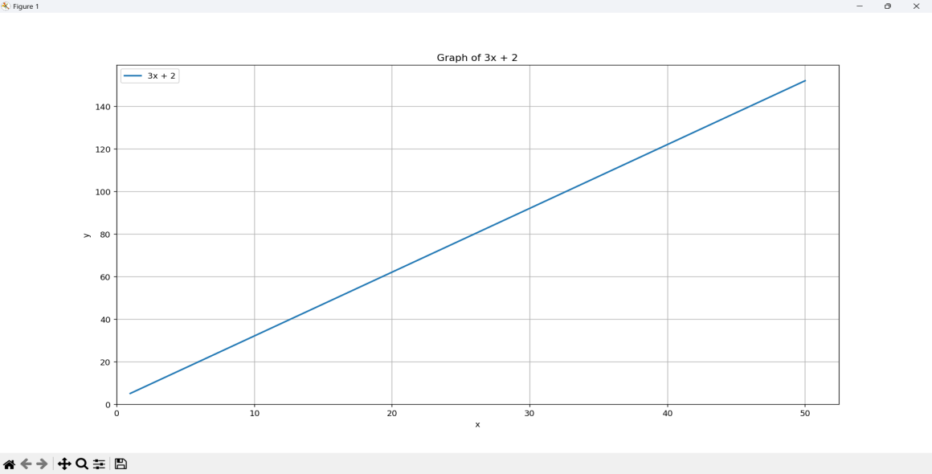

prob. 2

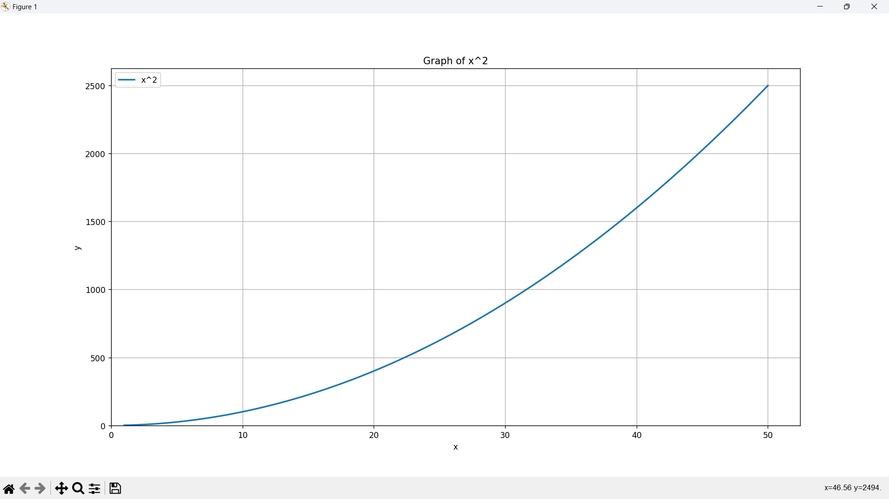

prob. 3

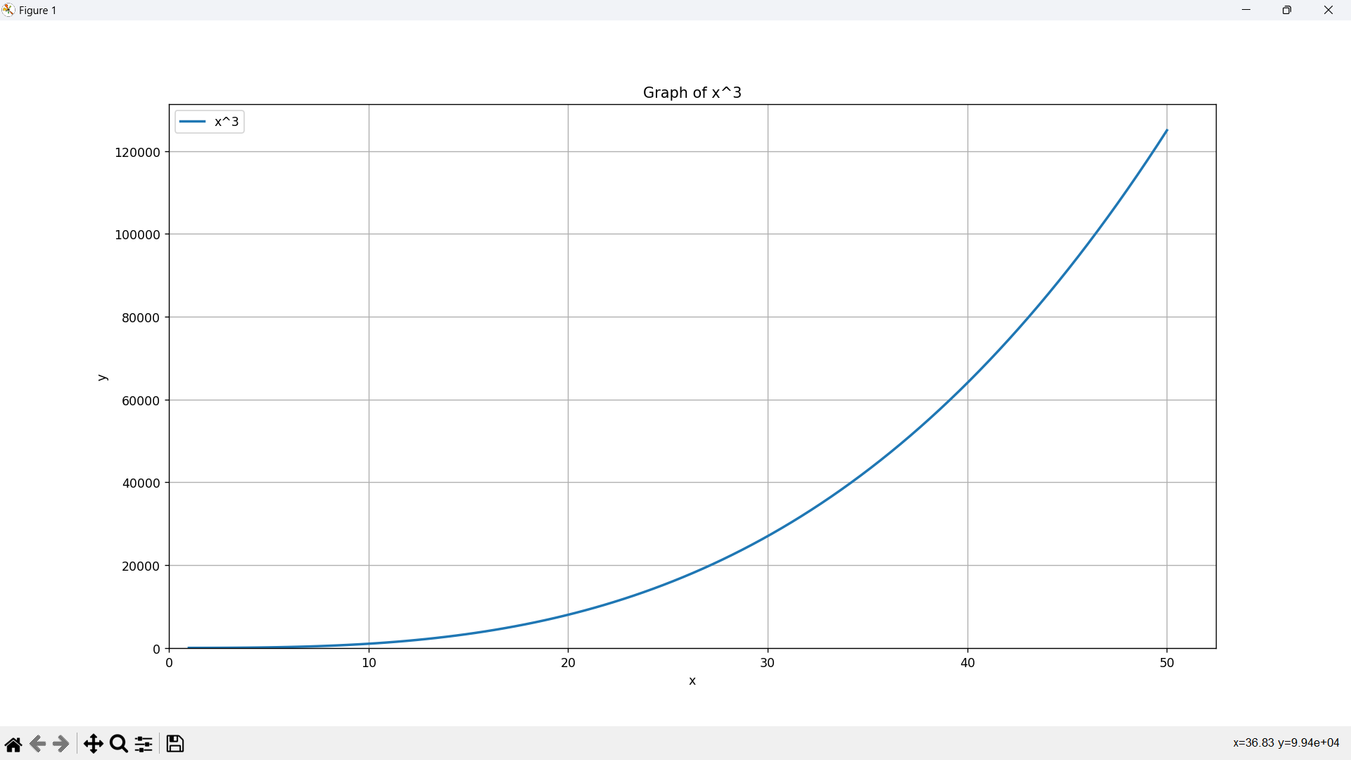prob. 4

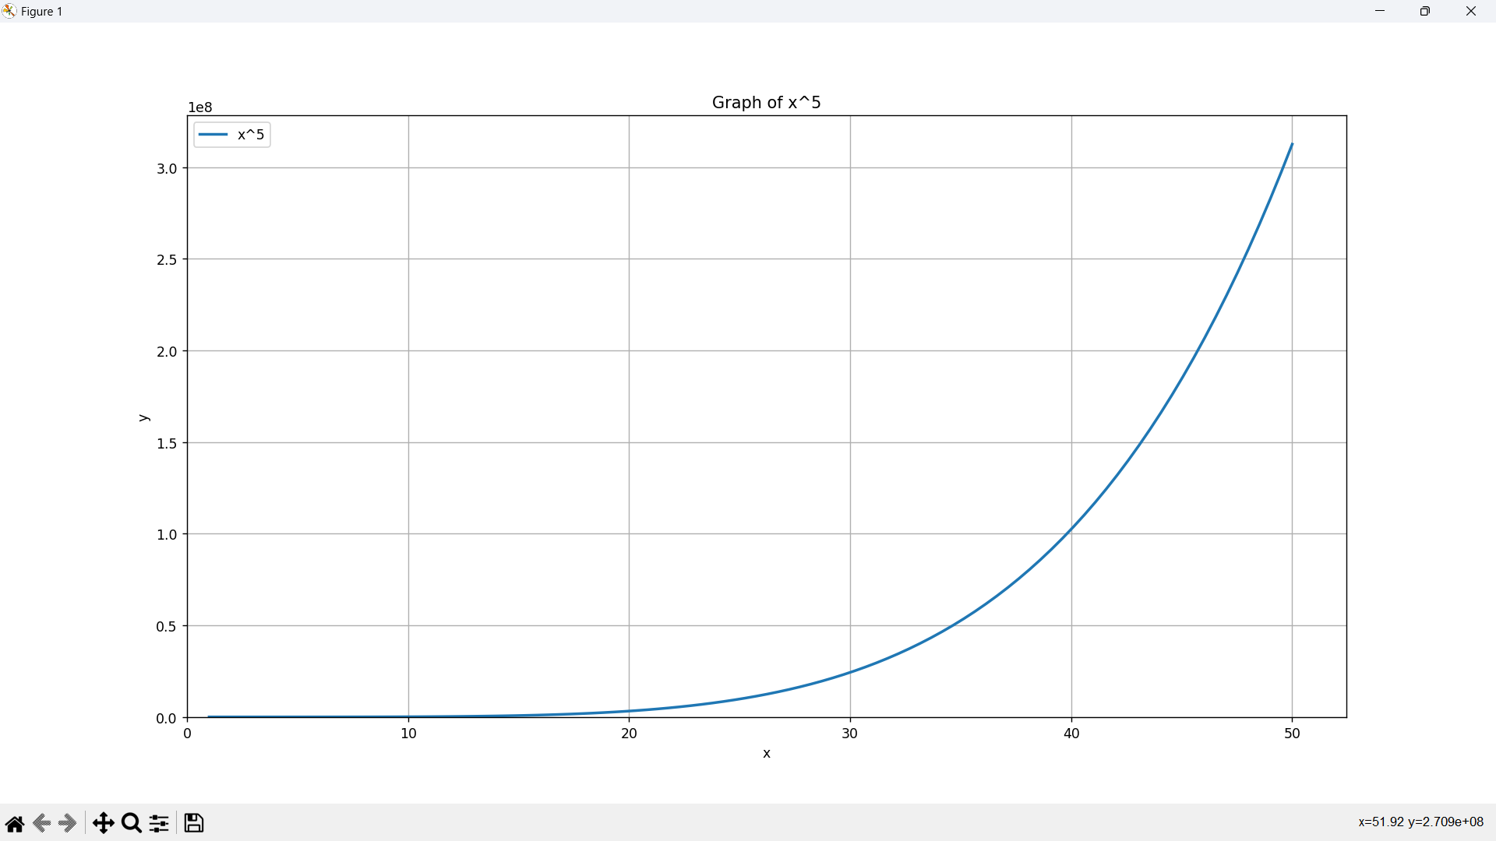prob. 5

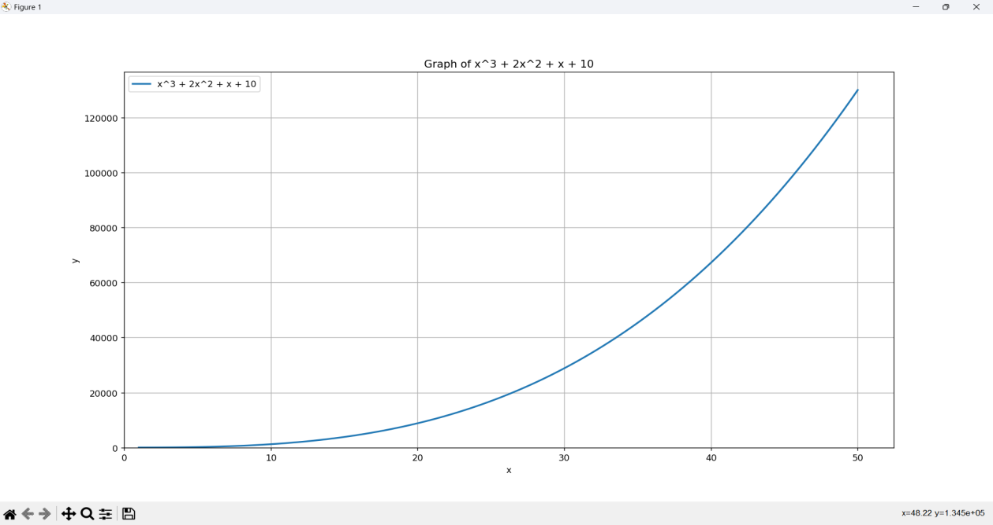prob. 6

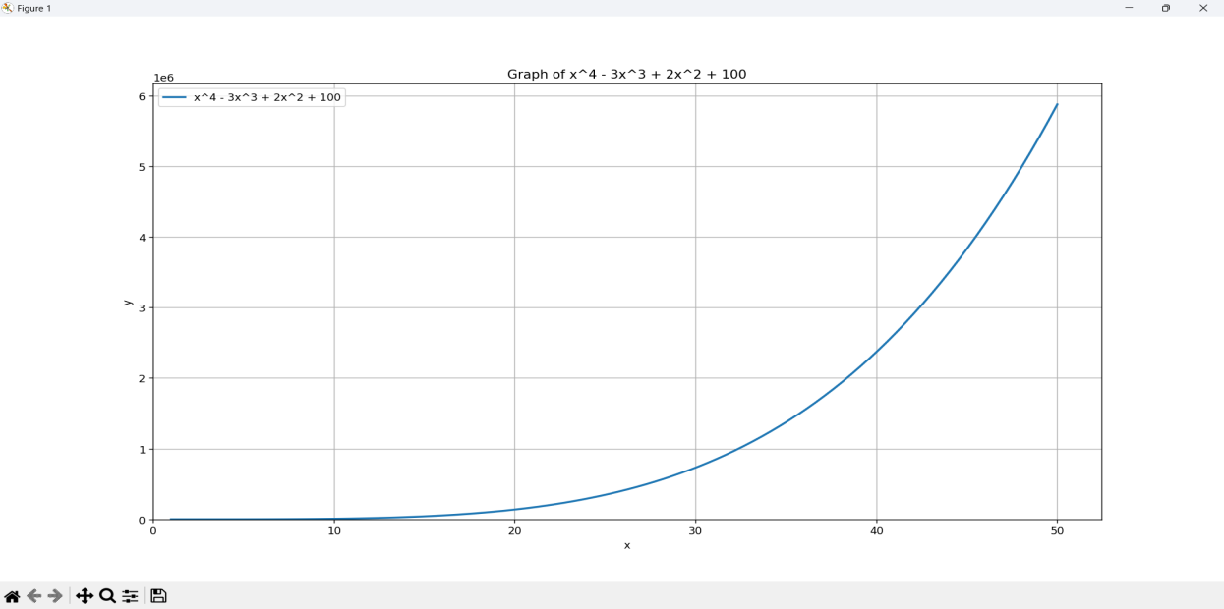prob. 7

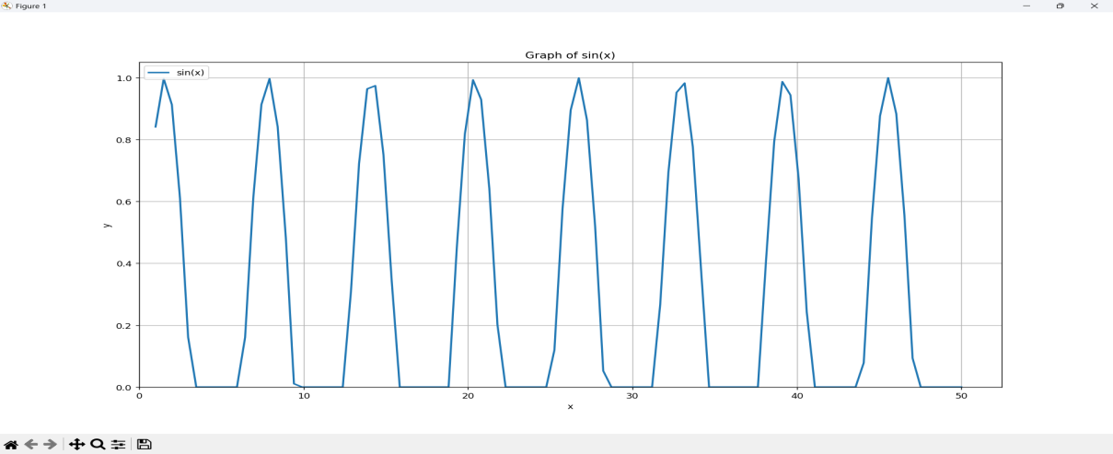  
prob. 8

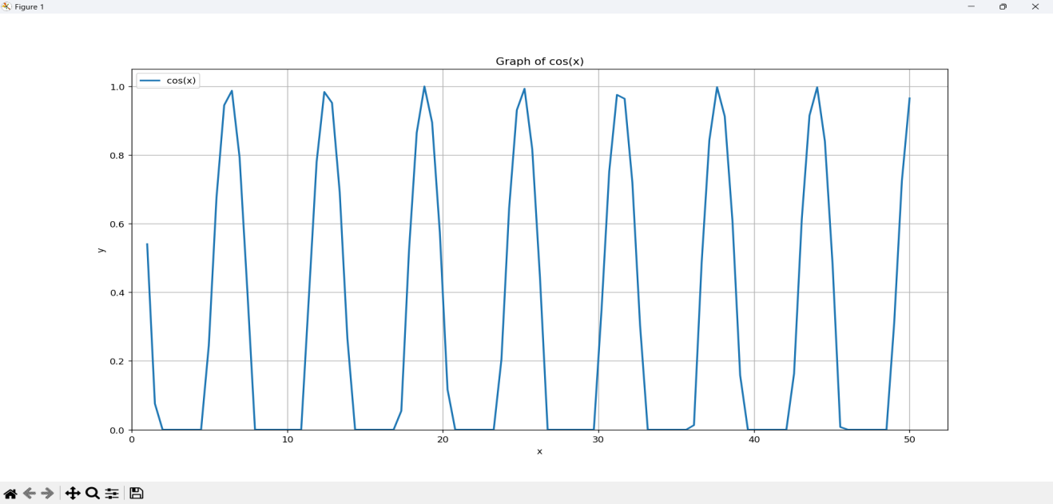  
  
prob. 9

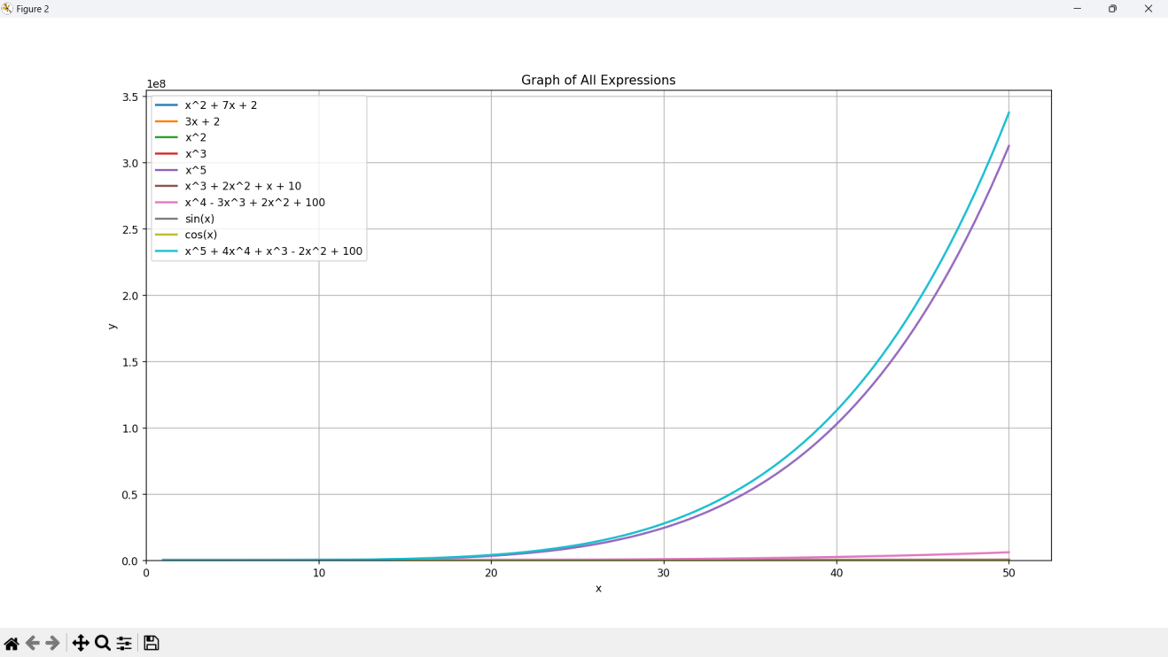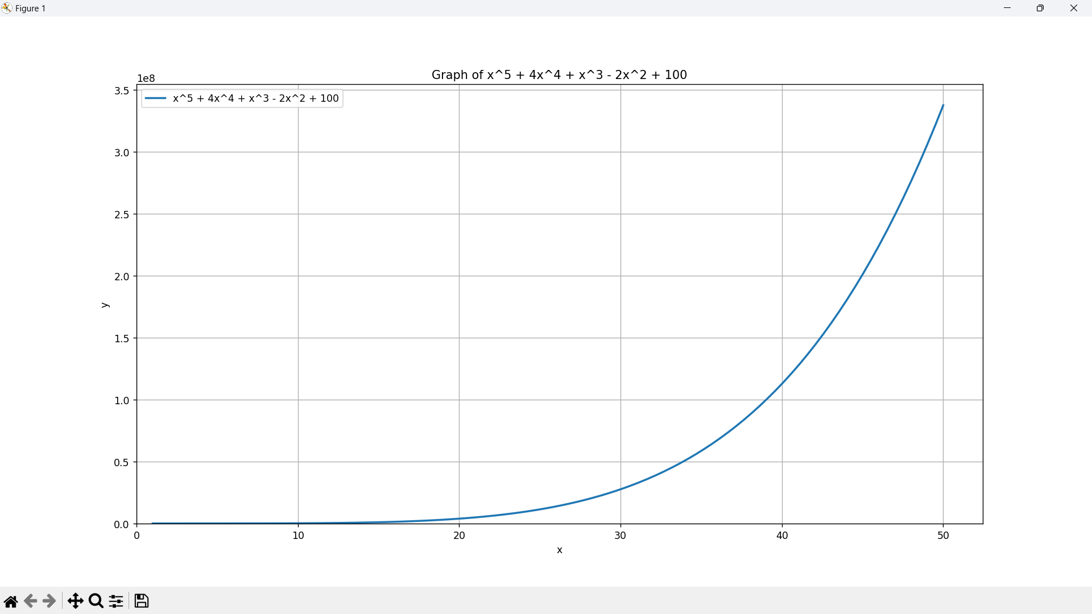  
prob. 10  
  
  
  
  
  
  
  
  
  
  
  
  
*Graph of all expression*

*Given Problems:*

prob. 1: x^2 + 7x + 2

prob. 2: 3x+2

prob. 3: x^2

prob. 4: x^3

prob. 5: x^5

prob. 6: x^3+2x^+ x +10

prob. 7: x^4-3x^3 + 2x^2 - x + 11

prob. 8: sin(x)

prob. 9: cos(x)

prob. 10: x^5 + 4x^4 + x^3 - 2x^2 + 100

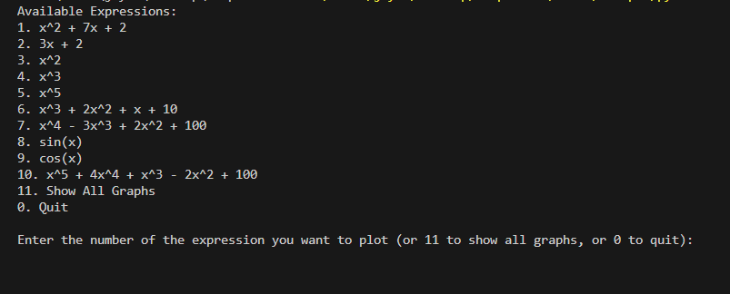*Terminal display*