AWS Business Outcomes Xcelerator (BOX)
Automatum × OBP — Marketplace Compliance Accelerator: Multi-Partner Feasibility Study

Submission Summary
Study Submitter Name/Title | [Submitter name and title — to supply]
Submitter Phone/Email | [Submitter phone and email — to supply]
Date Submitted | [Date — to supply]
Lead Partner | Automatum — owns the listed software and is seller of record.
Supporting Partners | Only Best Practices (OBP) — delivers the engagement.
Customer Use Case | An ISV is pursuing enterprise deals that require procurement through AWS Marketplace. The engagement makes the product transactable on AWS — Well-Architected review, remediation, Foundational Technical Review and a published listing.
AWS Services | AWS Marketplace; AWS Marketplace Management Portal (AMMP); AWS Well-Architected Framework Review; AWS Foundational Technical Review (FTR); AWS Partner Central / ACE.
Expected Launch Date | [Launch date — to confirm]
Is this a Public Sector solution? | No.
Is this a Business Outcomes Solution? | Yes. The buyer is the CRO, co-sponsored by the CISO, and the outcome is top-line. Enterprise buyers increasingly procure software through AWS Marketplace, and this engagement is for reaching them. The ISV can transact the enterprise pipeline it already holds once the listing is published, and from the same listing the ISV pursues net new revenue from net new customers. Each of those deals transacts on AWS Marketplace, where the enterprise buyer settles against AWS spend it has already committed, so procurement clears for the ISV. FTR acceptance grants AWS Qualified Software status and Solutions Finder placement, and the ISV looks to that standing for reach among buyers already spending on AWS. The listing is also what lets the ISV register its own deals in ACE, and from there the ISV works towards AWS co-sell, the account-team relationships that come with it, and a wider top of funnel. The solution combines AWS components (Marketplace, the Well-Architected Framework Review, the Foundational Technical Review), Automatum's listing and seller-of-record position, and OBP's delivery.
Target Industry for solution? | Independent software vendors, horizontal across industries. [Priority verticals — to confirm.]
Target Customer Persona for solution? | [CRO] — the revenue owner whose enterprise deals depend on a Marketplace listing. [CISO] co-sponsors where the Well-Architected and FTR evidence is what the enterprise buyer is asking for. Both to be validated against OBP's closed and in-flight deals.

Partnership Overview
Partner 1 Name | Automatum — lead partner. Owns the listed software and is seller of record for all four solutions.
SFDC Link | [AWS SFDC link — to supply]
APN SFDC Link | [APN SFDC link — to supply]
Partner Tier | [Tier as displayed on Partner Central — to attach with Partner ID and date checked]
Partner Since | [Date — to supply]
Business Plan Owners | [Named owner — to supply]
Current APN Programs | [Current APN programs — to supply]
Office Locations | [Office locations — to supply]
Key Focus Verticals of Partner | [Key focus verticals — to supply]
EXISTING Competencies & Service Delivery Programs | [Existing competencies and service delivery programs — to supply]
Partner 2 Name | Only Best Practices (OBP) — supporting partner. Delivers the engagement.
SFDC Link | [AWS SFDC link — to supply]
APN SFDC Link | [APN SFDC link — to supply]
Partner Tier | [Tier as displayed on Partner Central — to attach with Partner ID and date checked]
Partner Since | [Date — to supply]
Business Plan Owners | [Named owner — to supply]
Current APN Programs | [Current APN programs — to supply]
Office Locations | [Office locations — to supply]
Key Focus Verticals of Partner | [Key focus verticals — to supply]
EXISTING Competencies & Service Delivery Programs | [Existing competencies and service delivery programs — to supply]
Partner 3 Name (if needed), add Partner 4+ below. | Not applicable — two partners.
SFDC Link | Not applicable — two partners.
APN SFDC Link | Not applicable — two partners.
Partner Tier | Not applicable — two partners.
Partner Since | Not applicable — two partners.
Business Plan Owners | Not applicable — two partners.
Current APN Programs | Not applicable — two partners.
Key Focus Verticals of Partner | Not applicable — two partners.
EXISTING Competencies & Service Delivery Programs | Not applicable — two partners.

Solution Overview
Executive summary | Automatum and OBP propose the Marketplace Compliance Accelerator: a fixed-fee project that makes an ISV's product transactable on AWS Marketplace, in 14 to 18 business days of delivery, for $10,000.  What the ISV pursues is net new: the enterprise buyer who procures through AWS Marketplace, a customer within the ISV's reach once its listing is published, and the revenue those deals bring the ISV.  Automatum leads the solution, owns the listed software and is seller of record; OBP delivers the engagement. The customer signs one agreement and transacts through AWS Marketplace on Automatum's listing, with software on one line and professional services on the other.  For the CRO the outcome is enterprise deals the ISV holds today and can close on AWS Marketplace, on the procurement route the enterprise buyer already uses. For the CISO it is Well-Architected and FTR evidence an enterprise buyer will accept, produced inside the same engagement. Well-Architected data collection and remediation are automated by OBP's own tooling.
Description of Solution | Final delivery is a published, transactable AWS Marketplace listing, with the compliance evidence an enterprise buyer and AWS both require.  The engagement covers: a Well-Architected Framework Review conducted and its findings remediated in the product; the AWS Foundational Technical Review prepared and submitted; the Marketplace listing built, configured and taken through publication; architecture diagrams maintained in AMMP to evidence the "Deployed on AWS" badge; and seller registration completed.  Marketplace access is a precondition for a growing share of enterprise software procurement, and FTR acceptance grants AWS Qualified Software status and Solutions Finder placement, valid two years. Demand is evidenced by [pipeline figure — to supply from OBP's closed and in-flight deals].
Technology considerations | Delivery is professional services against AWS-operated systems; every software component the engagement uses is already built and in service.  Components: OBP operates automated Well-Architected data collection that suggests answers to the questionnaire and generates CloudFormation and AWS CLI templates resolving findings. Automatum supplies the Marketplace listing the product publishes to, and is seller of record. AWS supplies Marketplace, AMMP, the Well-Architected tool and the FTR process.  Labour: OBP compliance engineering, plus [N] hours of the customer's own engineering availability for remediation. The customer supplies tax, bank and legal data for seller registration. The components listed above are the complete set for the engagement. Licence cost recovery sits inside the engagement fee.
Market Fit | Target market: ISVs whose enterprise deals require Marketplace procurement, at the pre-listing or pre-FTR stage. A second segment buys on trust evidence: the AWS standing and directory presence that follow FTR acceptance are what the enterprise security review asks for, and the CISO sponsors the work.  Demand: enterprise buyers require Marketplace transactability, and ISVs pursue AWS co-sell, which depends on it. Past the first deal, what an ISV targets from a published listing compounds: further enterprise deals clearing procurement on the same route, its own deals entering AWS co-sell through ACE, AWS account teams working alongside its sellers, and more prospects entering the funnel.  Competitors: AWS systems integrators offering listing services, ISVs attempting it in-house, and AWS's own self-service path. The offer is a fixed fee, a stated delivery window, and an automated Well-Architected component.
Marketing strategy | Reach: AWS co-sell through ACE, with five ACE opportunity submissions committed by the partners for this solution; and joint outbound from both partners.  [Sponsored AWS marketing campaign participation — to confirm.]
Organization/Teaming Structure | OBP delivers with existing compliance engineering staff. Automatum contributes the listing and the seller-of-record position.  The delivery window is a staffing commitment. [Concurrent engagement capacity — to confirm.]  The volumes currently forecast sit within the capacity of the team already in place.
Schedule | Per engagement: 14 to 18 business days of delivery, counted as business days worked on the engagement; [the clock start — to define] and it runs from the customer's inputs being met.  Constraints: the publication date is governed by AWS's FTR review queue, which AWS schedules; the twelve-month listing deadline applies from entry [clock basis — per Solution ID from entry, or programme-level — to confirm with AWS].
Initial Financial projections | List price $10,000 fixed, 50% on signature and 50% on completion. Twenty hours of remediation are included; further blocks of ten hours are $1,000 each.  [Volume forecast and margin — to supply.]
Draft Reference Architecture | 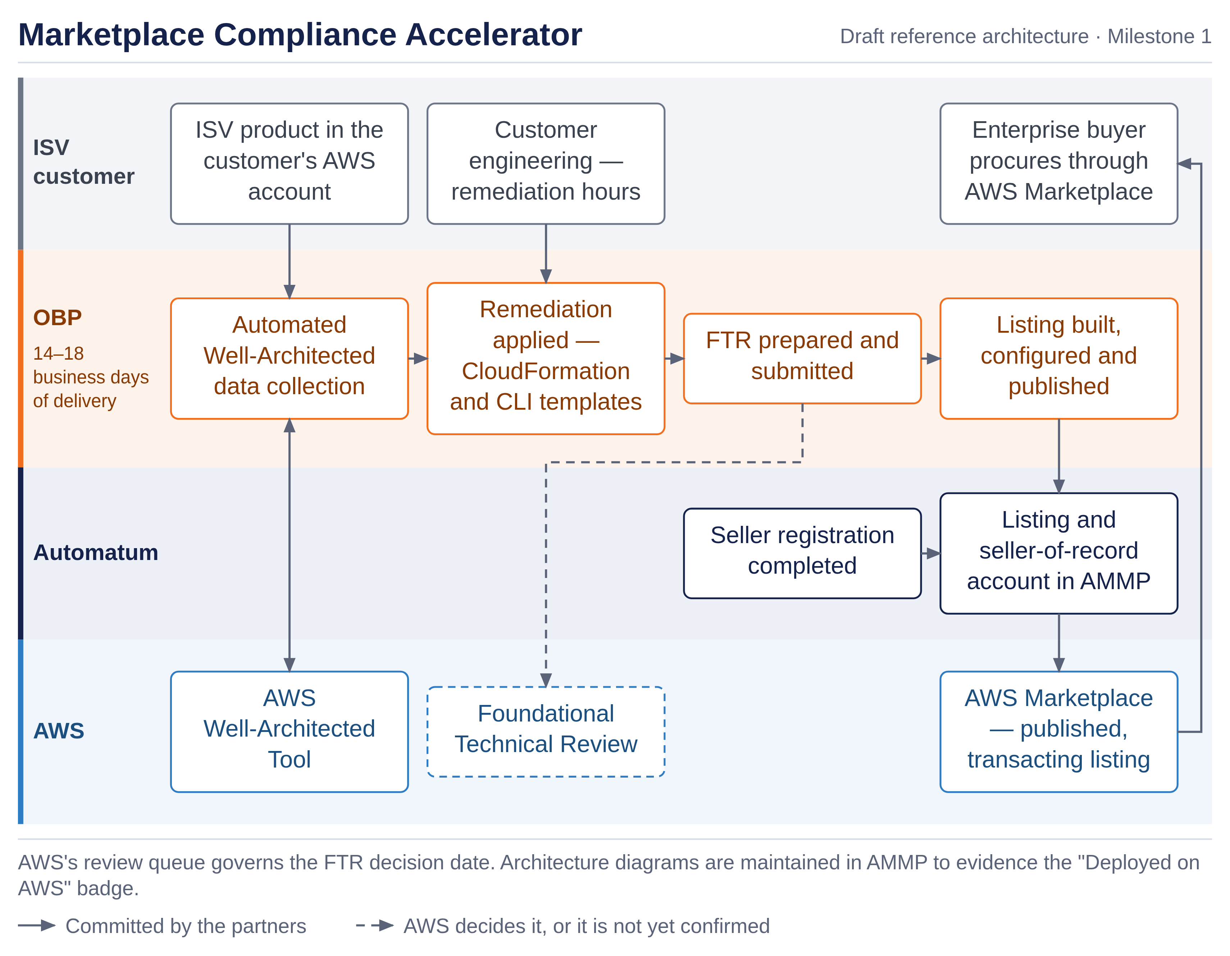
First Customer Targets | [Initial customers involved in solution design, with ACE opportunity links where entered — to supply.]
Findings and recommendations | Both partners recommend proceeding.  Findings: the CRO is the buyer and the outcome sought is top-line. The work is repeatable, the delivery window is provable, the effort is largely automated and the commercial structure is simple.

Solution Team Structure
Which Partner is the first line of support? How does the support model work? | OBP is first line of support for the engagement and for the compliance work. Automatum is first line for anything touching the listing itself, private offers or the seller-of-record position, since those sit in its account. Escalation between the partners is [named path — to define], and the customer sees a single named OBP owner throughout.
Who generated opportunities for the solution? If multiple, describe how the partners work together? | Both partners source. OBP sources from its own compliance and AWS practice pipeline; Automatum sources from its listing and ISV relationships; AWS sources through ACE, where five opportunity submissions are committed for this solution. An opportunity is registered against this Solution ID.
Have the partners determine if they can work together commercially? | Not yet. Both partners have seen the engagement structure — one customer agreement per Solution ID, with the software and the professional services carried on separate lines of Automatum's listing. The commercial terms between the partners cover the revenue split on each line, the flow of funds and payment trigger, Marketplace fee treatment and milestone apportionment.

Next steps: Submit Feasibility study here.

AWS Feedback
Additional input and recommendations from AWS teams | [leave blank in submission. AWS feedback to be included with any feedback or additional steps required.]

We define a Business Outcome Solution as one that impacts a customer’s top or bottom line.

