AWS Business Outcomes Xcelerator (BOX)
Automatum × OBP — Managed AWS Alliances: Multi-Partner Feasibility Study

Submission Summary
Study Submitter Name/Title | [Submitter name and title — to supply]
Submitter Phone/Email | [Submitter phone and email — to supply]
Date Submitted | [Date — to supply]
Lead Partner | Automatum — owns the listed software and is seller of record.
Supporting Partners | Only Best Practices (OBP) — delivers the engagement.
Customer Use Case | An ISV with an AWS listing and an AWS revenue target of its own needs a named Director of Alliances to run the AWS partnership and drive its AWS programme progression — ISV Accelerate, Competency acceptance, MDF, and its own BOX Program listings.
AWS Services | AWS Partner Central / ACE; AWS Marketplace; ISV Accelerate Program; AWS Competency Programs; AWS Marketing Development Funds (MDF); AWS Business Outcomes Xcelerator.
Expected Launch Date | [Launch date — to confirm]
Is this a Public Sector solution? | No.
Is this a Business Outcomes Solution? | Yes. The buyer is the CRO, with the CEO co-sponsoring at smaller ISVs, and the outcome is top-line: net new revenue and net new customers the ISV sources through AWS. The AWS-sourced pipeline and co-sell revenue the ISV works toward come from the programme benefits it qualifies for and the co-sell opportunities AWS originates. The retainer prepares and files those applications, and from Growth holds weekly ACE hygiene checks; what the ISV pursues on that footing is standing with the AWS field — at Professional, introductions to Account Executives, Partner Sales Managers and a Segment Leader — MDF and sponsored-campaign leads at the top of its funnel, and the co-sell deals AWS routes to it. Each co-sell deal the ISV closes counts on its own books as revenue and a customer won through AWS; where that deal transacts on the ISV's listing, it registers there as a Marketplace transaction and in ACE as an entry of the ISV's own. The solution combines components from AWS (Partner Central, ACE, ISV Accelerate, Competency, MDF), from Automatum (the listing and seller-of-record position) and from OBP (the alliance function itself). What it supplies is the Director of Alliances seat, staffed as a retained service.
Target Industry for solution? | Independent software vendors, horizontal across industries. [Priority verticals — to confirm.]
Target Customer Persona for solution? | [CRO] — the revenue owner who carries the ISV's AWS-sourced pipeline and co-sell revenue. [CEO] co-sponsors at ISVs where the CEO carries the revenue number. Both to be validated against OBP's closed and in-flight deals.

Partnership Overview
Partner 1 Name | Automatum — lead partner. Owns the listed software and is seller of record for all four solutions.
SFDC Link | [AWS SFDC link — to supply]
APN SFDC Link | [APN SFDC link — to supply]
Partner Tier | [Tier as displayed on Partner Central — to attach with Partner ID and date checked]
Partner Since | [Date — to supply]
Business Plan Owners | [Named owner — to supply]
Current APN Programs | [Current APN programs — to supply]
Office Locations | [Office locations — to supply]
Key Focus Verticals of Partner | [Key focus verticals — to supply]
EXISTING Competencies & Service Delivery Programs | [Existing competencies and service delivery programs — to supply]
Partner 2 Name | Only Best Practices (OBP) — supporting partner. Delivers the engagement.
SFDC Link | [AWS SFDC link — to supply]
APN SFDC Link | [APN SFDC link — to supply]
Partner Tier | [Tier as displayed on Partner Central — to attach with Partner ID and date checked]
Partner Since | [Date — to supply]
Business Plan Owners | [Named owner — to supply]
Current APN Programs | [Current APN programs — to supply]
Office Locations | [Office locations — to supply]
Key Focus Verticals of Partner | [Key focus verticals — to supply]
EXISTING Competencies & Service Delivery Programs | [Existing competencies and service delivery programs — to supply]
Partner 3 Name (if needed), add Partner 4+ below. | Not applicable — two partners.
SFDC Link | Not applicable — two partners.
APN SFDC Link | Not applicable — two partners.
Partner Tier | Not applicable — two partners.
Partner Since | Not applicable — two partners.
Business Plan Owners | Not applicable — two partners.
Current APN Programs | Not applicable — two partners.
Key Focus Verticals of Partner | Not applicable — two partners.
EXISTING Competencies & Service Delivery Programs | Not applicable — two partners.

Solution Overview
Executive summary | Automatum and OBP propose Managed AWS Alliances: OBP acts as the ISV's Director of Alliances for twelve months across three strictly additive tiers, priced $2,500 / $5,000 / $7,500 a month.  The solution puts a named owner on the AWS partnership and drives the ISV's own AWS programme progression. What the partners commit to is the machinery — a named owner with a named backup, partnership reviews held and minuted, quarterly AWS plans, and every ISV Accelerate, Competency, MDF and BOX Program listing application prepared and filed. What they target is what AWS decides: acceptance, MDF availability, listings approved and AWS-sourced leads.  For the CRO the outcome is the top line: net new revenue and net new customers the ISV pursues through AWS — the programme benefits it qualifies for, and the co-sell opportunities that originate with AWS. For the CEO, who co-sponsors at the smaller end of that market, it is a staffed AWS partnership and the AWS programme funding the ISV goes after.
Description of Solution | Final delivery is twelve months of a staffed AWS partnership: a named Director of Alliances, a fixed cadence of partnership reviews and quarterly AWS plans, and a filed application trail against every AWS programme the ISV qualifies for.  Tier outcomes the ISV pursues: at Essentials, ISV Accelerate acceptance (unlocking up to 25k in MDF), one Competency acceptance (up to 50k in MDF), one BOX Program listing (unlocking 35k in AWS credits, 35k in cash and 55 leads via a sponsored AWS marketing campaign), and AWS-facing marketing collateral. At Growth, up to three Competency acceptances and three BOX Program listings, quarterly events, weekly ACE hygiene checks and funding application support. At Professional, all applicable Competency programmes, uncapped BOX Program listings, and introductions to four Account Executives, two Partner Sales Managers and one Segment Leader.  The BOX Program listings referenced above are the ISV customer's own participation, which this retainer drives them toward.
Technology considerations | Delivery is a staffed alliance function: the engagement supplies people, cadence and a filed application trail, and runs entirely on systems AWS already operates.  AWS supplies Partner Central, ACE, the programme applications and the funding mechanisms. Automatum supplies the listing and the seller-of-record position, and files the partners' ACE opportunities from [whose Partner Central instance — to confirm]. OBP supplies the alliance function: the named owner, the reviews, the plans, the application preparation and the reporting.  The components listed above are the complete set for the engagement. Licence cost recovery sits inside the engagement fee.
Market Fit | Target market: ISVs with an AWS listing and AWS revenue ambition, typically below the size at which a full-time Director of Alliances is affordable.  Demand: AWS programmes carry benefits an ISV qualifies for through its listing, and AWS awards them on the applications an ISV files and the co-sell records it keeps current. ISVs at this size buy that work to become known to the AWS field, to bring MDF and sponsored campaigns to the top of their funnel, and to win the co-sell deals AWS routes to them. Each such deal is net new revenue and a net new customer for the ISV, and where it transacts on the ISV's listing it lands there as a transaction and in ACE as an entry of the ISV's own — the track record the next round of applications and co-sell is argued from. Building that record cycle after cycle is what the ISV works toward, and AWS decides each further round of benefits and co-sell.  Competitors: a direct Director of Alliances hire, and AWS consulting partners offering alliance advisory. The offer is a named owner at a stated cadence with a filed application trail.
Marketing strategy | Reach: AWS co-sell through ACE, with five ACE opportunity submissions committed by the partners for this solution; and joint outbound from both partners.  [Sponsored AWS marketing campaign participation — to confirm.]
Organization/Teaming Structure | OBP staffs each engagement with a named alliance lead and a named backup, so the cadence holds through absence.  The staffing model sets named-owner hours per rung and how many accounts one owner can hold. [Staffing model — to confirm.]  Hiring is anticipated at [volume threshold — to model].
Schedule | Per engagement: a twelve-month term, with the review and planning cadence running from kickoff. [Cadence counts and the action-log service level — to confirm with the staffing model.]  Constraints: every programme outcome runs to AWS decision timelines, which AWS sets; the twelve-month listing deadline applies from entry [clock basis — to confirm with AWS].
Initial Financial projections | List price $2,500 / $5,000 / $7,500 a month across three strictly additive tiers, on a twelve-month term. Priced on the seniority of the person on the account.  Each rung carries its own included volumes and overflow rates. [Volume forecast, retainer payment terms and margin — to supply.]
Draft Reference Architecture | 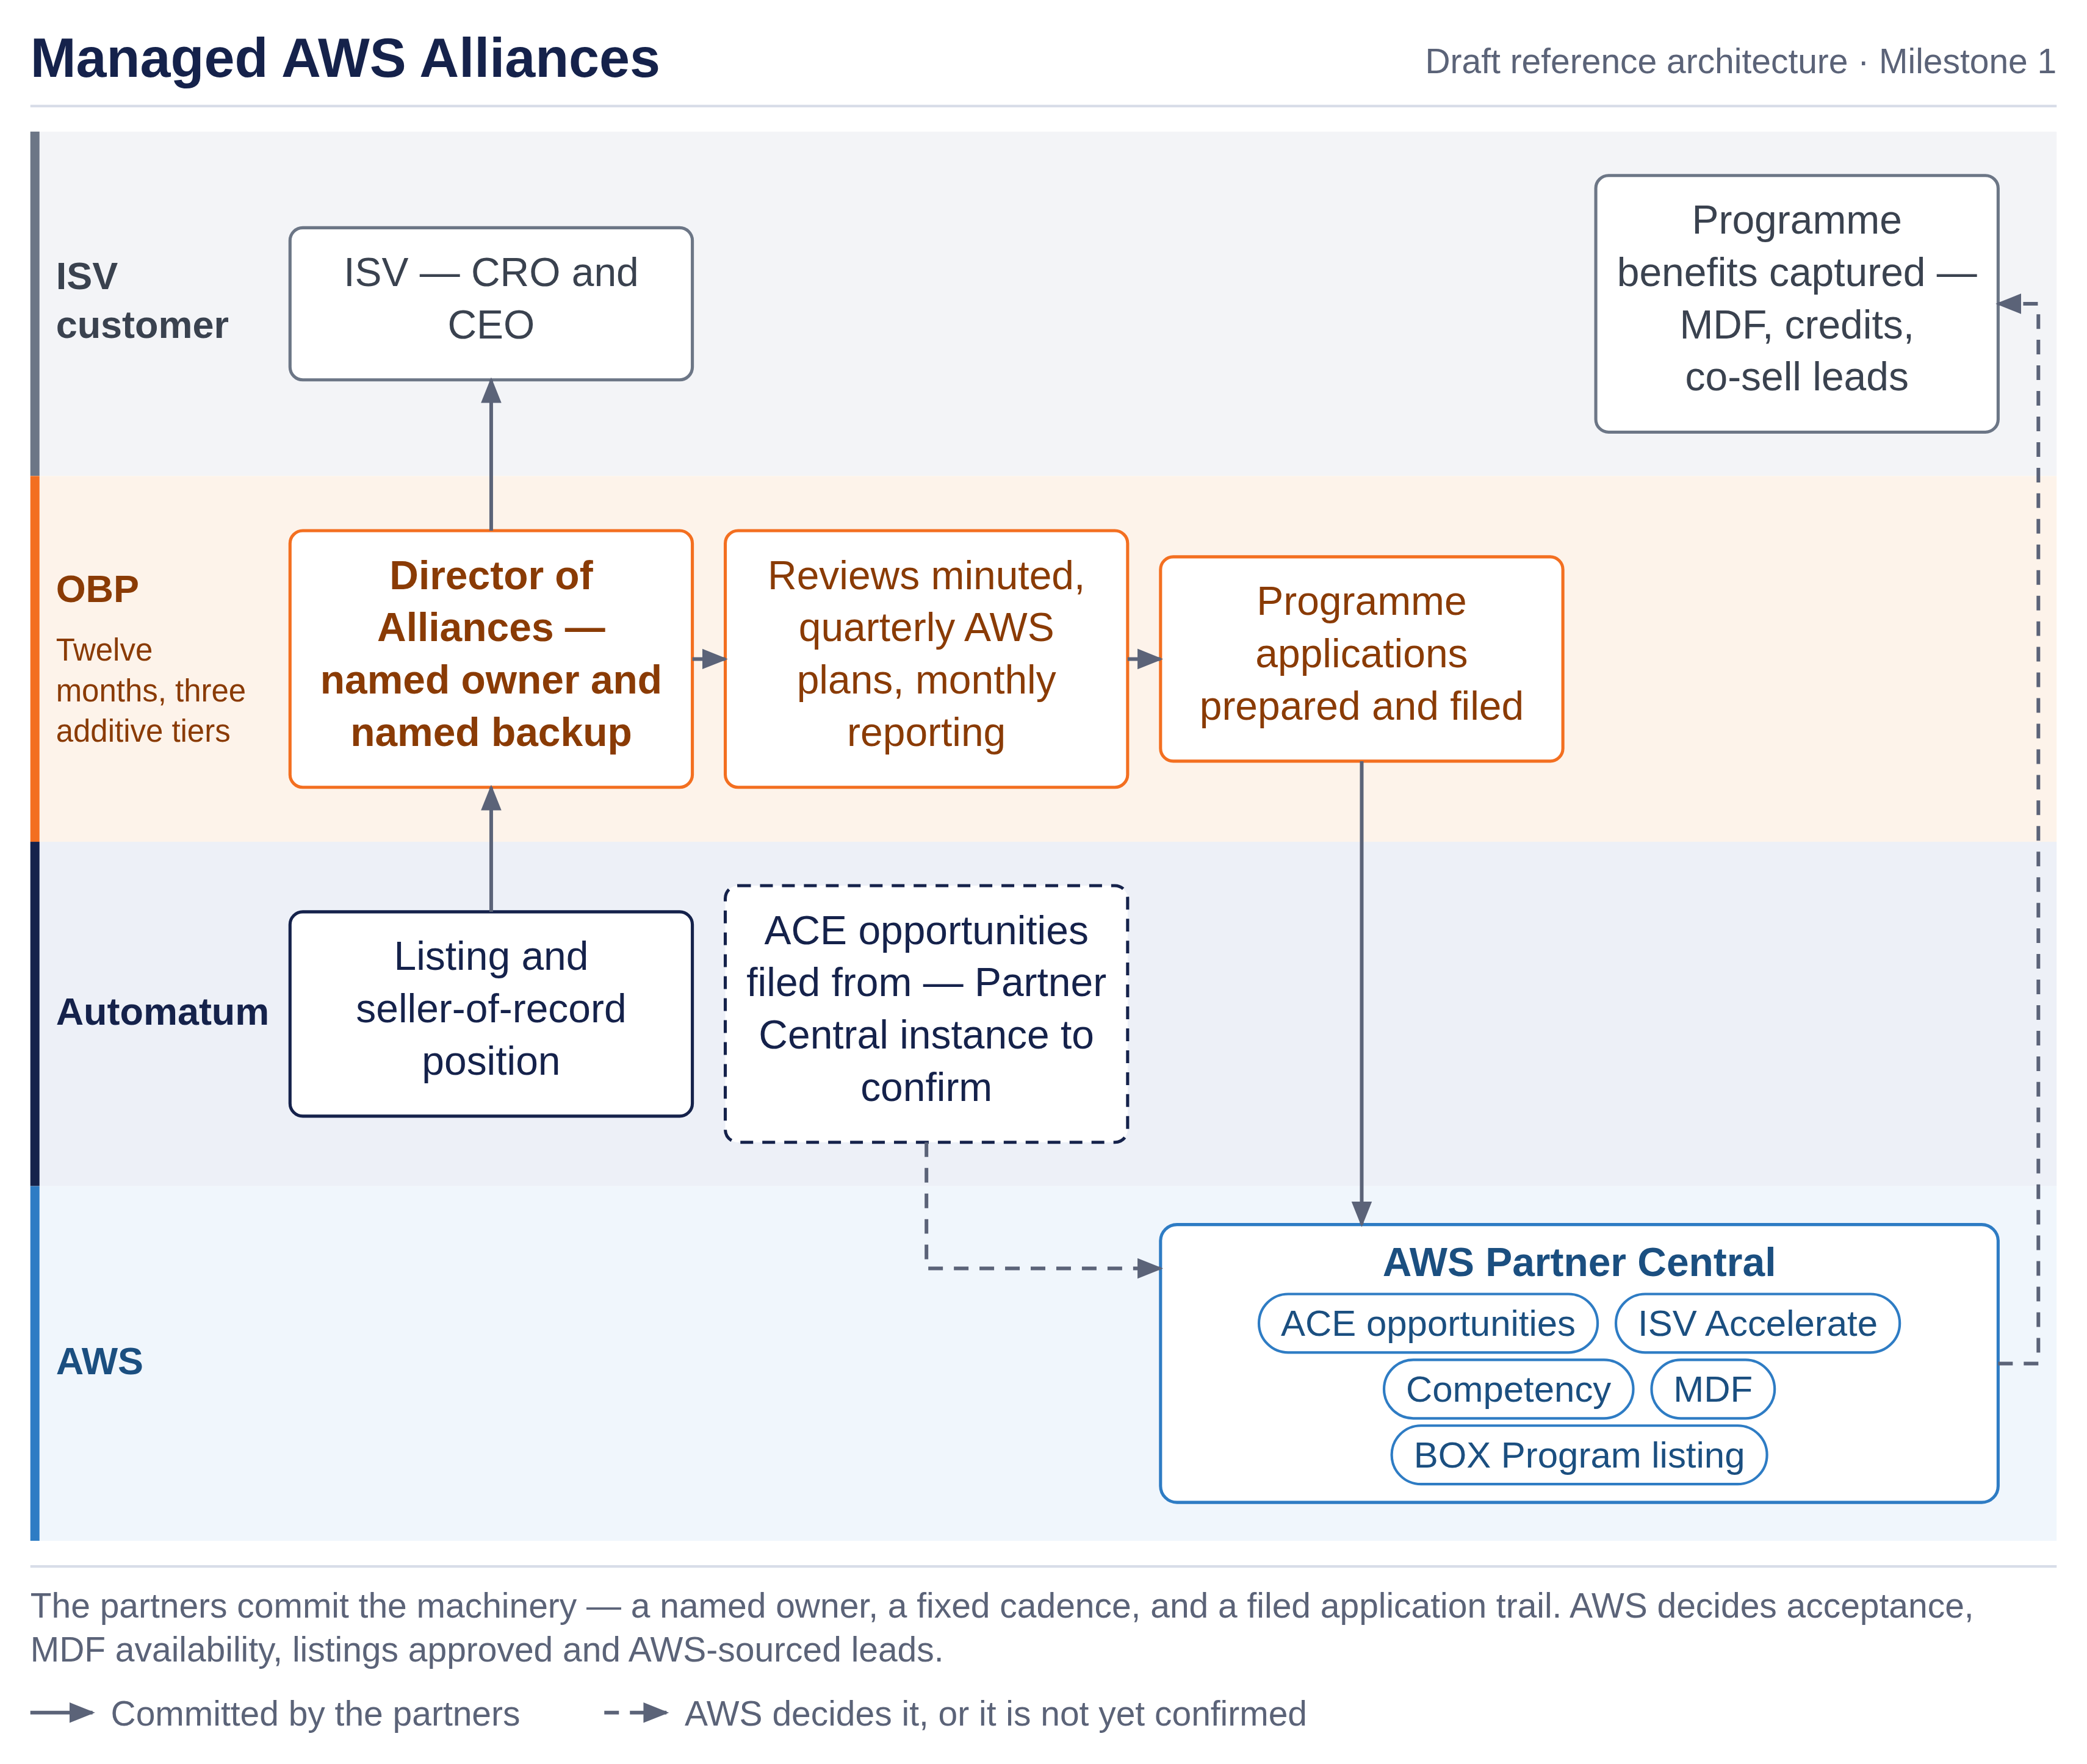
First Customer Targets | [Initial customers involved in solution design, with ACE opportunity links where entered — to supply.]
Findings and recommendations | Both partners recommend proceeding.  Findings: the buyer is the CRO, and the CEO co-sponsors; the outcome is top-line — AWS-sourced pipeline the ISV converts into net new customers and revenue of its own — with a commercial model sound at list price. Every commitment here is a staffing commitment, and delivery capacity is the open risk.

Solution Team Structure
Which Partner is the first line of support? How does the support model work? | OBP is first line of support and owns the customer relationship through a named alliance lead with a named backup. Automatum is first line for the listing, private offers, selling authorizations and the seller-of-record position. Escalation between the partners is [named path — to define].
Who generated opportunities for the solution? If multiple, describe how the partners work together? | Both partners source, and AWS sources through ACE, where five opportunity submissions are committed for this solution — Automatum and OBP registering their own sales of it. An opportunity is registered against this Solution ID. The ISV customer's co-sell deals are the customer's own opportunities, raised on the customer's own deals and running through the customer's own opportunity flow.
Have the partners determine if they can work together commercially? | Not yet. The commercial terms between the partners cover the revenue split on each line, the flow of funds and payment trigger, Marketplace fee treatment and milestone apportionment.

Next steps: Submit Feasibility study here.

AWS Feedback
Additional input and recommendations from AWS teams | [leave blank in submission. AWS feedback to be included with any feedback or additional steps required.]

We define a Business Outcome Solution as one that impacts a customer’s top or bottom line.

