AWS Business Outcomes Xcelerator (BOX)
Automatum × OBP — Managed Marketplace Operations: Multi-Partner Feasibility Study

Submission Summary
Study Submitter Name/Title | [Submitter name and title — to supply]
Submitter Phone/Email | [Submitter phone and email — to supply]
Date Submitted | [Date — to supply]
Lead Partner | Automatum — owns the listed software and is seller of record.
Supporting Partners | Only Best Practices (OBP) — delivers the engagement.
Customer Use Case | An ISV needs its AWS Marketplace listing built and then operated at volume — compliance engineering, a private offer desk, listing configuration and monthly reporting on offers, Marketplace revenue and listing health.
AWS Services | AWS Marketplace; AWS Marketplace Management Portal (AMMP); AWS Well-Architected Framework Review; AWS Foundational Technical Review (FTR); Channel Partner Private Offers (CPPO); AWS Partner Central / ACE.
Expected Launch Date | [Launch date — to confirm]
Is this a Public Sector solution? | No.
Is this a Business Outcomes Solution? | Yes. The buyer is the CRO, co-sponsored by the COO, and the outcome is directly top-line: the listing is the mechanism through which the ISV transacts on AWS, and the offer desk converts demand the ISV already has into offers drafted and issued. The net new the ISV is after is revenue and customers won on Marketplace — deals that close because the offer reaches the buyer fast enough, and channel deals reachable through a CPPO. The rung sets the included offer band the desk operates, up to 50, 100 or 200 offers a year, and what the ISV pursues through each offer its buyer accepts is revenue booked on a subscription running through its own listing, an opportunity it can register in ACE, a customer relationship it holds on AWS, and its name in front of the AWS sellers working that account, at the top of its own funnel. It combines AWS components (Marketplace, AMMP, FTR, CPPO), Automatum's listing and seller-of-record position, and OBP's operations function. What it supplies is the offer desk and the compliance engineering behind the listing, staffed as a retainer.
Target Industry for solution? | Independent software vendors, horizontal across industries. [Priority verticals — to confirm.]
Target Customer Persona for solution? | [CRO] — the revenue owner whose private offers and Marketplace revenue run through the listing. [COO] co-sponsors where the listing is carried as an operational function. Both to be validated against OBP's closed and in-flight deals.

Partnership Overview
Partner 1 Name | Automatum — lead partner. Owns the listed software and is seller of record for all four solutions.
SFDC Link | [AWS SFDC link — to supply]
APN SFDC Link | [APN SFDC link — to supply]
Partner Tier | [Tier as displayed on Partner Central — to attach with Partner ID and date checked]
Partner Since | [Date — to supply]
Business Plan Owners | [Named owner — to supply]
Current APN Programs | [Current APN programs — to supply]
Office Locations | [Office locations — to supply]
Key Focus Verticals of Partner | [Key focus verticals — to supply]
EXISTING Competencies & Service Delivery Programs | [Existing competencies and service delivery programs — to supply]
Partner 2 Name | Only Best Practices (OBP) — supporting partner. Delivers the engagement.
SFDC Link | [AWS SFDC link — to supply]
APN SFDC Link | [APN SFDC link — to supply]
Partner Tier | [Tier as displayed on Partner Central — to attach with Partner ID and date checked]
Partner Since | [Date — to supply]
Business Plan Owners | [Named owner — to supply]
Current APN Programs | [Current APN programs — to supply]
Office Locations | [Office locations — to supply]
Key Focus Verticals of Partner | [Key focus verticals — to supply]
EXISTING Competencies & Service Delivery Programs | [Existing competencies and service delivery programs — to supply]
Partner 3 Name (if needed), add Partner 4+ below. | Not applicable — two partners.
SFDC Link | Not applicable — two partners.
APN SFDC Link | Not applicable — two partners.
Partner Tier | Not applicable — two partners.
Partner Since | Not applicable — two partners.
Business Plan Owners | Not applicable — two partners.
Current APN Programs | Not applicable — two partners.
Key Focus Verticals of Partner | Not applicable — two partners.
EXISTING Competencies & Service Delivery Programs | Not applicable — two partners.

Solution Overview
Executive summary | Automatum and OBP propose Managed Marketplace Operations: a twelve-month retainer that gets a listing live and then operates it at volume, priced $1,500 / $3,000 / $6,000 a month.  For the CRO the outcome is what the ISV pursues on its own AWS Marketplace listing: net new revenue and net new customers, from offers issued at the volume the rung provides for and from channel deals a CPPO opens. For the COO it is the listing carried as an operating function, with a named owner behind it and a monthly view of offers, Marketplace revenue and listing health.  All nine services are delivered at every rung — compliance engineering, listing engineering, and the offer desk and reporting. Volume, turnaround and review cadence set the rung. Pricing is on throughput: the rungs track the included offer band, at the same rate per included offer at each.
Description of Solution | Final delivery is a live AWS Marketplace listing operated at the rung's volume, with a written service level issued at onboarding, twelve monthly operating packs and an annual state-of-the-listing review.  Nine services at every rung: a Well-Architected Framework Review conducted and findings remediated — the FTR takes a completed WAFR as its input, so compliance engineering runs before the listing is built; the FTR prepared and submitted; the listing built, configured and taken through publication; architecture diagrams maintained in AMMP to evidence the "Deployed on AWS" badge; CRM integration configured for Marketplace offers and subscriptions; a private offer desk operating direct offers and CPPOs; listing configuration changes inside the rung's turnaround; and monthly reporting on offers, Marketplace revenue and listing health.  Rung depth: one, two or four Well-Architected reviews; up to 50, 100 or 200 offers operated per year; listing configuration changes in five, three or one business days.
Technology considerations | Delivery is professional services against AWS-operated systems; every software component the engagement uses is already built and in service.  AWS supplies Marketplace, AMMP, the Well-Architected tool, the FTR process and the CPPO mechanism. Automatum supplies the listing, issues every private offer as seller of record, and provides the CRM and Partner Central integrations. OBP supplies compliance engineering, the offer desk, listing configuration and reporting.  OBP drafts and submits offers; Automatum issues them. Each issue turnaround here rests on a matching internal turnaround at Automatum. [CRM platforms Automatum's integration supports — to confirm.] The components listed above are the complete set for the engagement. Licence cost recovery sits inside the engagement fee.
Market Fit | Target market: ISVs transacting on AWS Marketplace at volume, or intending to, where the desk behind the listing is the piece the revenue owner buys in.  Demand: driven by private offer volume. An ISV issuing offers at any material rate needs a desk. Volume is what an ISV compounds on: renewals and expansions it pursues on its own listing, a co-sell record it can build in ACE, and AWS customer relationships it can carry into next year's pipeline.  Competitors: a Marketplace operations hire, AWS consulting partners offering listing management, and ISVs operating the desk in-house. The offer is a stated offer band with a stated turnaround, priced linearly against the band.
Marketing strategy | Reach: AWS co-sell through ACE, with five ACE opportunity submissions committed by the partners for this solution; and joint outbound from both partners.  [Sponsored AWS marketing campaign participation — to confirm.]
Organization/Teaming Structure | OBP staffs a named operations owner and a named backup, with the desk open across a stated coverage window. The top rung's increment is coverage and response band.  Every turnaround at a rung is a staffing commitment. [Desk coverage window and time zone, and accounts per owner — to confirm.]  Hiring is anticipated at [volume threshold — to model].
Schedule | Per engagement: a twelve-month term. The listing work runs at the start of the term; the operating cadence runs across all twelve months.  Constraints: AWS's FTR review queue governs the publication date; AWS-mandated catalog and policy changes arrive on AWS's schedule and are assessed within the rung's turnaround, though landing them before an AWS deadline may require the customer's own engineering.
Initial Financial projections | List price $1,500 / $3,000 / $6,000 a month on a twelve-month term — $18,000, $36,000 and $72,000 across the term, against included offer bands of 50, 100 and 200 offers a year. The rate per included offer is identical at all three rungs.  [Overflow rates above the included band — to set.] [Volume forecast, retainer payment terms and margin — to supply.]
Draft Reference Architecture | 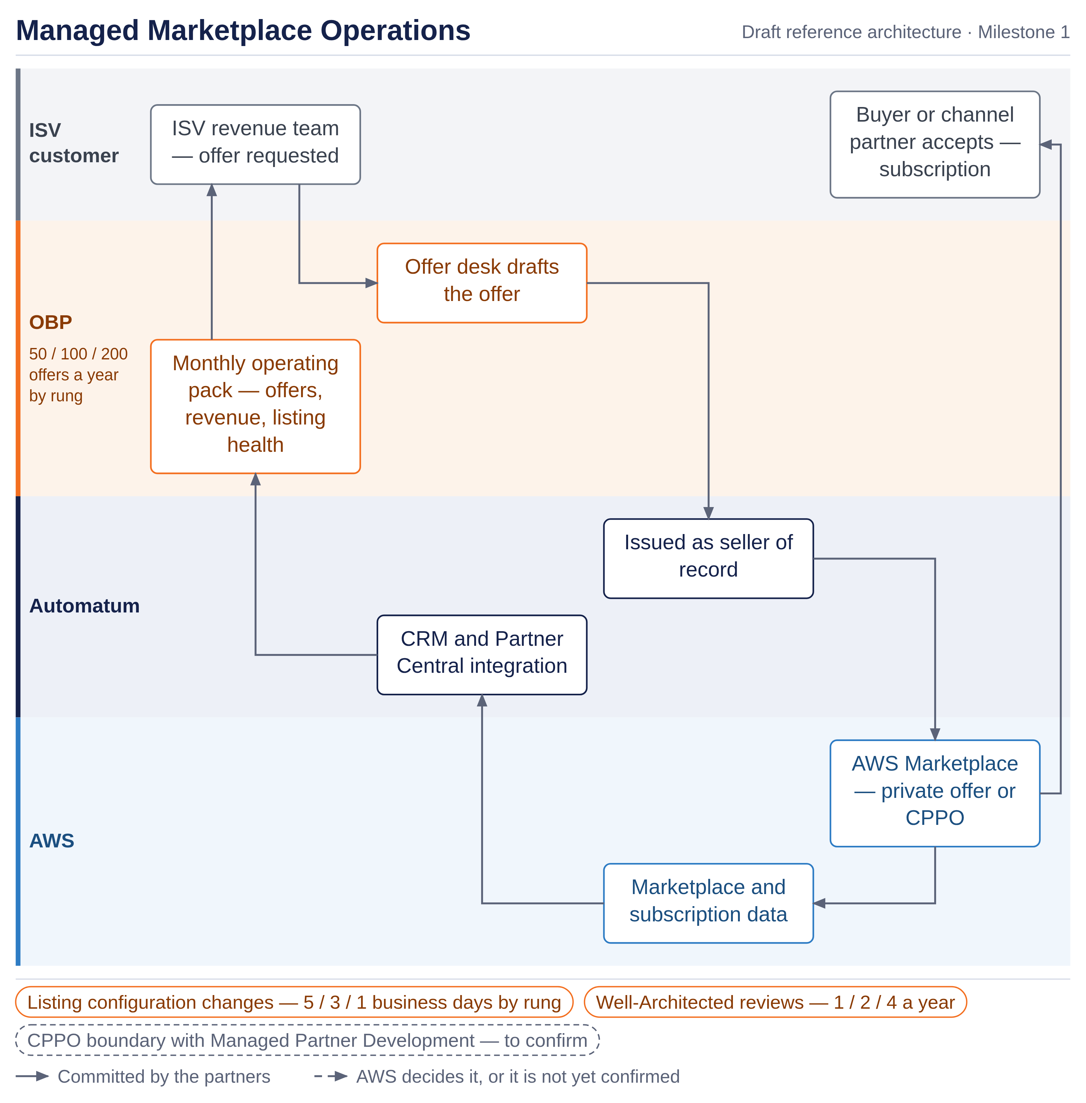
First Customer Targets | [Initial customers involved in solution design, with ACE opportunity links where entered — to supply.]
Findings and recommendations | Both partners recommend proceeding.  Findings: the buyer is the CRO, co-sponsored by the COO, and the outcome is a top-line one — the net new revenue and net new customers the ISV pursues on its own listing. The solution is repeatable, and its pricing tracks its own included band.

Solution Team Structure
Which Partner is the first line of support? How does the support model work? | OBP is first line of support for the desk, compliance engineering and reporting, through a named operations owner with a named backup. Automatum is first line for the listing itself, offer issuance and the seller-of-record position. The handoff between the two on an offer, and its turnaround, are [to agree].
Who generated opportunities for the solution? If multiple, describe how the partners work together? | Both partners source, and AWS sources through ACE, where five opportunity submissions are committed for this solution. An opportunity is registered against this Solution ID. The ISV's own deals reaching AWS co-sell are registered by the ISV under its own opportunity flow.
Have the partners determine if they can work together commercially? | Not yet. The commercial terms between the partners cover the revenue split on each line, the flow of funds and payment trigger, Marketplace fee treatment and milestone apportionment. OBP publishes an offer-issue or listing-configuration turnaround once Automatum agrees a matching internal turnaround behind it.

Next steps: Submit Feasibility study here.

AWS Feedback
Additional input and recommendations from AWS teams | [leave blank in submission. AWS feedback to be included with any feedback or additional steps required.]

We define a Business Outcome Solution as one that impacts a customer’s top or bottom line.

