AWS Business Outcomes Xcelerator (BOX)
Automatum × OBP — Managed Partner Development: Multi-Partner Feasibility Study

Submission Summary
Study Submitter Name/Title | [Submitter name and title — to supply]
Submitter Phone/Email | [Submitter phone and email — to supply]
Date Submitted | [Date — to supply]
Lead Partner | Automatum — owns the listed software and is seller of record.
Supporting Partners | Only Best Practices (OBP) — delivers the engagement.
Customer Use Case | An ISV needs a reseller channel on AWS built and run — partners recruited and managed, a CPPO deal desk, selling authorizations, enablement, a partner system of record and attribution reporting.
AWS Services | AWS Marketplace; Channel Partner Private Offers (CPPO); selling authorizations; AWS Partner Central / ACE; AWS Marketplace seller reporting.
Expected Launch Date | [Launch date — to confirm]
Is this a Public Sector solution? | No.
Is this a Business Outcomes Solution? | Yes. The buyer is the CRO, co-sponsored by the VP Channel where that role exists, and the outcome is top-line: net new customers reached through resellers, and partner-sourced revenue added to what the ISV's own sellers close. Both are targets the ISV pursues through the channel, and the end customer's decision to buy settles them. A partner deal transacts as a CPPO on the ISV's AWS Marketplace listing, attributed through Partner Revenue Measurement so the ISV can see what its channel sources; that deal is the ISV's own to register in ACE for AWS co-sell; and the AWS relationships and accounts a reseller holds are the top of funnel the ISV is reaching for. The solution combines AWS components (Marketplace, CPPO, selling authorizations, attribution), Automatum's listing and seller-of-record position, and OBP's channel function, with OBP's partner system of record, included in the fee.
Target Industry for solution? | Independent software vendors, horizontal across industries. [Priority verticals — to confirm.]
Target Customer Persona for solution? | [CRO] — the revenue owner accountable for partner-sourced revenue. [VP Channel] co-sponsors where the channel function already exists. Both to be validated against OBP's closed and in-flight deals.

Partnership Overview
Partner 1 Name | Automatum — lead partner. Owns the listed software and is seller of record for all four solutions.
SFDC Link | [AWS SFDC link — to supply]
APN SFDC Link | [APN SFDC link — to supply]
Partner Tier | [Tier as displayed on Partner Central — to attach with Partner ID and date checked]
Partner Since | [Date — to supply]
Business Plan Owners | [Named owner — to supply]
Current APN Programs | [Current APN programs — to supply]
Office Locations | [Office locations — to supply]
Key Focus Verticals of Partner | [Key focus verticals — to supply]
EXISTING Competencies & Service Delivery Programs | [Existing competencies and service delivery programs — to supply]
Partner 2 Name | Only Best Practices (OBP) — supporting partner. Delivers the engagement.
SFDC Link | [AWS SFDC link — to supply]
APN SFDC Link | [APN SFDC link — to supply]
Partner Tier | [Tier as displayed on Partner Central — to attach with Partner ID and date checked]
Partner Since | [Date — to supply]
Business Plan Owners | [Named owner — to supply]
Current APN Programs | [Current APN programs — to supply]
Office Locations | [Office locations — to supply]
Key Focus Verticals of Partner | [Key focus verticals — to supply]
EXISTING Competencies & Service Delivery Programs | [Existing competencies and service delivery programs — to supply]
Partner 3 Name (if needed), add Partner 4+ below. | Not applicable — two partners.
SFDC Link | Not applicable — two partners.
APN SFDC Link | Not applicable — two partners.
Partner Tier | Not applicable — two partners.
Partner Since | Not applicable — two partners.
Business Plan Owners | Not applicable — two partners.
Current APN Programs | Not applicable — two partners.
Key Focus Verticals of Partner | Not applicable — two partners.
EXISTING Competencies & Service Delivery Programs | Not applicable — two partners.

Solution Overview
Executive summary | Automatum and OBP propose Managed Partner Development: a twelve-month retainer that stands up and runs an ISV's reseller channel on AWS, priced $2,500 / $5,000 / $7,500 a month.  What the partners commit to is the roster under management and the machinery around it — up to six, up to twelve, or an uncapped roster of net new partners recruited and managed, a CPPO deal desk at the rung's turnaround, training on cadence, channel reviews with sourced-pipeline and attribution reporting, and OBP's partner system of record operated inside the fee. What they report and target is partners issuing offers, because that depends on the partners themselves.  For the CRO the outcome is top-line: customers a reseller opens for the ISV, and revenue the channel sources alongside its own sellers, both of which the ISV targets and the end customer decides. For the VP Channel it is the channel itself running: agreements executed, a roster under management, and a deal desk answering partner registrations inside its stated turnaround, which OBP staffs and operates. Ramp from first outreach to a first partner transaction models at eight months, which sets the twelve-month term.
Description of Solution | Final delivery is a working reseller channel: executed partner agreements and a margin schedule, a live partner portal carrying onboarding, deal registration and commission tracking, recruitment and enablement running on a named cadence, a deal desk answering registrations, and a monthly report whose headline number is partners issuing offers.  Rung depth: up to six, twelve or an uncapped roster of net new partners recruited and under management; twice-yearly, quarterly or monthly training and enablement sessions; a CPPO deal desk at one business day, eight business hours or four business hours; quarterly, monthly or fortnightly channel reviews with sourced-pipeline and attribution reporting.  At every rung: recurring selling authorizations drafted, issued and tracked in AWS Marketplace; OBP's partner system of record stood up and operated inside the engagement fee; and Partner Revenue Measurement attribution configured for the channel.  AWS permits only one partner identifier per resource, so partner attribution runs on user agent string.
Technology considerations | Delivery is a staffed channel function against AWS-operated systems, plus one licensed component.  AWS supplies Marketplace, the CPPO mechanism, selling authorizations and attribution. Automatum supplies the listing, the seller-of-record position and the offer issuance. OBP supplies recruitment, agreements, enablement, training, the deal desk and the reviews.  OBP's partner system of record — portal, onboarding, deal registration and commission tracking, with CRM sync — is stood up and operated inside the engagement fee, and it is the auditable source behind the partners-issuing-offers count. [Seats per rung — to confirm.] The components listed above are the complete set for the engagement. Licence cost recovery sits inside that fee.  One mechanism requires AWS and Automatum confirmation before the outcome model is final: whether, and by what mechanism, a third-party reseller can issue offers against Automatum's listing while Automatum is seller of record. The reported metric depends on it.
Market Fit | Target market: ISVs with a live AWS listing and an intention to sell through resellers, at the point where the channel function is still to be built.  Demand: driven by ISVs discovering that Marketplace channel revenue requires partners who are themselves registered, authorized and enabled, work that requires an owner. What draws them is the compounding they are after: a partner sale transacts as a CPPO on the ISV's AWS Marketplace listing, with Partner Revenue Measurement attribution behind it, and the AWS relationships and accounts a reseller already holds are where an ISV looks to widen the top of its funnel.  Competitors: a channel manager hire plus a PRM subscription, and channel consultancies. The offer is a committed roster under management, a stated deal-desk turnaround, and a count held in a system of record.
Marketing strategy | Reach: AWS co-sell through ACE, with five ACE opportunity submissions committed by the partners for this solution; and joint outbound from both partners.  [Sponsored AWS marketing campaign participation — to confirm.]
Organization/Teaming Structure | OBP staffs a named channel manager with a named backup, and at the top rung a named deal-desk owner with a stated coverage window.  The deal-desk turnarounds and the review cadence are staffing commitments. [Named-owner hours per rung and accounts per owner — to confirm.]  Hiring is anticipated at [volume threshold — to model].
Schedule | Per engagement: a twelve-month term, set by the eight-month ramp from first outreach to a first partner transaction.  Constraints: each recruited partner must clear its own AWS gate — paid seller registration, tax interview, USD disbursement and service-linked role — which is the partner's own act, taken on the partner's own timing.
Initial Financial projections | List price $2,500 / $5,000 / $7,500 a month across three rungs, on a twelve-month term. Priced on the seniority of the person on the account.  The partner system of record is carried inside the engagement fee. [Volume forecast, seats per rung, retainer payment terms and margin — to supply.]
Draft Reference Architecture | 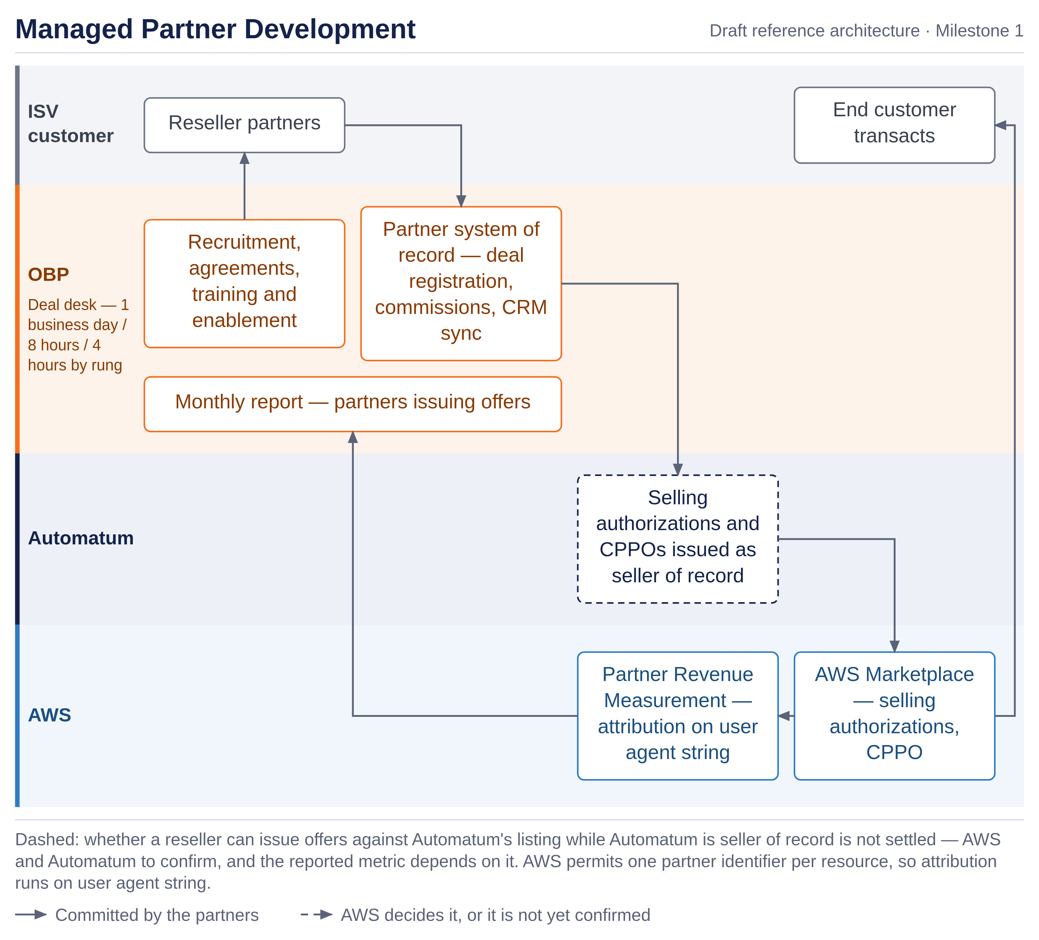
First Customer Targets | [Initial customers involved in solution design, with ACE opportunity links where entered — to supply.]
Findings and recommendations | Both partners recommend proceeding.  Findings: the buyer is the CRO, and the outcome type is top-line — the customers and revenue an ISV targets from a reseller channel. The ramp to a first partner transaction is eight months, which sets the term, and the reported metric sits in a system of record where a customer can audit it. The material risk is a mechanism question: the outcome model depends on a third-party reseller being able to issue offers against Automatum's listing while Automatum is seller of record. Confirm before build.  Open before build: the reseller offer-issuance mechanism, and ownership of the partner agreements and the channel record at end of term or on non-renewal.

Solution Team Structure
Which Partner is the first line of support? How does the support model work? | OBP is first line of support for the channel, the deal desk and the partner system of record, through a named channel manager with a named backup. Automatum is first line for the listing, offer issuance and selling authorizations. Recruited partners are supported by OBP; the ISV's own customers remain the ISV's.
Who generated opportunities for the solution? If multiple, describe how the partners work together? | Both partners source, and AWS sources through ACE, where five opportunity submissions are committed for this solution — each one covering an engagement of Managed Partner Development the partners are pursuing. An opportunity is registered against this Solution ID. Deals the ISV's channel sources are filed to AWS co-sell by OBP as the ISV's own opportunities.
Have the partners determine if they can work together commercially? | Not yet. The commercial terms between the partners cover the revenue split on each line, the flow of funds and payment trigger, Marketplace fee treatment and milestone apportionment.

Next steps: Submit Feasibility study here.

AWS Feedback
Additional input and recommendations from AWS teams | [leave blank in submission. AWS feedback to be included with any feedback or additional steps required.]

We define a Business Outcome Solution as one that impacts a customer’s top or bottom line.

