Early Fixation of the Vertically Unstable Pelvis: The Role of Iliosacral Screw Fixation of the Posterior Lesion
- J. F. Keating
- J. Werier
- P. Blachut
- H. Broekhuyse
- R. N. Meek
- P. J. O'Brien
Authors and Affiliations
Journal of Orthopaedic Trauma 13(2):p 107-113, February 1999.
Abstract
Objectives:
To evaluate the effectiveness of the use of iliosacral screw fixation in the management of the vertically unstable pelvis.
Study Design:
Retrospective analysis with clinical follow-up of patients to assess functional outcome.
Methods:
Thirty-eight vertically unstable pelvic fractures were treated using iliosacral screw fixation. Anterior fixation was by means of plating in sixteen pelves and by external fixation in fifteen pelves. Four pelves had no anterior fixation. Complications were recorded and radiographs were analyzed to classify fractures and identify screw misplacement and malunion. Twenty-six patients had a functional evaluation.
Results:
Five patients (13 percent) suffered a pulmonary embolus in the early postoperative period, one of which was fatal, a hospital mortality of 2.6 percent. Screw misplacement occurred in five patients but there were no adverse sequelae. In thirty-four cases with radiographic follow-up, malunion was noted in fifteen cases (44 percent). A lower rate of malunion (36 percent) was noted with internal fixation of the anterior lesion. Of twenty-six patients with long-term follow-up, only four (15 percent) had no pain. Sacroiliac fusion for pain was performed in three patients (11 percent). Twelve patients (46 percent) returned to their pre-injury occupation, six patients (23 percent) changed occupation, and nine patients (30 percent) had not yet returned to work by last follow-up.
Conclusions:
Iliosacral screw fixation is a useful method of fixation in the vertically unstable pelvis but needs to be augmented by rigid anterior fixation to minimize malunion.
Vertically unstable fractures of the pelvis are uncommon, but it is well established that the extensive disruption of the pelvis is associated with high rates of mortality and late morbidity (5,15-17). In recent years efforts have been made to improve the results by a more interventional approach. External fixation has been recommended by some authors, but the ability of a frame to stabilize the posterior lesion is limited and loss of reduction is common (29). There is now increased interest in the use of internal fixation of the posterior disruption (28). There are a variety of methods available, including iliosacral screws, sacral bars, and anterior and posterior plating techniques. Most reported series of pelvic fracture fixation have relatively small numbers and are characterized by high complication rates, with the worst results being associated with vertically unstable fractures (7,18,25). The benefits of fixation remain to be clearly established and the optimal methods of fixation, particularly for sacroiliac dislocations and sacral fractures, are still a source of controversy.
Iliosacral screw fixation has been popularized by Routt (22,23). These screws may be used for both sacroiliac joint dislocations and sacral fractures and can be placed percutaneously if a satisfactory closed reduction can be obtained. The present study reviews the use of this method in the management of the vertically unstable pelvis. The aim of the study was to evaluate the effectiveness of the technique in maintaining reduction and to assess the longer-term functional outcome following these severe injuries.
MATERIALS AND METHODS
Thirty-eight vertically unstable pelvic fractures were treated over a five-year period from March 1988 to June 1993. There were twenty-one males and seventeen females with a mean age of twenty-nine years (range 16 to 59 years). Motor vehicle accidents accounted for twenty-five cases; four of these were pedestrians, four were motor-cyclists, and the remainder were car occupants. Of the remaining thirteen injuries, four were sustained as a result of crushing injuries at work and nine were the result of a fall from a height. In four patients the pelvis was the only injury; the remaining patients had multiple injuries. The median injury score was 25 (range 16 to 54).
Prior to operative treatment patients were evaluated radiographically with standard anteroposterior, inlet, and outlet views of the pelvis. This was augmented in most cases with a computed tomography scan of the pelvis. The pelvic fractures were classified according to the current AO classification of pelvic disruptions. There were twenty-eight C1, three C2, and seven C3 patterns. Of thirty-one patients with unilateral vertically unstable hemipelves, the posterior lesion was on the right side in fifteen patients and on the left side in sixteen patients. Of the fifteen patients with right-sided lesions there were five sacroiliac dislocations and ten sacral fractures. Of the sixteen patients with left-sided lesions there were nine sacroiliac dislocations and seven sacral fractures. Of the remaining seven cases with type C3 injuries there were two right sacroiliac dislocations and five right sacral fractures; there were also two left sacroiliac dislocations and five left sacral fractures. There were twenty-seven sacral fractures (fifteen right-sided fractures and twelve left-sided fractures) in twenty-three patients (four patients had bilateral fractures). According to the classification proposed by Denis et al. (4), there were five Type I fractures, twenty Type II fractures, and two Type III fractures. Three of the pelvic fractures were open.
Thirteen patients (34 percent) had a preoperative nerve root or lumbosacral plexus lesion. All of these nerve injuries were observed in patients with sacral fractures. Thus, the incidence of nerve injury was 56 percent in this group of twenty-three patients with sacral fractures. All four patients with bilateral sacral fractures had a neurological deficit. In two patients the lesion consisted of pain in an S1 to S3 distribution and impairment of sensation with no significant motor loss. In one of the other two patients there was motor weakness of plantar flexion and knee flexion and a neurogenic bladder. The final patient with bilateral sacral fractures had a burst fracture of L1 with a cauda equina lesion, and the relative contribution of the sacral fractures was difficult to quantify. Nine patients had a unilateral sacral fracture associated with a neurological deficit. In five patients this was characterized by pain and dysthesia in the distribution of the S1 to S3 nerve roots in the absence of significant motor impairment. The remaining four patients had the sensory symptoms but also an associated motor deficit. This consisted of weakness of plantar flexion and knee flexion on the affected side. Two patients also had weakness of dorsiflexion and eversion.
Definitive fixation was performed within twenty-four hours in thirty-two cases. The remaining six patients were initially managed elsewhere and subsequently referred to our unit for definitive management of the pelvic injury. One was treated within forty-eight hours of injury, two within seventy-two hours, and the other three patients were treated within seven days of their injury. Nineteen patients (50 percent) were hypotensive, with a systolic blood pressure of less than 100 millimeters of mercury at the time of presentation to the admitting institution. Eight of these patients had a laparotomy to deal with intraperitoneal sources of blood loss before definitive orthopaedic fixation. Treatment included bowel resection in two cases, repair of liver lacerations in one case, repair of a ruptured diaphragm in two cases, and three splenectomies. One patient had an open bladder repair and concomitant anterior fixation. Thirteen patients who underwent prone fixation had significant injuries elsewhere. These included seven chest injuries with multiple rib fractures, usually accompanied by pulmonary contusion, and seven patients who had intraabdominal injuries. Despite these injuries, it was possible to stabilize the patients hemodynamically to allow fixation of the posterior pelvic injury.
All orthopaedic operative procedures were performed by or under supervision of one of the authors. Iliosacral screw fixation was used in all cases for fixation of the posterior element of the injury. In twenty-two cases an open reduction of the sacroiliac joint or fracture was performed through a posterior longitudinal incision with the patient positioned prone on the operating table. Once reduction of the fracture or dislocation had been performed, screw fixation was carried out under fluoroscopic guidance into the sacral ala or body. In the remaining sixteen cases, closed reduction and percutaneous placement of cannulated screws was performed as described by Routt et al. (22).
A total of eighty-five screws were used. In the thirty-one patients with unilateral vertically unstable hemipelves, one screw alone was used in three cases, two screws in twenty-five cases, and three screws in the remaining three cases (Fig. 1). In seven patients with bilateral vertical instability, one screw on each side was used in one case, and two screws on one side and one on the other was used in two cases; in the remaining four cases two screws on each side were used. In four cases, the screws used were placed into the sacral ala. A further two cases had one screw into the ala and two into the body of S1. In the remaining cases screw fixation was into the body of S1.
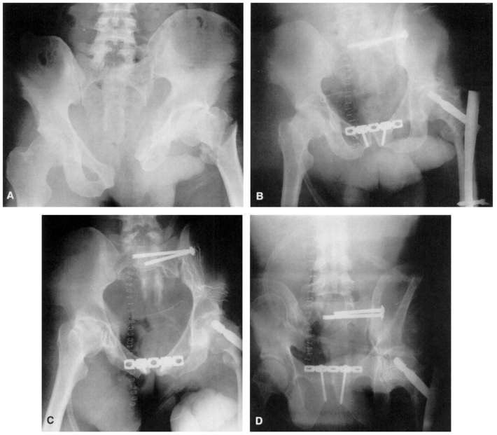
Open multimedia modal

FIG. 1
Open multimedia modal

A: Vertically unstable left hemipelvis with sacroiliac dislocation. Anteroposterior (B), inlet (C), and outlet (D) views showing satisfactory reduction after fixation.
In cases where internal fixation was carried out, the anterior lesion was usually addressed first, because this facilitates closed reduction of the posterior lesion. Where plating was required, it was performed through a Pfannenstiel incision or ilioinguinal approach, using pelvic reconstruction plates. In the present series, external fixation was used in fifteen cases and internal fixation with plating in sixteen cases. In cases where external fixation was used, the iliosacral screws were placed first because the external fixation frame makes imaging of the sacrum more difficult. The external fixation consisted of a simple anterior trapezoidal frame. Seven patients had no fixation of the anterior lesion. In three of these, the posterior lesion was a bilateral sacral fracture that had allowed the pelvic ring to displace in a vertical or posterior direction in relation to the lumbosacral junction. There was no obvious anterior lesion. In the remaining four cases, the anterior lesion consisted of pubic rami fractures that were minimally displaced after fixation of the posterior lesion.
Patients with unilateral lesions were allowed to mobilize weight-bearing on the unaffected side with touch weight-bearing on the affected side. Patients with bilateral lesions were kept non-weight-bearing for a period of at least six weeks. External fixators were removed between six and eight weeks postinjury. After discharge, the authors reviewed patients clinically and radiologically. The mean period of follow-up was nineteen months (range 13 to 48 months). Clinically a neurological assessment was made of lower limb motor and sensory function. The presence of malunion was inferred in the presence of an apparent leg length discrepancy in excess of two centimeters. Inlet-outlet and anteroposterior pelvic views were taken. Reductions with residual displacement in excess of one centimeter in any plane were taken to represent a malunion. Follow-up radiographs to fracture union were available in thirty-four cases.
Initial data regarding clinical results and complications were available for all patients. Patients were asked to return for a follow-up assessment. Of the original thirty-eight patients, one died in the hospital and one died subsequently of unrelated causes. One patient was from Korea and could not be traced. Two patients were in jail and were unable to attend for a follow-up visit. Seven other patients were resident in British Columbia at the time of the accident but could not be traced for follow-up; they had moved and no forwarding address could be found. This left a group of twenty-six patients (58 percent) available for functional assessment. These patients were asked to report persistent pelvic pain. Comparison of occupational and recreational history was made pre- and postinjury. Functional outcome was assessed with the SF-36 disability questionnaire.
RESULTS
Five patients (13 percent) had pulmonary emboli in the early postoperative period, one of which was fatal, a hospital mortality of 2.6 percent. There were no other early deaths. Screw misplacement occurred in five patients (13 percent). Three patients had screws protruding through the anterior aspect of the sacrum. Two patients had screws that protruded into the S1 foramen. This was not detected during fluoroscopic placement and was only apparent on postoperative radiographs. In both cases the screws were repositioned. No new neurological or vascular injuries were observed in spite of these errors.
Of twenty-two patients who had an open reduction of the posterior injury, deep infection occurred in three (14 percent), all of whom had posterior sacroiliac joint dislocations. Two of the patients with deep infection were male; one sustained the injury as a pedestrian and the other as the result of a crushing injury to the pelvis at work. Both had significant soft tissue injury of the posterior pelvis with contusion and some degloving. The third deep infection occurred in a sixteen-year-old girl who was operated on four days after the injury. A closed reduction could not be achieved and open reduction was difficult. All infections required debridement with implantation of antibiotic beads. Infection was controlled in all three. There were no deep infections in cases where screws were inserted percutaneously, and there was no deep infection with anterior internal fixation. Pin tract infections of external fixator pins complicated five of the fifteen cases where frames were used.
In thirty-two patients (84 percent), an anatomic or near anatomic reduction was obtained at the initial operative procedure. In six patients, there was residual displacement in excess of one centimeter at the completion of fixation. Over the course of the following two months, a gradual loss of reduction was noted in a further ten patients (26 percent) (Fig. 2). Radiographs following fracture union were available in thirty-four cases. Fifteen (44 percent) of these were noted to have a malunion. The extent of final malunion varied from 1.4 to 2.3 centimeters (mean 1.7 centimeters). In seven patients with no anterior fixation, malunion occurred in four (57 percent). Three of these cases were patients with minimally displaced public rami fractures following reduction of the posterior lesion; the other patient had a bilateral sacral fracture. Radiographs were available in thirteen cases treated with external fixation; malunion was noted in six (46 percent). In five of these deformity recurred while the frame was still in situ. In the other patient the displacement occurred after a frame in place for eight weeks was removed. Five of sixteen patients (36 percent) in whom the anterior lesion was plated sustained a malunion. In one of these the malunion was due to breakage of a 3.5-millimeter plate and in the remainder was due to loss of posterior fixation. These differences in malunion rates relating to the method of anterior fixation did not achieve statistical significance. Malunion was noted in nine of sixteen (56 percent) sacral fractures and seven of sixteen (43 percent) sacroiliac dislocations, but the difference was not statistically significant. Seven patients (18 percent) had an apparent leg length discrepancy attributable to a pelvic malunion.
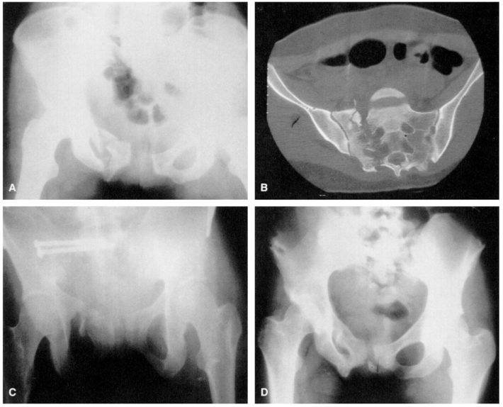
Open multimedia modal

FIG. 2
Open multimedia modal

A, B: Vertically unstable right hemipelvis with transforaminal sacral fracture. C: Outlet view showing an initially satisfactory reduction after application of external fixation and insertion of two iliosacral screws. D: Malunion developed after removal of the fixator at two months, with residual superior translation of the hemipelvis and external rotation deformity.
Of twenty-six patients with long-term follow-up regarding functional outcome, only four (15 percent) had no pain. The remainder had troublesome pain; in three (11 percent) this was severe and disabling. Three patients (11 percent) to date have had sacroiliac joint fusions for debilitating posterior pelvic pain. In one patient, the fusion failed and had to be repeated; this patient still has disabling pain. The other two patients experienced partial relief of symptoms.
Prior to injury, twelve patients were in occupations involving heavy manual labor, six were in semi-skilled or light manual work, five were in sedentary occupations, and three were unemployed. At the time of follow-up, twelve patients (46 percent) had returned to their original occupation. This included seven patients who returned to heavy manual work, two patients who returned to light manual work, and three patients who returned to their sedentary occupation. Six patients (23 percent) had changed their occupation or altered their duties because they were unable to manage their original employment. This included two patients in manual work, two in light manual work, and one in a sedentary position. Nine patients (30 percent) were unable to work and were on long-term disability. This group included three patients who were unemployed at the time of the accident, three patients in heavy manual work, two patients in light manual work, and one patient in a sedentary occupation.
Eight patients (31 percent) had resumed their preinjury level of recreation. Of the other eighteen patients, eight (31 percent) had resumed a more restricted level of activity and ten (38 percent) were unable to take part in any recreational activity. There was no difference in functional outcome between patients with sacral fractures and those with sacroiliac joint dislocations. The results of the SF-36 analysis showed a wide variation in results for the eight categories. The median value for each parameter is given in Table 1. It can be seen that the lowest score occurred for patient perception of social function and vitality. The means for the other parameters were also generally low, although emotional function was least affected.
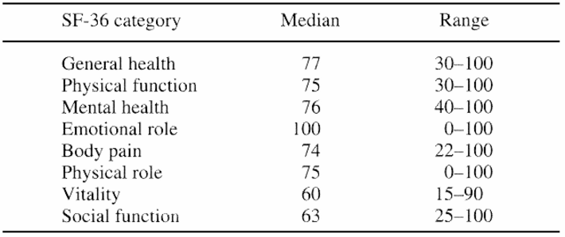
Open multimedia modal

TABLE 1. SF-36 values at the time of final follow-up
Open multimedia modal

Ten patients of this group who had a pelvic malunion had a tendency to a poorer outcome. Among the sixteen patients with no malunion, eight returned to their original occupation (compared with four out of ten with a malunion) and six returned to their original leisure activities (compared with only one of those with a malunion). The numbers were not large enough to achieve statistical significance.
Of thirteen patients who had a neurological lesion, one died; follow-up data were available on only eight of the remaining twelve. Of the eight, three were patients with bilateral sacral fractures. One patient had persistent numbness in a sacral root distribution, and the other two had unilateral motor weakness with weak plantar flexion and knee flexion. One of these patients had a neurogenic bladder with no evidence of recovery. Of the other five patients, three had sensory dysfunction alone that had exhibited incomplete recovery. The remaining two patients had motor weakness of plantar flexion and knee flexion that had persisted without recovery.
DISCUSSION
Unstable pelvic injuries have been associated with high rates of morbidity and mortality (2,3,13,21,27). The results of treating these injuries conservatively have been disappointing. Traction and pelvic slings confine these patients to prolonged recumbence, and the reduction at best is imprecise. In a series comparing operative with nonoperative treatment of unstable pelvic fractures, Latenser et al. (9) found that the hospital stay was 37.8 percent longer in the nonoperative group. The operative group also required less blood transfusion and had no deaths, compared with 16.7 percent mortality in those managed nonoperatively. Burgess et al. (1) reported lowering of overall mortality rates to 8.6 percent with accurate identification of unstable injury patterns and early operative stabilization of the pelvis.
External fixation has been the most common modality of treatment and has many advantages in the management of these injuries. It can be applied relatively quickly in the emergency situation with a percutaneous technique, a particular asset in cases where the patient is hemodynamically unstable. Riemer et al. (20) were able to show a reduction in mortality from 26 percent to 6 percent in the management of pelvic ring injuries following introduction of external fixation. Simple anterior external fixation, however, will not adequately stabilize vertically unstable pelvic fractures (12,27). Loss of reduction has been reported in vertical shear injuries treated with anterior Hoffmann frames (12,29). More complex frames have been tried but are much more difficult to apply and have limited patient acceptability (14).
There has been increasing interest in the role of internal fixation in the management of these injuries. A number of recent reports have suggested that mortality and long-term functional results can be improved by a more interventional operative protocol (6,9,11,28). In many cases the anterior fracture can be stabilized by plating, which is the method of choice in cases where it is technically feasible. The selection of fixation method for the posterior lesion is more controversial.
Sacral bars have the advantage of simplicity and relative safety. They are also versatile and can be used for sacroiliac joint dislocations, for sacral fractures, and in patients with bilateral posterior lesions. However, judging the quality of the reduction is difficult and there is a risk of over-compression with nerve injury when a sacral fracture is present. In addition, the ends of the bars are often prominent and a source of discomfort to the patient (8).
More direct methods of reduction and fixation include techniques of anterior and posterior plating. Anterior fixation plating of a sacroiliac dislocation is a useful technique, and there are plates specifically designed for the purpose (10,19). Simultaneous exposure of the anterior lesion is possible and the quality of reduction is therefore easier to assess. However, access to the sacral side is limited and injury to the L5 nerve root is a definite risk. Anterior plating is not feasible for sacral fractures because the medial access is too limited. Posterior approaches have been advocated, particularly for sacral fractures. Pohlemann et al. (17) have shown biomechanically that local osteosynthesis with specially designed plates is comparable to the fixation achieved with sacral bars. Mears et al. (15) have suggested the use of a double cobra plate to deal with complex bilateral posterior lesions. Published clinical data for these techniques are limited. Some authors have noted a high complication rate in association with posterior pelvic wounds (8,27). The present series reflects this problem, with a deep infection rate of 14 percent complicating cases in which the posterior lesion required an open reduction.
Sacroiliac screw fixation is a well-recognized technique for treating the posterior lesion. There are limited data on its use, particularly for the more unstable patterns of injury. Iliosacral screws may be used for both sacral fractures and sacroiliac joint dislocations. Fixation has most commonly been carried out using an open posterior approach. More recently the use of percutaneous placement with the patient in the supine position has been described (22). This method has particular advantages in the multiply traumatized patient and in patients with hemodynamic instability where it is desired to minimize blood loss. However, an adequate closed reduction must be obtained prior to screw placement.
Some concern has been expressed about the safety of the technique, and with screw misplacement there are undoubtedly significant risks to the cauda equina and the L5 and S1 nerve roots in particular. The need for high-quality fluoroscopic imaging and technical expertise has been emphasized if the technique is to be used safely (22,23). Bony anatomical variations are common in this region, and the importance of the lateral view of the sacrum to show the alar slope is now well recognized (24). The potential for screw misplacement is well illustrated in the present study. Fortunately, the degree of error was small and no vascular or neurological sequelae ensued.
Routt et al. (23) reported on the use of percutaneous iliosacral screws in sixty-eight pelvic fractures, of which forty-three were Type C injuries. Closed reduction of the posterior lesion was possible in fifty-one cases. Malreduction occurred in twelve (18 percent) and failure of fixation in a further three cases. Shuler et al. (26) reported no loss of reduction in fifteen unstable pelvic fractures treated by iliosacral screw fixation. The major complication of the technique in the present series was the high rate of malunion. Although the present series includes a comparatively large number of vertically unstable injuries, the numbers when subdivided with respect to the anterior lesion and the additional fixation employed make firm conclusions difficult to draw. It seems clear, however, that these injuries have a marked tendency to redisplace, a trend that was most notable in fractures where no anterior fixation was employed. In retrospect, some form of anterior fixation would have been advisable in these cases. The use of external fixation reduced the malunion rate further, and the lowest rate was found in patients in whom the anterior pelvis had been plated. Although the numbers studied were not large enough to achieve statistical significance, the trend suggests that more rigid anterior fixation yields superior anatomical results.
As might be expected, the functional outcome following these severe injuries is poor in a high percentage of patients. Late pain in the region of the sacroiliac joint is a well-recognized problem, even in cases where the reduction is satisfactory (12). In the present series many patients had pain at the time of follow-up but it was severe in only 11 percent, an improvement over reports of similar injuries managed nonoperatively. The majority of our patients had also returned to work (69 percent) and some form of leisure activity (62 percent), statistics that are encouraging given the severity of the initial injury.
We believe that early stabilization of the vertically unstable pelvis is worthwhile in terms of reducing early mortality and morbidity and improving long-term functional outcome. Percutaneous iliosacral screws are very useful for dealing with the posterior lesion. However, our results suggest that for optimum anatomic results, rigid internal fixation of the anterior lesion is required.
Acknowledgment: We thank Ms. Carla Haber, research assistant, for her assistance in the preparation of this manuscript.
REFERENCES
- 1. Burgess AR, Eastridge BJ, Young JWR, et al. Pelvic ring disruptions: effective classification system and treatment protocols. J Trauma 1990;30:848-856.
Cited Here
- 2. Cryer HM, Miller FB, Evers BM, et al. Pelvic fracture classification: correlation with haemorrhage. J Trauma 1988;28:973-980.
Cited Here
- 3. Dalal SA, Burgess AR, Siegel JH, et al. Pelvic fracture in multiple trauma: classification by mechanism is key to pattern of organ injury, resuscitative requirements, and outcome. J Trauma 1989;29:981-1000.
Cited Here
View full references list
Keywords:
Pelvic fracture; Vertically unstable pelvis; Iliosacral screw fixation
Image Gallery
Open multimedia modal

FIG. 1
Open multimedia modal

A: Vertically unstable left hemipelvis with sacroiliac dislocation. Anteroposterior (B), inlet (C), and outlet (D) views showing satisfactory reduction after fixation.
Open multimedia modal

FIG. 2
Open multimedia modal

A, B: Vertically unstable right hemipelvis with transforaminal sacral fracture. C: Outlet view showing an initially satisfactory reduction after application of external fixation and insertion of two iliosacral screws. D: Malunion developed after removal of the fixator at two months, with residual superior translation of the hemipelvis and external rotation deformity.

