Week 4 ggplot RMB submission

Kiasa Salgado (A15255422)

October 17th, 2021

library(ggplot2)  
install.packages("ggplot2", repos = "http://cran.us.r-project.org")

##   
## The downloaded binary packages are in  
## /var/folders/x6/5z1hfstd7x3880lk3c9rx8yr0000gn/T//RtmpkwvEO2/downloaded_packages

# 1st geom_point() plot of cars data  
library(ggplot2)  
ggplot(cars) +  
 aes(x=speed, y=dist) +  
 geom_point()

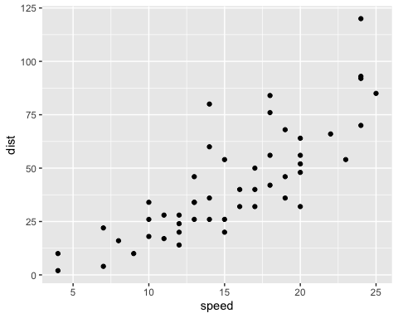

# Full plot attempt for cars  
library(ggplot2)  
ggplot(cars) +   
 aes(x=speed, y=dist) +  
 geom_point() +  
 labs(title="Speed and Stopping Distances of Cars",  
 x="Speed (MPH)",   
 y="Stopping Distance (ft)",  
 subtitle = "vroom",  
 caption="Dataset: 'cars'") +  
 geom_smooth(method="lm", se=FALSE) +  
 theme_bw()

## `geom_smooth()` using formula 'y ~ x'

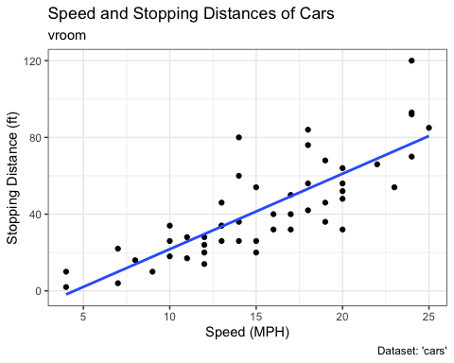

# moving on to data set genes  
url <- "https://bioboot.github.io/bimm143_S20/class-material/up_down_expression.txt"  
genes <- read.delim(url)  
head(genes)

## Gene Condition1 Condition2 State  
## 1 A4GNT -3.6808610 -3.4401355 unchanging  
## 2 AAAS 4.5479580 4.3864126 unchanging  
## 3 AASDH 3.7190695 3.4787276 unchanging  
## 4 AATF 5.0784720 5.0151916 unchanging  
## 5 AATK 0.4711421 0.5598642 unchanging  
## 6 AB015752.4 -3.6808610 -3.5921390 unchanging

p <- ggplot(genes) +   
 aes(x=Condition1, y=Condition2, col=State) +  
 geom_point()  
p + scale_colour_manual(values=c("blue","gray","red")) +  
 labs(title="Gene Expresion Changes Upon Drug Treatment",  
 x="Control (no drug) ",  
 y="Drug Treatment")

