**American International University-Bangladesh**

Amena Akter

Id: 20-42761-1

Data Science(D)

Dataset Sources:

https://www.kaggle.com/search?q=numeric+dataset

**Import Dataset**

mydata<- read.csv("C:/zoo.csv",header = TRUE,sep = ",")

mydata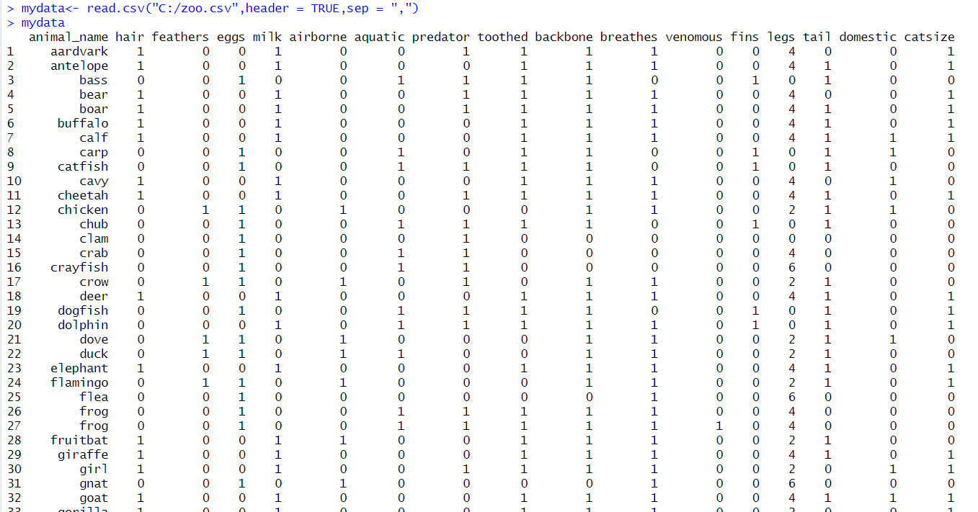

**Find data for attributes**

str(mydata)

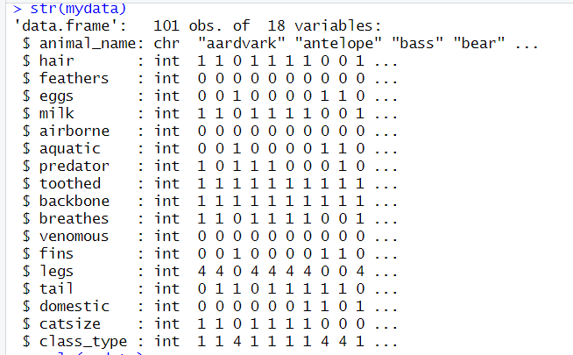

**Removing names from dataset**

mydata_new <- mydata[, -1]

mydata_new

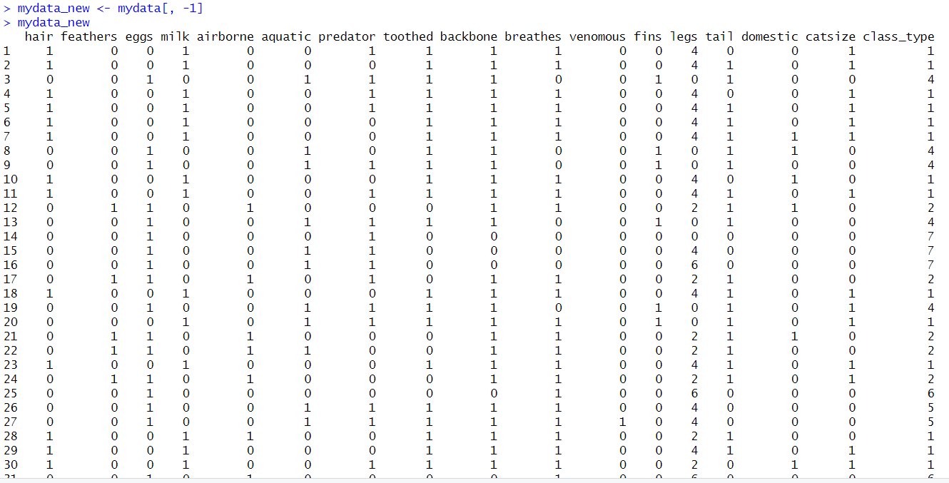

**Scalling Dataset**

scale(mydata_new)

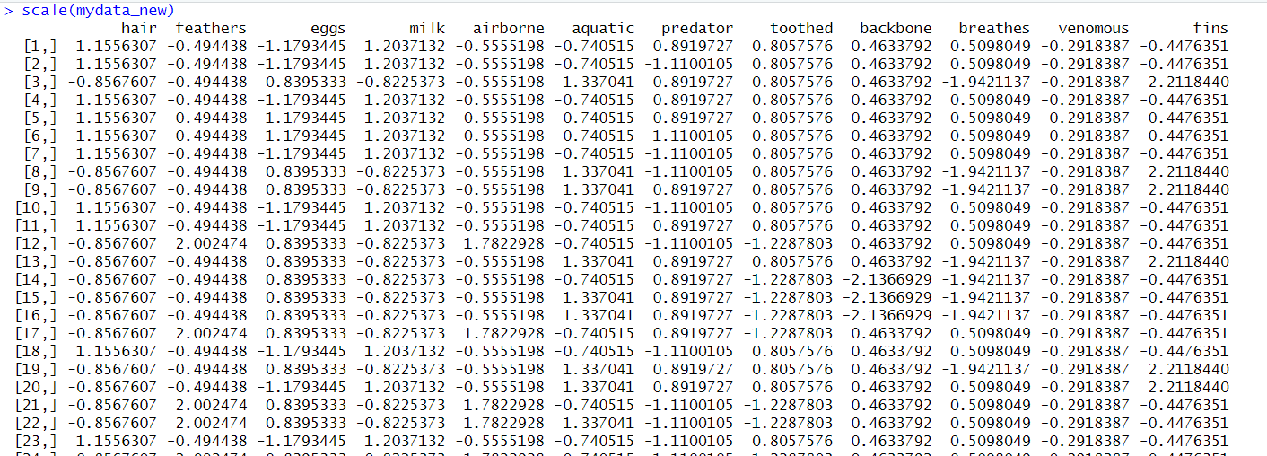

**Finding zero**

colSums(mydata == 0)



**Remove zero**

constant_cols <- which(colSums(mydata == 0) == nrow(mydata))

mydata_new <- mydata[,-constant_cols]

mydata_new

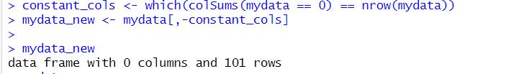

**Install Packages**

install.packages("ClusterR")

install.packages("cluster")

install.packages("factoextra")

**Library Packages**

library("ClusterR")

library("cluster")

library("factoextra")

**Optimal number of Clustering**

fviz_nbclust(mydata_new, kmeans, method = "wss")

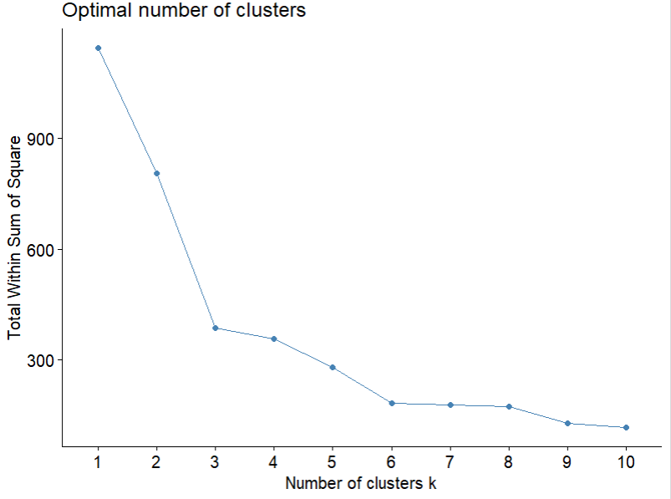

**K-Means Clustering Algorithm Applied**

**K-means Clustering Algorithm**

km <- kmeans(mydata_new, centers = 5, nstart = 25)

km

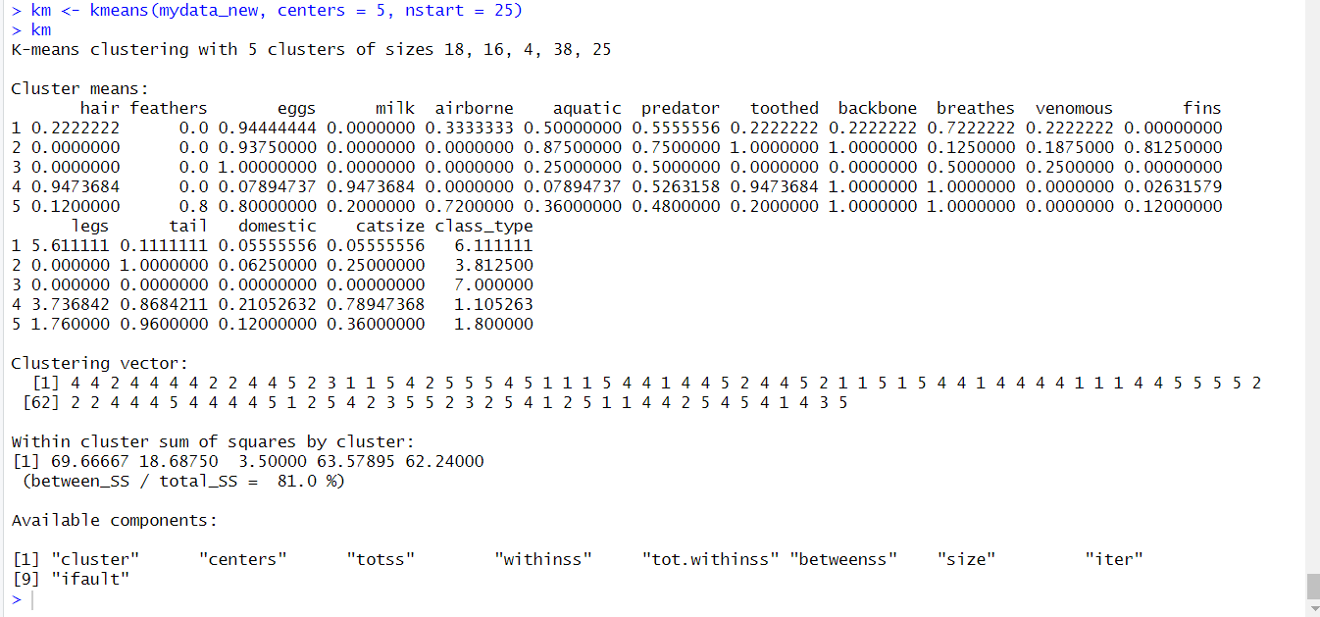

**Hierarchical Clustering**

hc <- hclust(dist(mydata_new))

plot(hc)

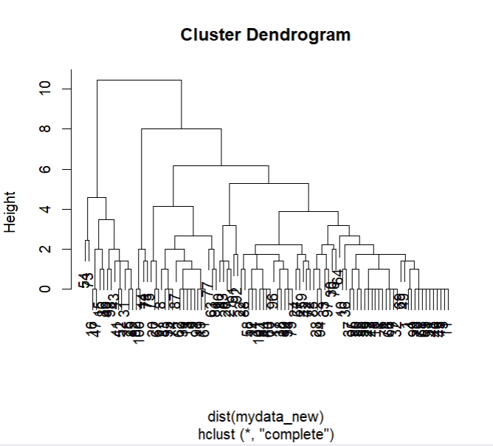

**Clustering Output Visualization**

k_clusters <- cbind(mydata_new, cluster = km$cluster)

k_clusters

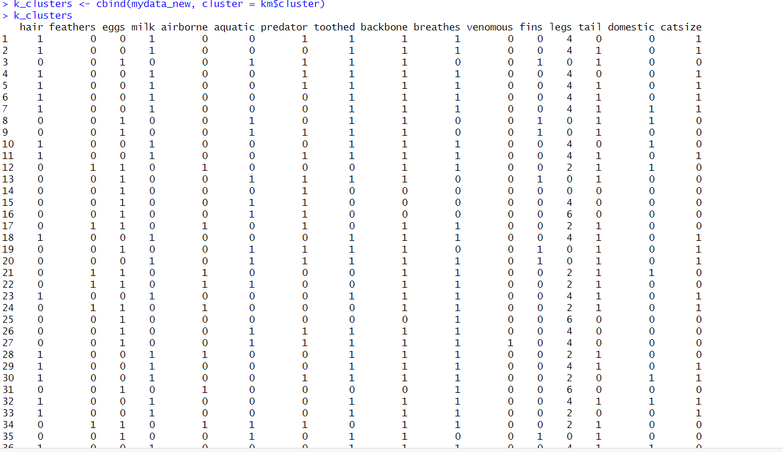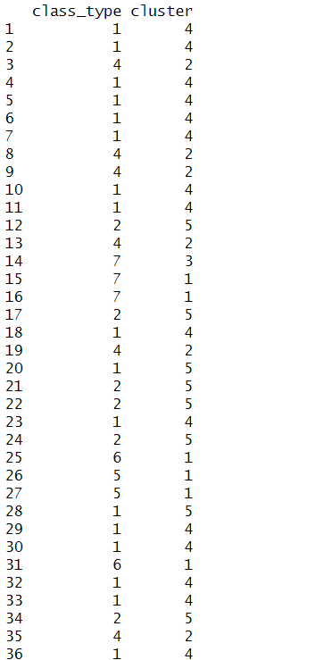

**Visualize clustering Plot output**

fviz_cluster(km, data = mydata_new)

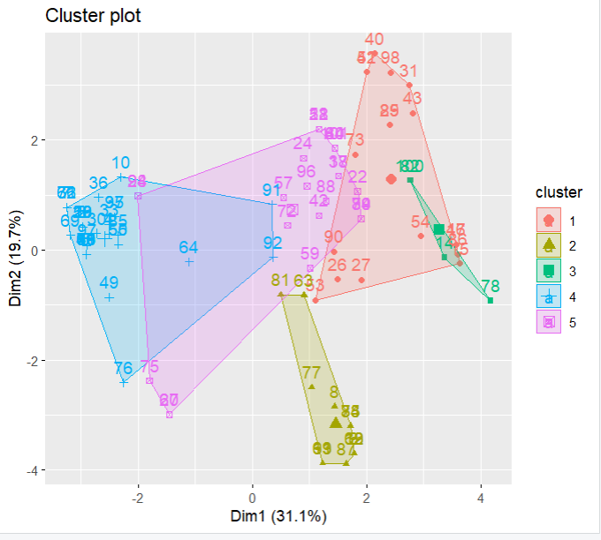

**Find means of each cluster**

aggregate(mydata_new, by=list(cluster=km$cluster), mean)

