FRANK.R

KIBET

2021-02-18

library(tidyverse)

## -- Attaching packages --------------------------------------- tidyverse 1.3.0 --

## v ggplot2 3.3.3 v purrr 0.3.4  
## v tibble 3.0.5 v dplyr 1.0.4  
## v tidyr 1.1.2 v stringr 1.4.0  
## v readr 1.4.0 v forcats 0.5.1

## -- Conflicts ------------------------------------------ tidyverse_conflicts() --  
## x dplyr::filter() masks stats::filter()  
## x dplyr::lag() masks stats::lag()

library(ggpubr)  
library(rstatix)

## Warning: package 'rstatix' was built under R version 4.0.4

##   
## Attaching package: 'rstatix'

## The following object is masked from 'package:stats':  
##   
## filter

library(car)

## Loading required package: carData

##   
## Attaching package: 'car'

## The following object is masked from 'package:dplyr':  
##   
## recode

## The following object is masked from 'package:purrr':  
##   
## some

library(apaTables)  
library(Hmisc)

## Loading required package: lattice

## Loading required package: survival

## Loading required package: Formula

##   
## Attaching package: 'Hmisc'

## The following objects are masked from 'package:dplyr':  
##   
## src, summarize

## The following objects are masked from 'package:base':  
##   
## format.pval, units

# Load the data  
data<-read.csv("C:/Users/KIBET/Desktop/data_handsfree2 (1).csv")  
head(data)

## part_id driving_condition hazzard_rt speed_avg speed_var  
## 1 1 phone 1176.42 102.62 6.10  
## 2 2 phone 1070.41 100.66 7.07  
## 3 3 phone 1058.12 102.61 7.33  
## 4 4 phone 1167.36 102.35 8.00  
## 5 5 phone 1150.50 104.93 7.81  
## 6 6 phone 1131.18 104.37 5.48

# Show a sample of the data by group  
set.seed(123)  
data %>% sample_n_by(hazzard_rt)

## # A tibble: 60 x 5  
## part_id driving_condition hazzard_rt speed_avg speed_var  
## <int> <chr> <dbl> <dbl> <dbl>  
## 1 39 no_phone 800. 99.5 6.23  
## 2 40 no_phone 832. 103. 8.84  
## 3 52 no_phone 845. 96.0 7.38  
## 4 33 no_phone 873. 97.4 7.35  
## 5 60 no_phone 874. 97.0 4.28  
## 6 31 no_phone 889. 93.7 6.41  
## 7 35 no_phone 903. 94.5 5.16  
## 8 44 no_phone 905. 99.8 5.61  
## 9 55 no_phone 905. 95.2 5.98  
## 10 43 no_phone 907. 95.8 8.6   
## # ... with 50 more rows

#summary statistics  
data %>%  
 get_summary_stats(hazzard_rt, type = "mean_sd")

## # A tibble: 1 x 4  
## variable n mean sd  
## * <chr> <dbl> <dbl> <dbl>  
## 1 hazzard_rt 60 1050. 136.

Data <- data[,(3:5),drop=FALSE] # still a data.frame  
 get_summary_stats(Data)

## # A tibble: 3 x 13  
## variable n min max median q1 q3 iqr mad mean sd  
## * <chr> <dbl> <dbl> <dbl> <dbl> <dbl> <dbl> <dbl> <dbl> <dbl> <dbl>  
## 1 hazzard~ 60 800. 1307. 1.04e3 919. 1.18e3 257. 189. 1.05e3 136.   
## 2 speed_a~ 60 92.0 115. 1.01e2 96.8 1.05e2 7.72 5.17 1.01e2 4.96  
## 3 speed_v~ 60 1.95 11.5 6.52e0 5.45 7.77e0 2.33 1.79 6.62e0 1.97  
## # ... with 2 more variables: se <dbl>, ci <dbl>

#Since we assume that the variance are not the same in the two groups we use Welch t-test  
 res <- t.test(hazzard_rt ~ driving_condition,data = data)  
 res

##   
## Welch Two Sample t-test  
##   
## data: hazzard_rt by driving_condition  
## t = -18.943, df = 57.911, p-value < 2.2e-16  
## alternative hypothesis: true difference in means is not equal to 0  
## 95 percent confidence interval:  
## -275.8654 -223.1352  
## sample estimates:  
## mean in group no_phone mean in group phone   
## 925.4993 1174.9997

#Cohens-d for Welch test which gives the effect size  
 data %>% cohens_d(hazzard_rt ~ driving_condition, var.equal = FALSE)

## # A tibble: 1 x 7  
## .y. group1 group2 effsize n1 n2 magnitude  
## * <chr> <chr> <chr> <dbl> <int> <int> <ord>   
## 1 hazzard_rt no_phone phone -4.89 30 30 large

##Data Visualizations  
 # Create a box-plot  
 bxp <- ggboxplot(data, x = "driving_condition", y = "hazzard_rt",   
 ylab = "Hazzard Response time", xlab = "Phone Conversations", add = "jitter")  
 bxp

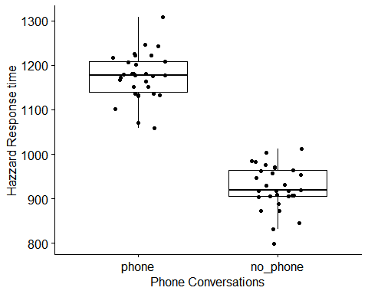

# Pre-registered: comparing average driving speed  
 #LeveneTest  
 # homogeneity of variance for speed  
 driving_speed <- levene_test(speed_avg ~ driving_condition,  
 data = data,  
 center = "median")

## Warning in leveneTest.default(y = y, group = group, ...): group coerced to  
## factor.

print(driving_speed)

## # A tibble: 1 x 4  
## df1 df2 statistic p  
## <int> <int> <dbl> <dbl>  
## 1 1 58 0.172 0.680

# t.test for driving speed  
 driving_t <- t.test(speed_avg ~ driving_condition,  
 data = data,  
 var.equal = TRUE,  
 alternative = "two.sided")  
  
 print(driving_t)

##   
## Two Sample t-test  
##   
## data: speed_avg by driving_condition  
## t = -10.676, df = 58, p-value = 2.596e-15  
## alternative hypothesis: true difference in means is not equal to 0  
## 95 percent confidence interval:  
## -9.500722 -6.500611  
## sample estimates:  
## mean in group no_phone mean in group phone   
## 97.0000 105.0007

#Cohens-d for Welch test which gives the effect size  
 data %>% cohens_d(speed_avg ~ driving_condition, var.equal = FALSE)

## # A tibble: 1 x 7  
## .y. group1 group2 effsize n1 n2 magnitude  
## * <chr> <chr> <chr> <dbl> <int> <int> <ord>   
## 1 speed_avg no_phone phone -2.76 30 30 large

##Data Visualizations  
 # Create a box-plot  
 bxp1 <- ggboxplot(data, x = "driving_condition", y = "speed_avg",   
 ylab = "Average Speed", xlab = "Phone Conversations", add = "jitter")  
 bxp1

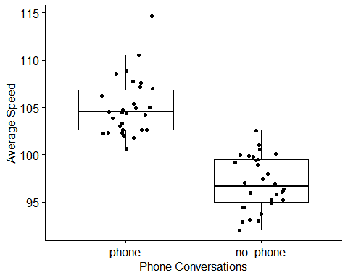

# Pre-registered: comparing speed variability  
 driving_variability <- levene_test(speed_var ~ driving_condition,  
 data = data,  
 center = "median")

## Warning in leveneTest.default(y = y, group = group, ...): group coerced to  
## factor.

print(driving_variability)

## # A tibble: 1 x 4  
## df1 df2 statistic p  
## <int> <int> <dbl> <dbl>  
## 1 1 58 0.194 0.661

# t.test for driving variability  
 variability_t <- t.test(speed_var ~ driving_condition,  
 data = data,  
 var.equal = TRUE,  
 alternative = "two.sided")  
   
 print(variability_t)

##   
## Two Sample t-test  
##   
## data: speed_var by driving_condition  
## t = -1.4858, df = 58, p-value = 0.1428  
## alternative hypothesis: true difference in means is not equal to 0  
## 95 percent confidence interval:  
## -1.7565412 0.2598745  
## sample estimates:  
## mean in group no_phone mean in group phone   
## 6.250667 6.999000

#Cohens-d for Welch test which gives the effect size  
 data %>% cohens_d(speed_var ~ driving_condition, var.equal = FALSE)

## # A tibble: 1 x 7  
## .y. group1 group2 effsize n1 n2 magnitude  
## * <chr> <chr> <chr> <dbl> <int> <int> <ord>   
## 1 speed_var no_phone phone -0.384 30 30 small

##Data Visualizations  
 # Create a box-plot  
 bxp2 <- ggboxplot(data, x = "driving_condition", y = "speed_var",   
 ylab = "Variability in Speed", xlab = "Phone Conversations", add = "jitter")  
 bxp2

