CLUA farmer registration

Victor Kibisu

2022-08-29

### import data

library(kableExtra)  
library(tidyverse)

## ── Attaching packages ─────────────────────────────────────── tidyverse 1.3.2 ──  
## ✔ ggplot2 3.3.6 ✔ purrr 0.3.4  
## ✔ tibble 3.1.7 ✔ dplyr 1.0.9  
## ✔ tidyr 1.2.0 ✔ stringr 1.4.0  
## ✔ readr 2.1.2 ✔ forcats 0.5.1  
## ── Conflicts ────────────────────────────────────────── tidyverse_conflicts() ──  
## ✖ dplyr::filter() masks stats::filter()  
## ✖ dplyr::group_rows() masks kableExtra::group_rows()  
## ✖ dplyr::lag() masks stats::lag()

library(ggthemes)  
library(summarytools)

##   
## Attaching package: 'summarytools'  
##   
## The following object is masked from 'package:tibble':  
##   
## view

library(scales)

##   
## Attaching package: 'scales'  
##   
## The following object is masked from 'package:purrr':  
##   
## discard  
##   
## The following object is masked from 'package:readr':  
##   
## col_factor

reg_form <- read.csv("CLUA_AP_farmer_registration_form.csv")  
reg_details <- read.csv("CLUA_AP_farmer_registration_form-farm_details.csv")

### merge data

## merge the files  
##rename column key  
reg_form <- reg_form %>%  
 rename_at("KEY", ~"PARENT_KEY")  
  
#merge the two datasets using the parent key  
  
CLUA_farmer <- merge(reg_form, reg_details, by="PARENT_KEY")

### Descriptives of the data

df2 <- CLUA_farmer[,64:125]  
#names(df2)  
  
## structure of the data  
#str(df2)

### clean data and run the descriptives

table(df2$group_climatechange.cc_response)

##   
## 1 2 3 4 5 6 7 1 2 3 5 6 7 4 1 2 5 6 7 1 2 6   
## 116 1 3 3 2   
## 1 3 4 5 6 1 3 4 5 6 7 1 3 5 1 3 5 6 1 3 5 6 7   
## 2 3 2 2 2   
## 1 3 5 7 1 4 5 6 1 6 1 6 7 1 6 8   
## 2 4 3 5 2   
## 2 3 2 3 4 2 3 4 6 2 3 5 2 3 5 6   
## 1 1 1 1 1   
## 2 3 5 7 2 3 6 2 4 2 4 3 2 4 6   
## 3 1 2 1 2   
## 2 4 6 5 2 4 7 2 5 2 5 6 2 5 7   
## 1 1 3 9 1   
## 2 6 2 6 7 2 7 2 7 5 3 2 6   
## 5 4 1 2 1   
## 3 4 5 6 7 3 5 3 5 6 3 5 6 7 3 6   
## 2 2 2 11 1   
## 3 6 5 3 6 7 3 7 5 6 4 4 2   
## 1 4 1 10 1   
## 4 2 7 6 4 3 1 4 3 5 6 4 5 4 5 6   
## 1 2 2 11 13   
## 4 5 6 7 4 6 4 6 5 4 6 7 4 7   
## 8 2 2 6 2   
## 5 5 2 5 3 5 4 6 7 5 4 6 7 2   
## 5 5 1 3 2   
## 5 6 5 6 2 5 6 3 4 5 6 7 5 6 7 2   
## 52 2 1 34 1   
## 5 6 7 4 5 7 5 7 2 6 6 3   
## 1 6 7 139 4   
## 6 4 6 5 6 7 6 7 3 6 7 4   
## 3 3 7 1 1   
## 6 7 5 6 7 5 3 6 7 5 4 6 7 8 7   
## 9 1 2 2 9   
## 7 3 2 7 3 6 7 4 7 6 5 7 6 5 4   
## 1 1 2 2 4   
## 8   
## 4

## create a function that splits the data into multiple coplumns  
split_into_multiple <- function(column, pattern = " ", into_prefix){  
 cols <- str_split_fixed(column, pattern, n = Inf)  
 # Sub out the ""'s returned by filling the matrix to the right, with NAs which are useful  
 cols[which(cols == "")] <- NA  
 cols <- as.tibble(cols)  
 # name the 'cols' tibble as 'into_prefix_1', 'into_prefix_2', ..., 'into_prefix_m'   
 # where m = # columns of 'cols'  
 m <- dim(cols)[2]  
   
 names(cols) <- paste(into_prefix, 1:m, sep = "_")  
 return(cols)  
}  
df3 <- df2 %>%   
 bind_cols(split_into_multiple(.$group_climatechange.cc_response, " ", "cc_response"))

## Warning: `as.tibble()` was deprecated in tibble 2.0.0.  
## Please use `as_tibble()` instead.  
## The signature and semantics have changed, see `?as_tibble`.  
## This warning is displayed once every 8 hours.  
## Call `lifecycle::last_lifecycle_warnings()` to see where this warning was generated.

## Warning: The `x` argument of `as_tibble.matrix()` must have unique column names if `.name_repair` is omitted as of tibble 2.0.0.  
## Using compatibility `.name_repair`.  
## This warning is displayed once every 8 hours.  
## Call `lifecycle::last_lifecycle_warnings()` to see where this warning was generated.

df3$cc_response_1 <- as.factor(df3$cc_response_1)  
levels(df3$cc_response_1) <- c("Agroforestry", "Use of Drought tolerant crops", "Rain water harvesting", "Irrigation", "Soil and water conservation", "Application of fertilizers and organic inputs", "Using different cropping systems", "Other")  
  
df3$cc_response_2 <- as.factor(df3$cc_response_2)  
levels(df3$cc_response_2) <- c("Use of Drought tolerant crops", "Rain water harvesting", "Irrigation", "Soil and water conservation", "Application of fertilizers and organic inputs", "Using different cropping systems")  
  
df3$cc_response_3 <- as.factor(df3$cc_response_3)  
levels(df3$cc_response_3) <- c("Agroforestry", "Use of Drought tolerant crops", "Rain water harvesting", "Irrigation", "Soil and water conservation", "Application of fertilizers and organic inputs", "Using different cropping systems", "Other")  
  
df3$cc_response_4 <- as.factor(df3$cc_response_4)  
levels(df3$cc_response_4) <- c("Use of Drought tolerant crops", "Rain water harvesting", "Irrigation", "Soil and water conservation", "Application of fertilizers and organic inputs", "Using different cropping systems")  
  
df3$cc_response_5 <- as.factor(df3$cc_response_5)  
levels(df3$cc_response_5) <- c("Use of Drought tolerant crops","Soil and water conservation", "Application of fertilizers and organic inputs", "Using different cropping systems")  
  
df3$cc_response_6 <- as.factor(df3$cc_response_6)  
levels(df3$cc_response_6) <- c( "Application of fertilizers and organic inputs", "Using different cropping systems")  
  
df3$cc_response_7 <- as.factor(df3$cc_response_7)  
levels(df3$cc_response_7) <- c( "Irrigation","Using different cropping systems")  
  
c_response <- df3 %>% select(c(cc_response_1, cc_response_2, cc_response_3, cc_response_4, cc_response_5, cc_response_6, cc_response_7)) %>% gather(Response, type)

## Warning: attributes are not identical across measure variables;  
## they will be dropped

freq(c_response$type) %>% kbl(caption = "Practices in response to climate change") %>%  
 kable_classic(full_width = F, html_font = "Cambria")

Practices in response to climate change

Freq

% Valid

% Valid Cum.

% Total

% Total Cum.

Agroforestry

38

3.5283194

3.528319

0.9154421

0.9154421

Application of fertilizers and organic inputs

388

36.0259981

39.554318

9.3471453

10.2625873

Irrigation

103

9.5636026

49.117920

2.4813298

12.7439171

Other

8

0.7428041

49.860724

0.1927246

12.9366418

Rain water harvesting

66

6.1281337

55.988858

1.5899783

14.5266201

Soil and water conservation

241

22.3769731

78.365831

5.8058299

20.3324500

Use of Drought tolerant crops

71

6.5923863

84.958217

1.7104312

22.0428812

Using different cropping systems

162

15.0417827

100.000000

3.9026741

25.9455553

<NA>

3074

NA

NA

74.0544447

100.0000000

Total

4151

100.0000000

100.000000

100.0000000

100.0000000

c_response %>%drop_na(type) %>% ggplot(aes(fct_infreq(type)))+  
 geom_bar(aes(y = (..count..)/sum(..count..)), fill = "#79c36a") +  
 geom_text(aes(y = ((..count..)/sum(..count..)), label = scales::percent((..count..)/sum(..count..))), stat = "count", vjust = -0.25) +  
 scale_y_continuous(labels = percent) +  
 labs(title = "Practices used in response to climate\n change",  
 x = "Type of Practice",  
 y = "Frequency")+  
 theme_tufte()+  
 theme(plot.title = element_text(face = "bold", size = 20, hjust = 0.5))+  
 coord_flip()

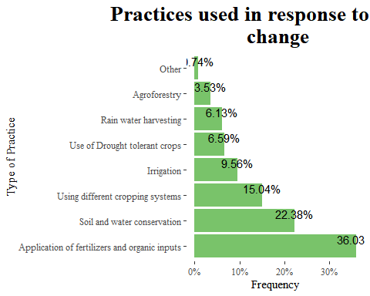 With respect to climate change the following are the practices that were used and the most used practice is application of fertilizers and organic inputs, soil and water conservation and thirdly using different cropping systems.

freq(df3$group_climatechange.cc_response_other)

## Frequencies   
## df3$group_climatechange.cc_response_other   
## Type: Character   
##   
## Freq % Valid % Valid Cum. % Total % Total Cum.  
## ------------------------------------- ------ --------- -------------- --------- --------------  
## (Empty string) 585 98.65 98.65 98.65 98.65  
## By using APCNF methods 4 0.67 99.33 0.67 99.33  
## Good Water management practices 1 0.17 99.49 0.17 99.49  
## He don't know 3 0.51 100.00 0.51 100.00  
## <NA> 0 0.00 100.00  
## Total 593 100.00 100.00 100.00 100.00

Other practices that were considered are APCNF methods and good water management practices.

table(df3$agric_advice.agricultural_advice)

##   
## 0 1   
## 10 583

df3$agric_advice.agricultural_advice <- as.factor(df3$agric_advice.agricultural_advice)  
levels(df3$agric_advice.agricultural_advice) <- c("No", "Yes")  
  
df3 %>% ggplot(aes(agric_advice.agricultural_advice))+  
 geom_bar(fill = "#79c36a", aes(y = (..count..)/sum(..count..)))+  
 geom_text(aes(y = ((..count..)/sum(..count..)), label = scales::percent((..count..)/sum(..count..))), stat = "count", vjust = 1.5, colour = "black")+  
 scale_y_continuous(labels = percent) +  
 labs(title = "Do you recieve agricultural advice",  
 x = "Agricultural advice",  
 y ="Percentage")+  
 theme_tufte()+  
 theme(plot.title = element_text(face = "bold", size = 20, hjust = 0.5))

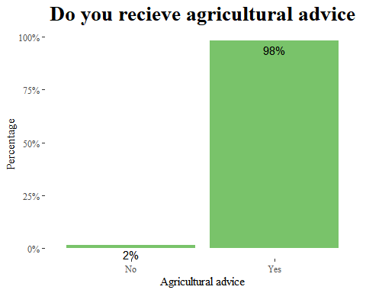

98% of the people receive agricultural advice.

df3 <- df3 %>%   
 bind_cols(split_into_multiple(.$agric_advice.agricultural_advice_source, " ", "agric_source"))  
  
df3$agric_source_1 <- as.factor(df3$agric_source_1)  
levels(df3$agric_source_1) <- c("TV", "Other", "Radio", "Lead farmers or other farmers", "Self help groups", "Government Extension", "Phone", "Internet")  
  
df3$agric_source_2 <- as.factor(df3$agric_source_2)  
levels(df3$agric_source_2) <- c("TV", "Radio", "Lead farmers or other farmers", "Self help groups", "Government Extension","School children/youth", "Written materials", "Phone", "Internet")  
  
df3$agric_source_3 <- as.factor(df3$agric_source_3)  
levels(df3$agric_source_3) <- c("TV","Development agencies", "Radio", "Lead farmers or other farmers", "Self help groups", "Government Extension","School children/youth", "Written materials", "Phone", "Internet")  
  
df3$agric_source_4 <- as.factor(df3$agric_source_4)  
levels(df3$agric_source_4) <- c("TV","Development agencies", "Other", "Lead farmers or other farmers", "Self help groups", "Government Extension","School children/youth", "Written materials", "Phone", "Internet")  
  
df3$agric_source_5 <- as.factor(df3$agric_source_5)  
levels(df3$agric_source_5) <- c("TV","Development agencies", "Radio","Self help groups", "Government Extension","School children/youth", "Written materials", "Phone", "Internet")  
  
df3$agric_source_6 <- as.factor(df3$agric_source_6)  
levels(df3$agric_source_6) <- c("Development agencies", "Other", "Lead farmers or other farmers", "School children/youth", "Written materials", "Phone", "Internet")  
  
df3$agric_source_7 <- as.factor(df3$agric_source_7)  
levels(df3$agric_source_7) <- c("Development agencies", "Other","Phone", "Internet")  
  
df3$agric_source_8 <- as.factor(df3$agric_source_8)  
levels(df3$agric_source_8) <- c("TV", "Development agencies")  
  
  
Agric_source <- df3 %>% select(c(agric_source_1, agric_source_2, agric_source_3, agric_source_4, agric_source_5, agric_source_6, agric_source_7, agric_source_8)) %>% gather(agriculture_source, type)

## Warning: attributes are not identical across measure variables;  
## they will be dropped

freq(Agric_source$type) %>% kbl(caption = "Agricultural advice source") %>%  
 kable_classic(full_width = F, html_font = "Cambria")

Agricultural advice source

Freq

% Valid

% Valid Cum.

% Total

% Total Cum.

Development agencies

182

8.9347079

8.934708

3.8364250

3.836425

Government Extension

351

17.2312224

26.165930

7.3988196

11.235245

Internet

81

3.9764359

30.142366

1.7074199

12.942664

Lead farmers or other farmers

537

26.3622975

56.504664

11.3195616

24.262226

Other

9

0.4418262

56.946490

0.1897133

24.451939

Phone

242

11.8802160

68.826706

5.1011804

29.553120

Radio

29

1.4236622

70.250368

0.6112985

30.164418

School children/youth

34

1.6691213

71.919489

0.7166948

30.881113

Self help groups

52

2.5527737

74.472263

1.0961214

31.977234

TV

418

20.5203731

94.992636

8.8111298

40.788364

Written materials

102

5.0073638

100.000000

2.1500843

42.938449

<NA>

2707

NA

NA

57.0615514

100.000000

Total

4744

100.0000000

100.000000

100.0000000

100.000000

Agric_source %>%drop_na(type) %>% ggplot(aes(fct_infreq(type)))+  
 geom_bar(aes(y = (..count..)/sum(..count..)), fill = "#79c36a") +  
 geom_text(aes(y = ((..count..)/sum(..count..)), label = scales::percent((..count..)/sum(..count..))), stat = "count", vjust = -0.25) +  
 scale_y_continuous(labels = percent) +  
 labs(title = "Sources of agaricultural advice",  
 x = "Source",  
 y = "Frequency")+  
 theme_tufte()+  
 theme(plot.title = element_text(face = "bold", size = 20, hjust = 0.5))+  
 coord_flip()

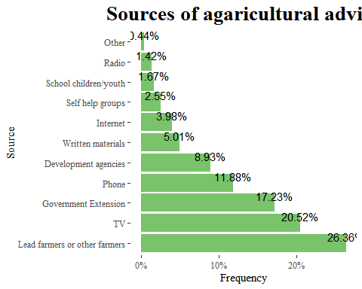 From the 98% who receive the agricultural advice, they do receive it mostly from lead farmers/other farmers, TV, Government extension, phone and development agencies.

table(df3$agric_advice.advice_source_other)

##   
##   
## 584   
## 1. Rhythu Mitra groups \n2. Farmer Producer Organisation \n3. Adivasi Mitra   
## 2   
## APCNF   
## 6   
## Nothing   
## 1

Other sources of advice that they get from is APCNF and farmer organisations.

table(df3$agric_advice.information_source_preferred)

##   
## 1 2 3 4 5 6 7 8 9 10 11   
## 48 5 332 44 70 1 4 46 7 28 8

df3$agric_advice.information_source_preferred <- as.factor(df3$agric_advice.information_source_preferred)  
  
levels(df3$agric_advice.information_source_preferred) <- c("TV", "Radio", "Lead farmers or other farmers", "Self help groups", "Government Extension","School children/youth", "Written materials", "Phone", "Internet", "Development agencies", "Other")  
  
freq(df3$agric_advice.information_source_preferred)

## Frequencies   
## df3$agric_advice.information_source_preferred   
## Type: Factor   
##   
## Freq % Valid % Valid Cum. % Total % Total Cum.  
## ----------------------------------- ------ --------- -------------- --------- --------------  
## TV 48 8.09 8.09 8.09 8.09  
## Radio 5 0.84 8.94 0.84 8.94  
## Lead farmers or other farmers 332 55.99 64.92 55.99 64.92  
## Self help groups 44 7.42 72.34 7.42 72.34  
## Government Extension 70 11.80 84.15 11.80 84.15  
## School children/youth 1 0.17 84.32 0.17 84.32  
## Written materials 4 0.67 84.99 0.67 84.99  
## Phone 46 7.76 92.75 7.76 92.75  
## Internet 7 1.18 93.93 1.18 93.93  
## Development agencies 28 4.72 98.65 4.72 98.65  
## Other 8 1.35 100.00 1.35 100.00  
## <NA> 0 0.00 100.00  
## Total 593 100.00 100.00 100.00 100.00

df3 %>% ggplot(aes(fct_infreq(agric_advice.information_source_preferred)))+  
 geom_bar(aes(y = (..count..)/sum(..count..)), fill = "#79c36a") +  
 geom_text(aes(y = ((..count..)/sum(..count..)), label = scales::percent((..count..)/sum(..count..))), stat = "count", hjust = 0.25) +  
 scale_y_continuous(labels = percent) +  
 labs(title = "Sources of agaricultural advice that is\n preffered",  
 x = "Preffered source",  
 y = "Frequency")+  
 theme_tufte()+  
 theme(plot.title = element_text(face = "bold", size = 20, hjust = 0.5))+  
 coord_flip()

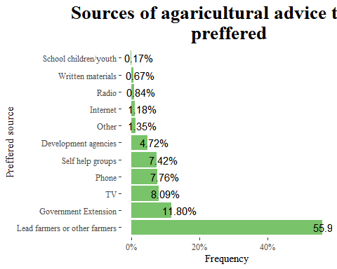

The farmers would prefer advice from lead farmers/other farmers, government extensions, phone and TV. But mostly its from lead farmers that is 59% of the people.

df3$farmer_groups.farmer_group <- as.factor(df3$farmer_groups.farmer_group)  
levels(df3$farmer_groups.farmer_group) <- c("NO", "YES")  
  
freq(df3$farmer_groups.farmer_group)

## Frequencies   
## df3$farmer_groups.farmer_group   
## Type: Factor   
##   
## Freq % Valid % Valid Cum. % Total % Total Cum.  
## ----------- ------ --------- -------------- --------- --------------  
## NO 200 33.73 33.73 33.73 33.73  
## YES 393 66.27 100.00 66.27 100.00  
## <NA> 0 0.00 100.00  
## Total 593 100.00 100.00 100.00 100.00

df3 %>% ggplot(aes(farmer_groups.farmer_group))+  
 geom_bar(fill = "#79c36a", aes(y = (..count..)/sum(..count..)))+  
 geom_text(aes(y = ((..count..)/sum(..count..)), label = scales::percent((..count..)/sum(..count..))), stat = "count", vjust = 1.5, colour = "black")+  
 scale_y_continuous(labels = percent) +  
 labs(title = "Are you a member of any organisation group?",  
 x = "Farmer group",  
 y="Percentage")+  
 theme_tufte()+  
 theme(plot.title = element_text(face = "bold", size = 20, hjust = 0.5))

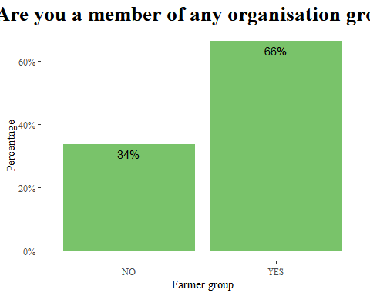

66% of the farmers belong to farmer groups.

df3$farmer_groups.farmer_group_type <- as.factor(df3$farmer_groups.farmer_group_type)  
levels(df3$farmer_groups.farmer_group_type) <- c("Cooperative", "Farmer group", "Women self help group", "Other")  
  
freq(df3$farmer_groups.farmer_group_type)

## Frequencies   
## df3$farmer_groups.farmer_group_type   
## Type: Factor   
##   
## Freq % Valid % Valid Cum. % Total % Total Cum.  
## --------------------------- ------ --------- -------------- --------- --------------  
## Cooperative 105 26.72 26.72 17.71 17.71  
## Farmer group 181 46.06 72.77 30.52 48.23  
## Women self help group 74 18.83 91.60 12.48 60.71  
## Other 33 8.40 100.00 5.56 66.27  
## <NA> 200 33.73 100.00  
## Total 593 100.00 100.00 100.00 100.00

df3 %>%drop_na(farmer_groups.farmer_group_type) %>% ggplot(aes(farmer_groups.farmer_group_type))+  
 geom_bar(fill = "#79c36a", aes(y = (..count..)/sum(..count..)))+  
 geom_text(aes(y = ((..count..)/sum(..count..)), label = scales::percent((..count..)/sum(..count..))), stat = "count", vjust = 1.5, colour = "black")+  
 scale_y_continuous(labels = percent) +  
 labs(title = "The type of farmer group",  
 x = "Farmer group type",  
 y="Percentage")+  
 theme_tufte()+  
 theme(plot.title = element_text(face = "bold", size = 20, hjust = 0.5))

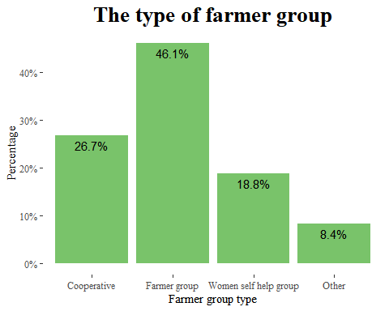

With the different organisation types 46% belonged to farmer groups, 26.7% to cooperatives and 18.8% to women self help groups.

table(df3$farmer_groups.group_type_other)

##   
## APCNF Raithu Baroda kendram   
## 560 3 2   
## Raithu Barosa kendram   
## 28

table(df3$farmer_groups.group_benefits)

##   
## 1 1 2 1 2 3 1 2 3 4 1 2 3 4 7 1 2 3 7 1 2 4   
## 200 1 49 10 2 7 6 12   
## 1 2 4 5 1 2 4 5 7 1 2 4 7 1 2 4 7 5 1 2 5 1 2 5 7 1 2 7 1 2 7 4   
## 2 4 81 4 1 1 10 2   
## 1 3 2 1 4 7 1 5 1 7 4 1 8 2 1 2 4 1 2 5   
## 5 28 46 2 6 3 3 3   
## 5 5 1 5 1 2 8   
## 96 5 1 3

df3 <- df3 %>%   
 bind_cols(split_into_multiple(.$farmer_groups.group_benefits, " ", "group_benefits"))  
df3$group_benefits_1 <- as.factor(df3$group_benefits_1)  
levels(df3$group_benefits_1) <- c("Knowledge & information", "Training", "Credit facilities", "Other")  
  
df3$group_benefits_2 <- as.factor(df3$group_benefits_2)  
levels(df3$group_benefits_2) <- c("Knowledge & information", "Training", "Labour", "Tools and equipment", "Credit facilities","Marketing", "Other")  
  
df3$group_benefits_3 <- as.factor(df3$group_benefits_3)  
levels(df3$group_benefits_3) <- c("Knowledge & information", "Training", "Labour", "Tools and equipment","Credit facilities", "Marketing")  
  
df3$group_benefits_4 <- as.factor(df3$group_benefits_4)  
levels(df3$group_benefits_4) <- c( "Tools and equipment","Credit facilities", "Marketing")  
  
df3$group_benefits_5 <- as.factor(df3$group_benefits_5)  
levels(df3$group_benefits_5) <- c("Credit facilities","Marketing")  
  
g_benefits <- df3 %>% select(c(group_benefits_1, group_benefits_2, group_benefits_3, group_benefits_4, group_benefits_5)) %>% gather(group_benefit, type)

## Warning: attributes are not identical across measure variables;  
## they will be dropped

freq(g_benefits$type) %>% kbl(caption = "Farmer group benefits") %>%  
 kable_classic(full_width = F, html_font = "Cambria")

Farmer group benefits

Freq

% Valid

% Valid Cum.

% Total

% Total Cum.

Credit facilities

163

16.4480323

16.44803

5.4974705

5.497471

Knowledge & information

291

29.3642785

45.81231

9.8145025

15.311973

Labour

30

3.0272452

48.83956

1.0118044

16.323777

Marketing

145

14.6316852

63.47124

4.8903879

21.214165

Other

9

0.9081736

64.37941

0.3035413

21.517707

Tools and equipment

147

14.8335015

79.21292

4.9578415

26.475548

Training

206

20.7870838

100.00000

6.9477234

33.423271

<NA>

1974

NA

NA

66.5767285

100.000000

Total

2965

100.0000000

100.00000

100.0000000

100.000000

p2 <- g_benefits %>%drop_na(type) %>% ggplot(aes(fct_infreq(type)))+  
 geom_bar(aes(y = (..count..)/sum(..count..)), fill = "#79c36a") +  
 geom_text(aes(y = ((..count..)/sum(..count..)), label = scales::percent((..count..)/sum(..count..))), stat = "count", vjust = 0.25) +  
 scale_y_continuous(labels = percent) +  
 labs(title = "Benefits obtained from the farmer groups",  
 x = "Benefit",  
 y = "Frequency")+  
 theme_tufte()+  
 theme(plot.title = element_text(face = "bold", size = 20, hjust = 0.5))  
  
# Rotate and adjust x axis text  
p2 + theme(axis.text.x = element_text(face = "bold", color = "#993333",   
 size = 10,angle = 90, hjust = 1))

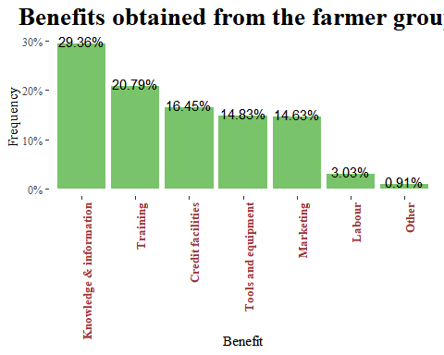

One of the interests was to look at the benefits they get from the groups, the most common was knowledge and information at 29.36%, credit facilities at 16.5% and training at 20.8%. These were the top 3 benefits.

table(df3$farmer_groups.group_benefits_other)

##   
## Exposure visits   
## 478 14   
## Sharing of knowledge\nExposure visits   
## 3

Other types of benefits are exposure visits and sharing of knowledge.

table(df3$observation_comment)

##   
##   
## 151   
## As farmer became older, He is unable to adopt all the new technologies and methods which are used for increasing crop yield   
## 2   
## Farmer following APCNF methods   
## 3   
## Farmer following the organic methods   
## 3   
## Farmer is working as MT in APCNF. He is guiding farmers related agricultural activities   
## 3   
## Fertilizer are available in the cooperative society   
## 3   
## Gollori Padma don't have her own land. She has taken the land for lease   
## 1   
## He has only single farm access.   
## 2   
## He is very old man. His lands are given for the his relatives on good will   
## 1   
## His son Satyanarayana is working as Lecturer in local college in contract base. This is added as secondary income for him   
## 2   
## Household head is in gulf country for work purpose ( the farmers father)   
## 1   
## In chemical plots FYM is applied when it is available for him.   
## 3   
## Nope   
## 2   
## The land has been left fallow for 2 months not 2 years   
## 4   
## This farmer is not following APCNF methods, because he is working in some private agency. He don't have time   
## 3

table(df3$endnote)

## < table of extent 0 >

#table(df3$end)

#table(df3$meta.instanceID)  
  
df3$group_farm.farm_location <- as.factor(df3$group_farm.farm_location)  
levels(df3$group_farm.farm_location) <- c("Home backyard", "Near habitation", "In the forest/tribal area")  
  
freq(df3$group_farm.farm_location)

## Frequencies   
## df3$group_farm.farm_location   
## Type: Factor   
##   
## Freq % Valid % Valid Cum. % Total % Total Cum.  
## ------------------------------- ------ --------- -------------- --------- --------------  
## Home backyard 152 25.72 25.72 25.63 25.63  
## Near habitation 362 61.25 86.97 61.05 86.68  
## In the forest/tribal area 77 13.03 100.00 12.98 99.66  
## <NA> 2 0.34 100.00  
## Total 593 100.00 100.00 100.00 100.00

df3 %>%drop_na(group_farm.farm_location) %>% ggplot(aes(group_farm.farm_location))+  
 geom_bar(fill = "#79c36a", aes(y = (..count..)/sum(..count..)))+  
 geom_text(aes(y = ((..count..)/sum(..count..)), label = scales::percent((..count..)/sum(..count..))), stat = "count", vjust = 1.5, colour = "black")+  
 scale_y_continuous(labels = percent) +  
 labs(title = "Where is the farm located",  
 x = "Farm location",  
 y="Percentage")+  
 theme_tufte()+  
 theme(plot.title = element_text(face = "bold", size = 20, hjust = 0.5))

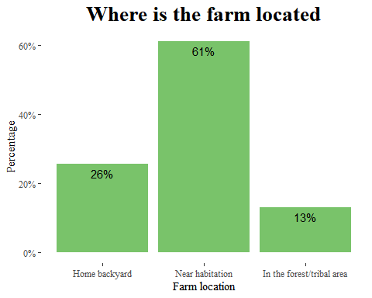

61% of the farms were located near habitations, 26% at the home backyards and 13% in the forest/tribal areas.

summary(df3$group_farm.farm_size)

## Min. 1st Qu. Median Mean 3rd Qu. Max.   
## 0.000 1.000 2.000 3.883 4.000 80.000

df3 %>% ggplot(aes(y =group_farm.farm_size))+  
 geom_boxplot(fill = "coral")+  
 labs(title = "Size of the farm",  
 y = "Farm size")

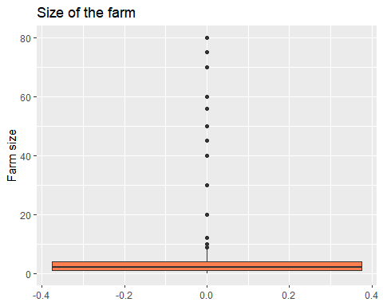

With the size of the farms there is a variation but with outliers with the average being 4.354 and maximum as 80.

df3$group_farm.farm_size_unit <- as.factor(df3$group_farm.farm_size_unit)  
levels(df3$group_farm.farm_size_unit) <- c("Acres", "Hectares", "Other")  
  
freq(df3$group_farm.farm_size_unit)

## Frequencies   
## df3$group_farm.farm_size_unit   
## Type: Factor   
##   
## Freq % Valid % Valid Cum. % Total % Total Cum.  
## -------------- ------ --------- -------------- --------- --------------  
## Acres 571 96.45 96.45 96.29 96.29  
## Hectares 1 0.17 96.62 0.17 96.46  
## Other 20 3.38 100.00 3.37 99.83  
## <NA> 1 0.17 100.00  
## Total 593 100.00 100.00 100.00 100.00

df3 %>% ggplot(aes(group_farm.farm_size_unit))+  
 geom_bar(fill = "coral")+  
 labs(title = "Measurements used",  
 x = "Farm size unit")

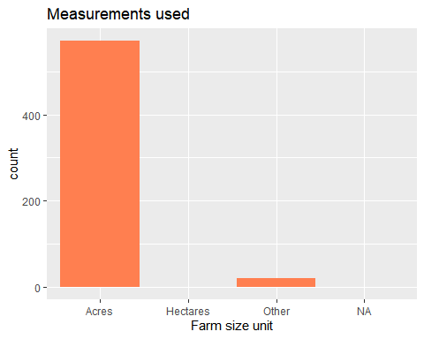

The farm size was measured in acres where only 1 case was in hectares.

table(df3$group_farm.measurement_unit_other)

##   
## Cents   
## 573 20

df3$group_farm.land_ownership <- as.factor(df3$group_farm.land_ownership)  
levels(df3$group_farm.land_ownership) <- c("Private/Purchase", "Private/Inheritance", "Communal", "Tribal area", "Rented", "Other")  
freq(df3$group_farm.land_ownership)

## Frequencies   
## df3$group_farm.land_ownership   
## Type: Factor   
##   
## Freq % Valid % Valid Cum. % Total % Total Cum.  
## ------------------------- ------ --------- -------------- --------- --------------  
## Private/Purchase 60 10.12 10.12 10.12 10.12  
## Private/Inheritance 313 52.78 62.90 52.78 62.90  
## Communal 3 0.51 63.41 0.51 63.41  
## Tribal area 107 18.04 81.45 18.04 81.45  
## Rented 102 17.20 98.65 17.20 98.65  
## Other 8 1.35 100.00 1.35 100.00  
## <NA> 0 0.00 100.00  
## Total 593 100.00 100.00 100.00 100.00

df3 %>%drop_na(group_farm.land_ownership) %>% ggplot(aes(group_farm.land_ownership))+  
 geom_bar(fill = "#79c36a", aes(y = (..count..)/sum(..count..)))+  
 geom_text(aes(y = ((..count..)/sum(..count..)), label = scales::percent((..count..)/sum(..count..))), stat = "count", vjust = 0.5, colour = "black")+  
 scale_y_continuous(labels = percent) +  
 labs(title = "Type of land ownership",  
 x = "Land ownership",  
 y="Percentage")+  
 theme_tufte()+  
 theme(plot.title = element_text(face = "bold", size = 20, hjust = 0.5))

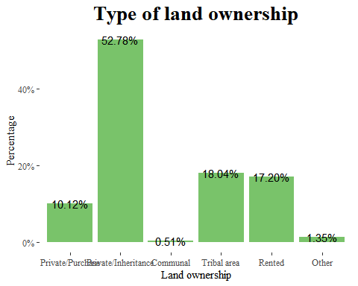

With regard to land ownership most of the land was private through inheritance representing 52.78%, then tribal area 18% then rented at 17.20%.

df3$group_farm.land_ownership_other <- as.factor(df3$group_farm.land_ownership_other)  
levels(df3$group_farm.land_ownership_other) <- c("NA", "Heridity", "NA", "No land", "Own","Own")  
freq(df3$group_farm.land_ownership_other)

## Frequencies   
## df3$group_farm.land_ownership_other   
## Type: Factor   
##   
## Freq % Valid % Valid Cum. % Total % Total Cum.  
## -------------- ------ --------- -------------- --------- --------------  
## NA 586 98.82 98.82 98.82 98.82  
## Heridity 3 0.51 99.33 0.51 99.33  
## No land 1 0.17 99.49 0.17 99.49  
## Own 3 0.51 100.00 0.51 100.00  
## <NA> 0 0.00 100.00  
## Total 593 100.00 100.00 100.00 100.00

df3 %>%filter(group_farm.land_ownership_other !="NA") %>% ggplot(aes(group_farm.land_ownership_other))+  
 geom_bar(fill = "#79c36a", aes(y = (..count..)/sum(..count..)))+  
 geom_text(aes(y = ((..count..)/sum(..count..)), label = scales::percent((..count..)/sum(..count..))), stat = "count", vjust = 0.5, colour = "black")+  
 scale_y_continuous(labels = percent) +  
 labs(title = "Type of land ownership Other",  
 x = "Land ownership other",  
 y="Percentage")+  
 theme_tufte()+  
 theme(plot.title = element_text(face = "bold", size = 20, hjust = 0.5))

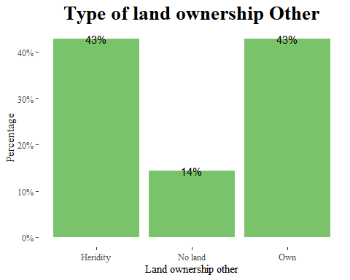

With other land ownership schemes owned and heredity having 43%.

summary(df3$group_farm.cropping_area)

## Min. 1st Qu. Median Mean 3rd Qu. Max.   
## 0.000 1.000 2.000 2.983 5.000 30.000

df3 %>% ggplot(aes(y =group_farm.cropping_area))+  
 geom_boxplot(fill = "coral")+  
 labs(title = "Cropping area",  
 y = "Cropping area")

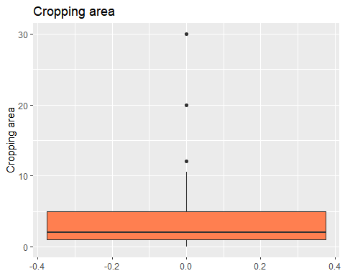

The cropping area had a minimum of 0 and maximum of 30 acres, though some cases were outliers.

table(df3$group_farm.cropping_area_unit)

##   
## 2 4   
## 586 6

df3$group_farm.cropping_area_unit <- as.factor(df3$group_farm.cropping_area_unit)  
levels(df3$group_farm.cropping_area_unit) <- c("Acres", "Other")  
freq(df3$group_farm.cropping_area_unit)

## Frequencies   
## df3$group_farm.cropping_area_unit   
## Type: Factor   
##   
## Freq % Valid % Valid Cum. % Total % Total Cum.  
## ----------- ------ --------- -------------- --------- --------------  
## Acres 586 98.99 98.99 98.82 98.82  
## Other 6 1.01 100.00 1.01 99.83  
## <NA> 1 0.17 100.00  
## Total 593 100.00 100.00 100.00 100.00

df3 %>% ggplot(aes(group_farm.cropping_area_unit))+  
 geom_bar(fill = "coral")+  
 labs(title = "Measurements used",  
 x = "Cropping area unit")

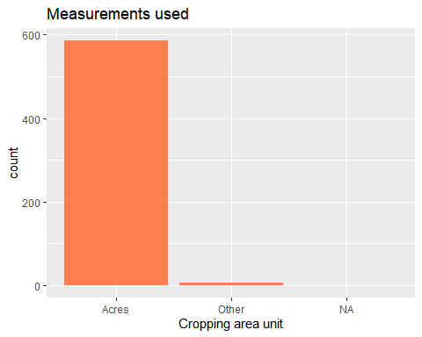 Bigger percentage of the units are in acres that is 99%.

table(df3$group_farm.cropping_area_other)

##   
## Cents No   
## 587 5 1

df3$group_farm.land_use <- as.factor(df3$group_farm.land_use)  
levels(df3$group_farm.land_use) <- c("Agriculture","Agriculture", "Forest land", "Forest land", "Pastureland", "Other")  
freq(df3$group_farm.land_use)

## Frequencies   
## df3$group_farm.land_use   
## Type: Factor   
##   
## Freq % Valid % Valid Cum. % Total % Total Cum.  
## ----------------- ------ --------- -------------- --------- --------------  
## Agriculture 532 89.71 89.71 89.71 89.71  
## Forest land 57 9.61 99.33 9.61 99.33  
## Pastureland 2 0.34 99.66 0.34 99.66  
## Other 2 0.34 100.00 0.34 100.00  
## <NA> 0 0.00 100.00  
## Total 593 100.00 100.00 100.00 100.00

df3 %>% ggplot(aes(group_farm.land_use))+  
 geom_bar(fill = "#79c36a", aes(y = (..count..)/sum(..count..)))+  
 geom_text(aes(y = ((..count..)/sum(..count..)), label = scales::percent((..count..)/sum(..count..))), stat = "count", vjust = 0.5, colour = "black")+  
 scale_y_continuous(labels = percent) +  
 labs(title = "How the land is used",  
 x = "Land use",  
 y="Percentage")+  
 theme_tufte()+  
 theme(plot.title = element_text(face = "bold", size = 20, hjust = 0.5))

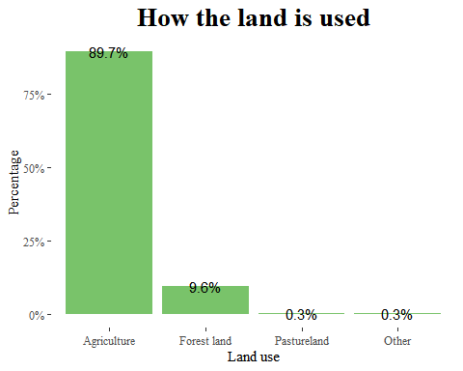 89.7% of the land is used for agriculture and 9.6% is used on forest land while only 0.3% is used as patureland.

table(df3$group_farm.land_use_other)

##   
## Nill No   
## 591 1 1

table(df3$group_soil.soil_quality)

##   
## High Low Medium   
## 5 81 507

df3 %>% ggplot(aes(group_soil.soil_quality))+  
 geom_bar(fill = "#79c36a", aes(y = (..count..)/sum(..count..)))+  
 geom_text(aes(y = ((..count..)/sum(..count..)), label = scales::percent((..count..)/sum(..count..))), stat = "count", vjust = 0.5, colour = "black")+  
 scale_y_continuous(labels = percent) +  
 labs(title = "Soil quility in the farm",  
 x = "Soil quality",  
 y="Percentage")+  
 theme_tufte()+  
 theme(plot.title = element_text(face = "bold", size = 20, hjust = 0.5))

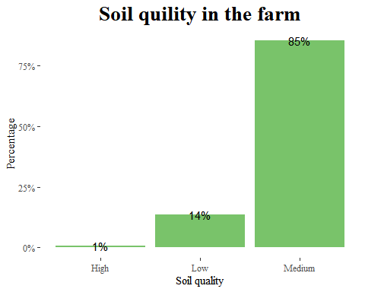 From the table and plot it shows that the soil quality is mostly medium which is 85%.

## string variable  
table(df3$group_soil.soil_quality_indicators)

##   
## 1. Based on soil colour and soil type\n2. Based on crevices present in the field   
## 1   
## 1. Based on the soil colour\n2. Based on the porosity of the soil   
## 1   
## 1. Crevices present in the soil.\n2. Based on the soil colour\n3. Water porosity capacity   
## 1   
## 1.Based on the porosity of the soil\n2. Based on the earthworms and \nearthworm castings present in the field   
## 1   
## Based of water infiltration rate and Earthworms.   
## 1   
## Based on soil colour   
## 1   
## Based on colour and yield   
## 1   
## Based on colour, soil organisms present, yield obtained   
## 1   
## Based on earth worms   
## 1   
## Based on earth worms and while ploughing the land.   
## 1   
## Based on earth worms count   
## 1   
## Based on earthworm castings and earthworms present in the soil   
## 1   
## Based on earthworm castings present in the soil and earthworms present in the soil   
## 1   
## Based on earthworms and earthworms castings present in the field   
## 8   
## Based on earthworms and earthworms castings present in the field and Based on soil colour and porosity capacity of the soil   
## 1   
## Based on earthworms present in the field   
## 1   
## Based on earthworms present in the field and earthworms castings present in the field   
## 2   
## Based on earthworms present in the soil   
## 1   
## Based on earthworms/ organisms present in the soil. If the earthworms are more in number, then the soil fertility is more. \nBased on colour of the soil   
## 1   
## Based on infiltration rate   
## 1   
## Based on presence of earthworm   
## 1   
## Based on presence of earthworms in the soil   
## 1   
## Based on soil by touching   
## 1   
## Based on soil colour   
## 18   
## Based on soil colour ; yield   
## 1   
## Based on soil colour and earthworm castings and earthworms present in the soil   
## 1   
## Based on soil colour and earthworms and earthworm castings present in the soil   
## 2   
## Based on soil colour and earthworms castings present in the soil   
## 1   
## Based on soil colour and earthworms seen in the field   
## 1   
## Based on soil colour and porosity capacity of the soil   
## 12   
## Based on soil colour and porosity of the soil   
## 3   
## Based on soil colour and soil organisms like earthworms present in the soil   
## 1   
## Based on soil colour and soil type   
## 1   
## Based on soil colour and yield   
## 2   
## Based on soil colour and yield obtained   
## 3   
## Based on soil colour and yield obtained from the farmers   
## 1   
## Based on soil colour, based on the yield   
## 1   
## Based on soil colour, yield obtained   
## 1   
## Based on soil colour, yield obtained from the crop   
## 1   
## Based on soil colour. If the soil colour is dark, then it is meant that the soil is healthy   
## 1   
## Based on soil colour; yield obtained   
## 1   
## Based on soil infiltration   
## 1   
## Based on the colour and porosity capacity of the soil   
## 1   
## Based on the colour of soil and earthworm and earthworms castings present in the soil   
## 1   
## Based on the colour of soil and earthworms and earthworm castings present in the soil   
## 5   
## Based on the colour of the soil   
## 19   
## Based on the colour of the soil and earthworms and earthworm castings present in the soil   
## 53   
## Based on the count of earthworms present in the soil   
## 1   
## Based on the count/ visible earthworms present in the field and earthworms castings present in the field   
## 1   
## Based on the earthworms and earthworms castings present in the field   
## 4   
## Based on the earthworms and earthworms castings present in the field.   
## 1   
## Based on the earthworms present in the field   
## 1   
## Based on the earthworms present in the field and earthworms castings present in the field   
## 1   
## Based on the porosity capacity of the soil and colour of the soil   
## 1   
## Based on the porosity of the soil and colour of the soil   
## 1   
## Based on the porosity of the soil and colour of the soil. Crevices present in the soil   
## 1   
## Based on the soil colour and earthworms and earthworm castings present in the soil   
## 1   
## Based on the soil colour and porosity capacity of the soil   
## 2   
## Based on the soil colour and porosity of the soil   
## 1   
## Based on the soil colour, cracks present in the soil   
## 1   
## Based on the soil colour.   
## 1   
## Based on the yield   
## 2   
## Based on the yield and soil colour   
## 1   
## Based on the yield comparing from the previous year yield   
## 1   
## Based on the yield obtained   
## 4   
## Based on the yield obtained from the field   
## 1   
## Based on the yield of the crop   
## 3   
## Based on yield   
## 17   
## Based on yield obtained   
## 7   
## Based on yield obtained from the crop   
## 1   
## Based on yield obtained from the farmers   
## 6   
## Based on yield obtained from the farmers. If the soil is fertile then we will get more yield   
## 1   
## Based on yield obtained from the previous year   
## 2   
## Because of yield   
## 1   
## By following APCNF methods   
## 1   
## By seeing the growth of the crop   
## 1   
## Colour   
## 1   
## Colour, yield   
## 1   
## Comparing yield   
## 1   
## Depending on the yield and use of pmds   
## 1   
## Earthworm and the soil is porous   
## 1   
## Gives good yield   
## 1   
## Growth of the crop   
## 9   
## Growth of the crop is good   
## 1   
## Nill   
## 1   
## No   
## 1   
## Presence of earthworms and through yield   
## 1   
## Soil and texture   
## 1   
## Soil color and growth of the crop   
## 1   
## Soil color and through soil testing   
## 1   
## Soil colour   
## 209   
## Soil colour and based on yield of the crop   
## 1   
## Soil colour and feel   
## 1   
## Soil colour and organisms   
## 1   
## Soil colour and soil testing   
## 1   
## Soil colour and texture   
## 11   
## Soil colour and texture and the soil is healthy   
## 1   
## Soil colour and texture and the soil is porous   
## 1   
## Soil colour and the current structure of soil and through soil testing   
## 1   
## Soil colour variation , earthworm presence   
## 1   
## Soil feel   
## 3   
## Soil feel method   
## 1   
## Soil gets damaged due to the fish pond nearby   
## 1   
## Soil is not that healthy   
## 1   
## Soil is porous   
## 3   
## Soil is porous and healthy   
## 1   
## Soil organisms   
## 9   
## Soil organisms and porosity of soil   
## 1   
## Soil structure ,earthworm count , yield   
## 1   
## Soil testing and earthworms count or biodiversity   
## 1   
## Soil testing and yield comparisons   
## 1   
## Soil testing through   
## 1   
## Soil texture   
## 42   
## Soil texture and color   
## 7   
## Soil texture and colour   
## 3   
## Soil texture and earthworms   
## 1   
## Soil texture and growth of the crop   
## 1   
## Soil texture and prolonged usage of chemicals   
## 3   
## Soil texture and soil organisms   
## 1   
## Soil texture and soil organisms like earthworms   
## 1   
## Soil texture and yield of the crop   
## 1   
## Soil texture but not better than zbnf plot   
## 1   
## Soil texture color and also the growth of the crop   
## 1   
## Through yield   
## 4   
## Through yield and disease attack   
## 1   
## Through yield and soil testing   
## 2   
## Through yield or soil colour   
## 1   
## Through yields and earthworms count   
## 1   
## Through yields and soil testing also the through nutrient deficiency   
## 1   
## Usage of chemicals he can say that the soil is not healthy   
## 1   
## Using chemicals from prolonged time so the quality got degraded   
## 1   
## Visually   
## 4   
## Visually seeing the soil   
## 2   
## Yield   
## 4   
## Yield comparisons   
## 1   
## Yield is good   
## 2   
## Yield, colour   
## 1   
## Yield,soil organisms   
## 1

#### soil types

df3$group_soil.soil_types <- as.factor(df3$group_soil.soil_types)  
levels(df3$group_soil.soil_types) <- c("NO", "YES")  
  
freq(df3$group_soil.soil_types)

## Frequencies   
## df3$group_soil.soil_types   
## Type: Factor   
##   
## Freq % Valid % Valid Cum. % Total % Total Cum.  
## ----------- ------ --------- -------------- --------- --------------  
## NO 544 91.74 91.74 91.74 91.74  
## YES 49 8.26 100.00 8.26 100.00  
## <NA> 0 0.00 100.00  
## Total 593 100.00 100.00 100.00 100.00

df3 %>% ggplot(aes(group_soil.soil_types))+  
 geom_bar(fill = "#79c36a", aes(y = (..count..)/sum(..count..)))+  
 geom_text(aes(y = ((..count..)/sum(..count..)), label = scales::percent((..count..)/sum(..count..))), stat = "count", vjust = 1.5, colour = "black")+  
 scale_y_continuous(labels = percent) +  
 labs(title = "Are there different soil types in\n your farm",  
 x = "Soil types",  
 y="Percentage")+  
 theme_tufte()+  
 theme(plot.title = element_text(face = "bold", size = 20, hjust = 0.5))

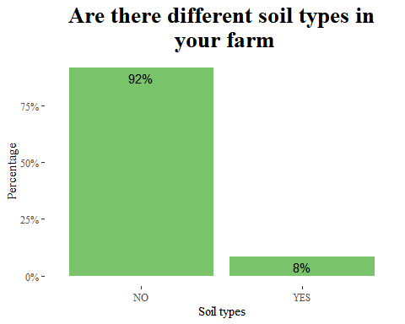

92% of the people said that there were no different types of soil in the farm where only 8% said that there was different soil types on there farms.

freq(df3$group_soil.num_soil_types)

## Frequencies   
## df3$group_soil.num_soil_types   
## Type: Integer   
##   
## Freq % Valid % Valid Cum. % Total % Total Cum.  
## ----------- ------ --------- -------------- --------- --------------  
## 1 4 8.16 8.16 0.67 0.67  
## 2 45 91.84 100.00 7.59 8.26  
## <NA> 544 91.74 100.00  
## Total 593 100.00 100.00 100.00 100.00

Among the 8% of those with different type of soil, 92% said that there was 2 types of the soils while 8% said 1 type.

table(df3$group_soil.soil_types_description)

##   
## Balck and Red soils   
## 544 1   
## Black and red colour Black and red sandy soils   
## 1 4   
## Black and red soils Black and red Soils   
## 7 1   
## Black and Red soils Black and red type soils   
## 1 3   
## Black soil and sandy soil Black soil; sandy soil   
## 1 1   
## Black soils Black soils and red sandy soils   
## 2 1   
## Black soils and Red soils Black soils and sandy soils   
## 2 1   
## Black soils, sandy soil Black soils; red soils   
## 1 2   
## Black soils; Red soils Red soil   
## 5 1   
## Red soils Red soils and black soils   
## 1 6   
## Red Soils and black soils Red; Black soils   
## 1 1   
## Sand and black soil Sand; Black soil   
## 1 1   
## Sand;black soil Sandy soils, black lateral soils   
## 1 1   
## Stone land, sandy   
## 1

df3$group_soil.soil_surface <- as.factor(df3$group_soil.soil_surface)  
levels(df3$group_soil.soil_surface) <- c("Crusted", "Not crusted")  
  
freq(df3$group_soil.soil_surface)

## Frequencies   
## df3$group_soil.soil_surface   
## Type: Factor   
##   
## Freq % Valid % Valid Cum. % Total % Total Cum.  
## ----------------- ------ --------- -------------- --------- --------------  
## Crusted 99 16.69 16.69 16.69 16.69  
## Not crusted 494 83.31 100.00 83.31 100.00  
## <NA> 0 0.00 100.00  
## Total 593 100.00 100.00 100.00 100.00

df3 %>% ggplot(aes(group_soil.soil_surface))+  
 geom_bar(fill = "#79c36a", aes(y = (..count..)/sum(..count..)))+  
 geom_text(aes(y = ((..count..)/sum(..count..)), label = scales::percent((..count..)/sum(..count..))), stat = "count", vjust = 1.5, colour = "black")+  
 scale_y_continuous(labels = percent) +  
 labs(title = "state of soil surface",  
 x = "Soil surface",  
 y="Percentage")+  
 theme_tufte()+  
 theme(plot.title = element_text(face = "bold", size = 20, hjust = 0.5))

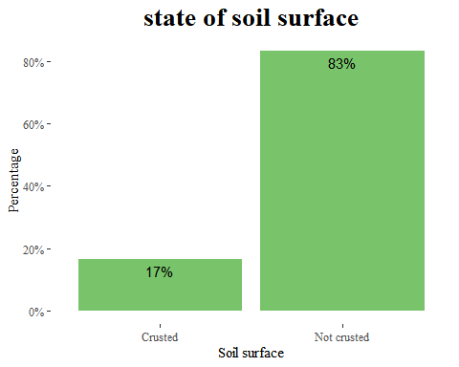

Only 17% of the soil is crusted while 83% is not crusted as in regards to state of the soil surface.

df3$group_soil.rock_gravel <- as.factor(df3$group_soil.rock_gravel)  
levels(df3$group_soil.rock_gravel) <- c("Less than 5", "Between 5-40", "More than 40")  
  
freq(df3$group_soil.rock_gravel)

## Frequencies   
## df3$group_soil.rock_gravel   
## Type: Factor   
##   
## Freq % Valid % Valid Cum. % Total % Total Cum.  
## ------------------ ------ --------- -------------- --------- --------------  
## Less than 5 379 63.91 63.91 63.91 63.91  
## Between 5-40 212 35.75 99.66 35.75 99.66  
## More than 40 2 0.34 100.00 0.34 100.00  
## <NA> 0 0.00 100.00  
## Total 593 100.00 100.00 100.00 100.00

df3 %>% ggplot(aes(group_soil.rock_gravel))+  
 geom_bar(fill = "#79c36a", aes(y = (..count..)/sum(..count..)))+  
 geom_text(aes(y = ((..count..)/sum(..count..)), label = scales::percent((..count..)/sum(..count..))), stat = "count", vjust = 1.5, colour = "black")+  
 scale_y_continuous(labels = percent) +  
 labs(title = "Percentage of your farm has rocks /stone,\n gravel cover ",  
 x = "Rock gravel",  
 y="Percentage")+  
 theme_tufte()+  
 theme(plot.title = element_text(face = "bold", size = 20, hjust = 0.5))

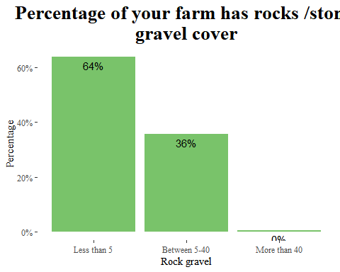

In terms of perecentage of the farms that contains rock gravel we see that farms with less than 5% was 64% while between 5 and 40 was 36%. we only had 2 cases were more than 40%.

df3$group_soil_erosion.erosion_prevalence <- as.factor(df3$group_soil_erosion.erosion_prevalence)  
levels(df3$group_soil_erosion.erosion_prevalence) <- c("NO", "YES")  
  
freq(df3$group_soil_erosion.erosion_prevalence)

## Frequencies   
## df3$group_soil_erosion.erosion_prevalence   
## Type: Factor   
##   
## Freq % Valid % Valid Cum. % Total % Total Cum.  
## ----------- ------ --------- -------------- --------- --------------  
## NO 516 87.02 87.02 87.02 87.02  
## YES 77 12.98 100.00 12.98 100.00  
## <NA> 0 0.00 100.00  
## Total 593 100.00 100.00 100.00 100.00

df3 %>% ggplot(aes(group_soil_erosion.erosion_prevalence))+  
 geom_bar(fill = "#79c36a", aes(y = (..count..)/sum(..count..)))+  
 geom_text(aes(y = ((..count..)/sum(..count..)), label = scales::percent((..count..)/sum(..count..))), stat = "count", vjust = 1.5, colour = "black")+  
 scale_y_continuous(labels = percent) +  
 labs(title = "Do you experience problems of soil erosion",  
 x = "Erosion Prevalence",  
 y="Percentage")+  
 theme_tufte()+  
 theme(plot.title = element_text(face = "bold", size = 20, hjust = 0.5))

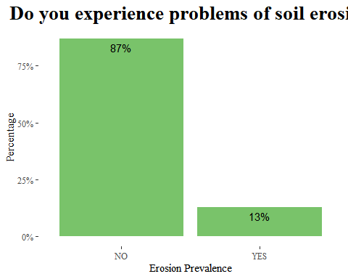

87% of the farmers indicated that they do not experience soil erosion problems.

df3$group_soil_erosion.erosion_type_farm <- as.factor(df3$group_soil_erosion.erosion_type_farm)  
levels(df3$group_soil_erosion.erosion_type_farm) <- c("Gully","Rill", "Sheet")  
  
freq(df3$group_soil_erosion.erosion_type_farm)

## Frequencies   
## df3$group_soil_erosion.erosion_type_farm   
## Type: Factor   
##   
## Freq % Valid % Valid Cum. % Total % Total Cum.  
## ----------- ------ --------- -------------- --------- --------------  
## Gully 56 72.73 72.73 9.44 9.44  
## Rill 20 25.97 98.70 3.37 12.82  
## Sheet 1 1.30 100.00 0.17 12.98  
## <NA> 516 87.02 100.00  
## Total 593 100.00 100.00 100.00 100.00

df3 %>%drop_na(group_soil_erosion.erosion_type_farm) %>% ggplot(aes(group_soil_erosion.erosion_type_farm))+  
 geom_bar(fill = "#79c36a", aes(y = (..count..)/sum(..count..)))+  
 geom_text(aes(y = ((..count..)/sum(..count..)), label = scales::percent((..count..)/sum(..count..))), stat = "count", vjust = 1.5, colour = "black")+  
 scale_y_continuous(labels = percent) +  
 labs(title = "Type of soil erosion in the farm",  
 x = "Erosion type",  
 y="Percentage")+  
 theme_tufte()+  
 theme(plot.title = element_text(face = "bold", size = 20, hjust = 0.5))

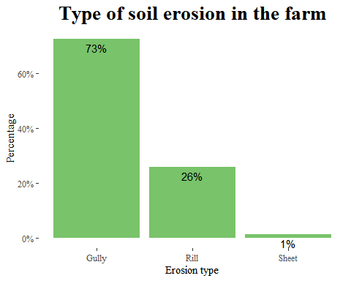

Among the 13% that experience soil erosion problems 73% experience gully erosion, 26% experience rill erosion and 1% face sheet erosion.

table(df3$group_soil_erosion.erosion_control_measures)

##   
## 2 3 3   
## 516 2 75

df3$group_soil_erosion.erosion_control_measures <- as.factor(df3$group_soil_erosion.erosion_control_measures)  
  
levels(df3$group_soil_erosion.erosion_control_measures) <- c(NA, "vegetative", "Structural")  
freq(df3$group_soil_erosion.erosion_control_measures)

## Frequencies   
## df3$group_soil_erosion.erosion_control_measures   
## Type: Factor   
##   
## Freq % Valid % Valid Cum. % Total % Total Cum.  
## ---------------- ------ --------- -------------- --------- --------------  
## vegetative 2 2.60 2.60 0.34 0.34  
## Structural 75 97.40 100.00 12.65 12.98  
## <NA> 516 87.02 100.00  
## Total 593 100.00 100.00 100.00 100.00

df3 %>%drop_na(group_soil_erosion.erosion_control_measures) %>% ggplot(aes(group_soil_erosion.erosion_control_measures))+  
 geom_bar(fill = "#79c36a", aes(y = (..count..)/sum(..count..)))+  
 geom_text(aes(y = ((..count..)/sum(..count..)), label = scales::percent((..count..)/sum(..count..))), stat = "count", vjust = 1.5, colour = "black")+  
 scale_y_continuous(labels = percent) +  
 labs(title = "Measures used to reduce soil erosion",  
 x = "Measures",  
 y="Percentage")+  
 theme_tufte()+  
 theme(plot.title = element_text(face = "bold", size = 20, hjust = 0.5))

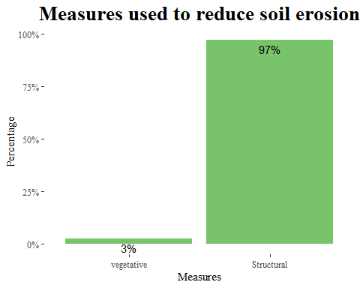

Most used method in reducing the soil erosion is strusctural method which covers 97%.

table(df3$group_soil_erosion.erosion_control_description)

##   
##   
## 591   
## We are arranging bunds with stones   
## 1   
## We used to make channels for storage of water.   
## 1

table(df3$group_crop_production.crop_type)

##   
## 1 1 10 14   
## 3 193 1   
## 1 10 16 14 1 14 1 16   
## 1 6 2   
## 1 2 1 2 10 1 2 10 11 6   
## 19 1 1   
## 1 2 10 14 1 2 14 1 2 14 10 9   
## 3 17 1   
## 1 2 14 15 1 2 14 15 9 10 16 1 2 14 16   
## 1 1 4   
## 1 2 14 6 1 2 14 9 1 2 15 14 16   
## 1 1 1   
## 1 2 5 6 11 1 2 6 14 1 2 6 14 10 16   
## 1 1 1   
## 1 2 7 1 2 9 14 1 2 9 14 10   
## 1 3 1   
## 13 11 16 9 14 14 10   
## 1 10 1   
## 14 16 15 16 16   
## 5 29 202   
## 16 1 16 10 11 16 11 10 8 7 6 5 4   
## 3 1 1   
## 16 11 8 7 10 16 13 6 16 13 6 7 5 4 8 10 11   
## 1 1 1   
## 16 15 16 2 16 7   
## 4 1 11   
## 16 7 11 8 4 16 7 8 10 11 16 8 7 5 4 11 10   
## 1 1 1   
## 2 2 11 10 14 16 2 14   
## 3 1 7   
## 2 14 11 16 2 14 16 2 14 16 11   
## 1 10 1   
## 2 14 5 16 2 16 2 5 11 14   
## 2 5 1   
## 2 5 11 14 16 2 5 14 16 2 5 14 16 11   
## 2 4 1   
## 2 5 16 14 2 5 6 14 16 2 5 6 9 11 13 14 16   
## 1 2 1   
## 2 6 16 2 6 9 10 11 14 16 4 16   
## 1 1 1   
## 4 5 10 11 16 6 16 7 1 16 6 11   
## 1 1 1   
## 7 10 16 8 7 16 7 8 16   
## 1 2 1   
## 8 7 16   
## 1

df3 <- df3 %>%   
 bind_cols(split_into_multiple(.$group_crop_production.crop_type, " ", "Crop_type"))  
df3$Crop_type_1 <- as.factor(df3$Crop_type_1)  
levels(df3$Crop_type_1) <- c("Paddy", "Guord", "Turmeric", "Pepper", "Other", "Finger millet", "Pearl millet", "Brinjal", "Red gram", "Cow peas")  
  
df3$Crop_type_2 <- as.factor(df3$Crop_type_2)  
levels(df3$Crop_type_2) <- c("Paddy","Tubers", "Okra","Guord", "Turmeric","Pepper", "Other","Finger millet", "Maize","Brinjal", "Red gram", "Cow peas")  
  
df3$Crop_type_3 <- as.factor(df3$Crop_type_3)  
levels(df3$Crop_type_3) <- c("Tubers", "Okra", "Guord", "Turmeric", "Pepper", "Other", "Maize", "Brinjal", "Red gram", "Cow peas", "Beans")  
  
df3$Crop_type_4 <- as.factor(df3$Crop_type_4)  
levels(df3$Crop_type_4) <- c("Tubers", "Okra", "Turmeric", "Pepper", "Other", "Maize", "Brinjal", "Red gram", "Cow peas", "Beans")  
  
df3$Crop_type_5 <- as.factor(df3$Crop_type_5)  
levels(df3$Crop_type_5) <- c("Tubers", "Okra", "Other", "Pearl millet", "Maize", "Brinjal", "Red gram", "Beans")  
  
df3$Crop_type_6 <- as.factor(df3$Crop_type_6)  
levels(df3$Crop_type_6) <- c("Tubers", "Okra", "Guord","Turmeric", "Other", "Pearl millet", "Brinjal")  
  
df3$Crop_type_7 <- as.factor(df3$Crop_type_7)  
levels(df3$Crop_type_7) <- c("Tubers", "Turmeric", "Other", "Maize", "Cow peas")  
  
df3$Crop_type_8 <- as.factor(df3$Crop_type_8)  
levels(df3$Crop_type_8) <- c("Tubers", "Other", "Pearl millet")  
  
df3$Crop_type_9 <- as.factor(df3$Crop_type_9)  
levels(df3$Crop_type_9) <- c("Okra")  
  
crop_type <- df3 %>% select(c( Crop_type_1, Crop_type_2, Crop_type_3, Crop_type_4, Crop_type_5, Crop_type_6, Crop_type_7, Crop_type_8,Crop_type_9)) %>% gather(crop_type, type)

## Warning: attributes are not identical across measure variables;  
## they will be dropped

freq(crop_type$type) %>% kbl(caption = "Crop types") %>%  
 kable_classic(full_width = F, html_font = "Cambria")

Crop types

Freq

% Valid

% Valid Cum.

% Total

% Total Cum.

Beans

5

0.5279831

0.5279831

0.0936856

0.0936856

Brinjal

10

1.0559662

1.5839493

0.1873712

0.2810568

Cow peas

12

1.2671595

2.8511088

0.2248454

0.5059022

Finger millet

104

10.9820486

13.8331573

1.9486603

2.4545625

Guord

36

3.8014784

17.6346357

0.6745363

3.1290987

Maize

23

2.4287223

20.0633580

0.4309537

3.5600525

Okra

21

2.2175290

22.2808870

0.3934795

3.9535319

Other

300

31.6789863

53.9598733

5.6211355

9.5746674

Paddy

266

28.0887012

82.0485744

4.9840734

14.5587409

Pearl millet

6

0.6335797

82.6821542

0.1124227

14.6711636

Pepper

54

5.7022175

88.3843717

1.0118044

15.6829680

Red gram

24

2.5343189

90.9186906

0.4496908

16.1326588

Tubers

22

2.3231257

93.2418163

0.4122166

16.5448754

Turmeric

64

6.7581837

100.0000000

1.1991756

17.7440510

<NA>

4390

NA

NA

82.2559490

100.0000000

Total

5337

100.0000000

100.0000000

100.0000000

100.0000000

crop_type %>%drop_na(type) %>% ggplot(aes(fct_infreq(type)))+  
 geom_bar(aes(y = (..count..)/sum(..count..)), fill = "#79c36a") +  
 geom_text(aes(y = ((..count..)/sum(..count..)), label = scales::percent((..count..)/sum(..count..))), stat = "count", vjust = -0.25) +  
 scale_y_continuous(labels = percent) +  
 labs(title = "Crop planted in the farm in the last 12 months",  
 x = "Crop type",  
 y = "Frequency")+  
 theme_tufte()+  
 theme(plot.title = element_text(face = "bold", size = 20, hjust = 0.5),  
 axis.text.x = element_text(face = "bold", color = "#993333",   
 size = 10,angle = 90, hjust = 1))

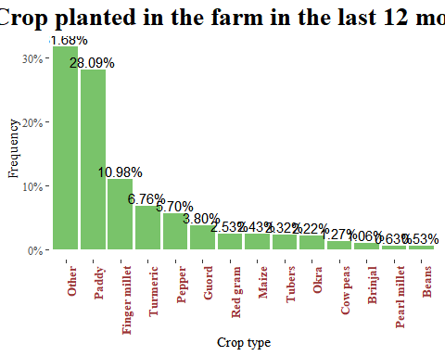

Comparing the crops planted in the farm in the last 12 months we have Paddy as the most common crop planted followed by finger millet, Turmeric and pepper.

library(tidytext)  
other_crop <- df3 %>% select(group_crop_production.crop_type_other)  
tk <- other_crop %>% unnest_tokens(word, group_crop_production.crop_type_other)  
  
# tk %>% anti_join(stop_words) %>%   
# count(word, sort = TRUE) %>% top_n(20)  
  
tk %>% anti_join(stop_words) %>%   
 count(word, sort = TRUE) %>%   
 filter(n > 2) %>%  
 mutate(word = reorder(word, n)) %>%  
 ggplot(aes(n, word)) +  
 geom_col() +  
 labs(y = NULL)

## Joining, by = "word"

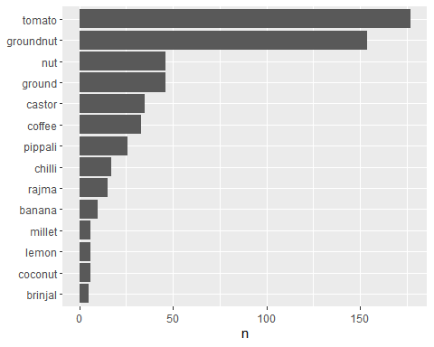

We had other crops that appeared on the crops planted and in this we look at which were this crops and we see that ground nuts were the most planted, followed by tomatoes, then castor and coffee.

df3 <- df3 %>%   
 bind_cols(split_into_multiple(.$group_crop_production.crop_production, " ", "Crop_prod"))  
  
df3$Crop_prod_1 <- as.factor(df3$Crop_prod_1)  
levels(df3$Crop_prod_1) <- c("Low soil fertility", "None", "Other", "Unreliable rainfall", "Drought", "Low soil moisture", "Pests", "Diseases", "High cost of farm inputs")  
  
  
df3$Crop_prod_2 <- as.factor(df3$Crop_prod_2)  
levels(df3$Crop_prod_2) <- c("Low soil fertility", "Other", "Unreliable rainfall", "Drought", "Low soil moisture", "Wrong crop selection", "Pests", "Diseases", "High cost of farm inputs", "Lack of available labour")  
  
df3$Crop_prod_3 <- as.factor(df3$Crop_prod_3)  
levels(df3$Crop_prod_3) <- c("Low soil fertility", "Unreliable rainfall", "Drought", "Low soil moisture","Wrong crop selection", "Pests", "Diseases", "High cost of farm inputs", "Lack of available labour")  
  
  
df3$Crop_prod_4 <- as.factor(df3$Crop_prod_4)  
levels(df3$Crop_prod_4) <- c("Low soil fertility", "Unreliable rainfall", "Drought", "Low soil moisture","Wrong crop selection", "Pests", "Diseases", "High cost of farm inputs", "Lack of available labour")  
  
  
df3$Crop_prod_5 <- as.factor(df3$Crop_prod_5)  
levels(df3$Crop_prod_5) <- c("Low soil fertility", "None", "Unreliable rainfall", "Low soil moisture", "Pests", "Diseases", "High cost of farm inputs", "Lack of available labour")  
  
  
df3$Crop_prod_6 <- as.factor(df3$Crop_prod_6)  
levels(df3$Crop_prod_6) <- c("Low soil fertility", "Drought", "Pests", "Diseases", "High cost of farm inputs", "Lack of available labour")  
  
df3$Crop_prod_7 <- as.factor(df3$Crop_prod_7)  
levels(df3$Crop_prod_7) <- c("High cost of farm inputs", "Lack of available labour")  
  
df3$Crop_prod_8 <- as.factor(df3$Crop_prod_8)  
levels(df3$Crop_prod_8) <- c("Lack of available labour")  
  
crop_prod <- df3 %>% select(c( Crop_prod_1, Crop_prod_2, Crop_prod_3, Crop_prod_4, Crop_prod_5, Crop_prod_6, Crop_prod_7, Crop_prod_8)) %>% gather(crop_prod, type)

## Warning: attributes are not identical across measure variables;  
## they will be dropped

freq(crop_prod$type) %>% kbl(caption = "Crop production") %>%  
 kable_classic(full_width = F, html_font = "Cambria")

Crop production

Freq

% Valid

% Valid Cum.

% Total

% Total Cum.

Diseases

409

20.2274975

20.22750

8.6214165

8.621417

Drought

52

2.5717112

22.79921

1.0961214

9.717538

High cost of farm inputs

309

15.2818991

38.08111

6.5134907

16.231029

Lack of available labour

107

5.2917903

43.37290

2.2554806

18.486509

Low soil fertility

245

12.1167161

55.48961

5.1644182

23.650928

Low soil moisture

119

5.8852621

61.37488

2.5084317

26.159359

None

4

0.1978239

61.57270

0.0843170

26.243676

Other

12

0.5934718

62.16617

0.2529511

26.496627

Pests

428

21.1671612

83.33333

9.0219224

35.518550

Unreliable rainfall

333

16.4688427

99.80218

7.0193929

42.537943

Wrong crop selection

4

0.1978239

100.00000

0.0843170

42.622260

<NA>

2722

NA

NA

57.3777403

100.000000

Total

4744

100.0000000

100.00000

100.0000000

100.000000

crop_prod %>%drop_na(type) %>% ggplot(aes(fct_infreq(type)))+  
 geom_bar(aes(y = (..count..)/sum(..count..)), fill = "#79c36a") +  
 geom_text(aes(y = ((..count..)/sum(..count..)), label = scales::percent((..count..)/sum(..count..))), stat = "count", vjust = 0.25) +  
 scale_y_continuous(labels = percent) +  
 labs(title = "Major factors affecting crop production\n in the farm",  
 x = "Factors",  
 y = "Frequency")+  
 theme_tufte()+  
 theme(plot.title = element_text(face = "bold", size = 20, hjust = 0.5),  
 axis.text.x = element_text(face = "bold", color = "#993333",   
 size = 10,angle = 90, hjust = 1))

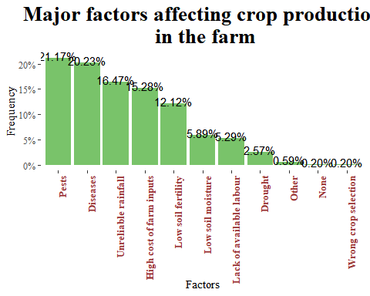 Pests seem to be the major factor affecting crop production on the farm followed by diseases, unreliable rainfall and high cost of farm inputs.

table(df3$group_crop_production.crop_production_other)

##   
##   
## 581   
## Field get flooded as it's in low level compared to the orchids around the farm   
## 1   
## Field gets flooded because it's lower than the other orchids around it   
## 1   
## He never even think of it   
## 2   
## Never even think of it   
## 1   
## Nill   
## 1   
## Strong winds   
## 2   
## Usage of bore water(salt water)   
## 1   
## Water from fish pond is affecting the crop production   
## 1   
## Water is being polluted   
## 1   
## Water is getting mixed up with the water of fish ponds which is affecting the crop production   
## 1

table(df3$group_crop_production.crop_productivity_enhance)

##   
## 1 1 2 1 2 4 1 2 5 1 2 6 1 4 1 5 1 5 2 2 2 1   
## 29 121 6 58 2 10 3 1 26 42   
## 2 1 4 2 1 5 2 1 6 2 3 2 3 1 2 3 1 5 2 3 4 2 3 4 5 2 3 5 2 3 5 4   
## 3 11 1 43 1 1 11 21 12 2   
## 2 4 2 4 5 3 2 5 2 5 1 2 5 6 2 6 2 6 5 3 3 2 3 2 4   
## 8 1 9 1 1 26 1 59 2 1   
## 3 4 3 4 5 3 4 5 6 3 5 3 5 4 3 6 4 4 3 5 6 4 5 4 5 6   
## 4 16 20 3 2 11 1 1 3 1   
## 5 5 2 5 2 1 5 2 3 1 5 4 6 6 2   
## 5 1 1 1 1 5 4

df3 <- df3 %>%   
 bind_cols(split_into_multiple(.$group_crop_production.crop_productivity_enhance, " ", "Crop_prod_enhance"))  
  
df3$Crop_prod_enhance_1 <- as.factor(df3$Crop_prod_enhance_1)  
levels(df3$Crop_prod_enhance_1) <- c("Chemical fertilizers", "Farmyard manure", "Compost", "Use of improved varieties", "Local varieties suited to the area", "Other")  
  
df3$Crop_prod_enhance_2 <- as.factor(df3$Crop_prod_enhance_2)  
levels(df3$Crop_prod_enhance_2) <- c("Chemical fertilizers", "Farmyard manure", "Compost", "Use of improved varieties", "Local varieties suited to the area", "Other")  
  
df3$Crop_prod_enhance_3 <- as.factor(df3$Crop_prod_enhance_3)  
levels(df3$Crop_prod_enhance_3) <- c("Chemical fertilizers", "Farmyard manure", "Compost", "Use of improved varieties", "Local varieties suited to the area", "Other")  
  
  
df3$Crop_prod_enhance_4 <- as.factor(df3$Crop_prod_enhance_4)  
levels(df3$Crop_prod_enhance_4) <- c("Chemical fertilizers","Compost", "Use of improved crop varieties", "Local varieties suited to the area", "Other")  
  
enhance <- df3 %>% select(Crop_prod_enhance_1, Crop_prod_enhance_2, Crop_prod_enhance_3, Crop_prod_enhance_4) %>% gather(crop_enhance, type)

## Warning: attributes are not identical across measure variables;  
## they will be dropped

freq(enhance$type) %>% kbl(caption = "Crop production enhance") %>%  
 kable_classic(full_width = F, html_font = "Cambria")

Crop production enhance

Freq

% Valid

% Valid Cum.

% Total

% Total Cum.

Chemical fertilizers

292

22.723735

22.72374

12.310287

12.31029

Compost

212

16.498054

39.22179

8.937605

21.24789

Farmyard manure

419

32.607004

71.82879

17.664418

38.91231

Local varieties suited to the area

177

13.774319

85.60311

7.462057

46.37437

Other

73

5.680934

91.28405

3.077572

49.45194

Use of improved crop varieties

2

0.155642

91.43969

0.084317

49.53626

Use of improved varieties

110

8.560311

100.00000

4.637437

54.17369

<NA>

1087

NA

NA

45.826307

100.00000

Total

2372

100.000000

100.00000

100.000000

100.00000

enhance %>%drop_na(type) %>% ggplot(aes(fct_infreq(type)))+  
 geom_bar(aes(y = (..count..)/sum(..count..)), fill = "#79c36a") +  
 geom_text(aes(y = ((..count..)/sum(..count..)), label = scales::percent((..count..)/sum(..count..))), stat = "count", vjust = 0.25) +  
 scale_y_continuous(labels = percent) +  
 labs(title = "How do you enhance crop productivity\n in the farm",  
 x = "Crop enhance",  
 y = "Frequency")+  
 theme_tufte()+  
 theme(plot.title = element_text(face = "bold", size = 20, hjust = 0.5),  
 axis.text.x = element_text(face = "bold", color = "#993333",   
 size = 10,angle = 90, hjust = 1))

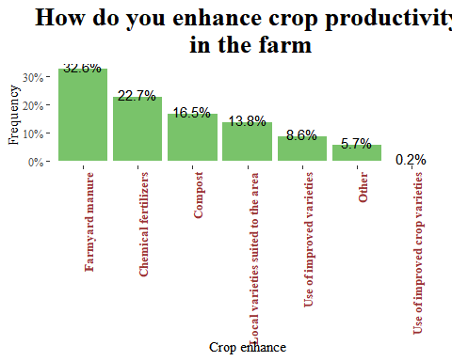 The crop productivity in the farms are highly enhanced by the following methods farmyard manure, chemical fertilizers, compost and local crop varieties suited for the area.

other_crop_prod <- df3 %>% select(group_crop_production.crop_productivity_other)  
tk1 <- other_crop_prod %>% unnest_tokens(word, group_crop_production.crop_productivity_other)  
  
tk1 %>% anti_join(stop_words) %>%   
 count(word, sort = TRUE)

## Joining, by = "word"

## word n  
## 1 ghanajeevanrutam 34  
## 2 jeevamrutam 34  
## 3 apcnf 28  
## 4 methods 27  
## 5 rainy 7  
## 6 season 7  
## 7 applying 5  
## 8 jeevamrutham 5  
## 9 jeevamruths 2  
## 10 neemastram 2  
## 11 application 1  
## 12 crop 1  
## 13 dravajeevamruth 1  
## 14 dravajeevamrutham 1  
## 15 ghanajeevamruth 1  
## 16 nill 1  
## 17 practices 1  
## 18 proposed 1  
## 19 providing 1  
## 20 timely 1  
## 21 zbnf 1

tk1 %>% anti_join(stop_words) %>%   
 count(word, sort = TRUE) %>%   
 filter(n > 2) %>%  
 mutate(word = reorder(word, n)) %>%  
 ggplot(aes(n, word)) +  
 geom_col() +  
 labs(y = NULL)

## Joining, by = "word"

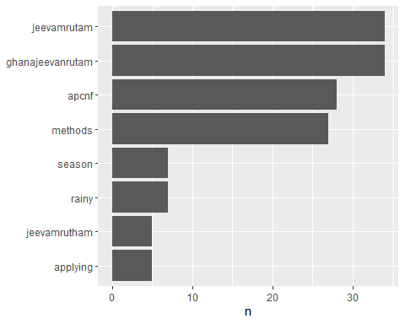 Other methods used for enhancing the crop productivity are jeevamrutam, gvm and APCNF methods.

df3$farm_management.crop_rotation <- as.factor(df3$farm_management.crop_rotation)  
levels(df3$farm_management.crop_rotation) <- c("NO", "YES")  
  
freq(df3$farm_management.crop_rotation)

## Frequencies   
## df3$farm_management.crop_rotation   
## Type: Factor   
##   
## Freq % Valid % Valid Cum. % Total % Total Cum.  
## ----------- ------ --------- -------------- --------- --------------  
## NO 255 43.00 43.00 43.00 43.00  
## YES 338 57.00 100.00 57.00 100.00  
## <NA> 0 0.00 100.00  
## Total 593 100.00 100.00 100.00 100.00

df3 %>%drop_na(farm_management.crop_rotation) %>% ggplot(aes(farm_management.crop_rotation))+  
 geom_bar(fill = "#79c36a", aes(y = (..count..)/sum(..count..)))+  
 geom_text(aes(y = ((..count..)/sum(..count..)), label = scales::percent((..count..)/sum(..count..))), stat = "count", vjust = 1.5, colour = "black")+  
 scale_y_continuous(labels = percent) +  
 labs(title = "Do you practice crop rotation on your farm",  
 x = "Crop rotation",  
 y="Percentage")+  
 theme_tufte()+  
 theme(plot.title = element_text(face = "bold", size = 20, hjust = 0.5))

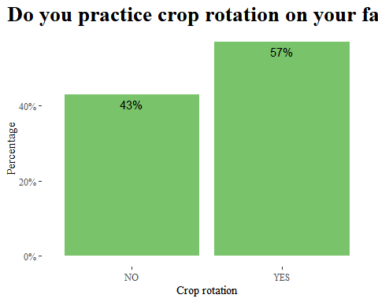 57% of the farmers practice crop rotation on their farms.

table(df3$farm_management.fallowing)

##   
## 0 1   
## 446 147

df3$farm_management.fallowing <- as.factor(df3$farm_management.fallowing)  
levels(df3$farm_management.fallowing) <- c("NO", "YES")  
  
freq(df3$farm_management.fallowing)

## Frequencies   
## df3$farm_management.fallowing   
## Type: Factor   
##   
## Freq % Valid % Valid Cum. % Total % Total Cum.  
## ----------- ------ --------- -------------- --------- --------------  
## NO 446 75.21 75.21 75.21 75.21  
## YES 147 24.79 100.00 24.79 100.00  
## <NA> 0 0.00 100.00  
## Total 593 100.00 100.00 100.00 100.00

df3 %>%drop_na(farm_management.fallowing) %>% ggplot(aes(farm_management.fallowing))+  
 geom_bar(fill = "#79c36a", aes(y = (..count..)/sum(..count..)))+  
 geom_text(aes(y = ((..count..)/sum(..count..)), label = scales::percent((..count..)/sum(..count..))), stat = "count", vjust = 1.5, colour = "black")+  
 scale_y_continuous(labels = percent) +  
 labs(title = "Do you practice fallowing on your farm",  
 x = "Fallowing",  
 y="Percentage")+  
 theme_tufte()+  
 theme(plot.title = element_text(face = "bold", size = 20, hjust = 0.5))

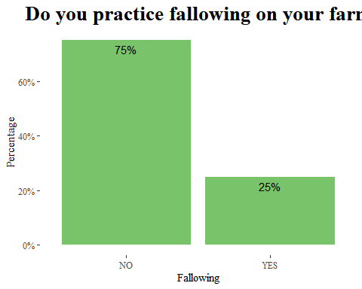

25% of the farmers practice fallowing on the farm.

summary(df3$farm_management.fallow_percent)

## Min. 1st Qu. Median Mean 3rd Qu. Max. NA's   
## 0.10 30.00 50.00 49.88 60.00 100.00 446

df3 %>% ggplot(aes(y = farm_management.fallow_percent))+  
 geom_boxplot(fill = "coral")+  
 labs(y = "Fallow percent",  
 title = "Percent of land left for fallowing")

## Warning: Removed 446 rows containing non-finite values (stat_boxplot).

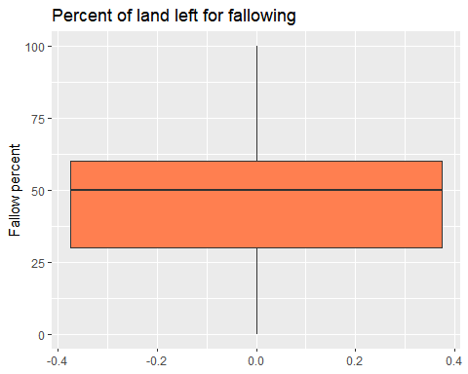

The farm management in terms fallow percent its minimum is 0.1, and maximum is 100 this means that there are those who practice fallowing 100% on there farms.

summary(df3$farm_management.fallow_years)

## Min. 1st Qu. Median Mean 3rd Qu. Max. NA's   
## 0.250 0.500 1.000 1.011 1.000 7.000 446

df3 %>% ggplot(aes(y = farm_management.fallow_years))+  
 geom_boxplot(fill = "coral")+  
 labs(y = "Fallow years",  
 title = "How long the land is left for fallow")

## Warning: Removed 446 rows containing non-finite values (stat_boxplot).

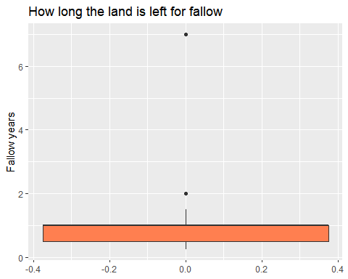

maximum number of years for fallowing is 7 years and minimum is 0.25.

df3$farm_management.burning <- as.factor(df3$farm_management.burning)  
levels(df3$farm_management.burning) <- c("NO", "YES")  
  
freq(df3$farm_management.burning)

## Frequencies   
## df3$farm_management.burning   
## Type: Factor   
##   
## Freq % Valid % Valid Cum. % Total % Total Cum.  
## ----------- ------ --------- -------------- --------- --------------  
## NO 584 98.48 98.48 98.48 98.48  
## YES 9 1.52 100.00 1.52 100.00  
## <NA> 0 0.00 100.00  
## Total 593 100.00 100.00 100.00 100.00

df3 %>%drop_na(farm_management.burning) %>% ggplot(aes(farm_management.burning))+  
 geom_bar(fill = "#79c36a", aes(y = (..count..)/sum(..count..)))+  
 geom_text(aes(y = ((..count..)/sum(..count..)), label = scales::percent((..count..)/sum(..count..))), stat = "count", vjust = 1.5, colour = "black")+  
 scale_y_continuous(labels = percent) +  
 labs(title = "Is the land burnt",  
 x = "Burning",  
 y="Percentage")+  
 theme_tufte()+  
 theme(plot.title = element_text(face = "bold", size = 20, hjust = 0.5))

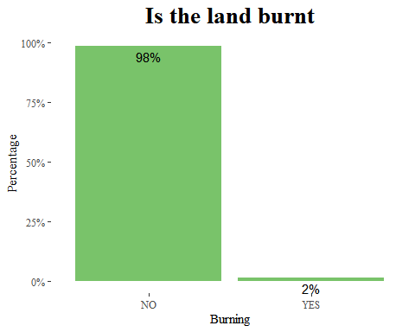 Only 2% of the farmers said that there land is burnt.

df3 <- df3 %>%   
 bind_cols(split_into_multiple(.$farm_management.crop_residue, " ", "Crop_residue"))  
  
df3$Crop_residue_1 <- as.factor(df3$Crop_residue_1)  
levels(df3$Crop_residue_1) <- c("Burnt", "Left in the field", "Used as mulch", "Used as fodder", "Other")  
  
df3$Crop_residue_2 <- as.factor(df3$Crop_residue_2)  
levels(df3$Crop_residue_2) <- c("Left in the field", "Used as mulch", "Used as fodder", "Other")  
  
df3$Crop_residue_3 <- as.factor(df3$Crop_residue_3)  
levels(df3$Crop_residue_3) <- c("Burnt", "Other")  
  
crop_residue <- df3 %>% select(Crop_residue_1, Crop_residue_2, Crop_residue_3) %>% gather(crop_residue, type)

## Warning: attributes are not identical across measure variables;  
## they will be dropped

freq(crop_residue$type) %>% kbl(caption = "Crop residue") %>%  
 kable_classic(full_width = F, html_font = "Cambria")

Crop residue

Freq

% Valid

% Valid Cum.

% Total

% Total Cum.

Burnt

7

1.047904

1.047904

0.3934795

0.3934795

Left in the field

292

43.712575

44.760479

16.4137156

16.8071951

Other

96

14.371258

59.131737

5.3962901

22.2034851

Used as fodder

226

33.832335

92.964072

12.7037662

34.9072513

Used as mulch

47

7.035928

100.000000

2.6419337

37.5491849

<NA>

1111

NA

NA

62.4508151

100.0000000

Total

1779

100.000000

100.000000

100.0000000

100.0000000

crop_residue %>%drop_na(type) %>% ggplot(aes(fct_infreq(type)))+  
 geom_bar(aes(y = (..count..)/sum(..count..)), fill = "#79c36a") +  
 geom_text(aes(y = ((..count..)/sum(..count..)), label = scales::percent((..count..)/sum(..count..))), stat = "count", vjust = 0.25) +  
 scale_y_continuous(labels = percent) +  
 labs(title = "How do you use the crop residues after\n harvest?",  
 x = "Crop residue",  
 y = "Frequency")+  
 theme_tufte()+  
 theme(plot.title = element_text(face = "bold", size = 20, hjust = 0.5),  
 axis.text.x = element_text(face = "bold", color = "#993333",   
 size = 10,angle = 90, hjust = 1))

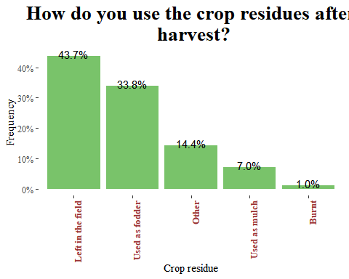

Most of the crop residues after harvest were left in the field that is 43.7%, 33.8% was used as fodder and only 7% was as mulch.

table(df3$farm_management.crop_residue_other)

##   
##   
## 498   
## Coffee and pepper permanent crops   
## 1   
## Coffee is permanent crop   
## 1   
## Deep plough in the field   
## 1   
## Firewood   
## 1   
## Give it to other farmer   
## 1   
## Give it to other farmers   
## 1   
## He sells the residues   
## 3   
## Incorporating into the field   
## 26   
## Incorporating into the field while ploughing   
## 44   
## Incorporating into the field while ploughing the land.   
## 1   
## Incorporating the crop residue while ploughing the field.   
## 1   
## Leaves of Coconut for household purpose   
## 1   
## Nill   
## 1   
## No wastage till now. But the leaves fallen will be used as compost when they dry   
## 1   
## Nothing   
## 1   
## Permanent crops   
## 2   
## Sell   
## 2   
## Sell it   
## 2   
## Sell the produce   
## 2   
## Used as compost by decomposing the residues in field itself   
## 1

table(df3$farm_management.farmyard_manure_use)

##   
## 0 1   
## 206 387

df3$farm_management.farmyard_manure_use <- as.factor(df3$farm_management.farmyard_manure_use)  
levels(df3$farm_management.farmyard_manure_use) <- c("NO", "YES")  
  
freq(df3$farm_management.farmyard_manure_use)

## Frequencies   
## df3$farm_management.farmyard_manure_use   
## Type: Factor   
##   
## Freq % Valid % Valid Cum. % Total % Total Cum.  
## ----------- ------ --------- -------------- --------- --------------  
## NO 206 34.74 34.74 34.74 34.74  
## YES 387 65.26 100.00 65.26 100.00  
## <NA> 0 0.00 100.00  
## Total 593 100.00 100.00 100.00 100.00

df3 %>%drop_na(farm_management.farmyard_manure_use) %>% ggplot(aes(farm_management.farmyard_manure_use))+  
 geom_bar(fill = "#79c36a", aes(y = (..count..)/sum(..count..)))+  
 geom_text(aes(y = ((..count..)/sum(..count..)), label = scales::percent((..count..)/sum(..count..))), stat = "count", vjust = 1.5, colour = "black")+  
 scale_y_continuous(labels = percent) +  
 labs(title = "Was farmyard applied in the past during the last season",  
 x = "Farmyard Use",  
 y="Percentage")+  
 theme_tufte()+  
 theme(plot.title = element_text(face = "bold", size = 20, hjust = 0.5))

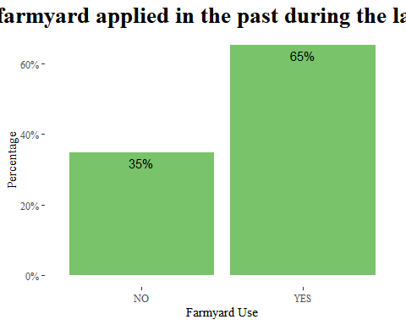

During the last season farmyard was only applied 65% on the farms.

df3 <- df3 %>%   
 bind_cols(split_into_multiple(.$farm_management.manure_use_crops, " ", "manure_crops"))  
df3$manure_crops_1 <- as.factor(df3$manure_crops_1)  
levels(df3$manure_crops_1) <- c("Paddy", "Guord","Turmeric", "Other", "Finger millet", "Brinjal", "Red gram")  
  
df3$manure_crops_2 <- as.factor(df3$manure_crops_2)  
levels(df3$manure_crops_2) <- c("Paddy","Tubers", "Okra", "Guord","Turmeric", "Other","Finger millet", "Brinjal", "Red gram", "Cowpeas")  
  
df3$manure_crops_3 <- as.factor(df3$manure_crops_3)  
levels(df3$manure_crops_3) <- c("Tubers", "Okra", "Turmeric", "Other","Maize", "Red gram", "Cowpeas", "Beans")  
  
df3$manure_crops_4 <- as.factor(df3$manure_crops_4)  
levels(df3$manure_crops_4) <- c("Tubers", "Other","Pearl millet", "Red gram", "Cowpeas", "Beans")  
  
df3$manure_crops_5 <- as.factor(df3$manure_crops_5)  
levels(df3$manure_crops_5) <- c("Okra", "Red gram", "Cowpeas")  
  
df3$manure_crops_6 <- as.factor(df3$manure_crops_6)  
levels(df3$manure_crops_6) <- c( "Brinjal", "Red gram")  
  
df3$manure_crops_7 <- as.factor(df3$manure_crops_7)  
levels(df3$manure_crops_7) <- c("Maize", "Brinjal")  
  
df3$manure_crops_8 <- as.factor(df3$manure_crops_8)  
levels(df3$manure_crops_8) <- c("Pearl millet","Maize")  
  
df3$manure_crops_9 <- as.factor(df3$manure_crops_9)  
levels(df3$manure_crops_9) <- c("Pearl millet")  
  
manure_crops <- df3 %>% select(manure_crops_1, manure_crops_2, manure_crops_3, manure_crops_4, manure_crops_5, manure_crops_6, manure_crops_7, manure_crops_8, manure_crops_9) %>% gather(manure_crops, type)

## Warning: attributes are not identical across measure variables;  
## they will be dropped

freq(manure_crops$type) %>% kbl(caption = "Manure crops") %>%  
 kable_classic(full_width = F, html_font = "Cambria")

Manure crops

Freq

% Valid

% Valid Cum.

% Total

% Total Cum.

Beans

3

0.6012024

0.6012024

0.0562114

0.0562114

Brinjal

6

1.2024048

1.8036072

0.1124227

0.1686341

Cowpeas

8

1.6032064

3.4068136

0.1498969

0.3185310

Finger millet

38

7.6152305

11.0220441

0.7120105

1.0305415

Guord

3

0.6012024

11.6232465

0.0562114

1.0867529

Maize

5

1.0020040

12.6252505

0.0936856

1.1804384

Okra

10

2.0040080

14.6292585

0.1873712

1.3678096

Other

235

47.0941884

61.7234469

4.4032228

5.7710324

Paddy

144

28.8577154

90.5811623

2.6981450

8.4691774

Pearl millet

4

0.8016032

91.3827655

0.0749485

8.5441259

Red gram

22

4.4088176

95.7915832

0.4122166

8.9563425

Tubers

3

0.6012024

96.3927856

0.0562114

9.0125539

Turmeric

18

3.6072144

100.0000000

0.3372681

9.3498220

<NA>

4838

NA

NA

90.6501780

100.0000000

Total

5337

100.0000000

100.0000000

100.0000000

100.0000000

manure_crops %>%drop_na(type) %>% ggplot(aes(fct_infreq(type)))+  
 geom_bar(aes(y = (..count..)/sum(..count..)), fill = "#79c36a") +  
 geom_text(aes(y = ((..count..)/sum(..count..)), label = scales::percent((..count..)/sum(..count..))), stat = "count", vjust = 0.25) +  
 scale_y_continuous(labels = percent) +  
 labs(title = "Crops cultivated by use of farmyard manure",  
 x = "Manure crops",  
 y = "Frequency")+  
 theme_tufte()+  
 theme(plot.title = element_text(face = "bold", size = 20, hjust = 0.5),  
 axis.text.x = element_text(face = "bold", color = "#993333",   
 size = 10,angle = 90, hjust = 1))

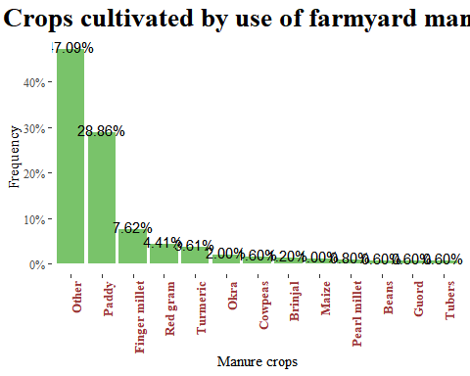 Crops that were cultivated by use of manure are as follows paddy, finger millet, red gram and turmeric. those were the top crops.

table(df3$farm_management.compost_use)

##   
## 0 1   
## 431 162

df3$farm_management.compost_use <- as.factor(df3$farm_management.compost_use)  
levels(df3$farm_management.compost_use) <- c("NO", "YES")  
  
freq(df3$farm_management.compost_use)

## Frequencies   
## df3$farm_management.compost_use   
## Type: Factor   
##   
## Freq % Valid % Valid Cum. % Total % Total Cum.  
## ----------- ------ --------- -------------- --------- --------------  
## NO 431 72.68 72.68 72.68 72.68  
## YES 162 27.32 100.00 27.32 100.00  
## <NA> 0 0.00 100.00  
## Total 593 100.00 100.00 100.00 100.00

df3 %>%drop_na(farm_management.compost_use) %>% ggplot(aes(farm_management.compost_use))+  
 geom_bar(fill = "#79c36a", aes(y = (..count..)/sum(..count..)))+  
 geom_text(aes(y = ((..count..)/sum(..count..)), label = scales::percent((..count..)/sum(..count..))), stat = "count", vjust = 1.5, colour = "black")+  
 scale_y_continuous(labels = percent) +  
 labs(title = "Was compost applied in the past during the last season",  
 x = "Compost Use",  
 y="Percentage")+  
 theme_tufte()+  
 theme(plot.title = element_text(face = "bold", size = 20, hjust = 0.5))

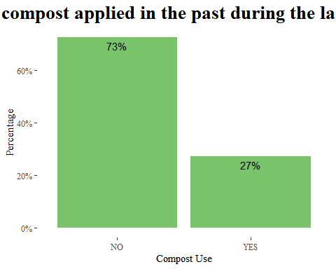

Only 27% use compost on the farms.

table(df3$farm_management.compost_use_crops)

##   
## 1 1 11 6 1 14 1 2 1 2 10 14   
## 431 50 1 17 4 1   
## 1 2 10 16 1 2 14 1 2 14 16 10 14 14 14 16   
## 1 7 3 1 7 2   
## 14 2 14 6 15 16 16 16 13 11 6 16 15   
## 1 1 9 20 1 1   
## 2 2 11 14 2 14 2 14 10 2 14 16 2 15   
## 8 1 9 1 6 1   
## 2 15 10 2 16 2 5 14 16 2 5 6 15 16 2 6 16 4 5 10 11   
## 1 3 1 1 1 1   
## 6 14   
## 1

df3 <- df3 %>%   
 bind_cols(split_into_multiple(.$farm_management.compost_use_crops, " ", "compost_crops"))  
  
df3$compost_crops_1 <- as.factor(df3$compost_crops_1)  
levels(df3$compost_crops_1) <- c("Paddy","Tubers", "Turmeric", "Pepper", "Other", "Finger millet", "Pearl millet", "Brinjal")  
  
df3$compost_crops_2 <- as.factor(df3$compost_crops_2)  
levels(df3$compost_crops_2) <- c("Okra", "Guord","Turmeric", "Pepper", "Other", "Finger millet", "Maize", "Brinjal")  
  
df3$compost_crops_3 <- as.factor(df3$compost_crops_3)  
levels(df3$compost_crops_3) <- c("Tubers", "Okra", "Turmeric", "Other", "Brinjal")  
  
df3$compost_crops_4 <- as.factor(df3$compost_crops_4)  
levels(df3$compost_crops_4) <- c("Okra", "Turmeric", "Pepper", "Other", "Brinjal")  
  
df3$compost_crops_5 <- as.factor(df3$compost_crops_5)  
levels(df3$compost_crops_5) <- c("Other")  
  
compost_crops <- df3 %>% select(compost_crops_1, compost_crops_2, compost_crops_3, compost_crops_4, compost_crops_5) %>% gather(compost_crops, type)

## Warning: attributes are not identical across measure variables;  
## they will be dropped

freq(compost_crops$type) %>% kbl(caption = "Compost crops") %>%  
 kable_classic(full_width = F, html_font = "Cambria")

Compost crops

Freq

% Valid

% Valid Cum.

% Total

% Total Cum.

Brinjal

6

2.1739130

2.173913

0.2023609

0.2023609

Finger millet

50

18.1159420

20.289855

1.6863406

1.8887015

Guord

1

0.3623188

20.652174

0.0337268

1.9224283

Maize

3

1.0869565

21.739130

0.1011804

2.0236088

Okra

4

1.4492754

23.188406

0.1349073

2.1585160

Other

49

17.7536232

40.942029

1.6526138

3.8111298

Paddy

84

30.4347826

71.376812

2.8330523

6.6441821

Pearl millet

1

0.3623188

71.739130

0.0337268

6.6779089

Pepper

13

4.7101449

76.449275

0.4384486

7.1163575

Tubers

6

2.1739130

78.623188

0.2023609

7.3187184

Turmeric

59

21.3768116

100.000000

1.9898820

9.3086003

<NA>

2689

NA

NA

90.6913997

100.0000000

Total

2965

100.0000000

100.000000

100.0000000

100.0000000

compost_crops %>%drop_na(type) %>% ggplot(aes(fct_infreq(type)))+  
 geom_bar(aes(y = (..count..)/sum(..count..)), fill = "#79c36a") +  
 geom_text(aes(y = ((..count..)/sum(..count..)), label = scales::percent((..count..)/sum(..count..))), stat = "count", vjust = 0.25) +  
 scale_y_continuous(labels = percent) +  
 labs(title = "Crops cultivated by use of compost",  
 x = "Compost crops",  
 y = "Frequency")+  
 theme_tufte()+  
 theme(plot.title = element_text(face = "bold", size = 20, hjust = 0.5),  
 axis.text.x = element_text(face = "bold", color = "#993333",   
 size = 10,angle = 90, hjust = 1))

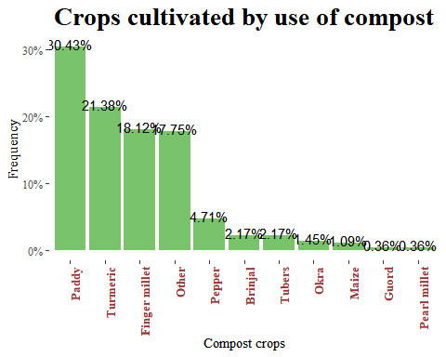

Crops that were with compost are Paddy 30.43%, Turmeric 21.38% and finger millet 18.12%.

table(df3$farm_management.mulch_use)

##   
## 0 1   
## 576 17

df3$farm_management.mulch_use <- as.factor(df3$farm_management.mulch_use)  
levels(df3$farm_management.mulch_use) <- c("NO", "YES")  
  
freq(df3$farm_management.mulch_use)

## Frequencies   
## df3$farm_management.mulch_use   
## Type: Factor   
##   
## Freq % Valid % Valid Cum. % Total % Total Cum.  
## ----------- ------ --------- -------------- --------- --------------  
## NO 576 97.13 97.13 97.13 97.13  
## YES 17 2.87 100.00 2.87 100.00  
## <NA> 0 0.00 100.00  
## Total 593 100.00 100.00 100.00 100.00

df3 %>%drop_na(farm_management.mulch_use) %>% ggplot(aes(farm_management.mulch_use))+  
 geom_bar(fill = "#79c36a", aes(y = (..count..)/sum(..count..)))+  
 geom_text(aes(y = ((..count..)/sum(..count..)), label = scales::percent((..count..)/sum(..count..))), stat = "count", vjust = 1.5, colour = "black")+  
 scale_y_continuous(labels = percent) +  
 labs(title = "Was mulch applied in the past during the last season",  
 x = "Mulch Use",  
 y="Percentage")+  
 theme_tufte()+  
 theme(plot.title = element_text(face = "bold", size = 20, hjust = 0.5))

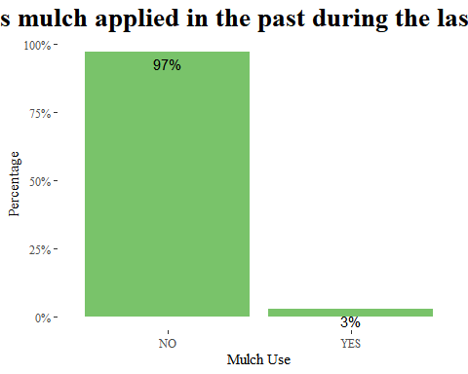

Only 3% of the farms is where mulch was applied or used in the past during the last season.

df3 <- df3 %>%   
 bind_cols(split_into_multiple(.$farm_management.mulch_use_crops, " ", "mulch_crops"))  
  
df3$mulch_crops_1 <- as.factor(df3$mulch_crops_1)  
levels(df3$mulch_crops_1) <- c("Turmeric", "Pepper", "Other", "Pearl millet", "Red gram", "Cowpeas")  
  
df3$mulch_crops_2 <- as.factor(df3$mulch_crops_2)  
levels(df3$mulch_crops_2) <- c("Okra", "Other", "Maize", "Red gram")  
  
df3$mulch_crops_3 <- as.factor(df3$mulch_crops_3)  
levels(df3$mulch_crops_3) <- c("Tubers", "Brinjal")  
  
df3$mulch_crops_4 <- as.factor(df3$mulch_crops_4)  
levels(df3$mulch_crops_4) <- c( "Okra", "Red gram", "Cowpeas")  
  
df3$mulch_crops_5 <- as.factor(df3$mulch_crops_5)  
levels(df3$mulch_crops_5) <- c("Tubers", "Red gram")  
  
df3$mulch_crops_6 <- as.factor(df3$mulch_crops_6)  
levels(df3$mulch_crops_6) <- c("Okra", "Brinjal")  
  
df3$mulch_crops_7 <- as.factor(df3$mulch_crops_7)  
levels(df3$mulch_crops_7) <- c("Gourd", "Maize")  
  
df3$mulch_crops_8 <- as.factor(df3$mulch_crops_8)  
levels(df3$mulch_crops_8) <- c("Other", "Pearl millet")  
  
  
mulch_crops <- df3 %>% select(mulch_crops_1, mulch_crops_2, mulch_crops_3, mulch_crops_4, mulch_crops_5, mulch_crops_6, mulch_crops_7, mulch_crops_8) %>% gather(mulch_crops, type)

## Warning: attributes are not identical across measure variables;  
## they will be dropped

freq(mulch_crops$type) %>% kbl(caption = "mulch crops") %>%  
 kable_classic(full_width = F, html_font = "Cambria")

mulch crops

Freq

% Valid

% Valid Cum.

% Total

% Total Cum.

Brinjal

3

6

6

0.0632378

0.0632378

Cowpeas

4

8

14

0.0843170

0.1475548

Gourd

1

2

16

0.0210793

0.1686341

Maize

3

6

22

0.0632378

0.2318718

Okra

5

10

32

0.1053963

0.3372681

Other

15

30

62

0.3161889

0.6534570

Pearl millet

3

6

68

0.0632378

0.7166948

Pepper

4

8

76

0.0843170

0.8010118

Red gram

6

12

88

0.1264755

0.9274874

Tubers

5

10

98

0.1053963

1.0328836

Turmeric

1

2

100

0.0210793

1.0539629

<NA>

4694

NA

NA

98.9460371

100.0000000

Total

4744

100

100

100.0000000

100.0000000

mulch_crops %>%drop_na(type) %>% ggplot(aes(fct_infreq(type)))+  
 geom_bar(aes(y = (..count..)/sum(..count..)), fill = "#79c36a") +  
 geom_text(aes(y = ((..count..)/sum(..count..)), label = scales::percent((..count..)/sum(..count..))), stat = "count", vjust = 0.25) +  
 scale_y_continuous(labels = percent) +  
 labs(title = "Crops cultivated by use of mulch",  
 x = "Mulch crops",  
 y = "Frequency")+  
 theme_tufte()+  
 theme(plot.title = element_text(face = "bold", size = 20, hjust = 0.5),  
 axis.text.x = element_text(face = "bold", color = "#993333",   
 size = 10,angle = 90, hjust = 1))

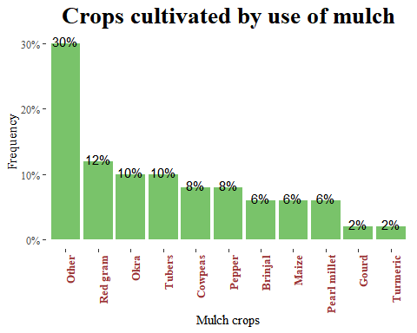

With the mulch crops we have red grams, Okra and Tubers as top 3.

df3$farm_management.chemical_fertilizer_use <- as.factor(df3$farm_management.chemical_fertilizer_use)  
levels(df3$farm_management.chemical_fertilizer_use) <- c("NO", "YES")  
  
freq(df3$farm_management.chemical_fertilizer_use)

## Frequencies   
## df3$farm_management.chemical_fertilizer_use   
## Type: Factor   
##   
## Freq % Valid % Valid Cum. % Total % Total Cum.  
## ----------- ------ --------- -------------- --------- --------------  
## NO 305 51.43 51.43 51.43 51.43  
## YES 288 48.57 100.00 48.57 100.00  
## <NA> 0 0.00 100.00  
## Total 593 100.00 100.00 100.00 100.00

df3 %>%drop_na(farm_management.chemical_fertilizer_use) %>% ggplot(aes(farm_management.chemical_fertilizer_use))+  
 geom_bar(fill = "#79c36a", aes(y = (..count..)/sum(..count..)))+  
 geom_text(aes(y = ((..count..)/sum(..count..)), label = scales::percent((..count..)/sum(..count..))), stat = "count", vjust = 1.5, colour = "black")+  
 scale_y_continuous(labels = percent) +  
 labs(title = "Was chemical fertilizer applied in the past\n during the last season",  
 x = "Chemical fertilizer Use",  
 y="Percentage")+  
 theme_tufte()+  
 theme(plot.title = element_text(face = "bold", size = 20, hjust = 0.5))

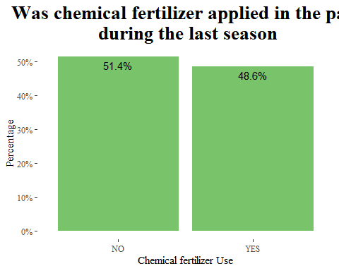

Only 48.6% of the farms was where the chemical fertilzers were applied in the last season, 51.4% did not apply.

df3 <- df3 %>%   
 bind_cols(split_into_multiple(.$farm_management.fertilizer_use_crops, " ", "fertilizer_crops"))  
df3$fertilizer_crops_1 <- as.factor(df3$fertilizer_crops_1)  
levels(df3$fertilizer_crops_1) <- c("Paddy", "Other", "Finger millet", "Red gram", "Cowpeas")  
  
df3$fertilizer_crops_2 <- as.factor(df3$fertilizer_crops_2)  
levels(df3$fertilizer_crops_2) <- c("Tubers", "Okra", "Other", "Red gram")  
  
df3$fertilizer_crops_3 <- as.factor(df3$fertilizer_crops_3)  
levels(df3$fertilizer_crops_3) <- c("Other")  
  
fertilizer_crops <- df3 %>% select(fertilizer_crops_1, fertilizer_crops_2, fertilizer_crops_3) %>% gather(fertilizer_crops, type)

## Warning: attributes are not identical across measure variables;  
## they will be dropped

freq(fertilizer_crops$type) %>% kbl(caption = "fertilizer crops") %>%  
 kable_classic(full_width = F, html_font = "Cambria")

fertilizer crops

Freq

% Valid

% Valid Cum.

% Total

% Total Cum.

Cowpeas

2

0.6514658

0.6514658

0.1124227

0.1124227

Finger millet

1

0.3257329

0.9771987

0.0562114

0.1686341

Okra

1

0.3257329

1.3029316

0.0562114

0.2248454

Other

172

56.0260586

57.3289902

9.6683530

9.8931984

Paddy

120

39.0879479

96.4169381

6.7453626

16.6385610

Red gram

10

3.2573290

99.6742671

0.5621135

17.2006745

Tubers

1

0.3257329

100.0000000

0.0562114

17.2568859

<NA>

1472

NA

NA

82.7431141

100.0000000

Total

1779

100.0000000

100.0000000

100.0000000

100.0000000

fertilizer_crops %>%drop_na(type) %>% ggplot(aes(fct_infreq(type)))+  
 geom_bar(aes(y = (..count..)/sum(..count..)), fill = "#79c36a") +  
 geom_text(aes(y = ((..count..)/sum(..count..)), label = scales::percent((..count..)/sum(..count..))), stat = "count", vjust = 0.25) +  
 scale_y_continuous(labels = percent) +  
 labs(title = "Crops cultivated by use of fertilizer",  
 x = "fertilizer crops",  
 y = "Frequency")+  
 theme_tufte()+  
 theme(plot.title = element_text(face = "bold", size = 20, hjust = 0.5),  
 axis.text.x = element_text(face = "bold", color = "#993333",   
 size = 10,angle = 90, hjust = 1))

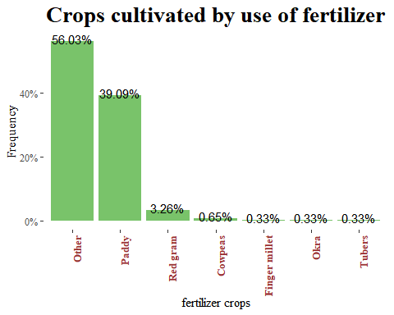

Other crops were the mostly used for fertilizers, then paddy and red gram.

df3$farm_management.herbicide_use <- as.factor(df3$farm_management.herbicide_use)  
levels(df3$farm_management.herbicide_use) <- c("NO", "YES")  
  
freq(df3$farm_management.herbicide_use)

## Frequencies   
## df3$farm_management.herbicide_use   
## Type: Factor   
##   
## Freq % Valid % Valid Cum. % Total % Total Cum.  
## ----------- ------ --------- -------------- --------- --------------  
## NO 495 83.47 83.47 83.47 83.47  
## YES 98 16.53 100.00 16.53 100.00  
## <NA> 0 0.00 100.00  
## Total 593 100.00 100.00 100.00 100.00

df3 %>%drop_na(farm_management.herbicide_use) %>% ggplot(aes(farm_management.herbicide_use))+  
 geom_bar(fill = "#79c36a", aes(y = (..count..)/sum(..count..)))+  
 geom_text(aes(y = ((..count..)/sum(..count..)), label = scales::percent((..count..)/sum(..count..))), stat = "count", vjust = 1.5, colour = "black")+  
 scale_y_continuous(labels = percent) +  
 labs(title = "Was herbicide applied in the past\n during the last season",  
 x = "Herbicide Use",  
 y="Percentage")+  
 theme_tufte()+  
 theme(plot.title = element_text(face = "bold", size = 20, hjust = 0.5))

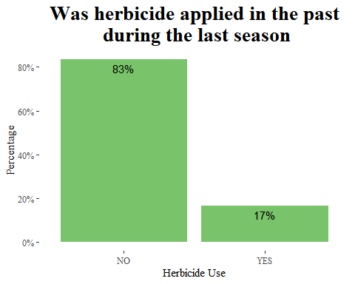

Only 17% applied herbicides on the farms.

df3$farm_management.pesticide_use <- as.factor(df3$farm_management.pesticide_use)  
levels(df3$farm_management.pesticide_use) <- c("NO", "YES")  
  
freq(df3$farm_management.pesticide_use)

## Frequencies   
## df3$farm_management.pesticide_use   
## Type: Factor   
##   
## Freq % Valid % Valid Cum. % Total % Total Cum.  
## ----------- ------ --------- -------------- --------- --------------  
## NO 319 53.79 53.79 53.79 53.79  
## YES 274 46.21 100.00 46.21 100.00  
## <NA> 0 0.00 100.00  
## Total 593 100.00 100.00 100.00 100.00

df3 %>%drop_na(farm_management.pesticide_use) %>% ggplot(aes(farm_management.pesticide_use))+  
 geom_bar(fill = "#79c36a", aes(y = (..count..)/sum(..count..)))+  
 geom_text(aes(y = ((..count..)/sum(..count..)), label = scales::percent((..count..)/sum(..count..))), stat = "count", vjust = 1.5, colour = "black")+  
 scale_y_continuous(labels = percent) +  
 labs(title = "Was pesticide applied in the past\n during the last season",  
 x = "Pesticide Use",  
 y="Percentage")+  
 theme_tufte()+  
 theme(plot.title = element_text(face = "bold", size = 20, hjust = 0.5))

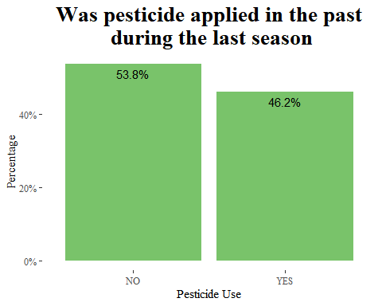

Only 46.2% applied pesticides on the farm.