8.2: TypeORM and how it is going to work around our other modules
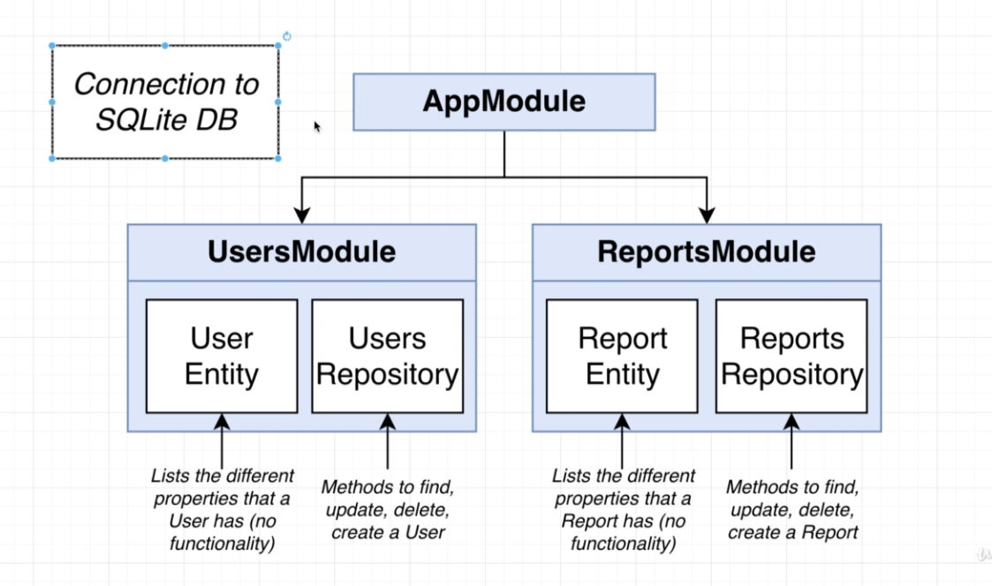

>creating user entity and report entity and mapping it to its own module and app modules.
8.3:
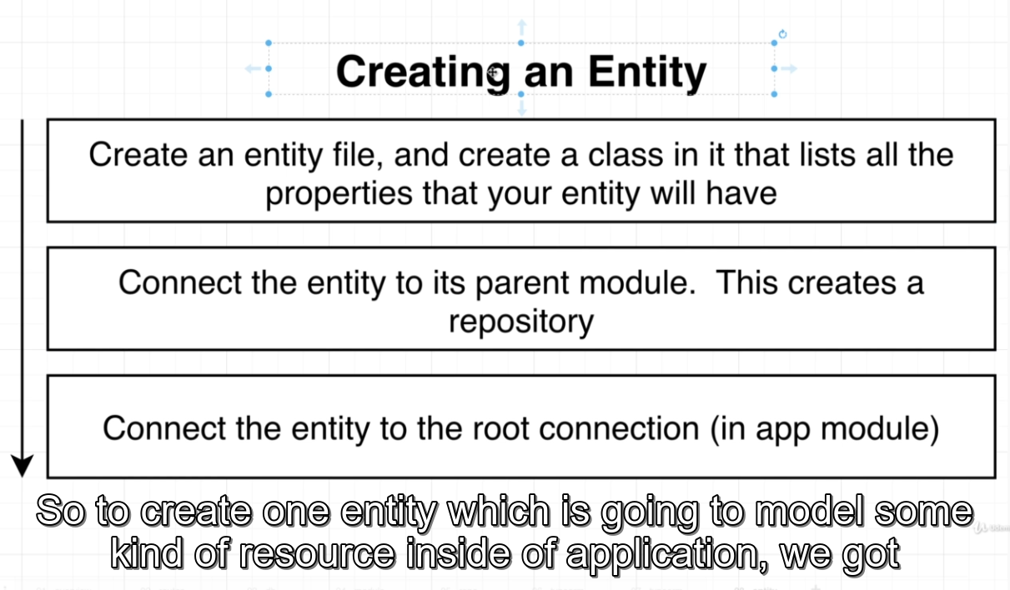
8.4 > create entity for reports module
8.5 > what is synchronize and migrations. How it is related. //no code written
8.6 > repositories //no code written
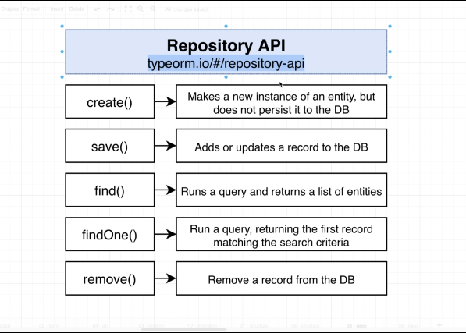

8.7 > //no code written – creating dummy route methods to understand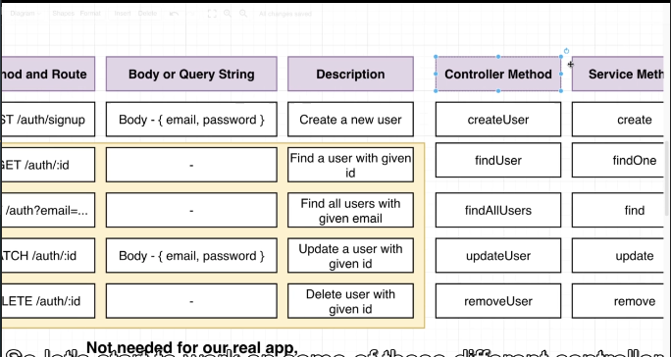
8.8 >
Writing up the user controller file for creating routing methods.
Initialized ValidationPipe for globally validating the incoming requests in main.ts. //App.useGlobalPipes()
Created a dto folder inside users module and started writing up the create-user-dto.ts for validating the createUser routing method inside of the controller.
npm i class-validator class-transformer

9.1
> Dependency Injection inside of our users service for using repository. Repository is automatically created by typeorm
> writing up the create method to store the post request’s payload into the db/sqlite3.
> going back to our users.controller and creating an instance of the usersService for dependency injection
> then assigning the create method into the routing handler method.

9.2
Quick review of the whole design flow

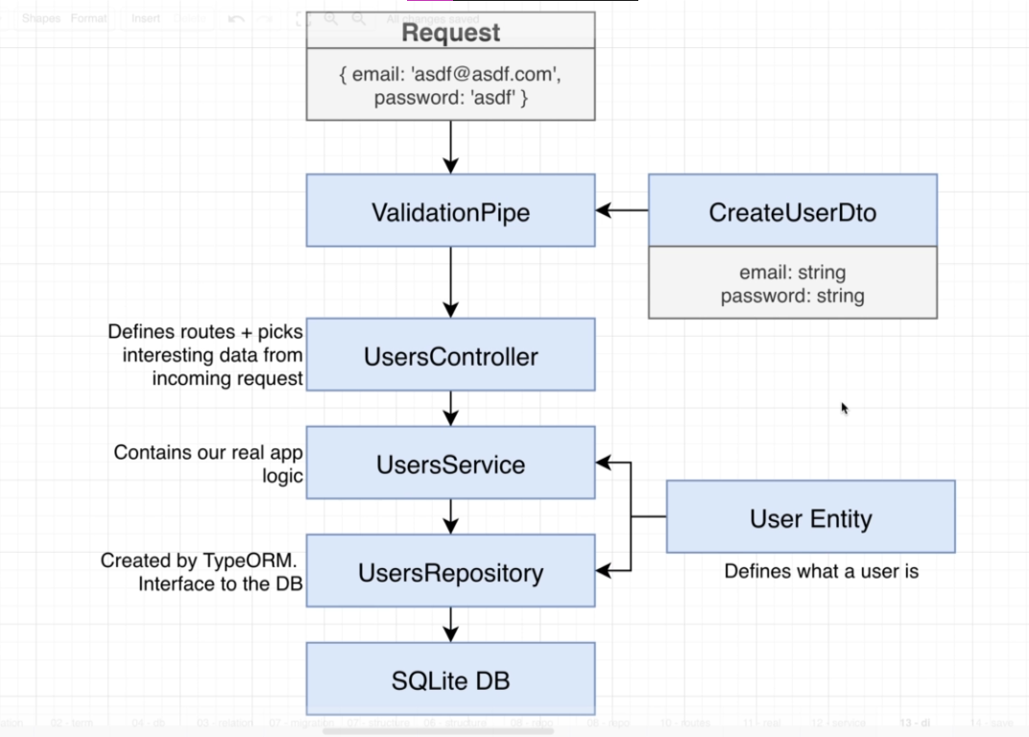

10.2
//DTO > data transfer object is not only used for handling incoming requests, it is also used in handling outgoing requests as well.
Custom interceptor > wire up custom DTOs > to describe how to serialize different user entities (admins, accounts etc)

10.3
Interceptors are used for intercept outgoing and incoming requests, it is similar as middleware.
Interceptors can be wired up in controller/route handling level. To do that we have to make a > Class CustomInterceptor.
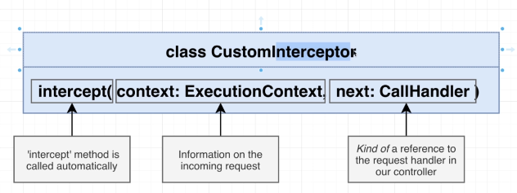

11.4
Hashing function() > Same string results into same output every time but any tiny changes make completely different hashes.
So when a same string/password is put by the user, the password at first is being hashed via hashing function() then the hash is being compared.
To prevent rainbow attack we use salts.
Salts are randomly generated.
A randomly generated salt and the user password is concatenated then hashed.
Then the randomly generated salt and the concatenated hashed password is saved into a db together. There is a separator between the salt and the concatenated hash.
So, when signin starts, first we find the email address then check the salt.(salt+user_pw)
We take the salt out then again concatenate it with the input password that the user has given and generate the hash by hashing function.
If the generated hash is same with the stored (salt + user pw) hash then the user has put the right pw.

11.8
Cookie session
Cookie session library is going to take an encrypted string from the header and then decrypt it.
It will resolve it as an js object.
We can use this session object to see who the currently signed in user is.
Npm install cookie-session @types/cookie-session

11.13
Guard > To guard the routing methods, to not allowing users to send requests to the route handlers if the user is not signed in
Interceptor + Decorator: To tell the route hander automatically who the currently signed in user is

11.16
DI can not be implemented into decorators. So we need to write an interceptor, do the dependency injection on there to call the userservice methods. On the interceptors, we are going to see if the userId in the session matches with the user entity by using userservice method. Then we will set a current user in the request session.
On the decorator we will just call the current user from the request session. That’s it.

11.18
After our interceptor runs then the decorator will run

