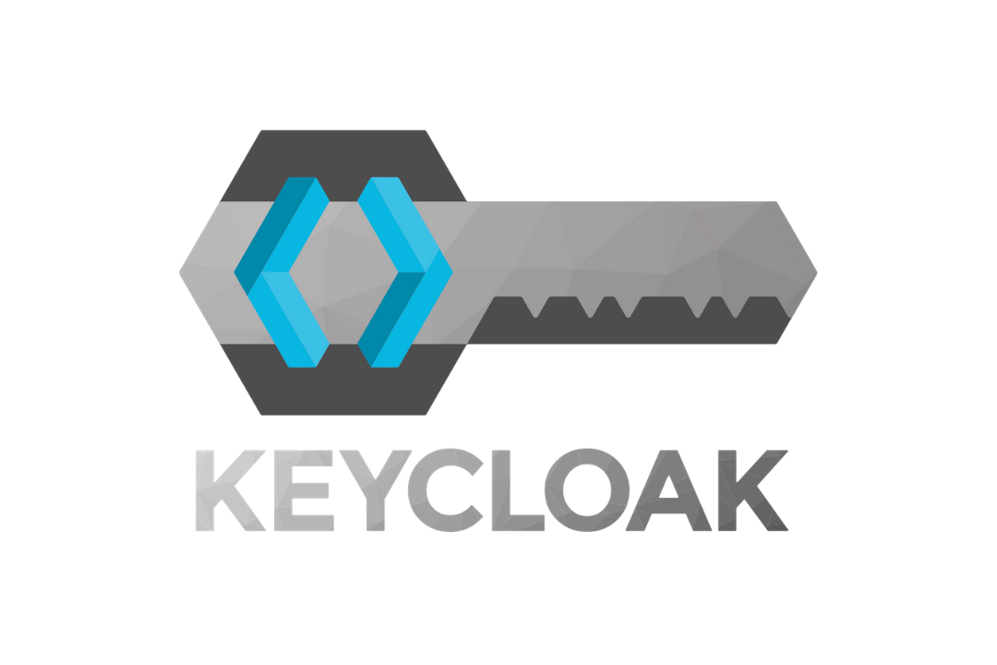

Keycloak 22 Guide by Sakib

Contents

Create Realm 3

Setup Group and Assign Realm Roles 4

Setup Group and Assign Client Roles 10

# Create Realm

Step-1

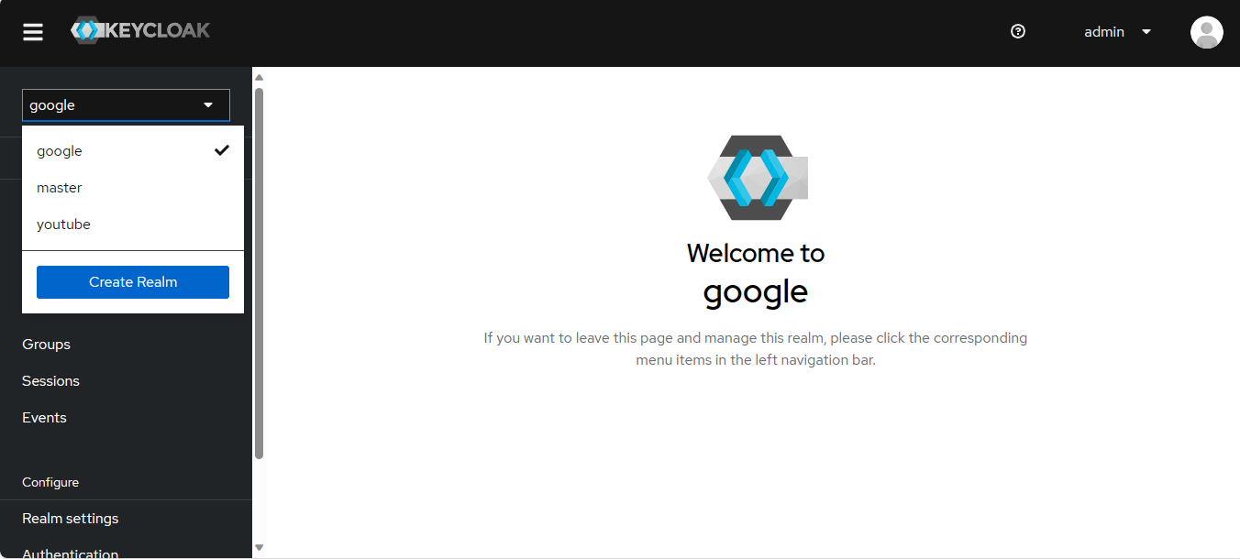

Step-2

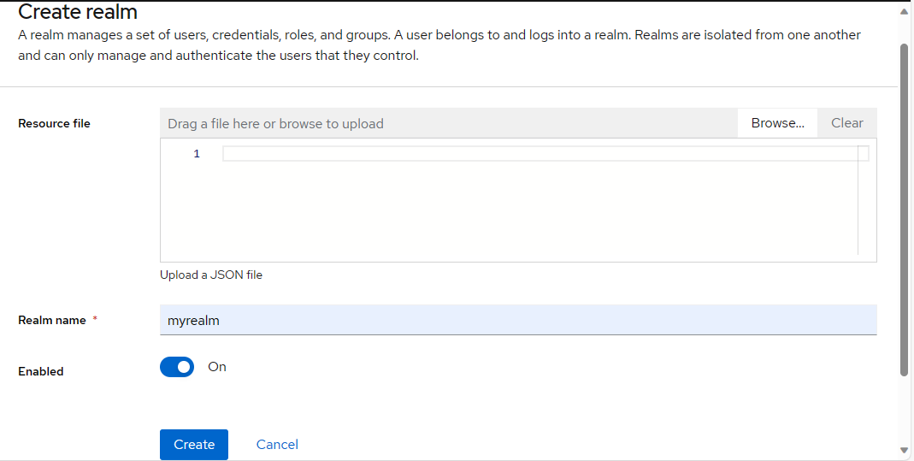

# Setup Group and Assign Realm Roles

**Step:1**

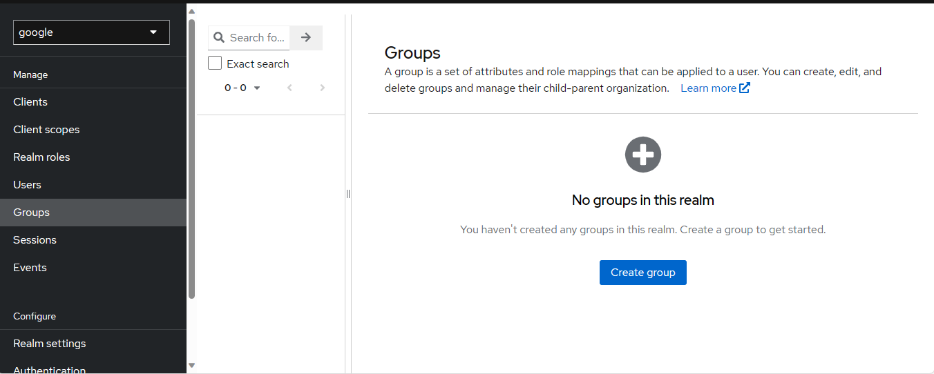

**Step:2**

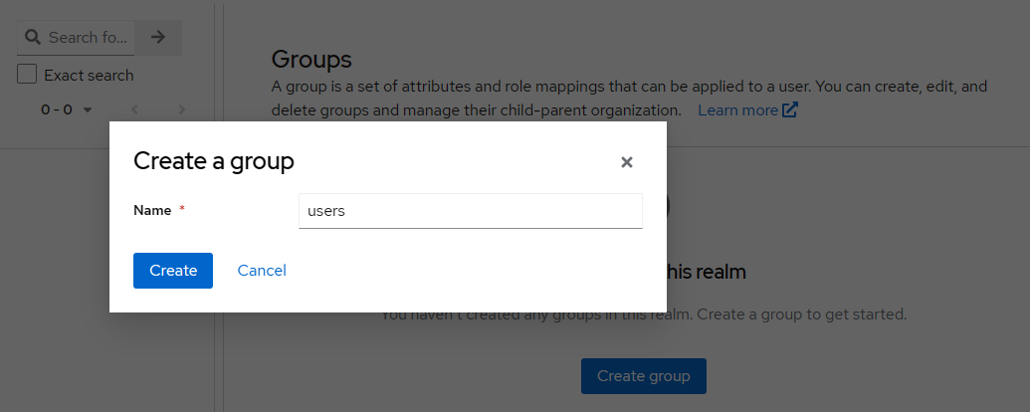

**Step:3** - Assign roles in group

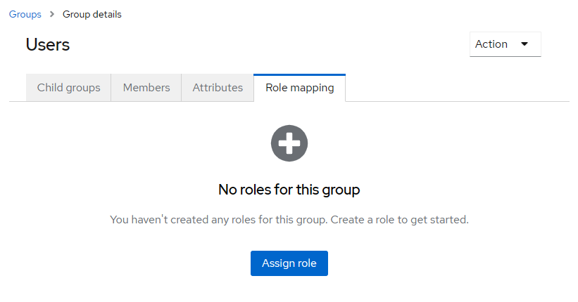

**Step:4** – Adding reading post permission for this USERS group

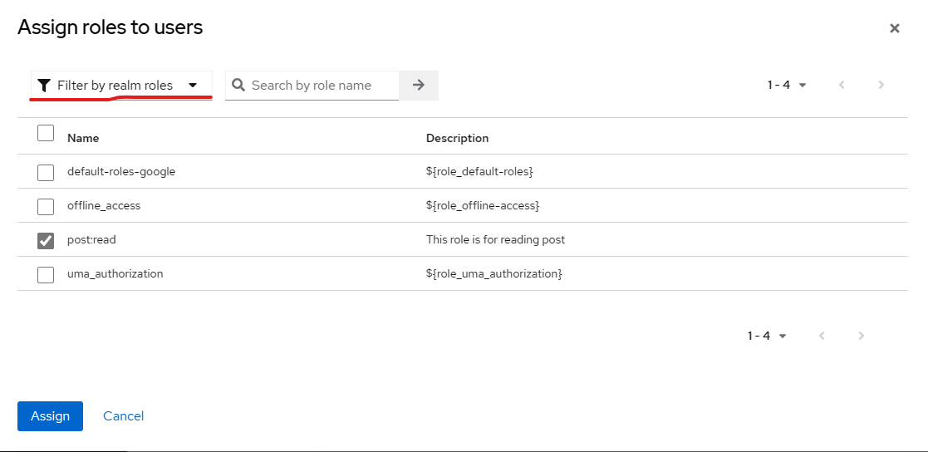

**Step:5** – Adding this USERS group in the client

Go to Client>{CLIENT_NAME}>Client Scopes

1. Go to the google-cli-dedicated (client scope name will depend on client name)

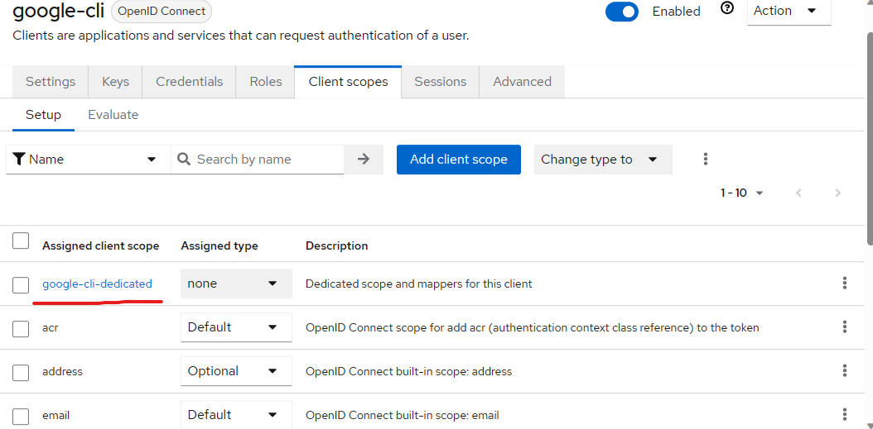

1. Click on Configure a new mapper

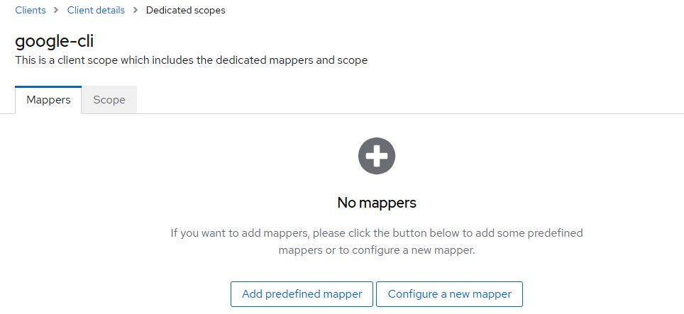

1. Click on Group Membership

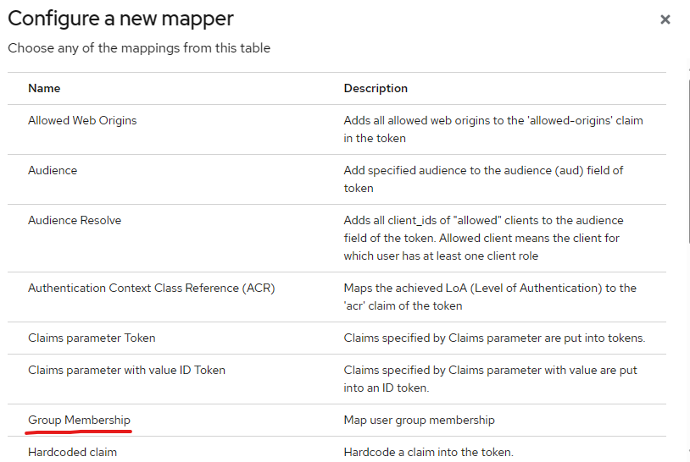

1. Click on Save

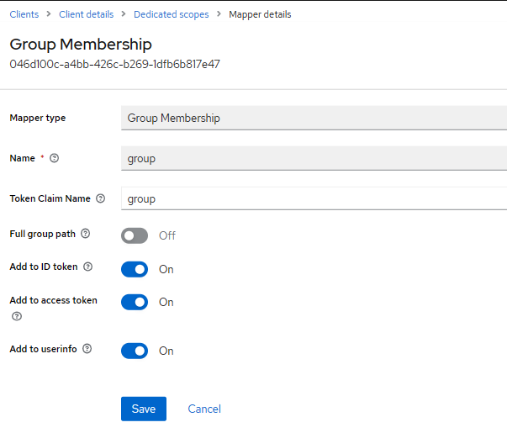

**Step-6**: Adding user to the group

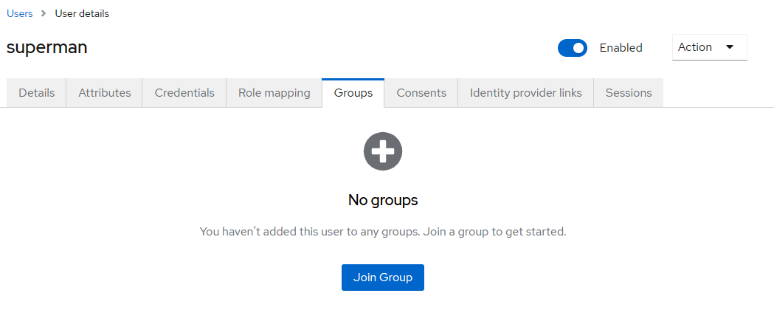

Add the user to the USERS group. Or we can add the user from group directly.

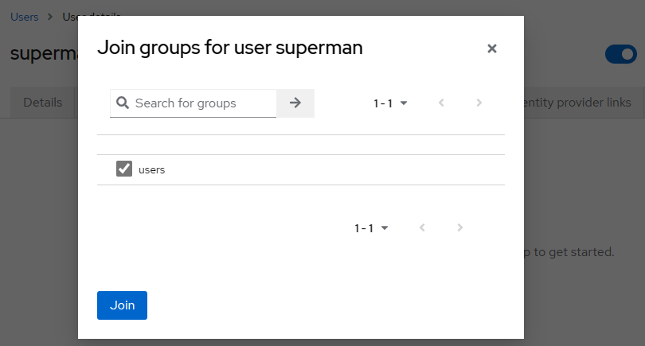

**Step-7** - Let’s check that user’s access token

Go to Client>{CLIENT_NAME}>Client Scopes. Then Evaluate tab  
  
i)

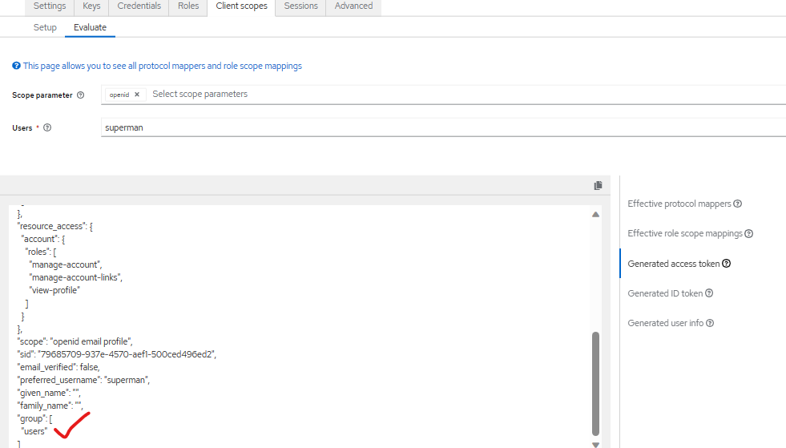

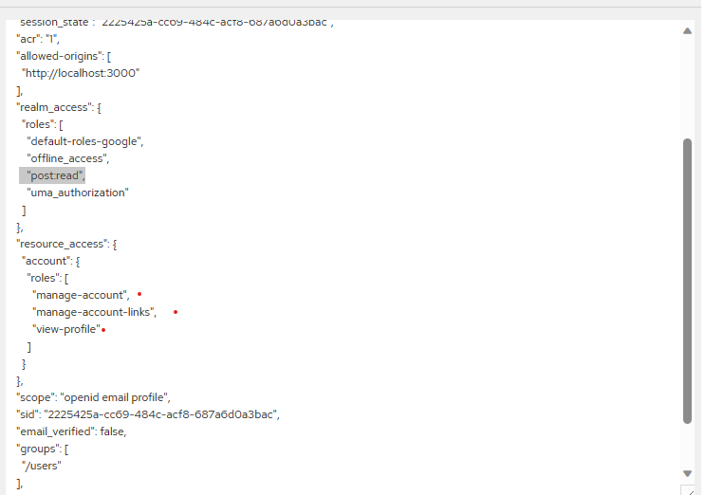

**Adding custom property for roles in access token**

This can be done by adding a new mapper in client scope  
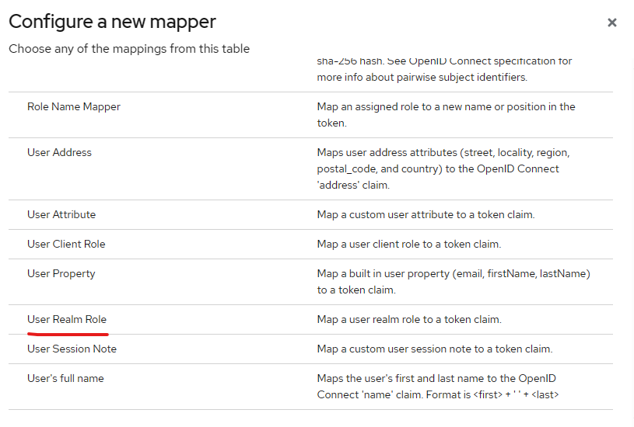  
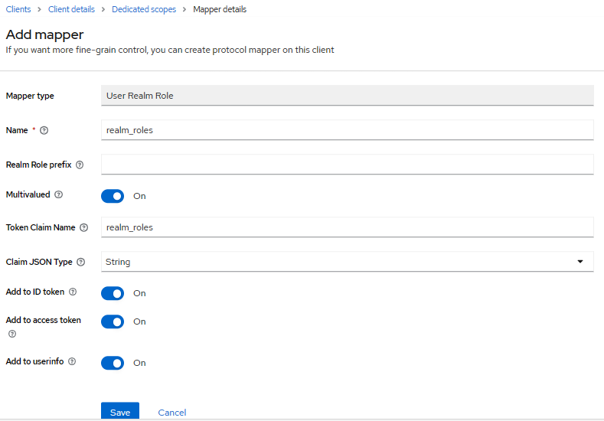

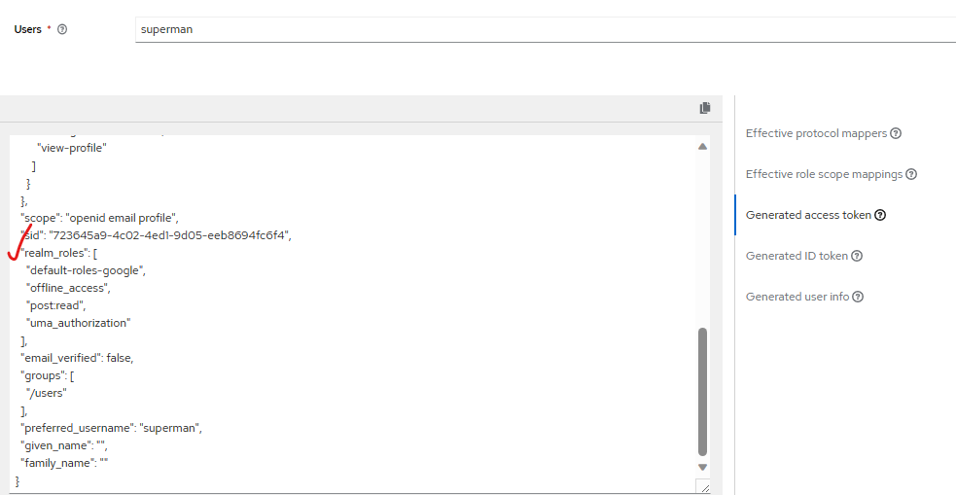

# Setup Group and Assign Client Roles

**Step:1**



**Step:2**



**Step:3** – Create Client Role  
Go to Client>{CLIENT_NAME}>Roles

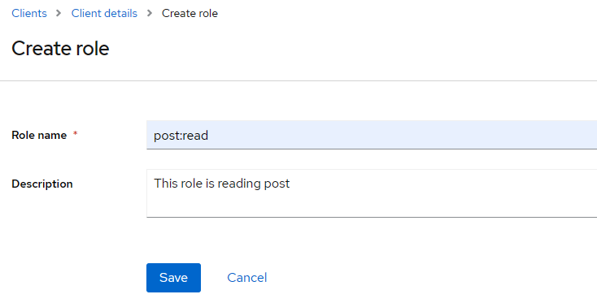

**Step:4** - Assign roles in group



**Step:5** – Adding reading post permission for this USERS group

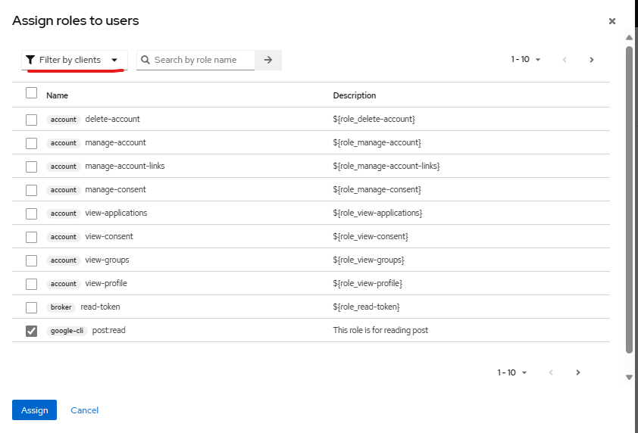

**Step:6** – Adding this USERS group in the client

1. Go to Client>{CLIENT_NAME}>Client Scopes



1. Go to the google-cli-dedicated (client scope name will depend on client name)



1. If one MAPPER already exist , click on By configuration  
     
   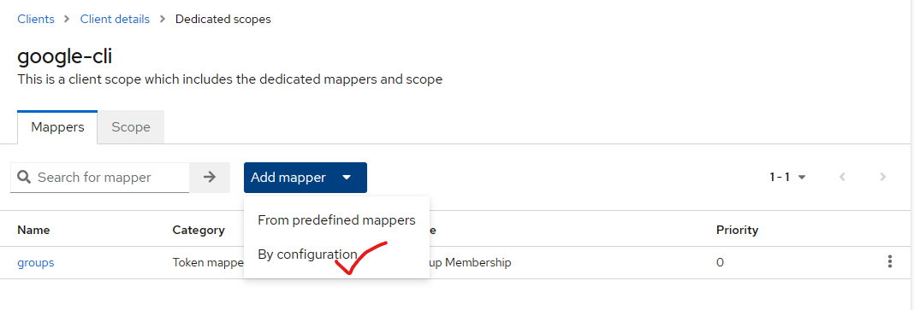
2. Click on User Client Role

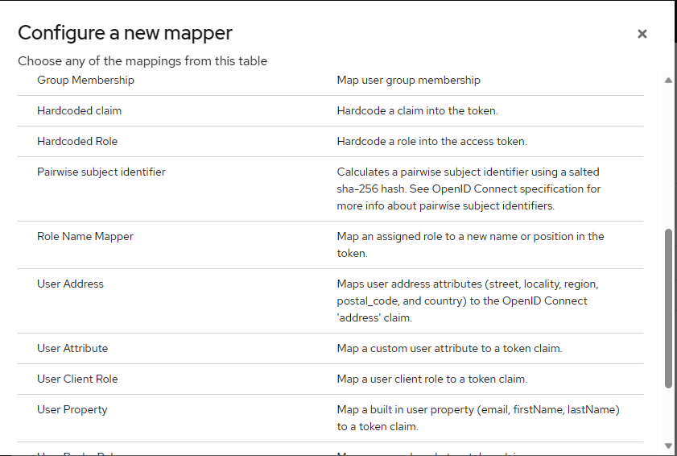

1. Cick on Save

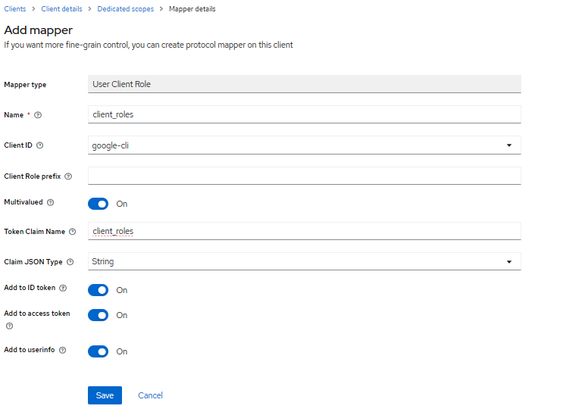

**Step-6**: Add the user to the USERS group. Or we can add the user from group directly.



Add group



**Step-7** - Let’s check that user’s access token

Go to Client>{CLIENT_NAME}>Client Scopes. Then Evaluate Tab

