Docklight ODBC Example
www.docklight.de / Date: 2020-04-16 / Author: Heggelbacher

Preparing the ODBC database connection
- Copy the example database weighting_bridge.mdb to a folder on your computer which standard read/write access.
- Open the Windows ODBC Data Sources (32 Bit) configuration
NOTE: On today’s Windows 10 64-bit, usually the 64 bit configuration is opened.
Use Windows key + R and %windir%\SysWOW64\odbcad32.exe to open the 32-bit configurator, according to
https://support.microsoft.com/en-us/help/942976/odbc-administrator-tool-displays-both-the-32-bit-and-the-64-bit-user-d
“ODBC Administrator tool displays both the 32-bit and the 64-bit user DSNs in a 64-bit version of Windows”
See also
https://superuser.com/questions/419832/how-can-i-open-the-32-bit-odbc-data-source-administrator-in-windows-7-64-bit
“How can I open the 32-bit ODBC Data Source Administrator in Windows 7 64-bit?”
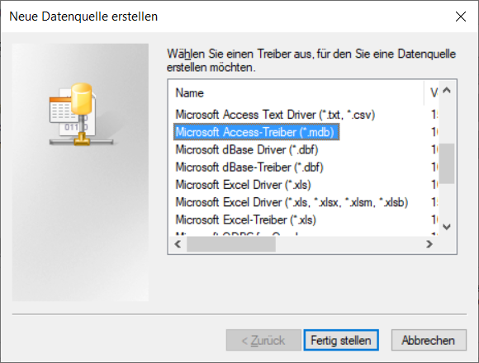
- Press Add… and append a new Microsoft Access Driver (.mdb) .
(You may need to scroll down a bit, there are sometimes multilingual drivers for MS Access on top of the list.)
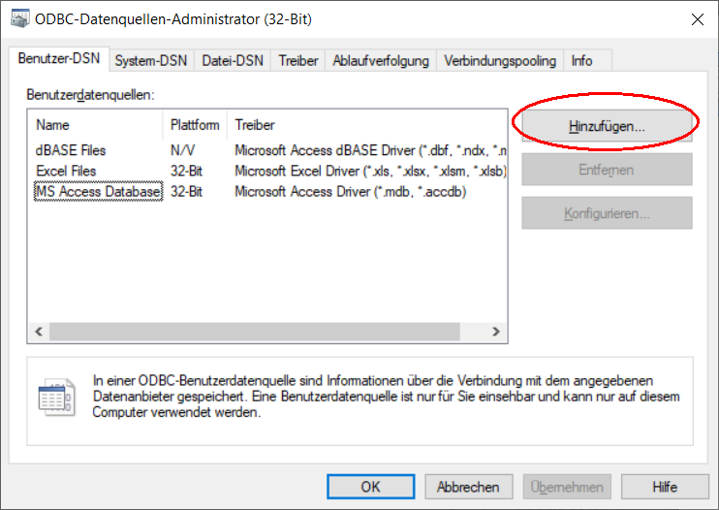

- Now set weighting as the data source name (DSN) and pick the weighting.mdb in the database dialog below:
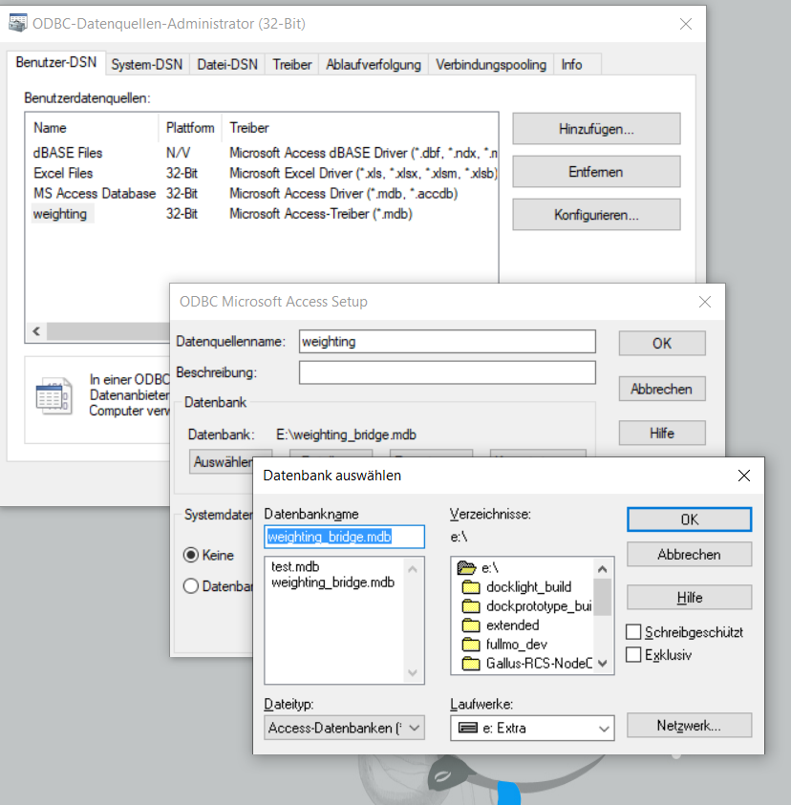
- Confirm everything with OK and return to the ODBC main dialog

NOTE: depending on your access rights and group policies on your computer, and the user account under which Docklight is started, Docklight might not have the required access rights for a User DSN. If you experience problems, try a System DSN instead.

Running the ODBC database example in Docklight Scripting
- Install Docklight Scripting from our web site at https://docklight.de/downloads/
- Download the following the Docklight_Tweak.exe utility from here:
https://docklight.de/download/Docklight_Tweak.zip
Then start Docklight_Tweak.exe, uncheck the Use Safe Subset… box and press Apply.
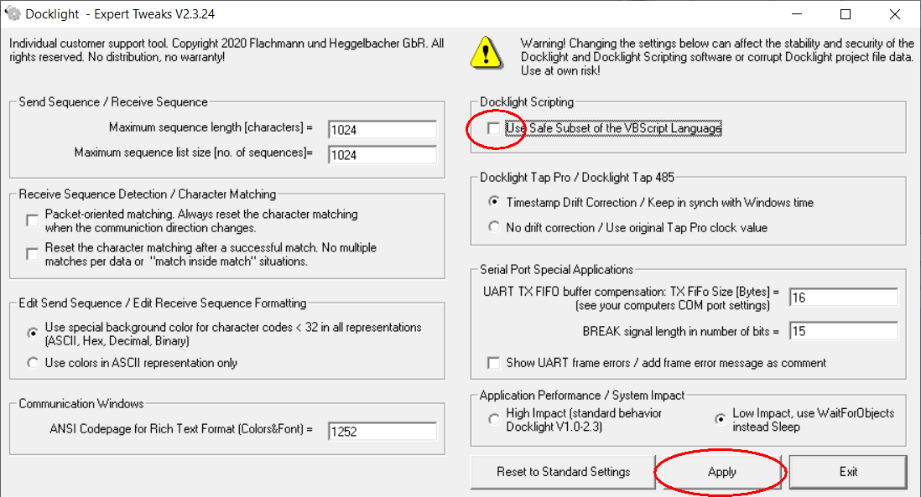
- Open the Docklight_ODBC_example.pts in Docklight Scripting, e.g. by double-click, and use menu Scripting -> Run Script… to start the example. It will create an additional record to the existing “Demo” recordset, and print the contents of the whole recordset
