MovingCap 349
Basic Setup
Author: Oliver Heggelbacher, rev: 05.09.2019
www.fullmo.de / www.kickdrive.de
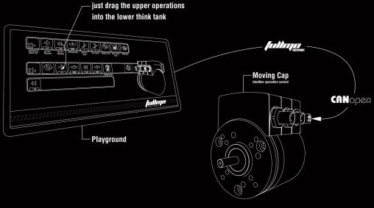
Safety Notices
 | For Qualified Personnel only  Fullmo MovingCap is a compact drive for industrial applications. Improper operation may result in injury.
 | Fullmo MovingCap drives may be preloaded with Python script programs and may start moving immediately after connecting the power supply.

Additional documentation (German) on MovingCap 349 can be found at:
https://fullmo.de/rotative-antriebstechnik/

The 24 VDC power connector for the MovingCap 349 compact drive is on the side of the drive shaft (the angle plug in the picture below).
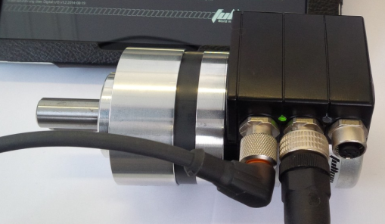
Connect the black Fullmo USB2Drive device via USB to your PC. Connect the USB2Drive via the CAN Bus cable (usually purple color) to the drive (the middle M12 connector).
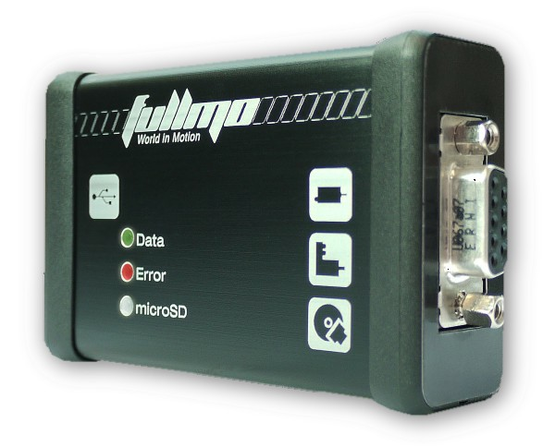
Download Kickdrive Zero: www.kickdrive.de/sw/KickdriveZero.exe
and start it by double-click.
Select the CANopen Drive Setup application from the Project Selector.
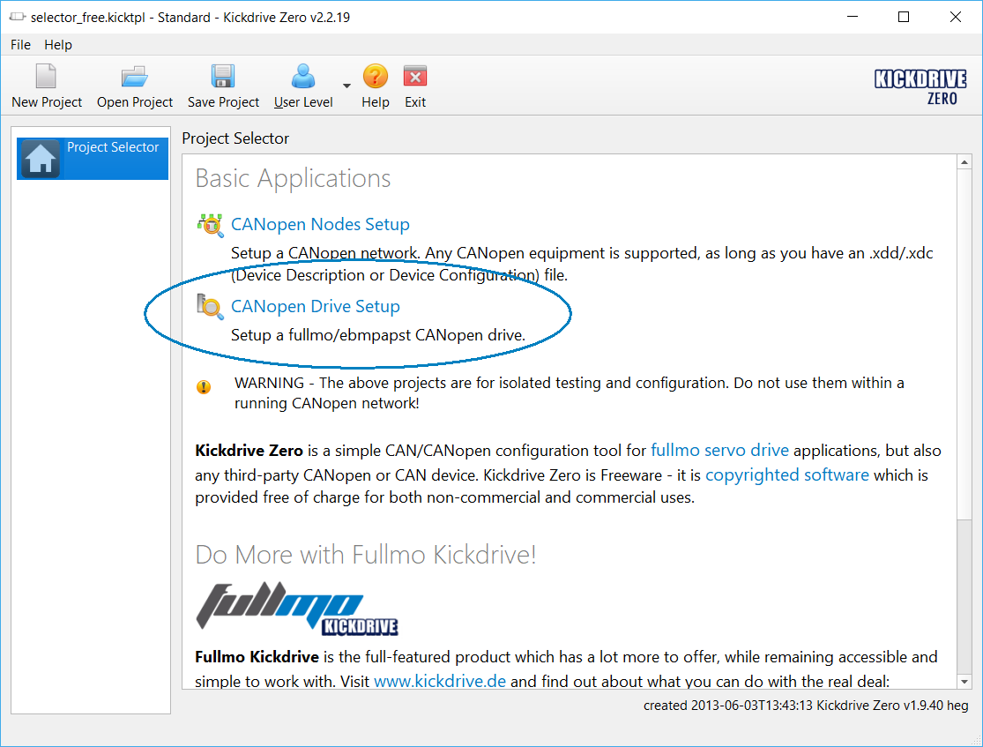

Select the tile / module Drive 01 > Setup
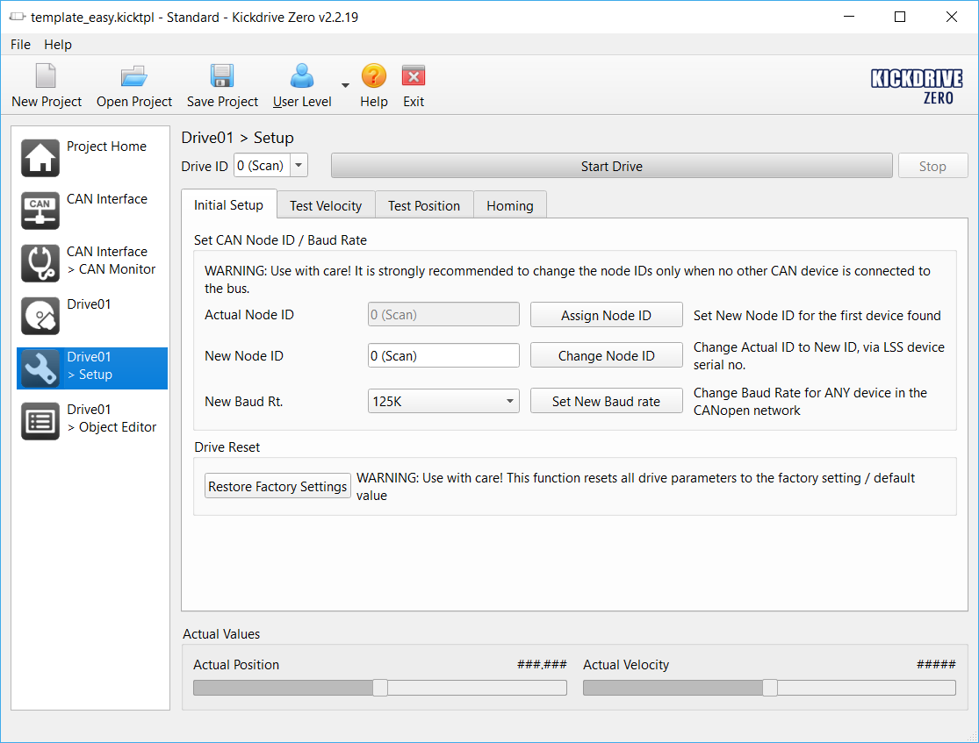
Press Start Drive. Kickdrive is now looking for the appropriate baud rate for the connected drive, as well as the correct node ID. If successful, the drive is initialized and Kickdrive confirms with a green status display.
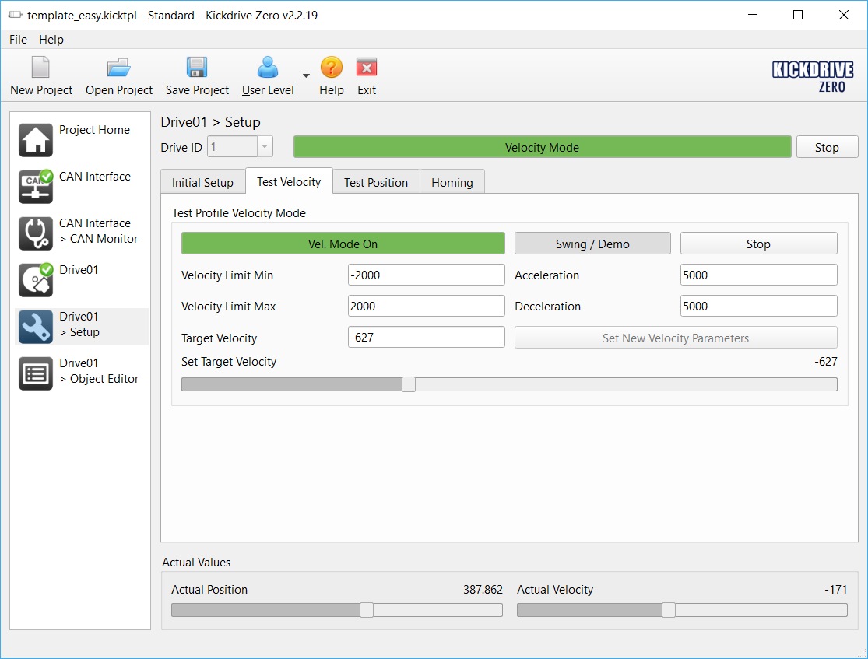
You can now rotate the drive right or left, e.g. by moving the slider in Set Target Velocity.
If the drive cannot be reached or the USB2Drive interface is not correctly connected, you will receive a corresponding feedback:
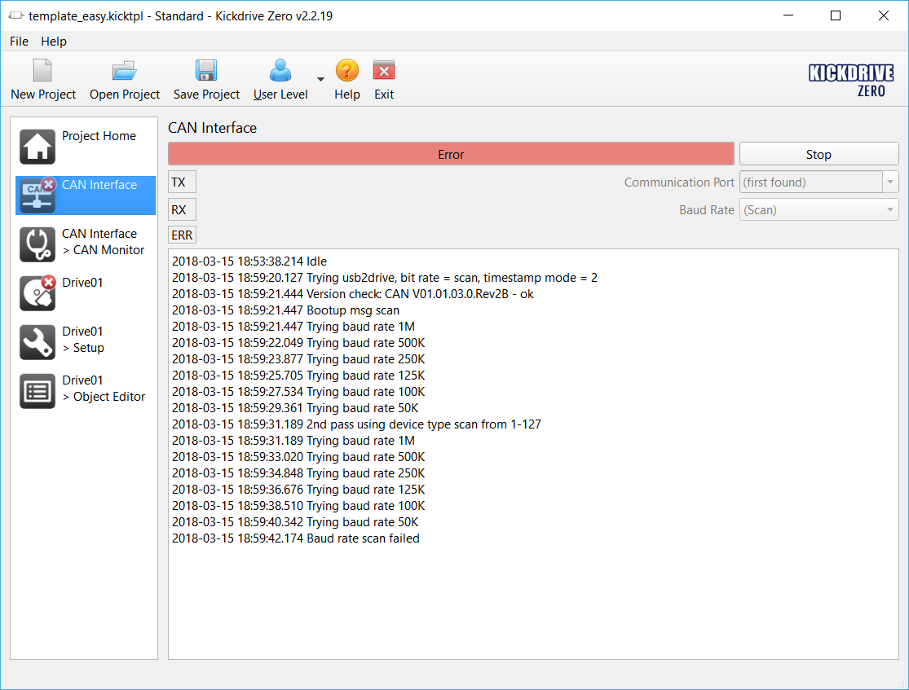
For use in CANopen fieldbus applications, both the CAN Baud Rate (bus speed) and the so-called CANopen Node Id of the drive must be set appropriately. In the module Drive 01 > Setup, see the Initial Setup area and the functions Assign Node ID and Set New Baud Rate to change your drive’s setup.
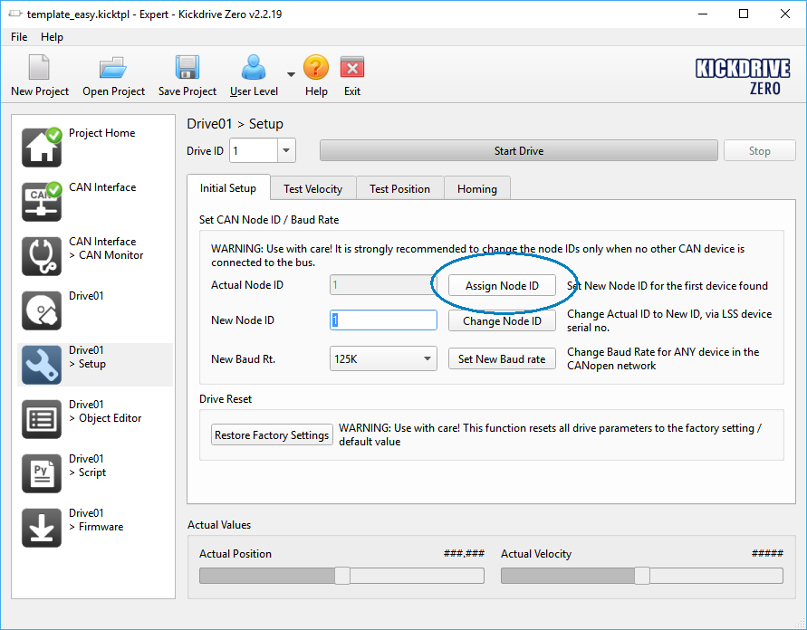
The Fullmo Playground demo (see fullmoPlaygroundDemoMovingCap349_en.pdf) for example requires Baud Rate = 125K and Node ID = 1.

A special feature of the MovingCap drives is the built-in Python application engine. To use it, switch User Level to Expert. The password is no secret and also expert.
Then go to the now available area Drive01 > Script and click Download. The Python example code for a simple left / right velocity operation is loaded into the drive and permanently stored.
 | The drive starts moving after completion of the download, also after supply voltage reset / reconnection.
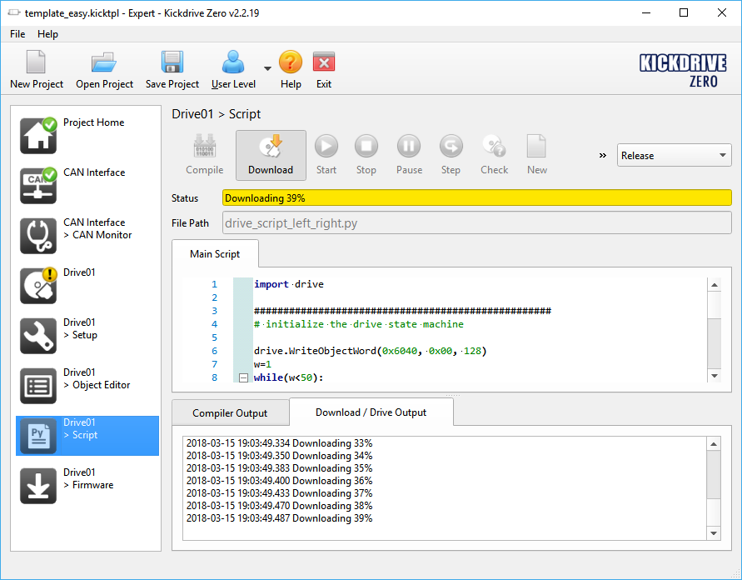
To delete the stored program, select New to create an empty script and perform Download again.
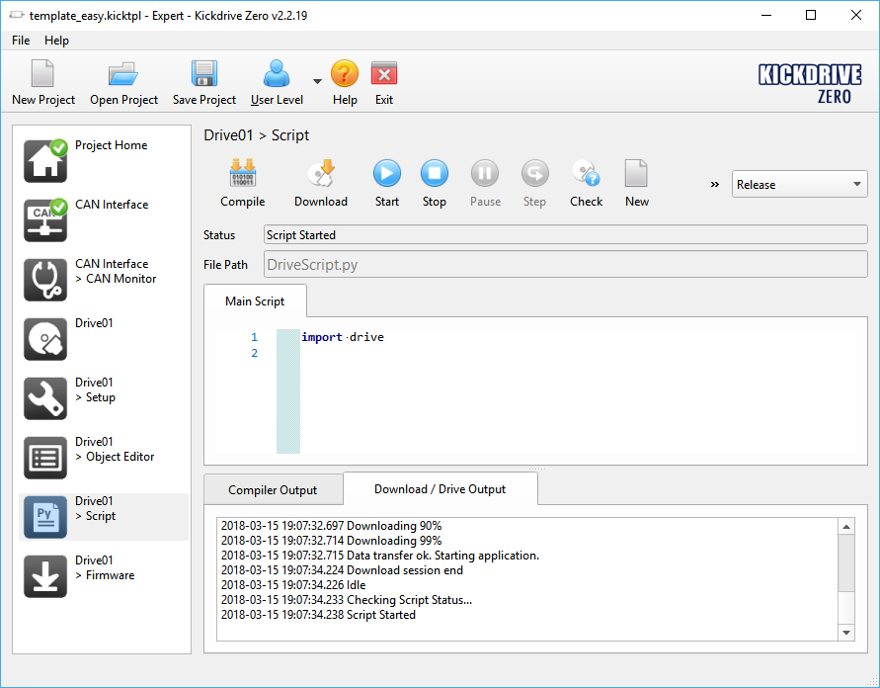
Another demo application for Python control is described in fullmoPlaygroundDemoMovingCap349_en.pdf.
The fullmo Kickdrive software offers complete drive parameterization and diagnostics including oscilloscope. More information can be found at https://kickdrive.de
This document and further documentation on MovingCap 349 can be found at: https://fullmo.de/rotative-antriebstechnik/

