Fix this profile!

Profile Audit: Be a privacy detective!
Below is a fictional online profile. It does not belong to a real person.
Your task: Highlight or circle everything that should be changed or hidden to stay safe online.

A Fictional Profile Example
Look into the image that represents the profile of Emma on some social platform.
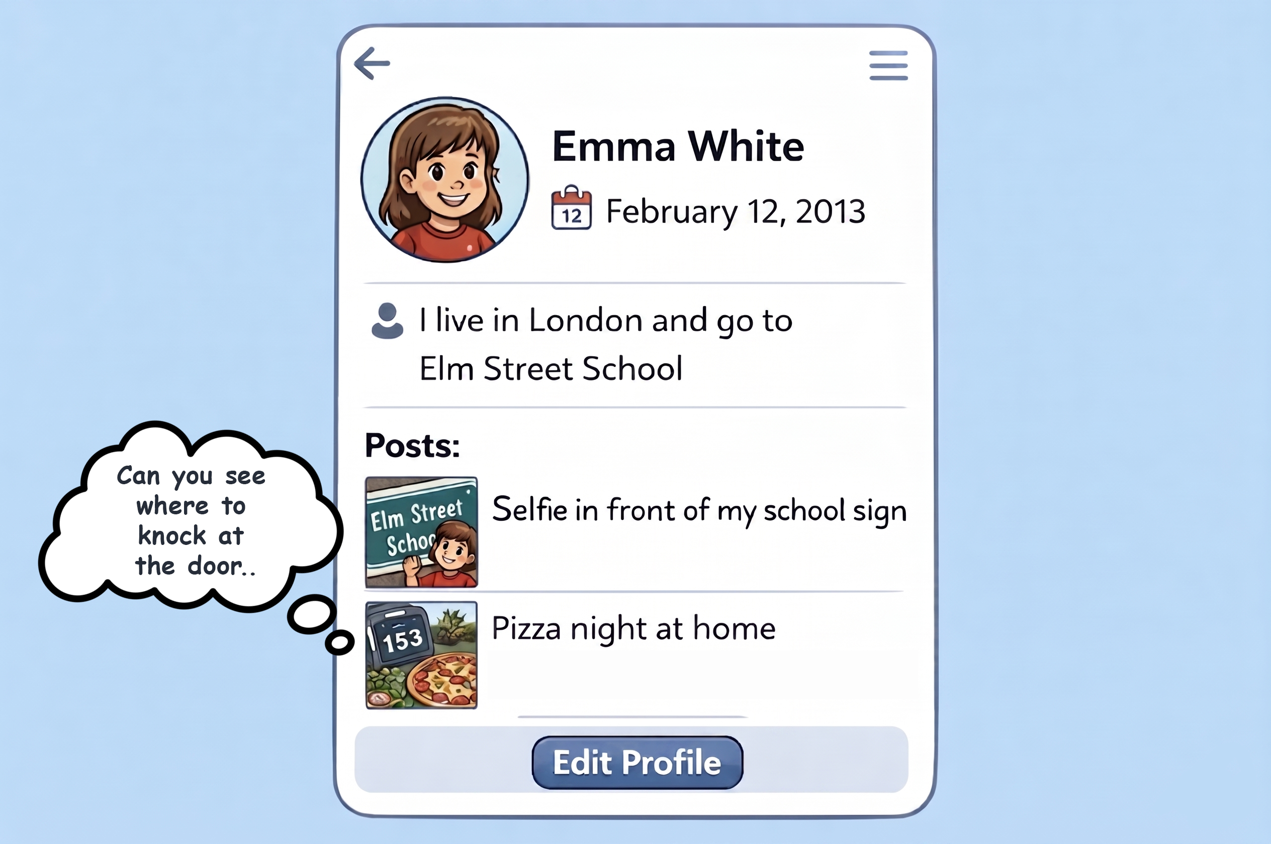
(Example picture created by ChatGPT)

Detective Questions
1) What information should be hidden or changed?
Write at least three things.

2) Why could this information be risky?

3) What could be the next steps to remove some digital traces and make her profile safer?

Remember:
A safe profile shares less, not more.

