Puzzle – Using Digital Traces “Members of the Brain Fights team”

Background information: Sun secondary school is preparing for the Brain Fight competition that is organised each year by students from several national universities. The competition will host 20 teams from secondary schools from all over the country. The team at Sun secondary school is very ambitious, and they would like to find out who they will compete with. By reviewing the information from online sources, the Sun school team were able to use digital traces to find out the profiles of the team members for the Moon secondary school, one of their competitors.

Task: Can you find out the profiles of the Moon secondary school team by solving this puzzle?

How to solve the puzzle: Read the digital traces text below and on Grid A, mark down facts using a plus sign and mark down things that are not facts with a minus sign. For example, according to the text Tom is very good in physics; thus, there should be a plus where the line of Tom and column of Physics intersect. Therefore, for other students Physics is a not a fact, and for Tom other subjects are not a fact. When you have completed Grid A then you can complete Table B. Table B will show you the profile of all of the Moon school team members and help you defeat them in the competition!

Digital traces text: Each team consists of five members. According to the summary about the team available on the organizers page, all members are of different age from 14 to 18 years old. According to the rules, the captain of the team is the oldest team member. Moon team has a female captain.

On the Moon school's website, there are photos from the recent contests where school students participated and achieved very good results. In one recent news piece, the caption under the photo says: "Our 16-year-old student Tom won the gold medal in the international Physics Competition". As the Moon team made a photo for the Mind Fight, when compared, the boy in the photo is the same as one of the members of the Moon Mind Fight team.

On social media, there is a list of Moon basketball men team members, all older than 15 years old as stated in the post last month. Among them, no one has first name initial L nor T. Moreover, they present themselves as heavily-STEM team with no one interested in Humanities or Languages.

On social media, Laura has a profile photo that shows her programming at the back computer terminal. Moreover, among her followed groups most are related to computing or programming, and she puts a like on every media post that presents a new technology. According to the social media, the 14-year boys of the schools have created a traveller club, their captain is a member of the team in the Mind Fights. Moreover, he coordinates school debates to promote national and foreign languages, being himself fluent in four languages.

After one of the Mind Fights the team posted: "Chemistry + Sport = Ice Skating!" According to the school rules, available on the school website, the ice-skating team members must be at least 16 years old.

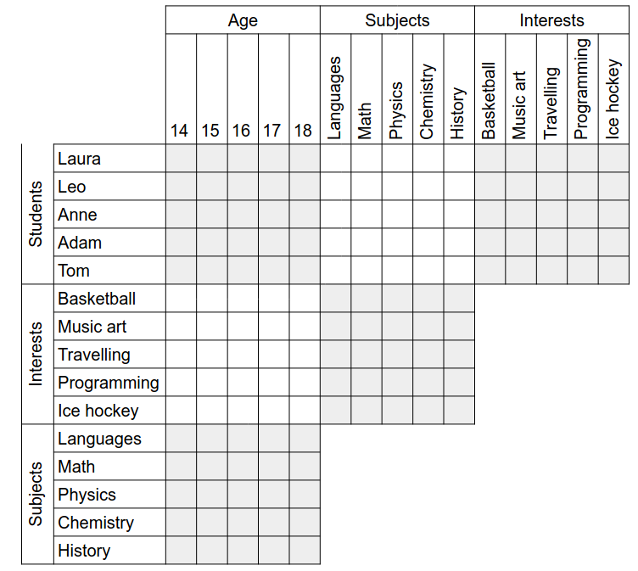
Grid A:

Table B:

 | Age | Subject | Interest
Laura
Leo
Anne
Adam
Tom

Captain: ________________

