Social Engineering: Dot-to-Dot Challenge
Student mission
You are exploring a Roblox-style game world. Some messages are safe, but others try to trick players into giving information, access, or money. Choose the safest or most accurate answer. Plot and connect the coordinate next to your answer. If your choices are correct, your route reveals a picture.

How to play:
• Start at position A (8, 18). For each question, choose A, B, or C.
• Draw a line from your current point to the corresponding coordinate. The first question (no. 1) has already been answered as an example. Question 1 had the answer A; thus, we moved to (14,18).
• After Question 12, lift your pencil and start again at position B (5,10) for Questions 13-15.
• When you finish, answer the reflection questions.
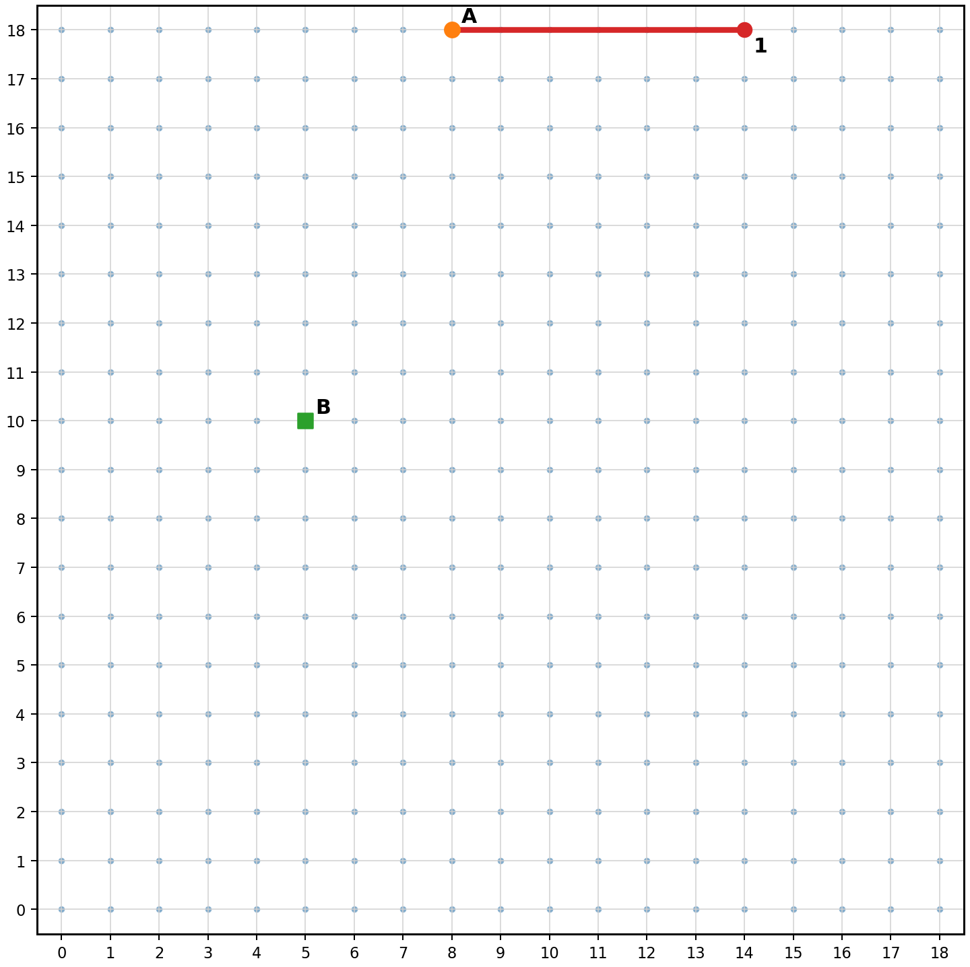

Question Route
Choose the best answer. Plot and connect the coordinate next to it.
Q1. A player writes in the game chat: "Free game currency today only! Click this link now." What is the best first thought?
A. It might be too good to be true; stop before clicking.  → (14, 18) | B. Click quickly before the offer ends.  → (8, 14) | C. Share it with the class group first.  → (12, 16) | My choice: ____

Q2. A message says: "Your account will be deleted in 5 minutes. Send your password to support." Which tactic is being used?
A. Friendliness  → (13, 15) | B. Urgency and fear  → (17, 16) | C. Teamwork  → (16, 18) | My choice: ____

Q3. Someone called "Official Game Helper" asks for your login code. What is the attacker most likely trying to get?
A. Access to your account  → (17, 11) | B. A normal game tip  → (18, 14) | C. Your opinion about the game  → (15, 13) | My choice: ____

Q4. A player says: "Give me your password and I will level up your character." What is the safest response?
A. Give the password, but change it later.  → (16, 9) | B. Do not share it; use Stop-Think-Check-Ask.  → (15, 7) | C. Ask them to promise they are honest.  → (18, 8) | My choice: ____

Q5. A known game friend suddenly writes in a different style and asks you to buy a gift card. What should you remember?
A. Familiar accounts can still be unsafe if they are hacked.  → (12, 4) | B. Known names are always safe.  → (14, 5) | C. Gift cards are not money.  → (16, 6) | My choice: ____

Q6. You receive: "Open this secret game update before everyone else." Which warning sign should you notice?
A. A normal update is always sent by random players.  → (11, 2) | B. Curiosity and an unexpected link are being used.  → (8, 2) | C. Secret updates make accounts safer.  → (10, 5) | My choice: ____

Q7. A player asks for your school email so they can "add you to a special winners list". What goal does this suggest?
A. Better teamwork only  → (7, 5) | B. Exercise  → (6, 3) | C. Information  → (4, 4) | My choice: ____

Q8. A pop-up says: "Pay 5 euros now to unlock a rare item. This offer ends in 60 seconds." What goal is most likely involved?
A. Money or in-game value  → (1, 7) | B. Homework help  → (3, 5) | C. A school project  → (2, 9) | My choice: ____

Q9. A player pretends to be a moderator and says you must obey because they are "in charge". Which tactic is this?
A. Authority  → (0, 11) | B. Relaxation  → (2, 11) | C. Creativity  → (1, 9) | My choice: ____

Q10. You are unsure whether a message is real. Which action best matches CHECK?
A. Click once to test it.  → (1, 14) | B. Look for warning signs and verify using an official source.  → (0, 16) | C. Reply quickly so you do not miss out.  → (3, 16) | My choice: ____

Q11. A friend is about to click a suspicious link in a group chat. What is a responsible helper action?
A. Forward it to more people.  → (5, 18) | B. Click it first to see what happens.  → (2, 17) | C. Warn them not to rush and suggest checking with an adult or official source.  → (3, 18) | My choice: ____

Q12. Which sentence best describes social engineering?
A. When someone tricks or persuades people to give information, access, or money.  → (8, 18) | B. Only when someone breaks a computer with code.  → (6, 17) | C. Only a joke in online games.  → (10, 16) | My choice: ____

Q13. Check route: What should you do first when a message makes you feel rushed?
A. Stop and pause before reacting.  → (7, 8) | B. React faster.  → (5, 7) | C. Send your details quickly.  → (8, 9) | My choice: ____

Q14. Check route: What should you THINK about before replying?
A. "Why is this person asking me for this?"  → (10, 12) | B. "How fast can I reply?"  → (9, 10) | C. "Will this make me look cool?"  → (8, 12) | My choice: ____

Q15. Check route: Who could you ASK if you are unsure?
A. A trusted adult, teacher, parent, or official support channel.  → (14, 15) | B. Only the person who sent the message.  → (12, 14) | C. A random player in the same game.  → (13, 12) | My choice: ____

Reflection:

- What picture did your route create?

- Write three social engineering warning signs from the questions.

- Choose one scenario. Explain what the attacker wanted: information, access, or money.

- Which step helps you most: Stop, Think, Check, or Ask? Why?

