git diff

* It compares staging area with working dir.

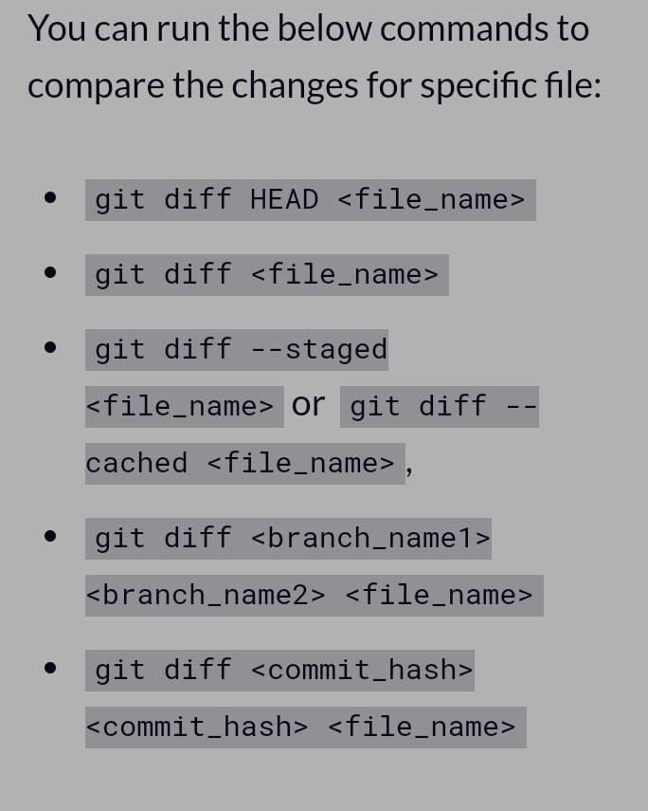

BIJAY@DESKTOP-LT4QQ47 MINGW64 /f/Git_repo (master)

$ git status

On branch master

Changes to be committed:

(use "git restore --staged <file>..." to unstage)

new file: static/new.txt

modified: terminal.docx

deleted: ~$rminal.docx

BIJAY@DESKTOP-LT4QQ47 MINGW64 /f/Git_repo (master)

$ git log

commit a66385766f22fb45bb1f50d9285c7505be3e31ef (HEAD -> master)

Author: KidOfCoding <myofficial97531@gmail.com>

Date: Sun Jun 18 14:19:36 2023 +0530

previous commit was a mistake, finally now we finished our work with .gitignore

commit 0ae5f30e948077f407490be0707493ddb3ed12f7

Author: KidOfCoding <myofficial97531@gmail.com>

Date: Sun Jun 18 14:11:37 2023 +0530

finished work with .gitignore

commit 5539f6c301b0d4455868b4adba323a53bdc9560a

Author: KidOfCoding <myofficial97531@gmail.com>

Date: Sun Jun 18 13:43:18 2023 +0530

Added .gitignore

commit 8d3e9f256dc5baa720f7976ac6df2411a9d3a646

Author: KidOfCoding <myofficial97531@gmail.com>

Date: Sun Jun 18 13:26:49 2023 +0530

without .gitignore

BIJAY@DESKTOP-LT4QQ47 MINGW64 /f/Git_repo (master)

$ git diff --staged

**diff --git a/static/new.txt b/static/new.txt**

**new file mode 100644**

**index 0000000..7b6a617**

**--- /dev/null**

**+++ b/static/new.txt**

@@ -0,0 +1,2 @@

+let's know git diff.

+I am going to modify you.

\ No newline at end of file

**diff --git a/terminal.docx b/terminal.docx**

**index aba4615..bf72b41 100644**

**--- a/terminal.docx**

**+++ b/terminal.docx**

@@ -1,2 +1,399 @@

.gitignore

+# without .gitignore

+

+BIJAY@DESKTOP-LT4QQ47 MINGW64 /f/Git_repo

+$ git init

+Initialized empty Git repository in F:/Git_repo/.git/

+

+BIJAY@DESKTOP-LT4QQ47 MINGW64 /f/Git_repo (master)

+$ git add --a

+

+BIJAY@DESKTOP-LT4QQ47 MINGW64 /f/Git_repo (master)

+$ git status

+On branch master

+

+No commits yet

+

+Changes to be committed:

+ (use "git rm --cached <file>..." to unstage)

+ new file: myexcel.xlsx

+ new file: normal.txt

+ new file: terminal.docx

+

+

+BIJAY@DESKTOP-LT4QQ47 MINGW64 /f/Git_repo (master)

+$ git commit -m "without .gitignore"

+[master (root-commit) 8d3e9f2] without .gitignore

+ 3 files changed, 21 insertions(+)

+ create mode 100644 myexcel.xlsx

+ create mode 100644 normal.txt

+ create mode 100644 terminal.docx

+

+BIJAY@DESKTOP-LT4QQ47 MINGW64 /f/Git_repo (master)

+$ git status

+On branch master

BIJAY@DESKTOP-LT4QQ47 MINGW64 /f/Git_repo (master)

$ git --staged .gitignore

unknown option: --staged

usage: git [-v | --version] [-h | --help] [-C <path>] [-c <name>=<value>]

[--exec-path[=<path>]] [--html-path] [--man-path] [--info-path]

[-p | --paginate | -P | --no-pager] [--no-replace-objects] [--bare]

[--git-dir=<path>] [--work-tree=<path>] [--namespace=<name>]

[--config-env=<name>=<envvar>] <command> [<args>]

BIJAY@DESKTOP-LT4QQ47 MINGW64 /f/Git_repo (master)

$ git diff --staged .gitignore

**Finished**