**ITE441 Database Management Systems**

**Final Project**

**‘Netflix’**

**Team members**

Karnsiree Karnka 2010160003

Watsamon Phongwanit 2010160002

Phonpraweena Kilangpradith 1901160037

**Introduction**

Netflix is the world’s leading media streaming platform, operating in nearly every country in the world. It offers an online streaming service of popular movies, TV shows, and documentaries that users can watch over the internet with hundreds of millions of subscribers around the world.

Our group chose to make a data model of ‘Netflix’ out of curiosity as we want to brainstorm what data would such a huge streaming service collect in their database.

We create the data model of Netflix according to these steps:

1. Design a Mini world
2. Draw an ER Diagram
3. Collect data for each attribute
4. Make Relational Schema
5. The forward engineer from ER diagram to create Schemas in My SQL
6. Use SQL commands to demonstrate database functionality

**Data Requirements**

1. **Miniworld**

To create a mini world, we researched and studied the type of data stored in the database of a website known as Netflix

After that, we came up with 6 main entities along with their attributes:

| **Entity** | **Attributes** |
| --- | --- |
| Tv shows/movies | · Movie ID  · Movie title  · Rating  · Release date  · Status (Seasons, Episodes)  · Popularity |
| Genre | · Genre ID  · Gender name |
| Cast | · Cast ID  · Movie ID  · Gender  · Character name  · Cast name |
| Customer user account | · Customer ID  · Profile name  · Name (First name, Last name)  · Login (Email, Password)  · Credit card number  · Phone number |
| Payment | · Payment ID  · Payment method  · Payment date  · Amount paid |
| Subscription | · Payment ID  · Subscription type  · Subscription date  · Price |

1. **ER Diagram**

Next step, we draw an ER diagram to label a relationship between each entity.

The primary key is the unique data of each entity were represented by underlining and the relationships are visually mapped.

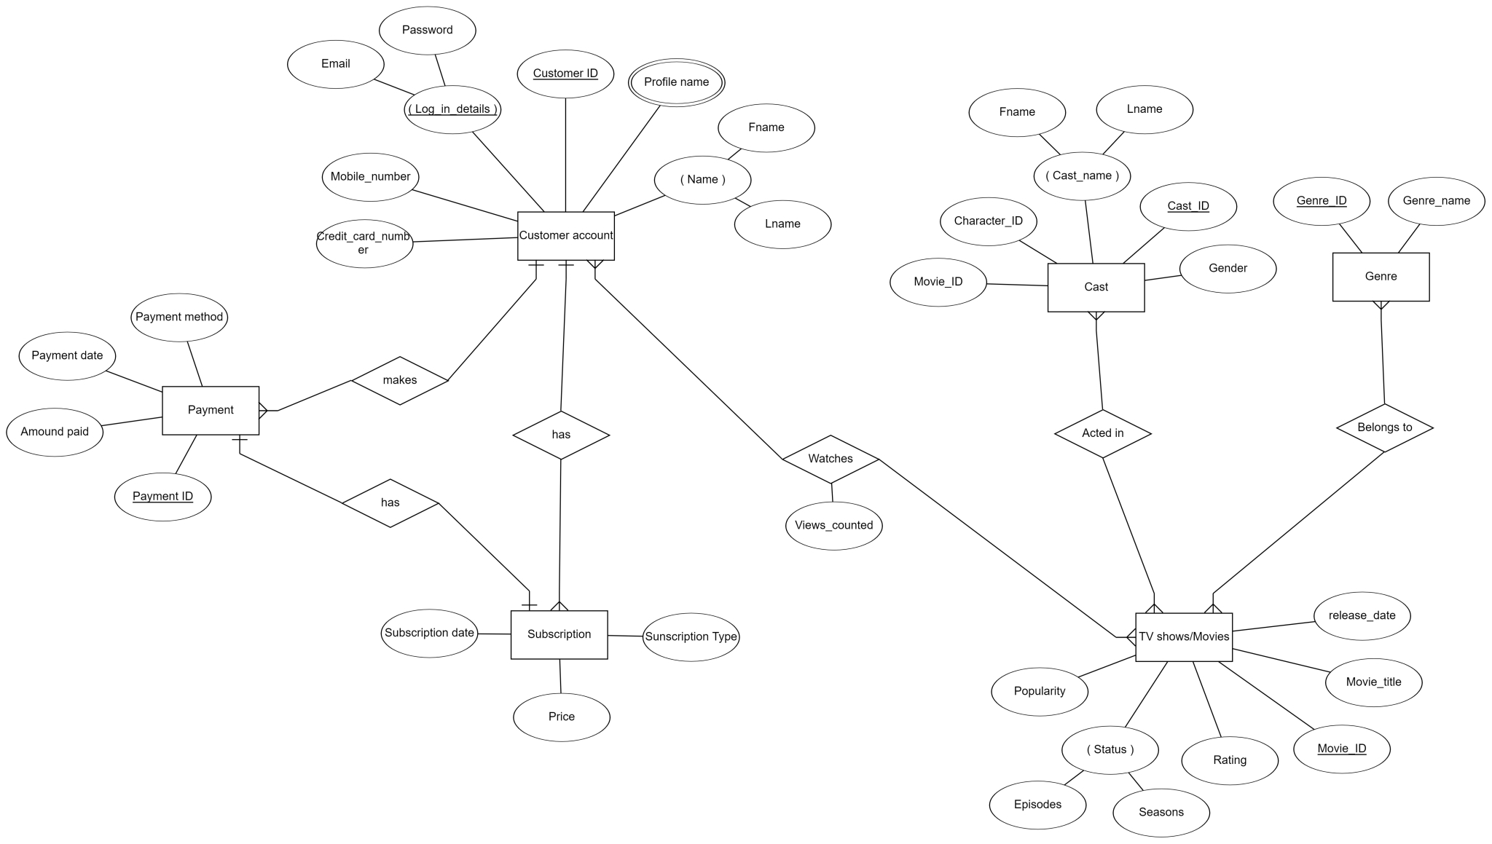

1. **Relational Schema**

Next, we convert our ER diagram in to relational schema to show the relationship even more straightforward

The foreign key and the new table that was created from the N-M relationship between entities were shown in this data model.

รูปภาพประกอบด้วย โต๊ะ

คำอธิบายที่สร้างโดยอัตโนมัติ

1. **Schemas in My SQL**

We created the same ER diagram in SQL workbench.

After forward engineering, schemas were built.

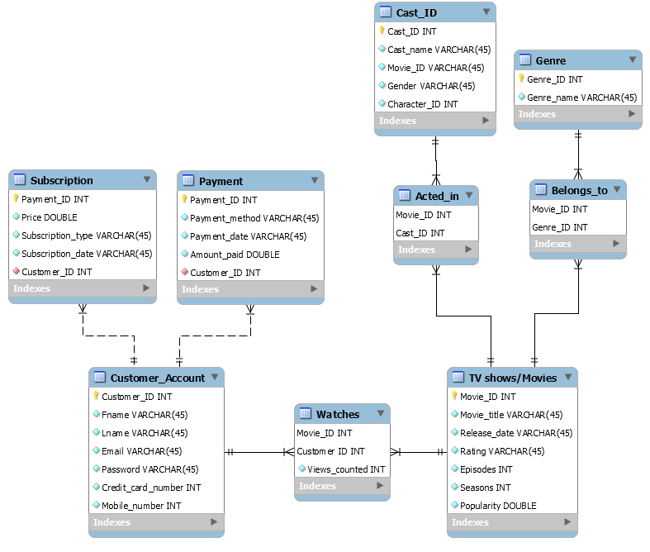

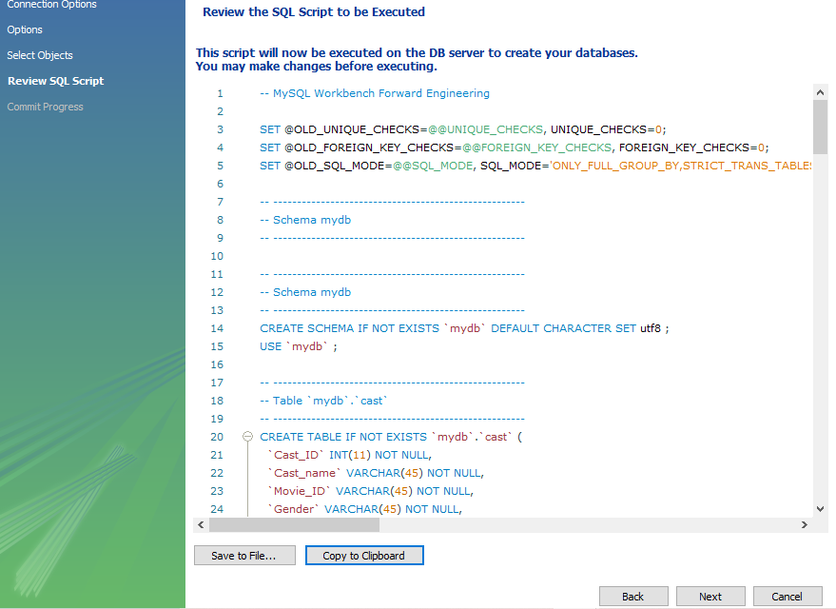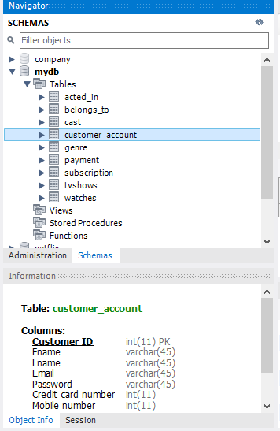

**Database**

These are the data that we input into the database of our 6 main entities

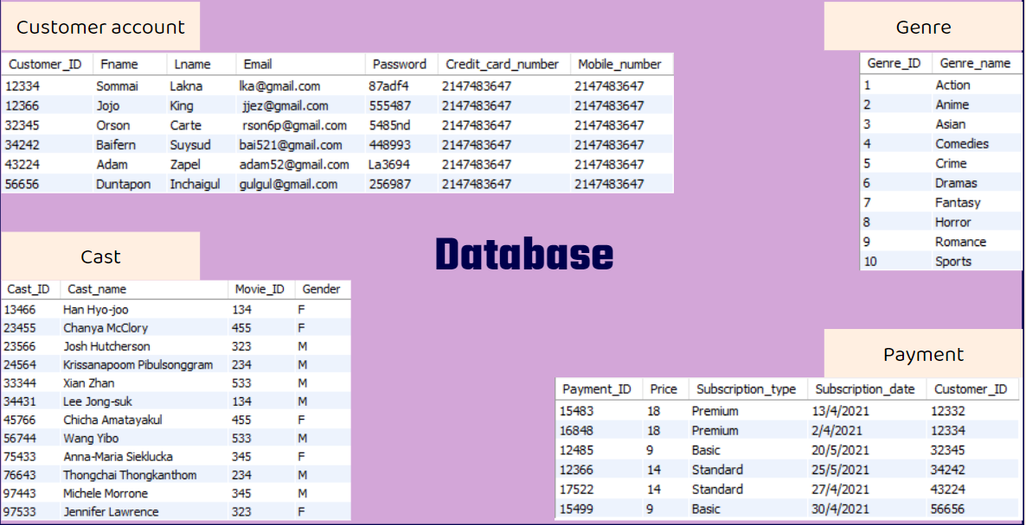

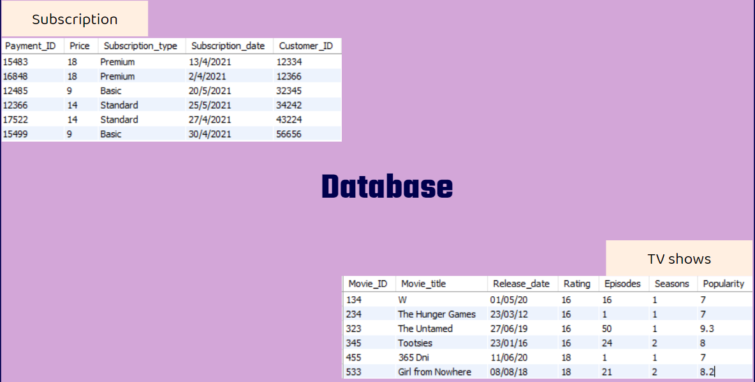

1. **SQL Commands**

After we input the data into the workbench, we were able to type in SQL commands to get the information we wanted from the database.

Test 1:

In the first test, we typed in a command to find the customer that has the first name ‘Sommai’.

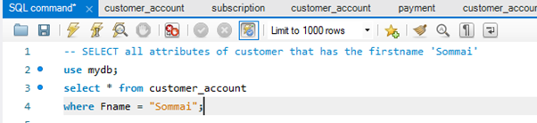

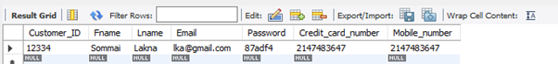

Test 2:

In this one, we want to find the names of movies that have a popularity >= 5.

Five movies showed up in the result and all of them met the conditions that we typed into the command.

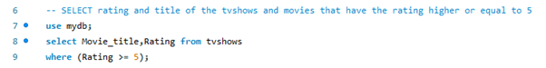

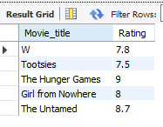

Test 3:

This one is slightly more complex, we want to find the full name of a customer that has subscribed to the standard package.

We need information from both the customer account table and subscription table.

Foreign keys ‘Customer ID’ was used to link these two tables.

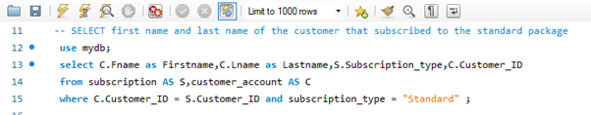

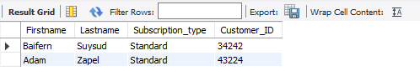

Test 4:

This is the last command that we tried out, we want to find the main cast name and gender that acted in the movie title called ‘The Untamed’.

Two main cast names showed up correctly with their gender information.

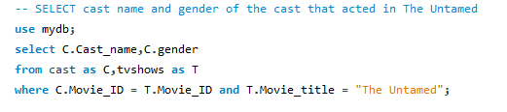

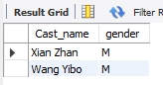

As all the results met the conditions that we typed into the command and matched with the data that we input into the database.

Thus, we can conclude that our database works correctly.

**Discussion & Conclusion**

Most of the problems that we encountered were My SQL Workbench related.

We had trouble doing the forward engineer process as the script seemed to have an error. To fix that, we tried to google the error code to find out which lines of the script caused the problem and then deleted them.

Another major problem that we encountered was about naming the primary keys. We forgot to put ‘_’ between the names and used a space bar instead, because of that, our first try to write SQL commands didn’t work out as the program can’t recognize the attribute names with space bars in between.

The solution that we came across was to rename the keys during the ER diagram process before forward engineering it into schemas.

What we can improve in our next project is to learn to be more careful and thoroughly check our work in each process before proceeding to the next step to prevent such errors from happening again.