全卷各分数段人数

|  |  |  |  |
| --- | --- | --- | --- |
| 分段说明 | 分段人数 | 分段率 | 累计分段率 |
| 0 | 10 | 0.01 | 0.01 |
| 1-9 | 443 | 0.5 | 0.51 |
| 10-19 | 3640 | 4.08 | 4.59 |
| 20-29 | 6574 | 7.37 | 11.96 |
| 30-39 | 6608 | 7.41 | 19.37 |
| 40-49 | 7498 | 8.41 | 27.77 |
| 50-59 | 9787 | 10.97 | 38.75 |
| 60-69 | 12378 | 13.88 | 52.62 |
| 70-79 | 14642 | 16.42 | 69.04 |
| 80-89 | 15480 | 17.36 | 86.39 |
| 90-99 | 11864 | 13.3 | 99.7 |
| 100 | 272 | 0.3 | 100 |

客观题各分数段人数

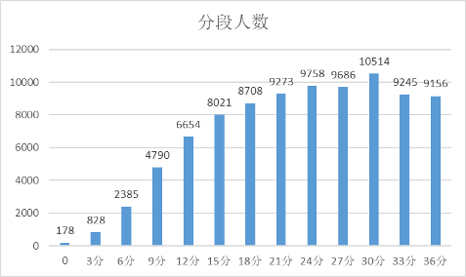

主观题各分数段人数

