

**E-Healthcare Online Consultation and Medical Subscription System**

A Capstone Project 2 by

Emilio Sanchez

Dave Q. Villegas

Sonny M. Santiago

Submitted to the Undergraduate Programs

Trimex Colleges - Biñan, Laguna

In Partial Fulfillment of the Requirements for the Degree

Bachelor of Science in Information Technology

**NOVEMBER 2021**

#### ACCEPTANCE AND APPROVAL SHEET

This THESIS/CAPSTONE Project entitled **“E-HEALTHCARE ONLINE CONSULTATION AND MEDICAL SUBSCRIPTION”** prepared and submitted by **Emilio Sanchez, Dave Q. Villegas and Sonny M. Santiago** in partial fulfillment of the course requirements for the Degree of Bachelor of Science information Technology was examined and recommended for acceptance and approval.

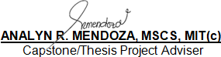

**PANEL OF EXAMINERS**

Defended in an Oral Examination before a duly

constituted panel with a grade of 2.00 on November 2022.

**CARLO A. BATITIS, MIT(c)**

Lead Panel

**Dr. LOUIE F. AGUSTIN Dr. RITO A. CAMIGLA, Jr.**

Member Member

Accepted and approved in partial fulfillment of the requirements for the Degree of Bachelor of Science information Technology

**CARLO A. BATITIS, MIT(c) Dr. RITO A. CAMIGLA, Jr.**

OIC - CCS VP for Academic & Student Affairs

**DEDICATION**

Keep your dreams alive. Understand to achieve anything requires faith and belief in yourself, vision, hard work, determination, and dedication. Remember all things are possible for those who believe.

**ACKNOWLEGEDMENT**

The researchers would like to thank first and for most the Lord God Almighty for His never ending grace; Our Teachers for giving us the knowledge and advice to finish this project with ease and also to our loving parents who are always there for financial support and they were the ones who showered us with encouragement in order for us to really do our best on this project. Without these, this project wouldn’t be successful or possible. That’s why we would like to say, Thank you and May God Almighty bless us all.

**TABLE OF CONTENTS**

Title Page i

Approval Sheet ii

Acknowledgement iii

Dedication iv

Abstract v

Table of Contents vi

List of Figures vii

List of Tablesviii

**Chapter 1: THE PROBLEM AND ITS SETTING**

* 1. Introduction and Background of the Study 1
  2. Statement of the problem 3
  3. General and Specific Objectives 4

1.3.1 General Objectives 5

1.3.2 Specific Objectives 5

1.4 Significance of the Study 6

1.5 Scope and Delimitations of the Study 7

1.6 Definition of Terms 8

1.7 Conceptual Framework 8

**Chapter 2: THEORETICAL FRAMWORKS**

2.1 Review of Related Literature 9

2.2 Gaps Bridged by the Present Study 9

**Chapter 3: OPERATIONAL FRAMEWORK**

3.1 Materials 10

3.1.1 Software 10

3.1.2 Hardware 11

3.1.3 Data 11

3.2 Methods 12

3.2.1 Experimental Design 12

3.2.2 Procedures for the different phases 13

3.2.3 Evaluation 14

**Chapter 4: RESULT AND DISCUSSION**

4.1 Results by phase of Study 15

4.2 Verification studies 16

**Chapter 5: SUMMARY OF FINDINGS, CONCLUSIONS, AND RECOMMENDATIONS**

5.1Summary of Findings 17

5.2 Conclusions 17

5.3 Recommendations 18

**REFERENCES** 19

**APPENDICES** 20

Appendix A 20

Appendix B 21

Appendix C 22

Appendix D 23

Appendix E (Curriculum Vitae) 24

**LIST OF FIGURES**

**PAGE**

**Fig: 1**  Conceptual Framework

**Fig: 2** Software Development 58

**Fig: 3** System Archetecture 61

**Fig: 4** Network Infastracture 63

**Fig: 5** Database Schema 64

**Fig: 6** Admin Module 65

**Fig: 7** Patient Module 66

**Fig: 8** Login 66

**Fig: 9** Patient Appointment 79

**Fig: 10** Accept & Decline 80

**Fig: 11** Live Chat 80

**Fig: 12** Proof & Receipt 81

**Fig: 13** Admin Management 82

**Fig: 14** Database 83

**Fig 15** Web Based Subscription & Description 85

**LIST OF TABLES**

**PAGE**

**Table: 1** Interview Questionnaire 58

**Table: 2** Hardware Specification 60

**Table: 3** Software Specification 60

**Table: 4** Test Matrix 70

**Table: 5** Test Plan for Admin Module 71

**Table: 6** Test Plan for Patient Module 72

**Table: 7** Doctors Module 73

**Table: 8** Linkert Scale 76

**ABSTRACT**

The Internet has been a steady source of medical data previously; it has just as of late been utilized for online private patient-doctor consultations. As of late, the market has seen a surge in applications providing healthcare services on the go. An online consultation has secured a foothold in the market and individuals are opening up to the likelihood of substituting a visit to a physical facility with an online option. This study reports a review of the literature on online medical consultation from various databases as well as various surveys and reports published. As per published work/reports/surveys, the various factors which led to a sudden surge in the online medical consultation are the convenience, shift in disease patterns, cost-effective, privacy and second opinion.

**Chapter 1**

**THE PROBLEM AND ITS SETTING**

**1.1 Introduction and Background of the Study**

In terms of providing treatment facilities and medical assessments, healthcare and healthcare professionals such as physicians have become an important part of everyone's life. Any person with a health condition would visit a doctor's clinic for a check-up and a prescription. Doctor and patient communication are one of the important things to increase patient satisfaction.

Communication between the doctor and the patient may be used to measure a variety of factors, including patient satisfaction. One factor that contributes to improved patient satisfaction is the length of the appointment. During consultations and seeking doctors' assistance during late hours, patients can find it difficult, as there are typically no clinical doctors available in the area. Doctors do not want to lose their clients or patients, so they strive to provide quality treatment and service to them.

The researchers will develop an E-healthcare Online Consultation and Medical Subscription System for Dra. Erlinda Breva Fernandez, Dra. Romero, and Dr. Dandie De Mesa that will enable them to continue providing healthcare to their patients while also providing them with a detailed and reliable consultation and prescription through online.

**1.2 Statement of the problem**

How to create a system that will provide an E-healthcare online consultation and medical subscription.

Specific Problems:

* How to develop a system that the doctors and patients can easily access to an e-healthcare online consultation and medical subscription?
* How to develop a system that the administrator, doctors, and patients can register and log in?
* How to develop a system where patients can make an appointment for online doctor consultations to have a medical prescription?
* How to develop a system that the doctors can accept or decline patient appointment requests?
* How to develop a system that the doctor and a patient can communicate through the use of live chat?
* How to develop a system that the users can upload, save, print and send images and medical prescription into email and chat?
* How to develop a system where the admin manages the users account and delete accounts and data if needed?
* How to develop a system that has a database for patient records and other data?

**1.3 General and Specific Objectives**

**1.3.1 General Objectives**

The main objective of the study is to design and develop a system that will provide E-healthcare online consultation and medical subscription.

* + 1. **Specific Objectives**
* To design and develop a system that the doctors, and patients can easily access to an e-healthcare online consultation and medical subscription.
* To design and develop a system that the administrators, doctors, and patients can register and log in for online consultation.
* To design and develop a system where patients can make an appointment for online doctor consultations to have a medical prescription.
* To design and develop a system that the doctors can accept or decline patient appointment requests.
* To design and develop a system that the doctor and a patient can communicate through the use of live chat.
* To design and develop a system that users can upload, save, print and send images and medical prescription into email.
* To design and develop a system where the admin manages the users’ accounts and deletes accounts and data if needed.
* To design and develop a system that will have a database for patient records and other data.

**1.4 Significance of the Study**

This study is being created to benefits the following:

* **Proponents.** The proposed study will benefit the proponent to obtain a degree after completing it. Knowing that it will take such a lot of time to complete, it will give a sense of achievement.
* **Doctors.** The proposed system will benefit and assist doctors in continuing to offer services to their patients as well as delivering comprehensive and accurate appointments and prescriptions through the internet.
* **Family.** The proposed system will benefit and assist families with health issues in having a convenient and secure online consultation with a doctor.
* **Future researchers.** Future researchers will benefit from the proposed study because it will provide them with references for related studies or literature to be used in their research study.
  1. **Scope and Delimitations of the Study**

The study has the following features and limitations.

**Scope of the Study**

* The proposed system will allow the doctor and the patient to have an online consultation through Internet and communication technology.
* The proposed system enables communication between doctors and patients through online live chat.
* The proposed system will allow users to upload, save, print, send, and receive images of patients' health status and prescriptions.
* The proposed system will allow clinic personnel to manage data.
* The proposed system enables the administrator to create new users and recover accounts that have been forgotten.

**Limitation of the Study**

* The proposed system will only be accessible through the internet.
* The doctor has to be online to assist the patient.

**1.6 Definition of Terms**

To provide the reader with a clear understanding of the terms used in the study, the following terms are defined as conceptual and operational.

* **Administrator**- The person in charge of monitoring and managing the system's processes.
* **Analysis-** A thorough examination to learn about its components, what they do, and how they are related to one another.
* **Consultation-** A meeting with a professional to take advice and discuss a problem.
* **Chat-** Real-time communication between two or more users via networked-connected computers, where the user can type a message that appears on the monitors of all other participants.
* **Database-** A collection of organized information that can be easily accessed, managed, and updated.
* **Download-** The process of transferring one or more files from a remote computer to a local computer.
* **E-mail-** Refer as electronic mail, the exchange of messages between users who have access to the same system who are connected through the use of the internet.
* **E-healthcare-** The use of information and communication technologies in healthcare.
* **Healthcare-** Doctors and assistants who work with patients to diagnose and treat health issues.
* **HTML-** (HyperText Markup Language) is the most fundamental building block of the Web.
* **Medical Subscription -** Referred as a medical prescription. A doctor's prescription medicine instruction to a patient and pharmacist.
* **Microsoft Office Access-** Is a database management system from Microsoft.
* **Online Consultation -** Refer as e-Consultation. A consultation between physician and patients through the use of internet.
* **Physician**- A licensed doctor who diagnoses health problems and prescribes medication to patients.
* **PHP** (Recursive acronym for PHP: Hypertext Preprocessor)- is a popular open source general-purpose scripting language that can be embedded in HTML and is well-suited for web development.
* **System-** Is a collection of elements or components that are grouped together for a specific purpose.
* **Webpage-** Is a document that is typically written in HTML and is viewed in an Internet browser.

**1.7 Conceptual Framework**

Requirement Analysis

Design

Coding

Testing

Deployment

Maintenance

**E-Healthcare Online Consultation**

**and**

**Medical Subscription System**

**OUTPUT**

**PROCESS**

**(SDLC)**

**Knowledge Requirements:**

* Doctor’s Information
* Consultation
* Medical Prescription
* Payment Process

**Software Requirements:**

* Visual Studio
* Microsoft Access
* Adobe Photoshop

**Hardware Requirements:**

* Computer unit or Laptop
* With 4gb up
* With 250gb HDD

**INPUT**

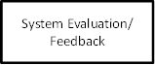

**Figure 1: Conceptual Framework**

the doctors to find out if he is licensed so we can rest assured to consult with him. and medical prescription and there are also software requirements php, ms access hardware and the requirements of the computer unit is with 4gp up and 250gb hdd. in the process of requirements analysis, design, coding, testing, deployment and maintenance and the subscription will go to the output for the patient to pay the doctors

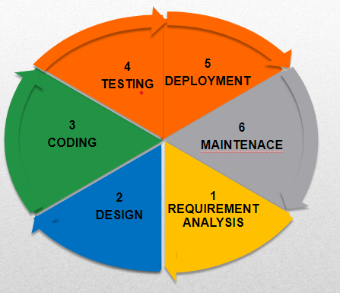

**Chapter 2**

**THEORETICAL FRAMEWORK**

**2.1 Review of Related Literature and Studies**

This chapter provides a summary of related literature and studies that the researchers performed in order to provide insight into the study's theoretical context. The researchers will be directed and assisted in gathering useful data by reviewing relevant materials.

**2.1.1 Review of Related Literature (Foreign)**

**E-healthcare**

According to Ossebaard, H. C et al (2016) [1] in E-Health and quality in health care: Implementation time. The use of Information and communication technologies in health and health care could increase healthcare quality. The existing evidence base shows that online education, self-management assistance, and tele-monitoring are cost-effective in a number of health and care domains. It is essential to strengthen implementation strategies in order to scale up eHealth technologies. This will hasten the much-needed transformation of healthcare systems, ensuring future access, sustainability, and efficiency for everyone.

According to Ariani A. et al.(2017) [2] in Innovative healthcare Applications of ICT for developing countries. Globally, there is a growing demand for a reliable, effective, and dependable healthcare delivery system, especially in developing countries with large populations and inaccessible areas. The use of information and communication technology (ICT) [3] to deliver healthcare services, particularly eHealth and its subcategory mHealth, has tremendous potential to reduce costs, advance health information exchange, and enhance healthcare access, as well as public and personalized medicine.

According to Susanto H. and Chen C.K (2017) [4] in Information and Communication Emerging Technology: Making Sense of Healthcare Innovation. E-health is a stage in which information and communication technology (ICT) is used to connect different clients. The internet promotes public health and clinical care, and it is easily accessible and capable of improving electronic health for healthcare organizations at all levels, including regional, community, and individual levels. The electronic medical record, which includes patient information and is accessible by healthcare professionals, is one aspect of e-Health. The management and maintenance of the server should also be monitored because it has an impact on many aspects of information technology. Using technology, administrative personnel can also keep track of their patients' clinical records and organize their financial management.

**Online Consultation**

According to Guo X. et. al.(2016) [5] in Online Healthcare Community Interaction Dynamics. With the growing issue of rapidly increasing global demand for healthcare services, often in the context of limited resources, determining how to creatively allocate and use healthcare services across a large population has become a major concern. Online consultation is being considered as a potential ICT-based partial solution. In contrast to traditional healthcare, online doctor-patient interaction is limitless in terms of time and space, whereas an online consultation is accessible to the entire community. In the long run, these characteristics are essential for achieving doctor and patient interaction and community development.

According to Almathami H.Y, et. al.(2020) [6] in Barriers and Facilitators That Influence Telemedicine-Based, Real-Time, Online Consultation at Patients’ Homes: Systematic Literature Review. Information and communication technology (ICTs) are being used by healthcare providers to improve their services. An online consultation is the term for this type of communication. ICT enabled health care systems that allow patients to exchange, upload, and communicate data or information in real time with a care provider, usually a physician at a clinical location, from the comfort of their own homes. However, external and internal factors may have a positive or negative impact on the use of online consultation services. External factors include both the system's environment and the system itself, while internal factors include user actions and motivation. External refers to the factors that affect users' acceptance and use of the health online consultation service, such as the environment in which it is used and the system itself. This includes the online consultation system's technical capabilities as well as the patient and clinician's user capabilities. Internal refers to the users' motives and attitudes when using and communicating with the device, which are essential factors in patients' acceptance of this technology. Patients' views and expectations of the relative benefits and costs of health online consultation system service over primary healthcare practices are one of these factors.

According to Hamza M.,et.al (2020) [7] in Doctor–patient communication in surgical practice during the coronavirus (COVID-19) pandemic.COVID-19 is a new respiratory disease that has spread throughout the world. Hospitals are now a breeding ground for this disease, and patients are advised to avoid them as much as possible. Corona virus 19 has infected a large number of healthcare workers. Furthermore, patients with compromised immune systems are more vulnerable to this potentially fatal contagious disease. Recommendations for social and home isolation to limit coronavirus spread are major factors limiting patients' communication with doctors about their disease. This has prompted them to consider an alternative safe form of doctor and patient communication that is not harmful to doctors, patients, or communities, and is also practical and affordable for the majority of people. Individuals can send and receive electronic communications such as phone calls, text messages, photos, videos, and voice messages. Patients can consult their doctor online and share photographs of infected or diseased body parts, which can provide a visual clue to the doctor treating their patient. This strategy will reduce the number of patients who visit hospitals, freeing up time, manpower, and resources for more serious cases. Furthermore, it will limit the spread of coronavirus. This strategy also enables doctors to work from home, eliminating the need for unnecessary hospital duties.

**Medical Subscription**

According to Omotosho A. et. al (2017) [8]  in Electronic Prescription System for Pediatricians. The electronic prescription system includes a knowledge base that contains drug information and a formulary. It gives the pediatrician access to the patient's electronic health record prior to issuing a prescription. The system was presented and developed using Microsoft Office Visio 2007, PHP, and My SQL database server. The system's implementation results demonstrated that it is capable of reducing common prescription errors because the most informed prescription is generated for the child electronically.

According to Kenawy A. S.et. al (2019) [9]  in their journal entitled, the impact of electronic prescription on reducing medication errors in an Egyptian outpatient clinic. Outpatient clinic in Egypt is using electronic prescription to reduce errors in medication of patients. Electronic prescribing has the potential to reduce errors in prescribing and dispensing associated with the use of handwritten prescriptions in the Egyptian outpatient clinic. However, more advanced and trusted systems are likely to be required for a more efficient effect on error rates and pharmacy workflow.

According to Oktarlina, R. (2020) [10]  in E-Prescribing: Benefit, Barrier, and Adopting Challenge in Electronic Prescribing. E-Prescribing is a system for electronically prescribing drugs that can be used as a stand-alone system or integrated with Electronic Health Records (EHRs). When implementing an E-Prescribing system, it is important to consider the system's benefits and barriers, as well as factors that can affect the system's success. The main benefit of using an E-Prescribing system is increased patient safety. However, the biggest barriers and challenges are cost related and adaptation by health facilities and related health workers.

**2.1.2 Review of Related Literature (Local)**

**E-Healthcare**

According to De Guzman C. D. (2018) [11] in Embracing new Healthcare technologies that empower Filipinos. Inequity persists, as healthcare remains out of reach for many people in rural and remote areas. The lack of an integrated health network has an impact on economic access as well as the quality and efficiency of healthcare services. Inadequate healthcare leads to higher costs and has a negative impact on economic productivity. To overcome distance and geographic barriers, one solution is to use telemedicine, or the use of telecommunications and information technology to serve and provide clinical healthcare from a distance. Technological advancements are occurring at an exponential rate, and basic telemedicine tools are both affordable and easily accessible. Expectations for more convenient care, and the popularity of telemedicine companies have increased. Everyone has access to real-time health screenings and consultations through the use of the internet. Benefits include less waiting time, lower travel costs and time to nearby health centers, and immediate access to prescriptions for certain conditions.

According to Mundin. M.T. (2019) [12]  in Philippines: Developing an eHealth infrastructure. When it comes to the availability of healthcare services, Filipinos frequently experience a crisis in confidence caused by a variety of factors, such as high costs, poor accessibility, and a lack of patient data or information. One key solution to the healthcare problems is the development of ehealth. Ehealth improves communication and responsiveness within the health care system, addressing obstacles to equitable access to health care, and supporting other health initiatives, such as universal health care. The development of an eHealth infrastructure improves the flow of health data. Information is being consolidated to make it easier for healthcare providers to access.

According to Arcinas M. M.,et al.(2020) [13] in E-health Services and Usage in the Philippines. E-health is still in the policy-making, planning, and initial implementation stages in the Philippines. The primary concern is to improve the flow of information through use of electronic means in order to support and facilitate the delivery of high-quality, responsive healthcare services. In 2014, the Department of Health (DOH) and the Department of Science and Technology (DOST) launched a specific e-health program called the Philippine Health Information Exchange (PHIE), which is focused on e-healthcare. Philippine Health Information Exchange is a centralized system of health-related registries and linkages that works with devices like RxBox. Through medical sensors in this device, patients can be diagnosed by monitoring blood pressure level. This medical information can be stored in the Philippine Health Information Exchange and can be accessed through another RxBox in other areas of the country. The private sector in the Philippines and abroad has also taken steps to introduce e-health services, such as PhilCare. New mobile apps like Hey Phil, mClinica, and SwipeRx are all examples of e-health services.

**Online Consultation**

According to Tugado A. (2020) [14]  in his journal entitled, the time has come for PH telemedicine. The appeal of telemedicine, which has finally arrived in the Philippines, can be extremely effective in the midst of the coronavirus pandemic, where mobility is limited and hospitals can become overburdened. Doctor Mike called Tugado to say how excited he was that Filipinos can now use the state-of-the-art system called Digital Online Consultation for our People’s Healthcare (DOCPH) for free. Doctor Mike was even more excited because  Senator Manny Pacquiao, was pushing the powerful idea that the use of telemedicine can help the people cope with the effects of community quarantine when they require medical consultations during difficult times. The problem of Filipinos today during the pandemic is how they can consult their illness with a doctor without going to the clinic in person so as not to be infected with the virus. Digital Online Consultation for our People’s Healthcare (DOCPH) is the answer to the problem. By providing effective and professional telemedicine services directly to the people across the country, Digital Online Consultation for our People's Healthcare (DOCPH) and its partners intend to ease the country's overcrowded healthcare system, allowing it to serve not only COVID-19 cases but also other common ailments cases even if the patient is at home.

Based on Mendoza J. M.(2020) [15]  in her journal Malnog-Mendoza:SPMC’S online derma consultation. Mendoza sent a message on the Southern Philippines Medical Center's dermatology department's Facebook page on April 13, 2020. She received a response from them within 20 minutes. She was asked to provide some information as well as photos of the affected areas. After that, Dr. Rea Dapiton sent Mendoza the prescription and instructed Mendoza to return for a follow-up check-up if the condition did not improve. The online consultation provided a benefit for Mendoza. First, she no longer has to go personally to the doctor's clinic to check on her son's condition and to be exposed to potential risks. They were able to receive expert advice from the comfort of their own home. Second, Mendoza saved money because she didn't have to pay for the consultation or spend money on gas to get to the clinic. Third, Mendoza saved time by avoiding traffic and waiting in long lines inside the clinic. The accessibility of online medical consultations is extremely beneficial.

According to Baron G.(2020) [16] in Physical therapist offers free online consultations. During the enhanced community quarantine, a Filipino physical therapist named Alexander Almonte is providing free online consultations to patients in need. Alexander Almonte has been offering free online consultations through the use of Facebook. Interviews are done online through the use of Facebook. Almonte ask what patients need, then he will send them online resources. Almonte also stated that his business has been slowed as a result of the lockdown because they are unable to treat patients at home. Online consultation is a big help in helping patients and keeping their business running during a pandemic.

**Medical Subscription**

Based on Rosario C. (2018) [17]  in How an electronic prescription works. Instead of a paper prescription pad, electronic prescriptions use computer-based security. Instead of a paper prescription pad, an electronic prescription uses computer-based security. The physician electronically signs the prescription, and the staff immediately sends it to the patient's e-mail address. One obvious benefit of using electronic prescriptions is that patients save valuable time. Electronic prescribing is the modern, computerized version of paper prescriptions. After the patient's diagnosis, the doctor types in or chooses the appropriate drug from a menu of options. The prescription is signed electronically and is secured with strong encryption and other security measures to prevent unauthorized access. Electronic prescriptions can reduce errors caused by poor penmanship when doctors write medications on a piece of paper in a hurry.

According to Quinones M. T.(2020) [18] in her article FDA allows prescribing, selling meds through E-prescription. The Food and Drug Administration (FDA) now allows drug-dispensing establishments to use electronic prescription to provide prescription and maintenance drugs to COVID-19 vulnerable individuals. With the imposition of Enhanced Community Quarantine to Luzon and the National Capital Region (NCR), the Food and Drug Administration (FDA) issued guidelines on the implementation of the use of electronic means of prescription for drugs for the benefit of individuals vulnerable to COVID-19 in order to address the difficulty for patients in obtaining necessary prescription and maintenance drugs from their licensed physicians. This alternative measure will benefit individuals vulnerable to COVID19, regardless of age or nationality, who are Senior Citizens, Persons with Disabilities (PWD), have chronic illnesses, or have immune compromised conditions and require prescription medicines and maintenance drugs. In terms of a written prescription, all licensed physicians can now issue prescriptions through the use of email or any other alternative mode considered an electronic document. All antibiotic, anti-infective, and anti-viral preparations require a separate e-prescription. Details required in the E-Prescription are; patient’s complete name, name of medicines or drug prescribed, dosage and all other pertinent matters similarly contained in a written prescription, doctor’s signature over complete name, doctor’s license number, doctor’s Professional Tax Receipt (PTR), if applicable. All drugstores, pharmacies, and similar drug dispensing establishments must recognize the validity and effectivity of the e-prescription.

According to Carlos R. A. (2020) [19] in his article DDB allows use of electronic prescription for dangerous drugs. The Dangerous Drugs Board (DDB) has approved the use of electronic prescriptions for dangerous drugs. Based on the Dangerous Drugs Board advisory, a patient or his authorized representative may present an electronic prescription for dangerous drugs to a drugstore or pharmacy to ensure proper medication dispensing. It was stated that the electronic prescription could be a photo of the special prescription form for dangerous drugs or a regular prescription form stored in a cellular phone or other electronic device. The prescribing physician's full name, business address, contact information, license number, and original signature should be included in the electronic prescription, as well as the patient's full name and address and the date of the prescription. The electronic prescription should also include the generic and brand names of the dangerous drug-containing medicine to be supplied, the dosage strength and form, the total number of dosage units or quantity required in words and its numerical equivalent, and the use direction. The DDB stated that there will be a no refill inscription in the electronic prescription. A person duly authorized by the patient may purchase medicines on the patient's behalf as long as a written or electronic authorization, the authorized individual's identification card, and the Eprescriptions are presented to authorized drugstore or pharmacy personnel.

**2.1.3 Review of Related Studies (Foreign)**

**E-healthcare**

According to the study of Ross J, et al. (2016) [20] factors that influence the implementation of e-health: a systematic review of systematic reviews (an update). There is a significant opportunity for e-health to provide cost-effective, high-quality health care, as well as government and healthcare system spending on e-health systems is rising globally. The large body of reviews in the field of e-health implementation, often based on a single technology, setting, or health condition, makes it difficult to access a comprehensive and comprehensible summary of available evidence to help plan and implement. Their review is an update and re-analysis of a systematic review of the literature on e-health implementation, culminating in a set of accessible and usable recommendations for anyone involved or interested in e-health implementation. As a result, forty-four reviews were included, the majority of which were from North America and Europe. There was representation of a variety of e-health technologies, including electronic medical records and clinical decision support systems. Primary care, secondary care, and home care are examples of healthcare settings. Individual e-health technology, the outer setting, the inner setting, individual health professionals, and the implementation process were identified as important implementation factors. In conclusion, this systematic review of reviews provides a literature synthesis that acknowledges the multi-level complexity of e-health implementation while also providing an accessible and useful guide for those planning implementations. New interpretations of large amounts of data from various e-health systems and healthcare settings have been generated and synthesized into a set of practice-relevant recommendations. This review adds another empirical test and identifies areas where more research is needed.

According to the study of Shaw T, et. al. (2017) [21] on their article What is eHealth? Development of a Conceptual Model for eHealth: Qualitative Study with Key Informants. Despite rapid growth in eHealth research, there is still a lack of consistency in the definition and use of eHealth terms. More widely cited definitions provide a broad understanding of eHealth but lack conceptual clarity needed to operationalize eHealth and enable its implementation in health care practice, research, education, and policy. More detailed definitions are frequently context or discipline specific, limiting the ease in which these definitions can be translated across a wide range of eHealth perspectives and situations. There is a need for an eHealth conceptual model that adequately captures its complexity and potential overlaps. This model must also be sufficiently detailed to allow for eHealth operationalization and hypothesis testing. The goal of the study is to create a conceptual practice-based eHealth model to help health professionals apply eHealth to their specific professional or discipline contexts. They used a semi structured interview method with key informants from organizations involved in health care delivery, research, education, practice, governance, and policy to learn about their perspectives and experiences with eHealth. For maximum diversity, they used purposeful sampling. For emergent domains, interviews were coded and thematically analyzed. As a result of their method ,thematic analyses revealed Three prominent but overlapping domains of eHealth: health in our hands using eHealth technologies to monitor, track, and inform health, interacting for health using digital technologies to enable health communication among practitioners and between health professionals and clients or patients, and data enabling health collecting, managing, and using health data. These domains combined to form an eHealth model that addresses the need for clear definitions and a taxonomy of eHealth while acknowledging the fluidity of the field and the strengths of initiatives that span multiple eHealth domains. Their conclusion is that this model extends current understanding of eHealth by providing clearly defined domains of eHealth while emphasizing the benefits of using digital technologies in ways that span multiple domains. It fills a gap in previous research by providing a scope of perspectives and examples of eHealth use.

Based on the study of Azogu I, et al.(2019) [22] from the book of [Proceedings of the 12th International Conference on Theory and Practice of Electronic Governance](https://dl.acm.org/doi/proceedings/10.1145/3326365)entitled, a framework for the adoption of blockchain technology in healthcare information management systems: a case study of Nigeria. The importance of record keeping and information sharing in the health care industry cannot be overstated. There is renewed interest in finding a solution to the issues of health record privacy and how these records can be easily accessed by healthcare providers in healthcare-service delivery. As a result, such records include a person's medical history as well as other information that helps in healthcare decisions. Because of the sensitivity of the information, easy access to a patient's health information is a critical aspect of health-care delivery that must be regulated and monitored. They propose a scalable framework that supports the adoption of blockchain technology in addressing the issues of privacy, information sharing, and record keeping in the health sector, based on the study grounded in interviews and document review.

**Online Consultation**

According to the study of Liddy C. et al. (2016) [23] in the book Family Practice titled Electronic consultation systems: worldwide prevalence and impact on patient care a systematic review. Many healthcare organizations are looking into the potential of electronic consultation services to help alleviate long wait times for specialist care. The objective of the study is to determine the efficacy, population impact, and costs associated with the implementation of electronic consultation services. A narrative synthesis approach was used in the study method to conduct a systematic review. The studies included in this review focused on communication between primary care providers and specialist physicians through asynchronous, directed communication over a secure electronic medium. The researchers used a modified version of the effective public health practice project quality assessment tool for quantitative studies to assess study quality. As a result of the research, the majority of the studies were conducted in the United States and focused on single specialty services. Patient populations, adoption or utilization, and provider attitudes were all considered as population health outcomes. Timely advice from specialists, good medical care, confirmation of diagnoses, and educational benefits were all mentioned by providers. Patient satisfaction ranged from 78% to 93%, with quick specialist response times ranging from 4.6 hours to 3.9 days, avoided referrals ranging from 12–84 percent, and satisfaction ranging from 78% to 93%. Despite the fact that electronic consultation systems are highly acceptable to patients and providers and provide improved access to specialist advice, there are still gaps in the impact of electronic consultation on population health and system costs. To achieve optimal health-system performance, electronic consultation services must include specialty services based on community needs and further investigate cost-effectiveness.

According to the study of Tuot D. S, et.al. (2018) [24] in the article titled evaluating diverse electronic consultation programs with a common framework. Electronic consultation is a new type of specialty care delivery that enables primary care providers and their patients to get expert advice without having to see a specialist in person. Individual early adopter electronic consultation programs in North America have shown benefits consistent with the encompassing goal of achieving the quadruple aim, such as high-quality care delivery that improves population health and achieves high satisfaction among providers, care-team members, and patients, while introducing cost-savings through new efficiencies. Electronic consultation programs have also been associated with positive access to specialty care and improved care coordination, high satisfaction among primary and specialty care providers, and a positive patient experience. The researchers used a case study approach, the reach effectiveness, adoption, implementation, and maintenance frameworks, and the quadruple aim evaluation frameworks to examine electronic consultation implementation across diverse delivery systems. The data comes from four early adopter healthcare delivery systems with diverse organizational structures, different patient populations, and well-established multi-specialty electronic consultation programs. Data sources include quantitative and qualitative data from each electronic consultation database, as well as quantitative and qualitative data from system end-users. According to the findings of the study, the organizational drivers of electronic consultation implementation were similar across systems challenges with timely and efficient access to specialty care, though unique system level facilitators and barriers influenced reach, adoption, and design. The effectiveness of implementation was consistent, with improved patient access to timely, perceived high quality specialty expertise with few negative consequences, resulting in high satisfaction among end-users. A core set of effectiveness and implementation metrics based on the Quadruple Aim, according to the researchers, may promote data-driven improvements and the spread of successful electronic consultation programs.

According to the study of Atherton, H., et al., (2018) [25]  in the journal article titled the potential of alternatives to face-to-face consultation in general practice, and the impact on different patient groups: a mixed-methods case study. International attention is focused on the potential role of various forms of communication technology in providing an alternative to face-to-face consultations in health care. There has been a lot of talk about how general practices should offer consultations by phone, e-mail, or internet video. However, little is known about how, when, for whom, and how these approaches may benefit patients and practitioners in general practice. The study's goals were to look at existing evidence about alternatives to face-to-face consultation. Conduct a scoping exercise to identify the current methods by which general practices provide these alternatives. Recruit eight general practices as case studies for focused ethnographic research, examining how the practice context, patient characteristics, type of technology, and purpose of the consultation interact to determine the impact of these alternatives. Synthesize the findings to develop a website resource on the implementation of alternatives to face-to-face consultations, as well as a framework for future evaluation. The research was conducted in general practices in England and Scotland with varying levels of experience implementing alternatives to face-to-face consultations. Telephone consultations, e-mail, electronic consultations, and the internet are all alternatives to face-to-face consultations. The main outcome measures of the studies are how context influenced the implementation and impact of alternatives to face-to-face consultation; the rationale for practices to implement alternatives; the use of various forms of consultation by various patient groups; and the desired benefits outcomes. The conceptual review took a realist review approach, which is a method for synthesizing research evidence on complex interventions. Researchers identified the underlying rationales for the use of these alternatives as a result of the studies, and they proved that different stakeholders have different perspectives on what they hope to achieve through the use of alternatives to face-to-face consultation. The current low adoption of alternatives, lack of clarity about purpose, and limited evidence of benefit, according to the study's findings, may be at odds with current policy, which encourages the use of alternatives.

**Medical Subscription**

According to the study of Deetjen, U. (2016) [26] in his studies, titled European e-Prescriptions: Benefits and Success Factors. Cyber Studies Programmed. Electronic prescriptions are an important component of future digital health systems that promise increased efficiency, improved patient safety through error reduction, and increased patient convenience. The issue is high on national and European policymakers' agendas, especially because it is part of the European Union's vision for a single digital market and cross-border healthcare. This study investigates the economic, health, and social benefits of e-prescriptions, as well as their realization within various time frames of policy implementation. The findings confirm some economic benefits, such as increased efficiency for prescribers and dispensers, savings from transparency, fraud reduction, and reduced printing costs; and health benefits, such as reduced medication errors, improved medication accessibility, increased monitoring of adherence to physician recommendations, and aggregate analysis of health data; and social benefits centered on patient satisfaction with the health-care system, societal financial relief, and elderly social care. However, whether these advantages are realized is dependent on the country's baseline system and, more importantly, how e-prescriptions are implemented and embedded in sociotechnical systems. The case studies also reveal seven success factors for implementing and getting the benefits of e-prescriptions: the health system's information technology maturity, thoughtful process and system design, standard facilitation, good leadership and stakeholder alignment, incentives and change management, population and workforce trust and digital readiness, and the availability of a suitable implementation plan. Overall, the study aims to improve awareness of the social importance of e-prescriptions and to encourage their further adoption in Europe through practice and policy recommendations.

According to the study of Lanham A, et.al. (2016) [27] in their study, titledElectronic prescriptions: opportunities and challenges for the patient and pharmacist. Electronic prescribing is part of a larger trend toward greater use of health information technologies. E-prescribing is viewed as a tool for improving patient-centered care, together with other health information technologies such as electronic health records and health information exchanges. Prescribers, payers, pharmacies and patients are all expected to benefit from e-prescribing. E-prescribing benefits are broadly classified as follows: patient safety, improved prescribing, efficiency or workflow, and cost savings. The majority of the research has concentrated on the advantages for prescribers. This review summarizes the existing literature on the impact of electronic prescribing on pharmacists and patients. While there are studies that support many of the proposed benefits to pharmacies, such as increased prescription legibility and improved workflow, there have also been studies that show unintended effects of e-prescribing. Similarly, studies on the patient's experience with e-prescribing show that patients do not always see all of the benefits of e-prescribing, which occur behind the scenes. There is room for more research and development of new technologies to improve the e-prescribing experience for pharmacists and patients alike.

According to the study of Novalendo, F., et al. (2018) [28] in their journal article titled Measurement of Success in The Integrated Prescribing Information System at Ananda Bekasi Hospital. In terms of reducing medication errors, electronic prescribing is highly beneficial to hospitals. Doctors are currently making a large number of errors when prescribing medications to patients. However, some patients are disobeying doctor-prescribed medications. The study intends to determine whether the prescription information system at Ananda Bekasi Hospital in Indonesia is successful and has a positive impact on doctor-patient interactions. System quality, information quality, service quality, usage intention, user satisfaction, and cost benefits are among the technological aspects considered when developing prescription information systems. In terms of technology, the following are the research findings on prescribing information systems: The quality of information influences usage intention and user satisfaction, as well as the cost-benefit analysis.

**2.1.4 Review of Related Studies (Local)**

**E-healthcare**

According to the study of Ongkeko A.Jr., et. al. (2016) [29]  in their study, titled Community Health Information and Tracking System (CHITS): Lessons from Eight Years Implementation of a Pioneer Electronic Medical Record System in the Philippines. Despite the lack of a national policy, the Community Health Information and Tracking System, the Philippines' first widely used electronic medical record system, has persevered over time and gradually expanded its geographic footprint. This study describes the process of developing the Community Health Information and Tracking System, the enabling factors and challenges that influenced its adoption, as well as its continued use and expansion over an eight-year period from 2004 to 2012. This research used a case study approach. The Community Health Information and Tracking System was created using user-centered collaborative and participative strategies. Community Health Information and Tracking System benefits include increased efficiency, improved data quality, streamlined records management, and improved morale among government health workers. Its longevity and growth as a result of peer and local policy adoption demonstrates that eHealth technology was designed for and by the people. While an increasing number of local governments have adopted computerization, the needs of end-users, program managers, and policymakers continue to change. There are already challenges in keeping the Community Health Information and Tracking System technically robust, up to date, and scalable. The absence of standards facilitates meaningful data exchange and use across various information systems. Infrastructure for electricity and connectivity, particularly in rural areas, must be established as soon as possible in order to meet overall development goals. With the goal of achieving universal health care, policy and operational gaps identified in this study must be addressed using a people-centered perspective and participatory strategies. More detailed research studies are needed to assess the effects of Community Health Information and Tracking Systems on public health program management and clinical outcomes.

According to the study of Albina M. E., Hernandez A. A.,(2018) [30] in their study, titled Assessment of the Elderly on Perceived Needs, Benefits and Barriers: Inputs for the Design of Intelligent Assistive Technology. As the elderly population grows, so do the challenges and issues associated with their care and support. One option for meeting the growing care needs of the elderly is assistive technology. Aside from technological aspects, the needs, benefits, and barriers play an important role in the successful use of assistive technologies, which account for this situation is relatively unexplored in the Philippines. Through a survey of the elderly in the Philippines, this study attempts to provide an initial understanding of the perceived needs, benefits, and barriers to assistive technologies. According to the survey results, elderly respondents perceived the need for assistive technologies for emergencies, daily activity and health monitoring, navigation, and communication as positively. Furthermore, the elderly respondents perceived significant benefits from the use of assistive technologies, such as assistance with daily activities, assistance in an emergency, increased safety, social interaction, and improved health condition. However, the findings show that cost, fear of dependence, need for assistance, privacy and security, and control and autonomy are all barriers to the use of assistive technologies.

According to the study of Ebardo R., and Celes N. J.,(2019) [31] Barriers to the Adoption of Electronic Medical Records in Select Philippine Hospitals: A Case Study Approach.The Philippine healthcare industry is always striving to provide high-quality medical services to all Filipinos. Technology is very important in this journey because it creates a mechanism for industry stakeholders to innovate and adapt to the changing needs of healthcare. The digitalization of patients' medical records is central to this technological revolution in healthcare. This paper investigates the challenges that healthcare providers face when implementing Electronic Medical Records, a technology that is regarded as a basic necessity in the majority of developed economies. Data is gathered under the supervision of the Technology Organization Environment. A multiple case study is used to understand the organizational barriers to the adoption of an Electronic Medical Records System. Complexity, a lack of infrastructure, and poor interface design are examples of technological barriers. Organizational barriers include user resistance and a lack of appropriate skills. Environmental barriers include difficulties with regulatory compliance and insufficient medical school orientation. This study discussed limitations and future directions before concluding.

**Online Consultation**

Based on the study of Pasco, P. M. (2016). [32] Physician User Perspectives in the Practice of Telemedicine in the Philippines. Telemedicine has the potential to close gaps in healthcare by providing expert advice to healthcare providers in remote areas, but it has been underutilized locally. The study's goal is to determine how the National Telehealth Center in Manila, Philippines, can manage user physician expectations of telemedicine in order to maximize its benefits by determining which factors influence physicians' adoption and use of telemedicine. A questionnaire adapted from the Unified Theory of Acceptance and Use of Technology model of technology acceptance was distributed to rural physicians as part of the study. Focus group discussions were also held with key informants to determine their perceptions and attitudes toward telemedicine. According to the findings of the study, social influence was the most important factor influencing intention to use telemedicine, and when combined with other factors studied, performance expectancy, effort expectancy, attitude, and facilitating conditions explained 54.8 percent of the variance in the decision to use telemedicine. The inadequacy of the current telecommunication infrastructure, as well as the need to have specialists always available to answer referrals, while retaining e-mail and messages for elective referrals, were major findings that emerged from the group discussions. According to the study's findings, practical steps such as sending out constant reminders, improving the existing support system, and recruiting thought leaders can increase the use and adoption of telemedicine among its target user physicians.

Based on the study of Day N.J.B., et. al., (2018) [33] Design of a Web-based and Electronic Health Record Management System for Medical Teleconsultation. One issue in the healthcare industry in the Philippines is the maldistribution of doctors, which has a significant impact on patients' access to proper healthcare. In 2015, deaths unattended by a doctor accounted for 59.2 percent of all deaths in the country. The use of a telepresence system is a viable solution because doctors can continue to provide healthcare services even if their patients are located in a remote location. The absence of medical features is one of the limitations of medical teleconsultation. The research included a wireless data hub that hosted the web application and an electronic health record (EHR) management system. MySQL was used to create the database structure. The web application was created using HTML5 and Flask to allow users to create, store, and access user and patient information, allow communication even at low internet speeds as low as 400Kbps, and receive real-time feed from medical services. The developed application was tested by invited medical professionals and received the following usability metrics: 93.89 percent completion rate, 93.58 percent over relative efficiency, highly satisfied users, and a high system usability score (SUS) of 82.5.

Based on the study of Diaz O., Periera J., (2019) [34] Using Health Chatbots for Behavior Change: A Mapping. The research uses mapping to survey the landscape of health chatbots along with three research questions: What diseases are chatbots treating? What patient competencies are chatbots designed to address? Which technical enablers of chatbots are most interesting in the health domain? Between 2014 and 2018, the researchers found 30 articles about health chatbots. The selected articles are subjected to a qualitative analysis by the researchers, who derive a triplet for each of them: technical enablers, competence, and illness. This data provides an initial overview of chatbot-mediated behavior change in the health domain. The main insights include: nutritional disorders and neurological disorders as the primary illness areas being addressed; “affect” as the human competence most pursued by chatbots to achieve behavior change; and “personalization” and “consumability” as the most valued technical enablers. On the other hand, major limitations include a failure to adhere to best practices for case-study reporting and a more in-depth examination of the broader sociological implications brought about by this technology.

**Medical Subscription**

Based on the study of Amaya J. M. H.MD., et. al., (2016) [35]  titled Medication errors: electronic vs. paper‐based prescribing. Experience at a tertiary care university hospital. Medication errors (ME) are estimated to be responsible for 7000 deaths each year. According to some studies, electronic prescribing systems have resulted in health benefits and patient safety, as well as resource savings. Other research suggests that they may increase the number of adverse events. Their study's goal was to compare medication errors detected during pharmacovigilance between electronic and paper-based prescriptions. This was an observational, cross sectional comparative study of 600 randomized medical records that were systematically reviewed by a pharmacovigilance team in search of ME. Each error was classified based on its severity, the National Coordinating Council for Medication Error and Prevention taxonomy, and the presence of high-risk medications. As a quality indicator, the number of errors per 100 prescribed medications, number of errors per record, and number of records with an error were calculated. As a result of their research, a total of 229 medical errors were discovered, with an average value per record of 0.38, of which 155 corresponded to the paper-based method and 74 to the electronic based method. The researchers concluded that using an electronic system was associated with a reduction in medical error when compared to a paper-based method.

**2.2 Gaps Bridged by the Present Study**

From the above review of the related literature and studies, the following gaps were determined:

1. Journal editors should allow a focus on implementation methods in scientific articles that deal with community interventions, either by allowing lengthier descriptions of interventions within articles or providing web‐based links to such in‐depth descriptions.

2. The premise of this paper is that the acknowledged gap between research and practice is primarily a gap between two sharply contrasting kinds of knowledge.The third way of bridging the gap is through the development of 'knowledge-creating schools' and the related idea

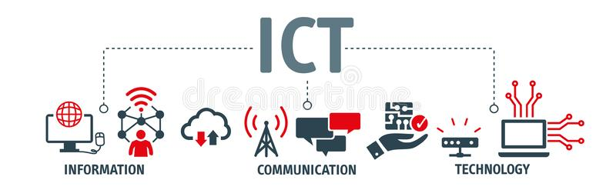

**Chapter 3**

**OPERATIONAL FRAMEWORK**

**3.1 Materials**

**3.1.1 Software**

The Windows 10 Operating System Software Requirement was used by the study's proponents. PHP will be used to develop the system, and Microsoft Access will be used as a database. Adobe Photoshop will be used in image editing for system backgrounds or design.

**3.1.2 Hardware**

To develop the proposed system, the study's proponents use the following hardware specifications. A desktop or laptop with 4 gigabytes of RAM to allow the computer to perform tasks and load applications, and a hard disk drive with 250 gigabytes of storage space.

**3.1.3 Data**

The study's proponents focused on the existing manual process and the issues encountered during clients’ clinic consultations. To create the best system for the users, the proponents used data collection methods such as interviews, questionnaires, and observation.

**3.2 Methods**

**3.2.1 Experimental design**

The proponents will use the development research method since the study focused on designing, developing, analyzing, and procedures. The (SDLC) System Development Life Cycle is followed by the researchers in this study, which has six phases that are vital to the successful creation and implementation of the system.

Figure 2 illustrates the process used in the SDLC model. These procedures are detailed below.

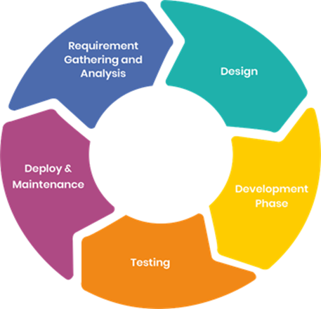

**Figure 2: Software Development Life Cycle Model**

**3.2.2 Procedure for the different phases**

**Requirement Gathering Phase**

The researchers conducted preliminary data collection through interviews with Dra. Erlinda Breva Fernandez M.D., Dra. Kristine Joy Romero M.D., and Dr. Dandie O. De Mesa, as well as some of Dra. Erlinda Breva Fernandez's staff and client to determine the requirements.

**Table 1. Interview Questionnaire**

|  |  |  |
| --- | --- | --- |
| **INTERVIEW QUESTION** | **Yes** | **No** |
| What is the clinic's current system? |  |  |
| Who manages the data and files? |  |  |
| What is the client's process for getting an appointment for a consultation? |  |  |
| Does the current system is secured and easy to use? |  |  |
| How do you list down the data for a new client or patient? |  |  |
| How do you track a list of your patients' records who want to be consulted?  How long does it take? |  |  |

|  |  |  |
| --- | --- | --- |
|  |  |  |
| What are the problems you have been encounter in giving medical prescriptions? |  |  |
| What is your current system for collecting payments for medical prescriptions and consultations? |  |  |
| Do you consider of having an online consultation and medical subscription system? |  |  |
| Would you like to have easy access to gathering, tracking, saving, sending and printing the data or files of clients or patients? |  |  |
| Do you prefer to have a communication with the patient through online live chat? |  |  |

**Design Phase**

In this phase, the system's design documents are prepared according to the requirements of the end-users. This helps in defining the system's overall architecture. We have decided how the system will function, what modules will be required, and how the system will look. This phase is important before proceeding to the coding phase.

**Table 2 Hardware Specification**

**Hardware Specifications**

**1.HEROKU** -What is Heroku? Heroku is a container-based cloud Platform as a Service (PaaS). Developers use Heroku to deploy, manage, and scale modern apps. Our platform is elegant, flexible, and easy to use, offering developers the simplest path to getting their apps to market.

**2. NODE.JS** -Node. js is a platform built on Chrome's JavaScript runtime for easily building fast and scalable network applications. Node. js uses an event-driven, non-blocking I/O model that makes it lightweight and efficient, perfect for data-intensive real-time applications that run across distributed devices.

**3.** **VISUAL STUDIO CODE** – Visual Studio Code is a streamlined code editor with support for development operations like debugging, task running, and version control. It aims to provide just the tools a developer needs for a quick code-build-debug cycle and leaves more complex workflows to fuller featured IDEs, such as Visual Studio IDE.

**4. GIT**  - Git is a version control system. Its original purpose was to help groups of developers work collaboratively on big software projects. Git manages the evolution of a set of files – called a repository – in a sane, highly structured way.

**Table 3 Software Specification**

**Software Specification**

**Everything listed here in the chart is what we used in our system.**

|  |
| --- |
| **HERUKO APP** |
| **NODE JS** |
| **GIT** |
| **VISUAL STUDIO** |









**System Architecture**

 

**Internet**

**Database**

**Admin/Assistant**



**E-Healthcare Consultation and**

**Medical Subscription.**



**Patient**



**Doctor**









**Printer**

**Medical Prescription**

**E-mail**

**Figure 3: System Architecture**

In figure 3, the E-Healthcare Consultation and Medical Subscription System are illustrated as a system that can be accessed through the internet. The system's users are the administrator or assistant, the doctor, and the patient. A database would be used to store data in the proposed system. Doctors and patient data may be managed by the admin. The use of live chat in this system allows the doctor and the patient to communicate. The doctor will send the prescription to the patient through email. The patient and the doctor will use the printer to print images, data and prescriptions.

**Network Design Infrastructure**

**Internet**









Tablet and Cellphone

Computer desktop

Modem



Wifi



Laptop

Computer desktop

**Figure 4: Network Infrastructure**

The figure above shows the network connectivity on how the users can access the system. It shows that internet is one of the important factors to access the system.

**Database Schema**

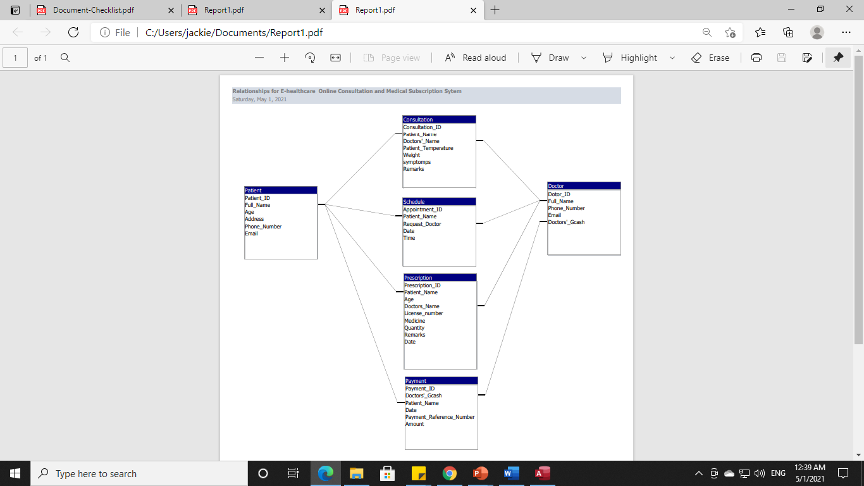

**Figure 5: Database Schema**

The above figure indicates the database has an entity relationship that can be created with tables and it consist of (6) tables.

**Use Case Diagram**

**ADMIN MODULE**



**ADMIN**

**Figure 6: Admin Module**

The above figure shows the functionality of the admin. Most of the information of doctors, patients’ data and schedule can be manage by the admin.

**PATIENT MODULE**



**PATIENT**

**Figure 7 : Patient Module**

The figure 7 shows the patient module, which allows the patient to book an appointment, and go through the consultation and payment process.

**DOCTOR’S MODULE**



**DOCTOR**

**Figure 8: Doctor’s Module**

This figure shows the doctor's module, which enables the doctor to view patients, accept and decline consultation requests, make consultation through the use of live chat, and make prescriptions.

**Coding Phase**

In this phase, the researchers will start to translate the system development into code. For coding, programs are divided into self-contained functions that focus on process and logical structure, as well as the data required for the process.

The researchers will use the PHP programming language to support the functions, processes, and logical structures of the system, which will be developed based on the needs of the users. Microsoft Access database for data storage.

**Testing Phase**

During this phase, the project will go through a testing plan and an operating procedure for each module.

Before a program can be used, four stages of testing must be completed: unit testing, integration testing, system testing, and acceptance testing.

**Unit Testing**

In this first step of testing, the project will test each component to determine whether or not it is fully functional. In this step, the project will run every time the code is updated to evaluate all of the problems it encounters so that they can be resolved as early as possible.

**Integration Testing**

Integration testing requires the combination of all modules within the system, as well as an evaluation of the project to determine how the modules function if they are not properly attached, and thus affecting the project's functionality.

**System Testing**

System testing is the first step in evaluating the project as a whole. At this stage, the goal is to determine whether or not the project complied with all of the criteria outlined and to ensure that it meets quality standards. The goal of this test is to collect data if the system is fully functional.

**Acceptance Testing**

The final step is acceptance testing, which determines whether the system is ready for release. During the software development life cycle, changes in requirements are frequently misunderstood in a way that does not meet the user's expected needs. During this final step, the client can test the system to see if it meets the needs of their business.

**Software Test Plan Flow**

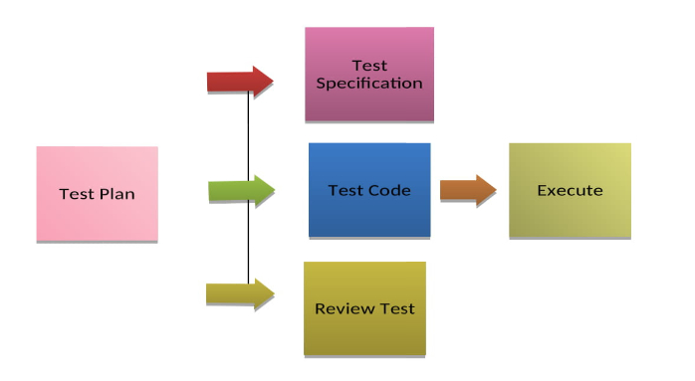

**Figure 9: Software Test Plan**

Test Specification Input Requirements, planned performance, and a series of module testing execution steps. This section includes subsections for each module to be evaluated, and each sub-modulus defines the cases to be tested. Different types of software testing are performed depending on the size of the project, the current project phase, and the amount of progress made in the coding process. Unit testing, also known as module testing, is used to test smaller parts of code like functions and modules. For example, to ensure that it works as expected, programmers can test each module individually, as well as conduct integration testing to test the interfaces between modules. When the system must communicate with other or third-party systems, system integration testing is performed. For interfaces with other devices, testing is performed against the device design specifications. Acceptance testing is a test performed by clients or end users to determine whether the system is acceptable. After executing the test code, you will be able to see which modules need to be corrected or revised, as well as check specific test results.

Table 4. Test Matrix

|  |  |
| --- | --- |
| **Modules** | **Test Type** |
| Admin Module | Unit Testing/ Integration |
| Patient Module | Unit Testing/ Integration |
| Doctor’s Module | Unit Testing/ Integration |

The three modules will be tested and trialed in this plan to determine if they are working properly and are connected to one another.

Below is the unit test plan for each module.

Table 5. Test Plan for Admin Module

|  |  |
| --- | --- |
| Test ID | 1 |
| Test Name | Admin |
| Description | Ensure that components pass unit and integration testing, and perform basic operations as expected. |
| Pre-requisite | None |
| Test Environment | Acceptance server |
| Test Strategy | Unit Testing |

|  |  |  |
| --- | --- | --- |
| **ADMIN** | | |
| **Step** | **Description** | **Expected Result** |
| 1 | Log in page must be displayed. | Log in page is displayed properly. |
| 2 | Allows the admin to manage, doctors’, patients’ and schedule data. | The application is working properly in terms of adding, deleting, and updating the data. |

One person will be assigned to perform testing on the Admin Module. The functions of adding, updating, and deleting were tested to see if they worked properly.

Table 6. Test Plan for Patient Module

|  |  |
| --- | --- |
| Test ID | 2 |
| Test Name | Patient |
| Description | Ensure that components pass unit and integration testing, and perform basic operations as expected. |
| Pre-requisite | None |
| Test Environment | Acceptance server |
| Test Strategy | Unit Testing |

|  |  |  |
| --- | --- | --- |
| **PATIENT** | | |
| **Step** | **Description** | **Expected Result** |
| 1 | Log in page must be displayed. | Log in page is displayed properly. |
| 2 | The System allows the patients to book an appointment consultation and have consultation to request communication and to process payment. | Patients can select an appointment schedule and submit a request for a consultation based on their availability, and payment can be processed. |

One person is assigned to test the module's functionality in terms of choosing a schedule, submitting a consultation request through use of live chat, and processing payment.

Table 7. Doctors Module

|  |  |
| --- | --- |
| Test ID | 3 |
| Test Name | Doctor |
| Description | Ensure that components pass unit and integration testing, and perform basic operations as expected. |
| Pre-requisite | None |
| Test Environment | Acceptance server |
| Test Strategy | Unit Testing |

|  |  |  |
| --- | --- | --- |
| **DOCTOR** | | |
| **Step** | **Description** | **Expected Result** |
| 1 | Log in page must be displayed. | Log in page is displayed properly. |
| 2 | The doctor enables to view patient’s data, accept and decline consultation request, make consultation through the use of live chat and make prescription. | The system is working properly in terms of receiving request and declining patient’s consultation request and properly work in making prescriptions. |

To check the doctors’ module functionality, personnel is assigned to check if the system is working properly to view patient data, accept and decline consultation requests, generate communication through the use of live chat, and make prescriptions.

**Operating Procedures**

If you have a feeling about your health the first thing you have to do is go to the heroku app site to log in your identity details to schedule with the doctor and wait for the doctor's call or message.

**Deployment Phase**

The researchers will conduct an orientation about the system's flow and how to use it prior to its deployment. A one-month trial will be planned to ensure that every single functionality is working properly.

**Maintenance Phase**

During this phase, corrective maintenance will be carried out. This requires improvements and adjustments to resolve issues discovered by users and confirmed by user error reports. There will also be quarterly maintenance to ensure the system's performance when end users use it.

**3.2.3 Evaluation**

Following the completion of the testing strategies, the researchers will formulate questionnaire to further assess the software. The questionnaire will be prepared in accordance with ISO 9126, the International Organization for Standardization's software product evaluation standard. This international standard defines five characteristics that describe hardware and software quality namely.

1. Functionality – The system features will be checked to ensure that they are all fully functional.
2. Reliability – The system’s fault tolerance and recoverability are high; it will not crash.
3. Usability – The users can easily understand and navigate the application. The design and images to be used are easily recognizable.
4. Efficiency – The system responds precisely and efficiently to commands. It resources such as memory, the CPU, and the network.
5. Maintainability – The system is easy to maintain and is stable.

These characteristics were rated by the respondents using 5-point Linkert Scales.

Table 8. Linkert Scale

|  |  |  |
| --- | --- | --- |
| **Scale** | **Range** | **Interpretation** |
| 5 | 4.5 – 5.0 | Strongly Agree |
| 4 | 3.7 – 4.5 | Agree |
| 3 | 2.8 – 3.6 | Neither Agree – Nor Agree |
| 2 | 1.9 – 2.7 | Disagree |
| 1 | 1.0 – 1.8 | Strongly Disagree |

On the other hand, the statistical treatments of this study were frequency and percentage distributions for data presentation weighted mean to determine the results of the software evaluations. Below are the evaluation criteria used by the proponents.

**Software Evaluation Criteria**

Name: ____________________________ Signature: __________________

Position: ___________________________

Direction: Check the box that corresponds to your answer. Use the legend as your guide.

LEGEND: 5 – Strongly Agree 4 – Agree 3 – Neutral

2 – Disagree 1 – Strongly Disagree

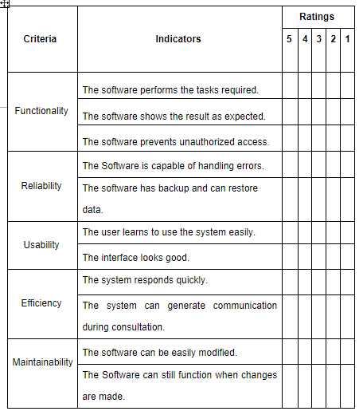

**Chapter 4**

**RESULTS AND DISCUSSION**

**4.1 Results by phase of study**

**Technical Description**

A web-based application is an application that uses a website as the interface or front-end. Users can easily access the application from any computer connected to the Internet using a standard browser. This contrasts with traditional desktop applications, which are installed on a local computer. The Web-Based E-Health Care Online Consultation will give way to easy collection and more accurate data analysis of faculty evaluation in lesser time. The Web-Based E-Health Care Online Consultation is a paperless process in which the evaluator will use the computer and the system to evaluate the teacher.

To design and develop a system that the doctors, and patients can easily access to an e-healthcare online consultation and medical subscription.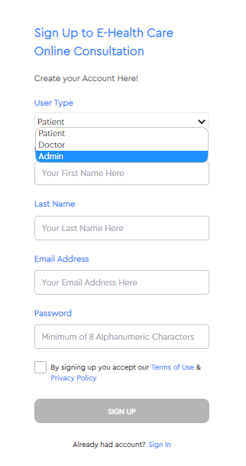

**Figure 8: Web-Based Login**

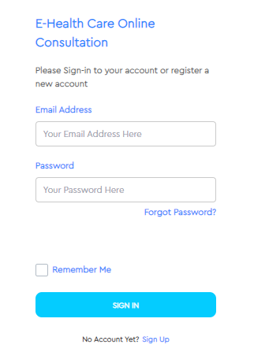

To design and develop a system that the administrators, doctors, and patients can register and log in for online consultation.

**Figure 9: Web Based Patient Appointment**

To design and develop a system that the administrators, doctors, and patients can register and log in for online consultation.

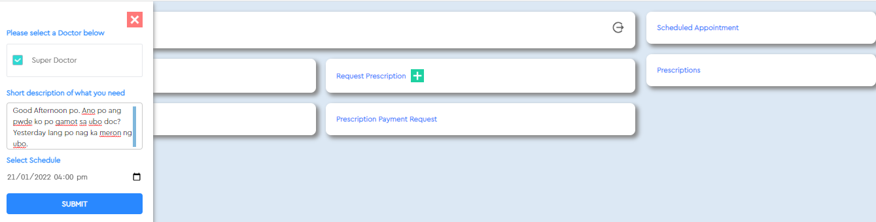

To design and develop a system where patients can make an appointment for online doctor consultations to have a medical prescription.

**Figure 10: Web Based Accept & Decline**

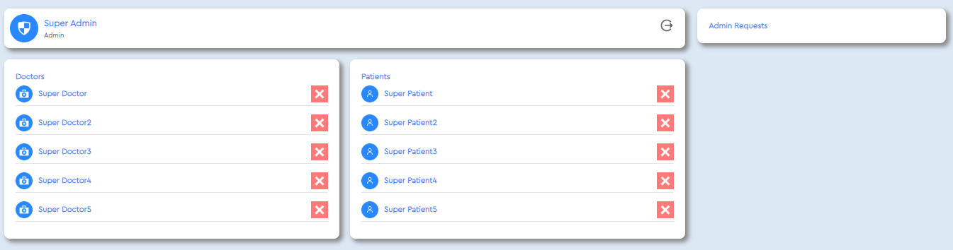

To design and develop a system that the doctors can accept or decline patient appointment requests.

**Figure 11: Web Based Live Chat**

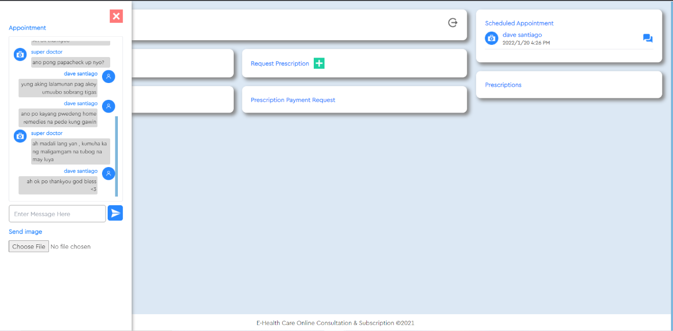

To design and develop a system that the doctor and a patient can communicate through the use of live chat.

**Figure 12: Web Based Proof & Receipt**

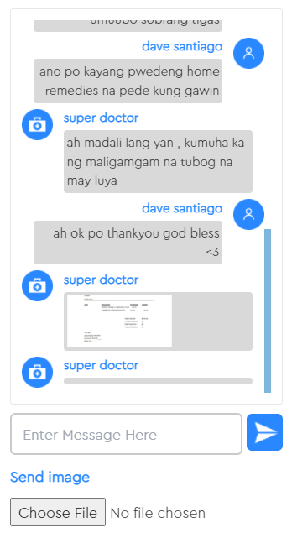

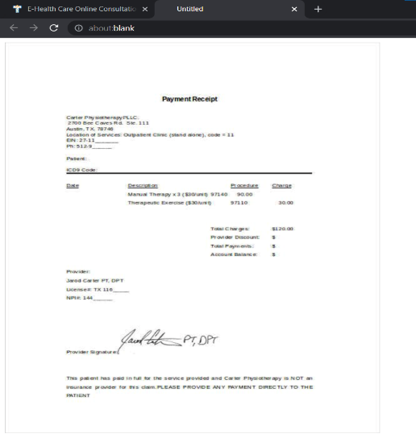

To design and develop a system that users can upload, save, print and send images and medical prescription into email.

**Figure 13: Web Based Admin Management**

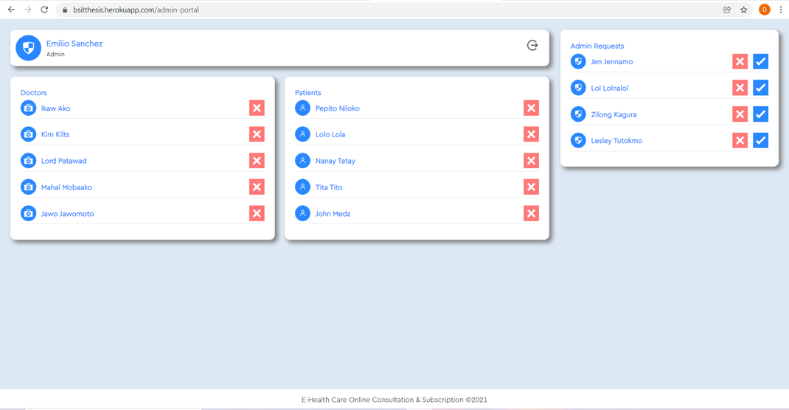

To design and develop a system where the admin manages the users’ accounts and deletes accounts and data if needed.

**Figure 14: Web Based Database**

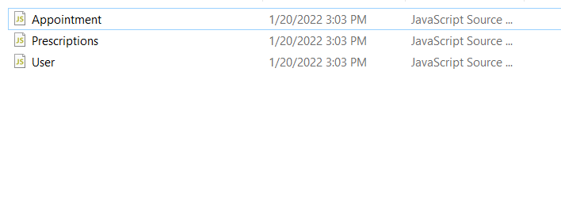

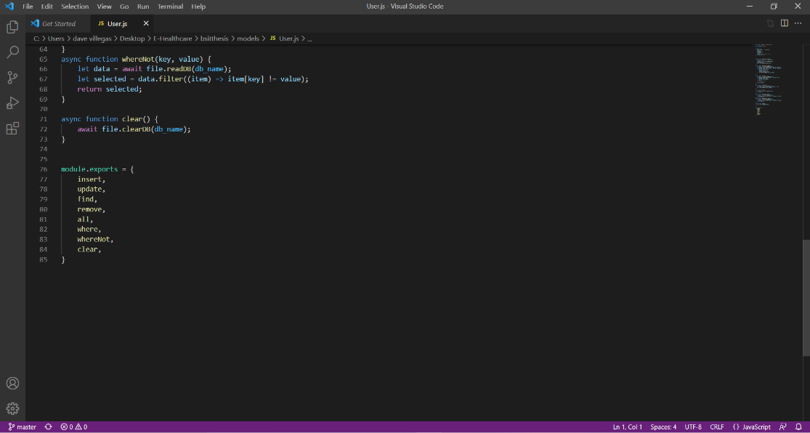

To design and develop a system that will have a database for patient records and other data.

**Figure 15: Web Based Subscription & Description**

**SUBSCRIPTION**

This is that 1st picture is the action of making or agreeing to make an advance payment in order to receive or participate in something. the newsletter is available only on. The definition of a subscription is an agreement you make in advance to receive something for a specific period of time.

Subscription Fee means the amount you pay for the Subscription Service.

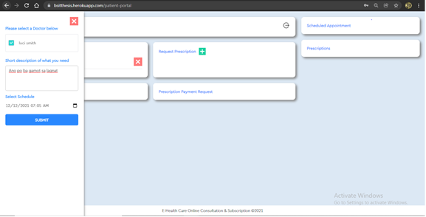

**PRESCRIPTION**

here in the 2nt picture is the prescription given by the doctor to the patients to buy the medicine

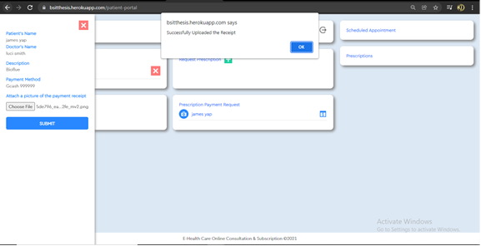

**4.2 Verification studies**

**Software Evaluation Using ISO9126**

The study is to evaluate the acceptability of the system using the ISO9126. The software was assessed using the set of quality metrics/criteria stated to validate the effectiveness of the software being developed. Criteria rank according to the opinion of respondents after evaluating the software, five being the highest and one as lowest.

|  |  |
| --- | --- |
| **CRITERION** | **Weigted**  **Mean** |
| **EFFICIENTCY** |  |
| * The software respond time is approriate | **4.9** |
| * The software execution time is approriate | **4.9** |
| * The resources used are approriate | **4.6** |
| * End users respond accurately and actively to the commands. | **4.3** |
| **AVERAGE** | **4.9** |

**Chapter 5**

**SUMMARY OF FINDINGS, CONCLUSIONS, AND RECOMMENDATIONS**

**5.1 Summary of findings**

haroku is the apps we used because we have already tried other apps and we have a hard time but those who tried and researched well found apps that can be used in our system,

this is the haroku apps that we choose because it's easier i process than other apps and that's how we studied these apps to make our work easier and our system ended immediately because of haroku.

**5.2 Conclusions**

1. Health systems are under increasing pressure to save money and improve quality.

2. There are hopes that, over the next decade, digital health and, specifically, the internet, harnessed as a health service tool, can address these aims by shaping individuals ’service use and health perceptions.

3. At the same time, as the embraces a responsive, patient-centered, listening culture, it is important that it is listening, interpreting and responding to the right signals.

4. In line with many other sectors, these signals are increasingly coming from online user-generated content, as patients use the internet to comment on their experiences of health and care services.

**5.3 Recommendations**

* 1. Doctor recommendation on healthcare consultation Recommending suitable doctors to patients on healthcare consultation platforms is important to both the patients and the platforms.
* 2. Although doctor recommendation methods have been proposed, they failed to explain recommendations and address the data sparsity problem, i.e. most patients on the platforms are new and provide little information except disease descriptions.
* 3. This research aims to develop an interpretable doctor recommendation method based on knowledge graph and interpretable deep learning techniques to fill the research gaps.
* 4. These issues raise the need to apply recommender systems in the healthcare domain to help both, end-users and medical professionals, make more efficient and accurate health-related decisions

**REFERENCES**

[1] Ossebaard, H. C, & Van G.P, L. (June 2016) **EHealth and quality in health care: Implementation time.** *International Journal for Quality in Health Care*, Volume 28, Pages 415–419.

<https://academic.oup.com/intqhc/article/28/3/415/1750408>

[2] Ariani A., Koesoema A.P.,& Soegijoko S. (2017) **Innovative Healthcare Applications of ICT for Developing Countries.** [*Innovative Healthcare Systems for the 21st Century*](https://link.springer.com/book/10.1007/978-3-319-55774-8), Page 15-70.

<https://link.springer.com/chapter/10.1007/978-3-319-55774-8_2>

[3] Susanto,H & Chen C. K (2017) **Information and Communication Emerging Technology: Making Sense of Healthcare Innovation.** [*Internet of Things and Big Data Technologies for Next Generation Healthcare*](https://link.springer.com/book/10.1007/978-3-319-49736-5)*.* Volume 23Page 229-250.

<https://link.springer.com/chapter/10.1007/978-3-319-49736-5_10>

[4] Almathami H.Y,MSc; Win K. T,PhD;& Gjorgieveska E.V,PhD (2020). **Barriers and Facilitators That Influence Telemedicine-Based, Real-Time, Online Consultation at Patients’ Homes: Systematic Literature Review.** *J Med Internet Res 2020;22(2):e16407*.

<https://www.jmir.org/2020/2/e16407/>

[5] Guo X, Guo S, Vogel, Li Y. (2016).**Online Healthcare Community Interaction Dynamics.** [*Journal of Management Science and Engineering*](https://www.sciencedirect.com/science/journal/20962320)Volume 1Page 58-74.

<https://www.sciencedirect.com/science/article/pii/S2096232019300095>

[6] Hamza M., Khan H.S., Sattar Z. A., Hanif M (2020) **Doctor–patient communication in surgical practice during the coronavirus (COVID-19) pandemic.** *British Journal of Surgery*, Volume 107, Page e193, <https://doi.org/10.1002/bjs.11661>

<https://academic.oup.com/bjs/article/107/7/e193/6094072?login=true>

[7] Kenawy A. S., Kett V.,(2019) **The impact of electronic prescription on reducing medication errors in an Egyptian outpatient clinic.** [*International Journal of Medical Informatics*](https://www.sciencedirect.com/science/journal/13865056)*.* [Volume 127](https://www.sciencedirect.com/science/journal/13865056/127/supp/C),  Pages 80-87.

<https://www.sciencedirect.com/science/article/abs/pii/S1386505618305380>

[8] Omotosho A, Asanga U., Fakorede A. (2017) **Electronic Prescription System for Pediatricians.**  [*arXiv:1707.02341*](https://arxiv.org/abs/1707.02341)*[cs.CY]*

[9] Oktarlina, R. (2020). **E-Prescribing: Benefit, Barrier, and Adopting Challenge in Electronic Prescribing.** *Journal of Medicine,* Vol. 21(2), Page 98 – 101.

<https://doi.org/10.3329/jom.v21i2.50213>

[10] Arcinas M. M., Tolentino M. P., Lituañas R. A., Cadeliña J. S., Obayashi Y. (2020) **E-health Services and Usage in the Philippines.** *Asia-Pacific Social Science Review* Vol. 20(2) 2020, pp. 149–157

<http://apssr.com/wp-content/uploads/2020/06/RB3.pdf>

[11] De Guzman C.D (2018) **Embracing new Healthcare technologies that empower Filipinos.** *Pwc Philippines.*

[*https://www.pwc.com/ph/en/pwc-needles-in-a-haystack/embracing-new-healthcare-technologies-that-empower-Filipinos.html*](https://www.pwc.com/ph/en/pwc-needles-in-a-haystack/embracing-new-healthcare-technologies-that-empower-Filipinos.html)

[12] Mundin M.T. (2019) **Philippines: Developing an eHealth infrastructure.** *Data Guidance*

[*https://www.dataguidance.com/opinion/philippines-developing-ehealth-infrastructure*](https://www.dataguidance.com/opinion/philippines-developing-ehealth-infrastructure)

[13] Tugado A. (2020) **The time has come for PH telemedicine.**  [*People's Journal*](https://archive.journal.com.ph/publications/peoples-journal)

<https://archive.journal.com.ph/editorial/opinion/time-has-come-ph-telemedicine-2>

[14] Mendoza J. M. (2020) **Molbog-Mendoza: SPMC's online derma consultation.** *SunStar Davao.*

<https://www.sunstar.com.ph/article/1853193/Davao/Lifestyle/Molbog-Mendoza-SPMCs-online-derma-consultation>

[15] Baron G. (2020) **Physical therapist offers free online consultations.** [*Manilabulletin_admin*](https://mb.com.ph/author/manilabulletin_admin) *Article.*

<https://mb.com.ph/2020/04/08/physical-therapist-offers-free-online-consultations/>

[16] Qinones M.T. (2020) **FDA allows prescribing, selling meds through E-prescription**.  *Article in**Philippine Information Agency.*

<https://pia.gov.ph/news/articles/1036499>

[17] Carlos R. A. (2020) **DDB allows use of electronic prescription for dangerous drugs.**

<https://www.pna.gov.ph/articles/1097377>

[18] Rosario C.(2018) **How an Electronic Prescription Works.**

<https://www.adsc.com/blog/how-an-electronic-prescription-works>

[19] Azogu I, Norta A, Papper I, Longo J,Draheim D.(2019) **A Framework for the Adoption of Blockchain Technology in Healthcare Information Management Systems: A Case Study of Nigeria.** [*ICEGOV2019: Proceedings of the 12th International Conference on Theory and Practice of Electronic Governance*](https://dl.acm.org/doi/proceedings/10.1145/3326365)*. Page 310-316.*

<https://doi.org/10.1145/3326365.3326405>

[20] Ross J, Stevenson F, Lau R, and Murray E.(2016) **Factors that influence the implementation of e-health: a systematic review of systematic reviews (an update).**  *Implementation Sci* **11,**146

<https://doi.org/10.1186/s13012-016-0510-7>

[21] Shaw T, McGregor D, Brunner M, Keep M, Janssen A, Barnet S.(2017) **What is eHealth? Development of a Conceptual Model for eHealth: Qualitative Study with Key Informants.** *J Med Internet Res 2017*;*19(10):e324*  
doi: [10.2196/jmir.8106](https://doi.org/10.2196/jmir.8106)

[22] Tuot D. S., Liddy C.,Vimalanda V.G, Pecina J., Murphy E. J, Kelly E, Simon S. R, North F., Orlander J. D., & Chen A.H. (2018) **Evaluating diverse electronic consultation programs with a common framework.**  *BMC Health Serv Res* **18,**814. <https://doi.org/10.1186/s12913-018-3626-4>

[23] Liddy C., Drosinis P., Keely E. (2016) **Electronic consultation systems: worldwide prevalence and their impact on patient care—a systematic review** . *Family Practice*, Volume 33, Issue 3, Pages 274 -285. <https://doi.org/10.1093/fampra/cmw024>

[24] Atherton, H., Brant, H., Ziebland, S., Bikker, A., Campbell, J., Gibson, A., McKinstry, B., Porqueddu, T., & Salisbury, C. (2018). **The potential of alternatives to face-to-face consultation in general practice, and the impact on different patient groups: a mixed-methods case study.** *Health Services and Delivery Research, 6(20), 1–199.* <https://ora.ox.ac.uk/objects/uuid:3220b9ad-65bb-43cd-9d98-a9eb6a88f80e>

[25] Novalendo, F., Syarief, R., & Suroso, A. I. (2018). **Measurement of Success in The Integrated Prescribing Information System at Ananda Bekasi Hospital.** *Indonesian Journal of Business and Entrepreneurship (IJBE)*, *4*(3), 282. <https://doi.org/10.17358/ijbe.4.3.282>

[26] Deetjen, U. (2016). **European e-Prescriptions: Benefits and Success Factors. Cyber Studies Programmed.**

<https://ora.ox.ac.uk/objects/uuid:440a8fe6-6421-4b62-9e5e-cb0f559667d6>

[27] Lanham A, Cochran G, Klepser D. (2016). **Electronic prescriptions: opportunities and challenges for the patient and pharmacist.** *Advanced Health Care Technologies*. Volume 2:Page 1-11  
<https://doi.org/10.2147/AHCT.S64477>

[28] Ongkeko A.Jr., Fernandez R.G., Sylim P.G., Amoranto J. A., Sy M.R., Santos A. D., Fabia J. G., Marcelo P. H., (2016) **Community Health Information and Tracking System (CHITS): Lessons from Eight Years Implementation of a Pioneer Electronic Medical Record System in the Philippines.** Volume 50 Number 4. Articles.

<https://actamedicaphilippina.upm.edu.ph/index.php/acta/article/view/769>

[29] Ebardo R., Celes N. J.,(2019) **Barriers to the Adoption of Electronic Medical Records in Select Philippine Hospitals: A Case Study Approach.**

<https://www.researchgate.net/publication/334754948_Barriers_to_the_Adoption_of_Electronic_Medical_Records_in_Select_Philippine_Hospitals_A_Case_Study_Approach>

[30] Albina M. E., Hernandez A. A.,(2018) **Assessment of the Elderly on Perceived Needs, Benefits and Barriers: Inputs for the Design of Intelligent Assistive Technology.** *16th International Conference on ICT and Knowledge Engineering (ICT&KE)*, Page. 1-10, **DOI:**[10.1109/ICTKE.2018.8612447](https://doi.org/10.1109/ICTKE.2018.8612447)

[31] Diaz O., Periera J., (2019) **Using Health Chatbots for Behavior Change: A Mapping** Study. *J Med Syst* **43,**135 <https://doi.org/10.1007/s10916-019-1237-1>

[32] Pasco, P. M. (2016). **Physician User Perspectives in the Practice of Telemedicine in the Philippines. *Journal of the International Society for Telemedicine and EHealth***, 4, e26(1-19).

<https://journals.ukzn.ac.za/index.php/JISfTeH/article/view/172>

[33] Day N.J.B., Carranza K. A. L. R., Lin L. M. S., Ponce A. R., Reyes R. O., (2018) **Design of a Web-based and Electronic Health Record Management System for Medical Teleconsultation.** *IEEE 10th International Conference on Humanoid, Nanotechnology, Information Technology,Communication and Control, Environment and Management (HNICEM)*, pp. 1-5, doi: 10.1109/HNICEM.2018.8666370.

[34] Amaya J. m. H.MD., Garcia F.G.R.MD., Castro C.J.Y.MD., Cardenas M. S. MD., Alarcon M. A. V. MD., Delgado D. A. G. MD. (2016) **Medication errors: electronic vs. paper‐based prescribing. Experience at a tertiary care university hospital.** *Journal of Evaluation in Clinical Practice.* <https://doi.org/10.1111/jep.12535>

**APPENDIX A**

## Endorsement Letter

**COLLEGE OF COMPUTER STUDIES**

March 24, 2021

**ALFRED PALDEZ**

MIS head

Trojan Building Poblacion Binan Laguna

Dear Sir Paldez

Good day!

We, *Emilio Sanchez, Dave Villegas and Sonny Santiago*, 3rd year B.S.I.T. students of TRIMEX COLLEGES, currently taking up the subject of IT PRC10 – CAPSTONE PROJECT 1, would like to request your permission to conduct an interview regarding with ‘*E-Healthcare Online Consultation in Trimex Colleges*’.

Thank you and hoping for your favorable response.

Sincerely,

Emilio Sanchez

Dave Villegas

Sonny Santiago

Noted by:



MR. CARLO A. BATITIS

ITPRC10 Instructor

OIC – College of Computer Studies

**APPENDIX B**

## Acceptance Letter (Adviser)

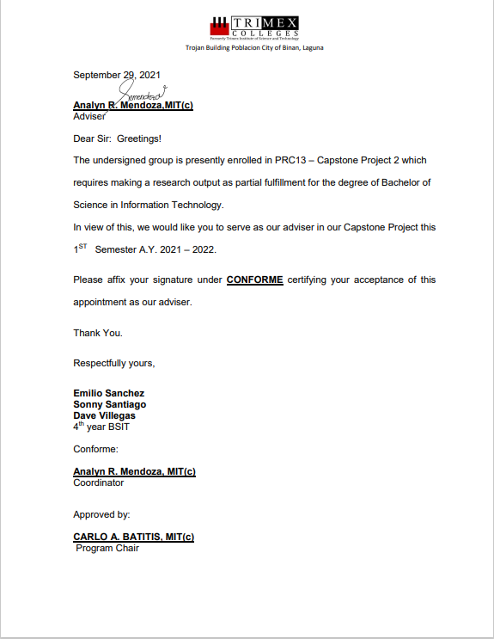

**APPENDIX C**

## Transcript of Interview

**APPENDIX D**

## Acceptance Letter (proposal & deployment)

April 29, 2021

From:

**Alfred Paldez**

MIS Head

Trojan Building Poblacion Biñan, Laguna

To:

**Emilio Sanchez**

**Dave Villegas**

**Sonny Santiago**

Students of Trimex Colleges

Dear Mr. Sanchez, Mr. Villegas, and Mr. Santiago,

Herewith this letter is to inform you that I and Trimex Colleges Inc. has studied

the proposal on “E-Healthcare Online Consultation” by the work of yours.

After much deliberation, I and Trimex Colleges Inc. is pleased to accept your

proposal because we think your proposal will help our school to improve and

we think it can also help to recruit students.

Thank you for submitting a proposal to us.

Respectfully,

https://lh5.googleusercontent.com/YP6PkDyv0E2VcZB31ubfX9WqUoug8IvIoMUcBaZM_pDQYpOQqRfLQyTp1vCPZqPYCMqEAs6pcXAqQqYaBOpLMZeQ-5Pfpg7KExMzvLfIBQuABAZbmVLJbqNA77nSFiOjlNmvmVLMzk7LQC3ZqyPksmFt0bEdx1BIC2dXqcgMENpof1Ts-Y6NFzAZVvpxw4xRz8hMMmuEGA

Alfred Paldez

**APPENDIX E**

**Survey Forms**

**APPENDIX F**

**Proof of engagement(w/ Client)**

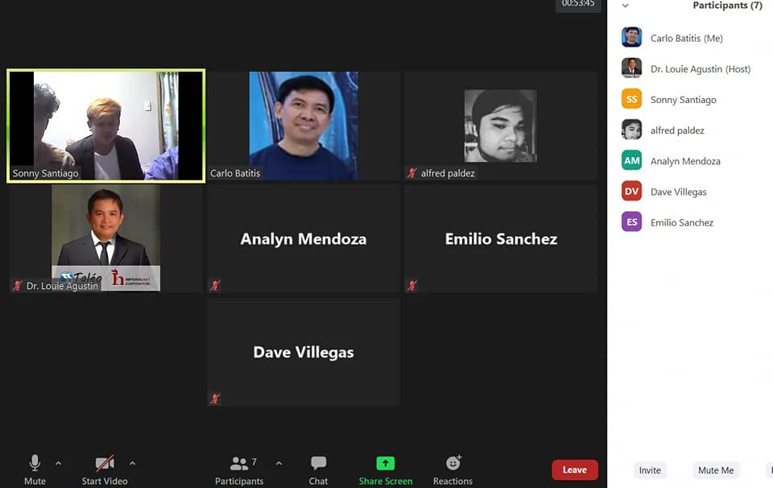

**APPENDIX G**

**CURRICULUM VITAE**



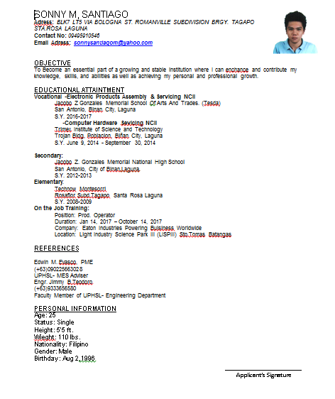

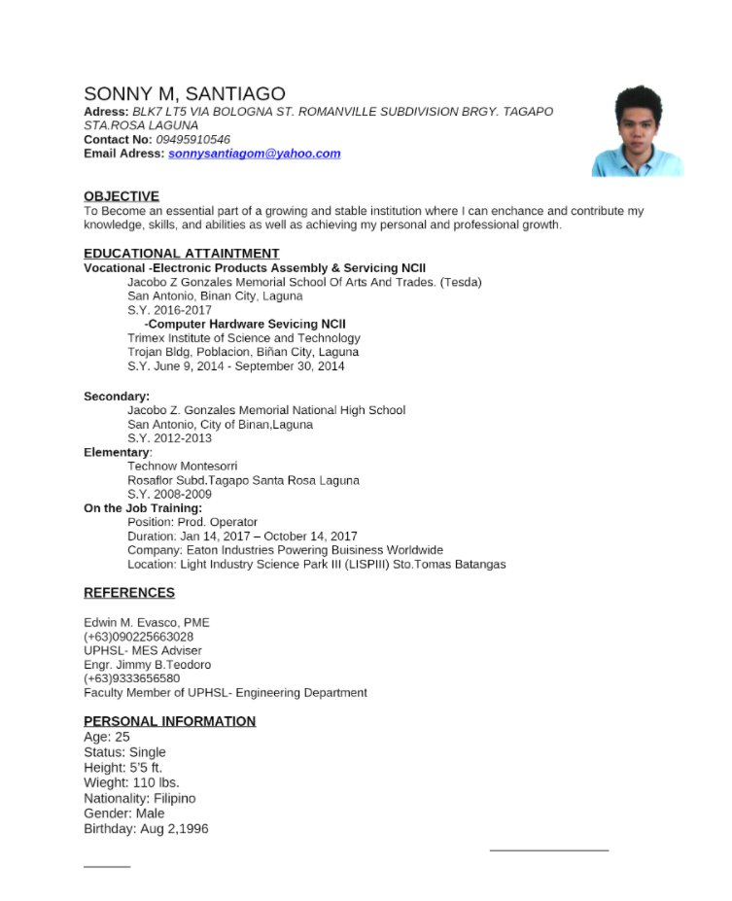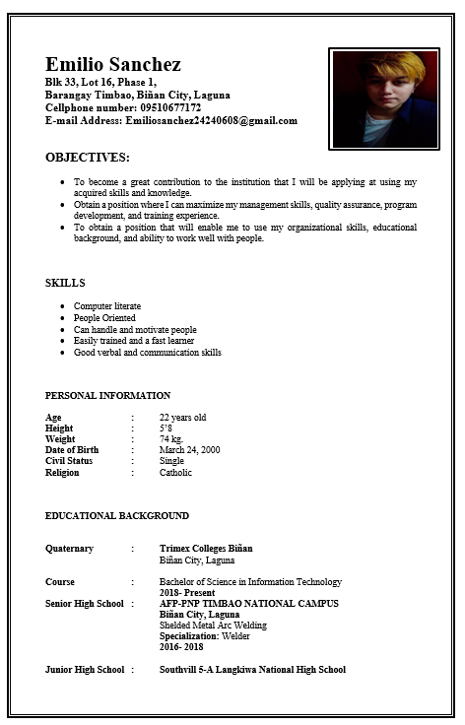

**APPENDIX H**

## User’s Manual

* + - 1. Sign up.



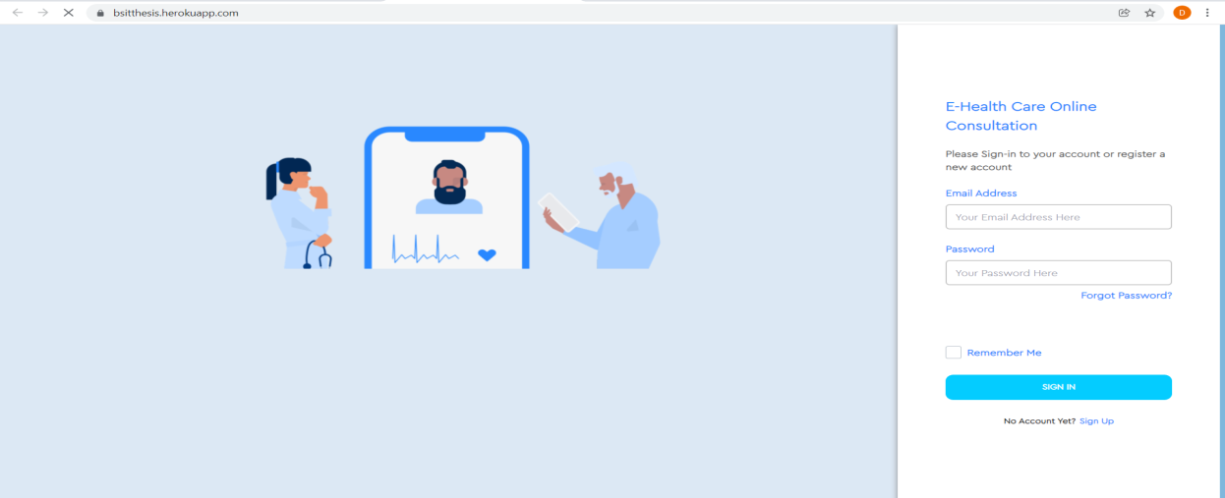

* + - 1. Login
      2. Precription/Subsription

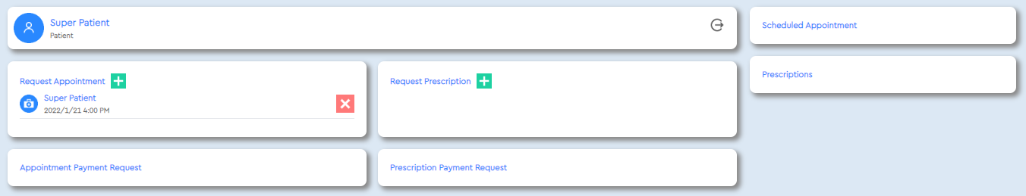

* + - 1. Approval of the doctors

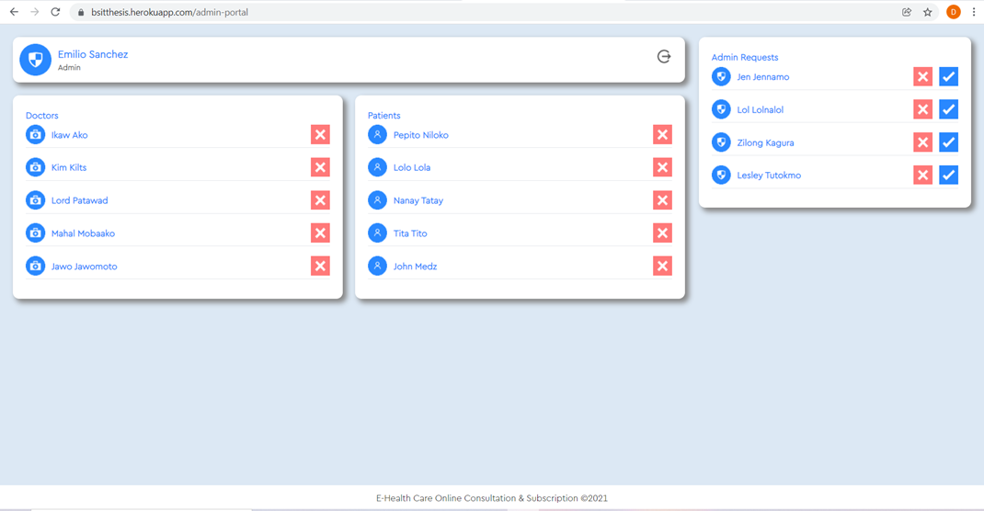

* + - 1. Prescription
      2. Proof of Receipt

