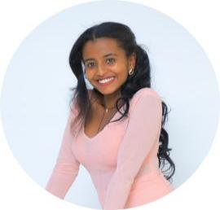

Contact

** : +251 986622329/ +2517631457**

** : kidshimelis23@gmail.com**

IMG_256**: github.com/Kidist-shimelis**

**:www.linkedin.com/in/kidist-shimelis**

**Kidist Shimelis Deribie**

Software Developer (Mobile app and Web developer)

Soft Skills

* Team work
* Adaptability
* Problem solving ability
* Attention to detail
* Curiosity and continuous learning
* Time management
* Effective Communication

**Proffesional Skills**

* JavaScript
* JavaFX,OOP
* React,C++
* React Native
* PHP,HTML,CSS
* Bootstrap
* UI design,MySQL
* Artificial intelligence
* Object oriented programming
* Web programming
* C++
* Machine Learning
* Final year Project I and II
* System Admin &Networking

Basic Courses that I have experienced with

* Software engineering
* Database
* Compiler Design
* Data Structure
* Research Methods
* Emerging technologies

**Additionally, I have hands-on experience with laravel projects and I have also developed tourism management system for Awi Zone as a final year project in turn helped me to develop so much coding and collabotative team work skills**

Education

Graduated from Injibara Univesity at 2025 GC With the bachlor degree of Computer science

Personal information

Name - Kidist Shimelis

Nationality - Ethiopian

Date of birth -Aug 18,2002 G.C

Gender - Female

Martial states - single

Health states - Very good

Criminal record - None

CGPA -3.73/4.00

National Exit exam Result - 86/100

Hobby - Music and Art

**Driven by a deep passion for cutting-edge technology, I bring a robust foundation in developing impactful, scalable digital solutions.With expertise spanning both front-end and back-end development, I specialize in building responsive and user-centric applications using React, laravel,JavaScript, PHP, HTML/CSS, python, Bootstrap, and Tailwind. My strong grasp of UI principles ensures that every product I develop is not only visually compelling but also highly functional. I am proficient in object-oriented programming (OOP), and C++, enabling seamless data handling and system interoperability. cross-platform applications tailored to diverse business needs.Beyond technical skills, I am highly committed to any task I take on, with a strong work ethic and a collaborative mindset. I am fully open to relocation and eager to contribute wherever my skills are needed, bringing flexibility and dedication to every opportunity I pursue.**

About Me