{#book}

{%coverImage}

{title}

{subtitle}

{/book}

By

Kids Tales Student Writers

Copyright © {year} Kids Tales

All rights reserved.

{#book}ISBN-13: {isbn13}

ISBN-10: {isbn10}{/book}

{#location}

About {name}

{%image}

{description}

{/location}

About Kids Tales

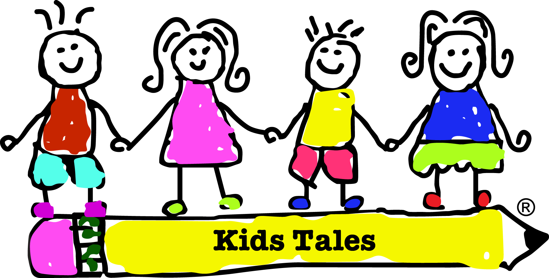

**What is Kids Tales?**

Founded by a kid for kids, Kids Tales is a non-profit that teaches kids who don’t have writing opportunities outside of school how to create, compose, and publish their own short story. Kids Tales gives every kid the opportunity to write creatively, become a published author, and have a voice.

**How does it work?**

During a Kids Tales workshop, 8 to 12-year-old kids spend one week brainstorming, writing, and editing their very own short story. At the end of the week, the stories are assembled in a collection and published as an anthology.

**Who teaches Kids Tales workshops?**

All Kids Tales' instructors are teenagers who love to write and teach. They are trained to teach Kids Tales workshops and are passionate and dedicated to helping kids find their voice though writing.

**For More Information**

Check out the Kids Tales website: [kidstales.org](http://kidstales.org/)

Contents

Add Headings (Format > Paragraph styles) and they will appear in your table of contents.

# Introduction

{#book}{introduction}{/book}

{teacherList}

Intructors

Kids Tales

{#stories}

# {title}

By {author}

{content}

{/stories}

**Meet The Authors**

{#students}

|  |  |
| --- | --- |
| {%image} | **{name}** {bio} |

{/students}

{#book}{%backImage}{/book}