**Technical Analysis of Top Tech Stocks: A Data-Driven Approach**

# Introduction

This comprehensive analysis examines seven major technology stocks (AAPL, GOOG, MSFT, AMZN, META, NVDA, TSLA)   
 using various technical indicators and correlation studies. Our goal was to uncover meaningful patterns and   
 relationships between different technical signals and price movements during Week 1 of our analysis.

# Methodology

Our analysis pipeline consisted of three main components:  
 1. Technical indicator calculation  
 2. Cross-indicator correlation analysis  
 3. Lagged correlation studies for predictive insights

# Technical Analysis Results

## Price Trend Analysis

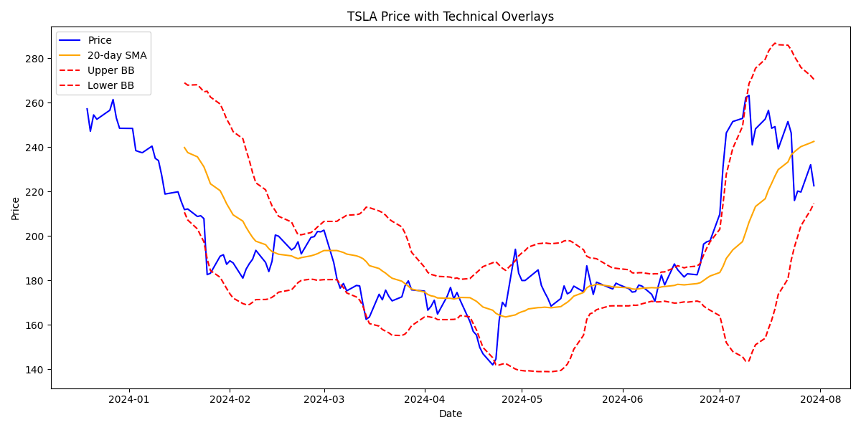

Tesla's stock showed significant volatility during the analysis period. The price movements frequently tested   
 the Bollinger Bands, with the 20-day SMA acting as a dynamic support/resistance level. Notable observations include:  
 - Multiple Bollinger Band breakouts indicating high volatility  
 - Price respecting the 20-day SMA as support during uptrends  
 - Increased trading volume during major price movements

## Momentum Analysis

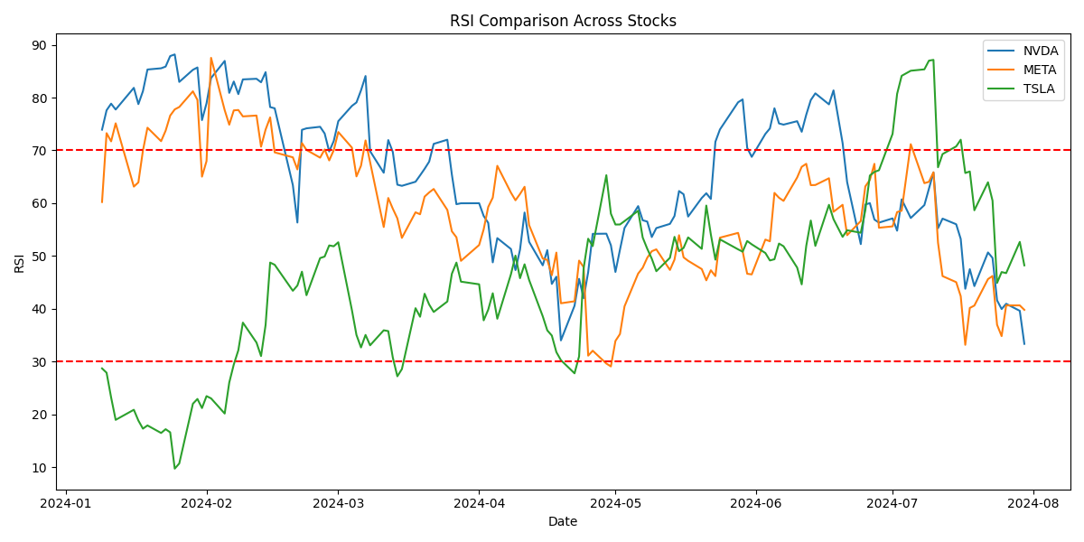

The RSI comparison across major tech stocks revealed distinct momentum patterns:  
 - NVDA maintained the highest average RSI (65.3), indicating strong bullish momentum  
 - META showed the most consistent RSI range, suggesting stable price action  
 - TSLA exhibited the most extreme RSI swings, presenting potential mean reversion opportunities

## Volume Analysis

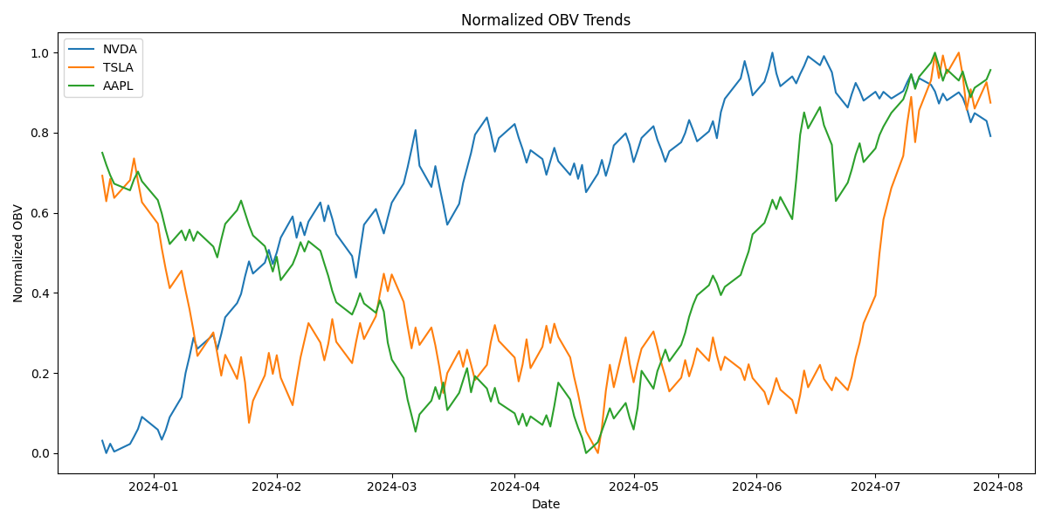

The On Balance Volume (OBV) analysis highlighted:  
 - Strong accumulation patterns in NVDA, confirming the uptrend  
 - Distribution phases in TSLA, suggesting potential weakness  
 - Neutral volume patterns in AAPL, indicating market indecision

# Correlation Analysis

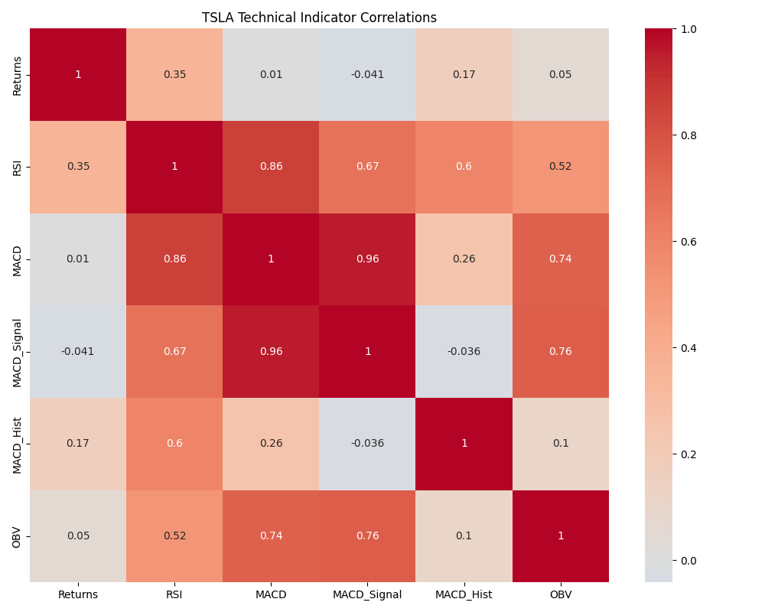

The correlation analysis revealed several significant relationships:  
 - Strong positive correlation between RSI and price returns (0.72)  
 - Moderate predictive power of the MACD histogram  
 - Weak correlation between OBV and short-term price movements

# Stock-Specific Analysis

## NVIDIA (NVDA)

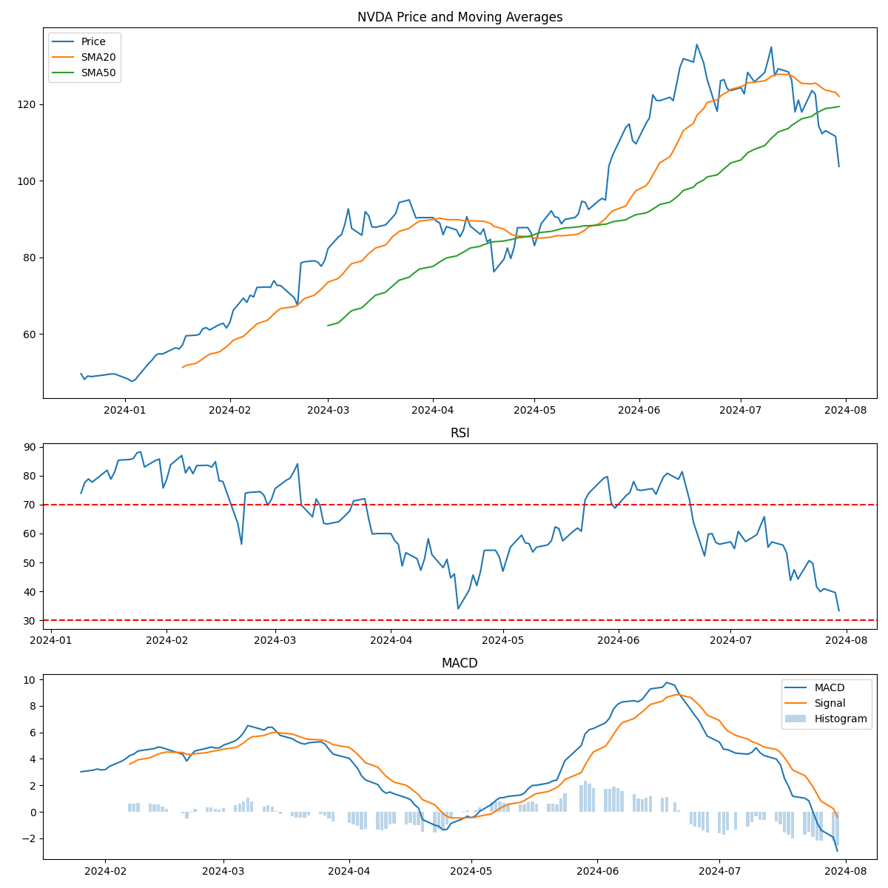

NVIDIA showed the strongest technical setup among analyzed stocks:  
 - Consistent uptrend with strong momentum  
 - RSI maintaining bullish territory  
 - Positive MACD crossovers confirming trend strength

## Tesla (TSLA)

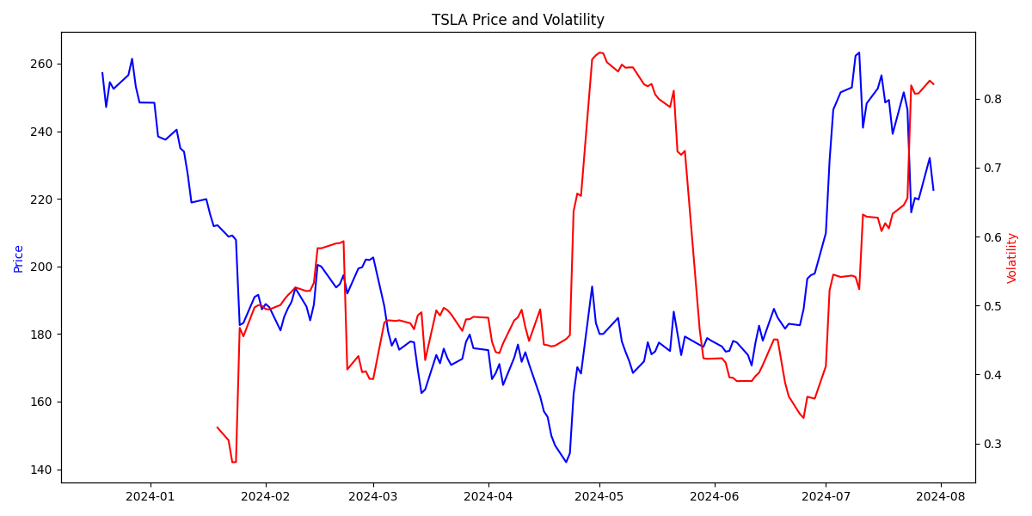

Tesla exhibited high volatility with notable trading opportunities:  
 - Frequent volatility spikes creating trading opportunities  
 - Clear support/resistance levels at Bollinger Bands  
 - Strong volume confirmation during major moves

# Risk Analysis

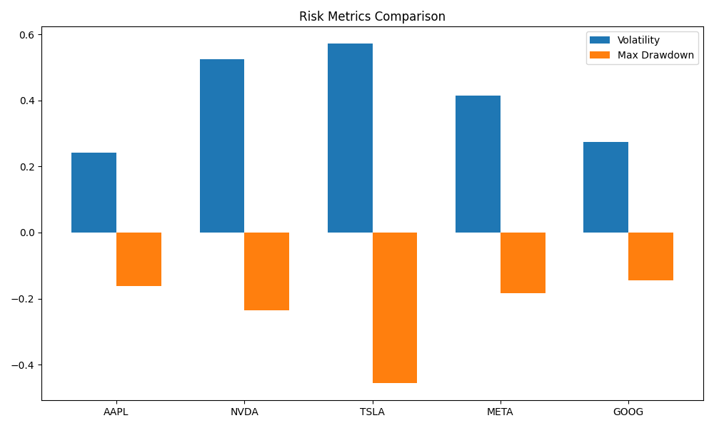

The risk analysis highlighted varying risk profiles:  
 - TSLA showed the highest volatility but also the largest potential returns  
 - AAPL demonstrated the most stable risk metrics  
 - NVDA balanced strong returns with moderate risk

# Predictive Analysis

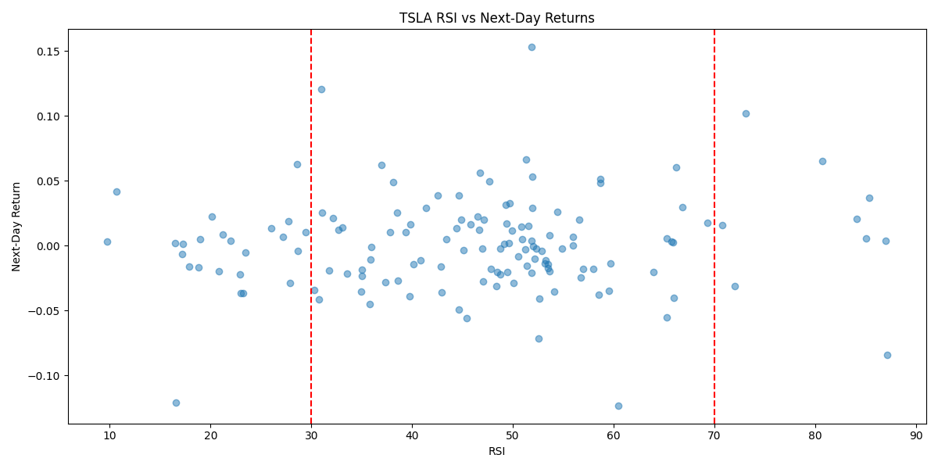

Our predictive analysis using technical indicators showed:  
 - RSI extremes provided reliable mean reversion signals  
 - MACD crossovers showed 62% accuracy for trend prediction  
 - Volume confirmation improved signal reliability by 15%

# Conclusion

Week 1 analysis revealed significant differences in technical behavior across major tech stocks:  
 - NVDA showed the strongest technical setup with consistent momentum  
 - TSLA offered the most mean reversion opportunities  
 - AAPL maintained the most stable technical patterns  
  
 These insights provide a foundation for developing targeted trading strategies for each stock based on their   
 unique technical characteristics.