Report
CS 352 project: L1 cache simulator

Problem statement:
The goal of the project is to create a level 1 data cache simulator in C++. Using object oriented programming, the source code is written to clearly illustrate how a data cache works. Also, by passing different parameters for the dimensions of the cache/memory, the statistics printed by the simulator can be compared. Varying parameters cache size (KiB), block size (Bytes), and associativity will affect the cache miss rates.

Solution:
.cc files can be made to include data structures for the cache and main memory.
Inside the cache data structure, an array of sets can be made. Each set would contain n blocks, depending on what the associativity is.
The cache would then hold all blocks of words until a block has to be evicted to the cache, depending on the cache replacement policy implemented (in this case, LRU).
The main memory would be given space for 16 megabytes (4 megawords, since 1 word = 4 bytes). This memory would only be written to when cache blocks need to be evicted from the cache or when all input of reads/writes are done.

Experiments:
The top 3 optimal configurations are :

Class design:
The cache simulator with 4 classes (including 2 structs). MainMemory, CacheMemory, Set, and CacheLine. Each aims to simulate that hardware compenent. Most of the implementation is in the CacheMemory class. It contains a MainMemory object and an array of Set objects. It also contains all the statistic variables and other useful variables as private members.
The MainMemory class has an integer array to hold all the data. It has simple accessors and mutators to interact with that data along with a print() method called by CacheMemory's print().
The Set struct, essentially a class, contains an array of CacheLine objects, the LRU algorithm, and read, write and print methods that are used only by the CacheMemory object.
The CacheLine struct contains and array of integer words, the tag and the valid and dirty bits. The print method is only called by Set's print method.
All the constructors help to initialize the data automatically when the objects are created.
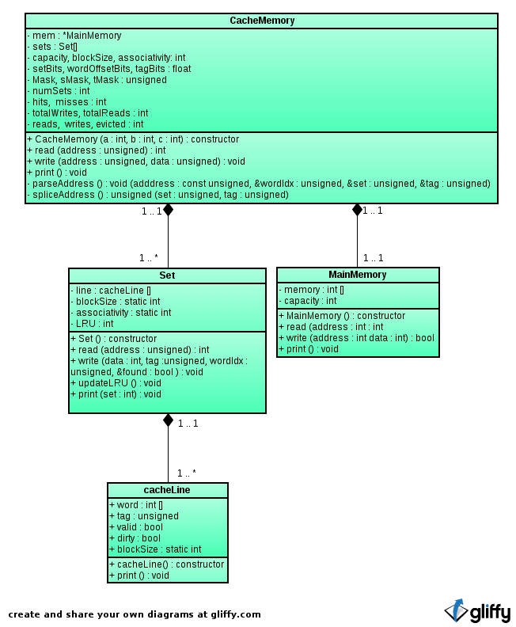
This designed helped keep methods small and readable. CacheMemory relied on Set to operate on it's data and Set relied on CacheLine to operate on data.

