TECHNICAL REPORT
World Crisis project

University of Texas at Austin
Computer Science 373
Summer 2012

Team: All the Single Ladies
Team members: Ian Buitrago, Jake Wilke, George Ross Shwarts, Fayz Rahman, Robert Reed
EXECUTIVE SUMMARY
The goal of the project is to track and aggregate information about different crisis around the world by building a website emulating the IMDB website design. There are several types of pages, including a splash page, import and export pages, a unit testing page. Hosted by the Google App Engine the site or “app” dynamically generates pages using data from the datastore. All crisis pages link to relevant people and organizations whose pages also link back to the crisis page. Users can submit more information about crisis, people, and organizations to the site in the form XML files conforming to our schema. This data is then parsed and stored in the database. This added information merges with the current data, without duplicating, on the site and is immediately viewable on the corresponding page. The export feature will generate a complete XML instance of all the data currently submitted to the Google datastore.

TABLE OF CONTENTS
EXECUTIVE SUMMARY..................................................................................................................i
INTRODUCTION.......................................................................................................1
DESIGN.......................................................................................................2
IMPLEMENTATION.......................................................................................................3
EVALUATION.......................................................................................................4

INTRODUCTION
* What is the problem
This type of site might help to bring awareness to these crises. Users can information on the site updated through the import facility.

* why is it interesting and important?
Completing this project involves using many different tools, including the Google App Engine, HTML, XML, python, gae Django, css stlye sheets and javascript.

*Why is it hard?

*What are the key components of your approach and results?

*Are there an specific limitations?

DESIGN
*What were your design decisions?
We designed the site with a clean look to emphasize the images and data about the crises. By using few so it attention . Colors are used sparingly
* What special features did you add?

* UI

* XML

IMPLEMENTATION

*What is your solution?

* framework and tools

*datastore

*import/export

*files and directory structure

*which teammate is most reponsible for each of the major components of the project

Hosted by the Google App Engine using python version 2.5.
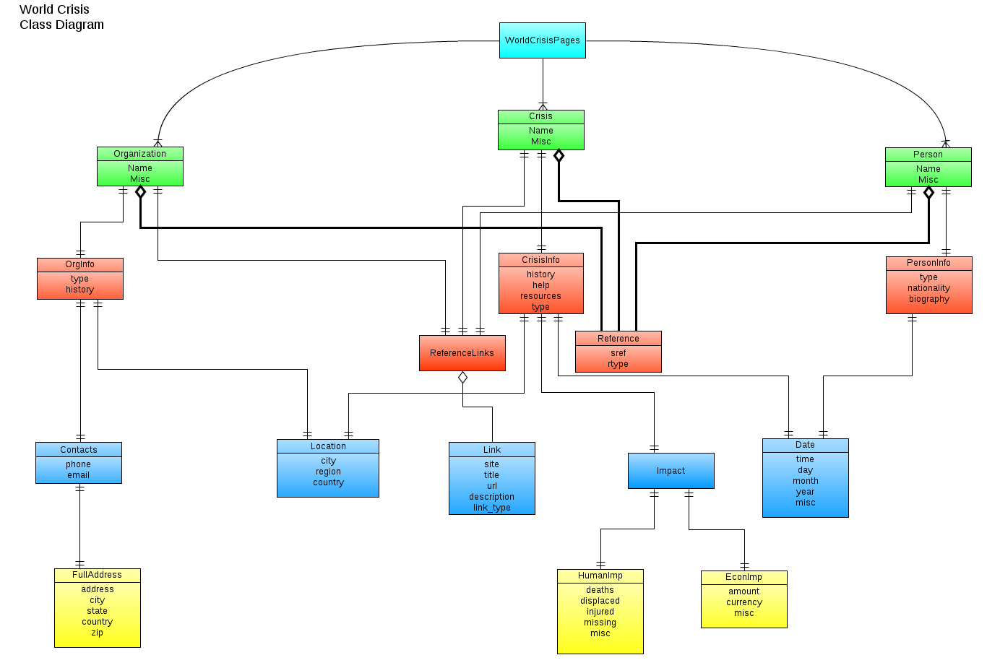Diagram 1: This UML diagram illustrates the relationship between classes in Models.py

UML diagram was done with the Gliffy website gliffy.com. This link has the latest version of the diagram: http://www.gliffy.com/pubdoc/3716424/L.png.

The website was done with Twitter bootstrap, gae django, css.

EVALUATION
*how did you test your solution

*unit tests

*performance tests

All the unit tests were performed using gaeunit. To run the gaeunit tests navigate to the test page from the splash page navigation bar located at the top through Data > Unit Tests or simply append /test to the end of the main page URL.

