Họ và tên : Hoàng Văn Kiên

MSSV:20205089

BÁO CÁO THỰC HÀNH LAB 1  
LẬP TRÌNH HƯỚNG ĐỐI TƯỢNG

# The Very First Java Programs

## *2.2.1* Write, compile the first Java application:

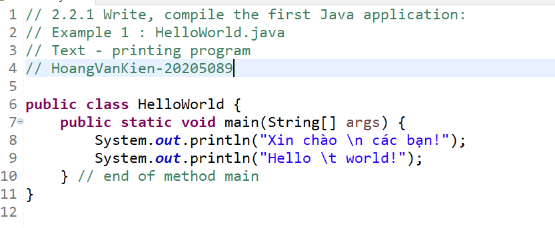

*Kết quả*

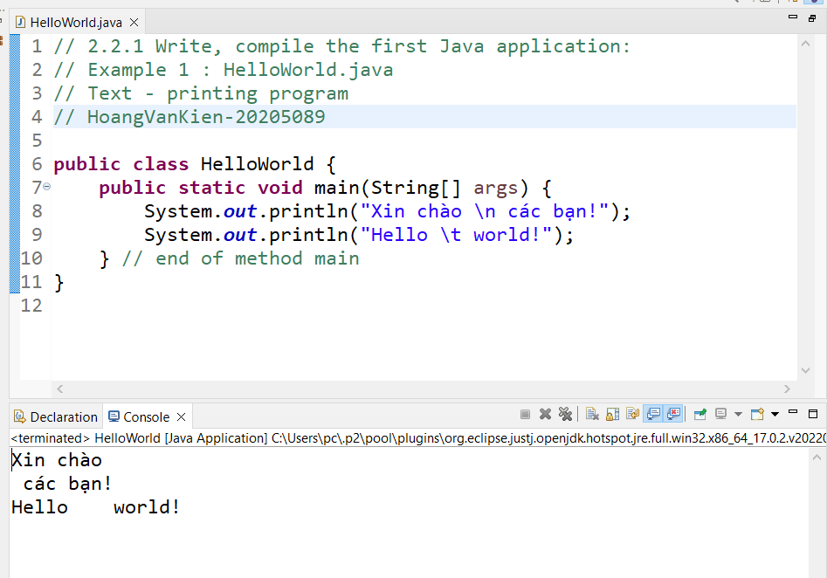

## 2.2.2 Write, compile the first dialog Java program

### 

### Ket qua

### 

## 2.2.3 Write, compile the first input dialog Java application

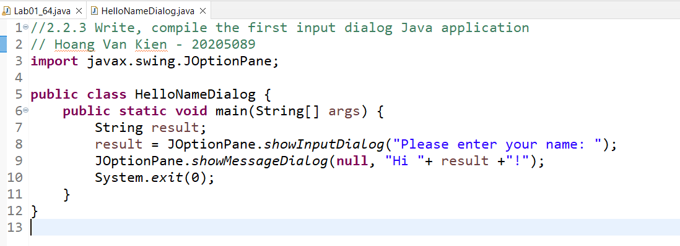

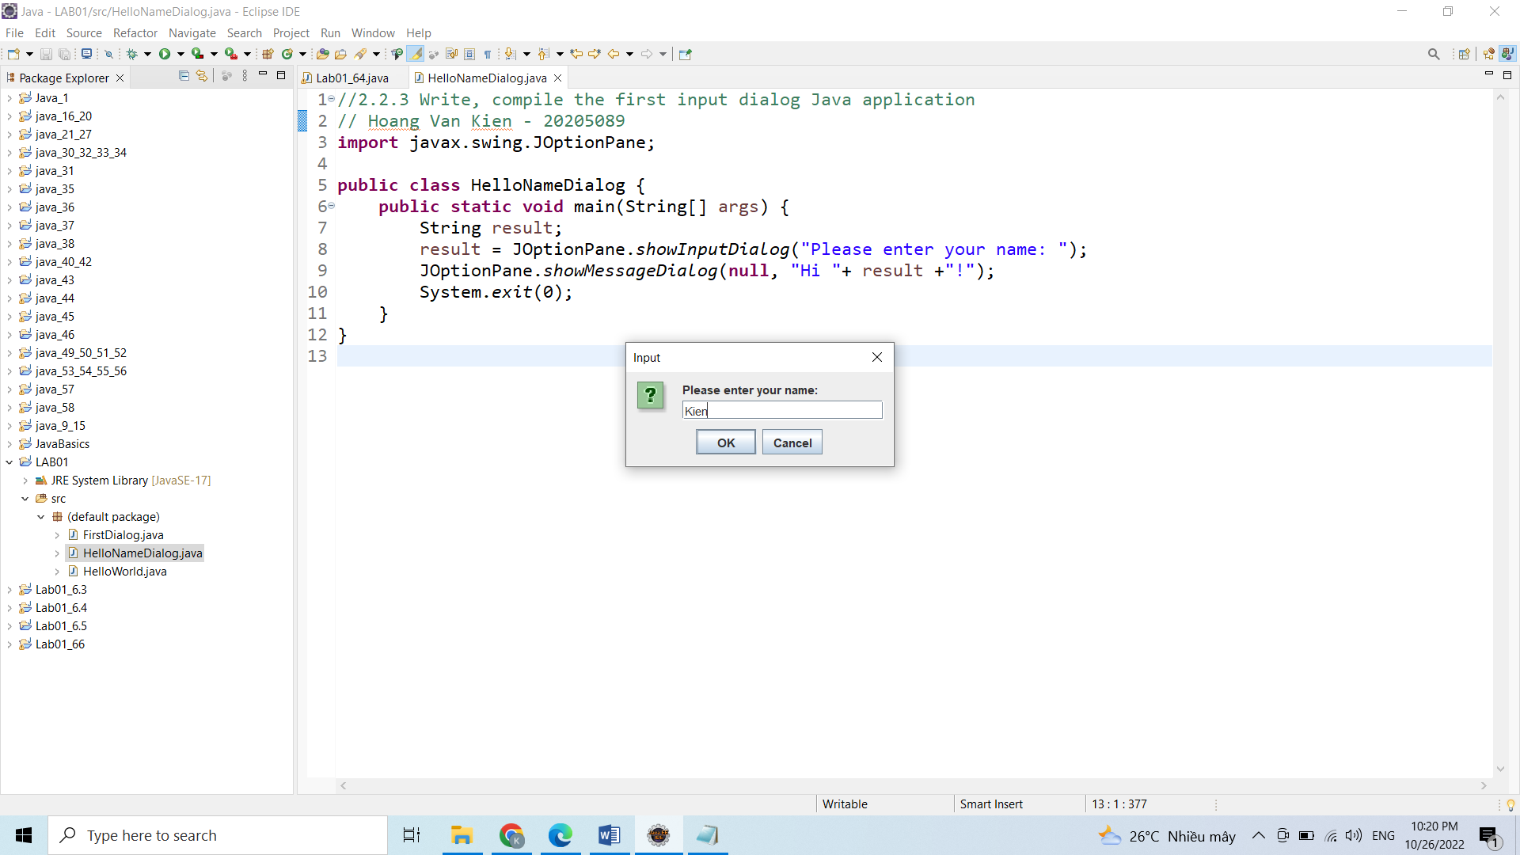

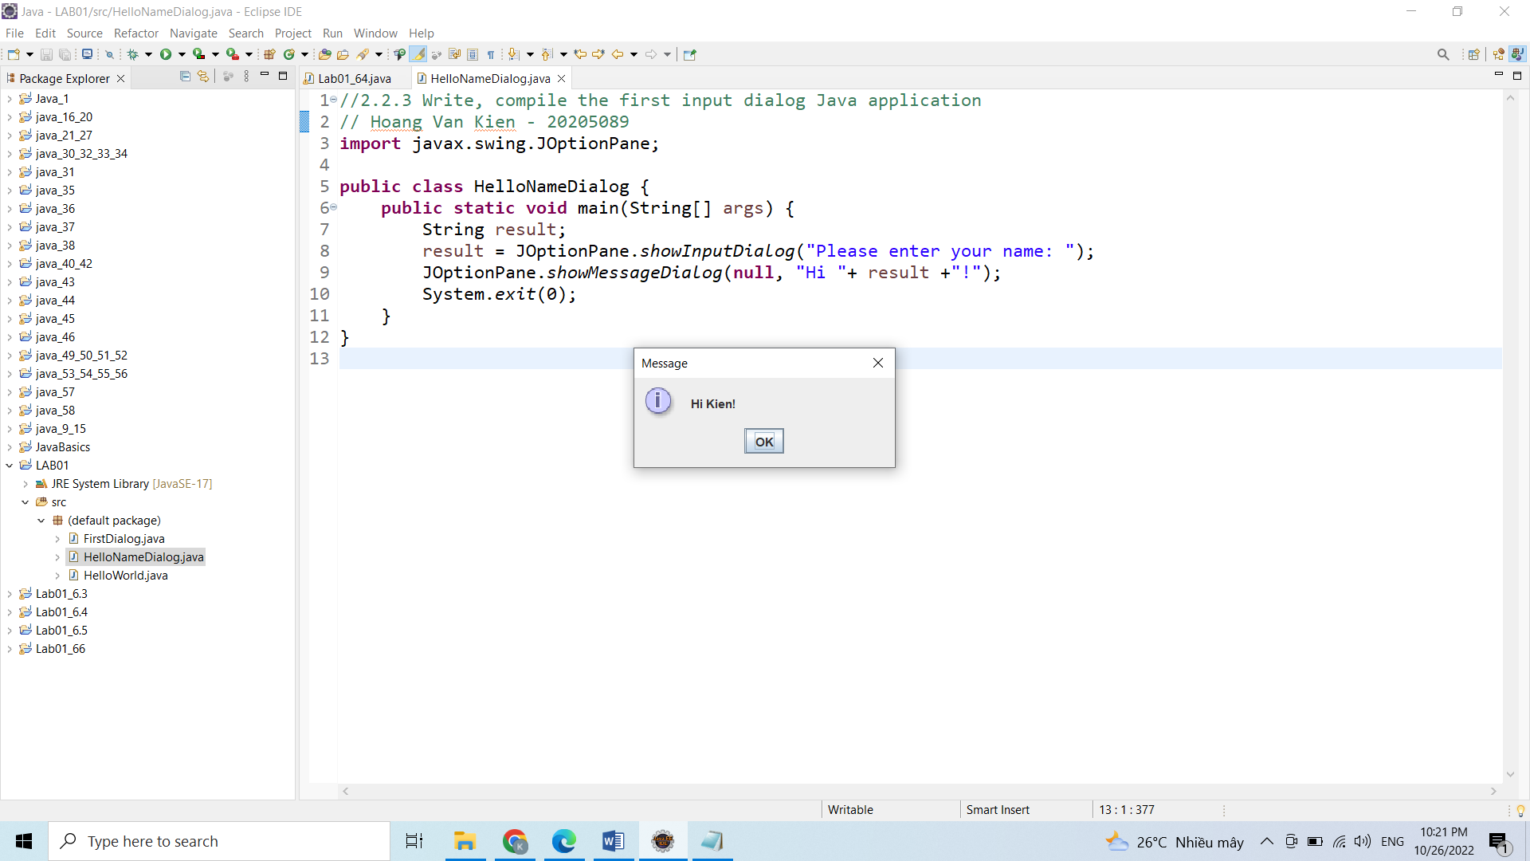

## 2.2.4 Write, compile, and run the following example:

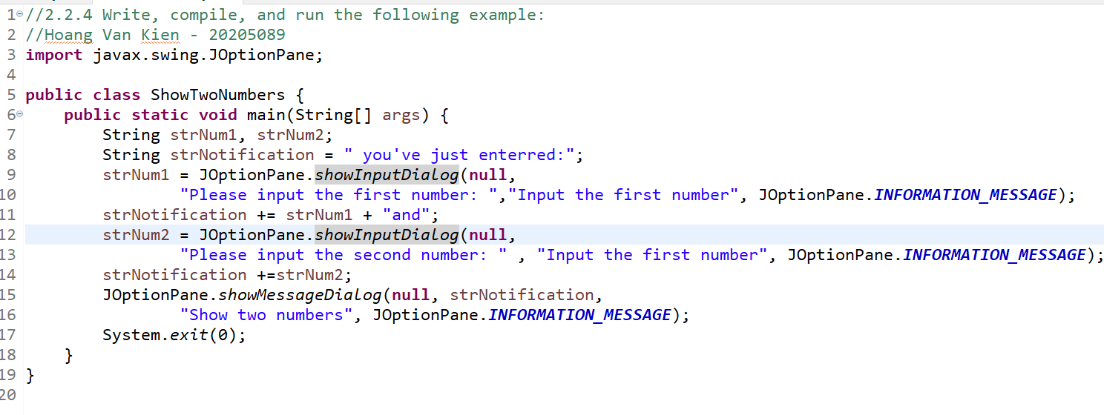

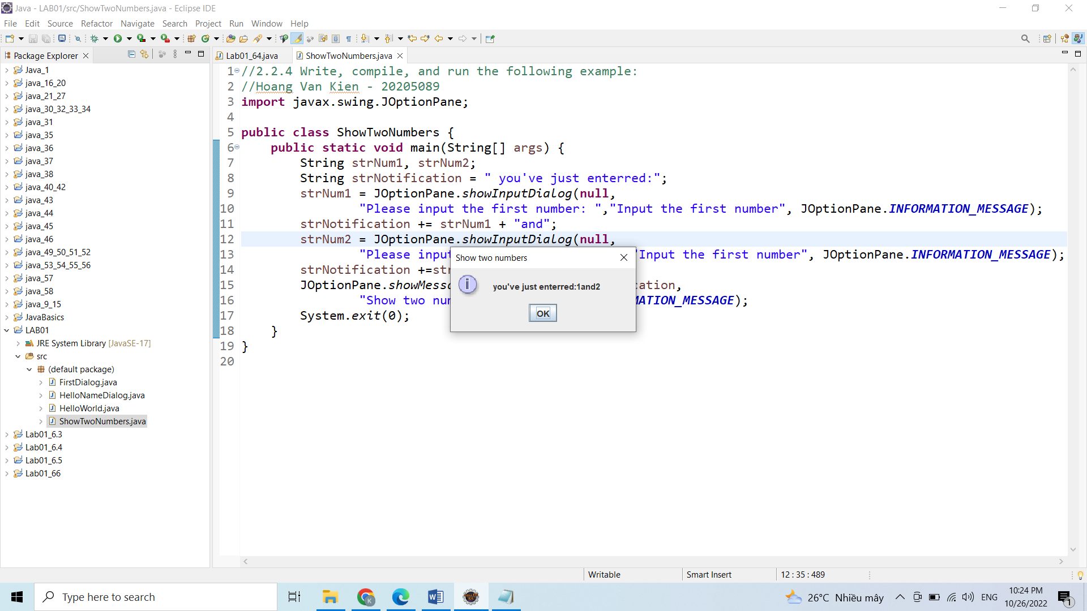

## 2.2.5 Write a program to calculate sum, difference, product, and quotient of 2 double numbers which are entered by users.

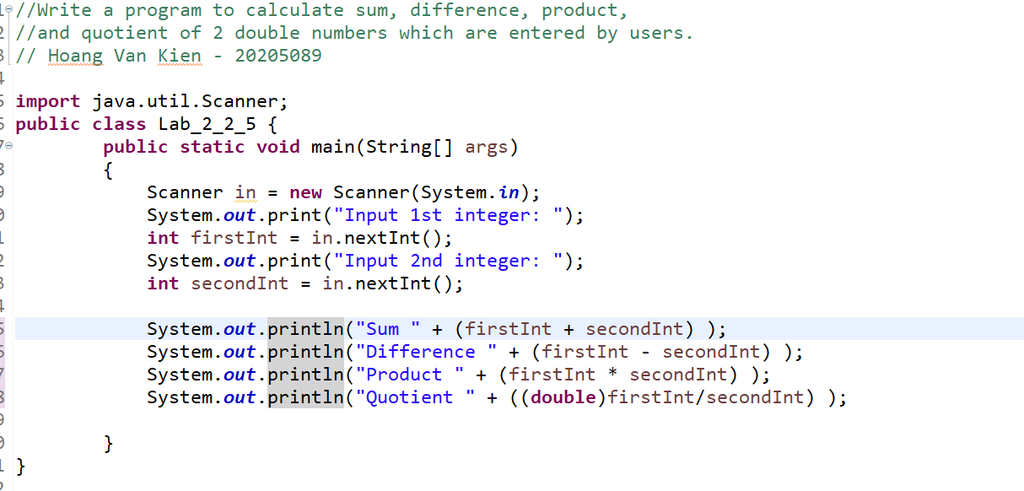

Ket qua

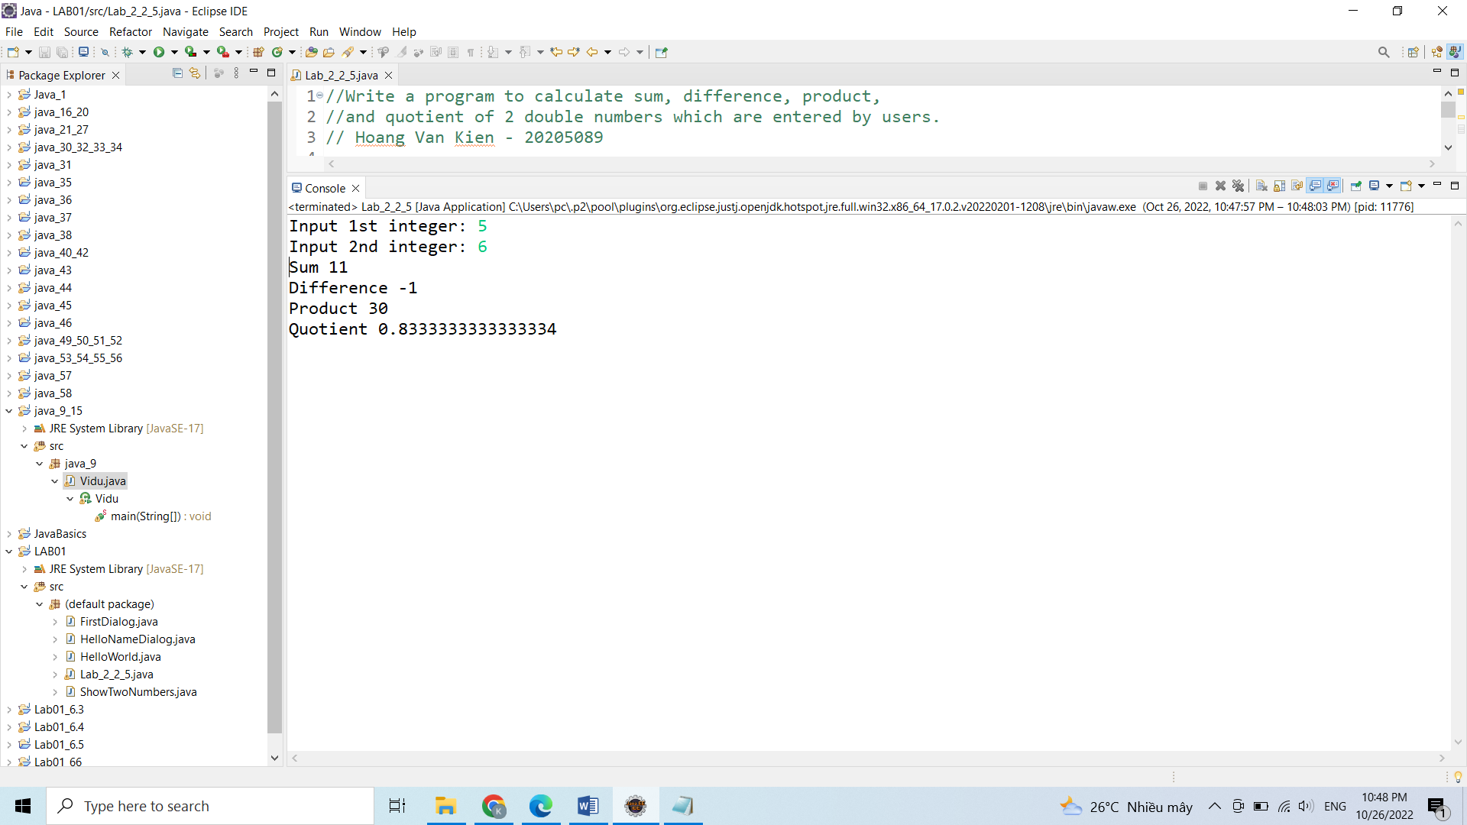

## 2.2.6 Write a program to calculate sum, difference, product, and quotient of 2 double numbers which are entered by users.

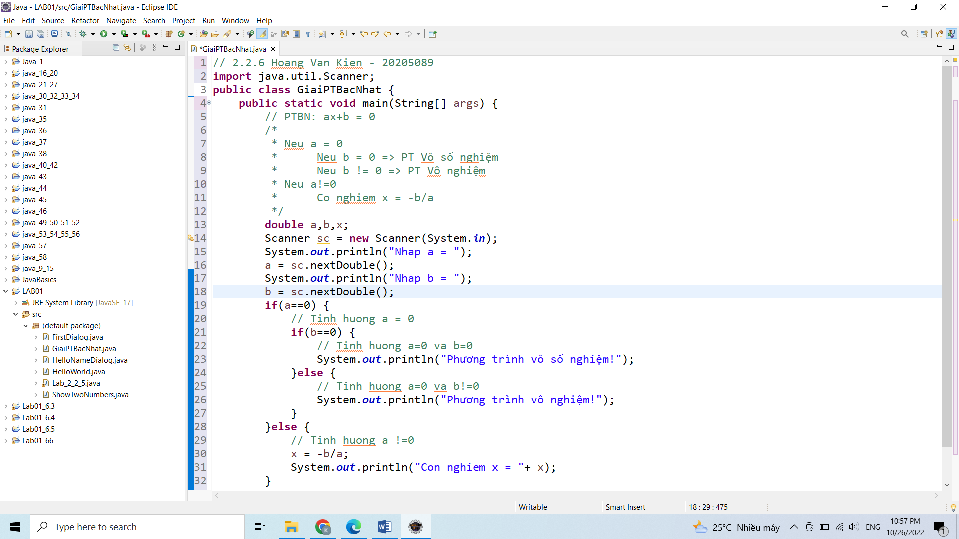

Giai Phuong trinh bậc 2

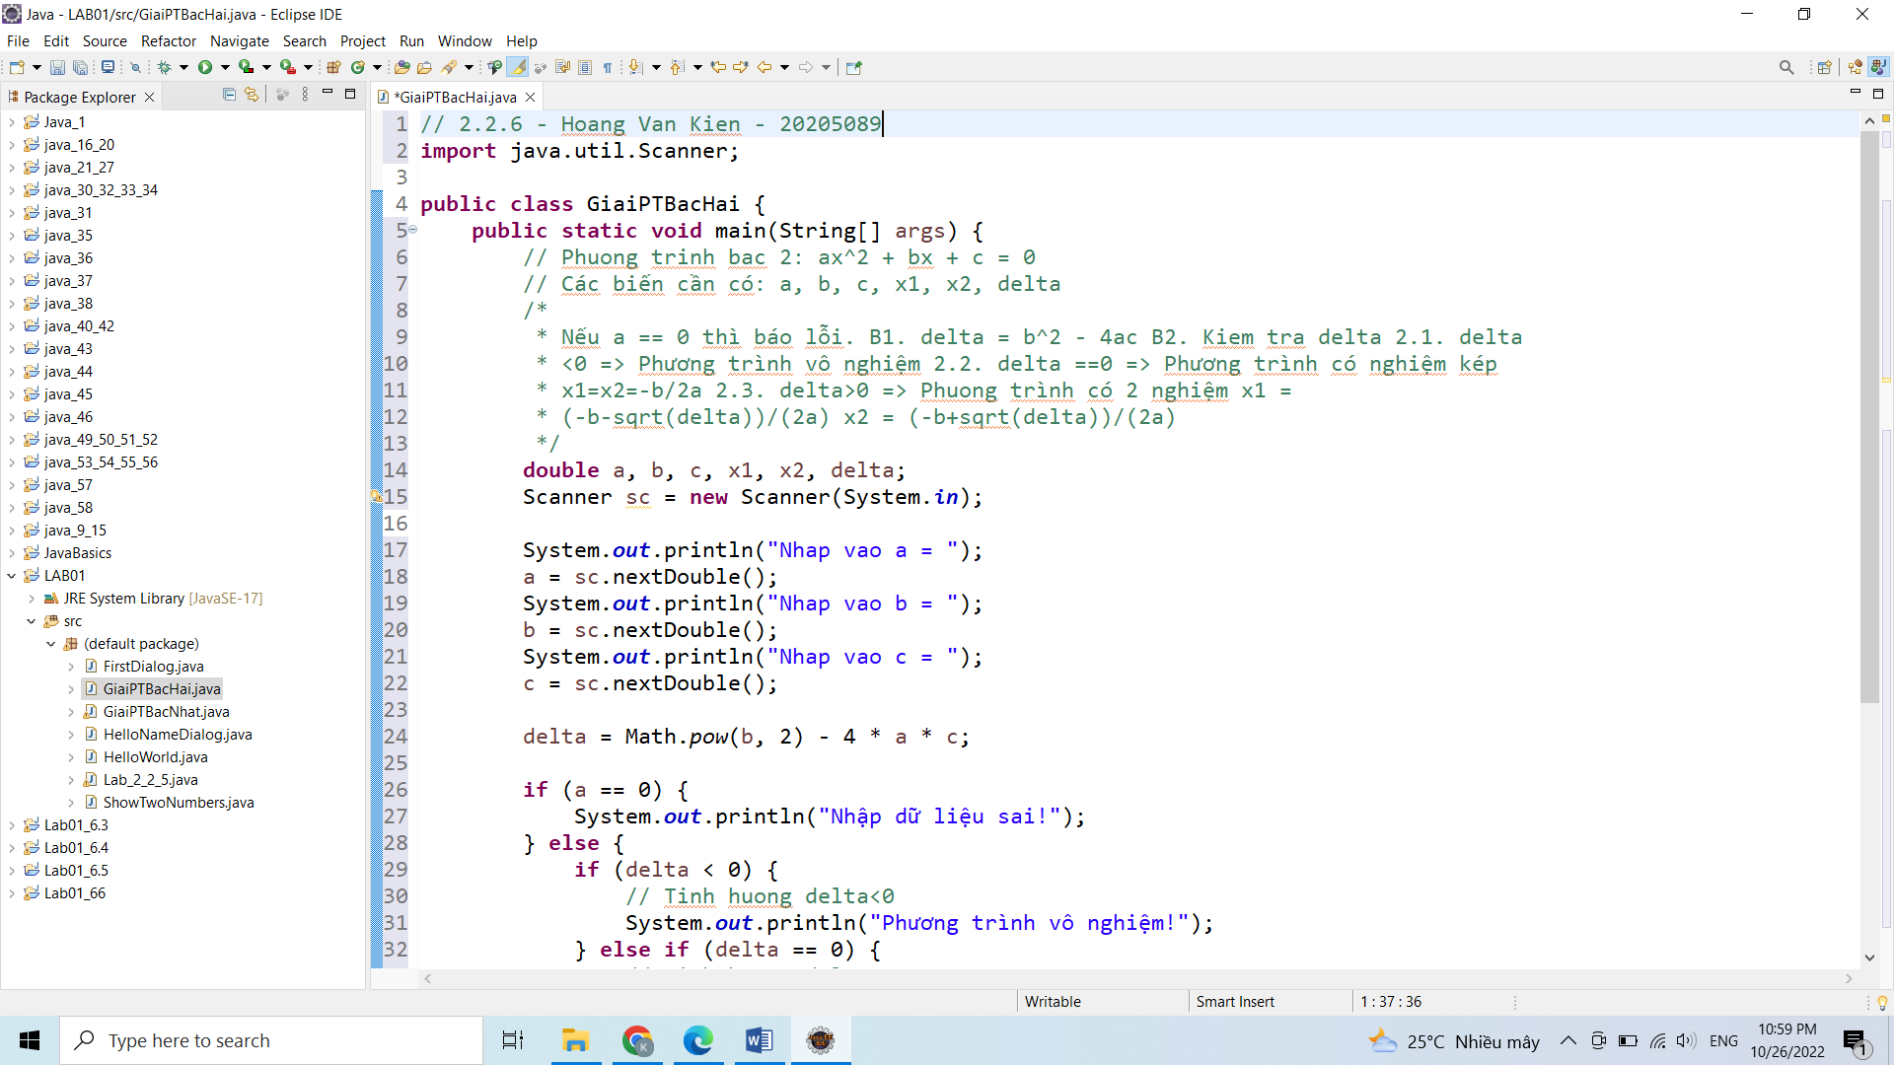

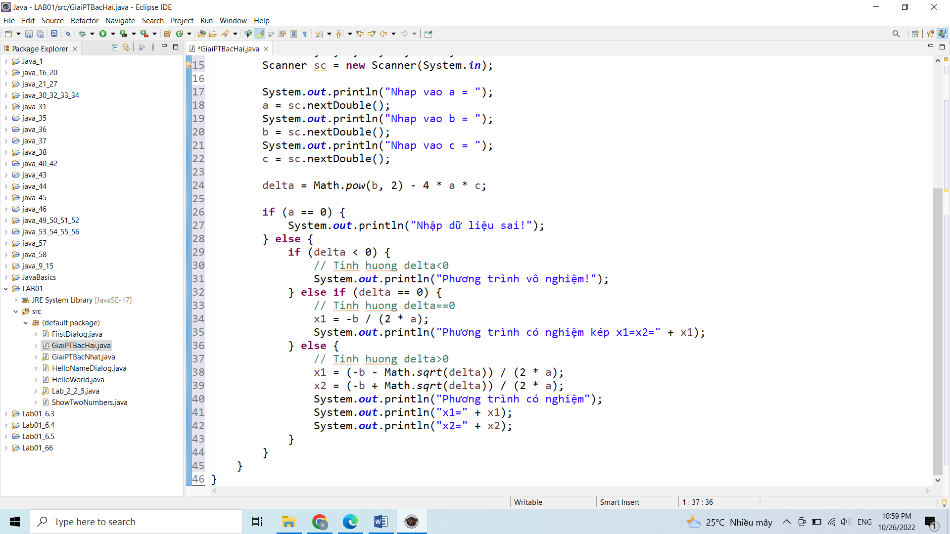

Giai hệ Phuong trình

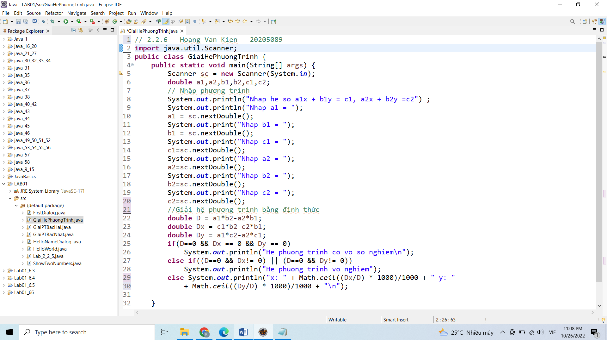

## 6 .Exercies

6.1 Write, compile and run the ChoosingOption program:

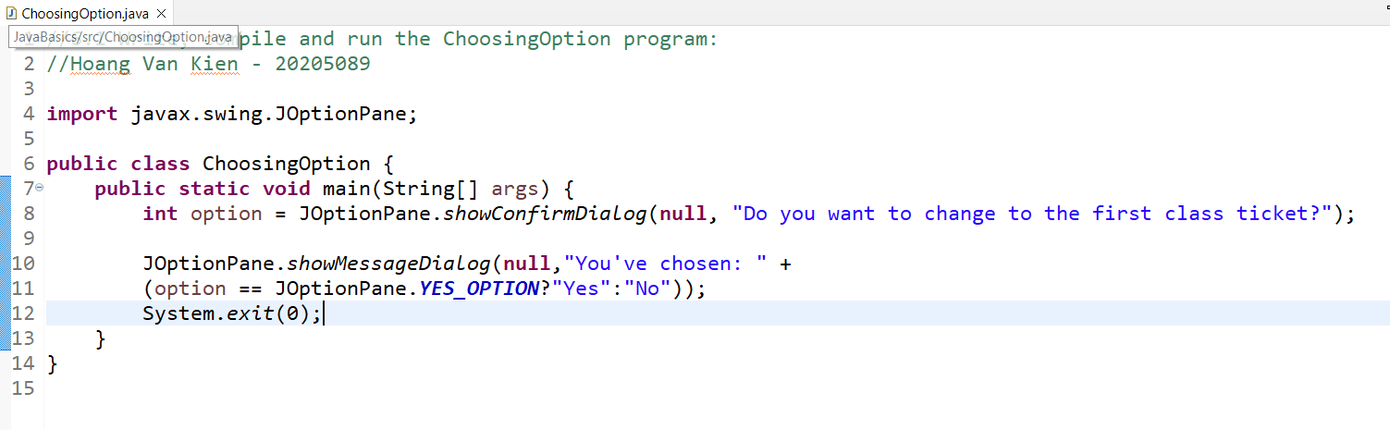

Ket qua:  
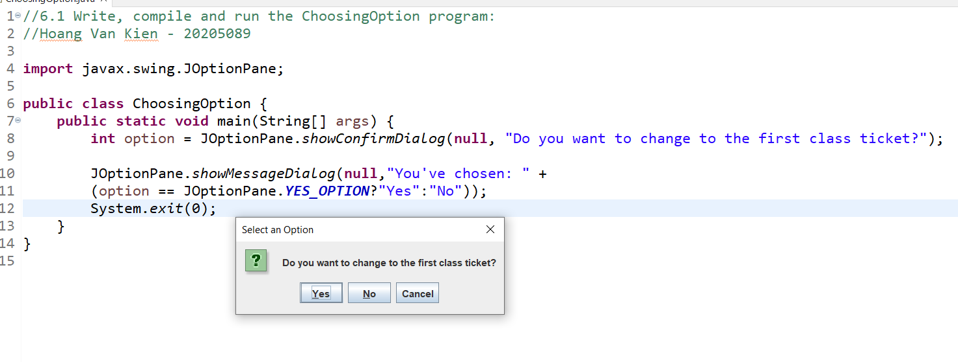

6.2 Write a program for input/output from keyboardi

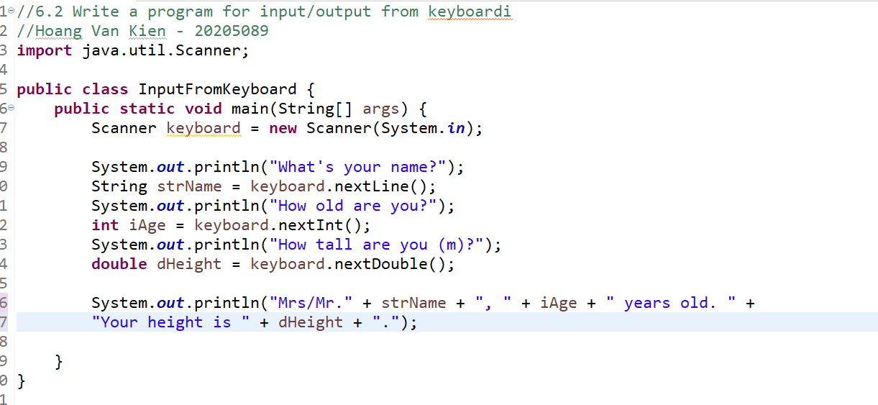

Ket qua:

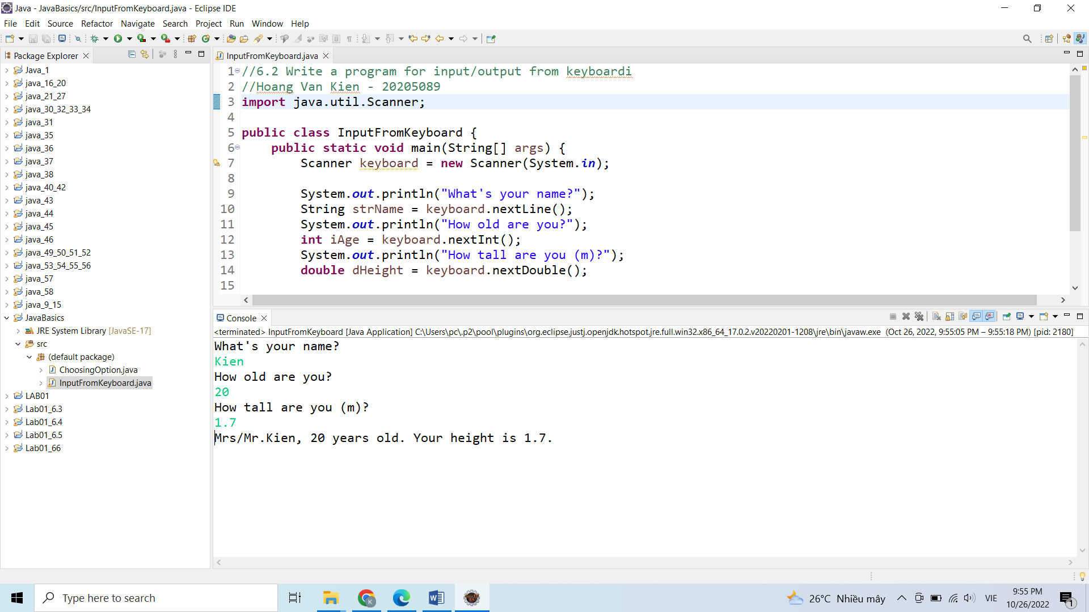

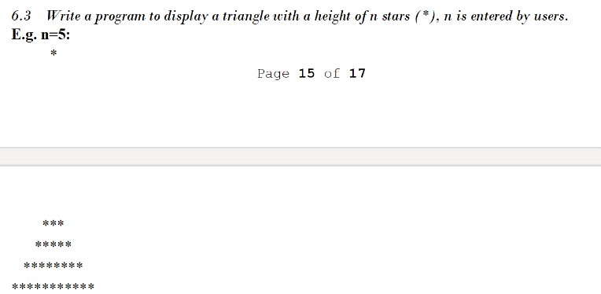

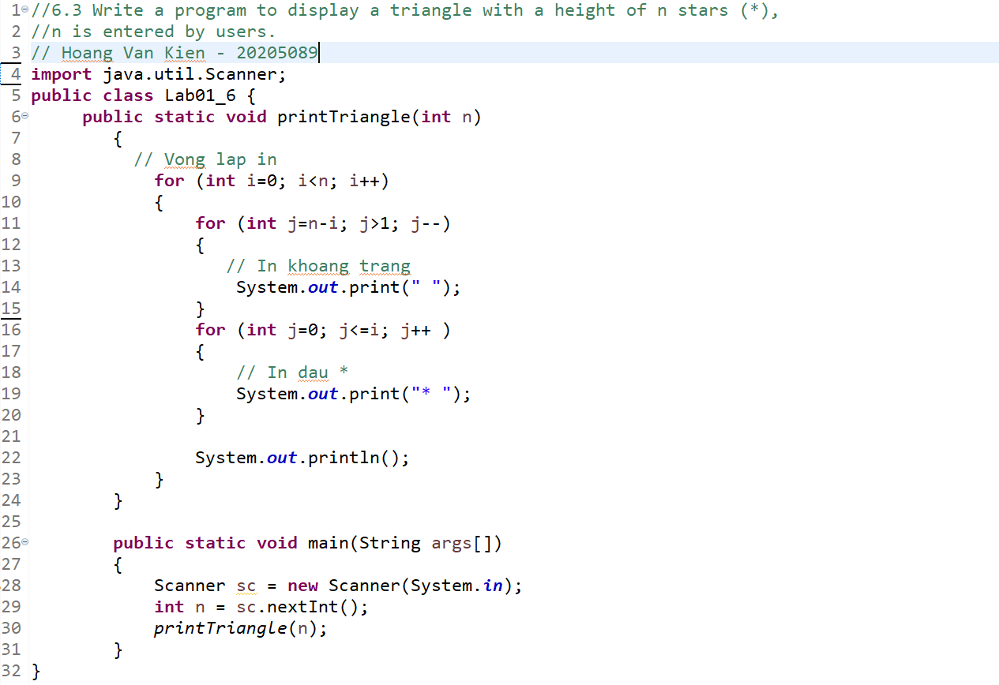

Ket qua:

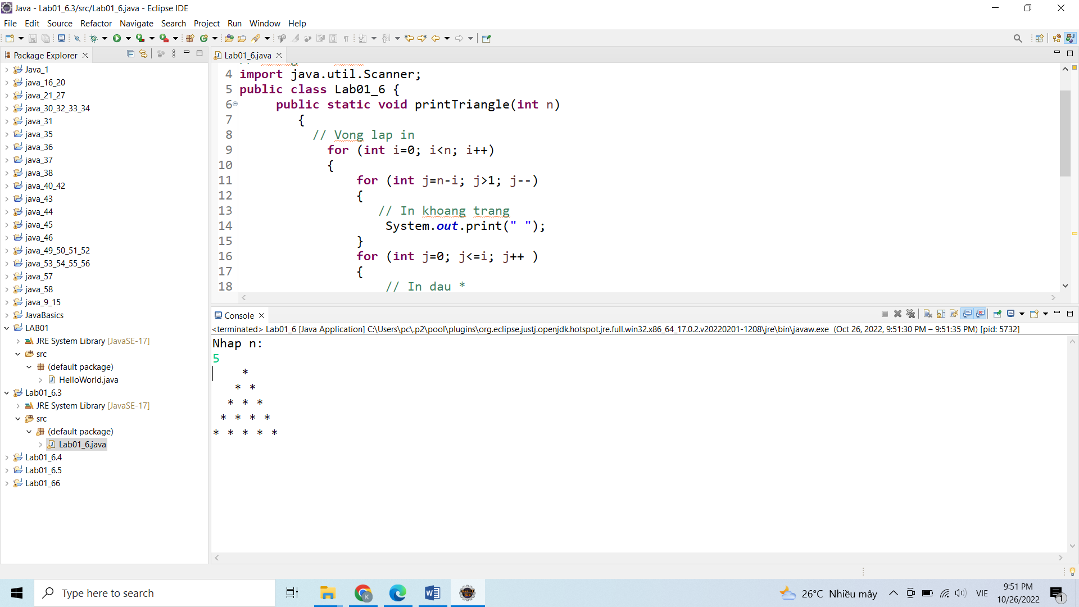

6.4 Write a program to display the number of days of a month

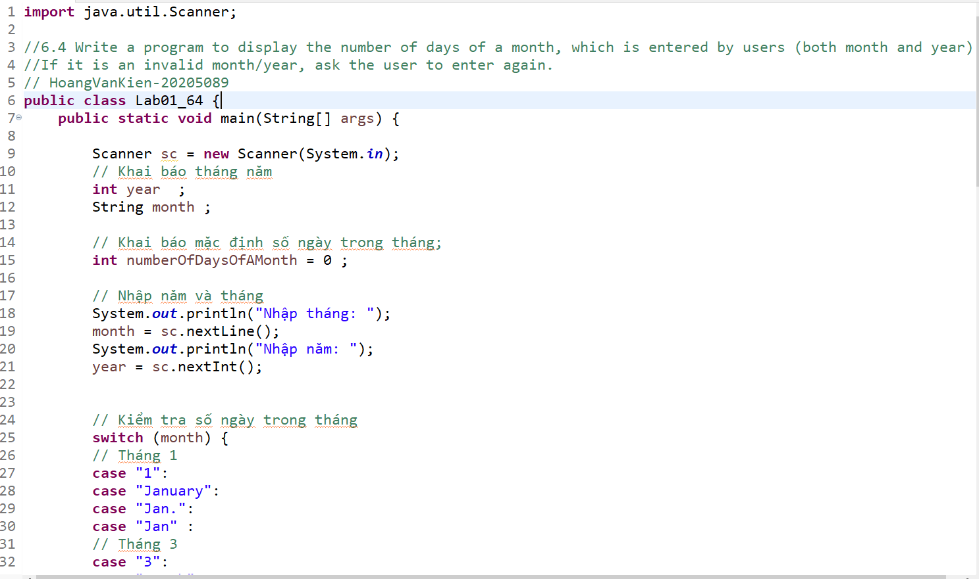

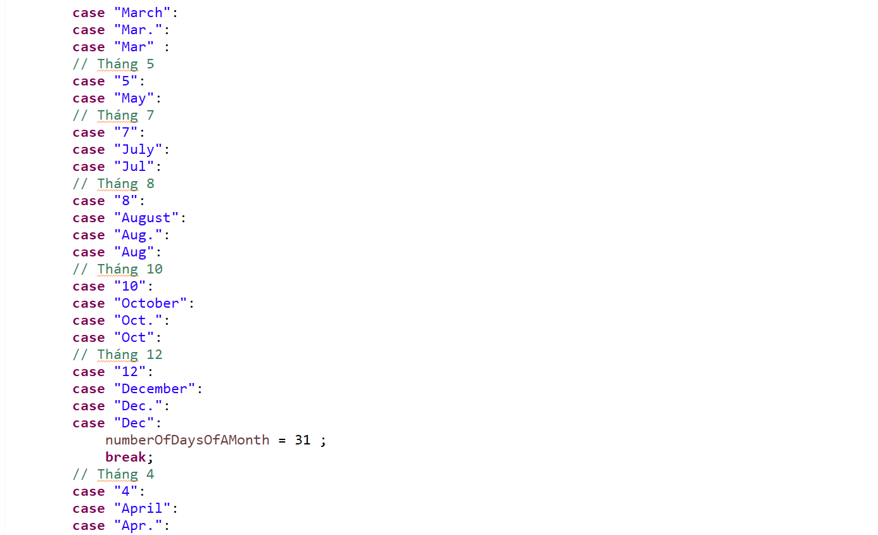

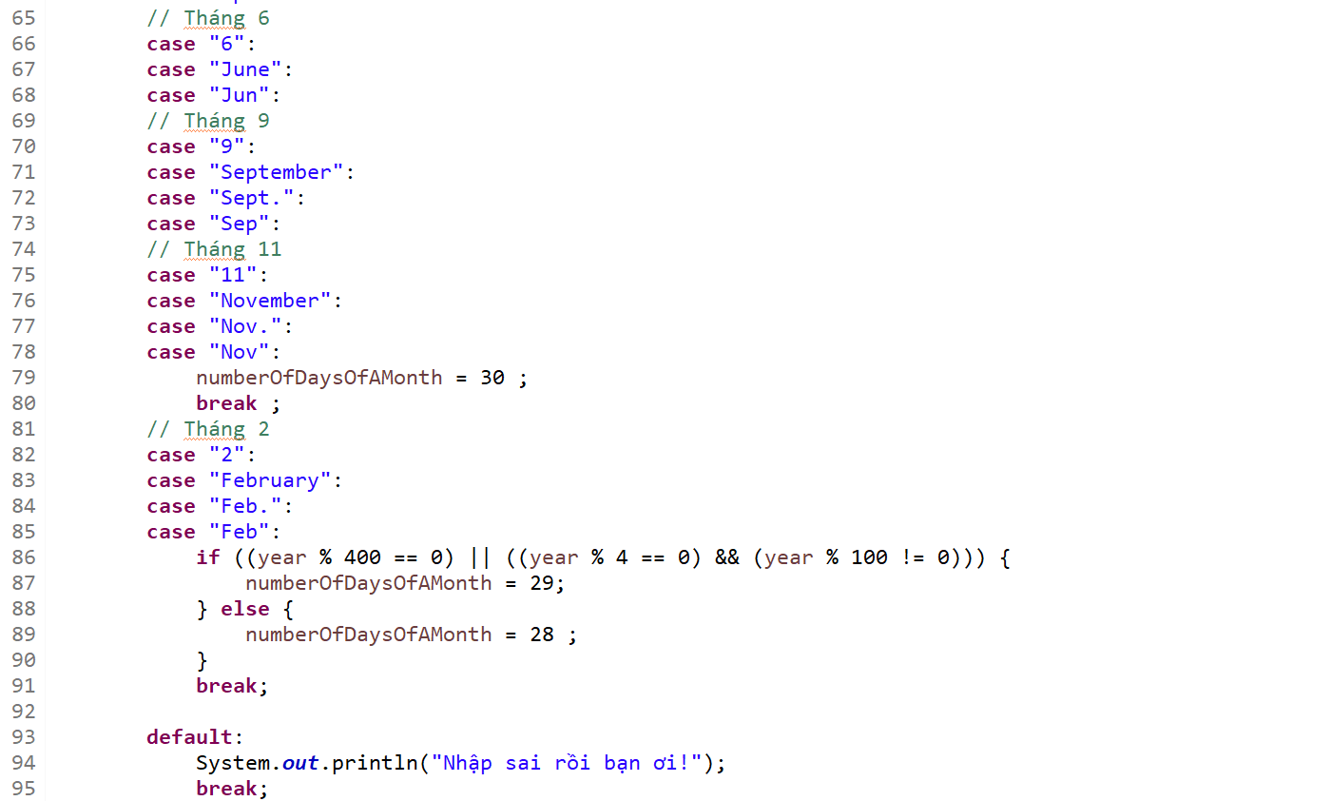

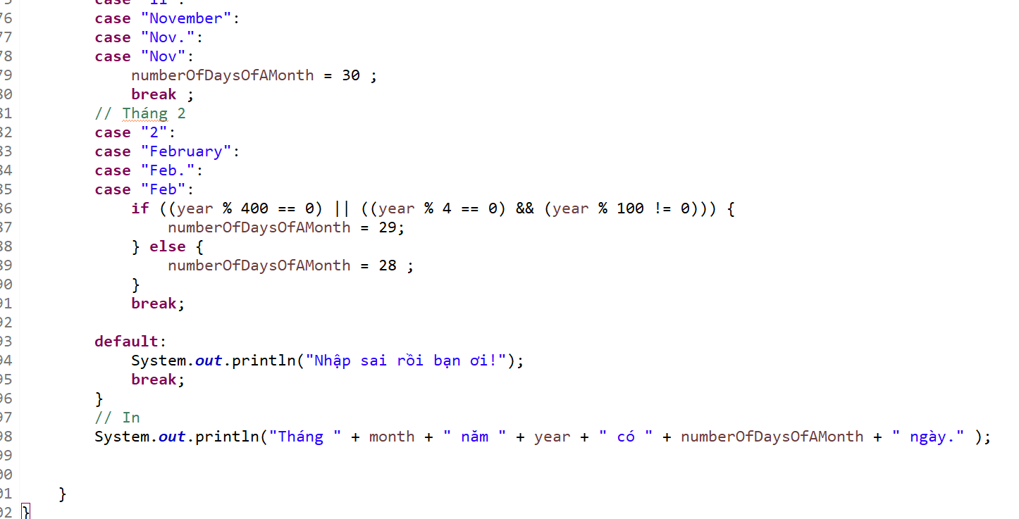

Ket qua:

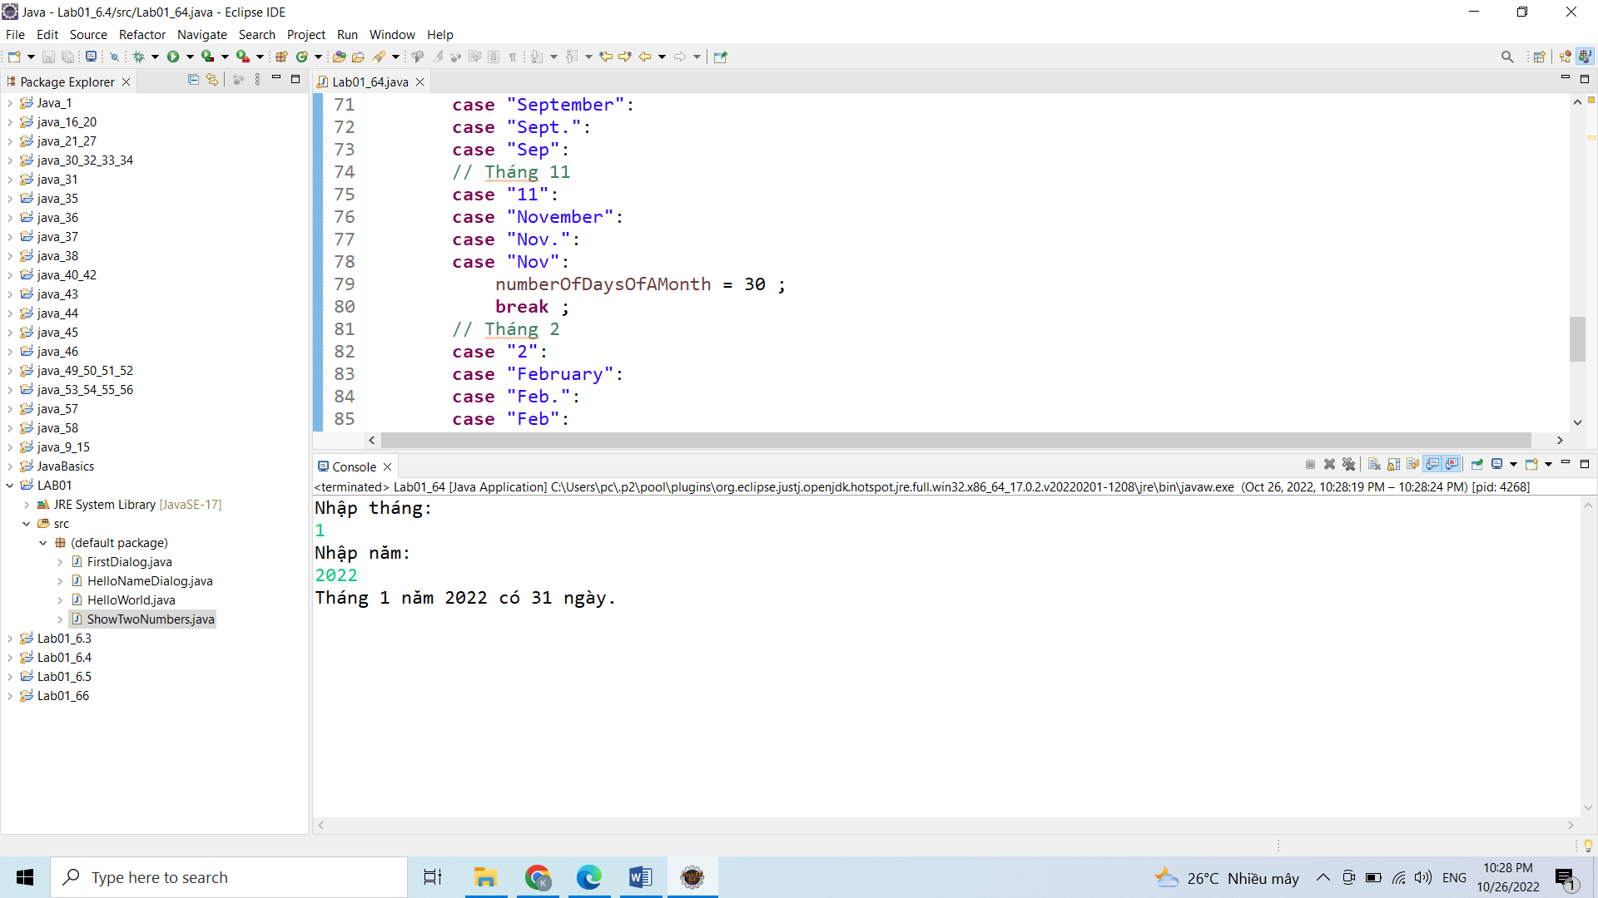

6.5 Write a Java program to sort a numeric array, and calculate the sum and average value of array elements.

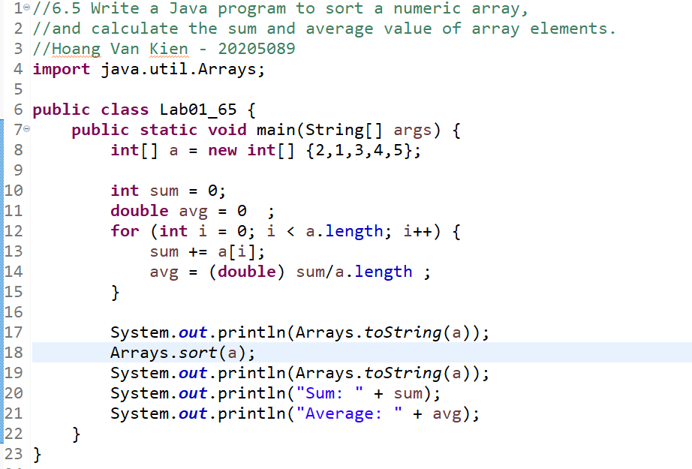

Ket qua:

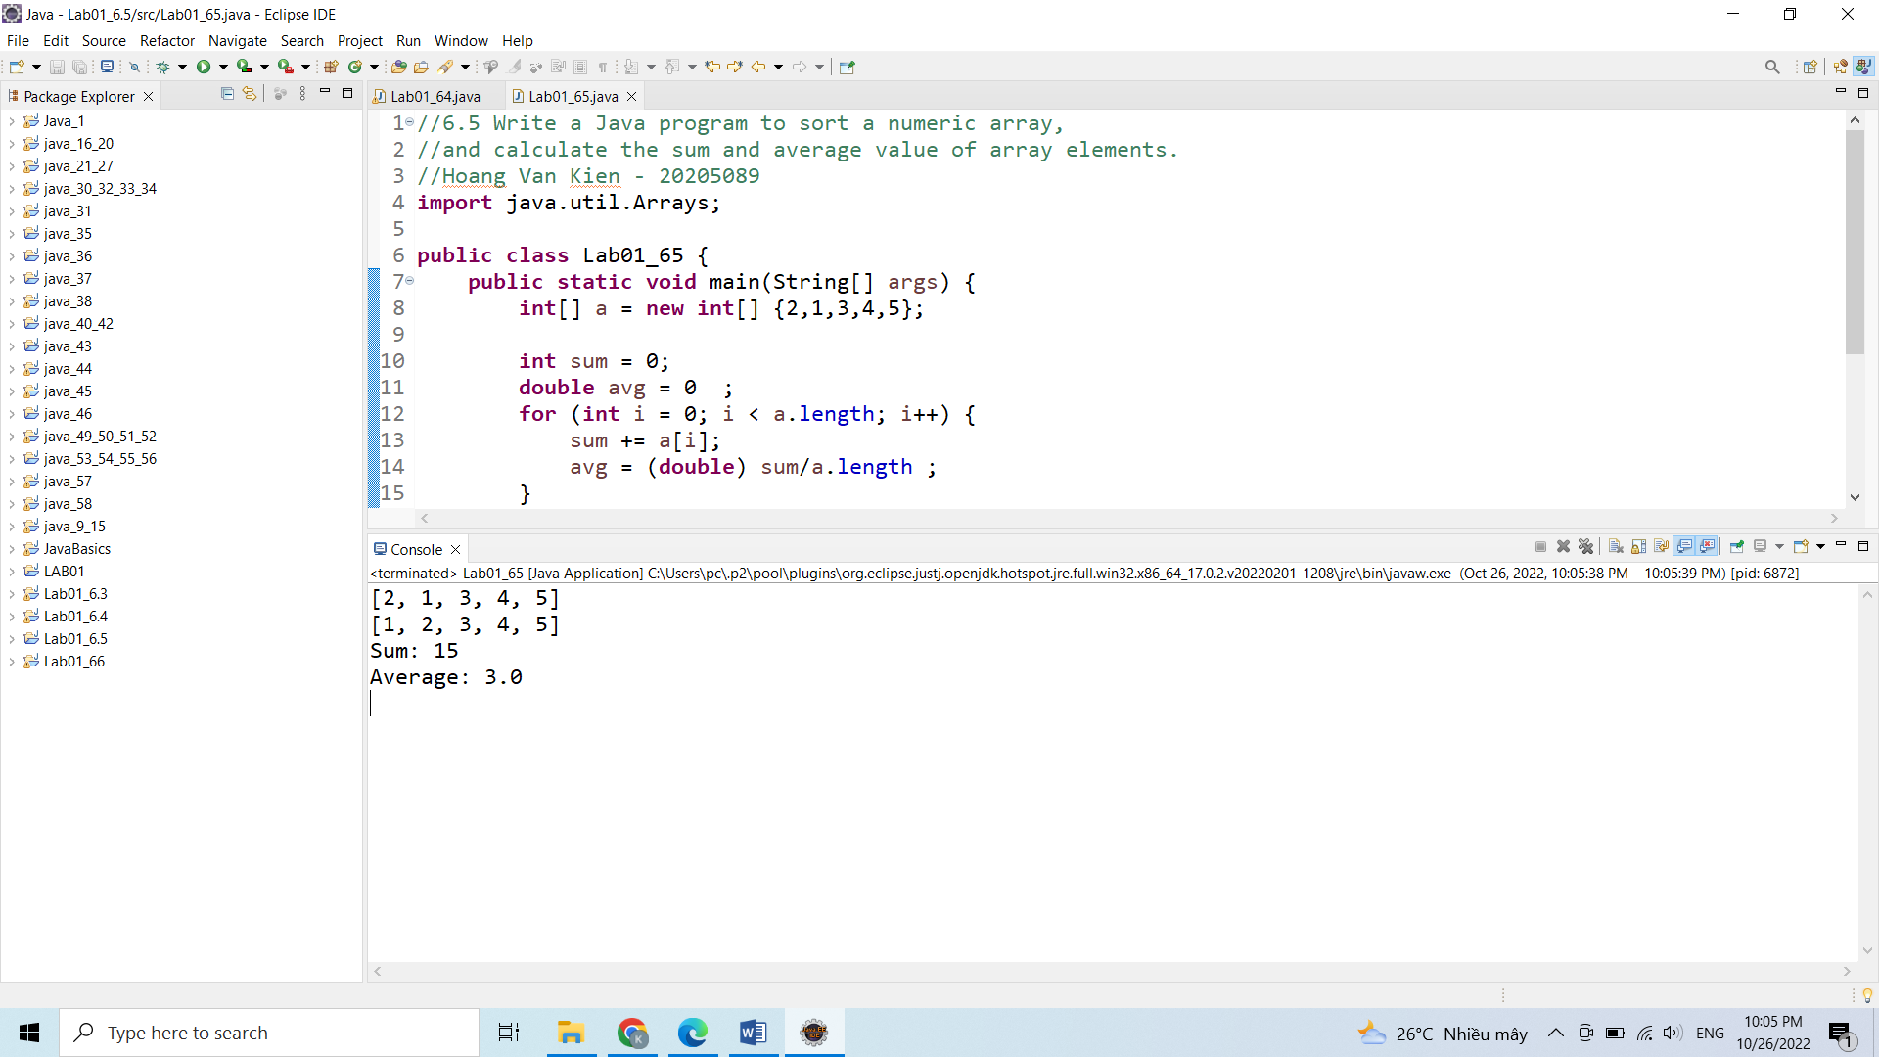

6.6 Write a Java program to add two matrices of the same size.

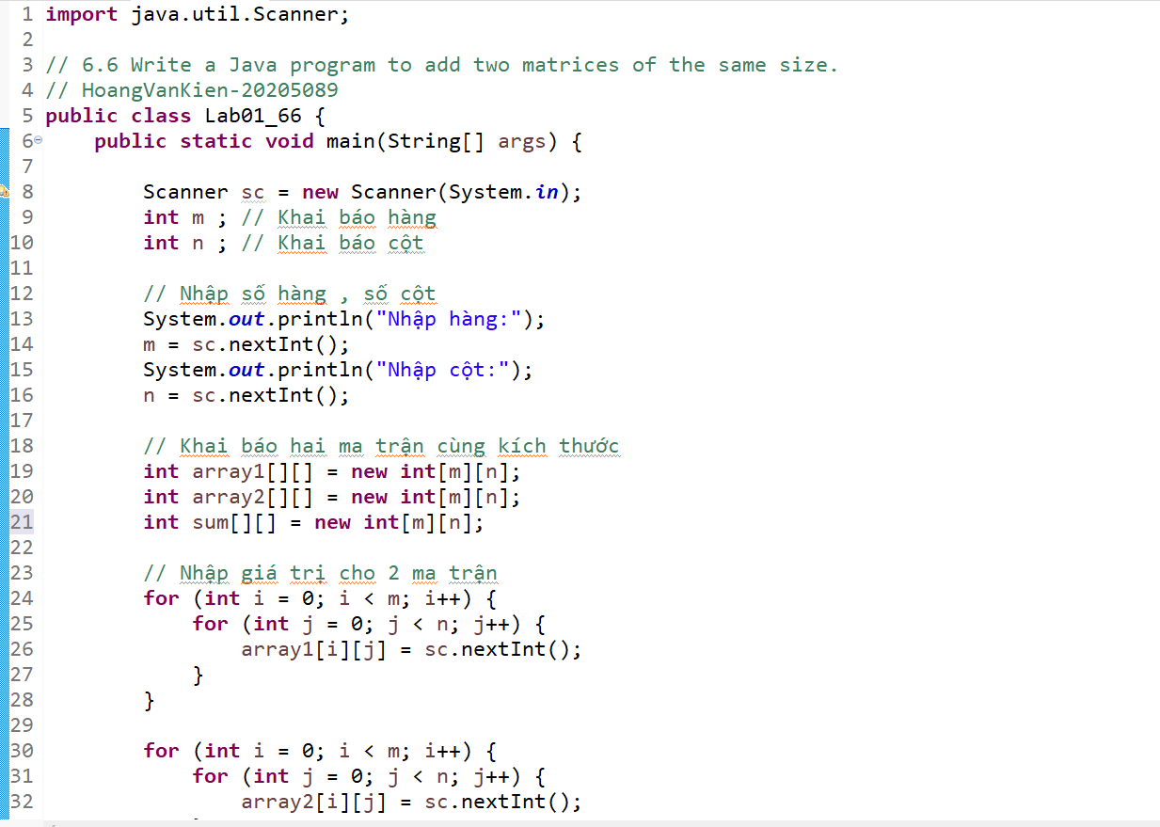

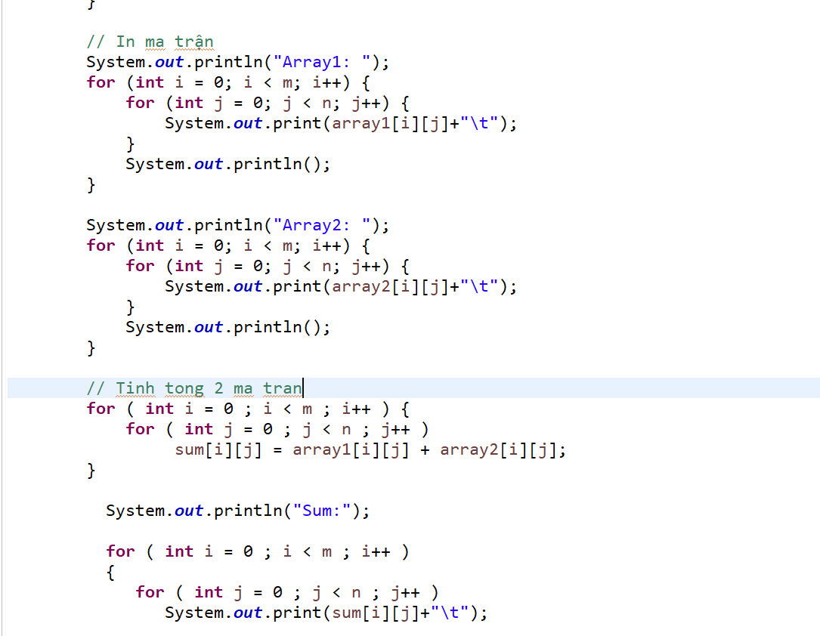

Ket qua:

