Unit 16 (6-10)

|  |
| --- |
| Asked sb if : hỏi ai liệu ….  Ask sb to Vnd: bao ai lam gi  Ask sb for st: hoi xin ai cai gi  Become + a job: become a photographer:  Become + adj: tro nen ntn (famous)  Take a shower = have a shower = take a bath  Take st = bring st: mang cai gi  Take sb to somewhere: mang ai do di dau  Wait for doi  A good view of sth: co cai nhin tot ve cai gi do.  Win/won + prize: - competition : gianh giai thuong  Of all ages: (o moi lua tuoi – children and adults)  Tired - > go to bed  A hard bed: mot chiec giuong cung – back (lung)  It takes sb ? time + to do sth: Ai mat bao lau de lam gi  S spend ? time Ving: ai danh bao lau de lam gi  Top floor : thang thuong  Waitress/ Waiter => friendly to customers  A slice of cake: mot lat banh, chanh (lemon)  A notice about sth: mot su chu y/ dieu chu y ve cai gi do  Thirsty: khat nuoc  Take the lift: bat thang may  A very expensive CD player: mot chiec dai dia CD rat dat  Cook a big meal : nau 1 bua thinh soan  Decide to do st= decide not to do st: quyet dinh lam gi/ quyet dinh ko lam gi  Would like to do sth = want to vnd: muon lam gi  Book + tickets/ seats/ a table: (dat)  Join + club: tham gia cau lac bo – member  Parents with children= family  A long way: duong dai, xa  Country: >< nationality  The same age: cung tuoi  Make sure: chac chan  Improve (v): get better : cai thien  Earn + money: = make money: kiem tien  Work in an office : lam viec o 1 van phong  Break + cups, plates: danh vo (coc, dia)  Feel + very upset/ sad: cam thay rat …dau kho, buon rau  Forget about sth: quen ve viec gi do  Short brown hair : toc ngan mau nau  Noisy (adj) >< quiet: on ao>< yen tinh  Enter a place – di vao cho nao do  High up: phia tren cao  The lift isn’t working >< out of order: bi hong  Expensive = cost much: dat do, dat  High # tall # long  Get a mobile phone: = buy a mobile phone  Try st: thu cai gi.  Try to do st: co gang lam gi  Put on + clothes, shoes, boots:= wear: deo, mac, doi, di  Have + breakfast, lunch, dinner: an sang, trua, toi  Prefer + Ving:thich lam gi hon  Prefer Ving to Ving: thich lam gi hon lam gi.  Low prices: gia thap  Full of people: = crowded: dong duc, dong nguoi  remember to do sth: nho phai lam gi  Practise (v)thuc hanh |

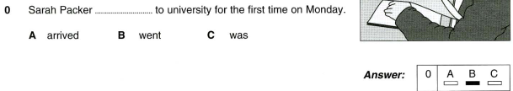











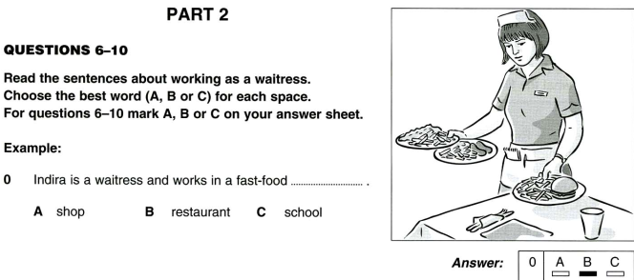

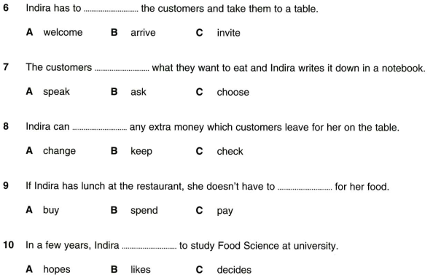

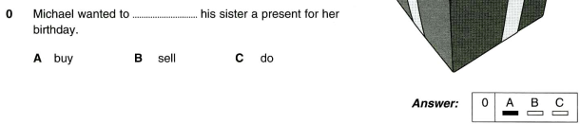











Writing part 7:



41. last 42. On 43. A 44. Was 45. Have



Part 5:

46. am 47. You 48. To 49. I / I’ll 50. opens

|  |  |
| --- | --- |
| See sb/st vnd: nhin thay ai lam gi (chung kien toan bo su viec)  See sb.st Ving: nhin that ai dang lam gi. |  |

Part 9:

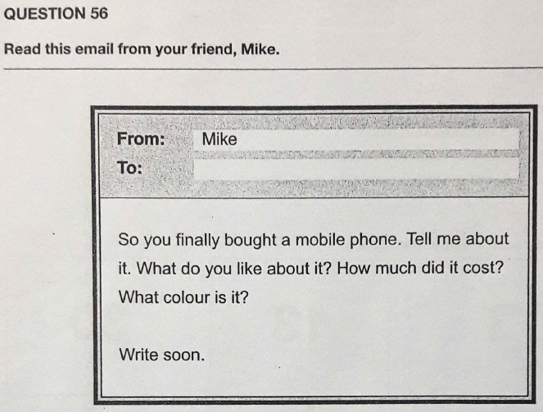

Dear Mike,

I finally bought a mobile phone. I like it because it is the newest model. It was 200 USD. It is pink. I hope to use it to learn English better. Write to me soon.

Love,

Name 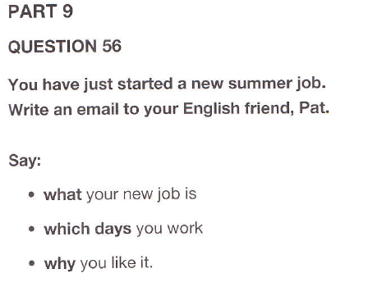

Dear Pat,

I have just started a new summer job. I am a waiter in a café near my house. I work from Monday to Saturday. I like it because it suits me. See you soon.

Linh

Dear Pat  
I have just started a new summer job. I work in a restaurant AND I’m a chef. Tomorrow is MY first day AT work. I love this job VERY MUCH because Ii is my dream.  
Trung

Dear MIKE,

Yesterday I started a new summer job. I am a waiter. I work from Monday to Friday. I do it because it is very interesting.

Write soon.

Dear Pat,

I feel so good because i have just started a new summer job. My new job is a doctor. I work every day. I like it very much because it is my dream.

Best wishes,

Binh

Dear Dog,  
I have just started a new summer job. I am a waiter. I will start working next week. I like it because i will meet many people.  
Best wishes,  
Manh

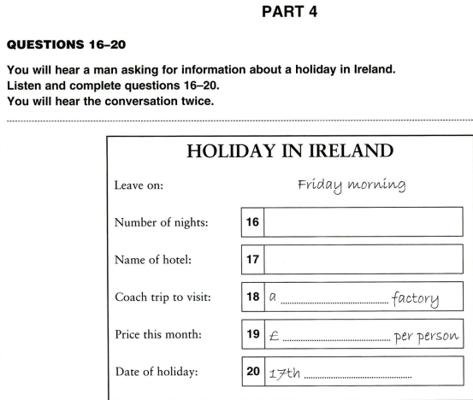

16. 2

17. KILDARE

18. glass

19. 129

20. November

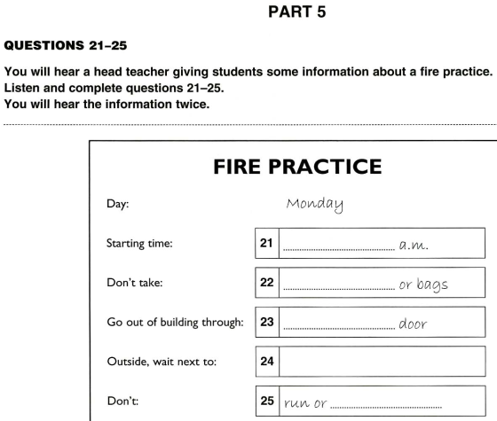22

22. coats

23. front

24. library

**HUONG DAN PHAN DOC SO 3_P1 (11-15)**

* Co 2 nguoi noi chuyen voi nhau.
* Tra loi, phan ung doi voi cau hoi, loi noi cua nguoi thu nhat.
* Tense.
* Yes/no.

