Analysis and Forecasting of PM2.5 Concentrations in Hanoi using Time Series Regression Models
Nguyen Trung Kien – Le Trung Thanh – Luu Duc Tung

Abstract
This report details the design and implementation of a machine learning project to forecast fine particulate matter (PM2.5) concentrations in Hanoi, Vietnam. Addressing the critical public health risks posed by high pollution levels, the project's primary objective is to develop a robust predictive model and deploy it in a production pipeline capable of generating actionable 7-day (168-hour) forecasts.
The methodology encompasses a complete data pipeline, beginning with data collection from the Weatherbit API and proceeding through rigorous preprocessing. Key data processing steps include the extraction of temporal features (e.g., hour, month, weekday) from timestamps and the critical removal of the Air Quality Index (AQI) feature to prevent data leakage and multicollinearity.
A comparative experimental framework was designed to evaluate three distinct regression models: Linear Regression, Random Forest, and XGBoost. These models were trained and tested on two versions of the dataset—one with original, unscaled data and another with data standardized using StandardScaler—to assess the impact of feature scaling. Performance was measured using standard regression metrics, including R² (Coefficient of Determination), RMSE (Root Mean Square Error), and MAE (Mean Absolute Error), with a target of R² > 0.95 and RMSE < 10µg/m³

Introduction and Problem Classification

Core Problem Context: PM2.5 Forecasting in Hanoi.
This project addresses a small – scale yet high – impact problem: forecasting the concentration of PM2.5 (fine particulate matter) in the air of Hanoi. PM2.5 refers to fine atmospheric particles with a diameter of 2.5 micrometers or less. They are considered the most dangerous air polluttant due to their ability to penetrate deep into the lungs and circulatory systems.
The specific context in Hanoi is particularly severe. While the World Health Organization (WHO) recommends that the 24 – hour average PM2.5 concentration should not exceed 15µg/m³, level in Hanoi are frequently recorded at over 50µg/m³, posing a direct and continuous threat to public health. Building an accurate forecasting model for this region is a critical first step in managing and mitigating pollutions risks.

Broader Problem Context: Public Health and policy Impact.
The problem of PM2.5 forecasting is part of a larger, multidisciplinary challenge that directly with public health and urban policymaking.
- Public Health: Prolonged PM2.5 exposure is a leading cause of severe health conditions, including respiratory diseases, cardiovascular diseases, and lung cancer. A reliable early warning system allows citizens to proactively protect their health, such as by planning outdoor activities, using appropriate protective equipment (like N95 masks), or avoiding outdoor exercise on days with high predicted pollution.
- Policy Planning: For government agencies, forecast data is a key decision-support tool. It provides a scientific basis for activating short-term interventions to mitigate pollution, such as issuing traffic restrictions, requesting temporary halts in operations of polluting factories, or implementing air-cleaning measures like street-water spraying.
- Scientific Research: Historical data and predictive models contribute to the scientific body of knowledge, helping researchers better understand the complex relationships between meteorological factors, human activity, and the formation of pollution sources.

Problem Classification: Regression.
From a machine learning technical standpoint, this is a Regression problem. This classification is not just a label but a foundational decision that influences the entire project design.
The problem is defined as regression because the model's objective is to predict a target variable that is a continuous numerical value. In this case, that value is the PM2.5 concentration, measured in µg/m³.
Identifying this as a regression task dictated a series of technical choices throughout the project:
- Model Selection: The chosen algorithms must be capable of predicting continuous values. This led to the selection of Linear Regression, Random Forest (in regression mode), and XGBoost (in regression mode)
- Evaluation Metrics: The metrics for success must measure the error between a predicted continuous value and an actual one. Consequently, the project used standard regression metrics, including R² (Coefficient of Determination), RMSE (Root Mean Square Error), and MAE (Mean Absolute Error)

Objectives, Motivation, and Contribution Scope
The project was designed with three clear layers of objectives, spanning technical performance requirements, practical application goals, and the motivation for methodological comparision.

Technical and Performance Objectives.
The core technical objective of the project was build and refine a machine learning model capable of forecasting with high accuracy. This performance was quantified by specific target metrics:
- Coefficient of Determination (R²) > 0.95.
- Root Mean Square Error (RMSE) < 10µg/m³.
Setting these dual goals represents a rigorous requirement. An R² > 0.95 demands that the model be able to explain over 95% of the variance in PM2.5 concentration, indicating it captures the general trends very well. Simultaneously, an RMSE < 10µg/m³ sets an absolute error limit, ensuring that even when the model is wrong, the average magnitude of the error remains within an acceptable range for practicel applications.

Application Objectives: From Experiment to Production.
The ultimate and most critical objective of the project was to transform the trained models from an experimental environment into a production tool with real-world utility.
The specific application goal is to provide a forecast of PM2.5 concentration for the next 7 days (168 hours) continuously. This process is not a one-time experiment but is designed to be run daily, continually updating with new forecasts. The output of this pipeline is a structured data file (pm25_predictions_comparison_7days.csv) and a set of six visualizations, ready to be integrated into other systems such as mobile apps, government dashboards, or hospital planning systems.

Experiment Motivation: Comaring Original vs. Scaled Data.
Beyond the application goal, the project carried a distinct academic and research motivation: to systematically compare the effectiveness of models when trained on two different versions of the data:
- Original Data (No Scaling): The raw data after feature processing, without scaling.
- Scaled Data (StandardScaler): Data processed using the StandardScaler technique to bring all features to a common scale (mean 0, standard deviation 1).
To achive this comparative goal, the project designed and executed a total of six destinct experiments (3 models x 2 datasets).
The two objectives (2 and 3) were intelligently combined. Instead of just picking a single “best” model for production, the final 7 – day forecast pipeline was designed to run both models (trained on Original and Scaled Data) in parallel. It then compares their forecast outputs in practice. This shows the project’s contribution is not just a single model, but a complete pipeline that allows this academic comparison to be continued and validated in a real – world application scenario.

Data Course Collection and Preparation Process
- Data Collection Architecture.
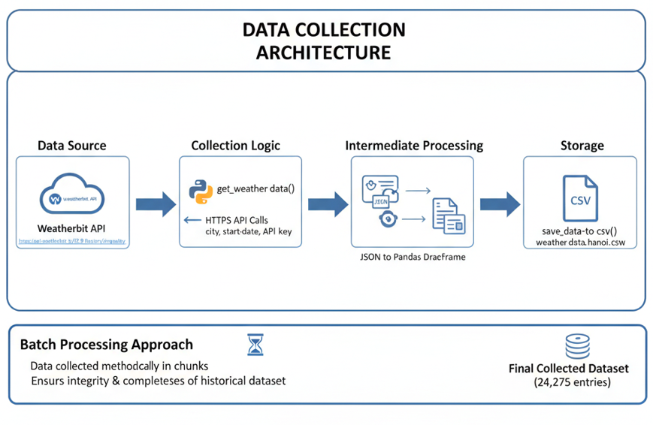
- Data Source: Historical air quality data is retrieved from the Weatherbit API, specifically the “https://api.weatherbit.io/v2.0/history/airquality” endpoint
- Collection logic: A custom Python function (get_weather_data()) is used to execute HTTPS API calls. This function is responsible for sending parameters (like city, start/end dates, and API key) and receiving a JSON response.
- Intermediate Processing: The returned JSON data is parsed and converted into a Pandas DataFrame structure for in-memory processing.
- Storage: Another custom function (save_data_to_csv()) is responsible for writing this DataFrame to a single CSV file (weather_data_hanoi.csv)
This architecture represents a batch processing approach. Data is collected methodically in chunks, rather than in a real – time stream. The design priority is to ensure the integrity and completeness of the historical dataset, even if the collection process is time – comsuming or interrupted. The final collected dataset contains 24,274 entries.
- Managing Time Factors and Data Integrity.
- Error Handing and Data Quality (Collection Phase).

