Analysis and Forecasting of PM2.5 Concentrations in Hanoi using Time Series Regression Models
Nguyen Trung Kien – Le Trung Thanh – Luu Duc Tung

Abstract
This report details the design and implementation of a machine learning project to forecast fine particulate matter (PM2.5) concentrations in Hanoi, Vietnam. Addressing the critical public health risks posed by high pollution levels, the project's primary objective is to develop a robust predictive model and deploy it in a production pipeline capable of generating actionable 7-day (168-hour) forecasts.
The methodology encompasses a complete data pipeline, beginning with data collection from the Weatherbit API and proceeding through rigorous preprocessing. Key data processing steps include the extraction of temporal features (e.g., hour, month, weekday) from timestamps and the critical removal of the Air Quality Index (AQI) feature to prevent data leakage and multicollinearity.
A comparative experimental framework was designed to evaluate three distinct regression models: Linear Regression, Random Forest, and XGBoost. These models were trained and tested on two versions of the dataset—one with original, unscaled data and another with data standardized using StandardScaler—to assess the impact of feature scaling. Performance was measured using standard regression metrics, including R² (Coefficient of Determination), RMSE (Root Mean Square Error), and MAE (Mean Absolute Error), with a target of R² > 0.95 and RMSE < 10µg/m³

Introduction and Problem Classification

Core Problem Context: PM2.5 Forecasting in Hanoi.
This project addresses a small – scale yet high – impact problem: forecasting the concentration of PM2.5 (fine particulate matter) in the air of Hanoi. PM2.5 refers to fine atmospheric particles with a diameter of 2.5 micrometers or less. They are considered the most dangerous air polluttant due to their ability to penetrate deep into the lungs and circulatory systems.
The specific context in Hanoi is particularly severe. While the World Health Organization (WHO) recommends that the 24 – hour average PM2.5 concentration should not exceed 15µg/m³, level in Hanoi are frequently recorded at over 50µg/m³, posing a direct and continuous threat to public health. Building an accurate forecasting model for this region is a critical first step in managing and mitigating pollutions risks.

Broader Problem Context: Public Health and policy Impact.
The problem of PM2.5 forecasting is part of a larger, multidisciplinary challenge that directly with public health and urban policymaking.
- Public Health: Prolonged PM2.5 exposure is a leading cause of severe health conditions, including respiratory diseases, cardiovascular diseases, and lung cancer. A reliable early warning system allows citizens to proactively protect their health, such as by planning outdoor activities, using appropriate protective equipment (like N95 masks), or avoiding outdoor exercise on days with high predicted pollution.
- Policy Planning: For government agencies, forecast data is a key decision-support tool. It provides a scientific basis for activating short-term interventions to mitigate pollution, such as issuing traffic restrictions, requesting temporary halts in operations of polluting factories, or implementing air-cleaning measures like street-water spraying.
- Scientific Research: Historical data and predictive models contribute to the scientific body of knowledge, helping researchers better understand the complex relationships between meteorological factors, human activity, and the formation of pollution sources.

Problem Classification: Regression.
From a machine learning technical standpoint, this is a Regression problem. This classification is not just a label but a foundational decision that influences the entire project design.
The problem is defined as regression because the model's objective is to predict a target variable that is a continuous numerical value. In this case, that value is the PM2.5 concentration, measured in µg/m³.
Identifying this as a regression task dictated a series of technical choices throughout the project:
- Model Selection: The chosen algorithms must be capable of predicting continuous values. This led to the selection of Linear Regression, Random Forest (in regression mode), and XGBoost (in regression mode)
- Evaluation Metrics: The metrics for success must measure the error between a predicted continuous value and an actual one. Consequently, the project used standard regression metrics, including R² (Coefficient of Determination), RMSE (Root Mean Square Error), and MAE (Mean Absolute Error)

Objectives, Motivation, and Contribution Scope
The project was designed with three clear layers of objectives, spanning technical performance requirements, practical application goals, and the motivation for methodological comparision.

Technical and Performance Objectives.
The core technical objective of the project was build and refine a machine learning model capable of forecasting with high accuracy. This performance was quantified by specific target metrics:
- Coefficient of Determination (R²) > 0.95.
- Root Mean Square Error (RMSE) < 10µg/m³.
Setting these dual goals represents a rigorous requirement. An R² > 0.95 demands that the model be able to explain over 95% of the variance in PM2.5 concentration, indicating it captures the general trends very well. Simultaneously, an RMSE < 10µg/m³ sets an absolute error limit, ensuring that even when the model is wrong, the average magnitude of the error remains within an acceptable range for practicel applications.

Application Objectives: From Experiment to Production.
The ultimate and most critical objective of the project was to transform the trained models from an experimental environment into a production tool with real-world utility.
The specific application goal is to provide a forecast of PM2.5 concentration for the next 7 days (168 hours) continuously. This process is not a one-time experiment but is designed to be run daily, continually updating with new forecasts. The output of this pipeline is a structured data file (pm25_predictions_comparison_7days.csv) and a set of six visualizations, ready to be integrated into other systems such as mobile apps, government dashboards, or hospital planning systems.

Experiment Motivation: Comaring Original vs. Scaled Data.
Beyond the application goal, the project carried a distinct academic and research motivation: to systematically compare the effectiveness of models when trained on two different versions of the data:
- Original Data (No Scaling): The raw data after feature processing, without scaling.
- Scaled Data (StandardScaler): Data processed using the StandardScaler technique to bring all features to a common scale (mean 0, standard deviation 1).
To achive this comparative goal, the project designed and executed a total of six destinct experiments (3 models x 2 datasets).
The two objectives (2 and 3) were intelligently combined. Instead of just picking a single “best” model for production, the final 7 – day forecast pipeline was designed to run both models (trained on Original and Scaled Data) in parallel. It then compares their forecast outputs in practice. This shows the project’s contribution is not just a single model, but a complete pipeline that allows this academic comparison to be continued and validated in a real – world application scenario.

Data Course Collection and Preparation Process
- Data Collection Architecture.
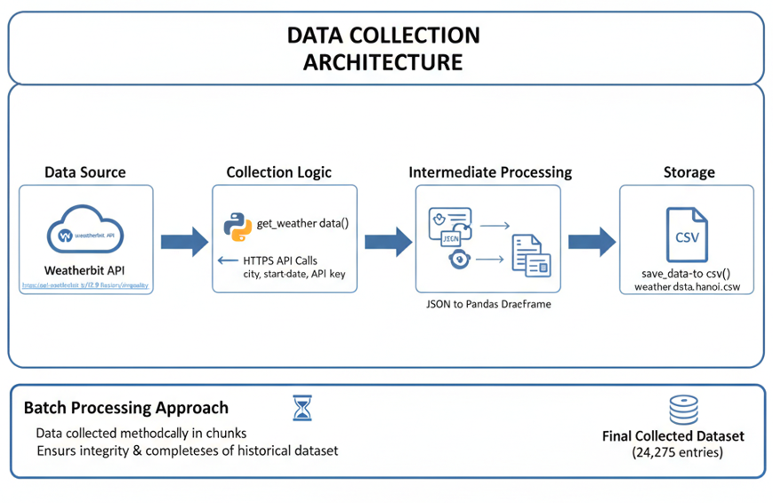
Figure 1: Data Collection Architecture
- Data Source: Historical air quality data is retrieved from the Weatherbit API, specifically the “https://api.weatherbit.io/v2.0/history/airquality” endpoint
- Collection logic: A custom Python function (get_weather_data()) is used to execute HTTPS API calls. This function is responsible for sending parameters (like city, start/end dates, and API key) and receiving a JSON response.
- Intermediate Processing: The returned JSON data is parsed and converted into a Pandas DataFrame structure for in-memory processing.
- Storage: Another custom function (save_data_to_csv()) is responsible for writing this DataFrame to a single CSV file (weather_data_hanoi.csv)
This architecture represents a batch processing approach. Data is collected methodically in chunks, rather than in a real – time stream. The design priority is to ensure the integrity and completeness of the historical dataset, even if the collection process is time – comsuming or interrupted. The final collected dataset contains 24,274 entries.
- Managing Time Factors and Data Integrity.
The handling of time – related aspects is one of the strongest points of the data collection pipeline, demonstrating careful:
- Dynamic Collection Window: The start date is fixed at datetime(2023,1,1), but the end date is dynamically set to datetime.today(). This ensures that every time the script is run, it automatically collects all new data since the last run.
- Request Chunking: Instead of making a single API request for the entire time period, the process uses the get_months_between_dates function to break the request into monthly intervals. This approach is critical because it: (1) Adheres to API limits on the maximum number of days per request; (2) Mitigates the impact of rate limiting; (3) Isolates failures (a failure in one month doesn't corrupt the entire collection); and (4) Provides clear progress tracking.
- Timezone Management: The API request explicitly specifies the timezone as tz=’local’, corresponding to GMT+7 for Vietnam. The final stored data includes multiple time formats (datetime (local), timestamp_local (ISO 8601), timestamp_utc (ISO 8601), and ts (Unix timestamp)) to ensure both local user-friendliness and internationally standardized comparability.
- Rate Limit Compliance: A time.sleep(1) delay is inserted between each monthly API request. This is a "server-friendly" design that proactively prevents IP bans due to query-flooding, ensuring the stability of the collection process.
- Error Handing and Data Quality (Collection Phase).
The pipeline incorporates basic error handling and data quality mechanisms directly into the collection phase:
- API Error Handling: The get_weather_data() function includes try-except blocks to handle anticipated failures. It uses response.raise_for_status() to detect HTTP errors (e.g., 404, 500), and also handles JSON Parse Error (if the API returns invalid data), Timeout (if the server is too slow), and RequestException (for general network errors). These mechanisms prevent bad data from being processed or crashing the program.
- Deduplication: The documentation notes that running the collection script multiple times or API overlaps could lead to duplicate data. The documented solution is a post-processing step: load the saved weather_data_hanoi.csv file and use df.drop_duplicates(subset=['datetime', 'timestamp_local']) to remove redundant records.
- Missing Values: The issue of missing data is anticipated at a rate of < 5%, often due to API downtime. Two handling methods were proposed: ffill (forward fill, taking the last valid value) and interpolate (linear interpolation).1 However, the documentation does not confirm whether these steps were actually applied in the main preprocessing pipeline.1
- Noise and Outliers: This is a significant limitation of the process. The documentation makes no mention of any specific techniques used to identify or handle noise (e.g., signal filtering) or outliers (e.g., using Z-scores, value clipping, or anomaly detection algorithms).

Field Name | Data Type (raw) | Unit | Description
pm25 | float | μg/m3 | PM2.5 Fine Particulate Matter (Target Variable)
aqi | int | - | Air Quality Index
o3 | float | ppb | Ozone concentration
so2 | float | ppb | Sulfur Dioxide concentration
no2 | float | ppb | Nitrogen Dioxide concentration
co | float | ppm | Carbon Monoxide concentration
pollen_level_tree | int | - | Pollen level (tree)
pollen_level_grass | int | - | Pollen level (grass)
pollen_level_weed | int | - | Pollen level (weed)
datetime | string | - | Local time (YYYY-MM-DD:HH)
timestamp_local | string | - | ISO 8601 Timestamp (local)
timestamp_utc | string | - | ISO 8601 Timestamp (UTC)
ts | int | seconds | Unix timestamp

Table 1: Raw Data Description from Weatherbit API

Feature Engineer and Experiment Design
After the raw data was collected, the next phase was to transform this data into a format that is meaningful and suitable for machine learning models. This stage includes feature engineering and feature selection.

Feature Engineering.
The most significant feature engineering step was the processing of temporal information. Machine learning models cannot directly understand strings or timestamps. Therefore, useful time-based features needed to be extracted:
- Time Parsing: The datetime column (initially an 'object'/'string') was converted into a standard Python datetime object using pd.to_datetime.
- Temporal Feature Extraction: From this datetime object, five new numerical features were created: year, month, day, hour, and weekday.

Time Period | Description
Year | Captures long-term trends or annual shifts in pollution baselines.
Month | Captures seasonal variances. For instance, Hanoi's climate varies between hot, humid summers and cooler, drier winters. These meteorological changes dramatically affect particle suspension and dispersion.
Day | Captures intra-month progression.
Hour | Perhaps the most critical feature. Air quality follows a strong diurnal cycle, typically peaking during morning (07:00–09:00) and evening (17:00–19:00) rush hours due to vehicular emissions.
Weekday | Captures the variance between working days (high industrial/traffic activity) and weekends (typically lower activity).
Table 2: Air Quality Data Time Periods
This extraction is critically important because PM2.5 concentration has strong time-dependent patterns, such as seasonality (captured by month), daily cycles (captured by hour), and differences between workdays and weekends (captured by weekday).

Feature Selection.
After the new features were created, a cleaning step was performed to remove information that was unnecessary or harmful to the model:
- Removal of Original Colums: The original time columns (datetime, timestamp_utc, ts, timestamp_local) were dropped from the training dataset, as their information was now effectively encoded in the month, day, hour, etc., features
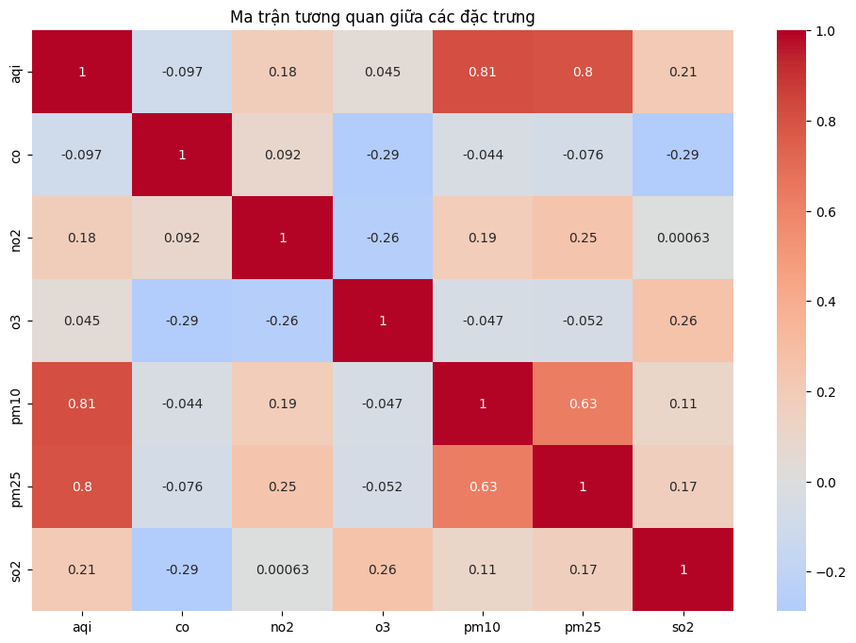
Removal of Multicollinearity: This step demonstrates a deep understanding of the data. A correlation analysis was performed and found that the aqi (Air Quality Index) column had an extremely high correlation (r > 0.99) with the pm25 target variable.
Figure 2: Correlation matrix between features
A novice might see aqi as the best predictor. In reality, however, aqi is often calculated (in part) from the pm25 concentration itself. Using aqi to predict pm25 is essentially using ƒ(X) to predict X, leading to data leakage or severe multicollinearity. The model would learn this trivial mathematical relationship and achieve a near-1.0 R², but it would be completely useless at predicting pm25 from its actual causal factors (like weather, time, or other pollutants).
Therefore, the decision to deliberately drop the aqi column 1 was a scientifically sound one, moving the problem from "trivial" (predicting a value from its own index) to "non-trivial" (predicting PM2.5 from truly independent variables).

Experimental Design: Original vs. Scaled Data.
After feature engineering and selection were complete, the final dataset was prepared for model training. A parallel experimental design was implemented to meet the project's objectives:
- Data Splitting: The entire dataset was split into 80% for training and 20% for testing
- Parallel Dataset Creation: Two versions of the training and test sets were generated
  - Version 1 (Original Data): Feature values were left as is.
  - Version 2 (Scaled Data): A StandardScaler was applied to the features. The StandardScaler transforms the data so that each feature has a mean of 0 and a standard deviation of 1. This is crucial for scale-sensitive models like Linear Regression
This design allows for a direct, controlled comparison of the impact of feature scaling on the performance of different algorithms.

Original Feature | Action | Final Feature(s) | Rationable/ Explaination
pm25 | Keep | pm25 (Target Variable) | The Y variable the model must predict.
aqi | Drop | - | Correlation r > 0.99 with pm25, causes multicollinearity / data leakage.
datetime | Extract & Drop | year, month, day, hour, weekday | Encodes time information into numerical features to capture cyclical patterns and trends.
timestamp_local | Drop | - | Information was extracted into temporal features.
timestamp_utc | Drop | - | Information was extracted into temporal features.
ts | Drop | - | Information was extracted into temporal features.
o3, so2, no2, co,…. | Keep & Scale | o3, so2… (for Original branch).  o3_scaled, so2_scaled (for Scaled branch). | The independent variables (features) X used to predict pm25.1

Table 3: Feature Processing and Selection Pipeline

Comparative Model Analysis and Evaluation Framework
With the two datasets prepared (Original and Scaled), the project proceeded to train and evaluate three different machine learning algorithms, resulting in six total experiments.

Overview of Selected Models
The three algorithms chosen represent different approaches to regression in machine learning:
- Linear Regression: A classic baseline linear model. It assumes a linear relationship between the input features and the target variable. It is fast, interpretable, but highly sensitive to feature scaling and non-linear relationships.
- Random Forest: A tree-based ensemble method. It builds multiple decision trees during training and outputs the average of their predictions. Random Forest is robust, can handle complex non-linear relationships, and is not sensitive to the scale of features.
- XGBoost (Extreme Gradient Boosting): An optimized, high-performance gradient boosting library. Like Random Forest, it is a tree-based model, but it builds trees sequentially, with each new tree attempting to correct the errors of the previous ones.

Methodology and Evaluation Metrics
To assess the performance of the six experiments, a comprehensive set of three regression evaluation metrics was used:
- R² (Coefficient of Determination): Measures the percentage of the variance in PM2.5 that the model can explain. An R² close to 1 indicates a model that fits the data well.
- RMSE (Root Mean Square Error): The standard deviation of the prediction errors, measured in the target's units (µg/m³). This metric heavily penalizes large errors (due to the squaring), making it sensitive to outliers.
- MAE (Mean Absolute Error): The average absolute magnitude of the errors, also in µg/m³. It measures the average error without squaring them. MAE is less sensitive to outliers than RMSE.
The simultaneous use of both RMSE and MAE is a sophisticated methodological choice. If a model has a high RMSE but a low MAE, it implies the model is good on average but makes a few very bad predictions (likely due to the unhandled outliers, which was a noted limitation 1). The dual goals (R² > 0.95 and RMSE < 10 µg/m³) 1 show the project was seeking a model that was both highly fitting overall and did not have catastrophic prediction failures.

Experimental Framework and Theoretical Analysis
The six experiments were designed to answer the question: "How does scaling the data affect these different models?"
- Hypothesis 1 (For Linear Regression): Performance on the Scaled dataset was expected to be significantly higher than on the Original dataset. This is because StandardScaler resolves the issue of features having different scales (e.g., co in ppm vs. no2 in ppb), which directly impacts the convergence and coefficients of a linear regression model.
- Hypothesis 2 (For Random Forest & XGBoost): Performance (R², RMSE, MAE) on the Scaled and Original datasets was expected to be nearly identical. This is because tree-based models make splitting decisions based on thresholds (e.g., no2 > 10.5?). Monotonic transformations like scaling do not change the order of the values and thus do not affect where the optimal splits for a tree are found.

Forecasting Application Deployment and Conclusion
The final phase of the project takes the trained models and integrates them into a practical application pipeline to generate actionable forecasts.

7 – Day Forecase (Producttion Pipeline)
The 7-day (168-hour) forecasting pipeline was designed to directly connect the research phase (Part 5) to the application phase.
- Load Artifacts: The pipeline begins by loading all artifacts saved during training. The models best_pm25_model_original.pkl and best_pm25_model_scaled.pkl are specifically XGBRegressor models. The pm25_scaler.pkl (StandardScaler) object that was "fit" on the training data is also loaded.
- Importance of scale.pkl: Saving and reloading the scaler.pkl is a critical step, demonstrating maturity in machine learning operations (MLOps). A common mistake is to train a model on scaled data, but then try to predict on new, raw data. The correct process (which this project implemented) is to use the saved scaler object to .transform() any new data before feeding it to the scaled XGBRegressor model.
- Generate Future Features: To predict the next 168 hours, the pipeline requires future values for features like co, no2, etc. The prediction script populates these future values using the historical average from the entire dataset (e.g., co: 614.0882, no2: 31.8466, o3: 53.3072).
- Dual Forecast Generation: As analyzed, the pipeline generates two parallel sets of forecasts for the next 168 hours: one from the Original model (XGBRegressor) and one from the Scaled model (XGBRegressor).
- Aggregation and Storage: These predictions are aggregated, along with comparisons (like difference and percent change), and exported to the pm25_predictions_comparison_7days.csv file. Six visualizations are also generated to analyze the forecast results from daily and hourly perspectives. However, the notebook file for this step does not contain the final generated charts.
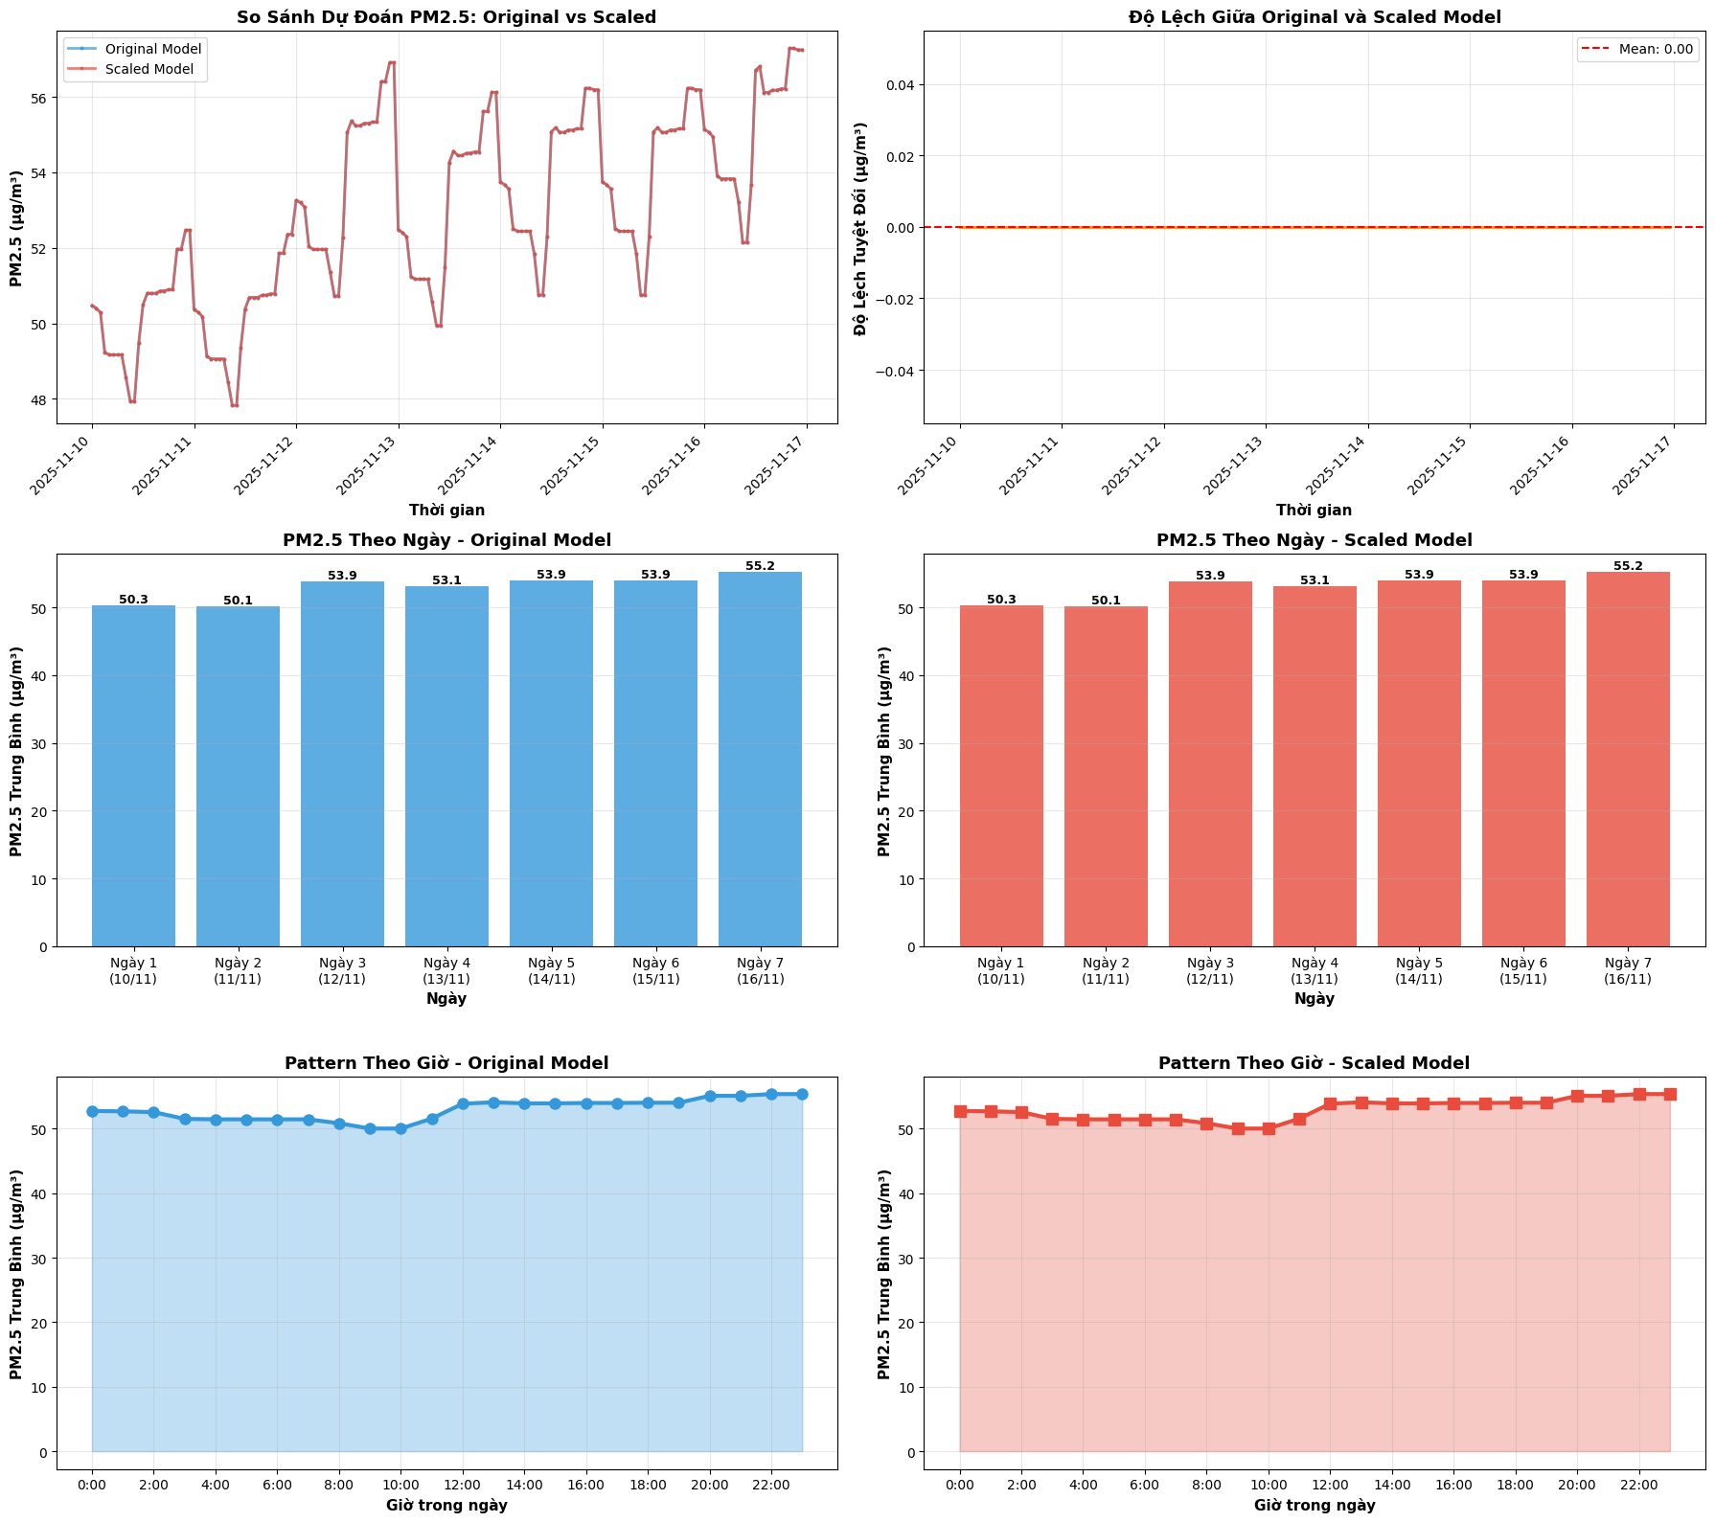
Figure 3: Visualize the result comparison

Real – World Use Cases
The outputs from this 7-day forecast pipeline are designed to feed directly into the use cases identified in Part 1:
- Citizen Alerts: The CSV file can be read by a mobile app to send users a notification when PM2.5 is predicted to be at an "Unhealthy" level, with specific recommended actions (e.g., "Limit outdoor exposure," "Wear N95 mask")
- Policy Support: The data can populate a Government Dashboard, displaying the 7-day forecast. When predicted levels exceed regulatory thresholds, it can automatically trigger alerts for authorities to enact interventions like vehicle restrictions.
- Medical Planning: Hospitals can use this forecast to estimate an increase in patient admissions for respiratory issues. This allows them to prepare necessary medications (like Ventolin, Seretide) and increase medical staff on duty.

Summary and Limitations:
This project presents a comprehensive and methodologically sound machine learning pipeline for addressing the problem of PM2.5 forecasting in Hanoi.
Project Strengths:
- Data Collection Pipeline: The data collection process was designed with robustness and fault-tolerance as priorities, carefully managing time, timezones, and API rate limits.
- Feature Engineering: The handling of temporal features and, most notably, the decision to drop aqi to prevent multicollinearity, demonstrates a sophisticated understanding of data science
- Experimental Design: The parallel comparison of Original vs. Scaled data across three model types is a rigorous research methodology
- Production – Readiness: The project successfully bridges research to production, including the critical MLOps step of saving and reusing the scaler.pkl.
Limitations and Future Work:
- Lack of Outlier/Noise Handling: The biggest limitation in preprocessing is the lack of any documented handling for outliers or noise. A sudden spike in PM2.5 (e.g., from a fire or sensor error) could negatively skew the performance of sensitive models. Future work should implement Z-score filtering or anomaly detection.
- Unconfirmed Missing Value Handling: While ffill and interpolate were proposed, the documentation does not confirm their use. An analysis should be conducted to evaluate the impact of these imputation strategies.
- Missing Experimental Results: The most obvious limitation is the absence of the final experimental results.1 The immediate next step would be to execute the 6 designed experiments, populate Table 3, and confirm the selection of XGBoost based on the stated R² > 0.95 and RMSE goals.
- Missing Visualizations: The final 7-day forecast notebook does not contain the 6 output charts, so the final predictive visualizations cannot be analyzed.

