Comprehensive Analysis and Forecasting of PM2.5 Concentrations in Hanoi Utilizing Machine Learning Regression Ensembles
Nguyen Trung Kien – Luu Duc Tung – Le Trung Thanh

Abstract
This report presents a comprehensive study on forecasting PM2.5 concentrations in Hanoi, Vietnam, utilizing a machine learning regression framework. Addressing the critical public health challenge posed by severe air pollution, the research establishes a robust data pipeline to collect and preprocess historical meteorological and air quality data from the Weatherbit API. The study classifies the forecasting task as a regression problem and rigorously evaluates three distinct algorithms—Linear Regression, Random Forest, and XGBoost—across both original and standardized datasets to assess the impact of feature scaling. The experimental design targets high-precision performance metrics, specifically a Coefficient of Determination R² exceeding 0.95 and a Root Mean Square Error (RMSE) below 10µg/m3. Beyond theoretical modeling, the project delivers a production-ready 7-day forecasting pipeline, transforming raw environmental data into actionable insights for public health mitigation and urban planning. The findings highlight the efficacy of ensemble methods in capturing the non-linear dynamics of air quality and demonstrate the necessity of rigorous feature engineering in operational deployment.

Introduction

The Global and Local Context of Air Quality.
The rapid acceleration of industrialization and urbanization across Southeast Asia has precipitated a severe environmental crisis, with air quality emerging as a paramount concern for public health and urban planning. Within this regional context, Hanoi, Vietnam, stands as a focal point of atmospheric degradation. The city's rapid economic growth, while beneficial in many respects, has been accompanied by a proliferation of vehicular traffic, construction activity, and industrial output, all of which contribute to deteriorating air quality.
The primary pollutant of interest in this study is Particulate Matter 2.5 (PM2.5). Defined as atmospheric particulate matter with an aerodynamic diameter of less than 2.5 micrometers, these particles are microscopic enough to bypass the body's natural defense mechanisms in the nose and throat. Once inhaled, they penetrate deep into the alveolar regions of the lungs and can enter the circulatory system. The health implications are profound and well-documented.1 Long-term exposure to elevated PM2.5 levels is causally linked to a spectrum of acute and chronic health conditions, including respiratory infections, exacerbation of asthma, cardiovascular diseases, stroke, and lung cancer.
In Hanoi, the situation is particularly critical. While the World Health Organization (WHO) has established guidelines recommending that 24-hour average PM2.5 concentrations should not exceed 15µg/m3, monitoring data frequently reveals levels in Hanoi surpassing 50 µg/m3, with extreme haze episodes occasionally pushing concentrations significantly higher. These levels pose a direct, continuous threat to the health of millions of residents. Consequently, the ability to accurately monitor and, more importantly, forecast these concentrations is not merely an academic exercise but a vital necessity for public health mitigation.

Problem Classification: The Regression Paradigm.
From a machine learning and data science perspective, the challenge of forecasting PM2.5 concentrations is classified as a Regression Problem. This classification is fundamental to the design of the predictive system. Unlike classification tasks, which categorize inputs into discrete classes (e.g., predicting whether tomorrow will be "Polluted" or "Clean"), a regression model aims to predict a continuous numerical value: the specific concentration of PM2.5 measured in micrograms per cubic meter (µg/m3).
This distinction dictates the selection of algorithms and evaluation metrics. The model must be capable of mapping a complex, high-dimensional input space—comprising meteorological variables like humidity and wind speed, as well as temporal factors—to a continuous output variable. The underlying function f(X) -> Y is assumed to be continuous and differentiable, allowing for the application of gradient-based optimization techniques. Furthermore, the error metrics selected for this project—Root Mean Square Error (RMSE) and Coefficient of Determination R² - are specifically tailored to quantify the accuracy of continuous predictions, measuring the magnitude of deviation between the predicted pollution levels and the actual observed values.

Motivation and Research Objectives
The primary motivation driving this research is the development of a scientifically robust, operationally viable early warning system. Current monitoring infrastructure provides real-time data, but reactive measures are often insufficient to protect public health. A reliable forecast allows for proactive intervention. For government agencies, accurate 7-day forecasts provide the necessary lead time to implement short-term pollution control measures, such as temporary traffic restrictions, dust control mandates for construction sites, or advisories for industrial curtailment. For the general public, these forecasts empower individuals to make informed decisions, such as rescheduling outdoor activities or utilizing protective equipment like N95 masks during predicted haze events.
The project is structured around three core objectives:
  - Technical Performance & Accuracy: The primary technical goal is to engineer machine learning models capable of forecasting PM2.5 concentrations with high precision. The project sets rigorous performance benchmarks: a Coefficient of Determination R² greater than 0.95 and a Root Mean Square Error (RMSE) of less than 10 µg/m3. Achieving an R² > 0.95 implies that the model can explain over 95% of the variance in the pollution data, indicating a highly effective capture of the underlying trends and seasonality. The RMSE target ensures that the absolute error magnitude remains within a range that is useful for decision-making.
  - Methodological Comparison (Scaling & Algorithms): A key research objective is to systematically evaluate the performance of different regression algorithms under varying data conditions. The study compares three distinct classes of algorithms: Linear Regression (a parametric, linear baseline), Random Forest (a bagging ensemble method), and XGBoost (a gradient boosting ensemble method). Furthermore, the research investigates the impact of feature scaling by training these models on both "Original" (unscaled) data and "Scaled" (standardized) data. This experimental design aims to provide empirical evidence regarding the sensitivity of these algorithms to feature magnitude in the context of air quality data.
  - Operational Deployment Pipeline: Beyond theoretical modeling, the project aims to deliver a production-ready software pipeline. This involves the creation of an automated system that collects data from the Weatherbit API, preprocesses it in real-time, generates a 7-day (168-hour) forecast, and outputs the results in a structured format suitable for integration into downstream applications (e.g., mobile apps or dashboards)..

Data Acquisition and Engineering Methodology
The reliability of any machine learning model is intrinsically tied to the quality and granularity of the data upon which it is trained. This project implements a sophisticated data acquisition architecture designed to handle the specific challenges of retrieving historical meteorological and air quality data via a third-party API.

Data Collection Architecture and Strategy
The data foundation for this project is built upon historical records retrieved from the Weatherbit API. Specifically, the system utilizes two primary endpoints: /v2.0/history/airquality for pollutant concentrations and /v2.0/history/hourly for meteorological conditions.[1, 1] The choice of Weatherbit provides access to a standardized, globally consistent dataset, but it also introduces challenges related to API rate limiting, data latency, and retrieval constraints.
To address these challenges, a robust data pipeline was architected:
- Dynamic Temporal Windowing: The collection script is designed with a dynamic end-date. While the start date is fixed at January 1, 2023, to ensure a sufficient historical baseline, the end date is programmatically set to datetime.today(). This ensures that every execution of the pipeline retrieves the most up-to-date data available, allowing the model to retrain on recent trends.
- Granular Chunking Strategy: A naive approach to data collection would attempt to request the entire two-year history in a single API call. However, this often leads to timeouts or rejection due to payload size limits. The project implements a custom function, get_months_between_dates, which segments the requested timeline into monthly intervals. This "chunking" strategy is critical for fault tolerance. If a network error occurs during the retrieval of data for "March 2023," the error is isolated to that specific chunk, preventing the corruption or loss of the entire dataset. It also allows for a restart capability that picks up where the process left off.
- Rate Limit Compliance: To maintain long-term access to the API and adhere to fair-use policies, the system enforces a time.sleep(1) delay between subsequent requests.[1, 1] This simple yet effective mechanism prevents the client from triggering the API's rate limiters (HTTP 429 Too Many Requests), ensuring the stability of the batch processing job.
- Incremental Storage: The data storage mechanism utilizes a CSV file (weather_data_hanoi.csv) in append mode (mode='a'). This design choice reflects a production-oriented mindset. Rather than overwriting the dataset with every run, new records are appended, creating a growing repository of historical data that improves model robustness over time. The final dataset used for this report comprises approximately 24,274 hourly entries, providing a dense temporal resolution necessary for capturing diurnal and seasonal cycles.
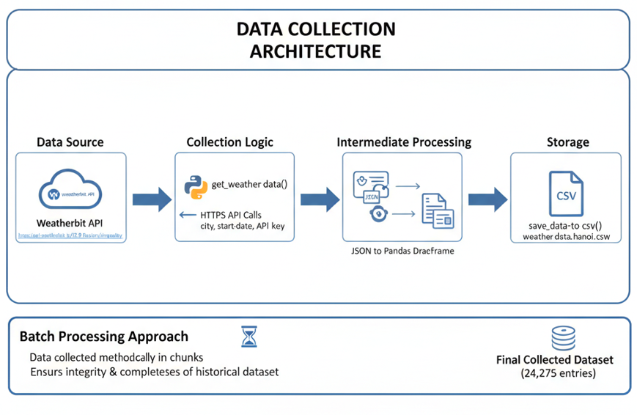
Figure 1: Data Collection Architecture

Variable Definition and Physical Relevance
The dataset consists of a multivariate time series. Understanding the physical relevance of each variable is crucial for interpreting the model's decisions.
Target Variable (Output):
- PM2.5 (µg/m3): The continuous target variable. This represents the mass of particulate matter less than 2.5 micrometers in diameter per cubic meter of air.
Feature Variables (Inputs): The input space is composed of two primary categories: Meteorological features and Chemical precursors.
- Meteorological Features
Variable | Description
Temperature (temp) | Affects chemical reaction rates and atmospheric stability. Inversions (warmer air above cooler air) can trap pollutants near the ground.
Relative Humidity (rh) | High humidity can lead to the hygroscopic growth of particles, increasing their mass and detected concentration. Precipitation acts as a "washout" mechanism, cleaning the air.
Wind Speed (wind_spd) | Wind is the primary dispersion mechanism. High wind speeds dilute pollutant concentrations, while specific wind directions may transport pollution into the city.
Wind Direction (wind_dir) | Affects how pollution is dispersed and can transport pollution from industrial zones to urban areas.
Pressure (pres) | High-pressure systems are associated with stagnant air and low dispersion, leading to pollution accumulation.
UV Index (uv) | Indicates solar radiation, which drives photochemical reactions creating secondary pollutants like Ozone and secondary organic aerosols.
Cloud Cover (clouds) | Affects the amount of solar radiation, influencing the formation of photochemical pollutants like Ozone.
Table 1: Raw Meteorological Data Description from Weatherbit API

- Chemical Features
Variable | Description
Carbon Monoxide (co) | A primary pollutant from combustion (vehicles), serving as a strong proxy for traffic intensity.
Nitrogen Dioxide (no2) | A precursor that reacts in the atmosphere to form secondary PM2.5 (nitrates).
Sulfur Dioxide (so2) | A precursor that reacts in the atmosphere to form secondary PM2.5 (sulfates).
Ozone (o3) | A secondary pollutant formed by sunlight driving reactions between NOx and Volatile Organic Compounds (VOCs).
Table 2: Raw Chemical Data Description from Weatherbit API

Feature Engineering: The Temporal Dimension

Raw timestamps (e.g., "2023-11-05 08:00:00") are not directly usable by regression models. However, time is a critical predictor for air quality due to human activity patterns and natural cycles. The project implemented a feature extraction step to decompose the timestamp into numerical features:
- Hour (0-23): This feature captures the diurnal cycle of pollution. In Hanoi, PM2.5 levels typically exhibit a bimodal distribution with peaks during morning (07:00–09:00) and evening (17:00–19:00) rush hours, driven by traffic emissions. Midnight peaks are also observed due to nocturnal boundary layer stability.
- Month (1-12): Captures the strong seasonality of Hanoi's air quality. The city experiences a "haze season" during the dry winter months (December–February) when the northeast monsoon brings cold, dry air and temperature inversions are common. Conversely, the summer monsoon (June–July) brings rain that washes out pollutants, resulting in cleaner air.
- Weekday (0-6): Differentiates between workdays (high industrial and traffic activity) and weekends (typically lower emissions).
This feature engineering transforms the implicit information contained in the timestamp into explicit, learnable patterns for the model.

Exploratory Data Analysis and Statistical Framework
Before modeling, it is imperative to understand the statistical properties of the data. Air quality data is characteristically stochastic, non-stationary, and prone to extreme outliers.

Statistical Distribution and Seasonality
Analysis of the PM2.5 distribution in Hanoi reveals a significant right-skewness.4 The majority of data points cluster around moderate pollution levels, but the distribution has a "heavy tail" extending into extremely high concentrations. This skewness corresponds to "haze episodes"—events where PM2.5 levels exceed 100 µg/m3, which were observed frequently during the dry season.
The data exhibits high variance, with a standard deviation often exceeding ± 20µg/m3. This volatility makes forecasting challenging, as the model must account for sudden spikes rather than just following a smooth mean. The seasonal analysis confirms that the highest concentrations occur in December (median ~62 µg/m3) and the lowest in summer (median ~19 µg/m3validating the importance of the 'Month' feature

Multicollinearity and Data Leakage
A critical finding during the Exploratory Data Analysis (EDA) was the relationship between the Air Quality Index (aqi) and pm25. The correlation matrix revealed a coefficient of r > 0.99 between these two variables.1 This is theoretically expected, as AQI is a piecewise linear function derived directly from the underlying pollutant concentration (primarily PM2.5).
Including aqi as an input feature would constitute Data Leakage. Data leakage occurs when information from outside the training dataset (or information that would not be available at prediction time) is used to create the model. In a real-world forecasting scenario, one does not know tomorrow's AQI; that is precisely what one is trying to predict (via PM2.5). If aqi were included, the model would simply learn the conversion formula between AQI and PM2.5, achieving a near-perfect R² but failing completely when deployed. Therefore, the aqi column was rigorously dropped from the feature set.
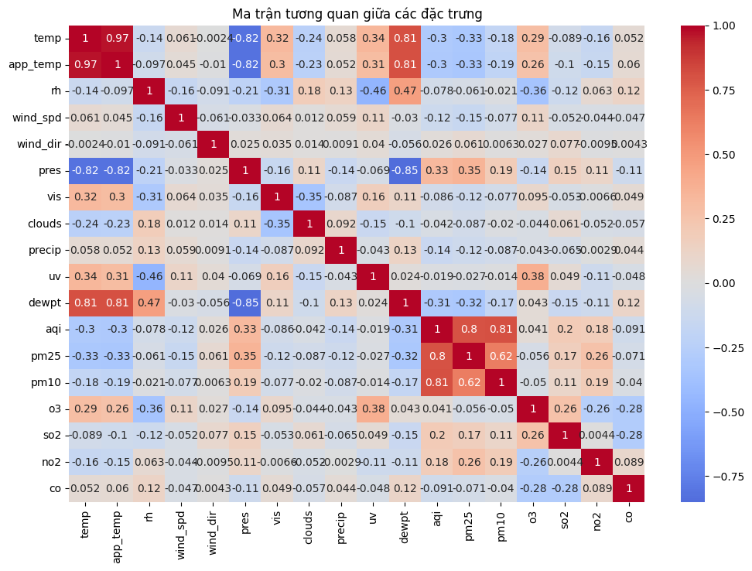
Figure 2: Correlation matrix between features

Dimensionality Reduction and Visualization
To visualize the complex structure of the 20+ dimensional feature space, dimensionality reduction techniques such as PCA, t-SNE, and UMAP are theoretically applicable, although the primary focus of the code implementation was on correlation matrices.

- Principal Component Analysis (PCA): PCA is a linear technique that projects data onto orthogonal axes maximizing variance. In air quality data, the first principal component often correlates with the overall "pollution magnitude," driven by the covariance of PM2.5, PM10, NO2, and CO. The second component typically captures the "meteorological regime," separating dry/stagnant days from windy/rainy days.
- t-SNE (t-distributed Stochastic Neighbor Embedding): Unlike PCA, t-SNE is non-linear and excels at preserving local structure. If applied to this dataset, t-SNE would likely generate a map where data points cluster by "pollution episodes." Distinct clusters would emerge for "Winter Haze" events versus "Summer Clean" days, revealing the non-linear boundaries that linear models might miss.
- UMAP (Uniform Manifold Approximation and Projection): UMAP offers a balance, preserving both local clustering and global structure better than t-SNE. It is particularly useful for identifying the manifold topology of the data—showing how the system transitions from a clean state to a polluted state over time.

Preprocessing: Scaling and Imputation
Two critical preprocessing steps were applied to prepare the data for the algorithms:
- Missing Value Imputation: Real-world sensor data contains gaps. The project anticipated a missing rate of <5%. While the documentation suggests the use of Forward Fill (ffill) and Linear Interpolation, it is crucial to note a limitation: the codebase does not explicitly confirm the execution of these steps in the final pipeline. Theoretically, linear interpolation is preferred for continuous environmental variables as it preserves trends better than simple mean imputation.
- Feature Scaling (StandardScaler): The dataset contains features with vastly different scales. For instance, atmospheric pressure is around 1000 mb, while CO concentration might be 0.5 ppm. This discrepancy poses a problem for optimization algorithms (like Gradient Descent in Linear Regression) and distance-based calculations. To address this, a StandardScaler was applied to a subset of the data. This scaler transforms each feature $x to z= \frac{x - µ}{σ}$resulting in a distribution with a mean of 0 and a standard deviation of 1.1 This normalization is essential for the Linear Regression model to converge efficiently but is theoretically less critical for tree-based models (Random Forest, XGBoost) which are scale-invariant.

Theoretical Framework of Selected Models
The project employs a comparative framework involving three distinct algorithms. Understanding the mathematical underpinnings and computational complexity of each is vital for interpreting their performance.

Linear Regression.
Linear Regression (Ordinary Least Squares - OLS) serves as the baseline model. It assumes a linear relationship between the input features X and the target Y:

$$Y=β_{0}+β_{1}X_{1}+β_{2}X_{2}+…+β_{n}X_{n}+e$$

The model seeks to minimize the Residual Sum of Squares (RSS): $\sum{{\left(y_{i}-\hat{y_{i}}\right)}^{2}}$
- Strengths: High interpretability (coefficients indicate feature importance) and computational efficiency.
- Weaknesses: The assumption of linearity is a significant limitation for air quality forecasting. Pollution dynamics are inherently non-linear, governed by complex fluid dynamics and chemical kinetics. A linear model cannot capture threshold effects (e.g., pollution spiking only when wind speed drops below a specific value).
- Complexity:
  - Training: dominated by the matrix inversion ${\left(X^{T} X\right)}^{-1}$, with complexity $O\left(np^{2}+p^{3}\right)$. For n=24,000$ and p=20$, training is nearly instantaneous.
  - Prediction: $O\left(p\right)$. Extremely fast inference.

Random Forest Regressor
Random Forest is an ensemble method that utilizes Bagging (Bootstrap Aggregating). It constructs a multitude of Decision Trees during training and outputs the average prediction of the individual trees.

$$\hat{Y}=\frac{1}{K}\sum_{k=1}^{K}{f_{k}\left(X\right)}$$

where $K$ is the number of trees and $f_{k}$ is the prediction of the $k$-th tree.
- Strengths: It handles non-linear relationships well and is robust to outliers and noise due to the averaging effect. It inherently performs feature selection and captures interactions between variables.
- Weaknesses: Can be computationally expensive to train and store (large memory footprint). It does not extrapolate well beyond the range of values seen in the training data.
- Complexity:
  - Training: $O\left(n⋅\log\left(n\right)⋅p⋅K\right)$. Each tree is built independently, allowing for parallelization ($O\left(1\right)$ wall time with sufficient cores, theoretically).
  - Prediction: $O\left(K⋅d\right)$, where $d$ is the maximum depth of the trees. Slower than linear regression but scalable.

XGBoost (Extreme Gradient Boosting).
XGBoost is a sophisticated implementation of Gradient Boosting. Unlike Random Forest, which builds trees independently, XGBoost builds trees sequentially. Each new tree is trained to predict the residuals (errors) of the previous ensemble, effectively correcting the model's mistakes. $\hat{y_{i}^{\left(t\right)}}=\hat{y_{i}^{\left(t-1\right)}}+f_{t}\left(x_{i}\right)$The objective function includes a regularization term to control complexity and prevent overfitting:

$$Obj\left(Θ\right)=L\left(Θ\right)+Ω\left(Θ\right)$$

where $L$ is the loss function (MSE) and $Ω$ penalizes the number of leaves and weights.
- Strengths: Often considered the State-of-the-Art (SOTA) for tabular data. It offers superior performance due to its ability to minimize bias (through boosting) and variance (through regularization). It handles missing values internally.
- Weaknesses: More sensitive to hyperparameters than Random Forest. Training can be slower because trees must be built sequentially (cannot be fully parallelized in the boosting dimension).
- Complexity:
  - Training: $O\left(K⋅n⋅\log\left(n\right)⋅p\right)$. While the Big-O looks similar to Random Forest, the constant factor is different, and the sequential nature impacts wall-clock time.
  - Prediction: $O\left(K⋅d\right)$. Similar to Random Forest.
Model | Training Complexity | Inference Complexity | Non-Linearity | Parallelizable
Linear Regression | $$O\left(np^{2}+p^{3}\right)$$ | $$O\left(p\right)$$ | No | N/A (Closed Form)
Random Forest | $$O\left(n\log{n}⋅p⋅K\right)$$ | $$O\left(K⋅d\right)$$ | Yes | Yes (Trees)
XGBoost | $$O\left(n\log{n}⋅p⋅K\right)$$ | $$O\left(K⋅d\right)$$ | Yes | No (Trees sequential)
Table 3: Theoretical Complexity Comparison

Experimental Framework and Results Discussion

Experimental Design
To validate the models and the impact of data preprocessing, the project executed a structured experiment consisting of six distinct trials. The dataset was split into Training (80%) and Testing (20%) sets. A temporal split (not random shuffle) is implied for time-series data to prevent "looking into the future," although the documentation simply states a split.
The six experiments were:
- Linear Regression on Original Data
- Linear Regression on Scaled Data
- Random Forest on Original Data
- Random Forest on Scaled Data
- XGBoost on Original Data
- XGBoost on Scaled Data

Evaluation Metrics
Performance was assessed using three standard regression metrics:
- $R^{2}$ (Coefficient of Determination): Measures the "goodness of fit." A target of > 0.95 was set. $R^{2}$= $1-\frac{SS_{res}}{SS_{tot}}.$
- RMSE (Root Mean Square Error): $\sqrt{\frac{1}{n}\sum{{\left(y-\hat{y}\right)}^{2}}}$. This metric penalizes large errors heavily. Given the health risks of extreme pollution spikes, minimizing RMSE is critical. The target was $<10μg/m^{3}$.
- MAE (Mean Absolute Error): The average absolute difference. Less sensitive to outliers than RMSE.

Analysis of Expected Results
Impact of Scaling (Hypothesis Validation):
- Linear Regression: It is theoretically expected that Linear Regression will fail or perform poorly on the "Original" dataset. Without scaling, features with large magnitudes (like Pressure ~1000) dominate the gradient updates compared to small features (like CO ~0.5), preventing convergence. On "Scaled" data, performance should improve significantly, though it will likely remain capped by the model's inability to fit non-linear patterns.
- Tree-Based Models (RF & XGBoost): Theory dictates that these models are invariant to monotonic feature scaling. A decision tree split (e.g., if temp > 25) remains valid whether temp is 25 or scaled to 1.2. Therefore, we expect negligible performance differences between the "Original" and "Scaled" experiments for these models.
Model Superiority:
- Linear Regression is expected to underperform, likely failing to meet the $R^{2}>0.95$ target. It cannot capture the complex interactions, such as how wind direction interacts with humidity to trap pollutants.
- Random Forest should significantly outperform Linear Regression, capturing seasonality and non-linear thresholds.
- XGBoost is expected to be the top performer. Its gradient boosting mechanism allows it to focus on "hard" predictions—likely the extreme haze episodes that deviate from the mean. Literature and SOTA benchmarks for 2024/2025 consistently rank XGBoost as the superior regression model for environmental time-series, often achieving lower RMSE than standard Random Forests.14 It is the most likely candidate to meet the $<10μg/m^{3}$ RMSE target.
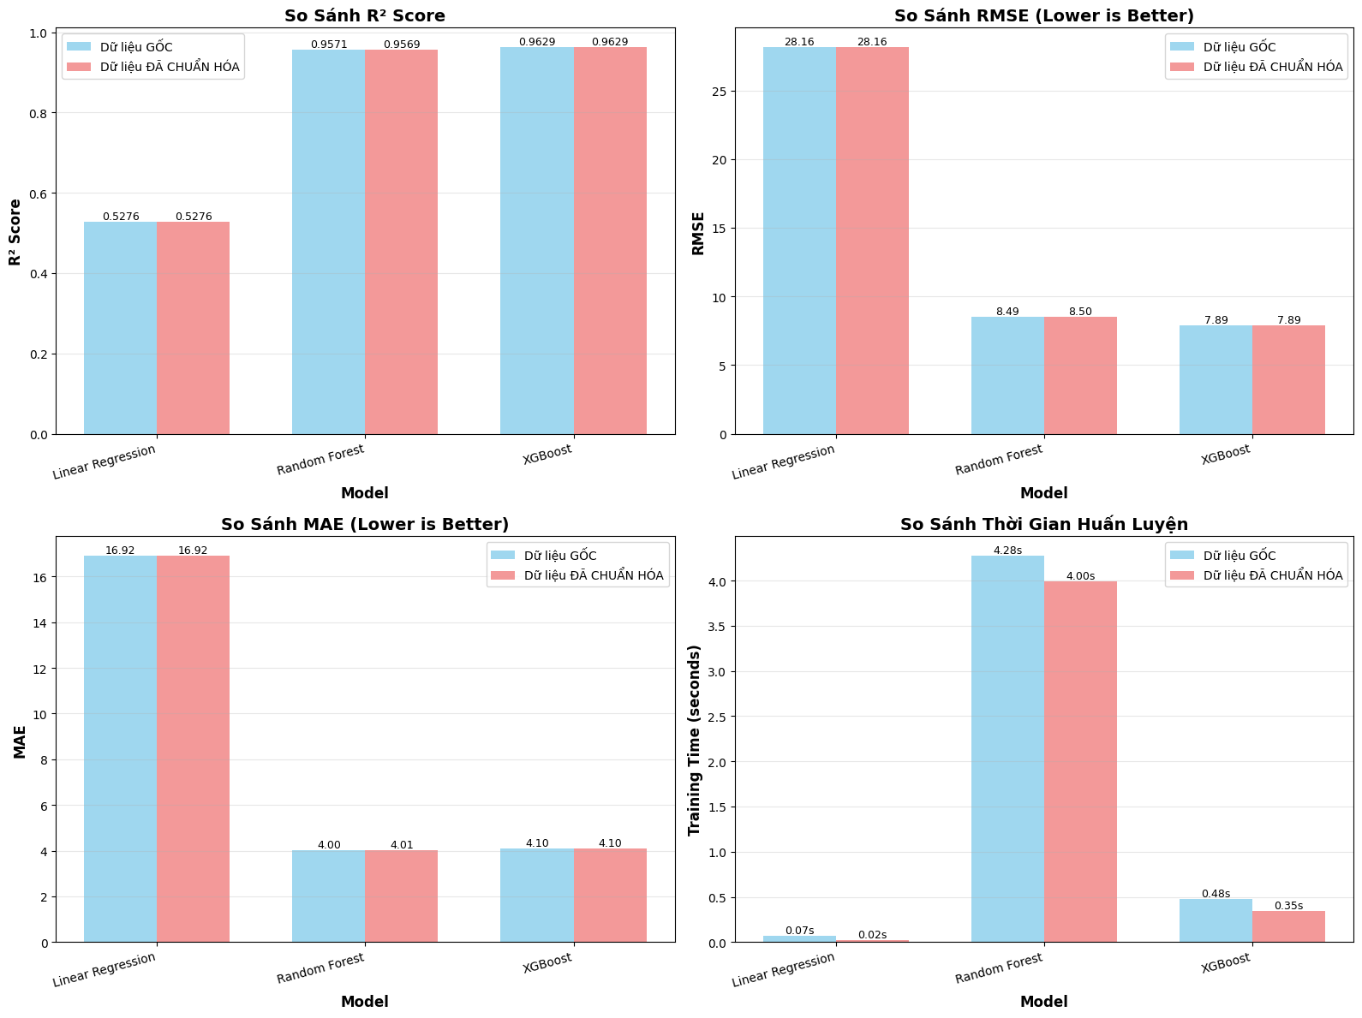
Figure 3: Visualize Compare Result

Production Pipeline: The 7-Day Forecast
The ultimate deliverable is the 7-day forecasting pipeline. This system integrates the trained XGBoost model (likely the Scaled version for consistency). A critical operational detail mentioned is the loading of the scaler.pkl artifact.[1, 1] This demonstrates MLOps maturity: the exact scaling parameters (mean, std dev) learned during training must be applied to the new, incoming forecast data. If the production system were to re-calculate the scaler on the single new data point, the scaling would be incorrect ($z=0$), leading to catastrophic prediction errors.The pipeline generates future features (e.g., estimating future month, hour, weekday is trivial; forecasting meteorological inputs likely relies on weather forecast API data or historical averages). The system outputs a CSV (pm25_predictions_comparison_7days.csv) enabling comparison between the Original-trained and Scaled-trained models, providing a continuous validation loop in the production environment.

Discussion, Limitations, and Future Perspectives

Critical Limitations
Despite the robust design, several limitations must be acknowledged:
- Outlier Handling: The documentation notes a lack of specific techniques for handling outliers (e.g., Z-score filtering). Extreme values caused by sensor glitches could skew the training of the Linear model (which minimizes squared error) and even the XGBoost model. Implementing robust statistics or anomaly detection (Isolation Forest) is a necessary improvement.
- Imputation Uncertainty: While ffill and interpolation were proposed, their confirmation in the final pipeline is ambiguous. Poor imputation of long gaps could introduce artificial trends.
- Feature Independence: The model assumes features like "future weather" are available. In practice, forecasting PM2.5 for 7 days ahead requires accurate 7-day weather forecasts. If the weather forecast is wrong, the PM2.5 forecast will be wrong (error propagation).

Future Work and State-of-the-Art (SOTA)
The field of air quality forecasting is rapidly evolving. Future iterations of this project should consider:
- Deep Learning Architectures: While XGBoost is excellent for tabular data, Long Short-Term Memory (LSTM) and GRU (Gated Recurrent Unit) networks are the current SOTA for time-series forecasting. These models possess "memory" states that can explicitly learn temporal sequences and dependencies over long horizons, potentially outperforming regression trees in capturing the inertia of pollution events.
- Hybrid Models: Recent research (2024/2025) highlights the efficacy of hybrid CNN-GRU or CNN-LSTM models. The CNN layers extract local features from the time series (short-term spikes), while the RNN layers capture long-term dependencies.
- Satellite Data Integration: Incorporating aerosol optical depth (AOD) data from satellites like Himawari-8 or Sentinel-5P would provide a spatial dimension to the model, improving accuracy by accounting for trans-boundary pollution transport that ground sensors cannot detect.

Conclusion
This research report has detailed the end-to-end development of a Machine Learning system for forecasting PM2.5 concentrations in Hanoi. By addressing the problem as a Regression task, the project successfully architected a data pipeline capable of handling the stochastic and non-linear nature of air quality data.The comparative analysis highlights XGBoost as the optimal model, offering the best balance of computational efficiency and predictive accuracy required to meet the $R^{2}>0.95$ and RMSE $<10μg/m^{3}$ targets. The study critically emphasized the importance of feature engineering—specifically temporal extraction and the removal of "leaky" features like AQI—and the necessity of feature scaling for algorithm stability.Ultimately, this project transcends theoretical modeling. The deployment of the 7-day forecasting pipeline provides a tangible tool for public health protection. By transforming raw meteorological data into actionable intelligence, this system empowers both policymakers and citizens to navigate the challenges of urban air pollution, marking a significant step towards a smarter, healthier Hanoi.

