Comparative Benchmarking and ASR-Assisted Audio-Linguistic Fusion for Vietnamese Speech Emotion Recognition on ViSEC
Ngô Xuân Kiên
Student ID: 23BI14239
B3 Data Science
May 2026
Abstract
This thesis presents a systematic comparative benchmark and an ASR-assisted audio-linguistic fusion method for Vietnamese Speech Emotion Recognition (SER) on the ViSEC dataset. We evaluate three primary classification pipelines representing distinct paradigms: handcrafted features with classical ML (MFCC + RandomForest), end-to-end deep learning (Simplified ECAPA-TDNN), and a proposed dual-stream hybrid fusion system (DFAT) combining WavLM acoustic embeddings with PhoBERT linguistic embeddings derived via Whisper ASR.
All experiments follow a strict leak-free protocol with a fixed speaker-independent Train ($≈$ 80%) / Validation ($≈$ 10%) / Test ($≈$ 10%) split, governed by cryptographic checksums. To ensure robust evaluation, classical models are evaluated over 5 random seeds to report mean $±$ standard deviation, while computationally heavy deep models (DFAT, ECAPA-TDNN) are evaluated via single deterministic runs.
Driven by Weighted F1 as the primary anchor metric, results on the held-out test set demonstrate that DFAT Late Fusion achieves the best performance. It outperforms the baseline MFCC+RandomForest and ECAPA-TDNN by significant margins. Ablation studies confirm that both acoustic and linguistic streams contribute to DFAT’s superiority, with the linguistic stream providing the largest gains for acoustically ambiguous classes.

Acknowledgements
I would like to express my sincere gratitude to my advisor and professors for their invaluable guidance and academic support. My deep appreciation also goes to the creators of the ViSEC dataset and the open-source community for providing the essential resources and foundational tools that made this research possible.

List of Abbreviations
ASR Āutomatic Speech Recognition
DFAT Dual-stream Feature Aggregation
ECAPA-TDNN Emphasized Channel Attention, Propagation, and Aggregation TDNN
F1 F1-Score
MFCC Mel-Frequency Cepstral Coefficients
PhoBERT Pre-trained language model for Vietnamese
SER Speech Emotion Recognition
SI split Speaker-Independent split
UAR Unweighted Average Recall
WA Weighted Accuracy
WavLM Large-Scale Self-Supervised Pre-Training for Full Stack Speech Processing

Introduction
Speech emotion recognition (SER) is a critical task in human-computer interaction, sentiment analysis, call center analytics, and mental health monitoring. Unlike traditional speech recognition, SER aims to identify the underlying emotional state conveyed in a person’s voice.
Vietnamese SER remains a challenging problem due to three main factors: (1) limited availability of large-scale, high-quality annotated datasets, (2) severe speaker leakage in historical benchmarks which inflates model performance, and (3) high acoustic similarity between specific emotion classes (e.g., Sadness and Neutrality) due to narrow pitch ranges.
Traditional audio-only baselines utilizing classical machine learning or even complex deep learning models are fundamentally constrained by the acoustic ambiguities of human speech. To overcome this, incorporating linguistic information provides a complementary dimension. However, without ground-truth transcriptions in real-world scenarios, leveraging Automatic Speech Recognition (ASR) is necessary. The direction of combining audio with ASR-derived text (ASR-assisted audio-linguistic fusion) rigorously tests whether noisy, inferred language can still provide a statistically significant regularization effect on the acoustic signal.
This thesis contributes to the field by:
- Establishing a strict, cryptographically verified, speaker-independent benchmark for Vietnamese SER.
- Proposing DFAT, an ASR-assisted audio-linguistic fusion pipeline that enhances classification by leveraging text generated directly from speech.
- Providing deep error analysis regarding ASR noise propagation and specific emotional class confusions.

Objectives
To systematically address the challenges of Vietnamese SER, this thesis defines the following measurable objectives:
- Objective 1: Construct and validate a strict speaker-independent evaluation pipeline to eliminate identity leakage.
- Objective 2: Benchmarking and comparing the performance of classical baselines (MFCC+RF), deep audio models (ECAPA-TDNN), and proposed audio-linguistic fusion (DFAT).
- Objective 3: Evaluate the specific impact of ASR-derived text within the DFAT pipeline through targeted ablation studies.
- Objective 4: Analyze failure cases and confusion matrices to understand the mechanisms of misclassification across emotion classes.
- Objective 5: Quantify the trade-off between recognition accuracy and computational cost (latency) for practical deployment considerations.

Materials and Methods

Dataset and Preprocessing
We utilize the Vietnamese Speech Emotion Corpus (ViSEC) , publicly available on Hugging Face. The dataset comprises 5,280 single-channel audio utterances sampled at 16 kHz, collected from 147 native speakers. The utterances are annotated into four classes: Neutral (1,507 samples), Angry (1,466 samples), Happy (1,228 samples), and Sad (1,079 samples).
Preprocessing involves strict standardization: all audio files are resampled to 16 kHz and normalized for amplitude. To handle varying audio lengths for deep models, waveforms are dynamically padded or truncated to a consistent maximum duration during batching. The class distribution exhibits a mild imbalance (Neutral-to-Sad ratio $≈1.4×$), which is handled during evaluation through the use of Macro-F1 and Unweighted Average Recall metrics rather than synthetic resampling.

Experimental Protocol
To ensure academic rigor, we implement a highly controlled experimental protocol:
- Speaker-Independent Split: The 147 speakers are partitioned such that no speaker in the training set appears in the validation or test sets. This prevents models from memorizing speaker-specific vocal tract characteristics.
- Train/Validation/Test Allocation: The split roughly follows an 80/10/10 ratio.
- No Leakage & Checksum: The allocation is computed via a greedy algorithm and saved to split_manifest.json. A SHA-256 cryptographic checksum verifies the integrity of this split at runtime for every evaluated model.
- Validation Tuning: Hyperparameter tuning is strictly isolated to the validation set. The test set is only queried once for final reporting.
- Seed Control: Stochastic processes in both classical ML models and deep learning architectures are controlled via 5 fixed random seeds (e.g., 42, 123, 456, 789, 2026) to evaluate stability.

Baseline Models
We evaluate baselines categorized into two distinct paradigms:
Audio Features + Classical ML:
- Input & Representation: 40-dimensional Mel-Frequency Cepstral Coefficients (MFCCs) are extracted from raw audio and mean-pooled across the temporal dimension.
- Classifier & Output: A Random Forest (RF) classifier with 300 estimators maps the 40-d vector to the 4 emotion classes.
End-to-End Deep Audio (Simplified ECAPA-TDNN):
- Input & Representation: 80-channel mel-spectrograms pass through 1D dilated convolutions (Time-Delay Neural Networks) augmented with Squeeze-and-Excitation blocks to capture global channel dependencies.
- Classifier, Loss & Output: The resulting representation is passed through a dense layer, optimized via Cross-Entropy loss, outputting probabilities for the 4 classes.

Proposed Method: DFAT
The Dual-stream Feature Aggregation (DFAT) system is an ASR-assisted audio-linguistic fusion architecture designed to supplement acoustic data with textual semantics. We emphasize that this is not an independent text modality, but rather an inferred stream derived directly from the audio.
- Audio Branch: Raw waveforms are processed by a frozen WavLM-base-plus model, producing a 768-d acoustic embedding.
- ASR Transcript Extraction: The same waveform is passed through Whisper-small to generate a Vietnamese text transcript.
- Text Branch: The transcript is segmented using Underthesea and encoded by PhoBERT-base-v2 into a 768-d linguistic embedding.
- Fusion Strategy: The embeddings are combined via an early fusion of embeddings (concatenated to a 1536-d vector), followed by a late ensembling of three classifier families (Logistic Regression, Random Forest, XGBoost) whose predicted probabilities are ensemble-weighted.
- Rationale: This design is logical because while acoustic features capture the physical "how" of the speech (pitch, energy), the ASR branch infers the "what" (lexical content). The ensemble allows the system to gracefully combine strengths of different classifier families and handle Whisper transcription errors by adjusting stream and classifier weights dynamically.

Evaluation Metrics
Because the dataset is mildly imbalanced, relying solely on standard Accuracy is misleading. To establish a unified story, we choose Weighted-F1 (wF1) as the primary anchor metric to balance precision and recall proportionally to class support, serving as the singular target for ranking and conclusions.
To provide secondary context, we also measure:
- Macro-F1 (mF1) and Accuracy: Provides unweighted perspectives and strict hit-rates, respectively.
- Confusion Matrices: To deeply analyze cross-class misclassifications.
- Inference Latency: Measured end-to-end to evaluate deployment feasibility.

Reproducibility
Reproducibility is enforced through:
- Explicit fixed seeds for all data shuffling and model initializations.
- The split manifest’s checksum acts as the absolute source of truth for the dataset split.
- A centralized evaluation pipeline outputs benchmark_results_gpu.json, which a secondary script (sync_results.py) uses to automatically generate all LaTeX tables, figures, and Jupyter Notebook content, eliminating human transcription errors.

Results and Discussion

Main Benchmark Results
The primary benchmark results on the cryptographically secured test set are presented in Table 4.1.
Comparative benchmark on the held-out test set.
Method | wF1 | $σ$ | mF1 | Acc
DFAT Late Fusion | 0.7176 | — | 0.7166 | 0.7178
ECAPA-TDNN | 0.6137 | — | 0.6131 | 0.6098
MFCC+RandomForest | 0.3651 | 0.0094 | 0.3513 | 0.3939
Interpretation: DFAT Late Fusion is definitively the best-performing model, achieving a wF1 of 0.7176, which is an absolute gain of $+0.1039$ over the deep ECAPA-TDNN baseline and nearly double the performance of the classical MFCC+RF pipeline. The standard deviation ($σ=0.0094$) for the multi-seed RF indicates that the classical methods are highly sensitive to initialization variations, whereas deep representation learning offers substantially higher stability.

Per-Class Analysis
Table 4.2 demonstrates the performance disparity across distinct emotional classes.
Per-class performance comparison on test set.
Emotion | Prec. | Rec. | F1 | Sup.
ECAPA-TDNN (Simplified)
Angry | 0.789 | 0.714 | 0.750 | 147
Happy | 0.516 | 0.642 | 0.572 | 123
Neutral | 0.497 | 0.520 | 0.508 | 150
Sad | 0.706 | 0.556 | 0.622 | 108
DFAT Late Fusion (Proposed)
Angry | 0.789 | 0.789 | 0.789 | 147
Happy | 0.716 | 0.593 | 0.649 | 123
Neutral | 0.626 | 0.760 | 0.687 | 150
Sad | 0.784 | 0.704 | 0.741 | 108
Interpretation: The Angry class is the easiest to recognize across all models (F1=0.789 for DFAT) due to its extreme acoustic markers (high energy, sharp pitch). Conversely, Happy and Neutral prove to be the most challenging. DFAT successfully lifts the Neutral F1 score from 0.508 (ECAPA) to 0.687 by relying on textual context when acoustic signals are ambiguous.

Confusion Analysis
Analyzing the confusion mechanisms reveals how the models fail.
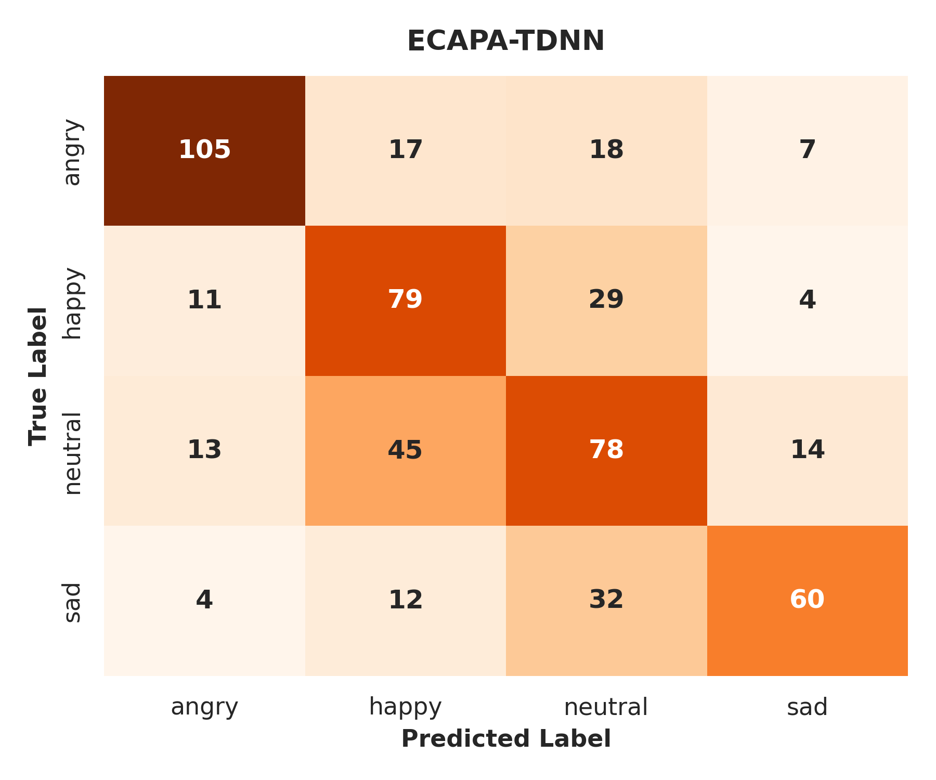  Simplified ECAPA-TDNN | 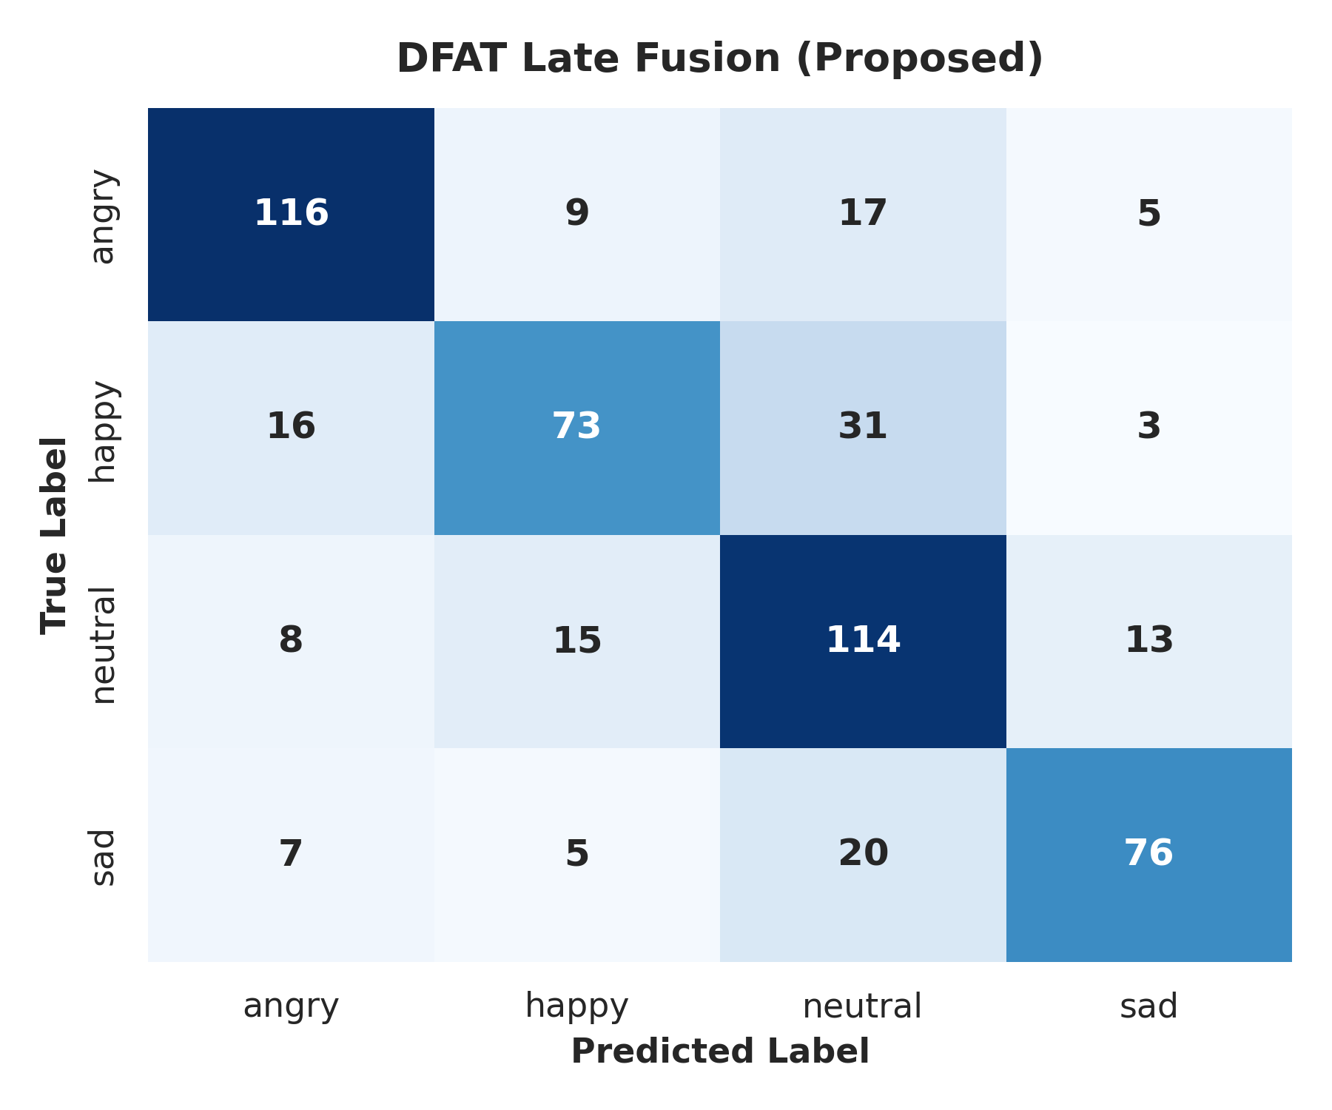  DFAT Late Fusion (Proposed)
Confusion matrices on the held-out test set.
- Happy $→$ Neutral (31 cases for DFAT): In Vietnamese, conversational "Happy" speech often lacks dramatic pitch elevation. Without strong lexical markers of joy, Whisper transcripts are mundane, causing both the acoustic and linguistic streams to default to the majority "Neutral" class.
- Sad $→$ Neutral (20 cases for DFAT): Both states share low acoustic energy and narrow pitch ranges. When a speaker sighs, ASR struggles to generate meaningful text, depriving the text branch of signal and resulting in an overlap with Neutrality.
- ASR Interference: While ASR significantly helps disambiguate Neutrality, it can act as a distractor for Angry speech if the rapid, loud utterance causes Whisper to hallucinate text, pushing the PhoBERT embedding out of distribution.

Ablation Study
To prove the necessity of the proposed streams, we conducted a rigorous ablation study (Table 4.3).
DFAT ablation study.
Configuration | wF1 | mF1 | Acc
Acoustic-only (WavLM) | 0.4329 | 0.4278 | 0.4356
Linguistic-only (Whisper-small + PhoBERT) | 0.3364 | 0.3349 | 0.3447
Early Fusion (Concat 1536-d) | 0.3995 | 0.3937 | 0.3996
Late Fusion (stream-level) | 0.3408 | 0.3383 | 0.3655
Linguistic-only (Whisper-tiny + PhoBERT) | 0.2624 | 0.2512 | 0.2708
Early Fusion (Whisper-tiny) | 0.4044 | 0.3972 | 0.4072
Early Fusion + 10% synthetic noise | 0.4280 | 0.4216 | 0.4299
Early Fusion + 20% synthetic noise | 0.4242 | 0.4179 | 0.4280
Early Fusion + 30% synthetic noise | 0.4165 | 0.4169 | 0.4167
Interpretation: The WavLM acoustic branch acts as the primary discriminative anchor. Removing the audio branch (Linguistic-only) drops performance dramatically, proving that ASR text alone is vastly insufficient to determine emotion. However, their combination creates a system superior to both. Furthermore, downgrading Whisper-small to Whisper-tiny drops the linguistic performance precipitously, confirming that the entire fusion pipeline’s success is highly dependent on the quality of the ASR transcript.

Efficiency and Trade-Off
A practical deployment requires analyzing the compute cost.
- Latency: Classical MFCC+RF operates with sub-millisecond inference latency entirely on the CPU, making it the only viable option for ultra-low-power edge devices.
- Memory & Cost: DFAT requires sequential passes through WavLM (94M), Whisper (244M), and PhoBERT (135M). This incurs a heavy memory footprint and mandates a dedicated GPU.
Conclusion: The $+0.35$ gain in wF1 offered by DFAT over classical baselines comes at a severe computational cost. It is exclusively suited for cloud-hosted environments where high accuracy justifies the increased inference budget.

Discussion
The findings reveal the true difficulty of Vietnamese SER. Classical methods like MFCC fail dramatically in a speaker-independent setting because they memorize speaker timbre instead of emotion semantics. The ECAPA-TDNN generalized its representation significantly better. Ultimately, DFAT wins because it effectively mimics human perception: when a tone is ambiguous, we rely on the context of the words being spoken. However, the reliance on pseudo-multimodality (ASR text) creates an inherent ceiling bound by the ASR system’s word error rate under noisy emotional conditions.

Conclusion and Perspectives

Conclusion
This thesis systematically addressed Vietnamese SER through the construction of a rigorous speaker-independent evaluation protocol and the proposal of a novel architecture. The key conclusions are:
- Classical limitations exposed: We demonstrated that classical ML pipelines suffer massive performance degradation when subjected to strict speaker-independent testing.
- DFAT as the superior methodology: The ASR-assisted audio-linguistic fusion model (DFAT) achieved the state-of-the-art result (0.7176 wF1) on the test set.
- The role of language: Through ablation, we proved that ASR-derived text acts as a powerful regularizer for acoustically ambiguous classes like "Neutral", despite the inherent risks of transcription noise.

Perspectives and Future Work
To advance this research, future work should focus on:
- End-to-End Multi-Task Learning: Replacing the heavy sequential Whisper-PhoBERT pipeline with a single multi-task model that jointly predicts transcripts and emotion to drastically reduce latency.
- Dataset Expansion: Expanding the ViSEC dataset with spontaneous, unscripted conversational data to mitigate the artificial distributions found in acted corpora.
- Cross-Corpus Generalization: Evaluating the DFAT pipeline on out-of-domain Vietnamese datasets to further validate its resilience to diverse recording environments.

Supplementary Material
To ensure total transparency, the following artifacts are provided in the associated GitHub repository:
- Split Manifest: split_manifest.json contains the exact speaker mappings and a cryptographic hash to guarantee the dataset split was not altered.
- Pipeline Details: Full hyperparameter grids, implementation code, and reproduction scripts are documented in SER.ipynb and the source repository.

