Product Requirements Document
Tutor Connect System (TCS) – Report 3

Version | v1.1
Date | 19/06/2026

Change Log
Version | Date | Author | Summary
v1.0 | 08/06/2026 | Nguyen Tien Anh | Initial plan
v1.1 | 19/06/2026 | Nguyen Tien Anh | Expanded scope to include Unverified Leads pipeline, social lead ingestion, center recruitment workflow, and updated use case inventory

Table of Contents
Change Log 1
Table of Contents 2
1. Business Flows 3
1.1 Overview 3
1.2 BF-01: End-to-End Tutor Recruitment 4
1.3 BF-02: Tutor Self-Service 5
1.4 BF-03: Profile Verification Management 5
1.5 BF-04: Escrow Payment and Class Lifecycle 6
1.6 BF-05: Platform Governance and User Support 7
1.7 BF-06: Social Lead Ingestion and Center CRM Conversion 7
1.8 BF-07: B2B Center Recruitment Pipeline 8
1.9 BF-08: Continuous Engagement & Reputation Loop 9
2. Conceptual Data Model 10
2.1 Entity Relationship Diagram 10
2.2 Entity List 10
2.3 Data Business Rules 16
3. User Requirements 16
3.1 Actor Definitions 16
3.2 Permission Matrix 17
3.3 Use Case Diagrams 19
3.4 Use Case Index 26
4. Functional Requirements 30
4.1 Modules & Features 30
4.2 Screen Inventory 38
4.3 External API Inventory 43
4.4 Background Job Inventory 43
5. Global Business Rules 44
6. Non-Functional Requirements & Constraints 45
6.1 Performance Requirements 45
6.2 Security Requirements 46
6.3 Out of Scope 46
6.4 Technical Assumptions 46

1. Business Flows

1.1 Overview
1) Context Diagram
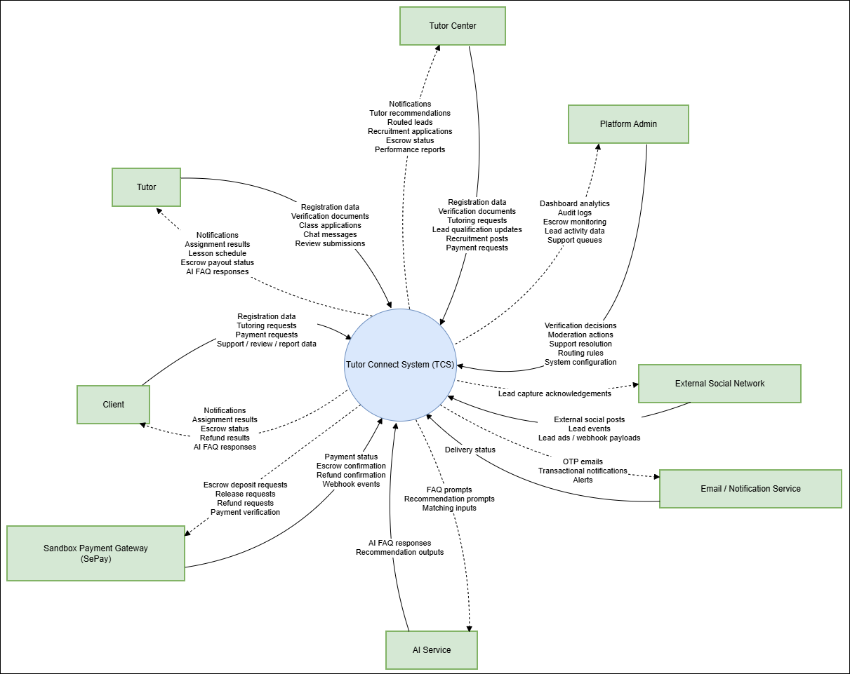
Figure 1. Context Diagram for Tutor Connect System (TCS)

2) Business Flow Index

BF-ID | Flow Name | Primary Actors | Trigger | End Condition
BF-01 | End-to-End Tutor Recruitment | Client, Tutor, Tutor Center | Client or Tutor Center posts a tutoring request | A tutor is assigned or the request is closed
BF-02 | Tutor Self-Service | Tutor | Tutor registers and completes profile | Tutor applies for classes and tracks outcomes
BF-03 | Profile Verification Management | Tutor, Tutor Center, Platform Admin | Tutor or Tutor Center submits verification documents | Verification request is approved or rejected
BF-04 | Escrow Payment and Class Lifecycle | Client, Tutor, Tutor Center, Platform Admin | Client or Tutor Center confirms tutor assignment and funds escrow | Funds are released, refunded, or resolved through dispute
BF-05 | Platform Governance and User Support | Platform Admin, Client, Tutor, Tutor Center | User submits report, dispute, support request, or admin reviews system events | Issue is resolved and status is closed
BF-06 | Social Lead Ingestion and Center CRM Conversion | External Social Network, Tutor Center, Platform Admin | Public social lead is captured or center receives an unverified lead | Qualified lead is converted into a class or rejected / archived
BF-07 | B2B Center Recruitment Pipeline | Tutor, Tutor Center | A Tutor Center publishes a general recruitment campaign looking for long-term internal tutors. | Tutors submit resumes, go through the center's assessment/interview funnel, and become verified members of that center's internal pool.
BF-08 | Continuous Engagement & Reputation Loop | Client, Tutor, Tutor Center | A matching class contract goes into the active status state (calendar schedules activated, milestone tracking initiated). | Both parties submit mutual ratings and performance reviews, and the AI Engine recalibrates the Tutor’s public Reputation Score.

1.2 BF-01: End-to-End Tutor Recruitment
Trigger: Client or Tutor Center decides to open a class requirement on the platform.
End condition: Tutor is assigned, e-contract is confirmed, and class becomes operational, or the class is closed without assignment.

Step | Actor | Action | UC-ID
1 | Client / Tutor Center | Creates or manages a class opening | → UC-17
2 | Tutor | Searches and filters suitable classes | → UC-15
3 | Tutor | Views class details and applies | → UC-16, UC-17
4 | Client / Tutor Center | Views and filters tutor applications | → UC-08, UC-09
5 | Client / Tutor Center | Reviews tutor public profile and confirms tutor assignment | → UC-10, UC-11
6 | Client / Tutor Center and Tutor | Confirm or reject e-contract | → UC-12
7 | System | Updates class status and notifies affected users | → UC-38, UC-39

Exception paths:
- Tutor withdraws before assignment.
- Client or Tutor Center rejects all applicants and closes or edits the request.
- Request is moderated or hidden by Platform Admin.

1.3 BF-02: Tutor Self-Service
Trigger: Tutor creates a new account.
End condition: Tutor has a complete profile, may be verified, and can track request applications and assignments.

Step | Actor | Action | UC-ID
1 | Tutor | Registers an account | → UC-01
2 | Tutor | Signs in | → UC-02
3 | Tutor | Manages personal profile | → UC-06
4 | Tutor | Submits verification documents and tracks verification status | → UC-64, UC-65
5 | Tutor | Searches and filters classes | → UC-15
6 | Tutor | Views class details and applies to class | → UC-16, UC-17
7 | Tutor | Manages submitted class applications and tracks outcomes | → UC-18
8 | Tutor | Views lesson schedule, receives recommended classes, and requests payment release when eligible | → UC-22, UC-25, UC-33
Exception paths:
- Tutor stops after registration and leaves profile incomplete, so application and verification-related actions remain unavailable until required profile data is completed.
- Tutor submits invalid or incomplete verification documents, and the verification request is rejected; Tutor must update documents and resubmit.
- Tutor withdraws an application or is rejected by the request owner, and that application path ends while the account remains active for other requests.
- Tutor account becomes suspended or locked, preventing access until resolved by system rules or Platform Admin.

1.4 BF-03: Profile Verification Management
Trigger: Tutor or Tutor Center submits documents for approval.
End condition: Verification request status becomes Approved or Rejected.

Step | Actor | Action | UC-ID
1 | Tutor / Tutor Center | Uploads verification documents | → UC-64
2 | Platform Admin | Reviews and moderates submitted verification documents | → UC-48
3 | Platform Admin | Reviews related tutor application records when verification evidence impacts trust status | → UC-49
4 | System | Updates verification result and applicant reviews status | → UC-65

Exception paths:
- Submitted documents are incomplete, expired, unreadable, or inconsistent, so Platform Admin rejects the request and asks for resubmission.
- Applicant edits sensitive profile data while request is pending, causing the current request to be cancelled or re-reviewed according to platform policy.
- Platform Admin cannot make a decision because supporting evidence is insufficient, so the request remains pending until additional documents are provided.

1.5 BF-04: Escrow Payment and Class Lifecycle
Trigger: Tutor assignment is confirmed.
End condition: Escrow funds are released to Tutor, refunded, or distributed after dispute resolution.

Step | Actor | Action | UC-ID
1 | Client / Tutor Center / Tutor | Manages payment methods and transaction state | → UC-24
2 | Tutor | Requests payment release after milestones or completion | → UC-25
3 | Client / Tutor Center | Approves or rejects tutor payment where business flow requires | → UC-26
4 | Client / Tutor Center / Tutor | Submits refund request if class fails or is cancelled | → UC-27
5 | Platform Admin | Processes refund requests and handles disputes | → UC-28, UC-29
6 | Platform Admin | Monitors escrow transactions and escrow ledger dashboard | → UC-30, UC-51
Exception paths:
- Client or Tutor Center fails to deposit escrow successfully, so the class cannot proceed to a funded state until payment succeeds.
- Class is cancelled before completion, so escrow is refunded according to refund policy and the class flow ends.
- One party disputes completion or service quality, so payment release is paused until Platform Admin resolves the dispute.
- Tutor requests release but Client or Tutor Center does not confirm within the allowed process window, so the case moves to manual review or dispute handling.

1.6 BF-05: Platform Governance and User Support
Trigger: A user needs support, reports abuse, or admin reviews platform activity.
End condition: Ticket, report, or moderation case is resolved.

Step | Actor | Action | UC-ID
1 | User | Requests support, reports users/classes, or submits review / feedback | → UC-35, UC-53, UC-54
2 | Platform Admin | Views dashboard, notifications, and support queues | → UC-39, UC-52, UC-63
3 | Platform Admin | Resolves class issues, manages user accounts, moderates feedback, and reviews lead or tutor application activity | → UC-19, UC-37, UC-44, UC-47, UC-49
4 | System | Updates status, audit records, and sends notification outputs | → UC-38, UC-39
Exception paths:
- The submitted report or support ticket lacks enough evidence, so Platform Admin requests clarification or closes the case without action.
- Reported behavior is not a policy violation, so the case is rejected and recorded as closed.
- The issue is financial or contractual and requires escalation to refund or dispute flow, so the case is transferred to the appropriate resolution path.
- The affected account or content is immediately dangerous or fraudulent, so Platform Admin may suspend the account or hide the content before the investigation fully concludes.

1.7 BF-06: Social Lead Ingestion and Center CRM Conversion
Trigger: Public social content or marketing lead data enters the platform lead funnel.
End condition: Unverified lead is reviewed, routed, qualified, converted to class, or archived.

Step | Actor | Action | UC-ID
1 | External Social Network | Pushes or exposes social lead data to the platform | → UC-46
2 | Platform Admin | Configures scraping and routing rules | → UC-50
3 | Tutor Center | Reviews unverified leads | → UC-40
4 | Tutor Center | Updates lead qualification status | → UC-41
5 | Platform Admin | Verifies qualified leads and sample records if necessary | → UC-45
6 | Tutor Center | Converts qualified lead to class and may publish center recruitment post | → UC-42, UC-55
7 | Tutor Center | Processes recruitment applications or manages tutors for that center workflow | → UC-56, UC-60

Exception paths:
- Lead is duplicated, low-quality, incomplete, or unrelated, so it is archived or rejected before conversion.
- Routing rules do not find a suitable center, so the lead remains pending for manual reassignment.
- The verified center cannot validate the lead offline, so the lead status is downgraded or closed without conversion.
- Social platform structure or anti-scraping behavior changes, so external capture reliability is degraded until rules are updated.

1.8 BF-07: B2B Center Recruitment Pipeline
Trigger: Tutor Center decides to expand its internal pool and creates a long-term recruitment posting.
End condition: Candidate status reaches HIRED (becomes part of the Center's internal pool) or REJECTED/WITHDRAWN (all terminal).

Step | Actor | Action | UC-ID
1 | Tutor Center | Creates and configures a long-term general recruitment campaign post | → UC-5
2 | Tutor Center | Reviews the criteria and publishes the recruitment post to the platform | → UC-55
3 | Tutor | Browse active center recruitment campaigns and views the deep-dive details | → UC-57
4 | Tutor | Submits a recruitment application, systematically attaching their digital profile/credentials | → UC-58
5 | Tutor Center | Reviews the incoming applications and moves promising candidates into the internal processing pipeline | → UC-56
6 | Tutor Center | Advances candidate to the Interview/Assessment stage and schedules an appointment | → UC-56
7 | Tutor | Tracks recruitment application progress and accepts the interview invitation schedule | → UC-59
8 | Tutor Center | Conducts assessment/interview, inputs final internal notes, and changes status to Passed or Rejected | → UC-56
9 | Tutor Center | Marks the successful candidate as Hired; system automatically links Tutor to Center's internal roster | → UC-56, UC-60
Exception paths:
- Tutor actively withdraws application at any point before the interview stage → Flow ends for that Tutor.
- Tutor Center rejects the tutor profile at any stage of the funnel → Status changes to REJECTED (terminal); automated system notification is dispatched; flow ends.

1.9 BF-08: Continuous Engagement & Reputation Loop
Trigger: An e-contract is fully signed, and milestone payment is deposited into the Escrow account, shifting the class status to Active.
End condition: The tutoring lifecycle concludes, cross-evaluations are recorded, and the AI Recalibrates the public Reputation Score (terminal).

Step | Actor | Action | UC-ID
1 | Tutor / Tutor Center | Sets up, updates, or adjusts the weekly teaching schedule slots for the active class | → UC-32
2 | Client / Tutor / Tutor Center | Views and syncs the live consolidated lesson schedule to keep track of upcoming sessions | → UC-33
3 | Client / Tutor / Tutor Center | Utilizes the internal text chat box to coordinate immediate classroom shifts or materials sharing | → UC-34
4 | Tutor | Formally submits a request for payment release upon hitting a contract milestone/session block | → UC-25
5 | Tutor / Tutor Center | Reviews the tutoring logs, confirms milestone criteria are met, and approves the Escrow release | → UC-26
6 | Tutor / Tutor Center | Submits a comprehensive performance evaluation and star rating of the Tutor's pedagogical quality | → UC-35
7 | Tutor | Submits feedback regarding Client cooperation, behavior, and environment compatibility | → UC-35
8 | Platform (System AI) | Automatically analyzes mutual feedback text/ratings data and recalibrates the Tutor's public score | → UC-10, UC-36
Exception paths:
- A severe issue arises during lesson delivery (e.g., tutor absent without notice) → Client initiates UC-19 (Resolve Class Issues) / UC-54 (Report User/Class) to flag the event for admin review.
- Client actively rejects the payment release due to a conflict → System pauses automation, redirects the parties to UC-27 (Submit Refund Requests) or UC-29 (Handle Disputes); flow shifts to BF-05 (Governance).

2. Conceptual Data Model

2.1 Entity Relationship Diagram
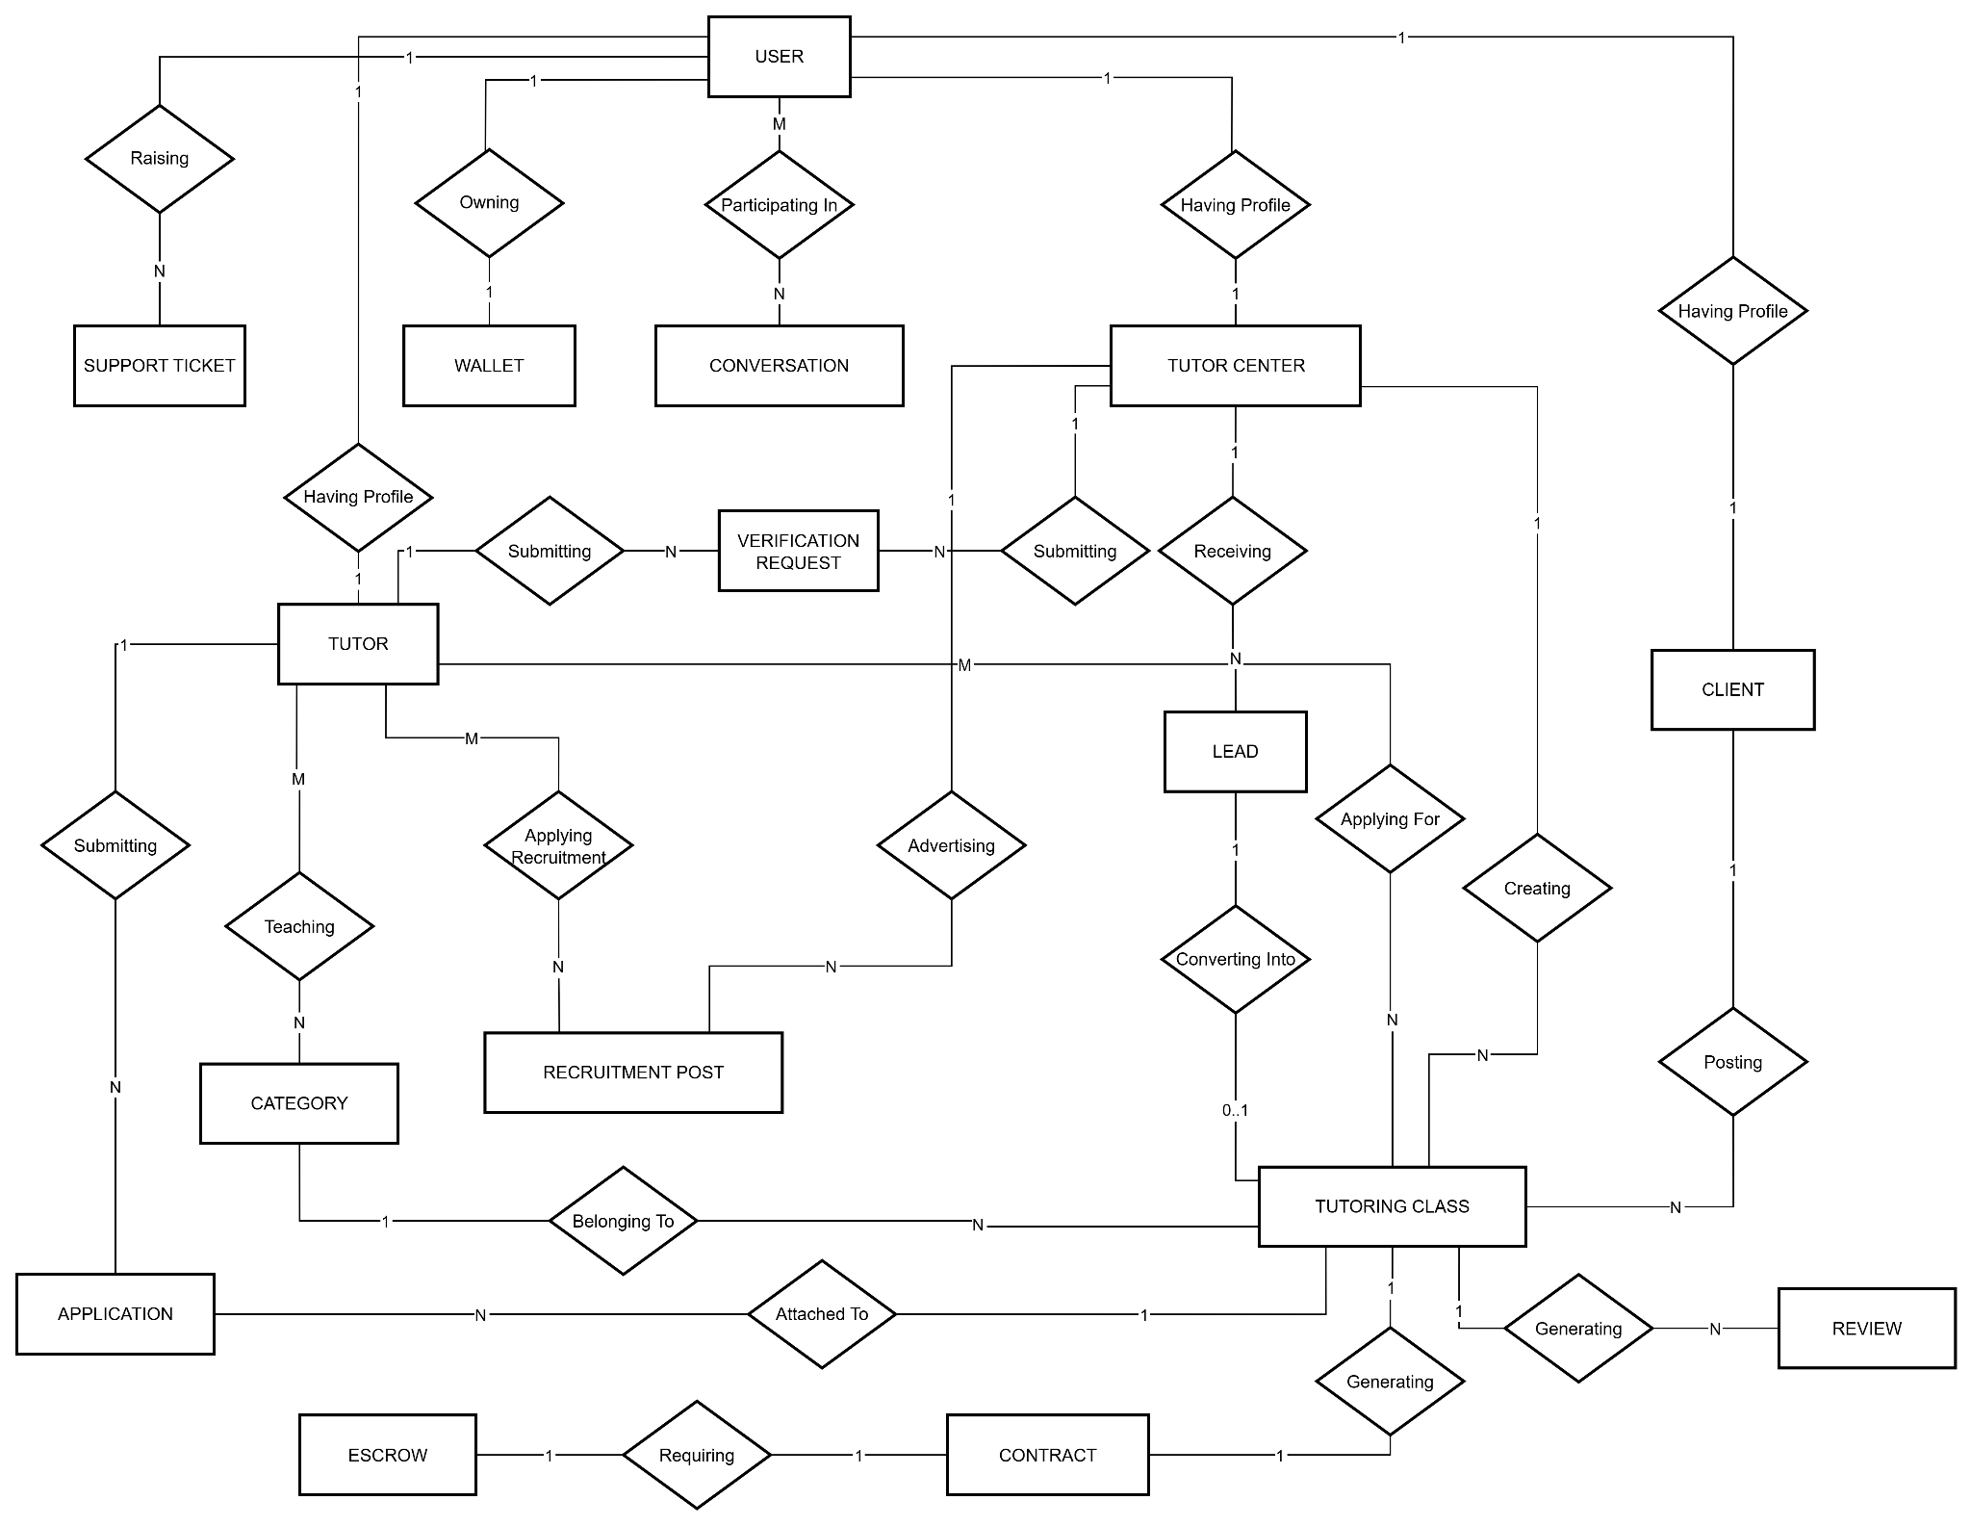
Figure 2. Entity Relationship Diagram for Tutor Connect System (TCS)

2.2 Entity List
1) Entity: User
Field | Value
Purpose | Represents the root account for every user in the platform, acting as the unique identity backbone.
Key business attributes | user_id (Identifier), email, password_hash, phone_number, status, created_at
Business identity | Email is unique and strictly non-duplicated across the entire system.
Status / lifecycle | ACTIVE, SUSPENDED, DELETED
FT-ID ref | FT-01, FT-02, FT-05, FT-08
2) Entity: Tutor
Field | Value
Purpose | Profile containing professional credentials and performance tracking metrics for individual tutors.
Key business attributes | tutor_id (Identifier, shares 1:1 link with User), full_name, gender, date_of_birth, education_level, experience_year, reputation_score, verification_status
Business identity | One profile mapping exactly to one base User account through a shared primary key constraint.
Status / lifecycle | PENDING, APPROVED, REJECTED
FT-ID ref | FT-02, FT-04, FT-07, FT-09
3) Entity: Client
Field | Value
Purpose | Profile representing students or parents who post single-class demands on the marketplace.
Key business attributes | client_id (Identifier, shares 1:1 link with User), full_name, phone_number, address, avatar_url
Business identity | One profile mapping exactly to one base User account.
Status / lifecycle | Inherits base account lifecycle state directly from the linked User entity.
FT-ID ref | FT-01, FT-03
4) Entity: TutorCenter
Field | Value
Purpose | Corporate profile representing tutoring agencies that manage leads, internal rosters, and institutional classes.
Key business attributes | center_id (Identifier, shares 1:1 link with User), center_name, tax_code, phone_number, address, verification_status
Business identity | One commercial workspace profile mapping strictly to one corporate User account.
Status / lifecycle | PENDING, APPROVED, REJECTED
FT-ID ref | FT-07, FT-08, FT-12, FT-13, FT-34, FT-35

5) Entity: Wallet
Field | Value
Purpose | Represents personal digital ledger balance held by users for payment processing and distribution.
Key business attributes | wallet_id (Identifier), balance, frozen_balance, updated_at
Business identity | System-wide wallet mapped to exactly one master user.
Status / lifecycle | Active, Suspended
FT-ID ref | FT-06
6) Entity: Category
Field | Value
Purpose | System configuration master tree mapping hierarchical multi-type domain taxonomy labels together.
Key business attributes | category_id (Identifier), parent_id (Self-referencing link), category_name, type, is_active
Business identity | Evaluated dynamically based on defined master type context (SUBJECT, EDUCATION_LEVEL, LOCATION, SYSTEM_CONFIG).
Status / lifecycle | Active, Inactive
FT-ID ref | FT-02, FT-03
7) Entity: TutoringClass
Field | Value
Purpose | Central operational record tracking marketplace class postings through matchings and completions.
Key business attributes | class_id (Identifier), title, description, tuition_fee, lesson_mode, number_of_sessions, status
Business identity | System-assigned unique tracking code generated when published by a Client or Tutor Center.
Status / lifecycle | DRAFT, OPEN, MATCHED, IN_PROGRESS, COMPLETED, CANCELLED, DISPUTED
FT-ID ref | FT-03, FT-04, FT-06, FT-09, FT-14
8) Entity: RecruitmentPost
Field | Value
Purpose | B2B mass hiring campaign published by a Tutor Center to recruit long-term internal tutors.
Key business attributes | recruitment_id (Identifier), title, description, requirements, benefit, required_experience, status
Business identity | Unique long-term staffing post separate from single marketplace tutoring classes.
Status / lifecycle | DRAFT, ACTIVE, CLOSED
FT-ID ref | FT-03, FT-04, FT-14
9) Entity: Lead
Field | Value
Purpose | CRM record capturing unverified customer inquiries from external marketing networks to fuel the center funnel.
Key business attributes | lead_id (Identifier), source, customer_name, phone_number, subject, budget, status
Business identity | Traceable source link origins (FACEBOOK_GROUP, FACEBOOK_ADS, MANUAL, MESSENGER).
Status / lifecycle | NEW, QUALIFIED, CONVERTED, CLOSED
FT-ID ref | FT-12, FT-13, FT-14
10) Entity: Conversation
Field | Value
Purpose | Internal secure group or private instant messaging channel hosting interaction records between actors.
Key business attributes | conversation_id (Identifier), created_at
Business identity | Unique chat routing instance containing historical communication history.
Status / lifecycle | Active, Archived
FT-ID ref | FT-05
11) Entity: Contract
Field | Value
Purpose | Multi-lateral digital service binding agreement tying terms between Client, Tutor, and platforms together legally.
Key business attributes | contract_id (Identifier), contract_no, contract_file_url, signed_at, status
Business identity | Immutable agreement generated directly per successful TutoringClass assignment match.
Status / lifecycle | DRAFT, SIGNED, ACTIVE, COMPLETED, TERMINATED
FT-ID ref | FT-06
12) Entity: Escrow
Field | Value
Purpose | Safe transactional vault locking target tuition transaction capital securely prior to systematic task verification releases.
Key business attributes | escrow_id (Identifier), amount, status, deposited_at, released_at
Business identity | Financial guarantee node bound tightly via a 1:1 relationship layout against its generated class contract.
Status / lifecycle | PENDING, DEPOSITED, RELEASED, REFUNDED, DISPUTED
FT-ID ref | FT-06
13) Entity: Application
Field | Value
Purpose | Represents an independent application record submitted by a tutor to a specific class request, containing its own operational lifecycle workflow.
Key business attributes | application_id (Identifier), tutor_id (Ref), class_id (Ref), proposed_rate, cover_letter, status, submitted_at, reviewed_at
Business identity | A Tutor can submit at most one application per unique Tutoring Class.
Status / lifecycle | SUBMITTED, UNDER_REVIEW, ACCEPTED, REJECTED, WITHDRAWN
FT-ID ref | FT-14
14) Entity: VerificationRequest
Field | Value
Purpose | Represents formal validation files and verification requests submitted by individual Tutors or Tutor Centers to unlock system credentials.
Key business attributes | request_id (Identifier), requester_id (Ref to User), requester_type (TUTOR / CENTER), document_urls (JSON/Text list of proofs), admin_notes, status, created_at, processed_at
Business identity | System-generated unique token tracking the sequence of dynamic verification attempts over time.
Status / lifecycle | SUBMITTED, UNDER_REVIEW, VERIFIED, REJECTED
FT-ID ref | FT-06, FT-07, FT-08, FT-37
15) Entity: Review
Field | Value
Purpose | Stores mutual ratings and feedback metrics recorded after a tutoring class session transitions into its completion state.
Key business attributes | review_id (Identifier), class_id (Ref), author_id (Ref to User), target_id (Ref to User), rating_stars, comment_text, status, created_at
Business identity | Strictly limited to a maximum of 2 review rows per operational class node (Client-to-Tutor and Tutor-to-Client).
Status / lifecycle | VISIBLE, HIDDEN, MODERATED
FT-ID ref | FT-29, FT-30
16) Entity: SupportTicket
Field | Value
Purpose | Centralized governance ticket tracking operational issues, data disputes, or user misbehavior reports reported to the platform administration.
Key business attributes | ticket_id (Identifier), reporter_id (Ref to User), target_class_id (Ref, Optional), category (DISPUTE / SYSTEM_ERROR / REPORT_USER), description, evidence_urls, assigned_admin_id, status, created_at
Business identity | Mapped seamlessly back to any master User session to enforce platform compliance logs.
Status / lifecycle | OPEN, IN_REVIEW, RESOLVED, CLOSED
FT-ID ref | FT-28, FT-38, FT-42

2.3 Data Business Rules
Rule | Description | Enforced On
Unique email | No two users may share the same email address | Account creation and email update
One application per request | A Tutor may submit at most one application for a given tutoring request | Application submission
Verification required for trust features | Tutors and Tutor Centers must complete verification before being presented as verified on the platform | Profile display and matching
Chat requires valid relationship | Users may only send messages when a valid matching, request, or class relationship exists | Chat access
Reviews require verified participation | Only users who genuinely participated in the class may create ratings and reviews | Review creation
Escrow required before class progression | Class may not proceed to funded lifecycle steps until escrow is created and funded when required | Assignment and payment flow
Accounts are not physically deleted | User accounts should be deactivated or suspended, not permanently removed from business records | User management
Sensitive document access is controlled | Verification files and evidence files must never be publicly accessible through guessable links | File access

3. User Requirements

3.1 Actor Definitions
Actor | Description | Sign-in Required | Notes
Platform Admin | External operators manage the platform: user account management, verification requests, content moderation, disputes, refunds, escrow ledger, master data catalog, analytics, and audit logs | Yes | Management and supervisory role. Not involved in day-to-day networking or teaching activities in the market
Client | Learner or guardian on the buyer side. Registers, creates and manages tutoring requests, searches, makes escrow payments, schedules and joins classes, rates,reviews, and raises support or disputes | Yes | The primary lessee in business operations
Tutor | Tutoring provider. Responsibilities include building and verifying profiles, searching for and applying for tutoring requests, managing assigned classes and schedules, and processing payments | Yes | Must hold status ‘Verified’ before searching, viewing details of, or applying to requests
Tutor Center | Organization posting requests and managing tutoring operations | Yes | Multi-tutor business unit. Governs only the resources it owns, it is not a platform-level privileged role
Authentication Service | External, system service that handles registration, login, logout, password reset, change | No | Secondary actor, never initiates a use case
Notification Service | External services, systems responsible for sending in-app notifications and campaigns, push notifications and Gmail messages | No | Secondary actor
Payment Gateway | External provider that processes deposits, withdrawals, escrow holds, refunds and payouts | No | Secondary actor
AI Service | System service powering the AI support chatbot, tutor recommendations and search-relevance weighting | No | Secondary actor
External Social Network | External lead source that provides public social lead data into the platform pipeline | No | API or scraping source, not an internal sign-in actor
Guest | Public visitor browsing general information or public tutor data if enabled | No | Read-only access only

Role hierarchy:
- No formal inheritance should be assumed unless explicitly defined by RBAC implementation.
- Platform Admin has governance permissions but should not automatically act as every business user in day-to-day flows.

3.2 Permission Matrix
Full = unrestricted · Restricted = conditions apply (see footnotes) · No = denied

Entity | Action | Platform Admin | Tutor Center | Client | Tutor | Guest
User account | Register | No | Full | Full | Full | No
User account | Login / Logout | Full | Full | Full | Full | No
User account | Reset / Change password | Full | Full | Full | Full | No
User account | Suspend / Reactivate | Full | No | No | No | No
Profile | Manage own profile | Full | Full | Full | Full | No
Tutor profile | View | Full | Full | Full | Full | Restricted
Verification request | Submit | No | Full | No | Full | No
Verification request | Approve / Reject | Full | No | No | No | No
Tutoring request | Create | No | Full | Full | No | No
Tutoring request | Edit / Close own | No | Full | Full | No | No
Tutoring request | Search / View | Full | Full | Full | Full | Restricted ²
Application | Submit | No | No | No | Full | No
Application | View own | No | No | No | Full | No
Application | View all for owned request | Full | Full | Full | No | No
Application | Accept / Reject | Full | Full | Full | No | No
Message | Send / Receive | Restricted | Full | Full | Full | No
Notification | View / Mark read | Full | Full | Full | Full | No
Escrow / Payment | Deposit / Manage own | Full | Full | Full | Restricted ³ | No
Escrow / Payment | Monitor all | Full | No | No | No | No
Review | Create | Restricted ⁴ | Restricted ⁴ | Restricted ⁴ | Restricted ⁴ | No
Review | Moderate / Delete | Full | No | No | No | No
Support / Report / Dispute | Create | No | Full | Full | Full | No
Support / Report / Dispute | Resolve | Full | No | No | No | No
Category / FAQ / system setting | Manage | Full | No | No | No | No
Dashboard | View | Full | Restricted ⁵ | Restricted ⁵ | Restricted ⁵ | No

¹ Guest tutor-profile access depends on whether public tutor catalog is enabled in the chosen release scope.
² Guest may only access public search or catalog views if exposed by the product; detailed internal workflows remain restricted.
³ Tutor may view payout and transaction history related to their own classes but does not fund escrow.
⁴ Review creation is restricted to verified class participants after class completion or eligible billing milestone.
⁵ Non-admin dashboard access is limited to each role's own operational data.

3.3 Use Case Diagrams
In this section, you need to provide the UC diagram(s) to show the actor-UCs and UC-UC relationships like the sample below. You can have multiple UC diagrams for the system, each diagram is for one actor or one workflow]
1) UCs for Authentication & RBAC
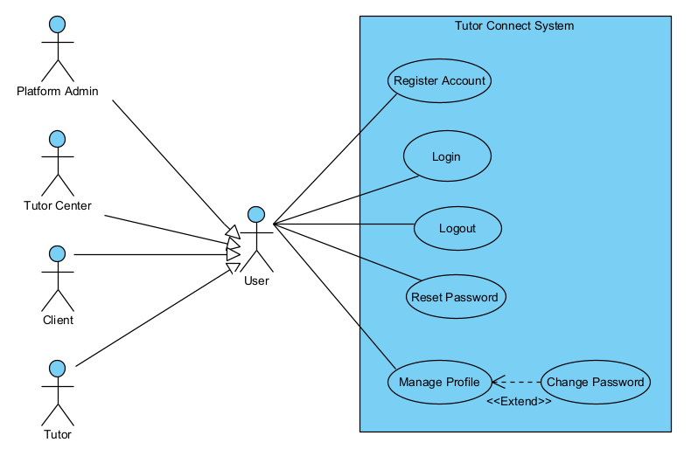
Figure 3. Use Case Diagram for Authentication & RBAC

2) UCs for Profile & Verification Workflow
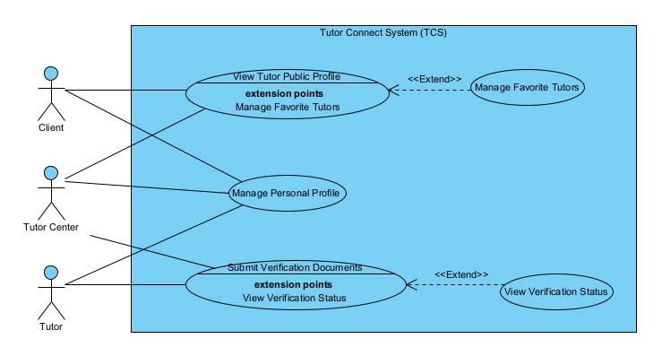
Figure 4. Use Case Diagram for Profile & Verification Workflow
3) UCs for Unified Tutoring Request & Class Life-cycle Management
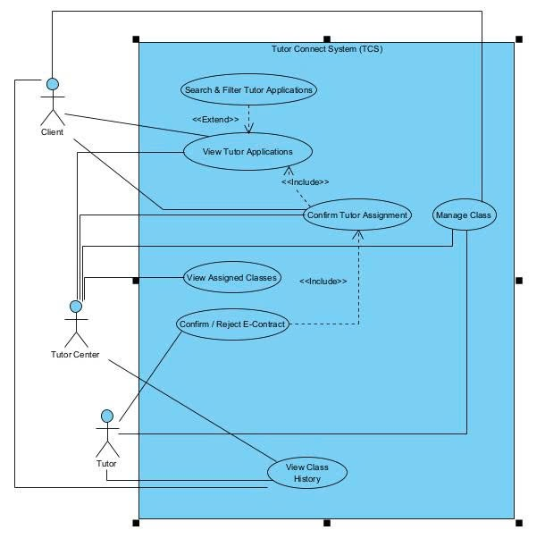
Figure 5. Use Case Diagram for Unified Tutoring Request & Class Life-cycle Management
4) UCs for Advanced Search & Filtering System
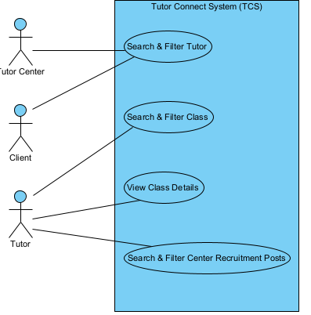
Figure 6. Use Case Diagram for Advanced Search & Filtering System

5) UCs for Internal Messaging & Real-Time Notification
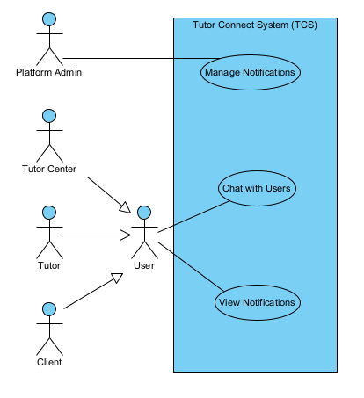
Figure 7. Use Case Diagram for Internal Messaging & Real-Time Notification

6) UCs for Smart Escrow Wallet & E-Contract Management
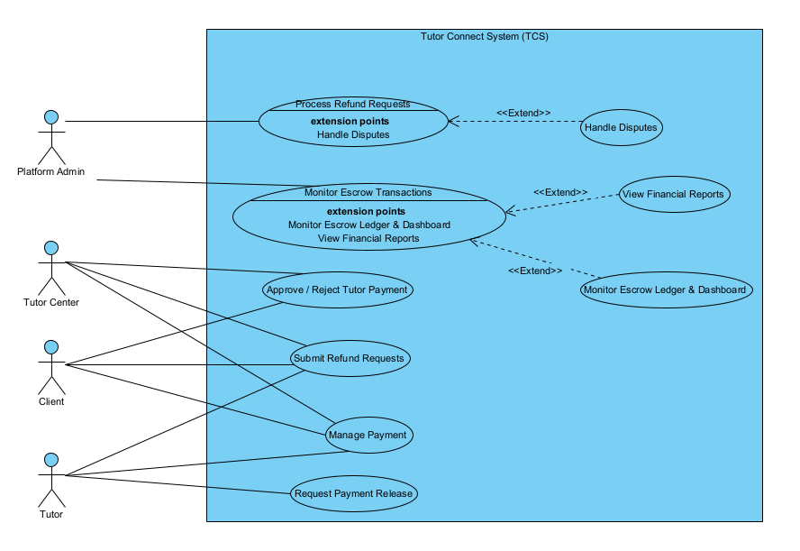
Figure 8. Use Case Diagram for Smart Escrow Wallet & E-Contract Management

7) UCs for Review & Reputation Management
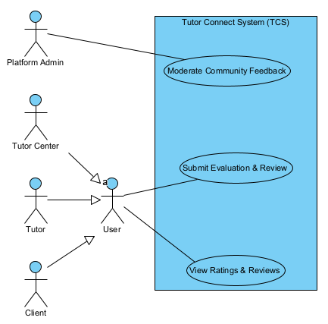
Figure 9. Use Case Diagram for Review & Reputation Management
8) UCs for Administrative Dashboard & Platform Monitoring
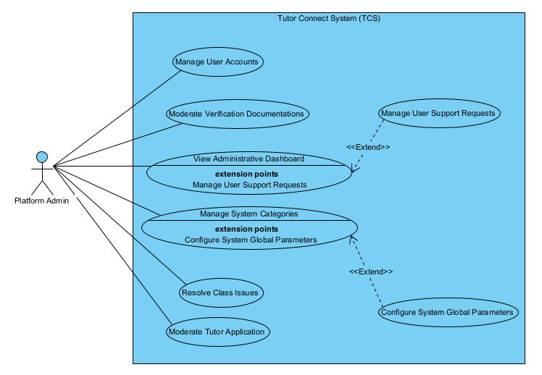
Figure 10. Use Case Diagram for Administrative Dashboard & Platform Monitoring

9) UCs for Intelligent Dynamic Matchmaking Engine
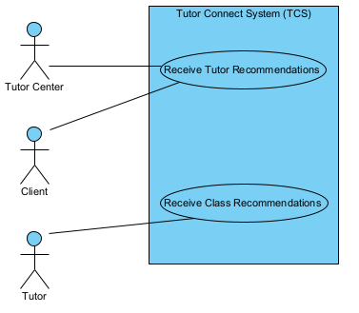
Figure 11. Use Case Diagram for Intelligent Dynamic Matchmaking Engine

10) UCs for AI-Powered FAQ Assistant
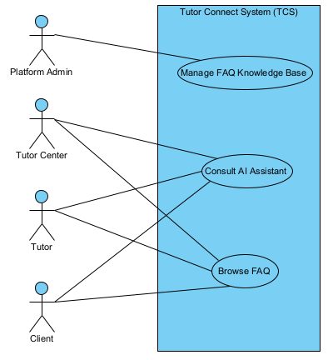
Figure 12. Use Case Diagram for AI-Powered FAQ Assistant

11) UCs for Scheduling & Calendar Management
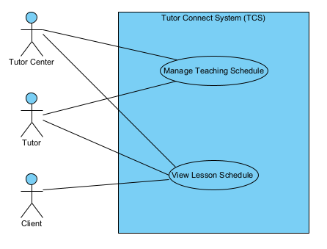
Figure 13. Use Case Diagram for Scheduling & Calendar Management

12) UCs for Social Data Scraping & NLP Lead Generation Engine
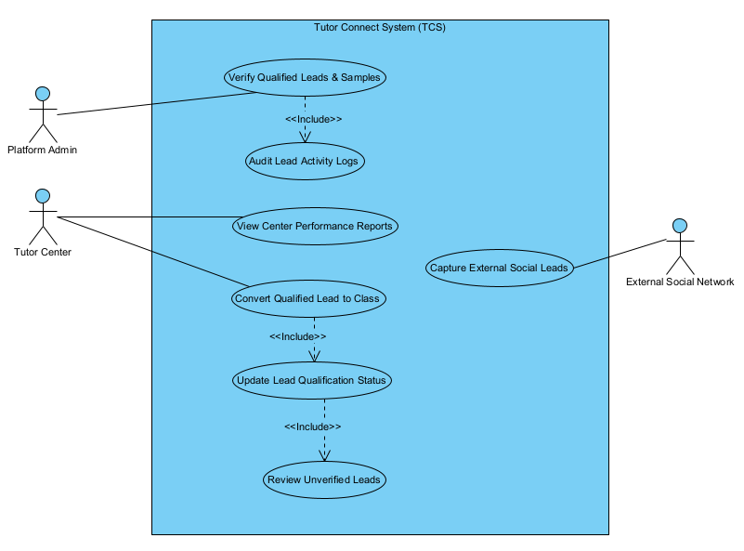
Figure 14. Use Case Diagram for Social Data Scraping & NLP Lead Generation Engine

13) UCs for Smart Lead Deduplication Module
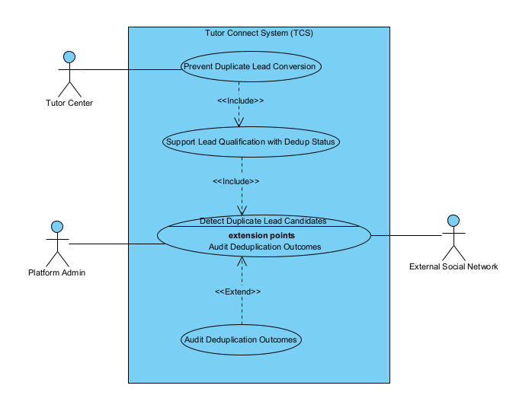
Figure 15. Use Case Diagram for Smart Lead Deduplication Module
14) UCs for Unified Lead & Marketing Automation Integration
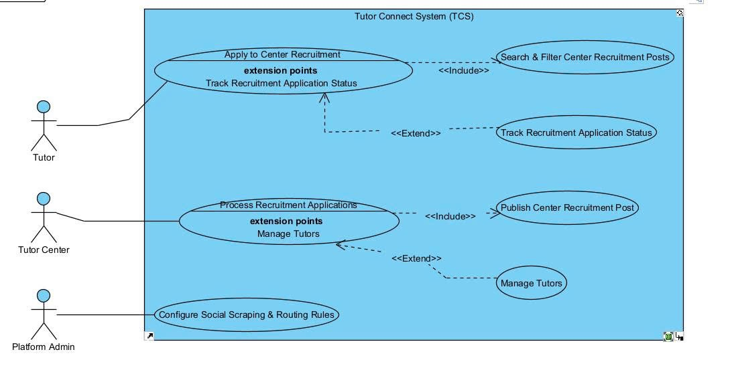
Figure 15. Use Case Diagram for Unified Lead & Marketing Automation Integration

3.4 Use Case Index
UC-ID | Use Case Name | Type | Primary Actor | Description
UC-01 | Register Account | UI | Client, Tutor Center, Tutor | Create a new platform account
UC-02 | Login | UI | Platform Admin, Client, Tutor Center, Tutor | Authenticate and access role-specific workspace
UC-03 | Logout | UI | Platform Admin, Client, Tutor Center, Tutor | End the current session
UC-04 | Reset Password | UI | Platform Admin, Client, Tutor Center, Tutor | Recover account access through reset workflow
UC-05 | Change Password | UI | Platform Admin, Client, Tutor Center, Tutor | Change password while signed in
UC-06 | Manage Personal Profile | UI | Platform Admin, Client, Tutor Center, Tutor | Manage user personal profile information
UC-07 | Manage Class | UI | Client, Tutor Center, Tutor | Create or manage operational class records
UC-08 | View Tutor Applications | UI | Client, Tutor Center | View tutor applications for owned classes
UC-09 | Search & Filter Tutor Applications | UI | Client, Tutor Center | Search and filter tutor applications
UC-10 | View Tutor Public Profile | UI | Client, Tutor Center | View detailed tutor public profile
UC-11 | Confirm Tutor Assignment | UI | Client, Tutor Center | Confirm tutor selection for a class
UC-12 | Confirm / Reject E-Contract | UI | Client, Tutor Center, Tutor | Review and confirm or reject generated e-contract
UC-13 | View Class History | UI | Client, Tutor Center, Tutor | Review past and current class history
UC-14 | View Assigned Classes | UI | Tutor Center | View center-assigned classes
UC-15 | Search & Filter Class | UI | Tutor | Search and filter available classes
UC-16 | View Class Details | UI | Tutor | View detailed class information
UC-17 | Apply To Class | UI | Tutor | Apply to an available class
UC-18 | Manage Applications | UI | Tutor | Manage submitted tutor applications
UC-19 | Resolve Class Issues | UI | Platform Admin | Resolve escalated class issues
UC-20 | Search & Filter Tutor | UI | Client, Tutor Center | Search and filter tutors
UC-21 | Receive Tutor Recommendations | UI | Client, Tutor Center | Receive tutor recommendations
UC-22 | Receive Class Recommendations | UI | Tutor | Receive class recommendations
UC-23 | Consult AI Assistant | UI | Client, Tutor Center, Tutor | Use the AI assistant for help and guidance
UC-24 | Manage Payment | UI | Client, Tutor Center, Tutor | Manage payment and wallet operations
UC-25 | Request Payment Release | UI | Tutor | Request release of escrowed payment
UC-26 | Approve / Reject Tutor Payment | UI | Client, Tutor Center | Approve or reject tutor payment request
UC-27 | Submit Refund Requests | UI | Client, Tutor Center, Tutor | Submit refund request
UC-28 | Process Refund Requests | UI | Platform Admin | Process and decide refund requests
UC-29 | Handle Disputes | UI | Platform Admin | Resolve financial or service disputes
UC-30 | Monitor Escrow Transactions | UI | Platform Admin | Monitor escrow transaction flows
UC-31 | View Financial Reports | UI | Platform Admin | View financial reports and summaries
UC-32 | Manage Teaching Schedule | UI | Tutor, Tutor Center | Create and manage teaching schedules
UC-33 | View Lesson Schedule | UI | Client, Tutor Center, Tutor | View lesson schedule
UC-34 | Chat with Users | UI | Client, Tutor Center, Tutor | Exchange messages with valid counterparties
UC-35 | Submit Evaluation & Review | UI | Client, Tutor Center, Tutor | Submit evaluation and review after class
UC-36 | View Ratings & Reviews | UI | Client, Tutor Center, Tutor | View ratings and reviews
UC-37 | Moderate Community Feedback | UI | Platform Admin | Moderate reviews and community feedback
UC-38 | View Notifications | UI | Client, Tutor Center, Tutor | View notification list
UC-39 | Manage Notifications | UI | Platform Admin | Manage notification dispatch and templates
UC-40 | Review Unverified Leads | UI | Tutor Center | Review captured unverified leads
UC-41 | Update Lead Qualification Status | UI | Tutor Center | Update qualification status of a lead
UC-42 | Convert Qualified Lead to Class | UI | Tutor Center | Convert validated lead into platform class
UC-43 | View Center Performance Reports | UI | Tutor Center | View center performance metrics
UC-44 | Audit Lead Activity Logs | UI | Platform Admin | Audit lead processing and history logs
UC-45 | Verify Qualified Leads & Samples | UI | Platform Admin | Verify qualified leads and samples when required
UC-46 | Capture External Social Leads | API | External Social Network | Ingest public social lead data into the platform
UC-47 | Manage User Accounts | UI | Platform Admin | Create, suspend, reactivate, or administratively manage platform user accounts
UC-48 | Moderate Verification Documentations | UI | Platform Admin | Moderate verification documents and evidence
UC-49 | Moderate Tutor Application | UI | Platform Admin | Moderate tutor application quality or policy issues
UC-50 | Configure Social Scraping & Routing Rules | UI | Platform Admin | Configure lead scraping and routing logic
UC-51 | Monitor Escrow Ledger & Dashboard | UI | Platform Admin | Monitor escrow ledger and finance dashboard
UC-52 | View Administrative Dashboard | UI | Platform Admin | View centralized administrative dashboard
UC-53 | Request Support | UI | Client, Tutor Center, Tutor | Request platform support
UC-54 | Report Users or Class | UI | Client, Tutor Center, Tutor | Report users, classes, or policy violations
UC-55 | Publish Center Recruitment Post | UI | Tutor Center | Publish center-owned tutor recruitment post
UC-56 | Process Recruitment Applications | UI | Tutor Center | Process applications for center recruitment posts
UC-57 | Search & Filter Center Recruitment Posts | UI | Tutor | Search and filter recruitment posts published by centers
UC-58 | Apply to Center Recruitment | UI | Tutor | Apply to a center recruitment post
UC-59 | Track Recruitment Application Status | UI | Tutor | Track status of center recruitment application
UC-60 | Manage Tutors | UI | Tutor Center | Manage internal tutor pool or assigned tutors
UC-61 | Browse FAQ | UI | Client, Tutor Center, Tutor | Browse frequently asked questions
UC-62 | Manage Favorite Tutors | UI | Client, Tutor Center | Add or remove favorite tutors
UC-63 | Manage User Support Requests | UI | Platform Admin | Handle submitted user support requests
UC-64 | Submit Verification Documents | UI | Tutor, Tutor Center | Submit verification documents for review
UC-65 | View Verification Status | UI | Tutor, Tutor Center | View verification result and feedback
UC-66 | Manage System Categories | UI | Platform Admin | Manage controlled category data used across the platform
UC-67 | Manage FAQ Knowledge Base | UI | Platform Admin | Create, update, publish, or retire FAQ knowledge content
UC-68 | Configure System Global Parameters | UI | Platform Admin | Configure global rules, thresholds, and platform-level operational settings

4. Functional Requirements

4.1 Modules & Features
1) Module List
Module | Purpose | Primary Actor(s)
Authentication & RBAC | Secure account lifecycle and access control for all internal roles | Platform Admin, Client, Tutor, Tutor Center
Profile Management & Verification Workflow | WorkflowManage profile data, tutor public profile, favorites, and digital verification workflow | Platform Admin, Client, Tutor, Tutor Center
Unified Tutoring Request & Class Life-cycle Management | Manage classes from direct creation, assignment, contract confirmation, and execution | Client, Tutor Center, Tutor
Advanced Search & Filtering System | Search and filter tutors, classes, applications, and recruitment posts | Client, Tutor Center, Tutor
Internal Messaging & Real-Time Notification | Support user chat, notification viewing, and admin notification control | Platform Admin, Client, Tutor, Tutor Center
Smart Escrow Wallet & E-Contract Management | Manage wallet, escrow, payment release, refunds, e-contract, and finance monitoring | Platform Admin, Client, Tutor, Tutor Center
Review & Reputation Management | Capture evaluations, ratings, and moderated reputation signals | Platform Admin, Client, Tutor, Tutor Center
Administrative Dashboard & Platform Monitoring | Manage dashboards, moderation, verification review, support, and audit operations | Platform Admin
Intelligent Dynamic Matchmaking Engine | Provide weighted recommendation and compatibility guidance for tutors and classes | Client, Tutor, Tutor Center
AI-Powered FAQ Assistant | Provide FAQ browsing, AI consultation support, and admin FAQ knowledge maintenance | Platform Admin, Client, Tutor Center, Tutor
Scheduling & Calendar Management | Manage lesson schedules, teaching slots, and schedule visibility | Client, Tutor Center, Tutor
Social Data Scraping & NLP Lead Generation Engine | Capture, normalize, and route unverified social leads into center workflows | External Social Network, Platform Admin, Tutor Center
Smart Lead Deduplication Module | Reduce duplicate and low-quality lead entries in the CRM funnel | Platform Admin, Tutor Center
Unified Lead & Marketing Automation Integration | Centralize lead ads, chatbot funnels, center recruitment posts, and lead conversion workflows | Platform Admin, Tutor Center, Tutor

2) Module: Authentication & RBAC

FT-ID | Feature | Priority | Description | UC-ID Ref | BF-ID Ref
FT-01 | User registration | Must | New Client, Tutor, or Tutor Center creates a platform account | UC-01 | BF-02
FT-02 | User login | Must | Existing internal user signs in and reaches the correct workspace | UC-02 | BF-02,05
FT-03 | Password recovery | Must | User recovers or changes password through reset workflow and OTP validation | UC-04 ,05 | BF-02
FT-04 | Role-based access control | Must | System routes and protects features based on role and permitted workspace access | UC-02 | BF-02,05
— | Logout session handling | Should | Signed-in user ends the current session safely even though it is not separately tracked in FT sheet | UC-03 | BF-02,05

3) Module: Profile & Verification Workflow

FT-ID | Feature | Priority | Description | UC-ID Ref | BF-ID Ref
FT-05 | Manage user profile | Must | User updates personal profile information and personal account-facing data | UC-06 | BF-02
FT-06 | Tutor credential upload | Must | Tutor uploads verification credentials and academic proof | UC-64 | BF-03
FT-07 | Tutor Center license submission | Must | Tutor Center uploads organization or license verification evidence | UC-64 | BF-03
FT-08 | Verification approval workflow | Must | Platform Admin reviews verification records and system exposes verification status outcomes | UC-48, 65 | BF-03

4) Modules: Unified Tutoring Request & Class Life-cycle Management

FT-ID | Feature | Priority | Description | UC-ID Ref | BF-ID Ref
FT-12 | Tutoring request and class lifecycle | Must | Core class record, tutoring request, and lifecycle creation are managed inside a single class domain | UC-07 | BF-01,04
FT-14 | Apply to class | Must | Tutor applies directly to an available class opportunity | UC-17 | BF-01,02
FT-15 | Manage class status | Must | System supports assignment, lifecycle state transitions, and history visibility | UC-07, 11, 13 | BF-01,04,08
FT-46 | Activity timeline | Should | System records timeline-style class activities and history milestones | UC-13 | BF-08
— | View tutor applications | Should | Request owner reviews tutor applications for an owned class | UC-08, 09 | BF-01
— | View assigned classes | Should | Tutor Center reviews center-assigned classes | UC-14 | BF-01

5) Modules: Advanced Search & Filtering System

FT-ID | Feature | Priority | Description | UC-ID Ref | BF-ID Ref
FT-09 | Search tutors | Must | Client or Tutor Center searches and filters tutor candidates | UC-20 | BF-01
FT-10 | View tutor profile | Must | Client or Tutor Center views detailed tutor public profile | UC-10 | BF-01
FT-11 | Favorite tutor | Could | Client or Tutor Center bookmarks or removes tutor favorites | UC-62 | BF-01
— | Search and filter class | Must | Tutor searches available classes | UC-15 | BF-01,02
— | View class details | Must | Tutor views detailed class information before applying | UC-15 | BF-01,02
— | Search and filter center recruitment posts | Should | Tutor searches center recruitment posts | UC-57 | BF-07

6) Modules: Internal Messaging & Real-Time Notification

FT-ID | Feature | Priority | Description | UC-ID Ref | BF-ID Ref
FT-18 | Internal chat | Must | Client, Tutor Center, and Tutor exchange real-time messages tied to valid business relationships | UC-34 | BF-05,08
FT-19 | Real-time notification | Must | User receives live notifications for relevant system and class events | UC-38 | BF-01,03,04,05,08
FT-45 | Notification center | Should | System offers notification list, management capability, and admin control surfaces | UC-38, 39 | BF-05,08

7) Modules: Smart Escrow Wallet & E-Contract Management

FT-ID | Feature | Priority | Description | UC-ID Ref | BF-ID Ref
FT-24 | Auto contract generation | Must | System generates e-contract artifacts to support contract confirmation flow | UC-12 | BF-04
FT-25 | Escrow deposit | Must | Users initiate and manage escrow deposit transactions | UC-24 | BF-04
FT-26 | Escrow release | Must | Tutor requests release and Client or Tutor Center approves payout release | UC-25, 26 | BF-04
FT-27 | Refund processing | Must | Users submit refund requests and Platform Admin processes refunds | UC-27, 28 | BF-04,05
FT-28 | Dispute submission | Must | Platform Admin handles dispute cases and financial conflict escalations | UC-29 | BF-04,05
FT-39 | Escrow monitoring | Must | Platform Admin reviews escrow dashboard, financial state, and monitoring outputs | UC-51 | BF-04,05
— | Monitor escrow transactions | Should | Platform Admin monitors escrow transactions operationally | UC-30 | BF-04
— | View financial reports | Should | Platform Admin views financial reporting summaries | UC-31 | BF-04,05

8) Modules: Review & Reputation Management

FT-ID | Feature | Priority | Description | UC-ID Ref | BF-ID Ref
FT-29 | Submit review | Must | Eligible user submits evaluation and review after class progress or completion | UC-35 | BF-08
FT-30 | Reputation score calculation | Must | System recalculates tutor reputation score and exposes viewable review results | UC-36 | BF-08

9) Modules: Administrative Dashboard & Platform Monitoring

FT-ID | Feature | Priority | Description | UC-ID Ref | BF-ID Ref
FT-23 | FAQ content management | Should | Platform Admin maintains FAQ content from the admin-side knowledge surface | UC-67 | BF-05
FT-36 | User management | Must | Platform Admin manages user accounts and lifecycle access status | UC-47 | BF-05
FT-37 | Verification management | Must | Platform Admin reviews verification documents and tutor application trust cases | UC-48, 49 | BF-03,05
FT-38 | Complaint management | Must | Platform Admin manages support queues and user complaint handling | UC-63 | BF-05
FT-39 | Escrow monitoring | Must | Platform Admin monitors finance state and escrow dashboard data | UC-51 | BF-04,05
FT-40 | Dashboard analytics | Must | Platform Admin views centralized administrative dashboard and aggregated analytics | UC-52 | BF-05
FT-41 | Audit log | Should | Platform Admin audits administrative lead and activity logs | UC-44 | BF-05,06
FT-42 | Report user | Should | Platform Admin receives and manages reported user or class incidents | UC-54 | BF-05
FT-43 | Block user | Must | Platform Admin blocks or suspends user accounts as part of governance flow | UC-47 | BF-05
FT-47 | System category configuration | Must | Platform Admin manages reusable category and taxonomy configuration | UC-66 | BF-05,06
— | Moderate community feedback | Should | Platform Admin moderates community feedback and review moderation cases | UC-37 | BF-05
— | Resolve class issues | Should | Platform Admin resolves escalated class issues | UC-19 | BF-05
— | Configure system global parameters | Must | Platform Admin manages global platform operational parameters x | UC-68 | BF-05

10) Modules: Intelligent Dynamic Matchmaking Engine
FT-ID | Feature | Priority | Description | UC-ID Ref | BF-ID Ref
FT-16 | Tutor recommendation | Should | Client or Tutor Center receives recommendation suggestions for tutor selection | UC-21 | BF-01
FT-17 | Dynamic weight matching | Must | System applies weighted matching logic for tutors and classes | UC-21, 22 | BF-01,02,08

11) Modules: AI-Powered FAQ Assistant

FT-ID | Feature | Priority | Description | UC-ID Ref | BF-ID Ref
FT-23 | FAQ content management | Should | Platform Admin maintains FAQ knowledge content for user-facing FAQ and support channels | UC-67 | BF-05
— | Use AI support | Could | User consults AI support for guided assistance | UC-23 | BF-05
— | Browse FAQ | Should | User browses FAQ knowledge content | UC-61 | BF-05

l. Modules: Scheduling & Calendar Management

FT-ID | Feature | Priority | Description | UC-ID Ref | BF-ID Ref
FT-20 | Availability management | Should | Tutor or Tutor Center manages available teaching slots and availability states | UC-32 | BF-08
FT-21 | Lesson scheduling | Must | System supports lesson scheduling and lesson calendar visibility | UC-32, 33 | BF-08
FT-22 | Conflict detection | Must | System checks and flags schedule conflicts during lesson planning | UC-32 | BF-08

13) Modules: Social Data Scraping & NLP Lead Generation Engine

FT-ID | Feature | Priority | Description | UC-ID Ref | BF-ID Ref
FT-31 | Facebook lead collection | Must | External social lead capture collects inbound public or social lead data | UC-46 | BF-06
FT-32 | NLP lead extraction | Must | System extracts structured lead information from captured content | UC-41 | BF-06
FT-34 | Lead routing | Must | Tutor Center reviews routed unverified leads and updates qualification status | UC-40, 41 | BF-06
FT-35 | Facebook lead ads integration | Must | Social lead ads or webhook integration pushes lead payloads into the platform | UC-46 | BF-06
FT-41 | Audit log | Should | Platform Admin audits lead activity and assignment history | UC-44 | BF-06
FT-44 | Lead assignment history | Should | Platform Admin reviews historical lead assignment traces | UC-44 | BF-06
— | Verify qualified leads and samples | Should | Platform Admin verifies qualified lead or sample records when required | UC-45 | BF-06
— | View center performance reports | Should | Tutor Center views lead conversion and center performance summaries | UC-43 | BF-06

14) Modules: Smart Lead Deduplication Module

FT-ID | Feature | Priority | Description | UC-ID Ref | BF-ID Ref
FT-33 | Lead deduplication | Must | System identifies duplicate lead candidates before routing or conversion | UC-46 | BF-06
FT-13 | Convert lead to class | Must | Qualified lead conversion respects duplicate prevention and class creation control | UC-42 | BF-06
— | Support lead qualification with deduplicate status | Must | Tutor Center sees duplicate-risk indicators while updating qualification status | UC-41 | BF-06
— | Audit deduplication outcomes | Should | Platform Admin reviews deduplication results and lead quality trail | UC-44, 45 | BF-06

15) Modules: Unified Lead & Marketing Automation Integration

FT-ID | Feature | Priority | Description | UC-ID Ref | BF-ID Ref
— | Configure social scraping & routing rules | Must | Platform Admin configures social lead capture and routing logic | UC-50 | BF-06
— | Publish center recruitment post | Should | Tutor Center publishes recruitment post for tutors | UC-55 | BF-06
— | Process recruitment applications | Must | Tutor Center processes applications for recruitment post | UC-56 | BF-06
— | Search & filter center recruitment posts | Should | Tutor searches center recruitment posts | UC-57 | BF-06
— | Apply to center recruitment | Must | Tutor applies to a center recruitment post | UC-58 | BF-06
— | Track recruitment application status | Should | Tutor tracks recruitment application status | UC-59 | BF-06
— | Manage tutors | Should | Tutor Center manages center tutor pool and assignments | UC-60 | BF-06
FT-13 | Convert lead to class | Must | Tutor Center converts qualified leads into class records through integrated lead-class flow | UC-42 | BF-06
FT-35 | Facebook lead ads integration | Must | Lead ads integration feeds unified lead capture pipeline | UC-46 | BF-06

x. Won't-Have (This Version)
Explicitly exclude features to prevent scope creep and tell Claude Code what NOT to implement.
- Native mobile application
- International payment infrastructure
- Live teaching or virtual classroom integration
- Physical background checks
- Full multilingual support

4.2 Screen Inventory
1) Screen Flow
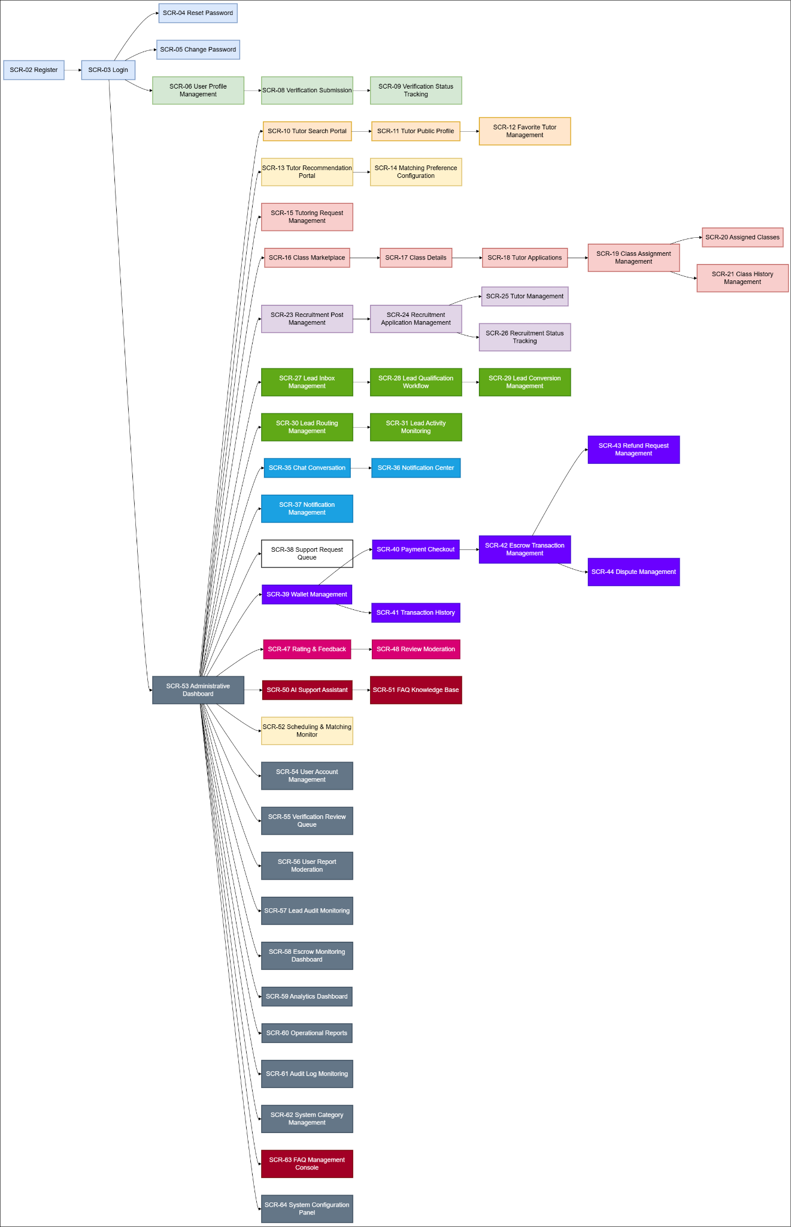
Figure 17. Screen Flow Diagram for Tutor Connect System (TCS)
2) Screen List

SCR-ID | Screen Name | Module | Description | FT-ID | UC-ID
SCR-02 | Register | Authentication & RBAC | Allows new users to create an account and access platform services | FT-01 | UC-01
SCR-03 | Login | Authentication & RBAC | Allows existing internal users to authenticate and enter the correct workspace | FT-02, FT-04 | UC-02
SCR-04 | Reset Password | Authentication & RBAC | Allows users to recover or change password using OTP-based recovery flow | FT-03 | UC-04, UC-05
SCR-05 | Change Password | Authentication & RBAC | Allows signed-in users to change their current password securely | FT-03 | UC-05
SCR-06 | User Profile Management | Profile Management & Verification Workflow | Allows users to view and update personal profile information | FT-05 | UC-06
SCR-08 | Verification Submission | Profile Management & Verification Workflow | Allows Tutors and Tutor Centers to submit verification documents | FT-06, FT-07 | UC-64
SCR-09 | Verification Status Tracking | Profile Management & Verification Workflow | Displays verification review result and approval status | FT-08 | UC-65
SCR-10 | Tutor Search Portal | Advanced Search & Filtering System | Allows Client or Tutor Center to search and filter tutors using platform criteria | FT-09 | UC-20
SCR-11 | Tutor Public Profile | Advanced Search & Filtering System | Displays tutor profile details, qualifications, and public trust signals | FT-10 | UC-10
SCR-12 | Favorite Tutor Management | Advanced Search & Filtering System | Allows Client or Tutor Center to save and manage favorite tutors | FT-11 | UC-62
SCR-13 | Tutor Recommendation Portal | Intelligent Dynamic Matchmaking Engine | Displays tutor recommendation results and matching suggestions | FT-16 | UC-21
SCR-14 | Matching Preference Configuration | Intelligent Dynamic Matchmaking Engine | Displays weighted matching outputs and preference-based matching controls | FT-17 | UC-21, UC-22
SCR-15 | Tutoring Request Management | Unified Tutoring Request & Class Life-cycle Management | Allows Client or Tutor Center to manage tutoring requests and related class lifecycle actions | FT-12 | UC-07
SCR-16 | Class Marketplace | Unified Tutoring Request & Class Life-cycle Management | Allows Tutors to browse available classes and class opportunities | FT-12 | UC-15, UC-16
SCR-17 | Class Details | Unified Tutoring Request & Class Life-cycle Management | Allows Tutor to review class details and apply to the selected class | FT-14 | UC-16, UC-17
SCR-18 | Tutor Applications | Unified Tutoring Request & Class Life-cycle Management | Allows Client, Tutor Center, or Tutor to review application-related information | — | UC-08, UC-18
SCR-19 | Class Assignment Management | Unified Tutoring Request & Class Life-cycle Management | Allows request owners to update assignment decisions and class status transitions | FT-15 | UC-11
SCR-20 | Assigned Classes | Unified Tutoring Request & Class Life-cycle Management | Allows Tutor Center to review classes already assigned within center operations | — | UC-14
SCR-21 | Class History Management | Unified Tutoring Request & Class Life-cycle Management | Displays class activity timeline and history events | FT-15, FT-46 | UC-13
SCR-23 | Recruitment Post Management | Unified Lead & Marketing Automation Integration | Allows Tutor Center to create and manage recruitment posts | — | UC-55
SCR-24 | Recruitment Application Management | Unified Lead & Marketing Automation Integration | Allows Tutor Center to process center recruitment applications | — | UC-56
SCR-25 | Tutor Management | Unified Lead & Marketing Automation Integration | Allows Tutor Center to manage accepted tutors in the center tutor pool | — | UC-60
SCR-26 | Recruitment Status Tracking | Unified Lead & Marketing Automation Integration | Allows Tutor to track center recruitment application status | — | UC-59
SCR-27 | Lead Inbox Management | Social Data Scraping & NLP Lead Generation Engine | Allows Tutor Center to review incoming unverified leads | FT-34 | UC-40
SCR-28 | Lead Qualification Workflow | Social Data Scraping & NLP Lead Generation Engine | Allows Tutor Center to update lead qualification workflow state | FT-34 | UC-41
SCR-29 | Lead Conversion Management | Unified Lead & Marketing Automation Integration | Allows Tutor Center to convert a qualified lead into class workflow | FT-13 | UC-42
SCR-30 | Lead Routing Management | Social Data Scraping & NLP Lead Generation Engine | Allows Platform Admin or Tutor Center to manage lead routing and qualification workflow states | FT-34 | UC-40, UC-41
SCR-31 | Lead Activity Monitoring | Social Data Scraping & NLP Lead Generation Engine | Displays administrative history of lead routing and assignment actions | FT-44 | UC-44
SCR-35 | Chat Conversation | Internal Messaging & Real-Time Notification | Provides real-time messaging between linked users | FT-18 | UC-34
SCR-36 | Notification Center | Internal Messaging & Real-Time Notification | Displays user notifications and real-time event alerts | FT-19, FT-45 | UC-38, UC-39
SCR-37 | Notification Management | Internal Messaging & Real-Time Notification | Allows Platform Admin to manage notification templates and dispatch behavior | FT-45 | UC-39
SCR-38 | Support Request Queue | Administrative Dashboard & Platform Monitoring | Allows Platform Admin to handle support requests and complaint cases | FT-38 | UC-63
SCR-39 | Wallet Management | Smart Escrow Wallet & E-Contract Management | Allows users to initiate and manage wallet and escrow deposit actions | FT-25 | UC-24
SCR-40 | Payment Checkout | Smart Escrow Wallet & E-Contract Management | Displays payment checkout and escrow payment state information | FT-25 | UC-24
SCR-41 | Transaction History | Smart Escrow Wallet & E-Contract Management | Displays transaction history and financial reporting views for relevant users | — | UC-24, UC-31
SCR-42 | Escrow Transaction Management | Smart Escrow Wallet & E-Contract Management | Allows contract confirmation and escrow release workflow | FT-24, FT-26 | UC-12, UC-25, UC-26
SCR-43 | Refund Request Management | Smart Escrow Wallet & E-Contract Management | Allows refund request submission and administrative refund processing | FT-27 | UC-27, UC-28
SCR-44 | Dispute Management | Smart Escrow Wallet & E-Contract Management | Allows dispute submission and dispute case handling | FT-28 | UC-29
SCR-47 | Rating & Feedback | Review & Reputation Management | Allows eligible users to submit evaluation and review records | FT-29 | UC-35
SCR-48 | Review Moderation | Review & Reputation Management | Allows Platform Admin to moderate reviews and community feedback | — | UC-37
SCR-50 | AI Support Assistant | AI-Powered FAQ Assistant | Allows users to interact with AI-guided support assistance | — | UC-23
SCR-51 | FAQ Knowledge Base | AI-Powered FAQ Assistant | Allows users to browse FAQ knowledge content | — | UC-61
SCR-52 | Scheduling & Matching Monitor | Scheduling & Calendar Management | Displays dynamic schedule conflict or advanced matching-related operational views | FT-17, FT-22 | UC-22, UC-32
SCR-53 | Administrative Dashboard | Administrative Dashboard & Platform Monitoring | Displays administrative dashboard analytics and operational summaries | FT-40 | UC-52
SCR-54 | Admin User Accounts | Administrative Dashboard & Platform Monitoring | Allows Platform Admin to manage, suspend, block, or reactivate user accounts | FT-36, FT-43 | UC-47
SCR-55 | Verification Review Queue | Administrative Dashboard & Platform Monitoring | Allows Platform Admin to review verification documentation and tutor application trust records | FT-08, FT-37 | UC-48, UC-49
SCR-56 | Reported User / Class Cases | Administrative Dashboard & Platform Monitoring | Allows Platform Admin to review reported users or class incidents | FT-42 | UC-54
SCR-58 | Escrow Monitoring Dashboard | Administrative Dashboard & Platform Monitoring | Displays finance and escrow monitoring dashboards | FT-39 | UC-51
SCR-59 | Dashboard Analytics | Administrative Dashboard & Platform Monitoring | Displays additional analytical dashboard reporting summaries | FT-40 | UC-52
SCR-61 | Audit Log Viewer | Administrative Dashboard & Platform Monitoring | Allows Platform Admin to audit lead activity and operational history logs | FT-41 | UC-44
SCR-62 | Category Management | Administrative Dashboard & Platform Monitoring | Allows Platform Admin to manage reusable system categories and taxonomy configuration | FT-47 | UC-66
SCR-63 | FAQ Knowledge Management | AI-Powered FAQ Assistant | Allows Platform Admin to create, update, and publish FAQ knowledge content | FT-23 | UC-67
SCR-64 | System Configuration | Administrative Dashboard & Platform Monitoring | Allows Platform Admin to configure global platform operational parameters | — | UC-68

4.3 External API Inventory
Fill details of each external API into the table with the columns and sample data as below
API-ID | API Name | Calling Path | Description
API-01 | SePay API | TCS -> SePay API | Supports wallet, escrow deposit, transfer, refund, and payment status operations
API-02 | Email / SMTP API | TCS -> Email provider | Sends OTPs, alerts, and transactional notifications
API-03 | AI FAQ / Recommendation API | TCS -> AI Service | Supports AI assistant responses and recommendation enrichment where enabled

4.4 Background Job Inventory
Fill details of each background job into the table with the columns and sample data as below
JOB-ID | Job Name | Group | Description | FT-ID | UC-ID
JOB-01 | Expire OTP codes | Scheduled | Marks password reset OTPs as expired after configured lifetime | FT-01 | UC-04
JOB-02 | Dispatch queued notifications | Scheduled / Event-driven | Sends queued system notifications or email notifications | FT-05 | UC-38, 39
JOB-03 | Reconcile escrow status | Scheduled | Syncs escrow and payment states with payment provider | FT-06 | UC-24, 25, 30, 51
JOB-04 | Cleanup obsolete temporary data | Scheduled | Removes expired temporary data such as stale reset tokens if implemented | FT-01 | UC-04
JOB-05 | Process inbound social leads | Scheduled / Event-driven | Normalizes captured social lead payloads and creates unverified lead records | FT-12 | UC-46
JOB-06 | Execute lead deduplication scan | Scheduled | Detects likely duplicate or low-quality leads before routing or conversion | FT-13 | UC-41, 42
JOB-07 | Apply lead routing rules | Scheduled / Event-driven | Assigns new leads to the appropriate center queue based on configured routing rules | FT-14 | UC-50
JOB-08 | Refresh FAQ delivery cache | Scheduled / Event-driven | Republishes or refreshes FAQ knowledge content used by browse FAQ and AI support channels | FT-10 | UC-61, 67
JOB-09 | Apply global configuration changes | Event-driven | Propagates newly saved platform parameters to dependent modules and scheduled processes | FT-08 | UC-68

5. Global Business Rules
Guidance
Rules affecting ≥2 unrelated features go here. Rules for only 1 feature go in UCS BR section. GBR-IDs are sequential (GB-01, GB-02…) and immutable. Rule statement must be precise and testable.

GBR-ID | Rule Statement | Applies To | Rationale | Enforced By | UC-IDs
GB-01 | Verification status must be visible wherever tutor trust is important, including profile and matching views | Tutor profile, tutor search, request evaluation | Supports trust and transparency for clients and tutor centers | System automatically on every relevant view | UC-17, UC-20, UC-35
GB-02 | Chat is allowed only when a valid request, assignment, or class relationship exists between participants | Messaging access | Prevents misuse and spam | System automatically on every chat access request | UC-08
GB-03 | Reviews may only be created by verified class participants after an eligible completion point | Review creation | Preserves review credibility | System automatically on every review submission | UC-14
GB-04 | Escrowed funds may not be released until class completion or equivalent release condition is satisfied | Payments and class lifecycle | Protects both payer and tutor | System automatically on every release action | UC-15, UC-24, UC-25
GB-05 | Verification documents and dispute evidence must never be accessible via public or guessable links | Document and evidence access | Protects sensitive personal information | System automatically on every file access request | UC-20, UC-26
GB-06 | Status transitions for verification, application, escrow, and dispute workflows must follow defined lifecycle rules | Cross-module status management | Prevents inconsistent business state | System automatically on every status update | UC-16, UC-20, UC-24, UC-26
GB-07 | Sensitive sign-in and reset-password failures must not reveal unnecessary account information beyond approved UX messages | Authentication and account recovery | Reduces information leakage to attackers | System automatically on failed auth recovery events | UC-02, UC-04

6. Non-Functional Requirements & Constraints

6.1 Performance Requirements
These values cascade into TDS §9.1 — keep them in sync.

Requirement | Target | Condition
Page load time | Any core page loads within 2 seconds | Under normal academic deployment and moderate concurrent usage
Form submission response | System acknowledges normal form submissions within 2 seconds | Up to 100 users active simultaneously
Maximum simultaneous users | System remains functional for at least 100 simultaneous users | Single server deployment assumption
Chat / notification responsiveness | Real-time updates should appear with minimal noticeable delay | Stable network and supported browser
Verification / payment action response | User receives confirmation quickly after action submission | Third-party API response time may affect final completion

6.2 Security Requirements
State the requirement, not the implementation mechanism. Implementation details → TDS §4.

Requirement | Description
Authentication required | Every internal page and action other than public entry points requires the user to be signed in
Password protection | Passwords must never be stored in readable form
RBAC enforcement | Every protected action must be validated against the user's role and relationship to the target data
Verification file access | Verification and evidence files must be access-controlled on every request
Chat access control | Users may only access chats associated with valid business relationships
Payment integrity | Escrow and refund actions must be traceable and protected from unauthorized access
Auditability | Important admin and financial actions should be traceable in logs or audit records

6.3 Out of Scope
Must be consistent with §3.X Won't-Have list.
- Native iOS / Android application
- International payment infrastructure
- Live virtual classroom integrations such as Zoom / Meet
- Automated social-platform scraping
- Physical background checks
- Full multilingual standards beyond the local release scope

6.4 Technical Assumptions
Things believed true about the operating environment. If an assumption proves false, TDS must be revisited.
- The system is delivered as a responsive web application.
- Front-end uses ReactJS and back-end uses Java Spring Boot.
- Communication between frontend and backend follows RESTful APIs, with WebSocket for real-time features where needed.
- The system uses MySQL 8.0 CE as the main relational database.
- Payment integration is expected to use SePay.
- The platform can use AWS and supporting services such as Firebase as described in the SRS.
- The deployment model for the thesis version is simplified and may run on a single server or tightly coupled environment.

This document defines WHAT the system must do and the rules governing it. For WHY and WHO → Vision & Scope document. For HOW built technically → 02_TDS_{{PROJECT_NAME}}.md. For HOW each feature flows → 03_UCS_{{PROJECT_NAME}}.md.

