**Specifications:**

1. Red LED (1)
2. Yellow LED (1)
3. Green LED (1)
4. 220 Resistors (3)
5. LCD 16 x 2 (1)
6. Push Button Green (1)
7. Push Button Red (1)
8. 4 x 4 Keypad (1)
9. Coin Hopper (1)
10. Dual Channel Relay Breakout Board (1)
11. Raspberry Pi 3 Model B+ (1)
12. SD Card 8GB (1)
13. PSU (Power Supply PC) (1)
14. LED Strip White (1)
15. Conveyor (1)
16. Load Cell Sensor (2)
17. Raspberry Pi Camera (1)
18. Female to Female Connecting Wires
19. Wires
20. Electrical Outlet 4 Slots (1)
21. SPDT Switch (1)

**Block Diagram:**

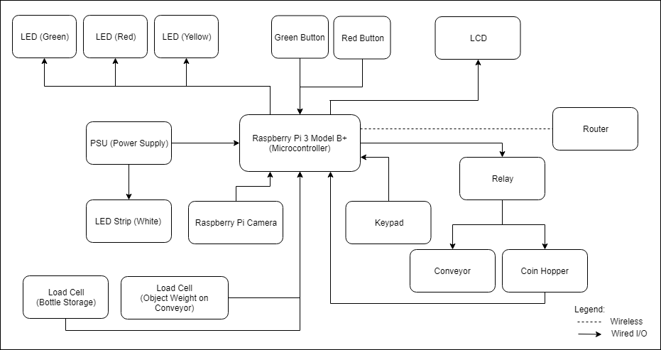

**Flow Chart:**