**TITLE**: GCSE (9-1) Computer Science – NEA Task 1

**INTRODUCTION**:

I am required to make a program that asks the user to sign in or make an account and password and then save it to an external document, I need to allow the user to make a selection of topic and difficulty and then load and setup the correct file which has the answers in, I also need to output the result into another file, and allow Fergus access to these files through his own user profile so he can create reports of each student. The topics I will test with will be Computer Science and

I will need to use abstraction to remove any unnecessary details from the question so there is just the necessary details to complete the question. I will then decompose the question so I know each part of the question and can work on them separately in their own functions and then combine them together in the final program. I also need to make a flow chart that will include all the required steps in the program starting at the beginning sign in all the way to the end where it saves the results of the test. And then, finally I will code the pseudocode so I can fit it all together and then reprogram it in Python.

I am going to use Python to create the program and I will test it with Python’s inbuilt debugger for syntax errors, write test tables to check for logic errors, and use destructive testing to try and break my program and see how it copes with each of my tests to make sure it won’t have any bugs so it runs as intended.

I will use structured programming to make it easier to debug and code by splitting all the main features into functions. This also makes it easier to read and edit at a later data in case I made any mistakes.

I will reference any third party documentation by stating the documents I used at the end of this document.

**SUCCESS CRITERIA**:

|  |  |
| --- | --- |
| **Success Criteria** | **Intended Outcome** |
| Create a unique username and password for each user and store it in an external document. | I will know I have achieved this by checking the document after testing the program a couple times to make sure that there are no data clashes. |
| Allow the student to pick the topic and difficulty they wish to complete. | I will know I have achieved this by using the program and making sure that the correct test loads and at the correct difficulty. |
| Load the questions and answers from a file stored externally to the game. | I will know that I have achieved this by using the program and making sure all the questions and answers appear with some test code which I can uncomment to see. |
| Display the score and grade achieved to the user and saves it to a file. | I will know that I have achieved this by using the program and seeing if this appears and also by checking the file that it will modify. |
| Allow Fergus access to output all the quizzes that have been taken and create reports for each user. | I will know that I have achieved this by creating an admin account for Fergus and running the commands that will do this and making sure that they create the correct files. |

|  |  |
| --- | --- |
| **Local Variables** | **Data Type** |
| **Login** | **Login** |
| userExists | Boolean |
| username | String |
| temp | String |
| userPassword | String |
| passCorrect | Boolean |
| password | String |
| **Signup** | **Signup** |
| name | String |
| age | String |
| x | Boolean |
| year | String |
| rePassword | String |
| count | Integer |
| userProfiles | String |
| writer | String |
| **Quiz** | **Quiz** |
| topicA | String |
| diffA | String |
| ansLoc | Integer |
| userAns | String |
| cs | String |
| question | String |
| ans | String |
| fake | Boolean |
| fake1 | Integer |
| fake2 | Integer |
| fake3 | Integer |
| x | Boolean |
| **Admin** | **Admin** |
| x | Boolean |
| y | String |
| z | String |
| seach | String |
| file | String |
| c | Boolean |
| topScore | Integer |
| count | Integer |
| sum | Integer |
| avg | Real |
| **Main** | **Main** |
| x | Boolean |
| y | Boolean |
| **Global Variables** | **Data Type** |
| username | String |
| userIsAdmin | Boolean |
| score | Integer |
| topic | String |
| diff | String |

Data validation will be in place to make sure the user enters an acceptable password when creating an account, this is to make sure that their password is strong enough so their account won’t be accessed by anyone else. Data validation will also be used when the user is actually completing the quiz to make sure they are only entering a single number that corresponds to their choice so they actually get a mark that corresponds to their ability. Also, it will be used to make sure Fergus uses the function he wants in his admin profile.

**PLAN AND DESIGN:**

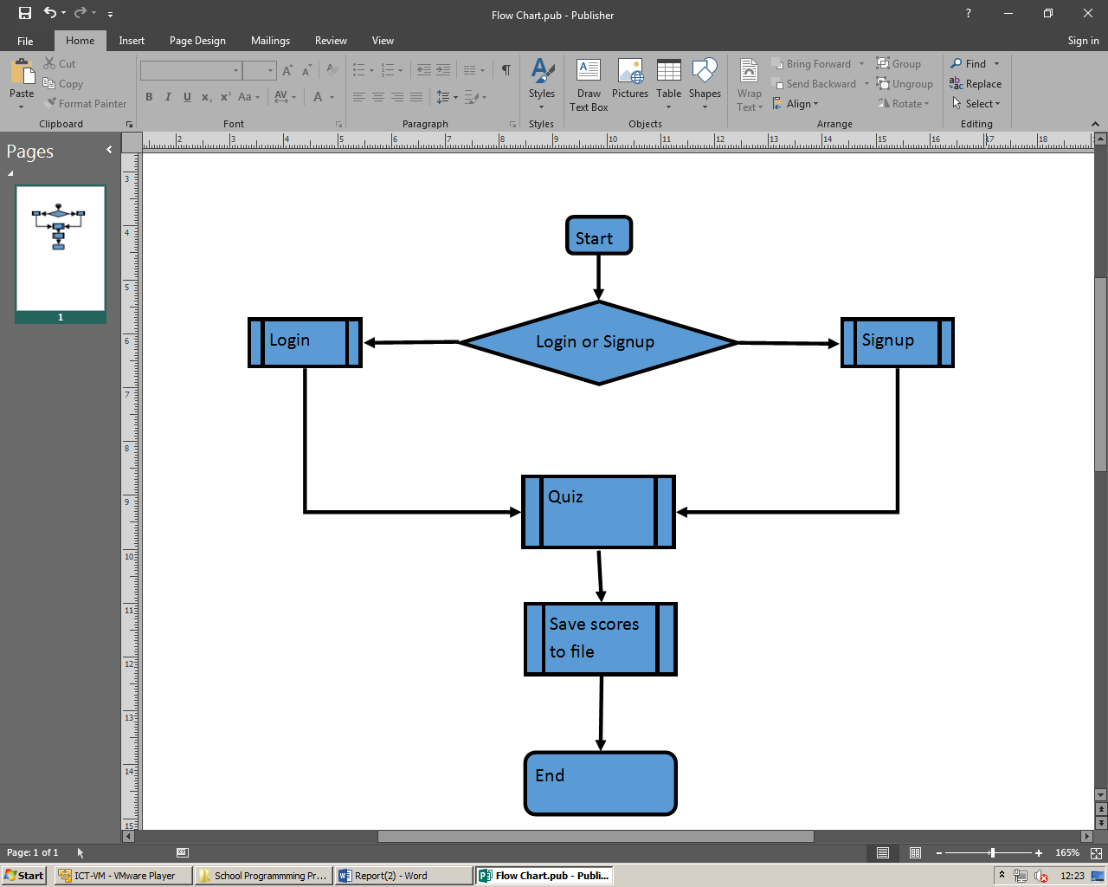

**PSEUDO CODE:**

IMPORT random //imports the functions that generate random numbers

IMPORT csv //imports the function that allows me to open the csv files that store the info for the program to work

//Defining the global variables

GLOABL score //int

GLOBAL userProfiles //csv

GLOBAL userScores //csv

GLOBAL user //string

GLOBAL userIsAdmin //booliean

GLOBAL compSciQuiz //csv

GLOBAL hisQuiz //csv

GLOBAL topic //int

GLOBAL diff //string

FUNCTION loadFiles()

//This code will allow the program access to all the external documents

userProfiles = FILE.OPEN("userProfiles.csv", "append") //Opens 'userProfiles.csv' and sets mode to append

userScores = FILE.OPEN("userScores.csv", "append") //Opens 'userScores.csv' and sets mode to append

compSciQuiz = FILE.OPEN("compSci.csv", "readOnly") //Opens 'compSci.csv' and sets mode to read only

hisQuiz = FILE.OPEN("his.csv", "readOnly") //Open 'his.csv' and sets more to read only

ENDFUNCTION

FUNCTION login()

//This code will allow the user to sign in to a pre-existing account

userExists = FALSE

WHILE userExists = FALSE DO //This makes the next section of code repeat until the user enters a correct username

OUTPUT "Enter your username"

user = INPUT

FOR row IN userProfiles //This goes through the entire csv document and tries to find the user profile

//This code makes sure that the user's account actually exists

//userPassword is a variable here

IF row[0] = user THEN //This checks to see if the user has entered the correct username

OUTPUT "Found user profile"

userPassword = row[1]

userExists = TRUE //This allows the loop to be broken

IF row[3] = Admin THEN //This checks to see if the user is an admin so they can see the users'

userIsAdmin = TRUE

ELSE THEN

userIsAdmin = FALSE

ENDIF

ENDIF

NEXT row

IF userExists = FALSE THEN

OUTPUT "User does not exist, try again"

ENDIF

ENDWHILE

OUTPUT "Please enter your password"

password = INPUT

WHILE password <> userPassword THEN

//This code makes sure that the user enters the correct password

OUTPUT "Wrong password, try again"

password = INPUT

ENDWHILE

OUTPUT "Welcome back "+user

ENDFUNTION

FUNCTION signup()

//This code will allow the user to create a new account so their data is saved

OUTPUT "Please enter your name"

name = INPUT

OUTPUT "Please enter your age"

age = INPUT

WHILE age <> NUMERIC THEN

OUTPUT "Please only enter a number"

age = INPUT

ENDWHILE

OUTPUT "Please enter your password"

pswdScore = 0

WHILE pswdScore < 5 THEN

//This is code to check the password to make sure its strong enough

//8 characters, a number, an upper and lower, a symbol

ENDWHILE

ENDFUNTION

FUNCTION quiz()

//This is the main quiz code, It will allow the user to select a topic and difficulty and complete it

score = 0

OUTPUT "Would you like to do computer science (1) or history (2)?"

topic = INPUT

WHILE topic <> 1 OR topic <> 2 THEN

OUPUT "Only enter either 1 or 2"

topic = INPUT

ENDWHILE

OUTPUT "Would you like to play in easy (e), medium (m) or hard (h)?"

diff = INPUT

WHILE topic <> e OR topic <> m OR topic <> h THEN

OUTPUT "Only enter either e, m or h"

diff = INPUT

ENDWHILE

IF topic = 1 THEN

OUTPUT "Computer Science"

FOR row IN compSciQuiz DO

question = row[0]

ans = row[1]

IF diff = e THEN

OUTPUT question

ansLoc = RANDOM.RANDINT(1, 2)

IF ansLoc = 1 THEN

OUTPUT "1."+ans

OUTPUT "2."+row[RANDOM.RANDINT(2, 4)]

userAns = ''

WHILE userAns <> 1 OR userAns <> 2 THEN

OUTPUT "Enter the number of your choice"

userAns = INPUT

ENDWHILE

ELSE THEN

OUTPUT "1."+row[RANDOM.RANDINT(2, 4)]

OUTPUT "2."+ans

userAns = ''

WHILE userAns <> 1 OR userAns <> 2 THEN

OUTPUT "Enter the number of your choice

userAns = INPUT

ENDWHILE

ENDIF

IF ansLoc = userAns THEN

score = score + 1

OUTPUT "Correct!"

ELSE THEN

OUTPUT "Incorrect"

ENDIF

ELSEIF diff = m THEN

OUTPUT question

ansLoc = RANDOM.RANDINT(1, 3)

IF ansLoc = 1 THEN

OUTPUT "1."+ans

OUTPUT "2."+row[2]

OUTPUT "3."+row[4]

userAns = ''

WHILE userAns <> 1 OR userAns <> 2 OR userAns <> 3 THEN

OUTPUT "Enter the number of your choice"

userAns = INPUT

ENDWHILE

ELSEIF ansLoc = 1 THEN

OUTPUT "1."+row[2]

OUTPUT "2."+ans

OUTPUT "3."+row[4]

userAns = ''

WHILE userAns <> 1 OR userAns <> 2 OR userAns <> 3 THEN

OUTPUT "Enter the number of your choice"

userAns = INPUT

ENDWHILE

ELSE THEN

OUTPUT "1."+row[2]

OUTPUT "2."+row[4]

OUTPUT "3."+ans

userAns = ''

WHILE userAns <> 1 OR userAns <> 2 OR userAns <> 3 THEN

OUTPUT "Enter the number of your choice"

userAns = INPUT

ENDWHILE

ENDIF

IF ansLoc = userAns THEN

score = score +1

OUTPUT "Correct!"

ELSE THEN

OUTPUT "Incorrect"

ENDIF

ELSEIF diff = h THEN

OUTPUT question

ansLoc = RANDOM.RANDINT(1, 4)

IF ansLoc = 1 THEN

OUTPUT "1."+ans

OUTPUT "2."+row[2]

OUTPUT "3."+row[4]

OUTPUT "4."+row[3]

userAns = ''

WHILE userAns <> 1 OR " <> 2 OR " <> 3 OR " <> 4 THEN

OUTPUT "Enter the number of your choice"

userAns = INPUT

ENDWHILE

ELSEIF ansLoc = 2 THEN

OUTPUT "1."+row[2]

OUTPUT "2."+ans

OUTPUT "3."+row[4]

OUTPUT "4."+row[3]

userAns = ''

WHILE userAns <> 1 OR " <> 2 OR " <> 3 OR " <> 4 THEN

OUTPUT "Enter the number of your choice"

userAns = INPUT

ENDWHILE

ELSEIF ansLoc = 3 THEN

OUTPUT "1."+row[2]

OUTPUT "2."+row[4]

OUTPUT "3."+ans

OUTPUT "4."+row[3]

userAns = ''

WHILE userAns <> 1 OR " <> 2 OR " <> 3 OR " <> 4 THEN

OUTPUT "Enter the number of your choice"

userAns = INPUT

ENDWHILE

ELSEIF ansLoc = 4 THEN

OUTPUT "1."+row[2]

OUTPUT "2."+row[4]

OUTPUT "3."+row[3]

OUTPUT "4."+ans

userAns = ''

WHILE userAns <> 1 OR " <> 2 OR " <> 3 OR " <> 4 THEN

OUTPUT "Enter the number of your choice"

userAns = INPUT

ENDWHILE

ENDIF

IF ansLoc = userAns THEN

score = score + 1

OUTPUT "Correct!"

ELSE THEN

OUTPUT "Incorrect"

ENDIF

ENDIF

NEXT row

ENDIF

IF topic = 2 THEN

OUTPUT "History"

FOR row IN hisQuiz DO

question = row[0]

ans = row[1]

IF diff = e THEN

OUTPUT question

ansLoc = RANDOM.RANDINT(1, 2)

IF ansLoc = 1 THEN

OUTPUT "1."+ans

OUTPUT "2."+row[RANDOM.RANDINT(2, 4)]

userAns = ''

WHILE userAns <> 1 OR userAns <> 2 THEN

OUTPUT "Enter the number of your choice"

userAns = INPUT

ENDWHILE

ELSE THEN

OUTPUT "1."+row[RANDOM.RANDINT(2, 4)]

OUTPUT "2."+ans

userAns = ''

WHILE userAns <> 1 OR userAns <> 2 THEN

OUTPUT "Enter the number of your choice

userAns = INPUT

ENDWHILE

ENDIF

IF ansLoc = userAns THEN

score = score + 1

OUTPUT "Correct!"

ELSE THEN

OUTPUT "Incorrect"

ENDIF

ELSEIF diff = m THEN

OUTPUT question

ansLoc = RANDOM.RANDINT(1, 3)

IF ansLoc = 1 THEN

OUTPUT "1."+ans

OUTPUT "2."+row[2]

OUTPUT "3."+row[4]

userAns = ''

WHILE userAns <> 1 OR userAns <> 2 OR userAns <> 3 THEN

OUTPUT "Enter the number of your choice"

userAns = INPUT

ENDWHILE

ELSEIF ansLoc = 1 THEN

OUTPUT "1."+row[2]

OUTPUT "2."+ans

OUTPUT "3."+row[4]

userAns = ''

WHILE userAns <> 1 OR userAns <> 2 OR userAns <> 3 THEN

OUTPUT "Enter the number of your choice"

userAns = INPUT

ENDWHILE

ELSE THEN

OUTPUT "1."+row[2]

OUTPUT "2."+row[4]

OUTPUT "3."+ans

userAns = ''

WHILE userAns <> 1 OR userAns <> 2 OR userAns <> 3 THEN

OUTPUT "Enter the number of your choice"

userAns = INPUT

ENDWHILE

ENDIF

IF ansLoc = userAns THEN

score = score +1

OUTPUT "Correct!"

ELSE THEN

OUTPUT "Incorrect"

ENDIF

ELSEIF diff = h THEN

OUTPUT question

ansLoc = RANDOM.RANDINT(1, 4)

IF ansLoc = 1 THEN

OUTPUT "1."+ans

OUTPUT "2."+row[2]

OUTPUT "3."+row[4]

OUTPUT "4."+row[3]

userAns = ''

WHILE userAns <> 1 OR " <> 2 OR " <> 3 OR " <> 4 THEN

OUTPUT "Enter the number of your choice"

userAns = INPUT

ENDWHILE

ELSEIF ansLoc = 2 THEN

OUTPUT "1."+row[2]

OUTPUT "2."+ans

OUTPUT "3."+row[4]

OUTPUT "4."+row[3]

userAns = ''

WHILE userAns <> 1 OR " <> 2 OR " <> 3 OR " <> 4 THEN

OUTPUT "Enter the number of your choice"

userAns = INPUT

ENDWHILE

ELSEIF ansLoc = 3 THEN

OUTPUT "1."+row[2]

OUTPUT "2."+row[4]

OUTPUT "3."+ans

OUTPUT "4."+row[3]

userAns = ''

WHILE userAns <> 1 OR " <> 2 OR " <> 3 OR " <> 4 THEN

OUTPUT "Enter the number of your choice"

userAns = INPUT

ENDWHILE

ELSEIF ansLoc = 4 THEN

OUTPUT "1."+row[2]

OUTPUT "2."+row[4]

OUTPUT "3."+row[3]

OUTPUT "4."+ans

userAns = ''

WHILE userAns <> 1 OR " <> 2 OR " <> 3 OR " <> 4 THEN

OUTPUT "Enter the number of your choice"

userAns = INPUT

ENDWHILE

ENDIF

IF ansLoc = userAns THEN

score = score + 1

OUTPUT "Correct!"

ELSE THEN

OUTPUT "Incorrect"

ENDIF

ENDIF

NEXT row

ENDIF

ENDFUNTION

FUNCTION admin()

//This code will allow Fergus access to the results of each user and allow him to make reports

x = TRUE

WHILE x = TRUE DO

OUTPUT "What do you want to do?"

OUTPUT "1. Report on a user"

OUTPUT "2. High scores"

OUTPUT "3. Averages"

OUTPUT "4. Exit"

y = INPUT

IF y = 1 THEN

OUTPUT "Enter the username of the user you want a report of"

z = 1

count = 1

userSearch = INPUT

FOR row IN userScores DO

IF row[0] = userSearch THEN

OUTPUT "Quiz"+count

OUTPUT "Topic:"+row[1]

OUTPUT "Difficulty:"+row[2]

OUTPUT "Score:"+row[3]+"/5"

count = count + 1

ENDIF

NEXT row

ENDIF

IF y = 2 THEN

OUTPUT "Enter the topic you want high scores from"

OUTPUT "1. CompSci"

OUTPUT "2. His"

topicSearch = INPUT

WHILE topicSearch <> 1 OR topicSearch <> 2 DO

OUTPUT "Try again"

topicSearch = INPUT

ENDWHILE

ENDIF

ENDWHILE

ENDFUNTION

FUNCTION saveData()

//This code will save the user's score to a seperate file

//globalVars user, score, diff, topic

temp = user+','+topic+','+diff+','+score

FILE.APPEND(temp)

ENDFUNTION

FUNCTION main()

//This is the main code that the program will run and it calls all the other functions in the right order

loadFiles()

LoginOrSignup = 0

WHILE LoginOrSignup <> (1 OR 2)

OUTPUT "Would you like to login (1) or create a new account (2)"

LoginOrSignup = INPUT

IF LoginOrSignup = 1 THEN //The user wants to login

login()

ELSEIF LoginOrSignup = 2 THEN //The user wants to make a new account

signup()

ELSE THEN

OUTPUT "Please enter either 1 or 2"

ENDIF

ENDWHILE

IF userIsAdmin = FALSE THEN

quiz()

saveData()

ELSE THEN

admin()

ENDIF

OUTPUT "Thank you for completing the quiz"

FILE.CLOSE(userProfiles)

FILE.CLOSE(userScores)

FILE.CLOSE(compSciQuiz)

FILE.CLOSE(hisQuiz)

ENDFUNTION

main()

INPUT "Press any key to end the program"

In the login section, username and password need to be tested. This could be done with correct and incorrect data and the data of another user. Then in the signup, age, year and password need to be tested. This can be done the same as before. Then in the quiz, the topic, difficulty and answers can all be tested the same. And the admin selection can be tested the same as well.

**DEVELOPMENT**:

**PYTHON CODE:**

#Python code for NEA

import random #imports the random class

import csv #imports the csv class

import os #imports the os class

#setting the global variables

username = '' #The variable that will store the user's username

userIsAdmin = False #This is used in main, it is used to give access to the admin commands

score = 0 #This is the score variable

topic = '' #This saves what topic the user is currently doing

diff = '' #This saves what Difficulty the user is currently doing

def login():

#This code allows the user to login to a pre-existing account

global username #Calling the golbal variables to edit

global userIsAdmin

print("Login")

userExists = False #This variable is used to stop the while loop

while userExists == False:

print("Enter your username")

username = input()

with open('userProfiles.csv', 'r') as csvfile: #Opens the file that stores the user data

cs = csv.reader(csvfile, delimiter = ',')

for row in cs: #for every row in the file

if username == row[0]: #it checks to see if the username

print("User Found") #the user entered matches an

userExists = True #existing user

userPassword = row[1]

if row[3] == 'Admin': #This checks to see if the user is an admin or not and changes the value accordingly

userIsAdmin = True

if userExists == False: #This code gets ran if it cannot find the user in the file

print("User does not exist, try again")

passCorrect = False #This cariable is used to stop the while loop

while passCorrect != True:

print("Enter your password")

password = input()

if password == userPassword: #This checks to see if the password the user entered matches the one on the file

print("Correct Password")

passCorrect = True

else:

print("Incorrect Password, Try again")

print("Welcome back", username)

def signup(): #This is ran to setup a user profile

global username #Calls the global variable

print("Signup")

print("Enter your name")

name = input() #Asks for their name to make the username from

print("Enter your age")

age = input() #Asks for their age to make the username from

x = True #This variable is used to stop the while loop

while x == True:

if age.isnumeric(): #This stops the loop when the user only enters a number and nothing else

x = False

else:

print("Only enter a number") #data validation

print("Enter your age") #This makes sure the value will have the right format

age = input()

x = True #This variable is used to stop the while loop

while x == True:

print("Enter your year number (e.g. '10' or '11')")

year = input()

if age.isnumeric(): #data validation

x = False

else:

print("Only enter a number") #Makes sure the year is imputted correctly

x = True #This variable is used to stop the while loop

while x == True:

print("Enter your password")

password = input()

print("Re-Enter your password")

rePassword = input()

if password == rePassword: #data validation

print("The passwords match") #Checks to make sure the user entered the correct password

x = False

else:

print("The passwords do not match")

count = 0 #This is used to make sure the right number of characters are in the username

for i in name:

if count < 3:

username = username + i #This adds the letters to the username

count = count + 1 #Increases the count so the right number of characters are in the username

username = username + age #Adds the age to the username so it is properly formatted eg Kie14

print("Your username is: ", username)

with open('userProfiles.csv', 'a', newline = '') as csvfile: #Opens the csv file to save the new user profile

writer = csv.writer(csvfile, delimiter = ',')

writer.writerow([username, password, name, year, age]) #Writes all the required data to the file

def quiz():

global score #Calls all the globals

global topic

global diff

print("Would you like to do computer science (1) or history (2)?")

topicA = True #This variable is used to stop the while loop

while topicA == True: #data validation

topic = input()

if topic == '1':

topic = 'CompSci' #Sets the topic variable to the right value for later on in hte program

topicA = False

elif topic == '2':

topic = 'His'

topicA = False

else:

print("Only enter 1 or 2")

topic = input()

print("Would you like to play in easy (1), medium (2) or hard (3)?")

diffA = True #This variable is used to stop the while loop

while diffA == True:

diff = input() #Sets the difficulty the user wants to take the quiz in

if diff == '1':

diffA = False

elif diff == '2':

diffA = False

elif diff == '3':

diffA = False

else:

print("Only enter 1, 2 or 3")

diff = input()

ansLoc = 0 #The answer location variable is defined here as python didn't like it getting defined later on in the program

userAns = '' #The saame problem as the last one

if topic == 'CompSci': #This is ran if the user wants to do the computer science quiz

print("Computer Science")

with open('compSci.csv', 'r') as csvfile: #Opens the quiz file

cs = csv.reader(csvfile, delimiter = ',')

for row in cs: #The loop for the quiz

question = row[0] #This sets the question to a variable because question is easier to remember than 'row[0]'

ans = row[1] #This was for the same reason but with 'row[1]'

if diff == '1': #This code is ran if the user wants to do the quiz on the easiest difficulty

print(question)

ansLoc = random.randint(1, 2) #This randomly places the answer in so the answer list is unique almost every time

fake = True #This variable is used to stop the while loop

while fake == True:

fake1 = random.randint(2, 4) #This code randomly sets the position of the fake answers

fake2 = random.randint(2, 4)

fake3 = random.randint(2, 4)

if fake1 != fake2 and fake1 != fake3 and fake2 != fake3: #This makes sure that all the fake answers are unique positions

fake = False

if ansLoc == 1: #This is ran if the answer is in the first position

print("1. ", ans)

print("2. ", row[fake1])

x = True #This variable is used to stop the while loop

while x == True:

print("Enter the number of your choice")

userAns = input()

if userAns == '1': #data validation

x = False

elif userAns == '2':

x = False

else:

print("Only enter the number of your choice")

elif ansLoc == 2: #This is ran if the answer is in the second position

print("1. ", row[fake1])

print("2. ", ans)

x = True

while x == True:

print("Enter the number of your choice")

userAns = input()

if userAns == '1':

x = False

elif userAns == '2':

x = False

else:

print("Only enter the number of your choice")

ansLoc = str(ansLoc) #This changes the answer location to a string so it is comparable to

if ansLoc == userAns: #the user answer variable because you can't compare an int to a string

score = score+1 #If the user was correct it increments the score

print("Correct")

else:

print("Incorrect")

elif diff == '2': #This is the code ran for the medium difficulty, refer to the first section as its all the same

print(question)

ansLoc = random.randint(1, 3)

fake = True

while fake == True:

fake1 = random.randint(2, 4)

fake2 = random.randint(2, 4)

fake3 = random.randint(2, 4)

if fake1 != fake2 and fake1 != fake3 and fake2 != fake3:

fake = False

if ansLoc == 1:

print("1. ", ans)

print("2. ", row[fake1])

print("3. ", row[fake2])

x = True

while x == True:

print("Enter the number of your choice")

userAns = input()

if userAns == '1':

x = False

elif userAns == '2':

x = False

elif userAns == '3':

x = False

else:

print("Only enter the number of your choice")

elif ansLoc == 2:

print("1. ", row[fake1])

print("2. ", ans)

print("3. ", row[fake2])

x = True

while x == True:

print("Enter the number of your choice")

userAns = input()

if userAns == '1':

x = False

elif userAns == '2':

x = False

elif userAns == '3':

x = False

else:

print("Only enter the number of your choice")

elif ansLoc == 3:

print("1. ", row[fake1])

print("2. ", row[fake2])

print("3. ", ans)

x = True

while x == True:

print("Enter the number of your choice")

userAns = input()

if userAns == '1':

x = False

elif userAns == '2':

x = False

elif userAns == '3':

x = False

else:

print("Only enter the number of your choice")

ansLoc = str(ansLoc)

if ansLoc == userAns:

score = score+1

print("Correct")

else:

print("Incorrect")

elif diff == '3':

print(question)

ansLoc = random.randint(1, 4)

fake = True

while fake == True:

fake1 = random.randint(2, 4)

fake2 = random.randint(2, 4)

fake3 = random.randint(2, 4)

if fake1 != fake2 and fake1 != fake3 and fake2 != fake3:

fake = False

if ansLoc == 1:

print("1. ", ans)

print("2. ", row[fake1])

print("3. ", row[fake2])

print("4. ", row[fake3])

x = True

while x == True:

print("Enter the number of your choice")

userAns = input()

if userAns == '1':

x = False

elif userAns == '2':

x = False

elif userAns == '3':

x = False

elif userAns == '4':

x = False

else:

print("Only enter the number of your choice")

elif ansLoc == 2:

print("1. ", row[fake1])

print("2. ", ans)

print("3. ", row[fake2])

print("4. ", row[fake3])

x = True

while x == True:

print("Enter the number of your choice")

userAns = input()

if userAns == '1':

x = False

elif userAns == '2':

x = False

elif userAns == '3':

x = False

elif userAns == '4':

x = False

else:

print("Only enter the number of your choice")

elif ansLoc == 3:

print("1. ", row[fake1])

print("2. ", row[fake2])

print("3. ", ans)

print("4. ", row[fake3])

x = True

while x == True:

print("Enter the number of your choice")

userAns = input()

if userAns == '1':

x = False

elif userAns == '2':

x = False

elif userAns == '3':

x = False

elif userAns == '4':

x = False

else:

print("Only enter the number of your choice")

elif ansLoc == 4:

print("1. ", row[fake1])

print("2. ", row[fake2])

print("3. ", row[fake3])

print("4. ", ans)

x = True

while x == True:

print("Enter the number of your choice")

userAns = input()

if userAns == '1':

x = False

elif userAns == '2':

x = False

elif userAns == '3':

x = False

elif userAns == '4':

x = False

else:

print("Only enter the number of your choice")

ansLoc = str(ansLoc)

if ansLoc == userAns:

score = score+1

print("Correct")

else:

print("Incorrect")

elif topic == 'His': #This is ran if the user wants to take the history quiz

print("History")

with open('his.csv', 'r') as csvfile: #This opens the history quiz file

cs = csv.reader(csvfile, delimiter = ',') #refer to the first section as its all the same

for row in cs:

question = row[0]

ans = row[1]

if diff == '1':

print(question)

ansLoc = random.randint(1, 2)

fake = True

while fake == True:

fake1 = random.randint(2, 4)

fake2 = random.randint(2, 4)

fake3 = random.randint(2, 4)

if fake1 != fake2 and fake1 != fake3 and fake2 != fake3:

fake = False

if ansLoc == 1:

print("1. ", ans)

print("2. ", row[fake1])

x = True

while x == True:

print("Enter the number of your choice")

userAns = input()

if userAns == '1':

x = False

elif userAns == '2':

x = False

else:

print("Only enter the number of your choice")

elif ansLoc == 2:

print("1. ", row[fake1])

print("2. ", ans)

x = True

while x == True:

print("Enter the number of your choice")

userAns = input()

if userAns == '1':

x = False

elif userAns == '2':

x = False

else:

print("Only enter the number of your choice")

ansLoc = str(ansLoc)

if ansLoc == userAns:

score = score+1

print("Correct")

else:

print("Incorrect")

elif diff == '2':

print(question)

ansLoc = random.randint(1, 3)

fake = True

while fake == True:

fake1 = random.randint(2, 4)

fake2 = random.randint(2, 4)

fake3 = random.randint(2, 4)

if fake1 != fake2 and fake1 != fake3 and fake2 != fake3:

fake = False

if ansLoc == 1:

print("1. ", ans)

print("2. ", row[fake1])

print("3. ", row[fake2])

x = True

while x == True:

print("Enter the number of your choice")

userAns = input()

if userAns == '1':

x = False

elif userAns == '2':

x = False

elif userAns == '3':

x = False

else:

print("Only enter the number of your choice")

elif ansLoc == 2:

print("1. ", row[fake1])

print("2. ", ans)

print("3. ", row[fake2])

x = True

while x == True:

print("Enter the number of your choice")

userAns = input()

if userAns == '1':

x = False

elif userAns == '2':

x = False

elif userAns == '3':

x = False

else:

print("Only enter the number of your choice")

elif ansLoc == 3:

print("1. ", row[fake1])

print("2. ", row[fake2])

print("3. ", ans)

x = True

while x == True:

print("Enter the number of your choice")

userAns = input()

if userAns == '1':

x = False

elif userAns == '2':

x = False

elif userAns == '3':

x = False

else:

print("Only enter the number of your choice")

ansLoc = str(ansLoc)

if ansLoc == userAns:

score = score+1

print("Correct")

else:

print("Incorrect")

elif diff == '3':

print(question)

ansLoc = random.randint(1, 4)

fake = True

while fake == True:

fake1 = random.randint(2, 4)

fake2 = random.randint(2, 4)

fake3 = random.randint(2, 4)

if fake1 != fake2 and fake1 != fake3 and fake2 != fake3:

fake = False

if ansLoc == 1:

print("1. ", ans)

print("2. ", row[fake1])

print("3. ", row[fake2])

print("4. ", row[fake3])

x = True

while x == True:

print("Enter the number of your choice")

userAns = input()

if userAns == '1':

x = False

elif userAns == '2':

x = False

elif userAns == '3':

x = False

elif userAns == '4':

x = False

else:

print("Only enter the number of your choice")

elif ansLoc == 2:

print("1. ", row[fake1])

print("2. ", ans)

print("3. ", row[fake2])

print("4. ", row[fake3])

x = True

while x == True:

print("Enter the number of your choice")

userAns = input()

if userAns == '1':

x = False

elif userAns == '2':

x = False

elif userAns == '3':

x = False

elif userAns == '4':

x = False

else:

print("Only enter the number of your choice")

elif ansLoc == 3:

print("1. ", row[fake1])

print("2. ", row[fake2])

print("3. ", ans)

print("4. ", row[fake3])

x = True

while x == True:

print("Enter the number of your choice")

userAns = input()

if userAns == '1':

x = False

elif userAns == '2':

x = False

elif userAns == '3':

x = False

elif userAns == '4':

x = False

else:

print("Only enter the number of your choice")

elif ansLoc == 4:

print("1. ", row[fake1])

print("2. ", row[fake2])

print("3. ", row[fake3])

print("4. ", ans)

x = True

while x == True:

print("Enter the number of your choice")

userAns = input()

if userAns == '1':

x = False

elif userAns == '2':

x = False

elif userAns == '3':

x = False

elif userAns == '4':

x = False

else:

print("Only enter the number of your choice")

ansLoc = str(ansLoc)

if ansLoc == userAns:

score = score+1

print("Correct")

else:

print("Incorrect")

print("You scored ",score,"/5") #This prints the score so the user can see how well they did

percent = score/5

percent = percent*100

print("Your percentage was ",percent,"%")

if score == 5:

print("You got an A")

elif score == 4:

print("You got a B")

elif score == 3:

print("You got a C")

elif score == 2:

print("You got a D")

elif score == 1:

print("You got an F")

if diff == '1': #This changes the difficulty variable for later use in the program

diff = 'Easy'

elif diff == '2':

diff = 'Medium'

elif diff == '3':

diff = 'Hard'

def admin(): #This code is ran when Fergus goes on his account

x = True

while x == True:

print("""Would you like to:

1. Create a report for a student

2. Find the best mark for a topic

3. Find the average for a topic

4. Exit

Enter the number of your choice""")

y = input()

while y.isnumeric() == False: #data validation

print("Only enter the number of your choice")

y = input()

if y == '1':

print("Enter the name of the student you want a report of") #This allows Fergus to make reports on any student

z = input()

with open('userScores.csv', 'r') as csvfile:

search = csv.reader(csvfile, delimiter = ',')

os.remove(z+'.txt') #This deletes any previous files that were made for that student so it doesnt create duplicata data

for row in search: #This scans the file for any results by the student he wishes to search for

if row[0] == z:

print("Found Test Results")

print("Writing To File")

file = open(z+'.txt', 'a') #Opens the file

file.write("Topic: "+row[1]) #Writes the topic

file.write("\nDifficulty: "+row[2]) #Writes the difficulty

file.write("\nScore: "+row[3]+"/5\n\n") #Writes the score

file.close() #Closes the file

print("Finished Writing, Continuing Search")

print("File Creation Complete")

print("Check "+z+".txt for the report")

elif y == '2': #This is used if Fergus wants the top scorers for a set topic and difficulty

print("1. Computer Science")

print("2. History")

print("Enter the number of your choice")

topic = input() #Asks for the input for the topic

while topic.isnumeric() == False: #data validation

print("Only enter the number of your choice")

topic = input()

if topic == '1': #Changes the topic number so it works better later on in the code

topic = 'CompSci'

elif topic == '2':

topic = 'His'

print("1. Easy")

print("2. Medium")

print("3. Hard")

print("Enter the number of your choice")

diff = input()

while diff.isnumeric() == False: #data validation

print("Only enter the number of your choice")

diff = input()

if diff == '1': #Changes the difficulty number so it works better later on in the code

diff = 'Easy'

elif diff == '2':

diff = 'Medium'

elif diff == '3':

diff = 'Hard'

count = 0

topScore = 5

c = True #This variable is used to stop the while loop

while c == True:

with open('userScores.csv', 'r') as csvfile: #Opens the file to search

search = csv.reader(csvfile, delimiter = ',')

for row in search:

if row[2] == diff:

if int(row[3]) == topScore: #If the result is of the correct difficulty and topic it will print the username of the user

print("\nName: "+row[0])

print("Score: "+row[3])

count = count+1

if topScore == 0: #If none were found it runs this code

print("No Results Found")

c = False #Breaks the while loop

elif count == 0:

topScore = topScore - 1

else:

c = False

print("\n")

elif y == '3': #This code get the average score

print("1. Computer Science")

print("2. History")

print("Enter the number of your choice")

topic = input()

while topic.isnumeric() == False: #data validation

print("Only enter the number of your choice")

topic = input()

if topic == '1': #Changes the topic number so it works better later on in the code

topic = 'CompSci'

elif topic == '2':

topic = 'His'

print("1. Easy")

print("2. Medium")

print("3. Hard")

print("Enter the number of your choice")

diff = input()

while diff.isnumeric() == False: #data validation

print("Only enter the number of your choice")

diff = input()

if diff == '1': #Changes the difficulty number so it works better later on in the code

diff = 'Easy'

elif diff == '2':

diff = 'Medium'

elif diff == '3':

diff = 'Hard'

with open('userScores.csv', 'r') as csvfile: #Opens 'userScores.csv'

search = csv.reader(csvfile, delimiter = ',')

sum = 0

count = 0

for row in search:

if topic == row[1]:

if diff == row[2]:

sum = sum + int(row[3]) #This scans through the file and adds the scores to the sum variable

count = count + 1 #Every time the criteria are met, the count increments so the average can be calculated at the end

avg = sum/count #This calculates the average from the sum and count from the previous bit

print("The average score is: ",avg)

elif y == '4': #This code stops the program

print("Exiting")

x = False #Breaks the while loop

else:

print("Only enter the number you want")

def saveData(): #This saves the quiz data

with open('userScores.csv', 'a', newline = '') as csvfile: #This opens the file

cs = csv.writer(csvfile, delimiter = ',')

cs.writerow([username, topic, diff, score, '']) #This saves the results

def main(): #The main code

print("Quiz")

print("Do you want to login (1) or signup (2)?")

x = True #This variable is used to stop the while loop

while x == True: #data validation

y = input()

if y == '1' or y == '2': #Asks if they want to signup or login and data validation

x = False #Breaks the while loop

else:

print("Only enter the number that corresponds to your choice")

if y == '1': #Based on the input of the previous section, the correct code is ran

login() #Runs the login

else:

signup() #Runs the signup

if userIsAdmin == True: #This runs if Fergus is signed in

admin() #Runs the admin code

else:

quiz() #Runs the quiz

saveData() #Saves the data

print("Thank you for using this program")

main() #Runs the main code

input("\nPress any key to end the program\n") #Stops the program from abruptly closing if in the command prompt/terminal window is open

**NOTEPAD FILES:**

userProfiles.csv

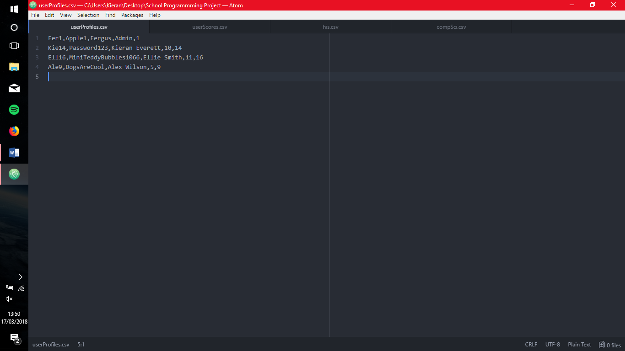

userScores.csv

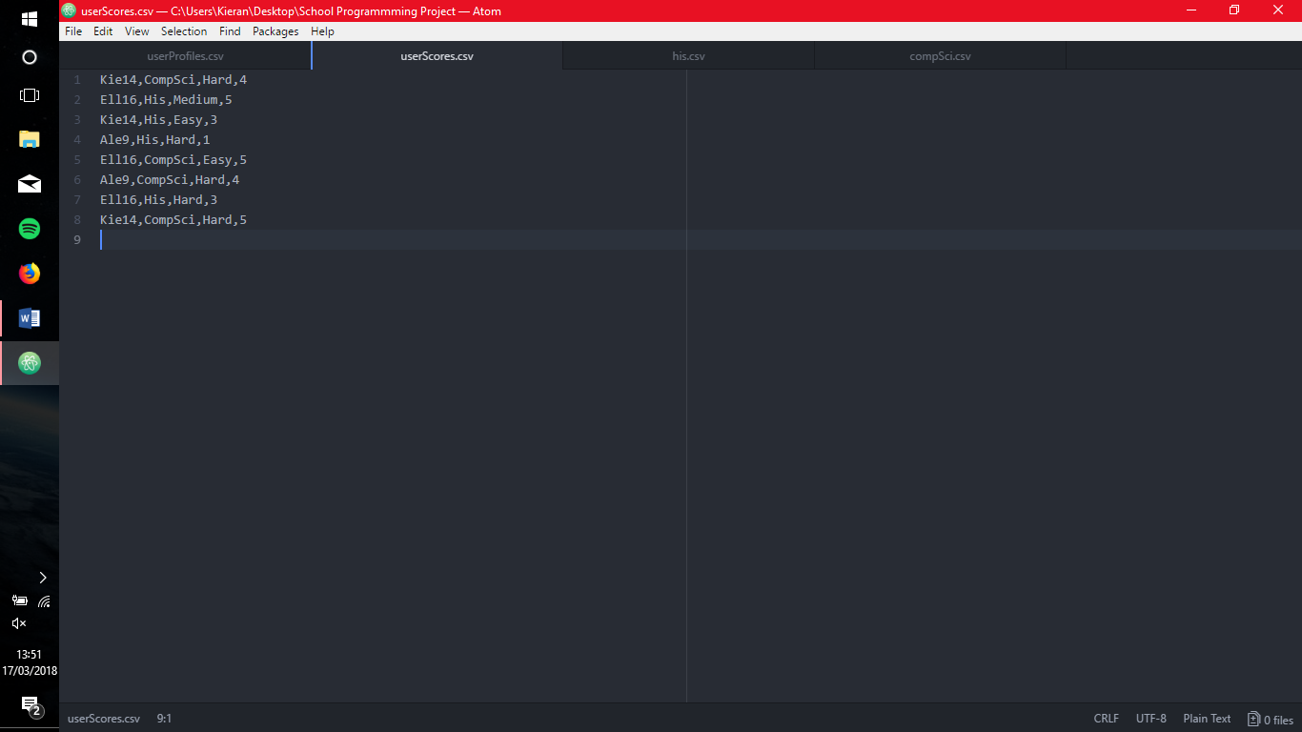

his.csv

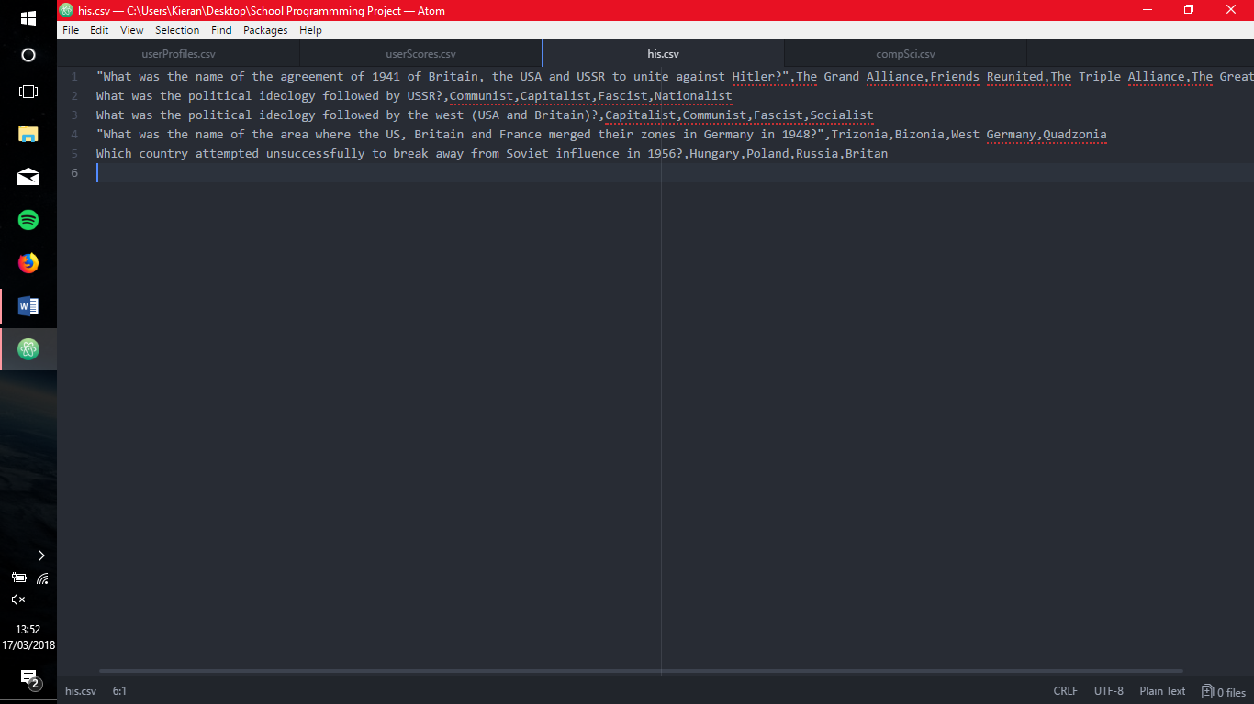

compSci.csv

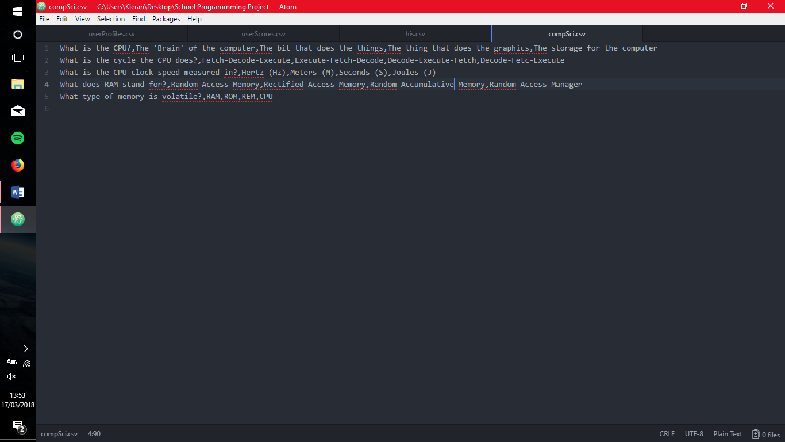

**TESTING AND REMEDIAL ACTION:**

Do you want to login (1) or signup (2)?

no

Only enter the number that corresponds to your choice

-1

Only enter the number that corresponds to your choice

1

Login

Enter your username

no

User does not exist, try again

Enter your username

1

User does not exist, try again

Enter your username

Kie

User does not exist, try again

Enter your username

Kie14

User Found

Enter your password

no

Incorrect Password, Try again

Enter your password

-1

Incorrect Password, Try again

Enter your password

1

Incorrect Password, Try again

Enter your password

Password

Incorrect Password, Try again

Enter your password

Password213

Incorrect Password, Try again

Enter your password

Password123

Correct Password

Welcome back Kie14

Would you like to do computer science (1) or history (2)?

no

Only enter 1 or 2

-1

Only enter 1 or 2

1

Would you like to play in easy (1), medium (2) or hard (3)?

no

Only enter 1, 2 or 3

-1

Only enter 1, 2 or 3

1

Computer Science

What is the CPU?

1. The 'Brain' of the computer

2. The bit that does the things

Enter the number of your choice

no

Only enter the number of your choice

Enter the number of your choice

-1

Only enter the number of your choice

Enter the number of your choice

3

Only enter the number of your choice

Enter the number of your choice

1

Correct

What is the cycle the CPU does?

1. Decode-Execute-Fetch

2. Fetch-Decode-Execute

Enter the number of your choice

1

Incorrect

What is the CPU clock speed measured in?

1. Hertz (Hz)

2. Meters (M)

Enter the number of your choice

1

Correct

What does RAM stand for?

1. Random Accumulative Memory

2. Random Access Memory

Enter the number of your choice

1

Incorrect

What type of memory is volatile?

1. RAM

2. REM

Enter the number of your choice

1

Correct

You scored 3 /5

Your percentage was 60.0 %

You got a C

Thank you for using this program

Press any key to end the program

**EVALUATION**:

My program has met all the original success criteria. I think my approach to the task worked quite well. However, if I was to do it again I would focus on the main code sooner as I left it to the very end to complete which didn’t leave me much time to do it all. Also, I would try to make the code smaller as it is very long. My Biggest challenge was probably trying to edit the csv files as this was the first time I used csv files, however, it was easy to learn with stack overflow and the python documents. Another challenge I had was trying to make the quiz random as I felt it would be too easy to complete if the quiz was the same every time so I made it randomly place the answers in so the answers would almost always be different (on the hardest difficulty, there are 4^4^4 combinations of answers so the students have to actually learn the answers).

**REFRENCES:**

Stack Overflow

Python Docs

Python for beginners