Week 1: Created Unity project, basic character moving around with placeholder model, folder structure in place and camera raycasting works to determine player look rotation. Developed working gun prototype with bullet prefab.

Week 1 Goal: Generate basic HUD layout, things like health, ammo, etc.

Week 1 Conclusion: HUD concept completed.

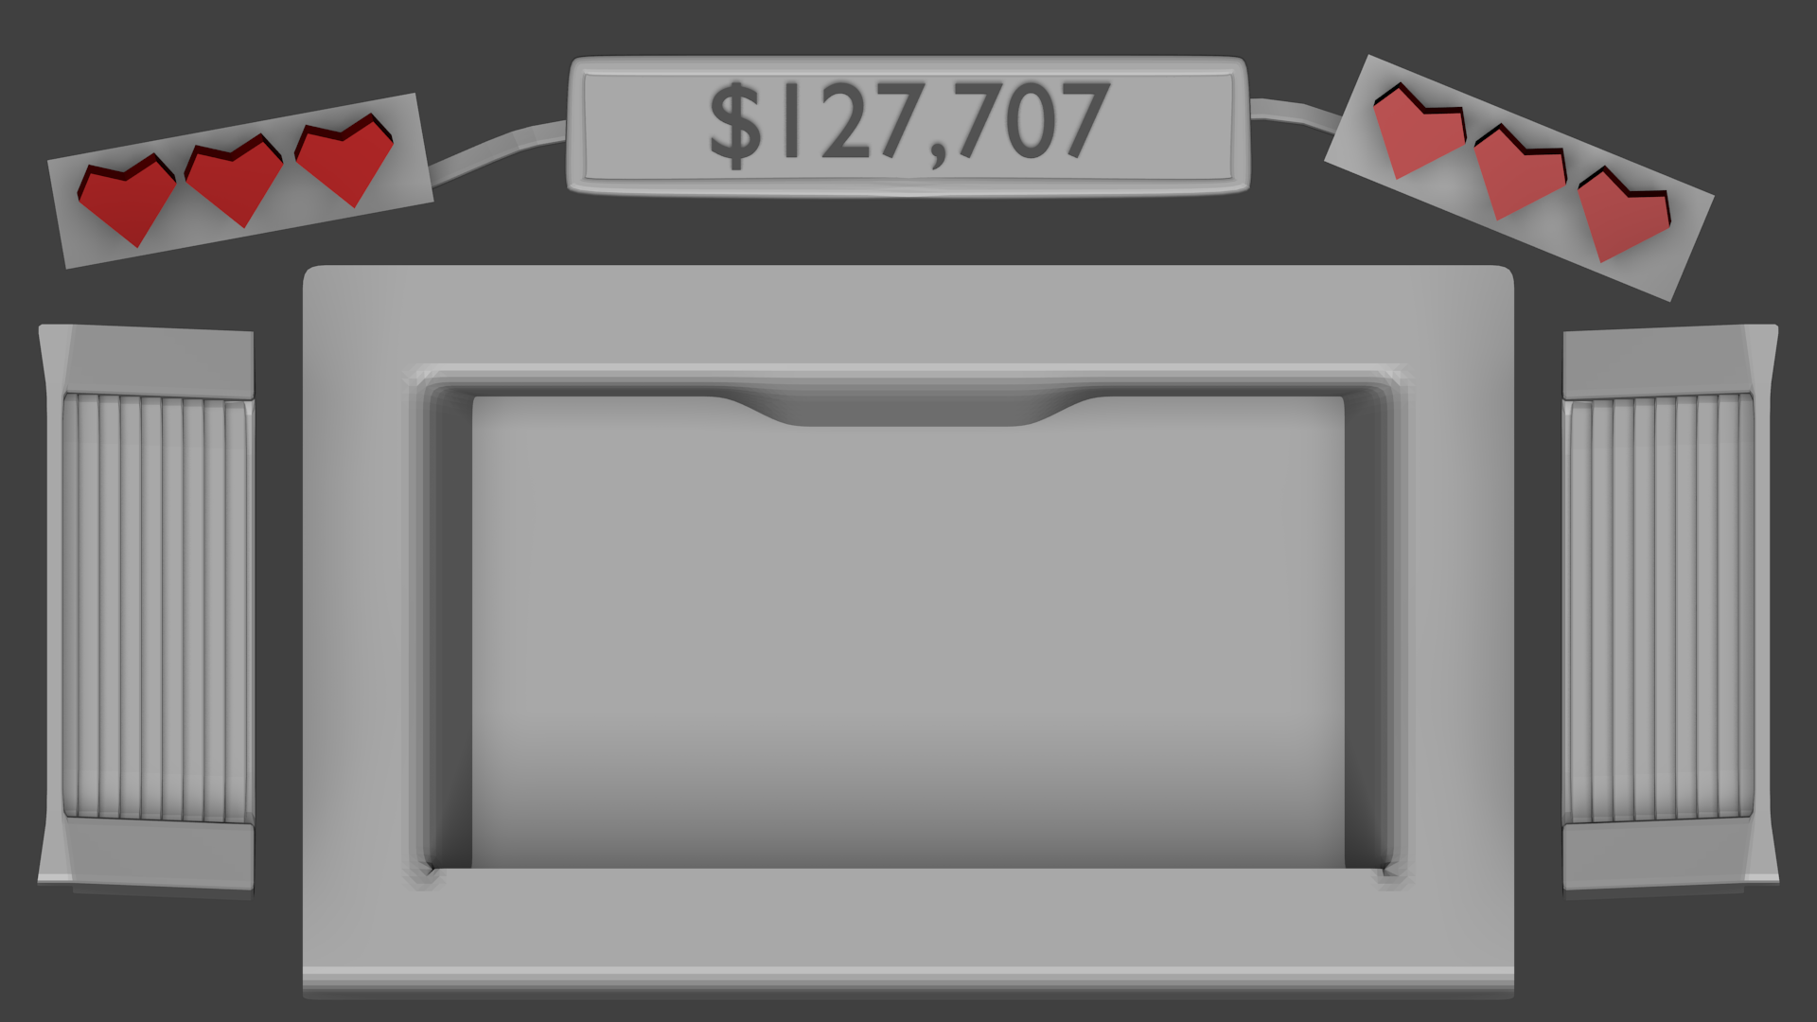
Week 2 Goal: Work on player damage system, get basic physical HUD working.

Week 2 Conclusion: Damage system in place, player can receive damage and be killed by environmental hazard.

