Can machine learning be used within a musical teaching application to analyse users data to better improve their musical learning experience?

Kieran Best

Individual Project U10834

Canterbury Christ Church University

2022/23

Table of Contents

Introduction 1

Literature Review 1

Requirements and Analysis 2

Methodology 2

Sprint Planning 2

User Stories 3

Personas 3

Design 3

Functional Requirements 3

Functional Requirements 3

Use Cases 3

UML Diagram 3

Wireframe Design 3

Finalised Design 3

Implementation and Testing 3

Hardware and Software Stack 4

Results 4

Findings 4

Goals achieved 4

Further work 4

Conclusion 4

Evaluating the Project 4

References 5

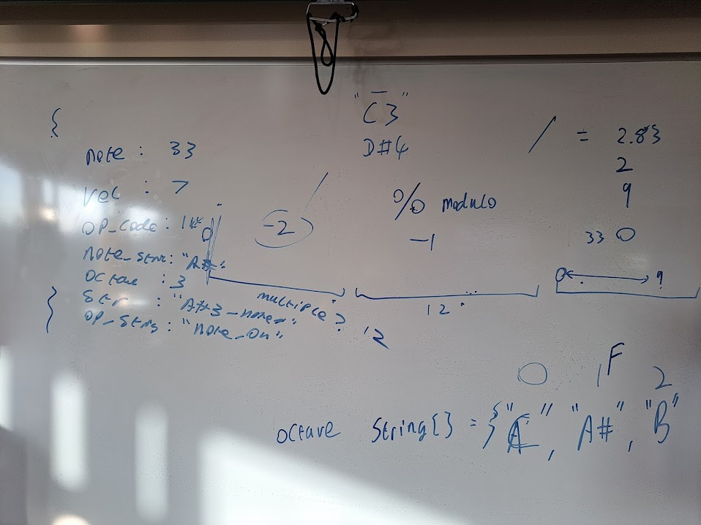

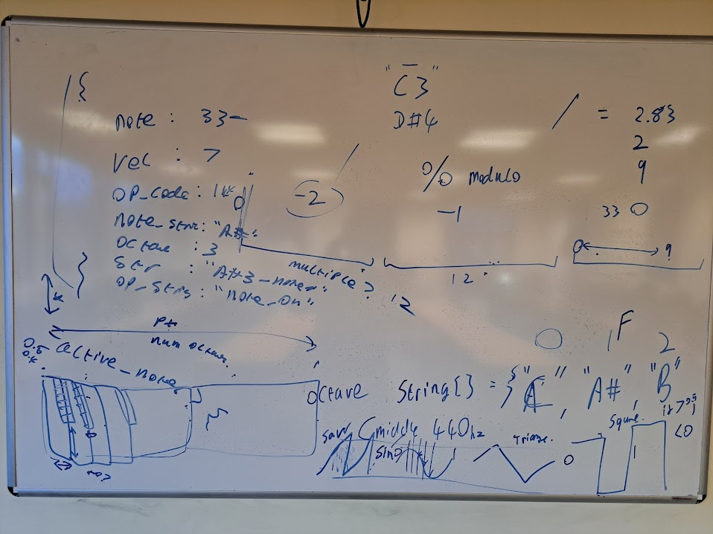

# Introduction

The overall aim of this project is to create an application that enables users to learn not only how to read sheet music but also to be able to play it in time on a piano. The application will then create new sheet music to test the user appropriately and not allow them to simply memorise a pattern. From here the application will measure the speed for users to hit the correct key and base its development journey tailored to the specific user; once the user is hitting the keys perfectly on time then it will progress to make it harder, whereas if the user keeps missing the timing, then it will slow it down to make it easier, if the user is hitting the wrong key, it will go back a stage to reshow the user which key is which note.

# Literature Review

Need an overview of the chapter.

Whilst there aren’t similar applications with the exact same features, there are those with some of the same features, such as ‘Simply Guitar’ and ‘Harmony City’ (Educational App Store, 2022) which will just teach you how to play a song, or applications such as ‘Tenuto’, ‘Piano Notes Fun’ and ‘Note Trainer Pro’ which will teach you how to read music. However, these applications are based upon recordings and not an interactive teaching;

**Need to find someone else who said the same thing**

Yuksel et al. (2016) explains that learning is best achieved when the users cognitive workload is at a particular level which can be very hard to achieve using a video. To attain the greatest level of education, Yuksel et al. (2016) states that the user must reach a “zone of proximal development” which can be difficult due to underlying factors such as:

* Difficulty of the task
* Users cognitive ability
* Instructional design
* Users motivation

However, these can be monitored with Intelligent Tutoring Systems (ITS) and Computer-Based Education (CBE) systems. Graesser, A.C. et al. explain that intelligent tutoring systems track the physchological state of users in fine detail through a process called student modelling. Student modelling follows characteristics such as “subject matter knowledge, skills, strategies, motivation, emotions, and other student attributes.” ‘ITS’ “adaptively responds” to users states and adjusts the course of the instructional agenda within its own constrains as opposed to a human taught lesson which will just follow a linear path (Graesser, A.C. et al., 2012). CBE dates back to the second world war as a way to effectively mass train soldiers in new protocols and at a cost-efficient way, this was done through the use of systems similar to that of PLATO (Programmed Logic for Automatic Teaching Operations (Lowe, 2001). PLATO was a educational tool developed back in 1961 as a way to teach a number of students through the use of displaying information and asking questions with the expected response to be numerical, algebraic, words or phrases and is taugh in a linear mathod with no form of digression. Lowe explained that within CBE also includes Computer-Based Instruction (CBI), Computer-Aided Instruction (CAl), Computer-Managed Instruction (CMI), Computer-Based Training (CBT), CBI delivered on the Internet or intranet, Internet-Based Training (IBT), and CBI delivered by CD-ROM and these were developed through the use of basic learning principles developed by Skinner (2012) whereby Skinner investigates the development of reinforcing “theory to human learning” whereby it has been used throughout the progression of programmed learning.

<https://dl.acm.org/doi/pdf/10.1145/2669485.2669514>

<https://dl.acm.org/doi/pdf/10.1145/2858036.2858388>

mention how P.I.A.N.O. doesn’t teach sight reading and how that’s ineffective due to <http://www.marthabeth.com/teaching_sight_reading.html> but find a paper on it

Whilst there are already plenty of options to allow users to learn to read sheet music and piano; none combine the two aspects as well as my proposed project.

# Requirements and Analysis

mention cognitive learning theory and how that will impact your application

This should state, in a more detailed way, the objectives of the project by requirement and the analysis should break the problem down into manageable steps. There may be more than one suitable approach; the analysis may cover more of the area than is finally implemented. Testing and evaluation should be given due consideration. It is important that you state how you will evaluate your work. For a design project it is appropriate to consider testing at the same time as specification.

## Methodology

The project will be created using an agile framework to better support its development, showing logical steps in its production process whilst also giving clear deadlines to each sprint. It will be created using JavaScript and tested using JavaScript testing frameworks such as Jasmine or Mocha. Once a prototype has been established, testing using reviews will be carried out as this will give a much better understanding of further development required.

## Sprint Planning

* Display that a key has been pressed on the terminal
* Display graphical shapes
* Keyboard input manipulates shapes in some way
* Display key pressed
* Create keyboard
* Keyboard input shows what key has been pressed on graphical keyboard (multiple keys if needed)
* Graphical keyboard resizes to canvas size
* Create music sheet outline
* Create shape on stave when note pressed
* Produce tone on key press (note on and note off)
* Produce specific key tone on key press
* Note moves across stave and repeats
* Note repeats to a different line/note
* Ability to change speed of note
* Press key at specific time to raise count
* Display more than one note at a time

## User Stories

* As a user the application must demonstrate which key I am pressing and what note that is to begin with.
* As a user the application must allow me to clearly follow which note I need to press and when.
* As a user the application must clearly define if I’ve pressed the correct key or not.
* As a user the application must be a plug in and play application, and not require me to install multiple drivers to run.
* As a user the application must develop my understanding by progressing to a harder difficulty.
* As a user the application must be visually appealing and not

## Personas

# Design

This should explain the design technique chosen (and justify why it is appropriate) from the various ones available; it should select a suitable subset of the things described in the analysis chapter and develop a design. Where trade-offs exist between different designs, the chosen approach should be justified. Suitable diagram-techniques (e.g. UML, other drawings) should be used where appropriate. If a method is applied selectively, explain which parts were used and why. Experimental projects should pay careful attention to control conditions, samples selected, etc. to ensure a valid result.

Accessibility - Colour contrast, fonts, layout, hovering, background, text shadow

## Functional Requirements

## Functional Requirements

## Use Cases

## Information Architecture?

## UML Diagram

## Wireframe Design

## Finalised Design

# Implementation and Testing

In addition to illustrating "coding traps", this should highlight particular novel aspects to algorithms. Testing should be according to the scheme presented in the Analysis chapter and should follow some suitable model - e.g. category partition, state machine-based. Both functional testing and user-acceptance testing are appropriate. For experimental/investigative projects, techniques developed should be evaluated against a standard result set for calibration, as well as the "live" data set. For theoretical projects, the relative power/expressiveness of the theory should be evaluated with respect to competing approaches.

# Hardware and Software Stack

What is needed to run this application?

# Results

## Findings

present all the results (products, experimental findings, theories, etc.) generated during the project. This may also include some off-topic findings that were not expected, or which were side-effects of other explorations.

## Goals achieved

describes the degree to which the findings support the original objectives laid out for the project. The goals may be partially or fully achieved, or exceeded. An experimental project may prove, or disprove the original thesis. A theoretical project may cover some or all of the example cases. Note that reporting of failures to achieve goals is important since a fundamental feature of the assessment procedures is that the processes (how you went about your project) are often as important as the products of the project.

## Further work

describes two things: firstly, new areas of investigation prompted by developments in this project, and secondly parts of the current work which were not completed due to time constraints and/or problems encountered.

# Conclusion

The conclusions can be summarised in a fairly short chapter (2 or 3 pages). This chapter brings together many of the points that you will have made in other chapters, especially in the previous results and discussion chapter. Do not be afraid of repeating some of your earlier statements here, albeit using different wording.

# Evaluating the Project

Evaluation for this project will be done through comparison of the initial specification and design documents against the finalised project. It will also look at each sprint to see if targets were completed on time and to the expected standard.

http://www.dcs.shef.ac.uk/intranet/teaching/public/projects/diststructure.html

# References

Educational App Store, 2022. Best Apps to Learn Music.

Graesser, A.C. et al., 2012. Intelligent tutoring systems. *APA educational psychology handbook,* 3:(Application to learning and teaching), pp. 451-473.

Lowe, J., 2001. Computer-base education: Is it a panacea?. *Journal of Research on Technology in Education,* 34(2), pp. 169-171.

Piano Sight Reading, 2022. Note Reading Apps.

Skinner, B., 2012. The sceice of learning and the art of teaching.. *Reading in Educational Psychology.,* Volume 66, p. 301.

uxwing, 2022. Keyboard Piano Icon.

Yuksel, B.F. et al., 2016. Learn piano with BACh: An adaptive learning interface that adjusts task difficulty based on brain state. *Proceedings of the 2016 chi conference on human factors in computing systems,* pp. 5372-5384.