Fire From Air: A Data Repository Creation with Satellite Images of Wildfire
Final report
Submitted for the BSc Computer Science
April 2025
by
Kieran McEvoy
Word count: XXXXX

Abstract
Wildfires are a highly destructive disaster that are increasing in number as the average global temperature increases due to global warming. Despite research into wildfire prediction, there is a lack of machine learning models to predict fires as well as no dataset for a suitable model to be trained upon.
Therefore, this paper aims to explore the task of predicting wildfires by training a deep learning model on a specifically created dataset captured by satellites with the hope to create a model that is effective at predicting wildfires before they happen. This will enable fires to be prevented and save lives, ecosystems and prevent damages to human infrastructure.
The paper will research different approaches and data sources and give reasoning for the choices made along the project’s timespan. The features in the data used to predict fires will be explained
The results of the project will be examined to assess the accuracy of the deep learning model and the quality of the created dataset and highlight successes and flaws of the approach taken. Since the subject is a relatively new area of research the evaluation of the project will explore future directions that could inform future research into the subject.

Acknowledgements
I would like to thank NASA and all those who worked on the Landsat projects as without the data being collected and made available to the public this project would not be possible.

Contents
Abstract i
Acknowledgements ii
Table of Figures 4
1 Introduction 5
1.1 Background to the project 5
1.2 Aims and objectives 5
1.2.1 Aims 5
1.2.2 Objectives 6
1.3 Research question 6
1.4 Report structure 6
2 Literature review 7
2.1 Technical background 7
2.2 Research into dataset creation 8
2.2.1 Regional Research 8
2.2.2 Satellites 9
2.2.3 Available Satellite datasets 10
2.3 Machine learning models 10
2.4 Conclusion 11
3 Requirements 12
3.1 Project pipeline 12
3.2 System requirements 12
3.3 Dataset requirements 13
3.4 Input requirements 13
3.5 Model Requirements 13
3.6 Interface requirements 13
3.7 Design constraints 14
4 Design 15
4.1 Dataset design 15
4.2 Interface design 16
5 Implementation 19
5.1 Dataset Creation 19
5.1.1 Selecting a region 19
5.1.2 Finding a fire 19
5.1.3 Extracting data 20
5.1.4 Data preprocessing 20
5.1.5 Allowing the user to swap the dataset 21
5.1.6 Difficulties in dataset creation 21
5.2 Model Implementation 23
5.2.1 Important Bands in Landsat 9 23
5.2.2 Convolutional Neural Network (CNN) 23
5.2.3 Hyperparameter tuning 24
5.2.4 User Interface 26
5.3 Testing 28
5.3.1 Model Training Performance 28
5.3.2 Model Testing 30
5.3.3 Interface Testing 33
5.4 Requirements to use the program 33
6 External concerns 34
6.1 Legal, social and ethical issues 34
6.2 Commercial issues and exploitation 34
7 Evaluation 35
7.1 Model evaluation 35
7.2 Dataset evaluation 35
7.3 Evaluation 35
8 Reflection 36
8.1 Development reflection 36
8.2 Future Development 36
8.3 Future Research 36
8.4 Project Conclusions 36
References 38
Appendix A 40
Appendix B 41

Table of Figures
Figure 1 - Project Pipeline flow diagram 10
Figure 2 - Home page design 14
Figure 3- Training page design 14
Figure 4 - Prediction page design 15
Figure 5 - Result page design 15
Figure 6 - About page design 16
Figure 7 - Instructions page design 16
Figure 8 - California in the google earth engine 17
Figure 9 - Bands available for Landsat 9 18
Figure 10 - Data available on the 5th of January 2025 19
Figure 11 - Data available between the 7th and 20th of January 2025 20
Figure 12 - Data available on the 21st of January 2025 20
Figure 13 - Untuned model architecture 22
Figure 14 - Hyperparameter tuning results 22
Figure 15 - Tuned model architecture 23
Figure 16 - GUI Home page 24
Figure 17 - GUI Training page 24
Figure 18 - GUI Prediction page 24
Figure 19 - GUI Results page 25
Figure 20 - Training validation set confusion matrix 26
Figure 21 - Model training accuracy 27
Figure 22 - Model training loss 27
Figure 23 - Testing fire confusion matrix 28
Figure 24 - Summer test confusion matrix 29
Figure 25 - Incompatible .tif file 30
Figure 26 - Error dialog box 30
Figure 27 - Interface not responding 31

Introduction

Background to the project
Wildfires are becoming increasingly a prevalent threat in today’s climate, they cause widespread
destruction to wildlife habitats, natural resources and even towns and cities. Being able to predict or
forecast such an event from happening could reduce or even remove the effects of such a disaster
by enabling authorities to put the proper procedures in place before the fire happens.
Almost 12 million hectares of forest burned in 2023. Canada accounted for around two thirds of the total forest burned that year alone and additionally counted for more than a quarter of the total loss of trees globally. (MacCarthy James et al., 2024)
There are many factors that can cause a wildfire, which makes it a challenge to accurately predict
when and where a fire may happen so a system that would be more effective than existing
technologies is needed to decrease the impact of the fires by providing early warnings about certain
high-risk areas.

The greatest threat to the natural environment is humans, global warming on average since 1850
has meant that the average temperature has increased by 0.06 degrees Celsius per decade.
However, since 1982 that rate has tripled(Lindsey Rebecca, 2024). This increase in global
temperature means that vegetation is drying out more often which can result in and increased
likelihood of fires. These fires from vegetation further add to global warming and can cause knock on
effects to the climate due to an increase in carbon in the atmosphere(MacCarthy James et al., 2024)
Additionally, human waste such as improperly discarded fuel sources or oil spills can contribute to
the number of wildfires if the fuel source manages to catch fire.

Satellites orbit the earth capturing images of the earths surface and taking readings of a large variety of data that can be used for a myriad of different tasks. The data captured in these images can be useful to finding early warnings of fires as even without specialized readings being taken, the raise in temperature before a fire may be visible within the landscape in the forms of more dried leaves and branches than would be present normally.

Aims and objectives

Aims
- The project should assist local authorities in becoming prepared for wildfires by providing them with early warnings about possible fires.
- A created dataset should be shared with the scientific community to further improve research and development past this project.
- A dataset should include multiple different features that could be important to fire prediction.

Objectives
- A machine learning model should be created to predict wildfires would decrease the chance and impact of fires as being able to predict or forecast such an event from happening could reduce or even remove the effects of such a disaster. This would enable authorities to put the proper procedures in place before the fire happens. The model must also retain a high level of accuracy being of over eighty percent to ensure that fires are consistently predicted correctly.

- A dataset must be created that includes areas in different states of a wildfire such as before, during and after the fire. This will allow a model to be trained and therefore predict the chances of a fire by allowing it to learn the differences between each stage of a fire so the model would be able to predict the likelihood of a fire happening in that region.

- The dataset must include high quality data that covers a wide range of factors that may contribute to a fire such as temperature readings as well as the Normalized Difference Vegetation Index for example. This means that the data collected must be satellite data as the sensors on the satellite’s either pick up this data or the data needed can be calculated from the satellite data.

Research question
“Can wildfires be predicted with available satellite data and machine learning techniques?”
The main objective of the project is to create a machine learning model to predict wildfires. Different machine learning techniques and data sources will be researched, evaluated and then implemented with a further evaluation of the results to answer the research question.
If the answer to the research question at the end of the project is yes, then this program may be invaluable to local governments and ecosystems as it will hopefully allow local authorities to implement preventative measures that can reduce or eliminate the damages that wildfires cause.

Report structure
For the remaining sections of the report, it will have the following structure. Section 2 will cover the literature review which will cover background research of wildfire prediction and explore possible routes for the project to take. Section 3 will cover the requirements and constraints facing the project which will be informed by the literature review.
Section 4 will cover the designing of the dataset and interface which will inform the implementation of the project which will be documented in section 5. Section 6 will cover the ethics and commercial aspects of the project. The results of the project will be documented in section 7. Finally, the project as a whole will culminate in Section 8 which will evaluate the project and discuss future work which the project can be used to inform

Literature review
Wildfire prediction is becoming increasingly important in today’s natural world, rising temperatures due to global warming and increasing human populations near or in natural habitats have amplified the frequency and severity of wildfires, making accurate prediction and so the intervention of these fires critical for mitigating their devastating impacts on ecosystems, communities, and economies.
There is not much available literature on predicting wildfires specifically, however, there are a multitude of papers discussing relevant information such as wildfire damage prediction, fire statistics and the performance and roles of different satellites. These topics can prove useful to a project on predicting whether wildfires will happen or not as some sections of these papers are relevant to the project in some way.
The literature review begins with a background of AI and then continues with research into the subject of fires and fire prediction technologies. This should highlight gaps in research and development into fire prediction and should inform the choices in the approach to the project such as the region to study and predict the likelihood of fires in as well as the types of satellite sensors available to collect data from.

Technical background
Artificial intelligence (AI) is an ever-developing area of research. The term artificial intelligence was coined by John McCarthy in 1955 as “the science and engineering of making intelligent machines”(teneo.ai, 2025). Since then, it has undergone major breakthroughs and developments such as deep learning which takes inspiration from neuroscience using layers of artificial neurons in a network. These methods can be supervised or unsupervised based upon the task, these tasks often include classification or regression.
Despite machine learning becoming a staple part of the modern world within the last decade, a lot of the groundwork was done by scientists after the end of the second world war. Alan Turing proposed the question, "Can machines think?" and described it as a game which he called the “imitation game." back in 1950(Turing, 1950).
The “Imitation game” was later changed to be called the Turing test, this test is composed of 3 individual entities. Usually a machine and two actors, one to interact with the machine and another to assist them. The aim of the test is to determine whether a human can decipher whether the responses are machine made or human.
Some large languages models in the modern area can now achieve high scores on the Turing test, with some models such as GPT 4.5 reaching up to 75%-win rate.(Jones & Bergen, 2025) These scores display the large developments in the area of Artificial intelligence since its inception.
Current technologies allow for the detection of objects in images or videos using deep learning techniques, these can allow cars for example to drive themselves as they are able to detect dangers in the upcoming road and employ actions to prevent any collisions from occurring. Such tasks are far beyond the realm of the Turing test, which only composed of conversation, and can assist people in many ways of life now, however, these tasks would not be able to be completed solely by machine learning without the pioneering developments in early machine learning completed by Alan Turning, John McCarthy and others.

Research into dataset creation

Regional Research
In this project selecting a region to select data from is highly important, this is due to the varying conditions across the globe that would make it hard for patterns about the causes of fires to be learnt by a model as the contrasting climates will have separate possible fire triggers. Additionally, selecting a region with a high number of wildfires per annum is also highly important as the dataset is much more likely to end up being unbalanced as well as those regions being less important to predict. This is because the low number of fires present does not stress the need for a tailored predictive model to prevent those fires.
Countries/States
Canada has a significant number of wildfires annually; however, large parts of the country are quite remote meaning that any help that could be done to prevent fires from happening will take significant time to arrive meaning that a model would have to predict fires way in advance when compared to California for example. Additionally, due to the remoteness of Canada’s forests there is a much lesser threat to people and their properties.
Greece is prone to wildfires due to the high temperatures experienced in the Mediterranean however in 2024 it did not experience many wildfires so there is not much recent data available. Greece experienced 86 wildfires with 103656 acres burned(Copernicus European Union, 2025) which is significantly less than what California experienced in 2024. Greece is also made up of multiple landmasses as it has a multitude of islands which may make preventative measures harder to put into place than other areas on the planet which are a singular landmass.
California alone had 8024 wildfires which burned 1050012 acres and damaged 2148 properties with 1716 of those being fully destroyed in 2024 alone.(State of California, 2025) California has also got large population centres inside wildfire prone zones which is shown in the large number of properties burnt by fires.
More specific regions
Alberta Canada, this is a decent choice as Alberta is a largely forested area and therefore the impact of fires on the local ecosystem could be massive. However, unlike regions closer to the equator, Alberta does have harsh winter conditions these often-reaching extreme cold temperatures of around -15 centigrade which will result in fires being very uncommon during the winter periods. This means that Alberta would not be a great choice for collecting fire data on as there will not be fires all year round which may mean there is a lack of data in the winter periods which may cause models to struggle with predicting scale in the winter.(H. Liang et al., 2019)
Northen California, in 2018 alone, wildfires cost nearly 800 million dollars in economic loss and claimed more than 100 lives in California. Over 1.6 million acres of land burned over that time. The area near Monticello and Winters, California, is characterized by complex topography and dense and heterogeneous vegetation which means that the region is very biodiverse and since Northen California has a long wildfire season due to its dry conditions almost all year round makes it a hotspot for wildfires, this as well as the increasing temperature due to global warming and the large human population close to these wildfire prone areas make Northern California a good choice for wildfire prediction. (H. Liang et al., 2019; Malik et al., 2021)
Region review
Overall California is the best region to collect data from for wildfire prediction, this is because of its high population density near wildfire prone areas and its high yearly occurrences of wildfires all year round. These two points highlight the need for a wildfire prediction model for California as wildfires in this state could be extremely costly to the environment as well as to inhabited areas close to fire prone areas. Additionally, California is one large landmass meaning proper preventative measures can be put in place much easier than a country or region with many islands.
Furthermore, due to the high abundance of fires in the California region, the project also has the flexibility to look at smaller regions within the state that are very vulnerable to fires if a lot of the data collected does not represent fires.

Satellites
There is a lack of tailored data to the task of wildfire prediction, most data accessible online fall into two categories, these being wildfire damage prediction and wildfire detection so a dataset must be created to solve this issue if any wildfire prediction is to take place. Therefore, choosing the correct data source is pivotal in a project like this as the data must be captured from a satellite that is up to date and also high quality in terms of the data it collects and the number of features that It can collect.
MODIS
The MODIS sensors on board the Terra and Aqua satellites provide data in 36 spectral bands in wavelengths ranging from 0.4 to 14.4 μm, with ground resolution being around 1000 m. Reflective Solar Bands which include Bands 1–19 and 26 and can detect Wavelengths between 0.4 to 2.1 μm. These bands are used for Monitoring vegetation, observing snow and ice and Detecting aerosols and clouds. Additionally, MODIS also has Thermal Emissive Bands which include Bands 20–25 and 27–36. Which can be used for Measuring surface and atmospheric temperatures, detecting fire and thermal anomalies, Studying Sea surface temperatures. Some of these bands are not very useful to fire prediction as in California there is little snow in most areas although it may have some snowy mountainous regions. Additionally, the bands that collect information on the surface temperatures may not be useful as it is nearly impossible for a fire to happen at sea without something like an oil spill prior as well as such a fire causing minimal damage to people.(D. Rashkovetsky et al., 2021)
VIIRS
The VIIRS (Visible Infrared Imaging Radiometer Suite) sensor was designed to be the successor to MODIS, it provides global daily active fire data at spatial resolutions of 375 m and 750 m which is more detailed than MODIS. MODIS experiences also more significant pixel size growth along the scan edge which can cause inaccuracies in the spatial resolution, whereas VIIRS uses an onboard aggregation scheme to minimize this. VIIRS sensor on Suomi NPP (SNPP) has been operational since 2012. The SNPP VIIRS and Aqua MODIS satellites also share similar equator passing times enabling there to be an effective comparison and consistency between the two sensors.(Fu et al., 2020)
LANDSAT
Landsat sensors have been around since the launch of Landsat 1 in 1972, the most recent satellite that has been launched is Landsat 9 which features 2 thermal spectral bands as wells as red, green, blue and infrared bands. Landsat features one of the highest spatial resolutions of any satellite which can view up to 30m, however Landsat is one of the slowest as it will return to the same point globally 16 days later. This slow time to return to a point means that Landsat may miss certain details that other satellite sensors may capture however, it’s high spatial resolution and multiple thermal bands offset this downside as it will deliver high quality data just not as frequently as the other sensors. (US geological survey, 2025)
Satellite selection review
MODIS captures a lot of data between its two satellites – terra and aqua, however, due to its low spatial resolution when compared to the other sensors and the aqua sensor not being very suited to the task of wildfire prediction it is not a great choice when compared to the other options. VIIRS is a decent choice due to its fairly high spatial resolution however, unlike Landsat it does not have thermal bands. Therefore, Landsat is the best choice for the task of wildfire prediction despite its slow orbit time as it captures the data necessary to form a prediction such as its thermal and near infrared bands. Additionally, any additional data required can be matched up with the Landsat data to fill any gaps that may appear.

Available Satellite datasets
There is a significant gap in available datasets that can be used for wildfire prediction specifically, this is due to the technology not being widely available therefore, the data used to create any existing prediction models are not available online. Most of the data available online that is not raw satellite data is tailored to the task of wildfire detection which is not useful for predicting fires as it does not have the necessary data points required and does not allow preventative measures to be put in place to mitigate risk.
Therefore, a dataset must be created to capture the necessary data such as vegetation and fire radiative power. However, there may be difficulties in making a dataset as the data will be imbalanced as there will be more data where fires do not happen then there will be for when fires are present. Therefore, creating a balanced dataset is critical to the success of any model trying to predict the likelihood of a fire.
An online source such as GEE can be used to create a dataset, GEE allows for a multitude of environmental data to be captured and exported. If needed the data can then be aggregated from different data sources and then aligning the data in location and time using the same projection if the data has actually been captured from different sources.(F. Huot et al., 2022)

Machine learning models
There are few to no models already in existence that are accessible resulting in a large gap in available models that could be used for this task. Most models accessible online fall into two categories, these being wildfire damage prediction and wildfire detection, both of which are not particularly useful to the project resulting in the need for a new model to be developed to complete the task of prediction.
Therefore, choosing and creating the correct model for the task of wildfire prediction is critical as to select a model that does not perform well on the available dataset could form incorrect predictions. Incorrect predictions will result in false positives and false negatives which can cost local authorities and environments severely.
CNN
Convolutional neural networks excel at extracting spatial features from images, such as patterns, edges, and textures. This can be used to detect relationships between pixels in the images to produce a prediction. Therefore, the CNN has emerged as a fundamental concept in the field of deep learning. Its ability to leverage vast amounts of data in the era of big datasets is different from traditional methods which often yield good results. Furthermore, a CNN can be used to process both 1D data and 2D images.(Kanwal et al., 2023) If a dataset was created from satellite data that was composed of 2D image tiles then a CNN would be a good choice for wildfire prediction.
Decision tree
Decision trees predict the target variable value by learning the decision-making rules that infer from the characteristics of the data, this can be useful for wildfire prediction as it allows the model to figure out what classifies a tile as having a fire in it. Slight changes in data can result in a completely different outcome, making the model prone to overfitting. This issue arises because decision trees tend to learn the noise in the training data along with the actual patterns, especially when the tree grows too deep. Overfitting can lead to high accuracy on the training dataset but poor generalization to unseen data, which is critical for applications like wildfire prediction as false predictions can have catastrophic consequences for the environment. To mitigate this, various techniques can be employed, such as limiting its depth, setting a minimum number of samples required to split a node, or alternatively using ensemble methods like Random Forests or Gradient Boosted Trees. These methods help improve the model’s robustness by reducing its sensitivity to small data variations.(Rezaei Barzani et al., 2023)
Logistic Regression
Logistic Regression models are frequently employed in wildfire prediction owing to its ease of use, high forecast accuracy, and quality of fitting. Logistic regression models can indicate the linkage between wildfire occurrence and driving factors, but the model is constrained by normality and linear requirements, which preclude the direct selection of acceptable variables. (Peng et al., 2023)

Conclusion
This literature review highlights specific gaps in research as well as available datasets and models which stresses the need for the creation of a high-quality dataset tailored to the task of wildfire prediction and a model to interpret and predict wildfires based on that dataset. The review also compares the choices available to complete the project and thus fill the gaps in existing research and resources available online.

Requirements

Project pipeline
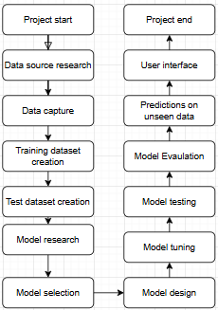
Figure 1 - Project Pipeline flow diagram
The project pipeline will start with researching possible data sources to collect suitable data from. From there the data required will be extracted and collected into a dataset for a model to train on. Additionally, more data will be collected to test the model on once it has been trained.
Once a dataset is created, research into a suitable model will take place based upon the data captured. Following the findings of this research, a model will be designed and then tuned to ensure that it is suitable for the task. The model will then be evaluated on its performance on the test set and then be able to perform predictions on unseen user inputted data.
After all of this has been completed, the final stage of the project pipeline will be making a user interface for the project that will enable users with no prior knowledge to effectively use the project to predict fires.

System requirements
The model and program will be programmed in python as it has a large number of libraries that are useful for Deep learning and Machine learning which will be critical to creating a prediction model.
The program will use many different libraries such as tensorflow and sklearn, additionally the interface will also be programmed in python for ease of programming as there can be important functions in one python which can be imported so it can be accessed seamlessly by an interface.
Therefore, the system will need to be able to interpret python code and the libraries used will be required to be installed for the program to work.

Dataset requirements
- The dataset must include recent historical fire data.
- The dataset must include data that includes factors that can contribute to a fire such as thermal readings and vegetation health.
- The dataset must only include data from the selected region of interest ensuring data outside of the range of coordinates is not considered.
- The dataset must have an equal ratio of data to prevent imbalances.
- No data must be stored by the program once it has been shut down and closed.

Input requirements
- The program must be able to handle .tif files and extract necessary data to make a prediction.
- The program must be able to handle incorrect inputs/data.

Model Requirements
- The model must be able to must be able to train efficiently so the model can train on machines without a dedicated graphics card.
- The model must be able to use several different factors to form a prediction to mitigate false positives.
- The model must be able to predict to an accuracy of above 80% on data taken from the region of interest

Interface requirements
- The interface must be able to show the user how to extract data that is suitable for use
- The interface must be easy to navigate and understand for new users
- The interface must not have a login page as the program does not need to save user information.
- The interface must display the image in a viewable format along with the prediction
- The interface must suggest ways to follow up on a prediction such as directing them to the necessary authorities or suggesting methods to prevent a fire.
- The interface must be able to explain to the user the errors that have occurred.

Design constraints
Landsat 9 has eleven different bands that are available on the google earth engine that can be extracted from an image that was exported. This means that any data that could be useful that is not captured by the satellite sensor will not be considered by the model.
Landsat 9 has a revisit time of sixteen days; this means that the model cannot perform real-time predictions as there is not a constant stream of data every day to predict on. This also means that data that does not fall upon the days where the satellite passes over the region will not be captured resulting in periods where any predictions cannot take place.
The satellite also has a spatial resolution of thirty metres resulting in that thirty-metre area being considered as one pixel, therefore, small anomalies that start off in a much smaller area than thirty metres might not be captured until it grows enough to fill the majority of the area.
Additionally, man-made fires are near impossible to predict as the model cannot predict that arson will happen, it will predict based on the satellite data which cannot account for this. However, if the ground is dry enough and hot enough it may still be picked up by the model.
As a result of hardware limitations only a singular area whether that be a state or a country can be considered. The varying conditions across the globe means that a large amount of data would be needed to be processed to tell the difference between areas as the necessary conditions to cause a fire is not the same in different regions.

Design

Dataset design
The dataset should include data from a specific fire in the chosen region, the fire must be available in the google earth engine. The dataset will then be extracted in tiles of the same size from the google earth engine. This ensures that the data will be a consistent shape allowing for effective feature recognition by a model.
Additionally, using a small tile-based approach allows the model to learn finer details instead of generalising over a much larger area. This is further amplified by the spatial resolution of the satellite being thirty metres resulting in each pixel covering a large area. For example, a large tile size of 1000x1000 pixels would include a large amount of data and fires are very unlikely to take up a significant amount of space over that area resulting in the model not learning anything from the data as well as the data taking a much greater processing time.
Splitting the data into 4 distinct categories will allow the model to sort each tile inputted into it into a category. This means that the patterns present in the training data can be learnt from and tiles can be predicted to be in a category based upon the patterns found in the data, patterns present before fires will help in fire prediction as if the conditions of an area before a fire occur in another area, then it is likely that area will experience a fire.
Furthermore, having categories for the model to predict instead of a percentage or score means that it is clearer to the user as a user with no prior knowledge will not be able to interpret a percentage of 35% of a fire occurring for example. Instead using a category-based system a user would be able to understand any output such as very likely for a fire to occur for example. It also allows for suggested actions based on the category rather than the user taking actions based on only a probability.
Since the dataset will be in a category-based approach, this means that data for each category will need to be captured. Unfortunately, due to the nature of the satellite data from the immediate vicinity to the during data cannot be collected as the satellite has a sixteen-day revisit interval. This means that the data will include sixteen days before, sixteen days after, during and a time with no recent fire to gather all stages of a fire possible from the engine. This means that the fire captured needs to last over a week for the data to be accurate. From this data a dataset can be extracted and used in predictions.
To help a user understand the dataset, a text file will accompany the data to explain the date and location of the fire and the area that was captured and extracted.

Interface design
Creating a user interface will allow users to operate the program effectively without the use of a console. Therefore, the program will be more accessible to use as the user will not need any knowledge or experience with the program before to operate it, all that the user will require to use the program is a file to input for a prediction and to download the program and dataset files.
Since the program does not need to take in any user data at any point the user does not need to log into the program or input any data other than to make a prediction on that data. This means that the interface can start on the home page.
Interface design
Since the interface design is focused on functionality rather than aesthetics the interface will be low fidelity so a high-fidelity design will not be required.
Home page
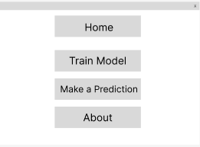
Figure 2 - Home page design
The home page will present the user with several options these including a page to train the model, make a prediction and an about page which will explain to the user how to operate the program if they are unsure. This will ensure that the user can perform the act of predicting the chances of a fire occurring in a timely manner and as every second before a fire starts is useful to enable preventative measures.
Training page
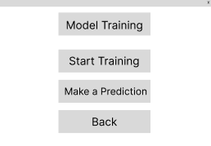
Figure 3- Training page design
Once the user has selected “Train Model” from the home page they will be sent to the model training page which features three options, these being a button to start the training of the model, a button to make a prediction after training and an option to go back to the home page.
The training button will cause the model to be trained on the dataset, using this approach instead of always using already existing model that was trained on the training dataset means that if a dataset is formatted correctly, it can be swapped into the model to train on instead of using the existing training dataset.
Prediction page
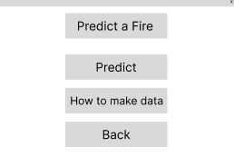
Figure 4 - Prediction page design
Following training the model the user will be presented with the option to navigate to a prediction page which will allow the user to select a file on their local storage devices to input into the program. Once the user has inputted a file the interface will navigate to a results page.
The prediction page will also give an option to display a page explaining how to create suitable data for the model to predict on as incorrect data will not be able to be used which could result in a fire occurring due to the time sensitive nature of making a prediction before a fire could occur.
Results page
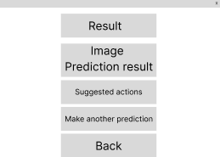
Figure 5 - Result page design
Once the program has switched to the results page it will present the user with the rgb image of the data as well as the prediction made by the model. The user will be given suggested actions based on the outcome of the prediction as well as an option to return to the prediction screen to input another piece of data.

About page
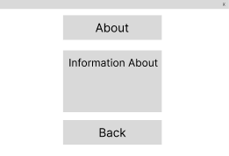
Figure 6 - About page design
The about page will provide the user with information about the program as well as how to operate it if they are unsure how to continue after opening the program. It will also include information on how to swap out the training data if the user wishes to use an alternative dataset to train a model on.
Data help page
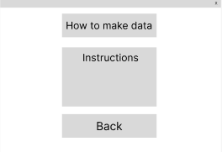
Figure 7 - Instructions page design
To help the user create suitable data for the model to process and form a prediction on there is a page instructing the user to create data the program can read. This is essential as the model can only process Landsat 9 Collection 2 Tier 1 raw data. Any other data will not be able to be used by the model and in a time sensitive situation such as fire prediction, ensuring the user is able to create correctly formatted data is critical to predicting fires in a timely manner.

Implementation

Dataset Creation

Selecting a region
To begin creating the dataset it must first be captured and exported from the google earth engine. To do this, California was first selected as it is the region chosen to collect data from due to its frequency of fires that regularly endanger people as discussed in the literature review.
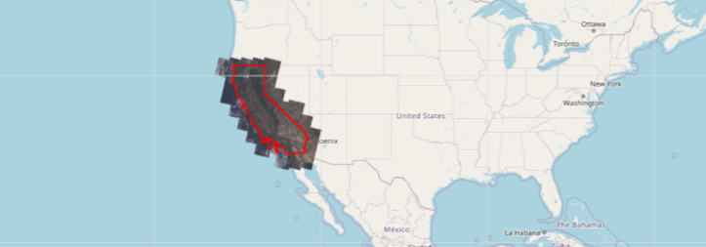
Figure 8 - California in the google earth engine
Due to the vast size of California, processing the entire dataset as one large file would be very time consuming and inefficient. This can be solved by splitting California into smaller, manageable tiles, allowing for detailed analysis of each tile. Using tiles also reduces the computational load and makes processing more efficient.
By analysing each geographical area separately, it avoids the risk of averaging out regional variations. This approach allows the model to focus on more localized patterns—such as terrain variations, and vegetation differences—that can significantly influence fire behaviour. Instead of the model learning patterns that are statewide, which may blur important features, it can learn more accurately from the smaller, detailed data points within each tile. This will increase the model's predictive accuracy.

Finding a fire
After selecting California to extract data from then a fire must be found in the data that’s available. This is a particularly difficult task as Landsat 9 has a revisit time of sixteen days. This means that the number of fires that can be found is dramatically reduced as the fire must be active in the area on the day of the satellite orbiting above it. To achieve this, fires that were quite large needed to be found due to the spatial resolution being thirty metres, this means that small fires may only appear as very few pixels. Once a list of notable fires was created the data was checked if it was available on a day the fire was active, if there was data, then a heatmap of pixel values was applied to the area to confirm that a fire was present.
The pacific palisade fire lasted twenty-four days meaning that some data had to be available as the satellite would have definitely revisited the area in that time. Additionally, the fire devastated a large area meaning that there is a large amount of data that will be available to collect. This means that a model is less likely to memorize the data as there is a lot more data than a smaller fire would produce. Additionally, this will mean that there is no data imbalance in the dataset as the majority of the data will fit into each category for classification.

Extracting data
Because the fire that is going to be used is the pacific palisades fire of January 2025 data can be extracted from that area specifically, this means that there is no imbalance in data as if the entire state of California was extracted from the google earth engine the dataset would be heavily imbalanced where only a tiny portion of the data would include a fire.
To extract the data the area of interest must first be selected. The graphical coordinates were found of the centre of the pacific palisades and a rectangle was drawn over the area ensuring that as little sea as possible is present in the data due to the area’s proximity to the coast. Removing as much ocean as possible is useful as the data will be redundant to the task of fire prediction as the water cannot physically catch fire unless oil is spilled over the area and that is very unlikely to occur on the coastline. The area was then tiled into smaller, equal size regions to reduce the size of the files and allow the model to detect finer details allowing for smaller anomalies to be detected. This is useful as the Landsat 9 satellite has a thirty-metre spatial resolution meaning that each pixel in the data is already very large and taking in a large image in one go can result in fires that cover smaller areas to be ignored by the model as even if they are quite large the area of the entire palisades is much greater.
The dataset meets the project’s requirements as it has an equal amount of data in each category, this being 72 tiles, ensuring that there is no imbalance in the data and thus it should not adversely affect training. Additionally, the dataset includes recent historical data that includes a wide range of factors such as thermal readings and other factors such as the Landsat Normalized Difference Vegetation Index can be calculated from the extracted data.
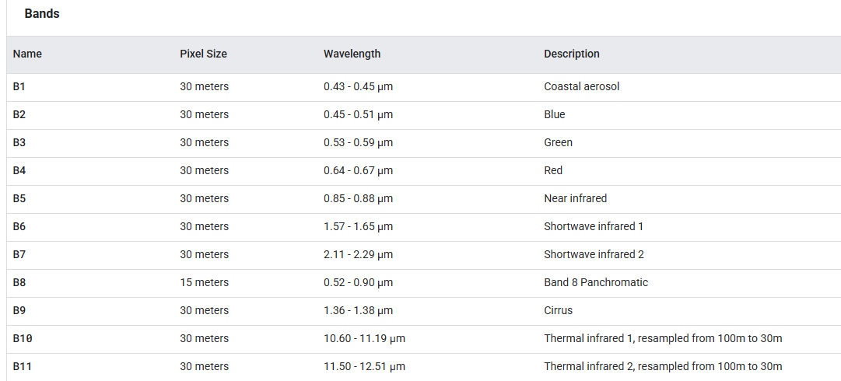
Figure 9 - Bands available for Landsat 9

Data preprocessing
The data must be normalised to be processed as the raw satellite data is not in a format suitable for direct use in machine learning models or statistical analysis due to its large size. Normalization ensures that the features have a consistent scale for easier processing.
As there is no baseline to normalize the values to for fires, the data will be normalized to the highest and lowest values in the data. This means that the data will be scaled to between zero and one resulting in the data being efficient to process compared to the raw values which will be much larger.
Additionally, a large number of bands are not that useful for making a prediction. There’s seventeen layers and eleven bands in the data available in Landsat 9 so the data needed to be processed would be quite large. This means that taking a smaller portion of the bands that directly influence the chance of a fire will make training the model efficient and remove redundant data.

Allowing the user to swap the dataset
Allowing the user to swap the dataset will allow the project to be useful for future development as the program and model architecture will be the same but the dataset will be able to be swapped by the user.
If the user was able to extract their own Landsat 9 data and sort it into the categories present in the training dataset and if the data was the same size as the data present in the training dataset then the user would easily be able to swap out the training dataset to tailor a model to a specific fire instead of the palisade fire present in the training dataset.
This would allow the model to train on a different set of data and possibly be used for other regions, the model would retain the same architecture but would be trained on an entirely different set of data.
To ensure that the user has the ability to do this, the model will not be saved and will be required to train every time the program is relaunched. However, this may mean that no prediction will be exactly the same as the model may have different weights each time it trains and may result in differing predictions.

Difficulties in dataset creation
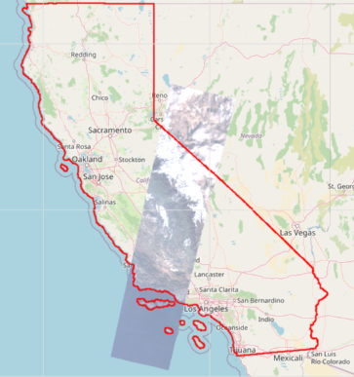
Figure 10 - Data available on the 5th of January 2025
This image shows the data available in the timespan of one day, between the 5th and 6th of January 2025. Data is only available in the highlighted California region in the strip of data where an image is shown over the map. Every other section of California on this day has no available data as the satellite has only passed over that region. This means that it is exceptionally difficult to find fires in the data as if they don’t align with a pass over California by the satellite, they will not be picked up by it and will remain undetected.

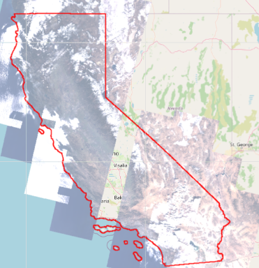
Figure 11 - Data available between the 7th and 20th of January 2025
This image shows all of the satellite passes between the 7th of January and the 20th of January 2025. As seen in the image, the strip that occurred between the 5th and the 6th has no data available in the image, this proves that the revisit time of the satellite is 16 days meaning that data is very scarce in a particular point as in between the interval nothing will be captured, meaning that it will be easy to miss fires and hard to capture fires to use as training data.
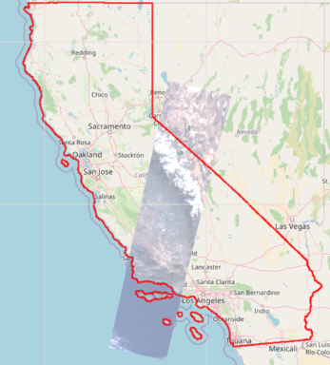
Figure 12 - Data available on the 21st of January 2025
This image was captured sixteen days later – between the 21st and 22nd of January 2025, the satellite has passed over the same region again for the first time since the previous image. This means that no data in this strip will be captured in between these images as the revisit time is sixteen days.
Due to the revisit time of the Landsat 9 satellite being sixteen days the before, after and during data has to be taken sixteen days either side of the fire which may result in the data not being very accurate however, there is no alternative solution as other satellites which may pass over the area do not have the same sensors as those that are present on Landsat 9. To account for data that may not include before, during or after conditions then data must be captured that includes no thermal anomalies. This means that any predictions that don’t include any conditions related to a fire will not be predicted as having fire like conditions therefore removing some misclassifications.
Additionally, the data does not include the day that it was taken only the solar angles when the images were captured. This means that time of day cannot be considered as for the time of day to be calculated using solar angles the data would also need to include world coordinates which is not present in the data. This means that the model may struggle with thermal anomalies at night as they may be seen as regular thermal readings in the daytime.

Model Implementation

Important Bands in Landsat 9
Once the data has been extracted from the engine and a dataset is created, certain bands must be extracted from each tile in the dataset. These bands are critical to forming a prediction on whether a fire is present or not.
Thermal infrared Bands 10 and 11
Bands 10 and 11 in Landsat 9 are important to figure out whether a fire is present as a higher thermal reading suggests that the surface temperature is high. A higher surface temperature could be a key indicator that a fire is present or will occur soon. Using both the values of these bands and NDVI will be necessary to form a prediction on a tile.
Normalized Difference Vegetation Index (NDVI)
NDVI is a useful value to have as it indicates the vegetation health and vegetation density, a value closer to 1 means that the vegetation present is dense and healthy whereas a value closer to zero means that the vegetation present in the area has unhealthy or little vegetation. A value below zero is also useful as it means that there is ocean present, and it is very unlikely that fires will appear on the surface of water.
NDVI is not like the other bands which are captured by the satellite, it must first be calculated using the near infrared and red bands. It is calculated using this formula:
NDVI = (NIR − Red) / (NIR + Red)
In Landsat 9: NDVI = (Band 5 − Band 4) / (Band 5 + Band 4) Range: −1 to 1
By including NDVI as a band to be processed by the model it means that the model can both examine the thermal readings as well as the vegetation health as high thermal readings and a low NDVI value could suggest a high chance of a fire occurring in that area.

Convolutional Neural Network (CNN)
After selecting the useful bands in the tiles and normalising them they are ready to be used to train a CNN. The model architecture must first be created and then fine-tuned to the problem. As the shape of the data has three layers currently as two thermal infrared bands are used along with the calculated NDVI band. This means that the input shape of the model must take in the shape of each layer as well as the three layers themselves.
The output shape has to be four as the CNN is a classification model and there is four categories present in the data for the model to predict between.

Hyperparameter tuning
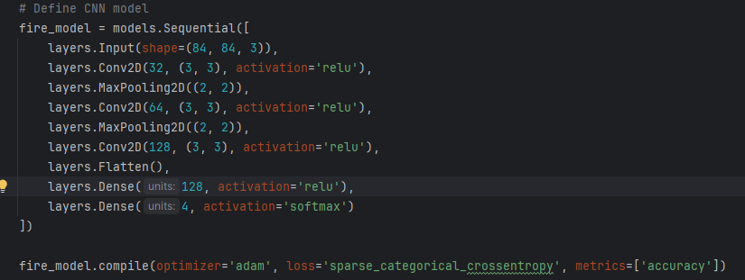
Figure 13 - Untuned model architecture
The model’s basic architecture follows this structure. However, this may not be the best architecture for the task of predicting wildfires therefore, the hyperparameters need to be tuned to find the best model for the task.
To do this the model was tested 20 times using keras tuner and using a random search algorithm to find the best hyperparameters for the model. This allows the algorithm to explore a range of hyperparameters and find the best ones for use and is generally faster and more efficient than other algorithms for hyperparameter tuning.
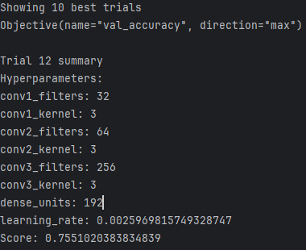
Figure 14 - Hyperparameter tuning results
After the random search algorithm had finished the best score was 0.755 which is a good score for the complex nature of the task. The hyperparameter values from the best trial can then be implemented into the model’s architecture which should result in a better performing model than the baseline model would have been.
Due to the nature of the task requiring a high accuracy, the tuned model will be useful in effectively predicting fires as it is suited to the task and may predict with a greater accuracy over the untuned model.
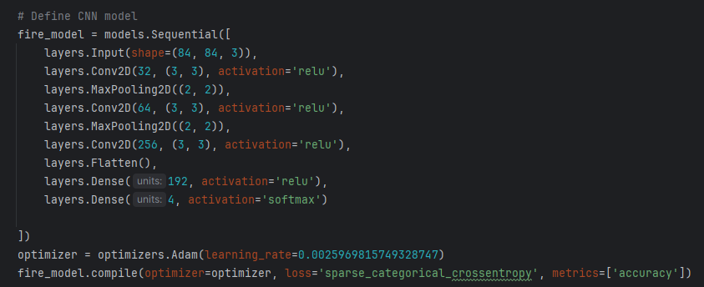
Figure 15 - Tuned model architecture
The model has three convolutional blocks with increasing sizes of filters as the depth of the model increases to help the model gradually learn more complex features in the data. Starting with a smaller filter also increases the efficiency of the model while also maintaining the performance of the model. Max pooling is also used after each filter to reduce the spatial dimensions by down sampling the data and retaining the useful features present in the data.
After the data has passed through the three convolutional blocks it is flattened into a one-dimensional array before being passed to a hidden layer which bridges the convolutional layers to the output layer by combining features into high level shapes or patterns. The output layer has four neurons which means there is one for each class. The SoftMax activation function converts the scores of each input into a probability which can be used to classify the data into one of the four categories.
The loss function of the model is sparse categorical cross entropy this means that the labels do not need to be one hot encoded and each class has a value of between 1 to 4. Using this approach allows the model to use a probability of the data being in a class and also improves computational efficiency.

User Interface
Since python is used for most machine learning tasks programming a GUI in tkinter is a good choice to use as tkinter is very lightweight and is an open-source library meaning that is completely free to use without any licensing.
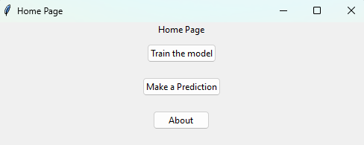
Figure 16 - GUI Home page
Since the designs were low fidelity, not much is required to be added to the base tkinter frame. For the home page a grid system was used to align all of the buttons and text to the middle of the screen allowing the content to be at the centre of the user’s view.
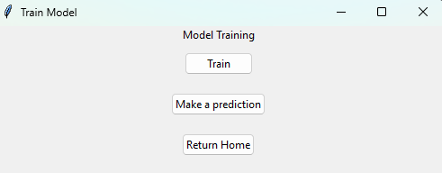
Figure 17 - GUI Training page
The training page follows a similar system with a grid to align the content. However, the buttons are not solely for navigation. The train button causes the model to be trained on the training dataset but often causes the interface to become unresponsive for a short amount of time depending on the hardware the model is training on. 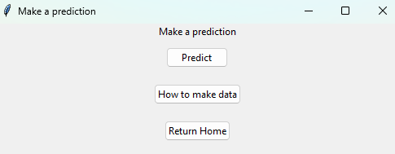
Figure 18 - GUI Prediction page
The prediction page also follows the design and uses a grid based system. The predict button opens a pop up window that allows the user to pick any .tif file on their local drives and input it into the model for a prediction to take place.
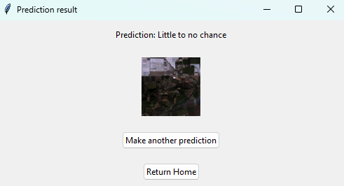
Figure 19 - GUI Results page
Once the user has inputted a suitable file it will display the prediction and also the RGB image extracted from the red, green and blue bands in the tile. This will allow the user to see where a possible fire will occur from an aerial view.
Due to the files extracted not storing coordinate data that cannot be shown alongside the image so it is assumed that the user knows the location of each tile but the aerial view will help with locating the area.
Overall, the interface created using Tkinter follows the designs well due to the interface being low fidelity as the program needs to be as smooth to use as possible for a user with no prior experience or knowledge of fire prediction. Additionally, creating a higher fidelity interface may be costly to computing resources and result in the model taking longer to train if more resources are allocated to displaying a user interface.

Testing

Model Training Performance
To train the model the dataset is split into two portions. One being 85% of the dataset which will be used for training, the remaining 15% of the dataset will be used to evaluate the model’s performance on the unseen data. Due to the dataset created containing only 288 files a larger number of evaluation data cannot be used as it will diminish the amount of data that the model will train on. Additionally, this means that the model must be carefully tuned to prevent overfitting and memorisation of the data.
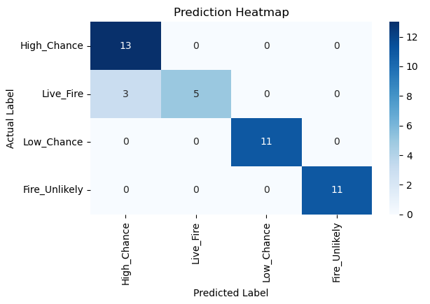
Figure 20 - Training validation set confusion matrix
The confusion matrix, present in figure 20, of the performance of the model on the test data split suggests that the model is performing well on the data and is able to categorize the data correctly as a large majority of the data was predicted correctly. Forty out of forty-three satellite images were predicted correctly which shows that the model has been able to effectively learn the differences between each state of a fire.
However, some of the data was predicted to be in the wrong category, this may be because of the revisit times of the satellite which may cause confusion in the predictions. Due to the high chance category including data as close to before a fire as possible given the satellite’s revisit time and the live fire category including data from sixteen days later which may mean that the fire is slowing down if the fire occurred closer to the before fire data than the live fire data.

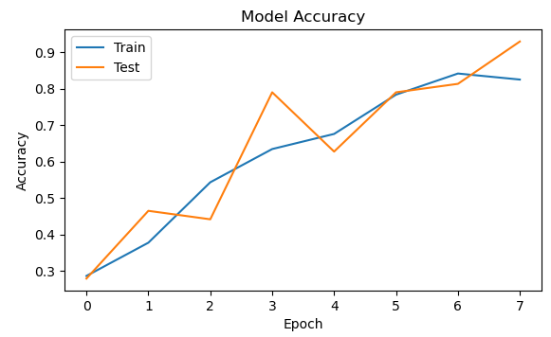

Figure 21 - Model training accuracy
The accuracy of the model increases with the number of epochs in both the training and testing and shows no significant signs of overfitting this means that the model is effective at learning. The test line does fluctuate a lot more than the train accuracy because the test data has not been seen before by the model. The training line does decrease at the eighth epoch, this may be because the model is starting to generalise the data incorrectly however, the testing accuracy continues to increase.
The model also managed to achieve an accuracy of 80% on the test set as well as the training set despite training accuracy falling slightly at the last epoch. This meets one of the project’s requirements as the model has been able to train to a high degree of accuracy.

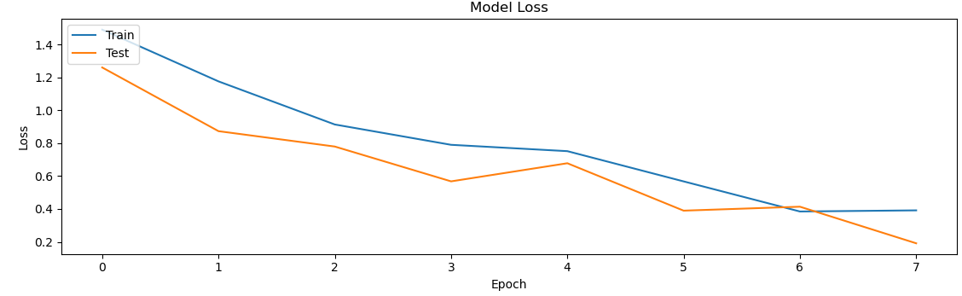
Figure 22 - Model training loss
Over the course of the epochs the loss graph also shows that the model is learning as the loss decreases in both the training and testing. The test loss decreases at a greater rate than the training loss which suggests that the model is able to generalize well and learn patterns at a fast rate. The test loss remains lower than the training loss almost throughout the entire set of epochs which is unusual, this may be due to the dropout layers in the model architecture as it introduces noise which may result in the training loss being higher here.
The training evaluation suggests that the model has been able learn patterns and generalise well and shows no signs of over or underfitting. Therefore, as a result of the training the model is well tuned for the task of predicting fires and needs to be tested rigorously to confirm that the model is successful.

Model Testing
Second California fire data
To further evaluate the model and its performance, data from another fire in southern California must be collected. This is because the model scales the values of thermal anomalies around the pacific palisades fire present in the dataset due to the lack of standard fire data.
To do this a small collection of data must be extracted from the google earth engine and given to the model to measure the performance of the model.
To test the model’s ability to predict between Low, High and Live fire conditions data was collected about the Ventura County “Mountain fire” in 2024. This dataset does not include data where there wasn’t a fire so any predictions in that category have been incorrectly predicted.
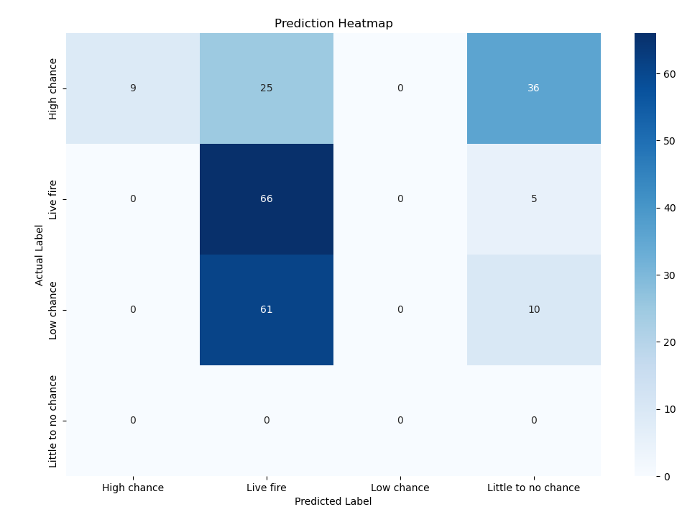
Figure 23 - Testing fire confusion matrix
The confusion matrix present in figure 23 shows that the model has struggled to predict well on this new unseen dataset. This may be due to the fire occurring at a different time of the year and elevation to the pacific palisade fire. The model was accurate predicting whether the data did actually contain a fire but inaccurate with the other categories. The model may have had a heavy bias towards the live fire category due to the conditions present before, after and during being a lot hotter than the pacific palisades fire.
Overall, the model has been confused by the unseen data which may be due to the fact that the mountain in Ventura County is wildly different to the pacific palisades which is much closer to the coast meaning that the model has become confused due to the variance in conditions. Mountainous regions may have a lower NDVI value than regions closer to the coast as it is harder for plants to grow at higher altitudes due to the lesser oxygen levels present which may be a factor in the incorrect predictions here.
Additionally, every fire is different meaning that fires that start hotter and burn hotter may be predicted incorrectly a lot of the time. To test this theory data will be collected from the summer season in the year to check for any inaccuracies due to the higher thermal averages in summer.
Data taken in the summer that does not include a fire
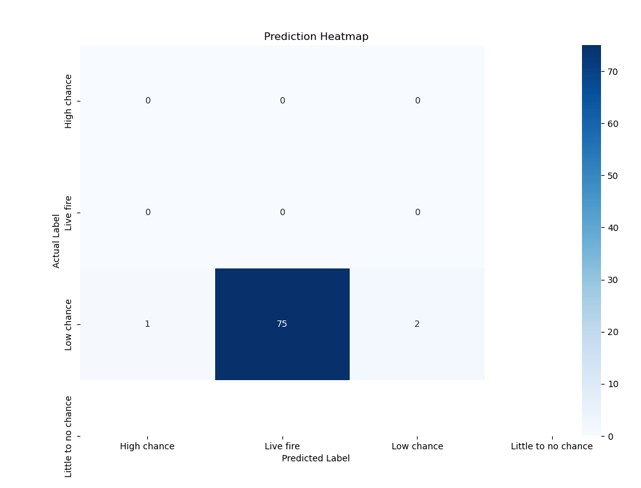
Figure 24 - Summer test confusion matrix
The model was tested on a dataset that only included data from the summer where a fire was not present to test the theory. The confusion matrix present in figure 24 shows that the model does not perform well on data from the hotter months due to the palisades fire being in the winter and the data was scaled around the palisades fire meaning that the model believes that there is a fire here due to the high thermal values in the summer months. Only three tiles were predicted to not be a live fire and none of these were predicted to be in the little to no chance category which shows a glaring weakness in the training data as the model believes the higher base temperature is actually a fire.
The Ventura County fire dataset that the model was tested occurred in the autumn which results in the baseline thermal activity being much lower than in the height of summer. Therefore, from these tests and experiments the model is not accurate in the warmer months but becomes more accurate towards the winter months. This is easily explained by the dataset purely containing data about a singular fire which occurred in the winter.
To resolve this issue a training dataset would need to cover a variety of fires across the year to ensure that predictions remain accurate throughout the year. This would ensure that fires are captured correctly however, it may also introduce the problem of the model not picking up cooler fires that occur in the winter if it recognises hotter fires but struggles on cooler fires.
Incorrect/Incompatible data
To test the model and the program’s ability to handle incorrect or invalid data some data will be given to the model to assess its performance. If the model is able to handle incorrect data, then it will open an error dialog box explaining the error to the user instead of crashing.
Due to the program’s only user input being inputting a file to the program for a prediction, this can be the only thing that can be tested. To test the program’s ability to handle this data an incompatible .tif will be inputted as the program will only accept .tif files.
Figure 25 - Incompatible .tif file
A screenshot of the pacific palisades area on google earth was saved as a .tif file and inputted into the program to test its handling of incorrect data.
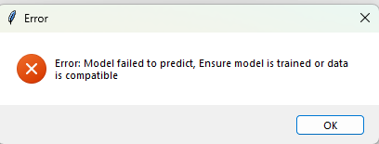
Figure 26 - Error dialog box
After submitting the screenshot, the program failed to predict on the image as it only has three bands for red, green and blue. This results in the program failing to access the thermal bands because they are not present causing an error. This error is caught by the program and the user is provided with a dialog box explaining to the user possible causes of the error.

Interface Testing
Incorrect inputs testing
To ensure that the interface cannot be broken by abnormal user inputs and behaviours it must be tested. If the program is able to handle abnormal user inputs, then the program will provide an error dialog popup which will explain to the user what caused the error instead of crashing the program.
Since the program only takes one input from the user and that has been tested in the previous section then this test will consist of abnormal behaviours to test for.
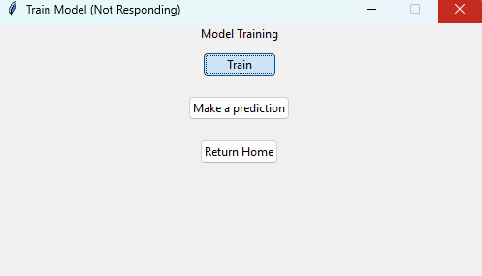
Figure 27 - Interface not responding
Clicking the train button will often cause the GUI to freeze as the model trains. This is further exacerbated if the user repeatedly clicks the train button before the GUI freezes as it sends more instructions to train the model which is already being trained.

Requirements to use the program
To use the program the user must have the following python libraries installed:
- Tkinter
- Rasterio
- Scikit-Learn
- Tensorflow
- PIL
- Keras
Once the user has successfully installed the libraries the program will be able to run without any other installations.
A requirements file will be provided alongside the program files which will include the correct versions and dependencies required.

External concerns

Legal, social and ethical issues
Due to government agencies often being funded by the taxpayer this means that false predictions where actions have been put in place to prevent a falsely predicted fire will cost the taxpayer as the money will be wasted preventing a fire that was not going to happen. Not only will it cost the authorities money it will also take up the time of the local authorities which could have been spent on other events that have happened.
Additionally, some wildfires are necessary to rejuvenate ecosystems and prevent larger fires from taking place. Some trees such as the Jack pine tree, although not present in California, require the presence of a fire as the temperature helps to release their seeds to plant more trees naturally. Preventing these types of fire could cause much more damage to the environment instead of letting them burn however, these fires should also be prevented but only if it endangers people or buildings. Preventing too many fires may also require local fire services to do controlled burns much more often than currently, this would simulate the smaller fires and prevent much larger dangerous fires.
The program does not need to take into account user data protection laws as at no point in operating the program does it handle user data. It only handles data extracted from the google earth engine or other ways of collecting Landsat 9 data.

Commercial issues and exploitation
Due to the data having to be extracted from the google earth engine then the program cannot be used to profit from as the data used was not originally created by me. The data was only extracted from the google earth engine. The project also does not include any material or libraries that require any licenses paid or unpaid to use meaning that the project can be used for free without any financial contribution.
Locking this program behind a paywall also means that some fires may not be prevented if users cannot access the program due to not paying for it which defeats the purpose of the program and may cost the environment and people much more than a fee to buy the program.

Evaluation

Model evaluation
The model was successful in regard to its accuracy target on the training and testing data where it achieved an accuracy of above 80% on both sets of data. This completes one of the project’s objectives it has maintained a high accuracy score and from this will enable local authorities or agencies to act accordingly to prevent fires.
However, the model did falter a large amount in tests which included data from a different area of California at a different time of year. This may be to do with the different baseline thermal temperatures in that area at that time of year as well as the fact that there are no standard values to a fire and the data was normalised around the training dataset resulting in higher average temperatures possibly being falsely predicted as a fire.

Dataset evaluation
The dataset creation was also somewhat successful as it includes a large amount of high-quality data that covers a large number of thermal or geological factors that could be used to predict the likelihood of a fire. Furthermore, the dataset includes different states of the pacific palisades wildfire such as before, during and after the fire which allows the model to learn the key differences and patterns to form a prediction.
However, since Landsat 9 is a satellite that orbits the earth, it can be an issue in collecting data for a specific region. This is because the revisit time of Landsat 9 is sixteen days. Any thermal activity or disturbances will not be able to be collected and thus no prediction can be made. These blind spots mean that fires that start within that window of time may not have been able to be predicted whatsoever and have slipped through.
Additionally, since the data does not include the day that it was taken it is difficult to calculate whether the data is in the day or night from solar angles available in the data. I could calculate this in the dataset I made however the data taken from the user may not include the date the data was taken by the sensor on. This can result in predictions not being as accurate depending on the time of day and season the data was taken on as it is hard to take that into account so for this project, therefore time of day and season have been ignored and used thermal readings and vegetation quality to form a prediction instead.

Evaluation
Overall, this project has been moderately successful in its aims as a model and dataset were created which can predict fires. However, there are many drawbacks to the data available and so it has exposed weaknesses of the model and dataset. Part of this is due to the data available not being able to be captured within a shorter period of time than the sixteen days revisit time therefore making it hard to capture a large number of fires to use in dataset as fires may occur but not be captured by Landsat 9. This resulted in the dataset only including a single fire which means that fires or thermal activity that is wildly different to the conditions present in this fire being incorrectly predicted by the model.

Reflection

Development reflection
The project was able to maintain its schedule due to the use of sprints, this allowed development to be done in multiple different stages. Splitting development into sprints allowed for each section of the project to be in different steps and allowed for deliverable prototypes at the end of each sprint. This allowed for development to flow well and reflections after each sprint to inform the next sprint’s development.
The model being designed to be lightweight assisted development meaning that it would never take more than a couple of minutes to train or test. However, this may be also partly due to the lack of available data for the palisade region where training data was captured. Due to the lack of available dedicated GPU for the project it was trained on a CPU meaning that training on a dedicated GPU could offset some of the time taken to train if the dataset was larger.

Future Development
To further develop the work on this project, creating a dataset that covers more fires across the different seasons and years will improve the results of the model. Additionally, if the new data included the date and time the data was captured from then the model could learn to differentiate between the seasons as the background thermal values differ between the seasons and the time of day. Having a model that could differentiate between these and a dataset that would include much more data would significantly improve the model’s performance.

Future Research
Furthering on from improving the data inside of the dataset, it would also be useful to research different regions and then either use multiple models each tailored to each country/region or expand the model to understand the differences between regions. This would help other regions across the globe protect against wildfires, not just California. A model and dataset that would be useful for entire countries or continents would be an invaluable tool and would save countless lives, ecosystems and infrastructure.

Project Conclusions
The project aimed to create both a dataset composed of satellite data and a machine learning model that would be trained on the dataset to predict the likelihood of a wildfire occurring in an area. The project was moderately successful with a dataset and a model being created to achieve the aims. However, after testing both the model and dataset had clear weaknesses which resulted in some testing data not being predicted accurately at all.
Based on the results of the project, the model is effective in predicting fires but has clear weaknesses due to the lack of available data resulting in the data only including one fire at one time of the year which results in the model being confused by data that has a higher background thermal reading such as is present in the summer months. However, if the fire had similar conditions to the pacific palisades fire which is present in the dataset, the fire was predicted with a higher degree of accuracy.
The project highlights the need for more regular data points in satellite imagery for the task of wildfire prediction as the data for each fire being limited or unavailable as a result of the sixteen-day revisit time. Further studies could use generated or augmented data to fill these gaps as the revisit time of a satellite cannot be easily changed to suit the project’s needs. Use of these data creation techniques could also increase the size of the dataset even without being used to fill in gaps, which may lead to an increase in model performance.
Wildfire prediction is still a new and developing field in machine learning as there are many different factors that can contribute to a wildfire and no fire is exactly the same as a previous one. Another area that was not explored by this project was the cause of the fire, as fires that were directly caused by humans such as arson related fires could not be considered by a model. This is because it is near impossible to predict that a fire will happen if a human has decided to start a fire in an area as the conditions before an arson related fire may not highlight any dangers of a fire in that area.
Furthermore, events such as lightning are not able to be predicted either and may also cause fires in areas that did not show any significant signs that a fire may happen in that area. The model may be able to predict that a fire may have a low chance to occur in an area, but it will likely never predict that there is a high chance to occur in that area. Further development on wildfire prediction could explore fires created by humans however, it is unlikely that human behaviour could accurately be predicted.
Hopefully based on the results and discussions in this project it can inform future developments in the challenging area of wildfire prediction using machine learning.

References
Copernicus European Union (2025) EFFIS annual statistics for greece. Available online: https://forest-fire.emergency.copernicus.eu/apps/effis.statistics/estimates/GRC [Accessed 01/07 2025].
D. Rashkovetsky, F. Mauracher, M. Langer & M. Schmitt (2021) Wildfire detection from multisensor satellite imagery using deep semantic segmentation. IEEE Journal of Selected Topics in Applied Earth Observations and Remote Sensing, 14 7001–7016.
F. Huot, R. L. Hu, N. Goyal, T. Sankar, M. Ihme & Y. -F. Chen (2022) Next day wildfire spread: A machine learning dataset to predict wildfire spreading from remote-sensing data. IEEE Transactions on Geoscience and Remote Sensing, 60 1–13.
Fu, Y., Li, R., Wang, X., Bergeron, Y., Valeria, O., Chavardès, R. D., Wang, Y. & Hu, J. (2020) Fire detection and fire radiative power in forests and low-biomass lands in northeast asia: MODIS versus VIIRS fire products. Remote Sensing, 12 (18), .
H. Liang, M. Zhang & H. Wang (2019) A neural network model for wildfire scale prediction using meteorological factors. IEEE Access, 7 176746–176755.
Jones, C. R. and Bergen, B. K., (2025), Large language models pass the turing test. UC San Diego, Available online: https://arxiv.org/pdf/2503.23674 [Accessed: 21/04/2025].
Kanwal, R., Rafaqat, W., Iqbal, M. & Weiguo, S. (2023) Data-driven approaches for wildfire mapping and prediction assessment using a convolutional neural network (CNN). Remote Sensing, 15 (21), .
Lindsey Rebecca, D. L. (2024) Climate change: Global temperature. Available online: https://www.climate.gov/news-features/understanding-climate/climate-change-global-temperature [Accessed 13/10 2024].
MacCarthy James, Richter Jessica, Tyukavina Sasha, Weisse Mikaela & Harris Nancy (2024) The latest data confirms: Forest fires are getting worse. Available online: https://www.wri.org/insights/global-trends-forest-fires [Accessed 13/10 2024].
Malik, A., Rao, M. R., Puppala, N., Koouri, P., Thota, V. A., Liu, Q., Chiao, S. & Gao, J. (2021) Data-driven wildfire risk prediction in northern california. Atmosphere, 12 (1), .
Peng, W., Wei, Y., Chen, G., Lu, G., Ye, Q., Ding, R., Hu, P. & Cheng, Z. (2023) Analysis of wildfire danger level using logistic regression model in sichuan province, china. Forests, 14 (12), .
Rezaei Barzani, A., Pahlavani, P. & Ghorbanzadeh, O. (2023) Ensembling of decision trees, knn, and logistic regression with soft-voting method for wildfire susceptibility mapping. ISPRS Ann.Photogramm.Remote Sens.Spatial Inf.Sci., X-4/W1-2022 647–652.
State of California (2025) 2024 incident archive. Available online: https://www.fire.ca.gov/incidents/2024 [Accessed 07/01 2025].
teneo.ai (2025) Homage to john McCarthy, the father of artificial intelligence (AI). Available online: https://www.teneo.ai/blog/homage-to-john-mccarthy-the-father-of-artificial-intelligence-ai [Accessed 21/04 2025].
Turing, A. (1950) Computing machinery and intelligence. 59 (236), 1–21.
US geological survey (2025) Landsat 9. Available online: https://www.usgs.gov/landsat-missions/landsat-9 [Accessed 01/11 2025].

Appendix A

Appendix B

