No. | 5SBLL17122025 dated 17 December 2025
Customer | 5Senses Beauty Limited | Contractor | Banuba FZCO
Customer’s address | RM1608, 16/F, APEC PLAZA ,49 HOI TUEN RD, KWUN TONG | Billing  address | IFZA Business Park, DDP, 27540-001, UAE
Company  number | 78459506-000-07-25-9 | Company  number | 27540
Contact name | Kieran Li | Billing  contact name | Anna Krot
Contact email | Kieran@5senses.global | Billing  contact email | accounts@banuba.com
Subcontractor’s details (if any) | N/A
Product, domain | B2B2C Asian Beauty Platform  Platform: web  Web domain: Will be provided further

The Customer acknowledges and agrees that demo Software was demonstrated by the Contractor prior to entering this Agreement; the Customer confirms he is aware of Software content, functionality and performance and agrees not to make any claims in respect of it.

Software | Tier (Virtual Try-ons per month) | SKU | Licence Fee | Term of Licence | Billing frequency | Annual amount
TINT make-up | Tier-1: 0 - 45,000 | Unlimited | 10,000 USD | 1 year | Annually upfront | 10,000 USD
 | Tier-2: 45,000 - 75,000 | Unlimited | 17,990 USD | 1 year | Annually upfront | 17,990 USD
 | Tier-3: 75,000 - 125,000 | Unlimited | 25,900 USD | 1 year | Annually upfront | 25,900 USD
The Licence payments for the TINT mentioned above are subject to the condition that the amount of Virtual Try-ons per month does not exceed the indicated limit with respect to the particular tier. If the amount of Virtual Try-ons per month exceeds the indicated limit in any given month, then, at the end of the respective month or, in case of termination of the Agreement, at the date of termination of the Agreement, the Customer shall be switched to the next tier of Virtual Try-ons per month and shall pay the difference for the remaining Virtual Try-ons. Parties may renegotiate the licensing terms in writing accordingly.
The Customer may request Extended Support services from the Contractor. The cost of such Extended Support is 1,000 USD per month and includes assistance with product (Make-up) digitization, bulk uploading, eight (8) hours of training and onboarding. The minimum term for which Extended Support may be requested is 3 (three) consecutive months.

Contractor may revise fees annually.
Additional terms and conditions
Definitions | Capitalised terms used but not defined in this Order Form have the meaning set forth in the Terms
Governing terms | Software Licensing Terms (the “Terms”) apply to this Order Form and are available at the following link: https://www.banuba.com/licensing-terms
Renewal terms | The initial period shall be automatically renewed for additional successive 12 months renewal terms, unless either party provides a written notice of non-renewal at least 30 days prior to the end of the current period.
Payment terms | With respect to the Licence Fee in the first year of licensing: NET 60  With respect to the Licence Fee in the subsequent years of licensing: NET 15  With respect to the Extended Support services: NET 15

This Order Form enters into legal force as of the date of the last signature below. Each signatory represents and warrants that said signatory is over 18 years of age and is duly authorised to sign this Order Form on behalf of the signatory’s respective business. Upon signature of this Order Form by Customer, this Order Form and the Terms become legally binding.

Client’s name 5Senses Beauty Limited- Simplex-ity.com | Banuba FZCO
Name: Kieran Li | Name: Aliaksei Shantora
Title: Managing Director | Title: General Manager
Date:12/27/2025 | Date:
Signature: ________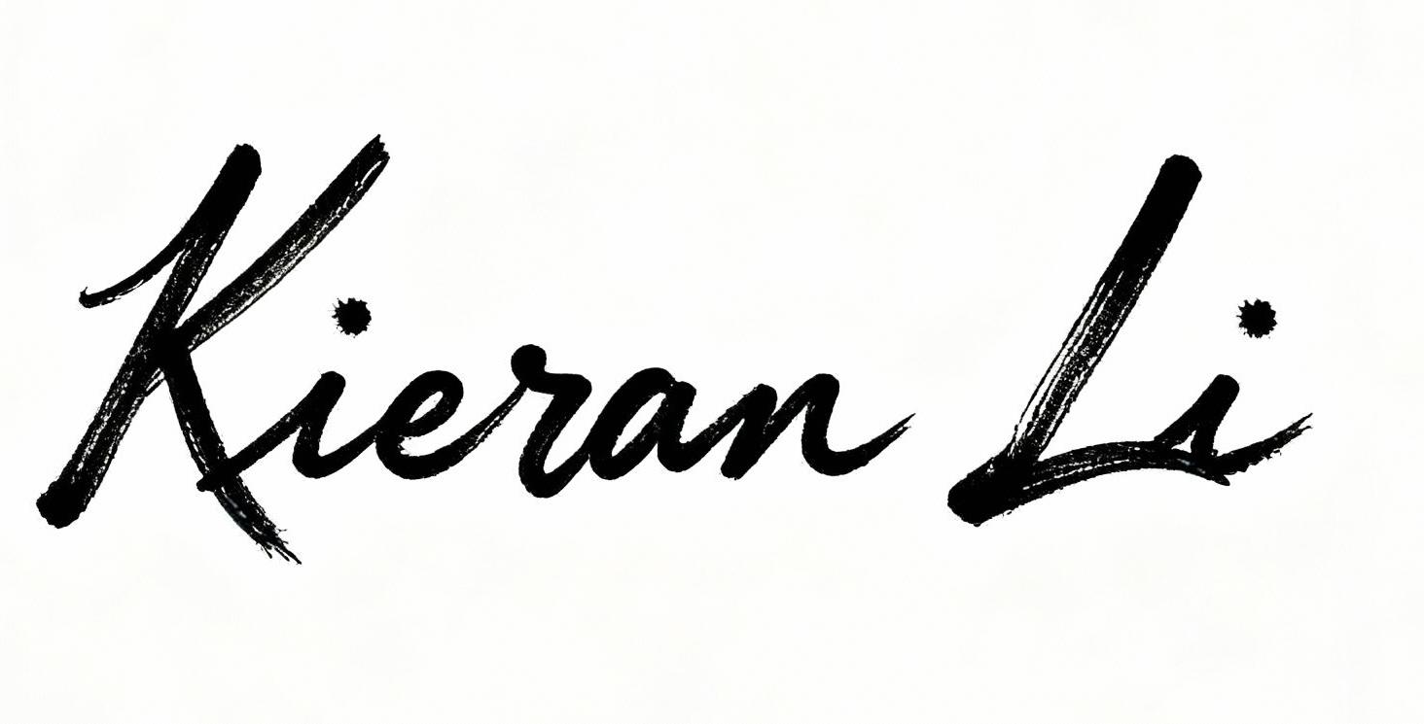__________ | Signature: __________________

